 |  |  |  | 
 |  |  |  |  |  | Requested by: |  | Mmamoloto
SARS BRANCH: |  | Gauteng North & Head Office
Address: | Various Offices
 | PTA
Contact Person:
Contact Number:

Request for Service: Job scope and specifications:
Item | Description | Location | QTY
1. | Remove existing blinds, Supply and Install new Vertical Blinds as per below spec: | HO & Gauteng North & offices | 1
1.1 | 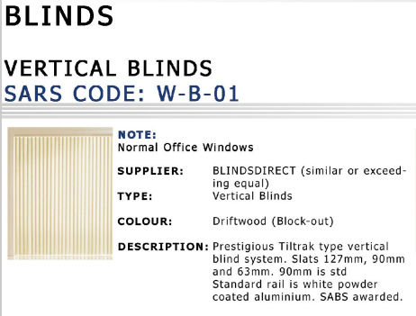
2 | Remove existing blinds, Supply and Install new Roller Blinds as per below spec: | HO & Gauteng North Offices | 1
2.1 | 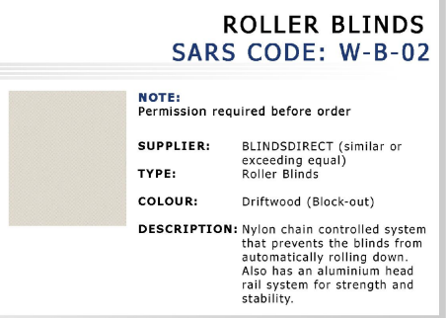
3 | Remove existing blinds, Supply and Install new Horizontal Wood Blinds as per below spec. | HO & Gauteng North Offices | 1
3.1 | 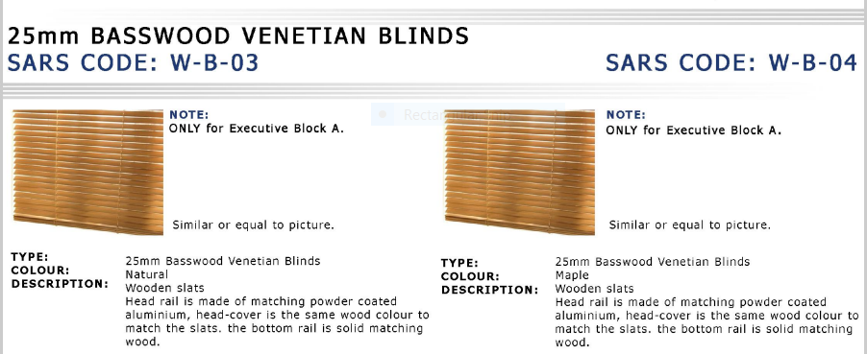
4 | Remove existing blinds, Supply and Install new Horizontal Aluminium Blinds as per below spec. | HO & Gauteng North Offices | 1
 | 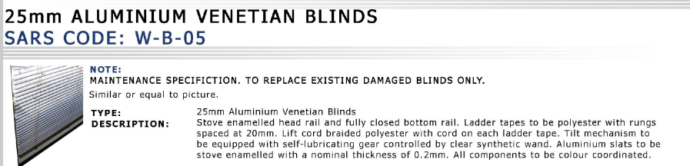
5 | NB. IT’S THE SERVICE PROVIDERS RESPONSIBILITY TO MAKE SURE THEY CHECK WITH THEIR SUPPLIER & CLIENT PRIOR TO INSTALLATION THAT THEY HAVE THE CORRECT SPECIFICATION.
6 | SERVICE PROVIDERS TO SUBMIT QUOTE PER WINDOW & QUOTATION TO BE APPROVED BY FM PRIOR TO INSTALLATION AS & WHEN REQUESTED

Description of services |  | Price value
Remove existing blind |  | R
Supply and Install vertical blind | 1 | R
Supply and Install roller blind | 1 | R
Supply and Install basswood venetian blind | 1 | R
Supply and Install aluminium venetian blind | 1 | R
Repair & Maintenance on each type of blind | 1 | R
Labour rate/during office hours 07:00-16:00 (Skilled artisan) | 1 | R
Labour rate/after-hours/ weekend/ holiday (Skilled artisan) | 1 | R
Labour rate/during office hours 07:00-16:00 (Assistant Artisan) | 1 | R
Labour rate/after-hours/ weekend/ holiday (Assistant artisan) | 1 | R
Normal call out | 1 | R
Total Vat Excl |  | R
VAT @15% |  | R
Grand Total Incl Vat @15% |  | R
Pricing Template

Applicable Mark-Ups

Material, Equipment hire & Sub-contracting markups allowed | Fixed Markup percentage
R0 – R4999.00 | 12%
R5000 – R19,999 | 10%
R20,000 – R100,000 | 7 %
R101,000 – R499,000 | 5 %

