CONTRACT
C1: AGREEMENTS AND CONTRACT DATA C2: PRICING DATA
C3: SCOPE OF WORK C4: SITE INFORMATION C5: ANNEXURES

CONTRACT

TABLE OF CONTENTS Page Colour

C1: AGREEMENTS AND CONTRACT DATA

C1.1: FORM OF OFFER AND ACCEPTANCE ................................................ | C3 | Yellow
C1.2: CONTRACT DATA ................................................................................ | C7 | Yellow
C1.2.1: CONDITIONS OF CONTRACT ...................................................... | C7 | Yellow
C1.2.2: PART A: DATA PROVIDED BY THE EMPLOYER ........................ | C9 | Yellow
PART B: DATA PROVIDED BY THE CONTRACTOR .................. | C11 | Yellow
C1.2.3: THE VARIATION TO T

HE GENERAL CONDITIONS OF CONTRACT C12 Yellow
C1.3: FORM OF GUARANTEE ....................................................................... | C18 | White
C1.4: AGREEMENT WITH ADJUDICATOR ................................................... | C20 | White
C1.5: AGREEMENT IN TERMS OF SECTION 37(2) OF THE OCCUPATIONAL HEALTH AND SAFETY ACT No 85 OF 1993.......... | C22 | White
C1.6: RETENTION MONEY GUARANTEE ..................................................... | C24 | White

C2: PRICING DATA

C2.1: INSTRUCTIONS.....................................................................................  C2.2: BILL OF QUANTITIES ........................................................................... | C26  C30 | Yellow  Yellow
C3: SCOPE OF WORK
TABLE OF CONTENTS .................................................................................... | C59 | Blue
C3.1: STANDARD SPECIFICATIONS ............................................................ | C61 | Blue
C3.2: PROJECT SPECIFICATIONS................................................................ | C62 | Blue
C3.3: PARTICULAR SPECIFICATIONS .........................................................  C4: SITE INFORMATION | C | Blue
C4.1: LOCALITY PLAN ................................................................................... | C84 | Green
C4.2: EXAMPLE OF CONTRACT SIGNBOARD DETAILS ............................ | C85 | Green

C1: AGREEMENTS AND CONTRACT DATA

C1.1 FORM OF OFFER AND ACCEPTANCE

OFFER
The Employer, identified in the Acceptance signature block, has solicited offers to enter into a contract in respect of the following works:

CONTRACT No.: MPO/1../2024
Mqula Culvert Bridge improvement
The Bidder, identified in the Offer Signature block below, has examined the documents listed in the Bid Data and addenda thereto as listed in the Bid Schedules, and by submitting this Offer has accepted the Conditions of Bid.
By the representative of the Bidder, deemed to be duly authorised, signing this part of this Form of Offer and Acceptance, the Bidder offers to perform all of the obligations and liabilities of the Contractor under the Contract including compliance with all its terms and conditions according to their true intent and meaning for an amount to be determined in accordance with the Conditions of Contract identified in the Contract Data.

The offered total of the prices inclusive of Value Added Tax is:
R ............................................................. (In words. ...............................................................................
. ),
This Offer may be accepted by the Employer by signing the Acceptance part of this Form of Offer and Acceptance and returning one copy of this document to the Bidder before the end of the period of validity stated in the Bid Data, whereupon the Bidder becomes the party named as the Contractor in the Conditions of Contract identified in the Contract Data.

Signature: (of person authorized to sign the Bid): ............................................................................
Name: (of signatory in capitals): .......................................................................................................
Capacity: (of Signatory): .................................................................................................................
Name of Bidder: (organisation): .....................................................................................................
Address: ..................................................................................................................................
..................................................................................................................................
Telephone number: .......................................... Fax number: ........................................

Witness:

Signature: ..................................................................................................................................
Name: (in capitals):..........................................................................................................................

Date: ..........................................
[Failure of a Bidder to sign this form will invalidate the Bid]

ACCEPTANCE
By signing this part of the Form of Offer and Acceptance, the Employer identified below accepts the Bidder’s Offer. In consideration thereof, the Employer shall pay the Contractor the amount due in accordance with the Conditions of Contract identified in the Contract Data. Acceptance of the Bidder’s Offer shall form an agreement between the Employer and the Bidder upon the terms and conditions contained in this Agreement and in the Contract that is the subject of this Agreement.

The terms of the contract are contained in

Part 1 Agreement, and Contract Data, (which include this Agreement) Part 2 Pricing Data, including the Bill of Quantities
Part 3 Scope of Work Part 4 Site Information
and the schedules, forms, drawings and documents or parts thereof, which may be incorporated by reference into Parts 1 to 4 above.
Deviations from and amendments to the documents listed in the Bid Data and any addenda thereto listed in the Bid Schedules as well as any changes to the terms of the Offer agreed by the Bidder and the Employer during this process of offer and acceptance, are contained in the Schedule of Deviations attached to and forming part of this Agreement. No amendments to or deviations from said documents are valid unless contained in this Schedule, which must be duly signed by the authorised representatives of both parties.
The Bidder shall deliver the Guarantee in terms of Clause 6.2 of the General Conditions of Contract 2015 within the period stated in the Contract Data, and he shall, immediately after receiving a completed copy of this Agreement, including the Schedule of Deviations (if any), contact the Employer’s agent (whose details are given in the Contract Data) to arrange the delivery of any other bonds, guarantees, proof of insurance and any other documentation to be provided in terms of the Conditions of Contract identified in the Contract Data, within 14 days of the date on which this Agreement comes into effect. Failure to fulfill any of these obligations in accordance with those terms shall constitute a repudiation of this Agreement.
Notwithstanding anything contained herein, this Agreement comes into effect on the date when the Bidder receives one fully completed original copy of this document, including the Schedule of Deviations (if any). Unless the Bidder (now Contractor) within five days of the date of such receipt notifies the Employer in writing of any reason why he cannot accept the contents of this Agreement, this Agreement shall constitute a binding contract between the parties.

Signature: ................................................................................................................................
Name: (in capitals) ........................................................................................................................
Capacity: .........................................................................................................................................
Name of Employer (organisation) ...................................................................................................
Address: .........................................................................................................................................
.........................................................................................................................................................

Witness:
Signature: ................................................ Name: ................................................................

Date: ................................................

SCHEDULE OF DEVIATIONS

The extent of deviations from the Bid documents issued by the Employer prior to the Bid closing date is limited to those permitted in terms of the Bid Data and the Conditions of Bid.

A Bidder’s covering letter will not necessarily be included in the final contract document. Should any matter in such letter, which constitutes a deviation as aforesaid becomes the subject of agreements reached during the process of offer and acceptance; the outcome of such agreement shall be recorded here.

Any other matter arising from the process of offer and acceptance either as a confirmation, clarification or change to the Bid documents and which it is agreed by the Parties becomes an obligation of the contract shall also be recorded here.

Any change or addition to the Bid documents arising from the above agreements and recorded here, shall also be incorporated into the final draft of the Contract.

- Subject: ..........................................................................................................................................
Details: ..........................................................................................................................................
..........................................................................................................................................
- Subject: ..........................................................................................................................................
Details: ..........................................................................................................................................
..........................................................................................................................................
- Subject: ..........................................................................................................................................
Details: ..........................................................................................................................................
..........................................................................................................................................
- Subject: ..........................................................................................................................................
Details: ..........................................................................................................................................
..........................................................................................................................................
- Subject: ..........................................................................................................................................
Details: ..........................................................................................................................................
..........................................................................................................................................
- Subject: ..........................................................................................................................................
Details: ..........................................................................................................................................
..........................................................................................................................................
By the duly authorised representatives signing this Schedule of Deviations, the Employer and the Bidder agree to and accept the foregoing Schedule of Deviations as the only deviations from and amendments to the documents listed in the Bid Data and addenda thereto as listed in the Bid Schedules, as well as any confirmation, clarification or change to the terms of the offer agreed by the Bidder and the Employer during this process of offer and acceptance.

It is expressly agreed that no other matter whether in writing, oral communication or implied during the period between the issue of the Bid documents and the receipt by the Bidder of a completed signed copy of this Agreement shall have any meaning or effect in the contract between the parties arising from this Agreement.

FOR THE BIDDER:

Signature:........................................................................................................................................
Name: .............................................................................................................................................
Capacity: .......................................................................................................................................
Bidder: (Name and address of organisation) ..................................................................................
.......................................................................................................................................

Witness:

Signature:........................................................................................................................................
Name: .............................................................................................................................................
Date: ................................................................

FOR THE EMPLOYER

Signature:........................................................................................................................................
Name: .............................................................................................................................................
Capacity: .......................................................................................................................................
Employer: (Name and address of organisation) .............................................................................
.......................................................................................................................................

Witness:

Signature:........................................................................................................................................
Name: .............................................................................................................................................
Date: ...................................................................

C1.2: CONTRACT DATA C1.2.1 CONDITIONS OF CONTRACT
C1.2.1.1 GENERAL CONDITIONS OF CONTRACT

This Contract will be based on the “General Conditions of Contract for Construction Works – 3rd Edition 2015", issued by the South African Institution of Civil Engineering. (Short title: “General Conditions of Contract 2015").

It is agreed that the only variations from the General Conditions of Contract 2015 are those set out hereafter under "Special Conditions of Contract".

C1.2.1.2 SPECIAL CONDITIONS OF CONTRACT

C1.2.1.2.1 GENERAL

These Special Conditions of Contract (SCC) form an integral part of the Contract. The Special Conditions shall amplify, modify or supersede, as the case may be, the General Conditions of Contract 2015 to the extent specified below, and shall take precedence and shall govern.
The clauses of the Special Conditions hereafter are numbered “SCC” followed in each case by the number of the applicable clause or sub-clause in the General Conditions of Contract 2015, and the applicable heading, or (where a new special condition that has no relation to the existing clauses is introduced) by a number that follows after the last clause number in the General Conditions of Contract 2015, and an appropriate heading.

C1.2.1.2.2 AMENDMENTS TO THE GENERAL CONDITIONS OF CONTRACT 2015

Contract Price Adjustment Schedule – Page 86

Replace paragraph beginning with “ “F” is the “Fuel Index” …” to “… Statistics South Africa.” with the following:-
“F” is the “Fuel Index” and shall be the Producer Price Index for Diesel at wholesale level for the
Coast as published in the Statistical News Release P0142.1, Table 12 of Statistics South Africa.

C1.2.1.3 PAYMENT OF LABOUR AND CLO

The ward councillor in whose wards work is to be done will, collectively identify a Community Liaison Officer (CLO) for the project and make the person known to the Contractor within two days of being requested to do so. The Contractor will be required to enter into a written contract with the CLO that specifies:
- The hours of work and the wage rate of the CLO (Current minimum wage prescribed is R150.00 per day).
- The duration of the appointment.
- The duties to be undertaken by the CLO which could include:
  - Assisting in all respects relating to the recruitment of local labour.
  - Acting as a source of information for the community and councilors on issues related to the contract.
  - Keeping the Contractor advised on community issues and issues pertaining to local security.
  - Assisting in setting up any meetings or negotiations with affected parties.
  - Keeping a written record of any labour or community issues that may arise.
  - Any other duties that may be required by the Contractor.

Responsibility for the identification of a pool of suitable labour shall rest with the CLO, although the Contractor shall have the right to choose from that pool. The Contractor shall have the right to determine the total number labourers required at any one time and this may vary during the contract.
The Contractor shall have the right to replace labour that is not performing adequately. Should such occasion arise, it must be done in consultation with the CLO.
The Contractor shall have the right to determine the total number of labourers required at any time, and this will vary through the duration of the contract

Local labour shall be paid in accordance with the Civil Engineering Industry minimum wage rate (Current minimum rate prescribe by the Mpofana Local Municipality is R 150.00 rand per day or per task or may change as per employer’s instruction), and all statutory conditions of employment shall be met.
It is the contractor responsibility to pay the Community Liaison Officer for the entire duration of the contract as per the provisional sum in the bill of quantities. In the event that the contractor’s work is not complete within the allowed duration, the community Liaison Officer shall still be paid for by the contractor until labour force is no longer required. This includes the penalty stage. If the item has not been allowed for in the bill of quantities therefore the contractor must allow in his rates for the Community Liaison Officer.

C1.2.2: CONTRACT DATA (Applicable to this contract)

A. DATA TO BE PROVIDED BY THE EMPLOYER

The following contract specific data are applicable to this contract.

REF. CLAUSE
No

DATA BY EMPLOYER

      - The Defects Liability Period is 6 months measured from the date of the Certificate of Completion.

      - The time for achieving Practical Completion is 6 months measured from the Commencement Date, including special non-working days.

Name of Employer: MPOFANA LOCAL MUNICIPALITY
1.1.1.26 The Pricing Strategy is Fixed Price

1.2.1.2 Address of Employer:
Physical: 10 Claughton Terrace Postal: PO Box 47 Mooi River Mooi River
3300 3300

Telephone No: (033) 263 1221
Fax No: (033) 263 1127

      - Name of Engineer: Isivivane Engineers CC

1.2.2 Address of Engineer:
Physical: 17 Neptune Road Postal: 17 Neptune Road Westville Westville
3629 3629
E-mail:info@isivivanengineers.co.za Telephone No: 031 287 8211

3.1.3: The Engineer is required to obtain the specific approval of the Employer for any expenditure in excess of the Contract Price.
4.4.7 If the main contractor fails to comply with the subcontracting requirements of 5%, then the 5% will be declared back to the client

    - The documentation required before commencement with Works execution are:
      - Health and Safety Plan (Clause 4.3)
      - Initial Programme (Clause 5.6)
      - Surety (Clause 6.2)
      - Insurance (Clause 8.6)
      - Letter of good standing for and C.O.I.D.A (Workman’s Compensation).
      - Proof of Notification for construction works to the Department of Labour
    - The time to submit the documentation required before the commencement of the Works is 14 days.
    - The non-working days are Sundays.

The special non-working days are the construction industry year end break and the following statutory public holidays as declared by National Government:
New Year’s Day, Human Rights Day, Good Friday, Family Day, Freedom Day, Workers’ Day, Youth Day, National Women’s Day, Heritage Day, Day of Reconciliation, Christmas Day and the Day of Goodwill.

The construction industry year end break commences on the first working day after 15 December and ends on the first working day after 5 January of the next year.
    - The penalty for failing to complete the Works is R 2500 per calendar day.

5.16.3 The latent defects period is 10 years
6.2.1 The security to be provided by the Contractor shall be:
Performance guarantee of 10% of the Bid sum up to the issue of the certificate of completion.
6.5.1.2.3 The percentage allowance to cover overhead charges is 15%.

6.8.3 Price adjustment for variations in the cost of special materials is not allowed.

Contract Price Adjustment will not be applicable.
6.10.1.5 The percentage advance on materials not yet built into the permanent works is: 80%.

6.10.3 The percentage retention on the amounts due to the Contractor is 10%.

The limit of retention money is 10% of the Contact sum.
        - The value of materials supplied by the Employer to be included in the insurance sum is nil.

        - The amount to cover professional fees for repairing damage and loss to be included in the insurance sum is R 100 000.00.
Special risk insurance issued by SASRIA is required.

8.6.1.3 The limit of indemnity for liability insurance is R10 000 000,00 (ten million rands only) for any single liability claim. Liability insurance shall include spread of fire risk.

10.4.2.
10.7.1
Failing Amicable Settlement and resolution by Adjudication, unresolved Disputes shall be referred to Arbitration.

B: DATA TO BE PROVIDED BY CONTRACTOR

REF. CLAUSE
No

DATA BY CONTRACTOR

1.1.1.9 Name of Contractor: ........................................................................................

1.2.1.2 Address of Contractor:
Physical: ............................................ Postal: .............................................
. ......................................................... . .......................................................
. ......................................................... . .......................................................

E-mail: ................................

Telephone No: .............................. Fax No: ........................................

C1.2.3: THE VARIATION TO THE GENERAL CONDITIONS OF CONTRACT

- GENERAL

These Special Conditions of Contract (SCC) form an integral part of the Contract. The Special Conditions of Contract shall amplify, modify or supersede, as the case maybe, the General Conditions of Contract 2015 to the extent specified below, and shall take precedence and shall govern.
The clauses of the Special Conditions of Contract hereafter are numbered SCC followed in each case by the number of the applicable Clause or Sub-Clause in the General Conditions of Contract 2015, and the applicable heading.

An asterisk (*) placed next to an SCC subclause number denotes the inclusion of an additional/new subclause for which no equivalent appears in General Conditions of Contract 2015.

VARIATIONS TO THE GENERAL CONDITIONS OF CONTRACT

The General Conditions of Contract for Construction Works (2015), published by the South African Institution of Civil Engineering, is applicable to this Contract.

  - DEFINITIONS
SCC1.1.15 The Employer means: MPOFANA LOCAL MUNICIPALITY

SCC1.1.16 The Engineer means: Isivivane Engineers cc SCC1.2.1 Add the following new sub-clauses to Sub-Clause 1.2.1:
SCC1.2.1.3* sent by facsimile irrespective of it being during office hours or otherwise;
SCC1.2.1.4* posted to the addressee via registered mail and delivered by the postal authorities; or
SCC1.2.1.5* delivered by a courier service and signed for by or on behalf of the addressee;

In the second sentence of the last paragraph of sub-clause 1.2.1 and after the word
addresses insert and/or facsimile.
SCC1.2.6 *Targeted Enterprise means a business which adheres to statutory labour practices, is a legal entity, registered with South African Revenue Service and is a continuing and Independent Enterprise for profit, providing a Commercially Useful Function and:
    - which is at least 51% Owned by one or more Previously Disadvantaged Individuals or, in the case of a company, at least 51% of the shares are Owned by one or more Previously Disadvantaged Individuals; and
    - whose management and daily business operations are in the Control of one or more of the Previously Disadvantaged Individuals who effectively own it: provided, however, that the annual average turnover excluding Value Added Tax (VAT) and any turnover generated in respect of work performed by other parties in a joint venture or a consortium, of the business during the lesser of the period for which the business has been operating, or the previous three financial years, does not exceed:

      - R25 million in respect of contractors who generate more than 75% of their turnover as Prime Contractors;
      - R10 million in respect of contractor who generate less than 25% of their turnover as Prime Contractors;
      - R2.5 million, in respect of labour-only sub-contractors;

      - R10 million in respect of Manufacturers;
      - R15 million in respect of Suppliers;
      - R2.5 million exclusive of any turnover generated in respect of outsourced activities which the enterprise does not have the in-house competence and expertise to perform, in respect of professional service providers; and
      - R2.5 million, in respect of other service providers, e.g. transporters, and that the sum of the average annual turnovers over the same period of all the business concerns which are under the Control of Previously Disadvantaged Individuals within the business entity or Affiliated Entities does not exceed one and a half (1.5) times the maximum allowable annual average turnover for the particular category of enterprise as set out in b) above, seeking Targeted Enterprise Status.

BASIS OF CONTRACT

SCC 2.1.4 *COMPLIANCE WITH APPLICABLE LAWS

Add the following:

The Contractor shall ensure that he and his Sub-contractors pay wages to their labour forces, including artisans, which are in accordance with those determined by the Department of Labour and which may vary from time to time during the Contract Period.

SCC 2.1.4.1 *The Employer and the Contractor hereby agree, in terms of the provisions of Section 37(2) of the Occupational Health and Safety Act, 1993 (Act 85 of 1993, and the New Construction Regulations, 2003), hereinafter referred to as “the Act”, that the following arrangements and procedures shall apply between them to ensure compliance by the Contractor with the provisions of the Act, namely:
  - The Contractor undertakes that the appropriate officials and employees of the Contractor, as well as Subcontractors, will fully acquaint themselves with all relevant provisions of the Act and the Regulations promulgated in terms of the Act.;
  - The Contractor undertakes that all relevant duties, obligations and prohibitions imposed in terms of the Act and Regulations will be fully complied with;
  - The Contractor hereby accepts sole liability for such due compliance with the relevant duties, obligations and prohibitions imposed by the Act and Regulations, and expressly absolves the Employer from itself being obliged to comply with any of the aforesaid duties, obligations and prohibitions;
  - The Contractor agrees that any duly authorised official of the Employer shall be entitled (although not obliged) to take such steps as may be necessary to ensure that the Contractor has complied with his undertakings as set out more fully in paragraphs (a) and (b) above, which steps may include, but will not be limited to, the right to inspect any appropriate site or premises occupied by the Contractor, or to inspect any appropriate records held by the Contractor; and
  - The Contractor shall be obliged to report forthwith to the Employer any investigation, complaint or criminal charge which may arise as a consequence of the provisions of the Act and Regulations, pursuant to work performed in terms of this contract, and shall, on written demand, provide full details in writing of such investigation, complaint or criminal charge.

SCC2.1.1 *AVAILABLE DATA AND EXISTING INFORMATION

Add the following:

All known existing underground services in the vicinity of the Works are shown on the drawings and immediately prior to undertaking any work the Contractor shall check the record of underground services in order to ascertain the presence of any new services. The exact position of these services cannot be guaranteed. The Contractor shall exercise due care when working near these services. If any service shown on the drawings is damaged by the Contractor, then the Contractor shall bear the cost of the repair by the responsible authority.
The Contractor shall immediately inform the Engineer if he discovers the existence of any underground service which is not shown on the drawings. If such service is undamaged when discovered, it shall from then on be deemed to be known service and, if subsequently damaged by the Contractor, its repairs shall be a charge on the Contractor. If such unknown service is damaged when discovered, the cost of repair shall be met by the Contractor unless he establishes to the satisfaction of the Engineer that such damage could not by the exercise of reasonable diligence have been avoided; such service shall thereafter be deemed to be known service and the provisions of the preceding paragraph shall apply.

2.6* GUARANTEE
SCC2.6.1 GUARANTEE

The Contractor shall deliver to the Engineer within such time as may be stated in the Contract Data a guarantee of an Insurance Company or Bank to be jointly and severally bound with the Contractor, in accordance with the provisions of the Form of Guarantee, in a sum equal to the amount stated in the Contract Data, for the due performance of the contract. The said Company or Bank shall be subject to approval by the Employer.

The Engineer shall be empowered to withhold all payment certificates until the Contractor has complied with his obligations in terms of this clause.
Expenditure incurred in obtaining such guarantee and the Form of Guarantee to be entered into shall be borne by the Contractor unless the Contract otherwise provides. The Form of Guarantee shall be returned to the Guarantor within 14 days after the issue of the Certificate or Certificates of Completion in respect of the whole of the Permanent Works.

The Contractor shall then be responsible for returning the Guarantee to the Guarantor.

Should the employer be made unable to return the Guarantee, the Employer shall write a suitably worded letter addressed to the Guarantor but delivered to the Contractor within the prescribed 14 days, stating that he has no further claim against the Guarantor and the Guarantee may be cancelled. The Contractor shall then be responsible for forwarding such letter to the Guarantor.
In the event that the Contractor fails to submit an acceptable guarantee in terms of this sub-clause within the time stated in the Contract Data and acceptable insurance policies and proof of payment of premiums and continuity of the policies within the time stated in Sub-Clause 35.1 hereof, the Engineer shall, with the Employers approval, be entitled to delay the commencement of the Works (and hence the Commencement Date) by the number of days the Contractor is late in submitting the required documentation. The construction period shall ipso facto be reduced by the number of days the contractor was late in submitting the required documentation.

EMPLOYER’S AGENTS INSTRUCTION

SCC4.2.2 After the word “instructions”, insert “(excluding the SABS 1200 Standardised Specifications)”

SCC4.7 FOSSILS, etc

Add the words “or traditional importance (such as burial sites)” between the words “interest” and “discovered” in the third line.

Clause 4.4: SUBCONTRACTING

Add the following clause to the end of Clause 4.4.4.:

If the contractor fails to comply with the subcontracting requirements as stipulated in the bid specification, then the contractor shall declare back to the employer the 5% of the construction amount.

4.11 COMPETENT EMPLOYEES SCC4.11.3* LOCAL LABOUR
Where it is a requirement that the Contractor employ local labour and local subcontractors on site, the Contractor shall, taking cognisance of the requirements of this Clause, appoint local labour subcontractors as required for the execution of the works and shall train and supervise them as may be necessary to execute and complete the tasks or functions for which they were employed. The preferred categories and ratios are as follows:
- 1/3 (one third) of labour be women (above youth age category of 35 years);
- 1/3 (one third) of labour be youth (men and women, 18 to 35 year age); and
- 1/3 (one third) of labour be men (above youth age category of 35 years).

8.3 EXCEPTED RISKS

SCC8.3.1 Append Sub-clause 8.3.1.9 with except where the Contract specifically so provides,

8.6 INSURANCES

SCC8.6.1 INSURANCES TO BE EFFECTED

Amend Sub-Clause 8.6.1 to read:
“The minimum amount of insurance required in terms of this Clause, as stated in the Contract Data, shall be, per event, the number of events being unlimited:”
Amend Sub-Clause 8.6.1.1 to read:

“Insurance of all materials stored off Site, and intended for incorporation in the Works, including their delivery to the Site and off-loading on Site, to the value of such materials for which payment is made in terms of Sub-Clause 49.1 hereof:”

SCC8.6.6 CONTRACTOR TO PRODUCE PROOF OF PAYMENT

Add to Sub-Clause 8.6.6.1

“The policies and the proof of payment of premiums and continuity of the policies shall be produced within such time as is stated in the Contract Data.”

SCC8.6.8* LEGAL PROVISIONS

Within such time as is stated in the Contract Data for the production of insurance policies in terms of the Sub-Clause 8.8.7, the Contractor shall deliver to the Employer a letter, either
SCC8.6.8* from his Insurance Company certifying that the Contractor has effected insurance with the Company for the full extent of his potentially liability under the Workmen’s Compensation Act 1977 (Act No 23 of 1985) in respect of all workmen employed by him on the Contract and undertaking to notify the Employer of the expiry date of the policy at least one calendar month before such date, or

SCC8.6.8* from the Workmen’s Compensation Commissioner certifying that the Contractor is currently in good standing with the Accident Fund.

SCC8.6.9* CLAIMS AGAINST INSURANCE

The Contractor shall immediately lodge any claim due under policies and press for early settlement. The Contractor shall proceed with making good of the damage and shall instruct the Insurers to pay all monies in settlement of the claim to the Employer. The Employer shall pay these monies to the Contractor in the monthly certificate in proportion to the progress of the repairs. These payments shall be the only payment to the Contractor for the costs of making good the full amount of the damage to the Works.

10.1.6* EXTENSION OF TIME FOR COMPLETION SCC10.1.6.1* TIME FOR COMPLETION
Where the industry regulated Christmas shutdown period of 3 weeks fall within the times for completion as calculated from the Commencement Date, the 3 week shutdown period shall be excluded from the calculation of the time for completion. No payments of any nature, including General Items payments, shall be made for the aforementioned 3-week shutdown period.

The time for completion of the Works shall be reduced by the amount of delay, if any, occasioned by the failure of the Contractor to submit an acceptable guarantee, insurance policies and proof of payment of premiums and continuity within the stipulated time.

SCC10.1.6.2* EXTENSION OF TIME FOR COMPLETION

In general, extension of time for the completion of the Works will, in terms of the General Conditions of Contract, be granted only for additional work and circumstances which could not have been reasonably foreseen.
No extension of time for completion will be granted on account of normal inclement weather, but extension of time shall be determined for abnormal rainfall or wet conditions that effect on progress of the Works. The method whereby an extension of time due to abnormal rainfall will be determined is as follows:
- Abnormal rainfall for each calendar month shall be the total working days in the month under consideration during which the Contractor is unable to proceed with his operations as specified under (2) below, less the number of days (from the table) representing normal rainfall for the month under consideration. (When drawing up his programme, the Contractor shall make provision for the expected delays shown in the table).
- The claim for extension of time shall be the sum of all the positive monthly totals for the Contract Period. Negative monthly totals shall be disregarded. A day shall be considered as lost when the Cluster Manager agrees that no work was done or was capable of being done on any item shown on the critical path of the current

construction programme. Items which are not shown on the critical path and have been affected by rainfall will not be considered for extension of time.

The Contractor is to erect a rain gauge on site. The rain gauge is to be monitored on a daily basis and daily readings recorded in the site diary.

6.8 ADJUSTMENTS IN PRICES SCC6.8.1 RATES AND PRICES
Amend Sub-Clause 6.8.1 to read:

“The rates and prices stated in the Pricing Data are not subject to Contract Price Adjustment, but shall be final and binding throughout the period of the Contract.”

6.10 PAYMENTS

SCC6.10.1.5 In Sub-Clause 6.10.1.5, line 6, amend “documentary evidence” to read “a signed statement.”

DEFECTS
SCC7.8.1 In Sub-Clause 7.8.1, paragraph 2, line 2, after the words “Defects Liability Period,” insert “or within the period specified by the Engineer,” and in line 3 replace “thereafter “with “after the Defects Liability Period.”

C1.3: FORM OF GUARANTEE

PRO FORMA
FORM OF GUARANTEE

Employer: (name and address)

Contract No.: MPO/04/2024

Mqula Culvert Bridge Improvement

WHEREAS
(hereinafter referred to as “the Employer”) entered into a Contract with

(hereinafter called “the Contractor”) on the day of 20

Contract No.: MPO/04/2024

AND WHEREAS it is provided by such Contract that the Contractor shall provide the Employer with security by way of a guarantee for the due and faithful fulfilment of such Contract by the Contractor;

AND WHEREAS (hereinafter referred to as “the Guarantor”) has/have at the request of the Contractor, agreed to give such guarantee;
NOW THEREFORE WE,
do hereby guarantee and bind ourselves jointly and severally as Guarantor and Co-principal Debtors to the Employer under renunciation of the benefits of division and excussion for the due and faithful performance by the Contractor of all the terms and conditions of the said Contract, subject to the following conditions:

    - The Employer shall, without reference and/or notice to us, have complete liberty of action to act in any manner authorized and/or contemplated by the terms of the said Contract, and/or to agree to any modifications, variations, alterations, directions or extensions of the Due Completion Date of the Works under the said Contract, and that its rights under this guarantee shall in no way be prejudiced nor our liability hereunder be affected by reason of any steps which the Employer may take under such Contract, or of any modification, variation, alterations of the Due Completion Date which the Employer may make, give, concede or agree to under the said Contract.

    - This guarantee shall be limited to the payment of a sum of money.
    - The Employer shall be entitled, without reference to us, to release any guarantee held by it, and to give time to or compound or make any other arrangement with the Contractor.

    - This guarantee shall remain in full force and effect until the issue of the Certificate of Completion in terms of the Contract, unless we are advised in writing by the Employer before the issue of the said Certificate of his intention to institute claims, and the particulars thereof, in which event this guarantee shall remain in full force and effect until all such claims have been paid or liquidated.

    - Our total liability hereunder shall not exceed the sum of

(in words) R (in figures)

    - The Guarantor reserves the right to withdraw from this guarantee by depositing the Guaranteed Sum with the beneficiary, whereupon the Guarantor’s liability hereunder shall cease.

    - We hereby choose our address for the serving of all notices for all purposes arising herefrom as

IN WITNESS WHEREOF this guarantee has been executed by us at

on this day of 20

As witnesses:
- Signature
Name in Block Letters

- Signature
Name in Block Letters
Duly authorized to sign on behalf of (Guarantor)

Address

C1.4: AGREEMENT WITH ADJUDICATOR

This agreement is made on the..............day of ................................. 20 between the Employer
(name of company / organisation)........................................................................................................
of (address)..........................................................................................................................................
. and the Contractor
(name of company / organisation) .......................................................................................................
of (address).........................................................................................................................................
..............................................................................................................................(hereinafter called the

Parties) and
(name).................................................................................................................................................
of (address) .........................................................................................................................................
..............................................................................................................................(hereinafter called the

Adjudicator)

Disputes or differences may arise/have arisen* between the Parties under a Contract No
......................... for (contract title) ...........................................................................................................
and these disputes or differences shall be/have been* referred to adjudication in accordance with the CIDB Adjudication Procedure, (hereinafter called "the Procedure") and the Adjudicator may be or has been requested to act.
(* Delete as necessary)

IT IS NOW AGREED as follows:

- The rights and obligations of the Adjudicator and the Parties shall be as set out in the Procedure.

- The Adjudicator hereby accepts the appointment and agrees to conduct the adjudication in accordance with the Procedure.

- The Parties bind themselves jointly and severally to pay the Adjudicator's fees and expenses in accordance with the Procedure as set out in the Contract Data.
- The Parties and the Adjudicator shall at all times maintain the confidentiality of the adjudication and shall endeavour to ensure that anyone acting on their behalf or through them will do likewise, save with the consent of the other Parties which consent shall not be unreasonably refused.

- The Adjudicator shall inform the Parties if he intends to destroy the documents which have been sent to him in relation to the adjudication and he shall retain documents for a further period at the request of either Party.

SIGNED by:

............................................. .............................................. ................................................
(Signature): (Signature): (Signature):

Name: .................................. Name: .................................. Name: ....................................
who warrants that he/ she is who warrants that he/ she is the Adjudicator in the duly authorized to sign for and duly authorized to sign for presence of
on behalf of the First Party in and on behalf of the Second the presence of Party in the presence of

............................................. .............................................. ................................................
Witness: (Signature) Witness: (Signature) Witness: (Signature)
Name: .................................. Name: .................................. Name: ....................................

Address: .............................. Address: .............................. Address: ................................
............................................. .............................................. ...............................................
............................................. .............................................. ...............................................

Date: .................................... Date: .................................... Date: ......................................

C1.5: AGREEMENT IN TERMS OF SECTION 37(2) OF THE OCCUPATIONAL HEALTH AND
SAFETY ACT No 85 OF 1993

THIS AGREEMENT is made between ......................................................................................................
(hereinafter called the EMPLOYER) of the one part, herein represented by: .........................................
.............................. ....................................................................................................................................
in his capacity as ;
AND: .................... ....................................................................................................................................
(hereinafter called the CONTRACTOR) of the other part, herein represented by.....................................
.............................. ....................................................................................................................................
in his capacity as: . ....................................................................................................................................
duly authorized to sign on behalf of the Contractor.

WHEREAS the CONTRACTOR is the Mandatory of the EMPLOYER in consequence of an agreement between the CONTRACTOR and the EMPLOYER in respect of
CONTRACT No.: MPO/04/2024 Mqula Culvert Bridge Improvement for the construction, completion and maintenance of the works;
AND WHEREAS the EMPLOYER and the CONTRACTOR have agreed to enter into an agreement in terms of the provisions of Section 37(2) of the Occupational Health and Safety Act No 85 of 1993, as amended by OHSA Amendment Act No 181/1993 (hereinafter referred to as the ACT);
NOW THEREFORE the parties agree as follows:
- The CONTRACTOR undertakes to acquaint the appropriate officials and employees of the CONTRACTOR with all relevant provisions of the ACT and the regulations promulgated in terms thereof.

- The CONTRACTOR undertakes to fully comply with all relevant duties, obligations and prohibitions imposed in terms of the ACT and Regulations: Provided that should the EMPLOYER have prescribed certain arrangements and procedures that same shall be observed and adhered to by the CONTRACTOR, his officials and employees. The CONTRACTOR shall bear the onus of acquainting himself/herself/itself with such arrangements and procedures.
- The CONTRACTOR hereby accepts sole liability for such due compliance with the relevant duties, obligations, prohibitions, arrangements and procedures, if any, imposed by the ACT and Regulations, and the CONTRACTOR expressly absolves the EMPLOYER and the Employer’s CONSULTING ENGINEERS from being obliged to comply with any of the aforesaid duties, obligations, prohibitions, arrangements and procedures in respect of the work included in the contract.

- The CONTRACTOR agrees that any duly authorized officials of the EMPLOYER shall be entitled, although not obliged, to take such steps- as may be necessary to ensure that the CONTRACTOR has complied with his undertakings as more fully set out in paragraphs 1 and 2 above, which steps- may include, but shall not be limited to, the right to inspect any appropriate site or premises occupied by the CONTRACTOR, or to take such steps- it may deem necessary to remedy the default of the CONTRACTOR at the cost of the CONTRACTOR.

- The CONTRACTOR shall be obliged to report forthwith to the EMPLOYER any investigation, complaint or criminal charge which may arise as a consequence of the provisions of the ACT and Regulations, pursuant to work performed in terms of this agreement, and shall, on written demand, provide full details in writing of such investigation, complaint or criminal charge.

Thus signed at for and on behalf of the CONTRACTOR

on this the ……………… day of ……......………..……… 20………

SIGNATURE: .............................................................................................................................................

NAME AND SURNAME: ...........................................................................................................................
CAPACITY: ............................................................................................................................................... WITNESSES: 1. ........................................................................
2. .......................................................................

Thus signed at for and on behalf of the EMPLOYER on this

the …………………………... day of ……………..……… 20………

SIGNATURE: .............................................................................................................................................
NAME AND SURNAME: ...........................................................................................................................

CAPACITY: ............................................................................................................................................... WITNESSES: 1. ........................................................................
2. .......................................................................

C1.6. RETENTION MONEY GUARANTEE

PRO FORMA

RETENTION MONEY GUARANTEE

MPOFAN LOCAL MUNICIPALITY

CONTRACT No. MPO/04/2024, for Mqula Culvert Bridge Improvement ISSUED TO: the Mpofana Local Municipality
represented by MUNICIPAL MANAGER (Hereinafter referred to as “the Employer”)
ON BEHALF OF: (Hereinafter referred to as “the
Contractor”)

In connection with
CONTRACT NO. MPO/04/2024, (Hereinafter referred to as “the Contract”)

WHEREAS the Employer and the Contractor have agreed that the Contractor may provide a guarantee in lieu of the whole or portion of the retention monies provided for under the Contract;

NOW THEREFORE we, the undersigned, undertake, in accordance with the following provisions, to pay the Employer such amounts as the Employer may, from time to time, demand from us.
- Each demand by the Employer shall be in writing signed by the Employer and delivered to us at

………………………………………………………………………………………………………………………
or such other address as we shall in writing notify to the Employer and shall be accompanied by a certificate complying with Clause 2, signed by the Engineer in office as such in terms of the Contract.

- The Engineer’s certificate referred to in Clause 1 shall certify

  - that he is the Engineer in office as such in terms of the Contract,
  - that the Contractor is in breach of his obligations under the Contract, and
  - that the amount demanded, which amount the certificate shall specify,

    - does not exceed the amount of retention monies which, but for this guarantee, would have been retained by the Employer in terms of the Contract at the date of the certificate, less the aggregate of the amounts of retention money actually retained by the Employer and the amounts previously paid by us to the Employer in terms hereof, and

    - does not exceed a genuine estimate of the cost to the Employer of having the breach referred to in paragraph (b) remedied less the aggregate of any amounts withheld by the Employer from payments due the Contractor in terms of the Contract by reason of the breach referred to, and any amount in retention money actually held by the Employer save to the extent that the same had been deducted from any previous demand in terms hereof.

- We shall within 28 days after our receipt of a demand complying with the provisions of Clauses 1 and 2 make payment to the Employer of the amount demanded at 10 Claughton Terrace, Mooi River or at such other address as the Employer shall in writing notify us.
- Subject to compliance with the provisions thereof, our liability to make the payments herein referred to shall be unconditional and shall not be affected nor diminished by any disputes, claims or counterclaims between the Employer and the Contractor.

- Our aggregate liability under this guarantee is limited to R …………… ................. ……………….

- This guarantee shall expire on the date on which the last of the retention monies, which but for this guarantee would have been retained by the Employer, becomes payable to the Contractor.

- This guarantee is not transferable and must be produced for endorsement if any part payment is made and must be returned to us against final payment of our aggregate liability or on the date of the expiry of the guarantee in terms of Clause 6, whichever is the earlier.
Signed in the presence of the subscribing witnesses:

At ……………………..…………………… for and on behalf of …………………………………………… on this ……………………………… day of ………………………………………………………………… Signature : .............................................................................................................................................
Capacity: ..............................................................................................................................................

Address: ................................................................................................................................................

As Witnesses:
- ………………………………………….. Name in Block Letters … ............................................

- ............................................................ Name in Block Letters .............................................. .

C2: PRICING DATA

C2.1 PRICING INSTRUCTIONS

GENERAL

The Schedule of Quantities forms part of the Contract Documents and must be read and priced in conjunction with all the other documents comprising the Contract Documents, which include the Conditions of Bid, Conditions of Contract, the Specifications (including the Project Specifications) and the Drawings.

DESCRIPTION OF ITEMS IN THE SCHEDULE

The Schedule of Quantities has been drawn up generally in accordance with the relevant provisions of the COLTO Standard Specifications for Road and Bridge Works for State Road Authorities (1998 edition) published by the South African Institution of Civil Engineering (SAICE).

The short descriptions of the items in the Schedule of Quantities are for identification purposes only and the measurement and payment clause of the COLTO Standard Specifications (1998 edition) and the Particular Specifications, read together with the relevant clauses of the amendments and additions contained in the Project Specifications and directives on the drawings, set out what ancillary or associated work and activities are included in the rates for the operations specified.

The item numbers appearing in the Schedule of Quantities refer to the corresponding item numbers in the COLTO Standard Specifications (1998 edition). Item numbers prefixed by the letter B refer to items of payment described in Part B Amendments to the Standard Specifications.
For the purposes of this Schedule of Quantities, the following words shall have the meanings hereby assigned to them:
Unit: The unit of measurement for each item of work as defined in the specifications. Quantity: The number of units of work for each item.
Rate: The payment per unit of measurement at which the Bidder Bids to do the work. Amount: The product of the quantity and the rate Bided for an item.
Lump Sum: An amount Bided for an item, the extent of which is described in the Schedule of Quantities, the specifications or elsewhere but the quantity of work of which is not measured in any units.

QUANTITIES REFLECTED IN THE SCHEDULE

The quantities given in the Schedule of Quantities are estimates only, and are subject to re-measure during the execution of the work. The quantities finally accepted and certified for payment, and not the quantities given in the Schedule of Quantities, shall be used to determine payments to the Contractor. The Contractor shall obtain the Engineer's detailed instructions for all work before ordering any materials or executing work or making arrangements for it. The quantities of material or work stated in the Schedule of Quantities shall not be regarded as authorisation for the Contractor to order material or to execute work.

The Works as finally completed in accordance with the Contract shall be measured and paid for as specified in the Schedule of Quantities and in accordance with the General and Special Conditions of Contract, the COLTO Standard Specifications subclause 1209(a), the Project Specifications and the Drawings. Unless otherwise stated, items are measured net in accordance with the Drawings, and no allowance has been made for waste. The validity of the contract will in no way be affected by differences between the quantities in the Schedule of Quantities and the quantities finally certified for payment.

PROVISIONAL SUMS

Where Provisional sums or Prime Cost sums are provided for items in the Schedule of Quantities, payment for the work done under such items will be made in accordance with Clause 6.6 of the General Conditions of Contract 2015. The Employer reserves the right, during the execution of the works, to adjust the stated amounts upwards or downwards according to the work actually done under the item, or the item may be omitted altogether, without affecting the validity of the Contract.

The Bidder shall not under any circumstances whatsoever delete or amend any of the sums inserted by the Employer in the "Amount" column of the Schedule of Quantities and in the Summary of the Schedule of Quantities unless ordered or authorised in writing by the Employer before closure of Bids. Any unauthorised changes made by the Bidder to provisional items in the schedule, or to the provisional percentages and sums in the Summary of the Schedule of Quantities, will be treated as arithmetical errors.

PRICING OF THE SCHEDULE OF QUANTITIES

The prices and rates to be inserted by the Bidder in the Schedule of Quantities shall be the full inclusive prices to be paid by the Employer for the work described under the several items, and shall include full compensation for all costs and expenses that may be required in and for the completion and maintenance during the defects liability period of all the work described and as shown on the drawings as well as all overheads, profits, incidentals and the cost of all general risks, liabilities and obligations set forth or implied in the documents on which the Bid is based. The rates and lump sums shall be comprehensive in accordance with subclause 1209(b) of the COLTO Standard Specifications for Road and Bridge Works for State Road Authorities (1998 edition).

Each item shall be priced and extended to the "Amount" column by the Bidder, with the exception of the items for which only rates are required, or items which already have Prime Cost or Provisional Sums affixed thereto. If the Bidder omits to price any items in the Schedule of Quantities, then these items will be considered to have a nil rate or price.
All items for which terminology such as "inclusive" or "not applicable" have been added by the Bidder will be regarded as having a nil rate which shall be valid irrespective of any change in quantities during the execution of the Contract.
Should the Bidder group a number of items together and Bid one lump sum for such group of items, this single lump sum shall apply to that group of items and not to each individual item.

The Bided lump sums and rates shall be valid irrespective of any change in the quantities during the execution of the contract.
The Bidder shall fill in rates for all items where the words "rate only" appear in the "Amount" column. The provisions of subclause 1209(f) of the COLTO Standard Specifications shall apply in rate only items. "Rate Only" items have been included where:
  - an alternative item or material is contemplated;
  - variations of specified components in the make-up of a pay item may be expected; and
  - no work under the item is foreseen at Bid stage but the possibility that such work may be required is not excluded.
For “Rate Only” items, no quantities are given in the "Quantity" column but the quoted rate shall apply in the event of work under this item being required. The Bidder shall, however, note that in terms of the Bid Data the Bidder may be asked to reconsider any such rates which the Employer may regard as unbalanced.

Reasonable compensation will be received where no payment item appears in respect of work required in terms of the Contract which is not covered in any other pay item.
All rates and amounts quoted in the Schedule of Quantities shall be in Rands and cents and shall

include all levies and taxes (other than VAT). VAT will be added in the summary of the Schedule of Quantities. Note that fractions of a cent in all rates shall be discounted.

CORRECTION OF ENTRIES

Incorrect entries shall not be erased or obliterated with correction fluid but must be crossed ut neatly. The correct figures must be entered above or adjacent to the deleted entry, and the alteration must be initialled by the Bidder.

INTERIM PAYMENTS

Unless otherwise specified, progress payments in Interim Certificates, referred to in Clause 6.10 of the General Conditions of Contract 2015, in respect of "sum" items in the Schedule of Quantities shall be by means of interim progress instalments assessed by the Engineer and based on the measure in which the work actually carried out relates to the extent of the work to be done by the Contractor.

Notwithstanding any custom to the contrary, the work as executed will be measured for payment in accordance with the methods described in the contract documents under the various items of payment.
Attention is directed to the provisions of Clause 1220 of the Standard Specifications regarding the measurement of quantities for payment. Except where specified otherwise than in Clause 1220, the nett measurements or mass of the finished work in place shall be taken for payment, but any quantity of work in excess of that prescribed shall be excluded.

UNITS OF MEASUREMENT

The units of measurement described in the Schedule of Quantities are metric units. The following abbreviations are used in the Schedule of Quantities.

mm = millimetre
m = metre
km = kilometre
km-pass = kilometre-pass m2 = square metre
m2-pass = square metre-pass ha = hectare
m3 = cubic metre
kW = kilowatt
m3-km = cubic metre-kilometre l = litre
kl = kilolitre
kg = kilogram
t = ton (1 000 kg)
No. = number
% = percent
PC sum = prime cost sum
MN-m = meganewton-metre
Prov sum = provisional sum kPa = kilopascal
MPa = megapascal
MN = meganewton
t-km = ton-kilometre
h = hour
dia = diameter
Sum = lump sum

CONSISTENCY OF RATES

In order to ensure that payments certified by the Engineer are reasonably consistent with the market value of the work done, and that variations in quantities do not distort the contract valuation, the rates, prices and amounts Bided in the Schedule of Quantities are required to be in balance.
A Bid will be considered out of balance if:

- the combined, extended total Bided for the item:
  - The Contractor's general obligations

    - Fixed obligations
    - Value-related obligations
    - Time-related obligations
exceeds a maximum of 15% of the Bid Offer (excluding contingencies, escalation and VAT).

- the rates, prices or amounts Bided for any other items differ by more than 20 (twenty) percent from either the next highest or next lowest rates, prices or amounts Bided, or else from the latest departmental estimates.

Any such unbalanced Bid may be rejected if, after fourteen (14) days of having been given written notice by the Employer to adjust those rates or lump sums which are unreasonable or out of balance, the Bidder fails to make the necessary satisfactory adjustments. These adjustments in rectification will be such that increases are balanced by decreases, leaving the Bid offer unchanged.

C2.2 BILL OF QUANTITIES
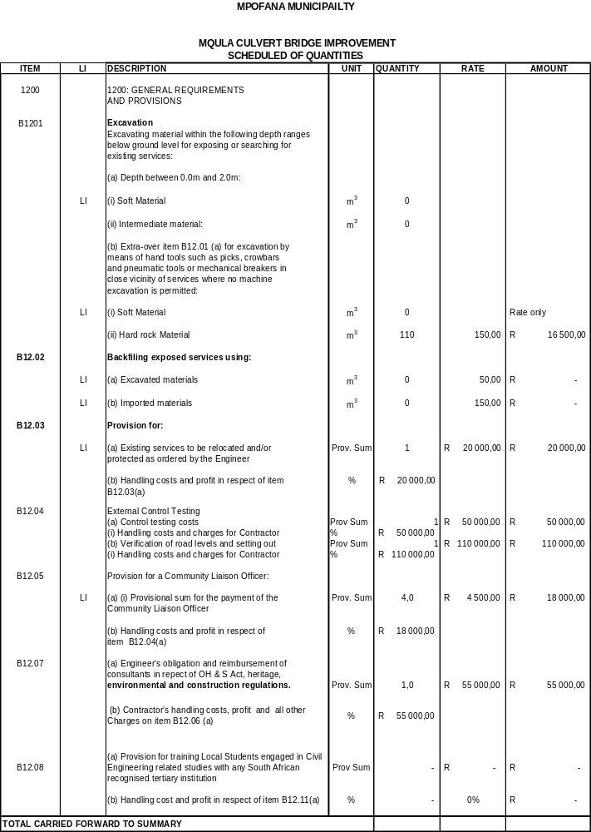

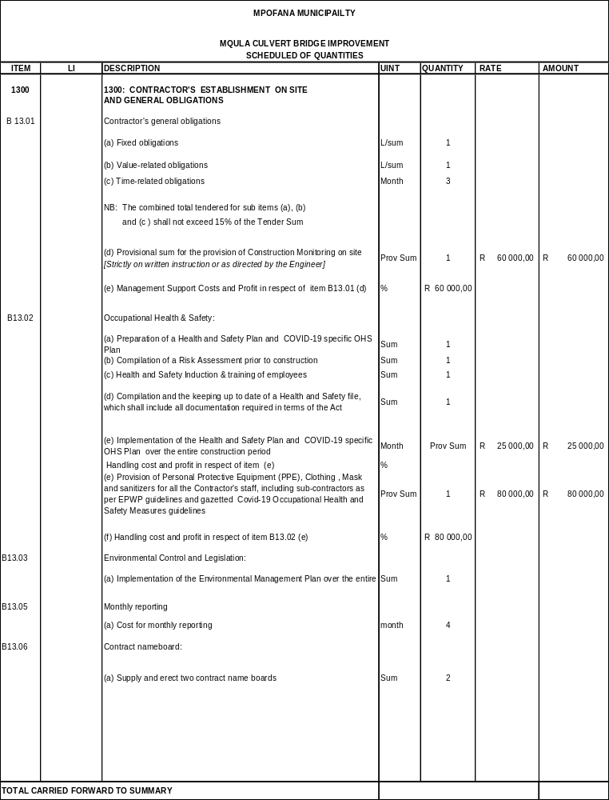

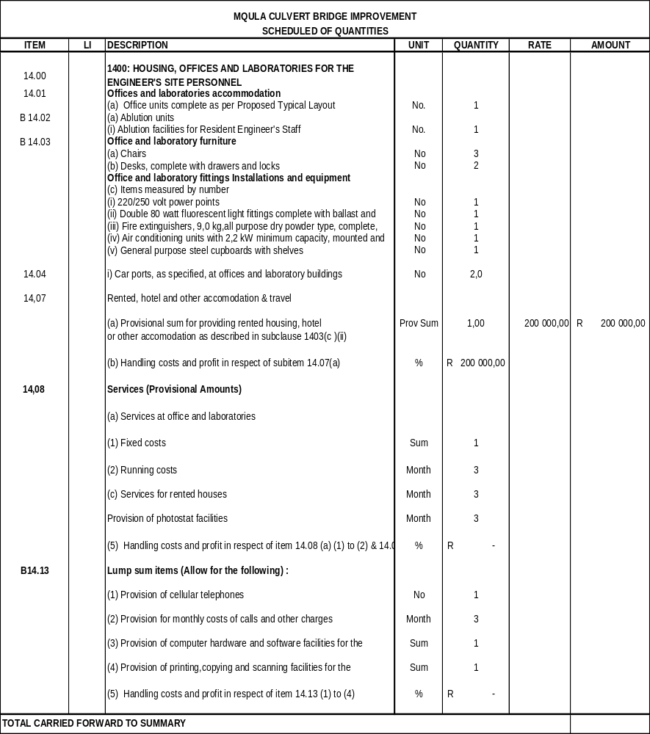

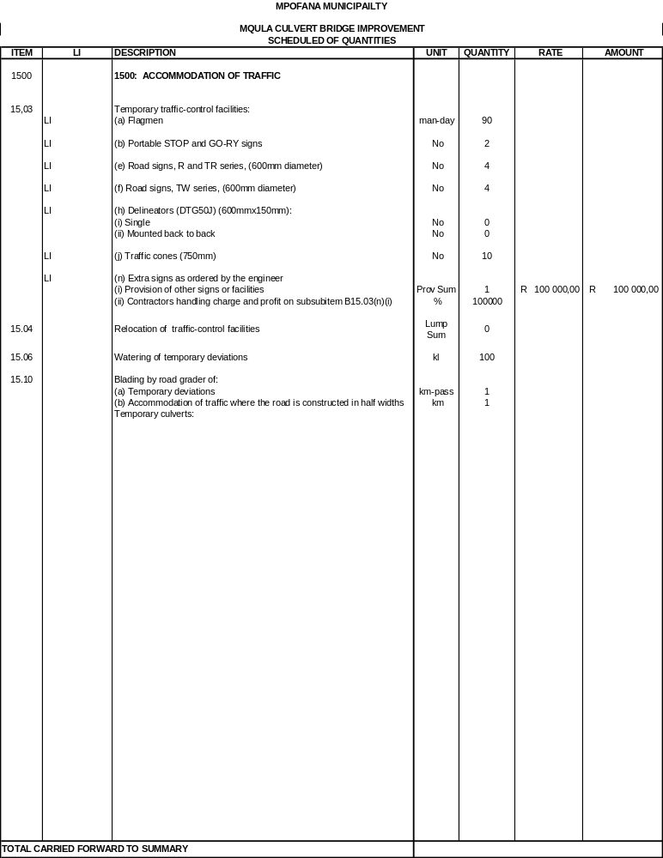

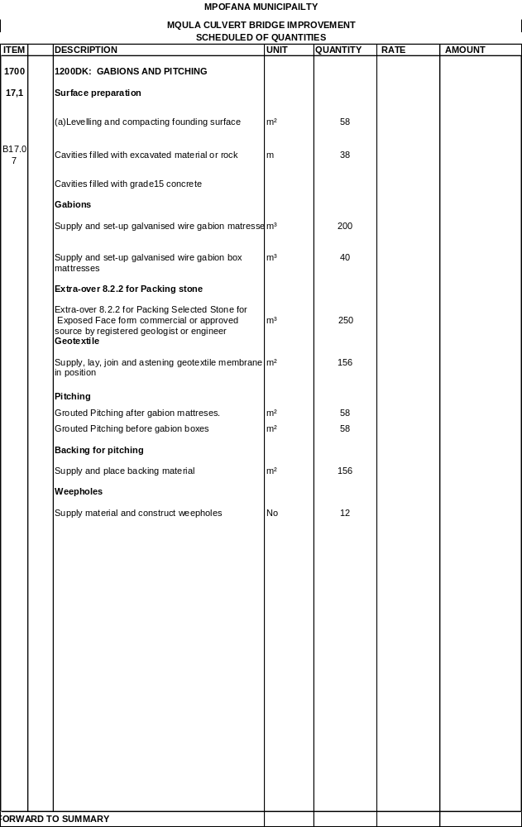

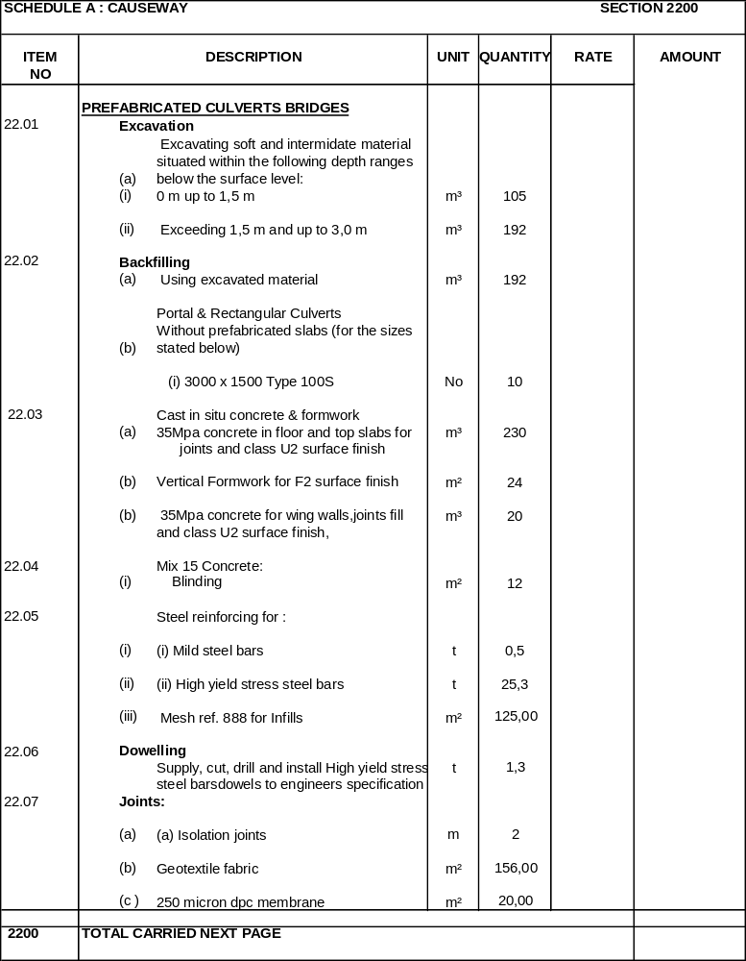
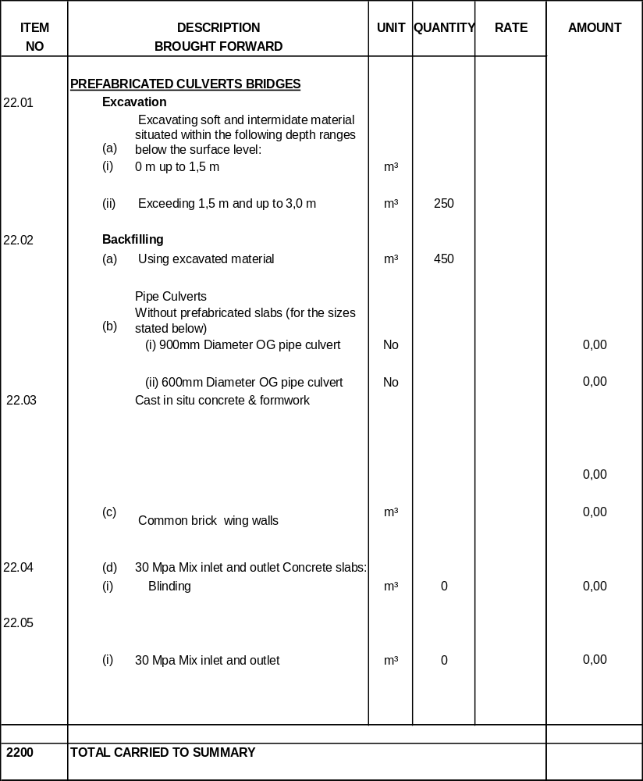

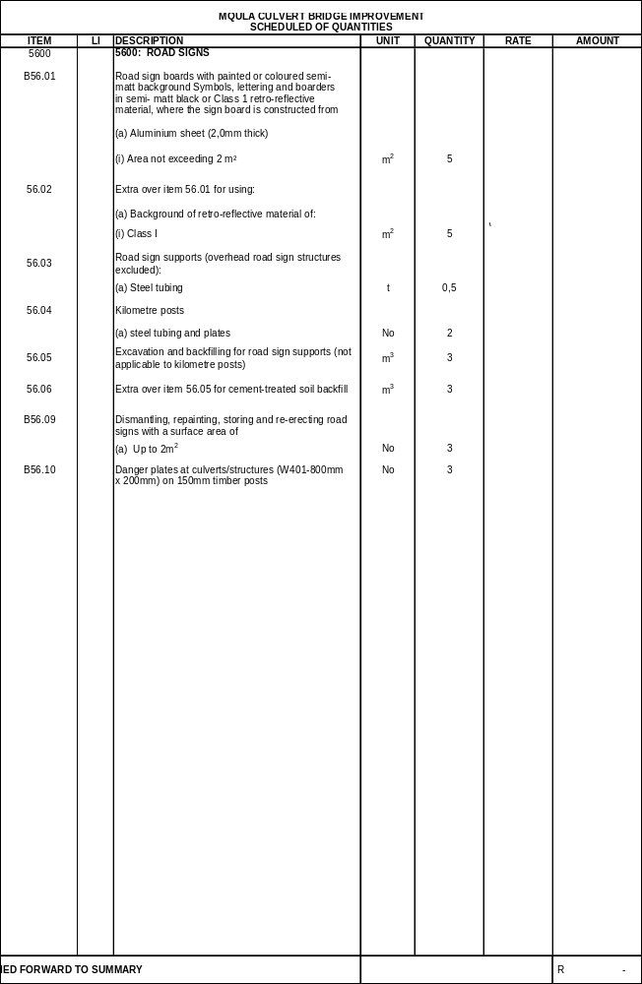

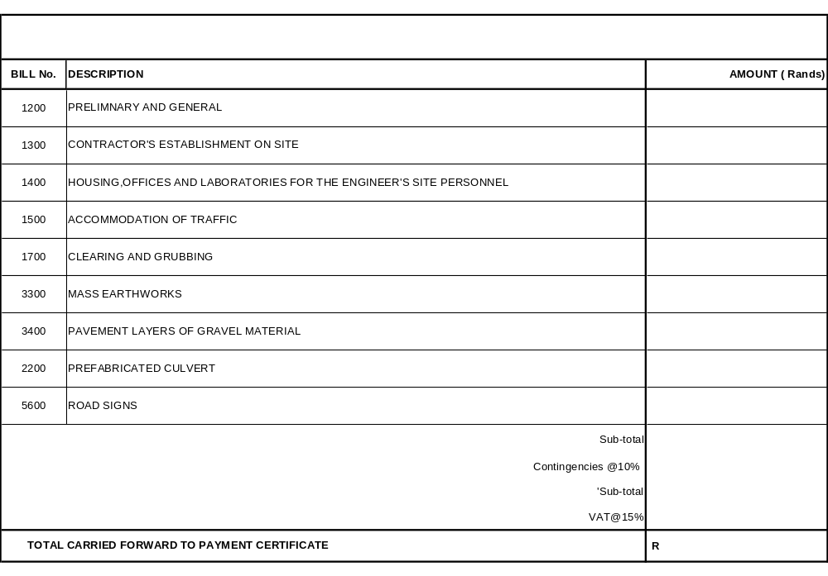

BLANK PAGE

BLANK PAGE

BLANK PAGE

C3: SCOPE OF WORK

TABLE OF CONTENTS | PAGE
C3.1 PROJECT SPECIFICATIONS ............................................................................ | C32
PART A: GENERAL
1. DESCRIPTION OF THE WORKS................................................................... | C62
2. DRAWINGS..................................................................................................... | C71
3. PROCUREMENT ............................................................................................ | C90
4. CONSTRUCTION ........................................................................................... | C90
5. MANAGEMENT............................................................................................... | C90

C3.2 PARTICULAR SPECIFICATIONS

PART B: ENVIRONMENTAL MANAGEMENT SPECIFICATION PART C: DAYWORK
PART D: OHSA 1993 HEALTH AND SAFETY SPECIFICATION PART E: JOINT VENTURE AGREEMENT SPECIFICATION

C3.1: PROJECT SPECIFICATION

The employer’s objective is to construct a standard gravel road on the Departmental managed and operated public facilities, In addition, this process will generate employment in surrounding areas.
The contract is located in a region of KwaZulu-Natal that has been historically impoverished by a lack of infrastructure access. This contract forms part of the Black Economic Empowerment which seeks to redress economic past imbalances of the past. It is therefore mandatory that the Contractor shall interact with the community via proactive project liaison with and project participation by its leaders and constituted organisations and forums, as well as through the employment of its people, and these activities shall constitute essential facets of the project.
This project forms part of the Mpofana Local Municipality and entails improvement of Mqula Box Culvert Bridge which is located at Mooi River
It is mandatory that the Contractor shall interact with the community via proactive project liaison with and project participation by its leaders and constituted organisations and forums, as well as through the employment of its people, and these activities shall constitute essential facets of the project.

PART A: GENERAL

DESCRIPTION OF THE WORKS

Employer’s objectives
- The employer’s objective is to improve Mqula Box Culvert Bridge for which the abutments were damaged by floods and is an infrastructure managed by the Mpofana Municipality, In addition, this bridge provides access to social and economic services for the communities across the river.
- The contract is located in a region of KwaZulu-Natal that has been historically impoverished by a lack of infrastructure access. This contract forms part of the Black Economic Empowerment which seeks to redress economic past imbalances of the past. It is therefore mandatory that the Contractor shall interact with the community via proactive project liaison with and project participation by its leaders and constituted organisations and forums, as well as through the employment of its people, and these activities shall constitute essential facets of the project.
- This project forms part of the Mpofana Local Municipality and entails Mqula Box Bridge Improvement which is located at Mooi River.
- It is mandatory that the Contractor shall interact with the community via proactive project liaison with and project participation by its leaders and constituted organisations and forums, as well as through the employment of its people, and these activities shall constitute essential facets of the project.
- The Contractor shall be required to attend meetings of the local Project Liaison Committee (PLC) from time to time. Requirements of the Expanded Public Works Programme (EPWP) are contained in Part F of section C3.3 Particular Specifications. These EPWP requirements also include provisions for the National Youth Service programme where applicable. Requirements in terms of Government’s initiatives for broad-based black economic empowerment with respect to small contractor development are contained in Part G of section C3.3 Particular Specifications.

Location of the Works

The project is situated in the Mooi River area at Mqula Area, Ward 04 of Mpofana Municipality.
The Contractor may tender for in a specific geographical area or multiple areas, depending upon, capacity of the company. However, the travelling from one region to another will be to the Contractors’ account, and the Contractor must make provision for this when tendering.

Overview of the Works

Holistically the project entails improvement of a box culvert bridge on the area of Mqula under Mpofana municipality. The works includes but not limited to, as elaborated below.

Extent of the Works

The Works to be carried out include the following main activities:

- The Contractor’s establishment on site and the provision of facilities for the Employer’s Agent, including a materials testing laboratory facility.
- Provision of survey control, and setting out of the Works.
- Site clearance with the road reserve.
- Construct and continuous maintenance of temporary road during the construction period for the accommodation of traffic.
- Clear the existing culvert bridge of debris and food-washed tree trucks stuck on the existing box culvert bridge
- Existing gravel material stripping of 150mm below the existing natural ground and stockpile on the roadside for later reuse
- Extension of the prefabricated concrete box culvert cross-drainage to increase waterway by two(2) segments of 5 No of 3000mmx1500mm concrete box culverts for each segment together with the reconstruction of the affected inlet and outlet concrete wing wall structures.
- Construction of concrete box culvert base and reinforcement using dowels to anchor on the riverbed
- Construction of a 150 mm thick selected subgrade layer (G7) to the top of the fill widening using gravel material imported from commercial sources.
- Construction of 150mm wearing course from a G6 type of material
- Installation of stormwater box culverts as per the drawing.
- Improvements to existing minor access points.
- Construct gabion baskets and fill them with rocks from approved commercial sources or alternatives as per the engineer’s or registered geologist's recommendation.
- Installation of road signs.
- Finishing and cleaning up of the road and road reserve.
- Removal of all site establishment facilities and construction equipment on completion of the Works.
- Making good of any defects during the Defects Liability Period OF 12 Months

Detailed description of the Works
The following description is a broad outline of the works and does not limit the work to be executed by the Contractor in terms of the contract. The description of some of the major items indicated in this section are indicative, not absolute, and are provided to define in general terms the overall scope of the project.
Approximate quantities of each type of work to be carried out in accordance with the contract documents are to be listed in the Schedule of Quantities once the roads are identified.

The site shall not only comprise the proclaimed road reserve but shall be extended in the broader sense to take account of all areas occupied by the Contractor, be it deliberate or unintentional, in the execution of the contract. The site includes all the land within the proclaimed limits of the road reserve along the extent of the works, borrow pits and quarry sites, stockpile areas, locations set aside for construction and supervision accommodation and any other location required for the execution of the Works.

Incidental intrusion into private or tribal property outside the road reserve shall not be permitted without the owner’s written authority. Any such agreement reached with a private or tribal landowner (occupier) shall include the proviso that any material or equipment on that site shall remain the exclusive property of the

Employer in terms of the contract.

The Municipality requires the contractors to establish the necessary machines and personnel to carry out surfacing, reseals or fog sprays depending on the need for a specific road to the approved seal design and specification. The works will be to prepare the surface to be sealed by washing, brooming, cleaning the roadway and to clear the road edge of any build-up of material or vegetation. The existing road studs if present will be removed or destroyed in the case of abnormalities.
The stone if required must be tested before being brought to site as well as in stockpile on site in order for the contractor to ensure that the stone being applied is to the specification as per surfacing design.
The stone in stockpile must be pre-coated with a suitable pre-coating product.

The contractor is responsible for all traffic control and safety in the area of the works. One lane must be available to the travelling public at all times and the maximum length of roadway to be under construction at any one time is 500m. At night all obstructions must be removed and the necessary signs such as no lines, loose stones, speed limits, etc. must be left on the site to ensure that the travelling public are safe. Some of these signs will need to be left on the road until such time that the road marking has been completed. Further, temporary road studs may be required to be placed to make the site at night safe.

After surfacing with the necessary attention to the joints and edges, the roadway must be broomed to assist with the stone orientation and to remove the excess aggregate. The site camp and aggregate stockpile sites must be cleared and cleaned to the satisfaction of the Municipality or its representative. This must include excess stone in the drainage elements. Spilt bitumen and the cut-off paper must be suitably disposed of at a registered waste disposal dump or as set out in the Environmental Management Plan.

Access to the Site

Mqula Box Culvert Bridge, Coordinates (29°01’58.1 S 30°13’40.2 E)

Demolition work

The Contractor is not required to carry out any demolition work to existing structures.

Spoiling of surplus material

Surplus material shall be spoiled in designated areas approved by the Employer’s Agent. The spoil material shall be disposed of in accordance with sub clause 3306(f) of the COLTO standard specifications.

Quantities

The approximate leading quantities for the permanent Works to be constructed will be issued as per respective roads to be identified by Project Managers.

Material investigations

Materials information is furnished in section C4.4 at the end of this document.

Material sources spoil and stockpile areas

All fill material shall be sourced from commercial sources.

The gravel materials for the subgrade, selected subgrade, subbase and shoulders shall be obtained from commercial sources.
Spoil material shall be disposed of in accordance with sub clause 3306(f) of the COLTO Standard Specifications. Spoil areas and areas for the temporary stockpiling of construction materials shall be determined and agreed on site in conjunction with the Employer’s Agent (and the PLC / local communities where applicable). The Contractor shall be permitted to use only these agreed spoil and stockpile areas, which shall be landscaped and vegetated on completion of the work.

All concrete material shall be from commercial sources.

Spoil areas and areas for the temporary stockpiling of construction materials shall be determined and agreed on site in conjunction with the Employer’s Agent, the PLC (where applicable) and the local communities (where applicable). The Contractor shall be permitted to use only these agreed spoil and stockpile areas, which shall be landscaped and vegetated on completion of the work.

Accommodation of traffic

The Contractor shall be required to accommodate traffic on the existing roadway on the existing detours.

Existing services

It is also expected that unknown domestic services crossings requiring relocation or protection may be encountered along the route as the work proceeds. The Contractor shall make every effort to establish the location of these services in any area prior to excavations commencing in that area. Such efforts shall include diligent enquiry and discussions with adjacent landowners, visual surface inspection and exploratory trenching investigation as necessary.

Employer’s Agent’s site offices and laboratory

The Contractor shall be required to provide furnished site office facilities, laboratory facilities, ablution facilities, and carports for the Employer’s Agent at a site located in close proximity to the Contractor’s office establishment and to the Works. A possible area for such site establishment shall be indicated at the Site Clarification Meeting.

Climate

The roads will be located on various areas from Cost Centre Offices and rainfall regions are yet to be identified.

Environment

The Contractor’s attention is called to clause B1233 of Part B of these Project Specifications and to the requirements of Part C: Environmental Management Specification contained in section C3.3 Particular Specifications.

Labour
A Project Liaison Committee has been established and is a vital means of communication between all parties involved with the project. The composition of the PLC comprises representatives of the Employer, the Employer’s Agent and formal structures within the community.

The Contractor shall make use of these communication channels, and shall appoint from amongst his site personnel a responsible person to participate in the affairs of the PLC, and this representative will be also required to attend the monthly PLC meetings.
It is mandatory that the Contractor shall interact with the community via proactive project liaison and project participation by its leaders and constituted organisations and forums, as well as through the employment of its people, and these activities shall constitute essential facets of the project.
Local labour is to be used and the employment of such labour is to be done in conjunction with the PLC. The PLC has formed a Labour Committee that shall assist the Contractor with the recruitment of local labourers to ensure an equal distribution of people employed between the Ward Councilor and various Amakhosi / Traditional Authorities in the area.

Labour-intensive construction methods

Labour-intensive construction shall mean the economically efficient employment of as great a portion of labour as is technically feasible to produce a standard of construction as demanded by the specifications with completion by the Due Completion Date, thus bringing about the effective substitution of labour for plant and equipment.

Appropriate portions of the Works included in the Contract shall be executed using labour-intensive construction methods.
Except where the use of plant is essential in order, in the opinion of the Employer’s Agent, to meet the specified requirements by the Due Completion Date, or where the use of plant is essential as a result of occupational health and safety considerations, the Contractor shall use only hand tools and equipment in the construction of those portions of the Works that are required in terms of these Project Specifications to be constructed using labour-intensive construction methods.

These portions of the Works shall be constructed utilizing only locally employed labour and/or the labour of local subcontractors, supplemented by the Contractor’s key personnel to the extent necessary and unavoidable, unless otherwise instructed by the Employer’s Agent and in accordance with the further provisions of the relevant sections of Portion B of the Project Specifications.
Subject to considerations of occupational health and safety, the portions of the Works to be executed using labour-intensive construction methods are:

      - Clearing and grubbing of the Site;
      - Excavation for structures up to 1,5m deep;
      - Bedding, selected fill, backfilling and compaction of all pipe trenches irrespective of depth, but assisted by mechanical compaction equipment in order to achieve the specified densities;
      - Transportation and spoiling of all trench materials, where the disposal site is located within 20 metres of the source;
      - Dismantling and re-erection of fences;
      - Mixing and placing of concrete;
      - Construction of all brickwork required for structures; and
      - Cleaning and tidying up of the Site.

In respect of those portions of the Works which are not listed above, the construction methods adopted and the plant utilized shall be at the discretion of the Contractor, provided always that the construction methods adopted and the plant utilized by the Contractor are appropriate in respect of the nature of the Works to be executed and the standards to be achieved in terms of the Contract.

Temporary Works

The Temporary Works required under this Contract shall include the traffic accommodation measures implemented, the provision of drainage control, falsework and formwork during the construction of the minor drainage structures, and the provision of any scaffolding or temporary propping used during the erection of the road signs.

All Temporary Works shall be removed from the Site on completion of the Contract.

Maintenance of the Works during the construction period

The Contractor shall take note of the various requirements of the General Conditions of Contract 2015 and the standard specifications with respect to the care and protection of the Works.
The handing-over of the road reserve for this contract is described in clause B1224 of these Project Specifications. The Contractor shall be responsible for maintaining this portion of the road from the date of hand-over until the issue of the Certificate of Practical Completion.

Testing of materials

A prime cost sum is to be included on specific materials needing testing such as gravel and concreteor allowed in section 8100 of the Schedule of Quantities for all acceptance control testing laboratory work to be carried out by the Employer’s Agent using the laboratory facilities included in section 1400 and/or commercial laboratory facilities.
The Contractor shall carry out at his own cost the required process control testing as specified in terms of the COLTO standard specifications.

Power supply and other services

The Contractor shall make his own arrangements concerning the supply of electrical power and all other services. No direct payment shall be made for the provision of electrical and other services. The cost thereof shall be deemed to be included in the rates and amounts tendered for the various items of work for which these services are required.

Construction in confined areas

It may be necessary for the Contractor to work within confined areas. Except where provided for in the specifications, no additional payment shall be made for work done in restricted areas. In certain places the width of the fill material and pavement layers may decrease to zero and the working space may be confined. The method of construction in these confined areas largely depends on the Contractor’s constructional plant. However, the Contractor shall note that, unless otherwise provided for in terms of the scheduled payment items in the COLTO Standard Specifications or these project specifications, measurement and payment shall be in accordance with the specified cross sections and dimensions only, irrespective of the method used for achieving these cross sections and dimensions, and that the tendered rates and amounts shall include full compensation for all special equipment and construction methods and for all difficulties encountered when working in confined areas and narrow widths, and at or around obstructions, and that no extra payment shall be made nor shall any claim for additional payment be considered in such cases.

Contractor’s campsite

Possible locations for a campsite shall be pointed out at the clarification meeting.

The Contractor shall make his own arrangements for the provision of his campsite and housing for construction personnel, but the chosen site shall be subject to the approval of the Employer’s Agent, the local authorities and, where applicable, the Project Liaison Committee (PLC) associated with the project.
The standard of the Contractor's camp, offices, accommodation, ablution, and other facilities must comply with the requirements of all local authority, environmental and industrial regulations concerned. In establishing and maintaining his campsite, due cognisance is to be taken of the requirements of clause B1233 of these Project Specifications.

The Contractor and personnel are to fully get familiarised on their own with all local by-laws and Government regulations for the employment, transport and accommodation of labour on site.

The Contractor shall particularly note that there is a high risk of theft, vandalism and damage to property in this area and strict security will be required for all plant, establishment, temporary works and partially completed works. The Contractor shall be responsible for providing security for all plant, establishment, temporary works and partially completed works. No separate payment shall be made for the provision of such security since full compensation for these costs shall be deemed to be included in the amount tendered for item B13.01(c) (The contractor’s general obligations: Time-related obligations).

Additional requirements for construction activities

The travelling public shall have the right of way on public roads, and the Contractor shall make use of approved methods to control the movement of his equipment and vehicles so as not to constitute a hazard

on the road. The Contractor’s tendered rates shall include full compensation for all costs which may arise from the construction and maintenance of deviations and construction under traffic. No claim for additional costs which may arise from these methods of traffic accommodation and no additional payment owing to inconvenience as a result of the Contractor’s method of working shall be considered.

Construction programme

In addition to any other restrictions accommodated by the Contractor in compiling the construction programme, the following constraints shall be considered in the preparation thereof:
- The whole of the Works (and the portions of the Works if completion in portions is required) shall be completed within the time period(s) stated (refer to the Contract Data in section C1.2.2).

- Working days lost due to abnormal rainfall shall be treated as set out in clause B1215.
- Allowance shall be made for non-working days and special non-working days (refer to the Contract Data in section C1.2.2).

- Construction activities must comply with all the specified environmental requirements including clause B1233 andthe requirements of Part C: Environmental Management Specification contained in section C3.3 Particular Specifications.
- Construction activities must comply with all the specified health and safety obligations including the requirements of Part E: OHSA 1993 Health and Safety Specification contained in section C3.3 Particular Specifications.
- Strict control of access to and from local public roads shall be required when construction vehicles, plant or equipment leave or enter the site.

- Throughout the contract period traffic must be accommodated through the site and all other contractors engaged on the construction of identified roads must be accommodated.
- The Contractor’s programme of work shall take due cognisance of risks by limiting the duration of the exposure of the various construction elements to natural phenomena.

For the guidance of Tenderers, a provisional preliminary construction programme is included below. This programme is given in good faith and no claims shall be entertained due to inaccuracies, discrepancies or omissions contained in the programme.

- DRAWINGS

The attached drawings that form part of the Tender documents shall be used for Tender purposes only.

The Contractor shall be supplied with three complete sets only of A0 paper print drawings. These A0 paper prints are issued free of charge and the Contractor shall make any additional prints he may require at his own cost.
Any information in the possession of the Contractor which the Employer’s Agent requires to complete the as-built drawings shall be supplied to the Employer’s Agent before a certificate of completion shall be issued.

Only figured dimensions shall be used and drawings shall not be scaled unless so instructed by the Employer’s Agent. The Employer’s Agent shall supply all figures / dimensions omitted from the drawings.

The levels given on the drawings are subject to confirmation on site, and the Contractor shall submit all levels to the Employer’s Agent for confirmation before he commences any structural construction work. The Contractor shall also check all clearances given on the drawings and shall inform the Employer’s Agent of any discrepancies.

The drawings for this contract comprise the following:

DESCRIPTION | DRAWING NO.
Plan Layout

Particular / generic specifications

As well as the ‘Amendments to the Standard Specifications’ contained in Part B of Section C3.2: Project Specifications, of this document, the following Particular Specifications as contained in Section C3.3, are applicable to this Contract:
Part C: Environmental Management Specification Part D: Day work
Part E: OHSA 1993 Health and Safety Specification
Part F: Requirements of the Expanded Public Works Programme (EPWP) Part G: Small Contractor Development
The ‘Standard Specifications for Road and Bridge Works for State Road Authorities’ is applicable to this Contract but contains references to the ‘General Conditions of Contract for Road and Bridge Works for State Road Authorities’ which is not applicable to this Contract. Table B1115 in Section C3.2: Project Specifications, amends these references to the 2015, 3rd edition of the General Conditions of Contract for Construction Works published by the South African Institution of Civil Engineering which is applicable to this Contract.

Certification by recognized bodies
No certification of items included in the works is required.

Plant and materials provided by the Employer
No plant and materials are to be provided by the Employer.

Services and facilities provided by the Employer
The Employer’s Agent’s site office and laboratory facilities will be paid for in terms of the Contract. No other services or facilities are to be provided by the Employer.
- MANAGEMENT

Applicable SANS 1921 standards
The following parts of SANS 1921 and associated specification data are applicable: SANS 1921-1: Part 1: General engineering and construction works SANS 1921-6: Part 6: HIV/AIDS awareness

Specification data associated with SANS 1921-1
Clause No. | Essential data
4.1.7 | There are no requirements for drawings, information and calculations for which the Contractor is responsible.
4.2.1 | The responsibility strategy assigned to the Contractor for the works is ‘A’.
4.3.1 | The programme must conform to clause 1204 ‘Programme of Work’ of the ‘Standard Specifications’ and clause 5.6 ‘Programme’ of the ‘General Conditions of Contract 2015’.
4.3.3 | The Contractor must give 24 hours’ notice for inspection of work that is to be covered up.
4.7.3 | Where applicable, the Contractor is afforded the opportunity of pricing an item to cover costs of unavoidable over-break.
4.12.2 | The samples of materials, workmanship and finishes that the Contractor is to provide and deliver to the Employer/Employer’s Agent are to be as described in clause 1205 ‘Workmanship and Quality Control’ of the ‘Standard Specifications’ and clause 7 ‘Quality  and Related Matters’ of the ‘General Conditions of Contract 2015’.
4.12.2 | The fabrication drawings that the Contractor is to provide to the Employer are none.
4.14.5 | The Contractor is to provide latrine and ablution facilities as described in Part C

Specification data associated with SANS 1921-1
Clause No. | Essential data
 | ‘Environmental Management Plan’ in Section C3.3: Particular Specifications of these Project Specifications.
4.14.6 | The requirements for the provision and erection of sign boards are as described in clause 1207 ‘Notices, Signs and Advertisements’ of the ‘Standard Specifications’, and as detailed in the ‘Example of Contract Signboard Details’ in Section C4: Site Information of these Project Specifications.
4.17.1 | The requirements for the termination, diversion or maintenance of existing services are described in clause B1202 of Part B of Section C3.2: Project Specifications.
4.17.3 | Services that are known to exist on the site are described in clause B1202 of Part B of Section C3.2: Project Specifications.
4.17.4 | The requirements for detection apparatus for locating underground services are none.
4.18 | The additional health and safety requirements are described in Part E ‘OHSA 1993 Health and Safety Specification’ in Section C3.3: Particular Specifications of these Project Specifications.

Additional clauses
      - Site meetings and procedures

Site meetings shall be convened as described in clause 1227 ‘Monthly Site Meetings’ of the ‘Standard Specifications’. The Contractor shall keep on site a set of minutes of all site meetings, daily records of resources (people and equipment employed), a site memoranda book (triplicate site diary book), a complete set of contract working drawings and a copy of the procurement document, and shall make these available at all reasonable times to all persons concerned with the contract.

Water and electricity

The Contractor is to provide water and electricity as described in clauses 1219 ‘Water’ and 1404 ‘Services’ of the ‘Standard Specifications’.

Specification data associated with SANS 1921-6
Clause No. | Essential data
4.2.1(a) | A qualified service provider is one that is an accredited or provisionally accredited training service provider in the HIV/AIDS field. A list of accredited service providers can be obtained from the Construction SETA (CETA) (tel. 011 265 5900), Health and Welfare SETA (HWSETA) (011 622 6852) or on the Health and Welfare SETA website:  www.hwseta.org.za.
4.2.1(a) | The HIV/AIDS awareness programme is to be repeated at four monthly intervals throughout the duration of the contract.

Additional clauses

The duration of each workshop shall not be less than 2½ hours.

Recording of weather

The Contractor shall erect a rain gauge and record the rainfall as described in clause 1215 of the ‘Standard Specifications’. This information together with other details of the prevailing weather conditions shall be recorded in the daily site diary.

Unauthorised persons

The Contractor shall keep unauthorised persons away from the Works at all times. Under no circumstances may the Contractor’s personnel be accommodated on the site.

Management meetings

Management meetings are to be held weekly at a time convenient to all concerned, to discuss planning and health and safety amongst other things. Attendance by the Contractor’s and the Employer’s Agent’s Representatives on site is mandatory, and attendance by other interested parties will be by invitation.

Forms for contract administration

The Employer’s Agent’s Representative will provide standard forms for ‘Site Diary’, ‘Site Memoranda’, ‘Requests for Inspection’ and any others deemed to be necessary during the contract.

Electronic payments

Payments of approved payment claims will be made electronically upon submission of the Contractor’s banking details.

Daily records

A site diary is to be compiled jointly by the Contractor’s and the Employer’s Agent’s Representatives on site and is to be agreed and signed by both parties. The original signed copy is to be retained by the Employer’s Agent’s Representative.

The Contractor is to keep daily records of people and equipment on site in a format to be agreed by the Employer’s Agent’s Representative, and is to provide copies to the Employer’s Agent’s Representative when requested.

Payment certificates

The contractor shall submit the following on a monthly basis to the Engineer in order to assist with the processing of the payment certificate and the preparation of CPG and EPWP.
- A detailed breakdown of the work done. (The work breakdown must be referenced strictly in accordance with the detailed priced bill of quantities and must be signed by contractor and resident engineer).
- A detailed breakdown of all variation order costs claimed (with specific reference to work done by the contractor) in the certificate concerned, together with copies of relevant contract instruction.
- A detailed breakdown of the work done by the CPG contractor. (The work breakdown must be referenced strictly in accordance with the detailed priced bills of quantities, as applicable).
- A written declaration authenticated by the Professional Contracts Manager/Engineer confirming, that the payment claims for work done by CPG contractor has been audited and amended by the contractor, prior to it being forwarded to the Engineer for evaluation.
- If applicable, a combined CPG and EPWP report which shall include reports on contractor and CPG contractor compliance, in accordance with the format required by the Engineer. In this regard, the combined, contractor and CPG contractor report must contain an affidavit certifying that all information contained the report as being true and correct.
- Proof of payment for items contained in provisional sums, proof of ownership of materials on site and documentation pertaining to contract price adjustment and special materials, are required as substantiation of claims for payment.

- Tax invoice: The contractor shall attach a tax invoice as prescribed in the value added Tax legislation to each payment certificate when presenting the certificate to the employer for payment. Such tax invoice shall correctly reflect the prescribed information and the amounts included in the payment certificate. Should the contractor fail to comply with these requirements, the date of presentation of the certificate shall be deemed to be delayed at the contractor’s default until such time as the requirements are met.

- All work claimed by CPG contractor must be submitted in a form of a certificate directed to the main contractor with all necessary backups supporting items claimed for, and must be certified and / or accepted by the main contractor and Engineer’s Representative for invoice.

Should anyone or any combination of the above requirements not be complied with, the engineer reserves the right to exclude any amounts that may have been due for certification from payment certificate concerned and/or delay the issue of payment certificates and/or, revise the contractual payment date, as applicable, until such time compliance is achieved.

In addition, the Engineer requires seven (7) working days to process the payment certificate once all of the above requirements are met.

Permits

No security/entrance permits are required by the Contractor’s personnel to enter the site.

Proof of compliance with the law

There are no requirements for the Contractor to verify compliance with any legislation.

C3.2: PARTICULAR SPECIFICATIONS

PART B: AMENDMENTS TO THE STANDARD SPECIFICATIONS

PROJECT SPECIFICATIONS RELATING TO THE STANDARD SPECIFICATIONS AND OTHER ADDITIONAL SPECIFICATIONS

In certain clauses in the COLTO Standard Specifications, allowance is made for a choice to be specified in the Project Specifications between alternative materials or methods of construction, and for additional requirements to be specified to suit a particular contract. Details of such alternatives or additional requirements applicable to this Contract are contained in this part of the Project Specifications. It also contains the necessary additional specifications required for this Contract.

The clauses and payment items dealt with in this part of the Project Specifications are numbered ‘B’ with a number corresponding to the relevant clause or item number in the COLTO Standard Specifications.
New clauses and payment items not covered by clauses or items in the COLTO Standard Specifications have been included here and have also been designated with the prefix ‘B’. Such clauses and items have been given a new number following upon the last number used in the particular section referred to in the COLTO Standard Specifications.

SECTION 1200: GENERAL REQUIREMENTS AND PROVISIONS B1202 SERVICES
Add the following at the end of clause 1202:

“A provisional sum is included in the Schedule of Quantities to cover the costs of relocating the known services. This provisional sum shall be used to effect payments for the services relocation work carried out by the subcontractor selected by the Contractor in consultation with the Employer for this purpose.”

B1205 WORKMANSHIP AND QUALITY CONTROL

Add the following paragraph to the end of clause 1205:

"Testing for quality control shall be conducted in accordance with the requirements of Section 8200 for Quality Control (Scheme 1)."

B1206 THE SETTING-OUT OF WORK AND PROTECTION OF BEACONS

Delete the first paragraph of clause 1206 in its entirety and replace it with the following:

“The Contractor shall comply with all legal provisions in regard to surveying and setting out work.”
Add the following paragraph to the end of clause 1206:

"It may become necessary to construct, level and coordinate new survey beacons during the course of the contract, or to protect existing survey beacons. A provisional sum is included in the Schedule of Quantities to cover the costs of such work."

B1209 PAYMENT

Contract rates

Add the following new paragraph at the end of sub clause 1209(a):

“All rates tendered are to be exclusive of VAT; and VAT shall be applied separately at the applicable rate”

B1212 ALTERNATIVE DESIGNS AND OFFERS

Add the following to the end of sub clause 1212(m):

"The provision for contract price adjustment in the original Tender Summary must not under any circumstances be altered in an alternative offer."

B1215 EXTENSION OF TIME RESULTING FROM ABNORMAL RAINFALL

Extension of time resulting from abnormal rainfall shall be calculated according to the requirements of Method (ii) (Critical-path method).

Method (ii) (Critical-path method)

Delete the words "(based on a five-day working week)" in the fifth and sixth lines of the second paragraph of Method (ii).

Add the following to the end of Method (ii):

"The value of “n” working days expected delay caused by normal rainy weather as referred to in Method (ii) shall be as given in Table B1215 below for each respective calendar month of any year:

Table B1215

Month | Expected delay of "n" working days due to normal rainy weather | Month | Expected delay of "n" working days due to normal rainy weather
January*** | 5 | July | 1
February | 4 | August | 1
March | 4 | September | 2
April | 3 | October | 3
May | 2 | November | 4
June | 1 | December*** | 5

*** Includes the whole month of December / January.

Each "n"-value in Table B1215 applies only to the calendar month immediately to the left of the number, and the "n"-values as specified shall not be taken as being carried forward so as to accumulate over the contract period. If no abnormal rainfall occurs during a particular calendar month in a particular year, then no extension of time for abnormal rainfall shall be granted with respect to that calendar month for that year, and no further consideration shall be given to that "n"-value in respect of that year.

Similarly, if the "n" working days expected delay caused by normal rainy weather during a particular calendar month in a particular year (for which the Contractor shall have made provision in his programme of work in accordance with Method (ii)) are not taken up (either in whole or in part) by standing time due to normal rainy weather during that month of that year, then no further consideration shall be given to those "n" working days (or portion thereof), which effectively have been gained, when any subsequent extension of time claims which may arise later during the contract period are assessed by the Employer’s Agent."

B1219 WATER

Add the following paragraph to the end of clause 1219:

“The Contractor shall arrange for chemical tests to be carried out to confirm the suitability of his proposed water sources for use as drinking water and for use in the concrete construction. The Contractor shall ensure that these tests also include testing for salinity and sugar content levels.
The Contractor shall note that the necessary permission must be obtained from the Department of Water Affairs for the abstraction of water from streams and rivers.”

B1224 THE HANDING-OVER OF THE ROAD RESERVE
Add the following paragraph to the end of clause 1224:

"The handing-over of the road reserve for this project shall be subject to the following restrictions:
- Only that portion of the road reserve to be identified shall be handed over to the Contractor. The Contractor shall be responsible for the maintenance along this portion of the road until completion of the contract.

- The Contractor shall be required to accommodate public traffic as well as the Employer’s other contractors working on various projects in the area related to the construction of identified roads.
- The Contractor shall be required to accommodate service owners and other contractors working on the services relocation and maintenance in the execution of their duties.”

B1229 SABS CEMENT SPECIFICATIONS

Add the following paragraphs to the end of clause 1229:

“All cement used on this contract shall comply with SANS 50197-1: Cement Part 1: Composition, specifications and conformity criteria for common cements.

Where reference is made in these Project Specifications or in the COLTO Standard Specifications to the former SABS cement specifications (e.g., SABS 471, SABS 626, SABS 831, SABS 1491), such reference shall be replaced with the new specification:
  - SANS 50197-1: Cement Part 1: Composition, specifications and conformity criteria for common cements.

The blending of cements on site shall not be permitted.”
Add the following new clauses at the end of Section 1200:

"B1230 COMMUNITY LIAISON

Project Liaison Committee

The process of implementing infrastructure projects will be undertaken by means of structured engagement between those responsible for the delivery of the project and the community.
A Project Liaison Committee (PLC) is a vital means of communication between the parties involved with the project. A PLC may be formed if the project is such that a specific community can be identified.

The PLC comprises representatives of the employer, the engineer and formal structures within the community. The contractor shall make use of these communication channels, and shall appoint from amongst his site personnel a responsible person to participate in the affairs of the PLC, and this representative shall also attend the monthly PLC meetings when so requested.

The PLC shall meet at least once every month until such time as it is of the opinion that it could fulfil its tasks by meeting less frequently.
The PLC deals with local labour on the project, and is tasked with:
- assisting with community liaison and the resolution of community disputes;
- devising fair and transparent procedures that will assist the contractor in the engagement of labour;
- advising on and monitoring labour issues; and
- Assisting in the resolution of labour disputes.

All labour recruitment, employment and associated risks shall remain the sole responsibility of the contractor.
A new pay item is included in section 1200 of the schedule of quantities relating to the payment of the PLC on a provisional sum basis. Payment under this item shall be made only for the period for which the duties of the PLC are required, and not necessarily for the full duration of the contract.

Community Liaison Officer (CLO)

The contractor, after consultation with the Project Liaison Committee (PLC), shall appoint a ccompetent local person as a Community Liaison Officer (CLO).The contractor shall appoint the CLO as part of his site personnel, and shall direct all his liaison efforts with the local community through the appointed CLO.
The period of employment and the remuneration of the CLO shall be determined jointly by the contractor, the engineer and the employer.

The CLO shall:
  - Represent the community and assist the contractor, the engineer and the employer with communication between them and the community;

  - work an 8-hour day with a total of 40 hours worked per week, and shall be present on site each day except when performing off-site community liaison activities;
  - Communicate daily with the contractor on Labour related issues such as numbers and skill;

  - Assist in the identification and screening of local labourers from the community in accordance with the contractor’s requirements;
  - Inform local Labour of their conditions of employment, including their period of employment;

  - Attend disciplinary proceedings involving local Labour, and ensure that hearings are fair and reasonable;

  - Attend all meetings at which the community and/or local labour are present or are required to be represented;
  - Attend monthly site meetings to report on community and local labour matters;

  - Keep a daily written record of interviews and community liaison;

  - Submit monthly returns regarding community liaison; and

  - Carry out all such other duties as agreed upon between all parties concerned.
A new pay item is included in section 1200 of the schedule of quantities relating to the payment of the CLO on a provisional sum basis. Payment under this item shall be made only for the period for which the duties of the CLO are required, and not necessarily for the full duration of the contract.

B1231 COMPENSATION FOR OCCUPATIONAL INJURIES AND DISEASES ACT, 1993

All labour employed on the site shall be covered by the Compensation for Occupational Injuries and Diseases Act, 1993, as amended. The Contractor shall pay in full, including the payment of the necessary levies, such amounts as are due in terms of the Act. These amounts shall not be included in the wage rates and shall be payments allowed for by the contractor in addition to the wages paid to Labour. The manner in which compensation in terms of this Act shall be handled shall be resolved by the Contractor at the commencement of the contract.

B1233 ENVIRONMENTAL IMPACT CONTROL

In addition to aspects of the design which are intended to avoid or reduce environmental impact, and in addition to normal good construction practice expected of the Contractor, the following requirements shall also be observed:
    - The Contractor shall comply with the requirements of Part C: Environmental Management Specification contained in section C3.3 Particular Specifications.

    - Clearing shall be limited to the road prism and, where applicable, to detours, which shall be sited in consultation with the Employer’s Agent and the local communities.

    - No littering by construction workers shall be allowed. A refuse control system shall be established for the collection and removal of refuse to the satisfaction of the Employer’s Agent.
    - Adequate provision shall be made for temporary toilet requirements in construction areas. Use of the veld for this purpose shall not be allowed under any circumstances.
    - Streams, rivers and dams shall be protected from direct or indirect spillage of pollutants, such as refuse, garbage, cement, concrete, sewage, chemicals, fuels, oils, aggregate tailings, wash water, organic materials and bituminous products. In the event of spillage, prompt action shall be taken to clear the affected area. Emergency measures in the event of spillage shall be set out and the responsible person shall be made aware of the required action. The construction of temporary and / or permanent dams shall be done with the necessary approvals from the Department of Water Affairs and Forestry and the Department of Environmental Affairs and Tourism.

    - Bituminous and / or other hazardous products shall not be spoiled on site and shall only be disposed of at licensed authorised disposal facilities.

    - Provision shall be made to prevent excessive erosion and siltation throughout the contract and in particular on adjacent land. Should excessive erosion and / or siltation take place outside the road reserve as a direct result of the Contractor’s construction activities, the Contractor shall be responsible for making good the erosion / siltation to the satisfaction of the landowner and the Employer’s Agent.

    - Invader species of plants shall be controlled.
    - Dust and noise pollution shall be restricted to acceptable levels.

No separate payment shall be made for observing these requirements as such payment shall be deemed to be included in the amount tendered for item B13.01(c) (The contractor's general obligations: Time-related obligations). Any avoidable non-compliance with these requirements shall be considered sufficient grounds for withholding payment of part or all of the amounts to be paid for the above item in order to pay for the repairs to any damages.

B1233 WORKMEN'S COMPENSATION ACT

All Labour employed on the site shall be covered by the Workmen's Compensation Act. The contractor shall pay in full, including the payment of the necessary levies, such amounts, as are due in terms of the Act. The contractor at the commencement of the contract shall resolve the manner in which Workmen’s Compensation will be handled. Amounts paid by the contractor shall not be included in the wage rates but shall be an extra payment allowed for by the contractor.

UNEMPLOYMENT INSURANCE FUND
The contractor will be responsible for payment or contribution of UIF for all Labour employed under the project. Proof of payment of UIF shall be available upon request.

B1235 MEASUREMENT AND PAYMENT

Item Unit

B12.01 Services:

- Protection, relocation, realignment, removal or
replacement of services provisional sum (Prov Sum)

- Handling costs and profit in respect of sub-item B12.01 (a) above percentage (%)

Expenditure under this item shall be made in accordance with clause 6.6 of the General Conditions of Contract 2015. The tendered percentage is a percentage of the amount of expenditure approved by the engineer under sub item B12.01 (a), and shall include full compensation for the handling costs of the contractor, and the profit in connection with the protection, relocation, realignment, removal or replacement of the relevant services.

Item Unit

B12.02 Construction of new survey beacons and protection of existing survey beacons:

- Provisional sum for new survey beacons to be constructed or
for existing survey beacons to be protected during construction provisional sum (Prov Sum)

- Handling costs and profit in respect of sub item B12.02 (a) above percentage (%)
Expenditure under this item shall be made in accordance with clause 6.6 of the General Conditions of Contract 2015. The tendered percentage is a percentage of the amount of expenditure approved by the engineer under sub item B12.02 (a), and shall include full compensation for the handling costs of the contractor, and the profit in connection with the construction of new survey beacons or the protection of existing survey beacons.

Item Unit

B12.03 Provision of a Community Liaison Officer (CLO):

- Wages, salary, allowances, etc provisional sum (Prov Sum)
- Handling costs and profit in respect of sub item B12.03 (a) above percentage (%)

Expenditure under this item shall be made in accordance with clause 6.6 of the General Conditions of Contract 2015.
The tendered percentage is a percentage of the amount of expenditure approved by the engineer under sub item B12.03 (a), and shall include full compensation for the handling costs of the contractor, and the profit in connection with the provision of a Community Liaison Officer (CLO).

Item Unit
B12.04 Monitoring of the Environmental Management Programme (EMPr) by the Environmental Control Officer (ECO):

- Monitoring of the EMPr by the ECO provisional sum (Prov Sum)

- Handling costs and profit in respect of sub item B12.04(a) above percentage (%)
Expenditure under this item shall be made in accordance with clause 6.6 of the General Conditions of Contract 2015. The tendered percentage is a percentage of the amount of expenditure approved by the engineer under sub item B12.05 (a), and shall include full compensation for the handling costs of the contractor, and the profit in connection with the monitoring of the EMPr by the ECO.”

SECTION 1300: CONTRACTOR'S ESTABLISHMENT ON SITE AND GENERAL OBLIGATIONS B1302 GENERAL REQUIREMENTS

Legal and contractual requirements and responsibility to the public

Add the following new paragraphs to the end of sub clause 1302(c):

"Legislation imposes mutual obligations on the employer and contractor in the performance of their duties to society and to the built and natural environment. To assist the contractor in understanding and assessing his obligations, and thus to make allowances for the cost of compliance with this legislation, Parts C, E, F and G are included in section C3.3 Particular Specifications in the project specifications.
The contractor's general obligations shall also include the training of temporary labour, the management of labour enhanced work, the application of the Compensation for Occupational Injuries and Diseases Act, 1993, and compliance with the requirements of Part C: Environmental Management Specification, Part E: OHSA 1993 Health and Safety Specification, Part F: Requirements of the Expanded Public Works Programme (EPWP) and Part G: Small Contractor Development contained in section C3.3 Particular Specifications.

Part C: Environmental Management Specification contains the environmental management specification for this project. Its provisions regulate the contractor’s construction methods so as to ensure responsible conduct with respect to the environment and responsible treatment of the environment relevant to the project. A new pay item B13.03 is included in section 1300 to allow the contractor to make separate provision for the cost of environmental management obligations during the construction process.

Part E: OHSA 1993 Health and Safety Specification contains the specifications that regulate the Contractor’s construction methods so as to ensure the health and safety of his employees and the public. A new pay item B13.02 is included in section 1300 to allow the contractor to make separate provision for the cost of health and safety obligations during the construction process.

Part F: Requirements of the Expanded Public Works Programme (EPWP) contains general EPWP employment and training requirements as well as requirements for employment and training in terms of the National Youth Service programme (where applicable – refer to Part F). In order to avoid duplication of training programmes and training facilities, all structured training, including the training described in Part G: Small Contractor Development, is measured and paid for in terms of the pay items provided for training in Part F: Requirements of the Expanded Public Works Programme (EPWP). Various pay items related to these requirements are included in Part F. However, to the extent that any costs relating to the requirements of Part F are not covered by the pay items in that section, the contractor shall include for such costs in the existing pay item B13.01 in section 1300.
Part G: Small Contractor Development contains provisions that regulate the Contractor’s construction processes for compliance with Government’s initiatives towards broad-based black economic empowerment. Various pay items related to these requirements are included in Part G (refer also to the previous paragraph regarding payment for the structured training described in Part G). However, to the extent that any costs relating to the requirements of Part G are not covered by the pay items in that section, the contractor shall include for such costs in the existing pay item B13.01 in section 1300. The contractor shall note that non-compliance with the provisions of Part G may lead to the imposition of penalties as described in clause G1003 (d).”

B1303 PAYMENT

Add the following at the start of clause 1303:

“All references in clause 1303 to the final value of the work increasing or decreasing by “twenty (20) per cent” in terms of the COLTO Standard Specification shall be read as increasing or decreasing by “fifteen
(15) per cent” in terms of the General Conditions of Contract 2015.

Separate provision has been made in the Schedule of Quantities for the pricing of the Contractor’s “General Items” obligations with regard to Health and Safety, and Environmental Management.”
Refer to the second sentence of the second last paragraph of clause 1303, page 1300-2 of the COLTO Standard Specifications and delete the words “from the date on which the Contractor has received the letter of acceptance in terms of clause 12 of the general conditions of contract,” and replace these words with the

following:

“from the Commencement Date in terms of clause 5.2.1 of the General Conditions of Contract 2015,”.
Add the following at the end of clause 1303:

"The amount payable to the contractor for time-related general obligations arising from extensions of time granted in accordance with clause 5.12.1.and 5.12.2 of the GCC 2015, shall be calculated as follows:

- The Contractor shall apply for the extension of time in terms of the number of days’ delay incurred calculated in accordance with clause 5.1 of the GCC 2015.
- The number of days’ extension of time calculated in accordance with clause 5.1 of the GCC 2015, finally granted shall then be added to the Due Completion Date of the contract by the engineer, commencing on the first working day after the day of the original Due Completion Date. Non- working days and special non-working days as defined in the contract data shall not be counted as working days in calculating the extended completion date.

- The number of calendar days extension of time granted from the original completion date to the extended completion date as calculated in (ii) above shall then be calculated, commencing on the first calendar day after the day of the original completion date.
The following formula shall then be used to calculate the number of month’s extension of time granted:

No. of months extension of time granted

= [(No. of calendar days extension of time granted / 365)] x 12
- The number of months extension of time granted calculated as in (iii) above shall be the number of additional months measured for payment for time-related general obligations under item B13.01(c) and in accordance with clause 5.12.3 as a result of the extensions of time granted.
Note: The number of months extension of time granted calculated as in (iii) above shall also be included in the measurement of any other items scheduled under Sections 1300, 1400, 1500 or elsewhere in the schedule of quantities that involve the unit of measurement "month" and that were provided on site for the full duration of the extended period. Where such items were provided for a portion of the extended period only, a pro rata payment shall be made, based on the number of calendar days the item was provided on site after the original completion date divided by the number of calendar days as calculated in (iii) above for the extension of time granted."

Item Unit

B13.01 The contractor’s general obligations:
Add the following before the start of the first paragraph of item 13.01:

"Sub items B13.01 (a), (b) and (c) are “General Items” as defined in clause 1.1.1.21 of GCC 2015.”
After the end of sub clause (iii) in the first paragraph of item 13.01, add the following new sub clauses which further define the contractor’s general obligations:

“(iv) Complying with the requirements and conditions of the additional specifications in Part F: Requirements of the Expanded Public Works Programme (EPWP) to the extent that any costs relating to the requirements of Part F are not covered by the pay items included in that section.
- Complying with the requirements and conditions of the additional specifications in Part G: Small Contractor Development relating to the Government’s broad-based black economic empowerment

initiatives to the extent that any costs relating to the requirements of Part G are not covered by the pay items included in that section.”
Add the following new payment items at the end of clause 1303:

“Item Unit

B13.02 Health and Safety obligations:

  - Fixed obligations for the preparation of risk assessments, safe work procedures, the project Health & Safety file, the Health & Safety plan and any other Health & Safety
matters that the Contractor deems necessary lump sum (Sum)
  - Fixed obligations for completing and checking the Project Health & Safety file and handing it over to the Employer
on completion of the Works lump sum (Sum)
  - Time-related obligations for updating and amending the risk assessments, the safe work procedures, the project Health & Safety file and the Health & Safety plan, and for full compliance with all Health & Safety matters during
the construction of the Works under the contract month
Payment of the lump sums tendered under sub-items B13.02(a) and (b) and the rate per month for sub item B13.02(c) shall, for the three sub-items together, include full compensation for all the contractor’s costs in respect of compliance with the OHS Act and Construction Regulations.

Payment of each of the lump sums tendered under sub-items B13.02 (a) and (b) shall be made in three instalments as specified in the COLTO standard specifications for the payment of the lump sum tendered under sub-item 13.01(a).
The tendered rate for sub-item B13.02(c) shall be paid as specified in the COLTO standard specifications for the payment of the tendered rate for sub-item 13.01(c).

B13.03 Environmental management obligations:
- Fixed obligations lump sum (Sum)
- Time-related obligations month

Payment of the lump sum tendered under sub item B13.03 (a) and the rate per month for sub item B13.03
(b) shall, for the two sub items together, include full compensation for all the contractor’s costs in respect of compliance with the Environmental Management Specification.

The lump sum tendered under sub item B13.03 (a) shall represent full compensation for the fixed part of the contractor’s environmental management obligations, i.e. that part which is substantially fixed and is not a function of the time required for the completion of the contract.
Payment of the lump sum tendered under sub item B13.03 (a) shall be made in three instalments as specified in the GCC standard specifications for the payment of the lump sum tendered under sub item 13.01(a).

The tendered rate per month for sub item B13.03 (b) represents full compensation for that part of the contractor’s environmental management obligations which are mainly a function of construction time.
The tendered rate for sub item B13.03 (b) shall be paid as specified in the COLTO standard specifications for the payment of the tendered rate for sub item 13.01(c).”

Item Unit
B13.04 Contract signboard number (No)

The unit of measurement shall be the number of contract signboards erected as instructed by the engineer.
The tendered rate shall include full compensation for providing and erecting each contract signboard complete (refer to the typical signboard face detail shown in Section C4.2), including for timber poles and fixings, excavation and backfill, and for dismantling and removing the signboard structures and reinstating the signboard area on completion.

Where work under the NYS programme is required in terms of the contract (refer to Part F in section C3.3 Particular Specifications), the NYS logo shall also be displayed on the signboard.

SECTION 8200: QUALITY CONTROL (SCHEME 1) B8201 SCOPE
Add the following to the end of clause 8201:

“Quality Control (Scheme 1) shall be applicable to this contract, unless otherwise specified.”

B8203 DEFINITIONS

Random sample

Add the following new paragraphs to the end of sub - clause8203(b):

“The contractor shall note that, in accordance with sub - clause8106(a), the testing of concrete test cubes is carried out in accordance with TMH1 method D1.
In accordance with TMH1 method D1, the average of three individual cube compressive test results is reported as the compressive strength of the test sample.

Referring to Table 8206/2, the “n”-values in the right hand column must therefore be multiplied by three in order to obtain the minimum number of individual test cubes to be made for a particular lot size. For example, for a lot size in the range 0 – 20 m3 (for which minimum sample size n = 4):
4 samples x 3 individual test cubes per sample = 12 individual test cubes required in total for the lot”

B8206 JUDGEMENT PLAN B
Delete in its entirety (1)(c) Voids of the Notes below table 8206/3 and replace it with the following:

“(c) | Voids
Ls | = | specified values – 1,0 percentage points
L’s | = | specified values + 1,0 percentage points”

E1. POINTMENT OF EMPLOYEES AND SUBCONTRACTORS

E6.1 Appointments

The Contractor shall appoint in writing all employees.

The Contractor shall appoint in writing all subcontractors, and such appointments shall be in compliance with the requirements of Construction Regulation 7.

E6.2 Health and safety induction training

No person shall be allowed or permitted to enter the site of the works unless such person has undergone health and safety induction training pertaining to the hazards prevalent on the site.
The Contractor shall ensure that all employees under his control, including subcontractors and their employees, undergo health and safety induction training by a competent person before commencement of construction work in compliance with Construction Regulations 7(5) and 9(3) and (4).

The Contractor shall ensure that all visitors to the construction site undergo health and safety induction and are provided with the necessary personal protective equipment in compliance with Construction Regulation 7(6).

E6.3 Medical certificate of fitness

The Contractor shall ensure that every employee, including subcontractors and their employees, has a valid medical certificate of fitness issued in compliance with Construction Regulation 7(1)(g) or 7(8) as applicable.

E2. APPOINTMENT OF SAFETY PERSONNEL

E7.1 Construction manager

Refer to Construction Regulation 8(1), (2), (3) and (4).
The Contractor shall appoint a full-time Construction Manager with the duty of managing all the construction work on the site, including the duty of ensuring occupational health and safety compliance.
The Contractor may also have to appoint one or more assistant construction managers to assist the Construction Manager where justified by the scope and complexity of the works.

E7.2 Construction health and safety officer

Refer to Construction Regulation 8(5) and (6).

Taking into consideration the size of the project and the dangers, hazards or risks that can be expected, the Contractor shall appoint in writing a full-time or part-time construction health and safety officer to assist in the control of all health and safety related aspects on the site. The construction health and safety officer shall be registered as required by the Chief Inspector of the Department of Labour and shall have the necessary competence and resources to perform his/her duties diligently.

E7.3 Construction supervisor

Refer to Construction Regulation 8(7), (8), (9) and (10).
The Contractor shall appoint a construction superintendent responsible for construction activities and ensuring occupational health and safety compliance on the construction site.
The Contractor may also have to appoint one or more competent employees to assist the construction superintendent where justified by the scope and complexity of the works.

E7.4 Health and safety representatives

In terms of Sections 17 and 18 of the Act (OHSA 1993) the Contractor, being the employer in terms of the Act for the execution of the contract, shall appoint a health and safety representative whenever he has more than 20 employees in his employment on the site of the works. The health and safety representative must be selected from employees who are employed in a full-time capacity at a specific workplace.

The number of health and safety representatives for a workplace shall be at least one for every 50 employees.
The function of health and safety representative(s) will be to review the effectiveness of health and safety measures, to identify potential hazards and major incidents, to examine causes of incidents (in collaboration with his employer, the Contractor), to investigate complaints by employees relating to health and safety at work, to make representations to the employer (Contractor) or inspector on general matters affecting the health and safety of employees, to inspect the workplace, plant, machinery, etc. on a regular basis, to participate in consultations with inspectors and to attend meetings of the health and safety committee.

E7.5 Health and safety committee

In terms of Section 19 of the Act (OHSA 1993), the Contractor (as employer) shall establish one or more health and safety committee(s) where there are two or more health and safety representatives at a workplace. The persons selected by the Contractor to serve on the committee shall be designated in writing.

The function of the health and safety committee shall be to hold meetings at regular intervals but at least once every three months, to review the health and safety measures on the contract, to discuss incidents related to health and safety with the Contractor and the inspector, to make recommendations regarding health and safety to the Contractor and to keep record of recommendations and reports made by the committee.

E7.6 Competent persons

The Contractor shall appoint in writing designated competent employees and/or other competent persons as required by the Act and Regulations. Such appointments shall be in accordance with the relevant applicable sections of the Act and Regulations as determined by the requirements of the contract.
A competent person may be appointed for more than one part of the construction work with the understanding that the person must be suitably qualified and able to supervise at the same time the construction work in all the work situations for which he has been appointed.

The appointment of competent persons to supervise parts of the construction work does not relieve the Contractor from any of his responsibilities for compliance with all requirements of the Construction Regulations.

E3. RECORDS AND REGISTERS

The Contractor is bound to keep records and registers related to health and safety on site as required by the relevant applicable sections of the Act and Regulations as determined by the requirements of the contract. Such records and registers shall be available for periodic inspection by inspectors, the Employer, the Employer’s Agent, subcontractors, employees and representatives of trade unions.

E4. CONTRACTOR’S RESPONSIBILITIES

For this contract the Contractor will be the mandatary of the Employer (Client), as defined in the Act (OHSA 1993), which means that the Contractor has the status of employer in his own right in respect of the contract. The Contractor is therefore responsible for all the duties and obligations of an employer as set out in the Act (OHSA 1993) and the Construction Regulations 2014.

Before commencement of work under the contract, the Contractor shall enter into an agreement with the Employer (Client) in terms of C1.4 ‘Agreement in terms of Section 37(2) of the Occupational Health and Safety Act No. 85 of 1993’, to confirm his status as mandatary (employer) for the contract under consideration.

The Contractor is advised in his own interest to make a careful study of the Act and the Construction Regulations as ignorance of the Act and the Regulations will not be accepted in any proceedings related to non-conformance to the Act and the Regulations.

E10. MEASUREMENT AND PAYMENT

It is a condition of this contract that contractors who submit tenders for this contract shall make provision in their various tendered rates and prices for all costs related to the health and safety measures required in terms of the Act and Regulations during the construction process.
  - Safety appointments

No separate additional payment will be made to cover the costs related to persons appointed as required in terms of the Act and Regulations to fulfil the various health and safety functions. Such persons include the Construction Manager, any assistant construction managers, the construction health and safety officer, the construction superintendent, any assistant construction superintendents, health and safety representatives, health and safety committee members and competent persons, all as referred to in sub-clauses E7.1 to E7.6 above. The Contractor shall therefore make provision in the various tendered rates and prices for all costs related to such persons.
  - Records and registers

The keeping of records and registers related to health and safety on site as described in clause E8 above shall be regarded as a normal duty of the Contractor for which payment shall be deemed to be included in the Contractor’s various tendered rates and prices, and for which no separate additional payment will be made except to the extent provided in item B13.02 of the Schedule of Quantities.

  - Medical certificates
No separate additional payment will be made to cover the costs related to obtaining the medical certificates of fitness required for every employee, including subcontractors and their employees, issued in compliance with Construction Regulation 7(1)(g) or 7(8) as applicable. The Contractor shall therefore make provision in the various tendered rates and prices for all costs related to such medical certificates.

ANNEXURE 2 (to OHSA 1993 Health and Safety Specification)

To: The Provincial Director, Department of Labour, ...................................................................

ANNEXURE 2

OCCUPATIONAL HEALTH AND SAFETY ACT, 1993

(Regulation 4 of the Construction Regulations, 2014) NOTIFICATION OF CONSTRUCTION WORK

(a) Name and postal address of Contractor:
..........................................................................................................................................

Name and telephone number of Contractor’s contact person:
..........................................................................................................................................

Contractor’s compensation registration number:
..........................................................................................................................................

(a) Name and postal address of Employer:
..........................................................................................................................................
..........................................................................................................................................

Name and telephone number of Employer’s contact person or agent:
..........................................................................................................................................

(a) Name and postal address of designer(s) for the project:
..........................................................................................................................................
..........................................................................................................................................

Name and telephone number of designer’s(s’) contact person(s):
..........................................................................................................................................
..........................................................................................................................................

Name and telephone number of Contractor’s Construction Manager on site appointed in terms of regulation 8(1):
...................................................................................................................................................

Name(s) of Contractor’s assistant construction manager(s) on site appointed in terms of regulation 8(2):
...................................................................................................................................................

Exact physical address of the construction site or site office:
...................................................................................................................................................

Nature of the construction work:
...................................................................................................................................................
- Expected commencement date: ...............................................................................................

- Expected completion date: .......................................................................................................
- Estimated maximum number of persons on the construction site:
Total: .................................. Male: ................................ Female: ………………………..
- Planned number of subcontractors on the construction site accountable to Contractor:
...................................................................................................................................................

Name(s) of subcontractors already selected:
...................................................................................................................................................
...................................................................................................................................................
...................................................................................................................................................

....................................................................... ...............................................................

Contractor Date

....................................................................... ...............................................................

Employer’s Agent (where applicable) Date

....................................................................... ...............................................................

Employer Date

THIS DOCUMENT IS TO BE FORWARDED TO THE OFFICE OF THE DEPARTMENT OF LABOUR PRIOR TO THE COMMENCEMENT OF WORK ON SITE.

3.3 PARTICULAR SPECIFICATIONS

PART G: SMALL CONTRACTOR DEVELOPMENT G1001 SCOPE

This section covers construction aspects relating to the processes by which the construction industry develops emerging small contractors.
In terms of this contract, the Contractor shall effect such development by subcontracting portions of the Works to Targeted Enterprises (as defined in clause G1002(a) below) such that the combined accumulated monetary value of the work undertaken and achieved by such Targeted Enterprises equals or exceeds the monetary value of the target set by the Employer for such work.

G1002 DEFINITIONS AND APPLICABLE LEGISLATION

Definitions

Unless inconsistent with the context, in these specifications the following terms, words or expressions shall have the meanings hereby assigned to them:
Contract Participation

Contract Participation in terms of this contract is a process by which the Employer implements Government’s objectives by setting a target relating to small contractor development which the Contractor shall achieve as a minimum.
Contract Participation Goal (CPG)

Contract Participation Goal is the monetary value of the target set by the Employer in the Contract Participation process.
Contract Participation Performance (CPP)

Contract Participation Performance is the measure of the Contractor’s progress in achieving the CPG. Project Management Team (PMT)
A team established at the commencement of the contract, comprising a representative from each of the Employer, the Employer’s Agent and the Contractor that will be responsible for various functions related to the implementation of the Contract Participation process.

African
A person of South African birth who is Black as defined and is of African descent. Black Women
A person of South African birth who is Black as defined and is of the female gender. Black Youth
A person of South African birth who is Black as defined and is under the age of 35 years. Disabled
A disabled person as defined in the relevant legislation.

Military Veterans

as defined in the Military Veterans Act, 2011 (No 18 of 2011). Targeted Enterprise
A Targeted Enterprise is any company engaged by the Contractor as a subcontractor and which is registered with the Construction Industry Development Board (CIDB) in a contractor grading designation equal to 1CE or 2CE or 3CE or 4CE and which is also registered by the CIDB as Potentially Emerging (PE).
The CPG scope in terms of Part G of this contract has been reserved for execution using only the following prescribed minimum numbers of Targeted Enterprise subcontractors registered with the CIDB in each of the contractor grading designations indicated:

- Grade 1CE PE (minimum of 4 x Targeted Enterprise subcontractors prescribed)
- Grade 2CE PE (minimum of 3 x Targeted Enterprise subcontractors prescribed)
- Grade 3CE PE (minimum of 1 x Targeted Enterprise subcontractors prescribed)
- Grade 4CE PE (minimum of 3 x Targeted Enterprise subcontractors prescribed)
Areas other than construction may, in addition, be utilised to achieve the minimum subcontracting goals required by this tender, and these may include, amongst others, materials, training, and security.

Ownership of the Targeted Enterprise must be a minimum of 51% from the following groups - African, Black Women, Black Youth, Disabled, and Military Veterans.
A minimum of one subcontractor must be 51% owned by a Targeted Enterprise from each of the following groups - African, Black Women, Black Youth, Disabled, and Military Veterans.

The Targeted Enterprise must be based in the Local Municipality (and ideally within the relevant ward) as determined by the Central Supplier Database (CSD).
The Targeted enterprise must have a valid level 1 to 3 B-BBEE certificate.

The sum of all subcontracting to subcontractors with a B-BBEE level lower than the main contractor may not exceed 25%.
Targeted Enterprises must be registered on the Central Supplier Database (CSD), tax compliant, and compliant with all other CSD verifications.

Applicable Legislation

The following Acts, as amended from time to time, are predominant amongst those which apply to the construction industry and are listed here for reference purposes only:

- The Constitution of South Africa;
- Municipal Finance Management Act No. 56 of 2003;
- Preferential Procurement Policy Framework Act No. 5 of 2000;
- Construction Industry Development Board Act No. 38 of 2000;
- Broad-Based Black Economic Empowerment Act No. 53 of 2003.

G1003 CONTRACT PARTICIPATION

Objective

Government’s objective for this contract in terms of its broad-based black economic empowerment initiatives is to develop emerging small contractors that qualify as Targeted Enterprises as defined above.

Contract Participation Targets

Contract participation is the process by which the Employer implements Government’s objectives. The Employer sets a target for construction by specified entities, the rand value of which is based on the services and work undertaken by the specified entities. The target rand value will be measured as that specified target percentage of the Contractor’s final certified value of work completed (excluding CPA and VAT) measured at the date of issue of the Certificate of Completion. The Contractor is obliged to commit to or exceed the target stated in section C1.2.2 Contract Data, Part A: Data provided by the Employer.

Contract Participation Goal (CPG)

The CPG is the monetary value of the target set by the Employer and will be calculated as follows:

CPG = final contract value (excluding CPA and VAT) x (target % set by the Employer for Targeted Enterprises)
The final contract value is the total value of certified work measured at the date of issue of the Certificate of Completion.

The value of the Provisional Sums scheduled under item G10.02 of Part G of the schedule of quantities shall not necessarily make up the full value of the works required to meet the CPG target set by the Employer. It is the Contractor’s responsibility to assess the work required to meet the CPG target and, if necessary, to engage Targeted Enterprises to execute work on the main contract as well to ensure that the CPG target is achieved.

Contract Participation Performance (CPP)

The CPP is the monetary value of the Contractor’s actual progress towards achievement of the CPG calculated as follows:

CPP = total value (excluding CPA and VAT) of contribution by Targeted Enterprises

The Contractor’s Contract Participation Performance will be measured monthly in order to monitor the extent to which he is striving to reach the CPG. The basis of monitoring shall be the levels of the individual contributions for Targeted Enterprises. Monthly returns, in a format approved by the Employer, are required from the Contractor and shall be submitted with each interim payment certificate. Failure to adhere to this requirement shall result in the delay of any payment due until the Employer’s Agent confirms that the information has been received.
To assist in the measurement of CPP, the Contractor shall include in his contract programme details of how he will achieve the CPG. This shall include CPG achievement details for both the specific work indicated for CPG in terms of this contract for completion by Targeted Enterprises as well as details for any other work that the Contractor may use towards achieving the CPG. The detail shall be provided not later than one month after the Employer’s Agent has accepted the original construction programme and shall be updated with every subsequent revision of the programme.

In the event that the Contractor fails to substantiate that any failure to achieve the Contract Participation Goal (CPG) is due to quantitative under runs, the elimination of items contracted to Targeted Enterprises, or any other reason beyond the Contractor’s control which may be acceptable to the Employer, the Contractor shall be liable for a penalty as prescribed in clause SCC 4.1.1 of section C1.2.1.2 Special Conditions of Contract. The penalty shall be calculated as follows:

Penalty | = | 5% of the monetary value by which the achieved monetary value (CPP) falls short of the target monetary value (CPG)
 | = | 5% of (CPG – CPP)

The penalty shall be applied on a pro rata basis according to a monthly evaluation of achievements against the programmed utilisation.

Accredited Registration

CPP for Targeted Enterprises shall only be accepted if the respective Targeted Enterprises for which services or work is being claimed as having been performed are registered with the CIDB in one of the defined categories. In addition, documentary evidence that such Targeted Enterprises are registered with the South African Revenue Services (SARS) shall be lodged with the Employer’s Agent before the work or service may be considered as having been performed by a Targeted Enterprise. The responsibility for producing evidence of such registration documentation shall rest with the Contractor.

Record keeping and Portfolio of Evidence

The Contractor shall assume responsibility for the compilation and maintenance of comprehensive records detailing each Targeted Enterprise’s progress during construction, starting from the award of a subcontract to a Targeted Enterprise until the successful completion of the subcontract work or termination of the subcontract.
The Contractor shall keep comprehensive records of the training given to each trainee and, at the successful completion of each training course, each trainee shall be issued with a certificate indicating the course content as proof of attendance and completion. The Contractor shall keep a register of certificates issued. Whenever required, the Contractor shall provide copies of such records to the Employer’s Agent.

The Contractor is also required to develop and/or maintain a portfolio of evidence for each Targeted Enterprise as described in clause G1009.7 below.

G1004 TENDER PROCESS FOR TARGETED ENTERPRISE SUBCONTRACTOR PROCUREMENT

The Contractor shall refer to the schedule of quantities contained in these Particular Specifications and to any other construction activities required to execute the Works in terms of this contract to determine how he intends to unbundle or package specific subcontracts for Targeted Enterprises and shall present his proposal to the PMT for approval.
The Contractor shall be responsible for compiling the tender documents that will enable him to engage the Targeted Enterprises.

In compiling the subcontract tender documents, the Contractor shall also include in each tender document any Tender Rules that may be relevant, and shall also include the proposed subcontract agreement. The Contractor shall compile each subcontract tender document in such a manner that it shall facilitate the achievement of all objectives and principles pertaining to the development of the Targeted Enterprises.
Draft tender documents shall be approved by the PMT before the Contractor invites tenders from Targeted Enterprises, who will be invited in consultation with the PMT and the local PLC.
The PMT shall conduct a compulsory briefing session to explain the Works required and the tender process to the Targeted Enterprises.

Tenders for the subcontracted works must close at a stipulated time and date. Tenders shall be placed in a suitable formal Tender Box of design approved by the PMT, located at the Contractor’s site office. The tender opening shall be conducted by the PMT.
The Contractor shall evaluate the tenders and shall submit the tender adjudication report for each subcontract to the PMT for review prior to award of each subcontract.

It shall be a condition of tender that the subcontractors appointed as Targeted Enterprises are registered with the Construction Industry Development Board (CIDB) in a contractor grading designation equal to 1CE or 2CE or 3CE or 4CE or 5CE or 6CE and are also registered by the CIDB as Potentially Emerging (PE).

It shall also be a condition of tender that Targeted Enterprises shall include in their tender submission the following documentation:
  - Valid letter of good standing from the Department of Labour.
  - A tax compliance status report.
  - A BEE verification certificate
  - Bank account details certified by the bank.
  - Certificate of registration of the tenderer in the required CIDB contractor grading designation, confirming the tenderer’s registration Status as “Active” at the closing date of tender.

The tender documents shall also contain the proposed subcontract agreement in accordance with clause G1007.1.

G1005 PROJECT MANAGEMENT TEAM (PMT)

Appointment

A Project Management Team (PMT) is to be set up comprising a representative from each of the Employer, the Employer’s Agent and the Contractor.

Duties and functions of the PMT

The duties and functions of the PMT are as follows:

  - determine the scope and extent of the works to be included in any particular subcontract;
  - determine the target tender price according to the scope of work, and adjust the target rates where relevant;
  - monitor the management of the tender process for the subcontracts to be executed by the Targeted Enterprises;
  - adjudicate and approve tenders for Targeted Enterprise subcontracts;
  - monitor the management of the subcontracts involving Targeted Enterprises;
  - monitor the training, mentoring and development of Targeted Enterprises.

G1006 GENERAL RESPONSIBILITIES OF THE CONTRACTOR TOWARDS TARGETED ENTERPRISE SUBCONTRACTORS

Obligations

The Contractor shall ensure that he complies with the following obligations:
      - institute a quality assurance system;
      - provide adequate training, coaching, guidance, mentoring and assistance to Targeted Enterprises;
      - provide financial support and other assistance to ensure that the Targeted Enterprises are able to meet their obligations and commitments with respect to their subcontracts, including acquisition of labour, equipment and materials; and
      - ensure that the contract participation goals and objectives are achieved.

G1007 MANAGEMENT OF TARGETED ENTERPRISE SUBCONTRACTS

The Contractor shall conclude the subcontract agreements, and provide the necessary management support to the Targeted Enterprise subcontractors. Failure by a Targeted Enterprise subcontractor to comply with the terms and conditions of the subcontract agreement shall result in penalties being applied or the subcontract terminated.

G1007.1 Compilation of Subcontract conclusion agreement

        - The Contractor in liaison with the PMT shall be responsible for the conclusion of each subcontract agreement. The agreement shall be in accordance with the provisions of sub - clause4.4 of the General Conditions of Contract for Construction Works 3rd Edition 2015 and shall be consistent with the terms and conditions in this contract. The agreement shall be subject to approval by the Project Management Team.

        - The terms and conditions of the subcontract agreement shall also specify the following:
          - an entitlement of the Targeted Enterprise subcontractor to receive such training as is contemplated in this contract;
          - an obligation on the Targeted Enterprise subcontractor to participate and co-operate in such training as is provided for in this contract;
          - the allowable sources from which workers may be drawn in terms of the contract;
          - the terms and conditions relating to the recruitment, employment and remuneration of workers engaged on the contract;
          - the training to be provided to the workers; and
          - the terms and conditions relating to payment of the Targeted Enterprise subcontractor. Such terms and conditions shall also include a clause stipulating that payment to a Targeted Enterprise subcontractor for work done shall be made within 30 days of the submission of the invoice by the Targeted Enterprise subcontractor to the Contractor. In the event of failure by the Contractor to make the payment by the due date, he shall pay to the Targeted Enterprise subcontractor interest, at the prime overdraft rate charged by the Targeted Enterprise subcontractor’s bank, compounded monthly, on all overdue payments from the date on which the same should have been paid to the date when payment is effected, without prejudice to the Targeted Enterprise subcontractor’s other rights under the contract or by law.

G1007.2 Quality of work and performance of the subcontractor

- The Contractor shall closely monitor and supervise all Targeted Enterprises and shall train, mentor, guide and assist each Targeted Enterprise in all aspects of management, execution and completion of his subcontract. This shall typically include assistance with planning of the works, sourcing and ordering of materials, labour relations, monthly measurements and invoicing procedures. The extent and level of such training, mentoring, guidance and assistance to be provided by the Contractor shall be commensurate with the basic level of subcontract applicable and shall be directed at enabling the Targeted Enterprise to achieve the successful execution and completion of their subcontract.

- The Contractor shall closely monitor and supervise all Targeted Enterprises and shall give reasonable warning to the Targeted Enterprise when any contravention of the terms and conditions of the subcontract has occurred or appears likely to occur. The Contractor shall, whenever feasible, give the Targeted Enterprise reasonable opportunity to make good any such contravention, or to avoid such contravention, and shall render all reasonable assistance to the Targeted Enterprise in this regard.

G1007.3 Dispute avoidance and resolution procedures

- When taking any disciplinary action or imposing a penalty as provided for in the subcontract, the Contractor shall explain fully to the Targeted Enterprise that such actions are provided for in the subcontract. If such action is contemplated this shall be discussed with the PMT before any action is taken.
- If the subcontractor, in the opinion of the Employer’s Agent, fails to comply with any of the criteria listed below, the Employer’s Agent shall issue a written warning to the Contractor, stating all the

areas of non-compliance. A copy of the letter of warning shall be forwarded to the Employer. The criteria are as follows:

  - acceptable standard of work as set out in the specifications;
  - progress in accordance with the time constraints in the subcontractor’s tender document;
  - punctual and full payment of the workforce and suppliers;
  - site safety; and
  - accommodation of traffic.

- The subcontractor shall have 21 days from the date of receipt of the letter of warning by the Contractor to address and rectify the issues raised by the Employer’s Agent, with the exception of the above sub clauses (b)(iv) and (v) for which the reaction time shall be in accordance with the relevant specifications for those aspects of the Works but shall not be longer than 24 hours. Failure by the subcontractor to comply with deadline set, will be sufficient grounds for the Contractor to apply a penalty, or terminate the subcontract provided that the PMT is satisfied that the Contractor has made every effort to correct the performance of the subcontractor.
- The Targeted Enterprise shall have the right to dispute any ruling given or deemed to have been given by the Contractor, Employer’s Agent or Employer. Provided that, unless the Targeted Enterprise shall, within 21 days after his receipt of a ruling or after a ruling shall have been deemed to be have been given, give written notice (hereinafter referred to as a Dispute Notice) to the Contractor, referring to this clause, disputing the validity or correctness of the whole or a specified part of the ruling, he shall have no further right to dispute that ruling or the part thereof not disputed in the said notice.

G1008 SPECIFIC WORK TO BE CARRIED OUT BY TARGETED ENTERPRISE SUBCONTRACTORS

For this particular contract, the following listed work has been identified in terms of this Particular Specification, Part G, as suitable for execution by Targeted Enterprises in order to assist the Contractor in achieving his CPG:

- Clearing and grubbing.
- Construction and clearing of drains.
- Installation of prefabricated box culverts including cast concrete wing wall inlet and outlet structures.
- Concrete channelling and concrete linings for open drains.
- Pitching, stonework and protection against erosion.
- Construction of gabions.
- Erection of guardrails.
- Erection of road signs.
- Landscaping and planting plants.
- Finishing the road and road reserve.
- Other work identified by the Employer to be executed in the community area.

The work to be carried out by Targeted Enterprises is not limited to the work listed above, and the Contractor may need to engage Targeted Enterprises on other aspects of the main contract work in order to achieve his CPG.

G1009 TRAINING, COACHING, GUIDANCE AND MENTORING

G1009.1 Obligations

This section provides details of the Contractor's obligations of implementing the National Skills Development Strategy. This strategy sets priorities for the skills development of workers. The Sector Education and Training Authorities (SETA) and provincial offices of the Department of Labour will play key roles in transforming the vision of the strategy into reality.

Supervision is included as part of the contractor’s general obligations for the administration and management of the Targeted Enterprises. However, training, coaching, guidance and mentoring are not

included as part of the Contractor’s general obligations unless specific provision to that effect has been made in the project specifications.

The Contractor shall, from the commencement of the contract, provide a structured development programme designed to improve the entrepreneurial and basic business management skills of identified Targeted Enterprises and hired labour that show initiative, as well as to improve their specific task skills (construction skills) commensurate with the applicable levels of subcontract that will enable the Targeted Enterprises to achieve the successful execution and completion of their subcontracts. The ultimate objective of training, coaching, guidance and mentoring is to develop the Targeted Enterprise subcontractors as far as their potential allows.

G1009.2 Definitions

- Training:
Training refers to the process of teaching a learner – usually in a classroom or simulated work environment situation. Training usually takes place with one teacher/trainer and several learners. Principles and theory are taught. Demonstrations are given. Assignments are then set to ensure that the learner is able to apply what has been taught. Training is done by a specialist in the subject, who is also qualified to train.

Example: Use of a dumpy level
Training would involve the theory of how a dumpy level works and how to calculate levels. A demonstration of how to set up and read a level could be given.

Coaching:
Coaching refers to hands-on training and is mostly on a one-on-one basis of tangible and measurable skills. It is typically on-site training, or learning-on-the-job. Coaching is training by the process of “watch-do- correct-practice”. The coach does the task while the learner watches and asks questions. Then the learner does the same task while the coach watches. The learner is corrected until the coach feels that he has the gained competence in the function. The learner is then left to practise the task or skill, which the coach oversees. Coaching is imparting a skill – usually manual or physical. A coach is usually a person doing the same type of work on a higher or more competent level, or a person who has a mastery of the skill/task. While training gives the theory or shows/explains the principles, coaching helps the learner become competent and master a skill. A coach is often in the direct reporting line, i.e. someone in authority. Coaching could be part of the management function and would make the job run more smoothly.

Example: Use of a dumpy level

Coaching would involve taking the learner onto site, setting up a dumpy level, reading levels. Then the coach would get the learner to do the job, while the coach checked the setting up and reading. Once the learner understands and can do the tasks, the coach checks periodically to ensure the learner is still doing the job properly.

The desired outcome of coaching is for the learner to “fit-the-mould”, and to do things the same way and to the same standard as the coach.

Guidance:
Guidance is anticipating where one might go wrong, or where one is doing a task in a complicated, inefficient or ineffective way, and giving advice as to how to achieve a better result. Guidance is mostly given by a person in the direct reporting line, but can be given by anyone. Guidance is not imparting skills, but suggesting ways to improve performance.

Example: Use of a dumpy level

A person who knows how to use a dumpy level would be given guidance as to where he would next set up the level to limit the number of set-ups. Guidance could be an extension of coaching.

Mentoring:
Mentoring is developing a person on a long-term career path. It is mostly about imparting skills that are often intangible and non-measurable. A mentor is seldom anyone in the direct reporting line – although he

could be a person several levels higher in that reporting line. Mentoring is more about developing a relationship and taking a personal interest in an individual. A mentor looks out for that individual and gives him advice that cannot be found in a book or in the normal course of business. The sort of issues a mentor discusses with the protégé include company politics, how to pick up work before others get wind of it, how to position one’s company to get a better competitive advantage, how to tender such that the tender is lowest but the profit is as good as or better than the next person, how to determine and assess risk. Mentoring helps the protégé think strategically, sharpen entrepreneurial skills and grow – both personally and in terms of the company. A mentor helps the protégé to develop insight and shrewdness. It is more about business skills to survive long-term than the technical, tactical or day-to-day activities of doing business.

The desired outcome of mentoring is for the protégé to develop his own style, i.e., to shape his own “mould”.

Supervision:
Supervision is instruction regarding the work to be performed, and ensuring it is carried out to specification and to the satisfaction of the supervisor. It is not instruction on how the work is to be performed, but rather on what work has to be performed, and usually has specific time frames.

G1009.3 Assessment of Targeted Enterprise potential

It is the responsibility of the Contractor to determine the level of development required by each Targeted Enterprise. This will require that the Contractor determine the level at which the Targeted Enterprise can operate competently and determine the skills already acquired by the Targeted Enterprise subcontractor in terms of training and on-the-job experience. In some circumstances Adult Basic Education Training (ABET) will need to be started before any formal training can commence. The assessment of each appointed Targeted Enterprise is to be produced by the Contractor for discussion at the first Project Management Team meeting following the appointment of the Targeted Enterprise.

G1009.4 Development Plan

Within a month of the first PMT meeting on the Targeted Enterprise assessments, the Contractor is to present a development plan, specific to each Targeted Enterprise. The development plan is to be reviewed by the PMT for appropriateness before being implemented.
The development plan is to include the following:
  - specify the development needs of each Targeted Enterprise contracting entity – the systems the entity lacks;
  - specify the development needs of the individuals comprising the entity – the skills the individuals within the entity lack;
  - the level to which that activity will be developed within the period of the contract;
  - whether training, coaching, guidance and/or mentoring is to be given in each activity;
  - the person/s responsible for each activity.

G1009.5 Identification and general training of potential Targeted Enterprises

    - The progression of training, coaching and mentorship may need to start with the identification and general training of potential Targeted Enterprises and hired labour that show initiative, and should end with their acquisition of sufficient management skills that will equip them to compete confidently for subcontract work beyond the duration of this contract. In addition, generic skills shall be taught where the need for these has been identified as being necessary amongst Targeted Enterprise workforces and hired labour.

    - Before commencing with any structured training, the Contractor shall submit his intended programme to the Project Management Team for approval of its subject content and proposed trainers, and the Contractor shall, if so, instructed by the PMT, alter or amend the programme and/or course content.

The Contractor shall be responsible for the provision of everything necessary for the delivery of the various training workshops and modules including:

      - Provision of a suitable fully serviced training venue facility;
      - Procurement of suitable accredited trainers;
      - Provision, in conjunction with the accredited trainers, of all the necessary training materials, including stationery and study materials; and
      - transportation of the learners to and from the training venue facility (it is therefore in the Contractor’s interest that the training venue facility be provided on the site in order to reduce these transportation costs).
In order to avoid duplication of training programmes and training facilities, all structured training, including the training described in this Part G: Small Contractor Development, shall be measured and paid for in terms of the pay items provided for training in Part F: Requirements of the Expanded Public Works Programme (EPWP).

G1009.6 Activities

The tasks for each of the activities making up the development plan are described below in further detail.

G1009.6.1 Technical

G1009.6.1(a) Technical Administrative Functions
General Tasks

- Understanding and interpreting drawings:
On Roadwork Construction Contracts, the reading of drawings is required at high levels of Targeted Enterprise development. The relevant drawings that would need to be understood include all relevant roadwork and concrete brick wall details for construction. Understanding and interpreting drawings includes the following:
  - Understanding the cross referencing to drawings from the contract documents and the bill of quantities;
  - Understanding the layout of the drawings;
  - Understanding the plan view and elevations and cross sections;
  - How to interpret, accurately lay out and construct the details.
- Setting out construction works:
This skill requires an understanding of the function and use of instruments such as the dumpy level, the theodolite, and procedures such as stringing a line.

- Technical know-how of all relevant Roadwork construction activities, and typically includes:
  - Environmental management;
  - Clearing and grubbing;
  - Excavations and backfilling;
  - Pre-cast and in-situ cast concrete works (including reinforcing where applicable);
  - Storm water channelling and catch pits / chutes;
  - Mass earthworks and pavement layers;
  - Concrete brick laying;
  - Road Furniture
  - Guardrails;
  - Finishing up and tidying of works.
The development plans shall maximise the exposure of each Targeted Enterprise to as many activities as is practicable.
- Task organization:
This activity involves the correct supervision of labour and organisation of tasks to ensure that labour is utilised most effectively. This includes the following:
  - Allocation of the appropriate number of people for the task;

  - Availability on site of the correct type and amount of material and equipment at the point of use;
  - Planning tasks ahead so that labour does not stand around waiting.
- Task prioritization:
Task prioritization must cover an understanding of critical paths, including identifying which tasks can be postponed and which are urgent. It includes planning and monitoring so that time targets are achieved. It must also cover gaining an understanding of the penalties applicable to late completion of tasks.
- Work schedule:
This is the ability to produce daily work plans and will assist with task organization. Daily work plans need to be developed into weekly and monthly work plans and vice versa. These plans assist in material ordering, plant scheduling, labour allocation, timeous completion of the work, and keeping track of profits/losses.
- Effectiveness:
Effectiveness is ensuring that a job gets done right, or properly.
Effectiveness is doing the right things.

- Efficiency:
Efficiency is ensuring that the job is done with the least effort and cost possible.
Efficiency is doing things right.

- Quality control:
Quality control requires knowledge of specifications and tolerances and ensuring that the work adheres to these, as well as understanding the requirements of the Employer.

- Measuring work done for payment certificates:
This is the ability to measure actual work done and to translate these measurements into a payment certificate. Knowledge must be gained of how to calculate escalation, how to claim for VOs and how to handle other claims.
- Site meetings:
Knowledge needs to be gained of the following:
  - The importance of site meetings;
  - Identifying the relevant personnel to attend site meetings;
  - Preparing for a site meeting;
  - Understanding progress reports including why they are important and how to prepare them;
  - Recording issues discussed at the meeting;
  - Implementing and follow through of issues recorded;
  - Understanding the process of the meeting and when to bring up various concerns is needed.
- Handling site instructions and VOs:
This is the ability to distinguish between site instructions and variation orders and how to respond to such instructions.
Materials Tasks

- Materials planning:
This includes the following:
  - Determining the quantity of materials required for each task and planning ordering;
  - Determine appropriate lead times to ensure that everything required to do a job is on hand;
  - Quantity take-offs for pricing a bill at higher levels of development.
- Receiving, storing and handling materials:

Receiving includes checking materials delivered against the delivery note and the order placed. Storage involves knowing what quantities and type of materials to store, planning accessibility, and safety of materials from theft, the weather, etc. Handling of materials needs to be carried out to ensure no wastage or damage.

- Waste control:
This includes the importance of waste control to reduce costs and the management of reducing waste of materials in storage and in use.

- The handling/installation of precast units:
Knowledge of precast units, handling and installation must be gained.

Equipment Tasks
- Machine Analysis:
This is the analysis of the use of equipment. It includes calculating fuel and hourly costs. This will enhance an understanding of the effective use of equipment, how to reduce costs and provide a background for pricing of equipment for tenders.

- Maintenance Schedule:
This covers the importance of maintenance of equipment and how to schedule this so that there is minimal disruption in day-to-day work.
- Appropriate and correct use of tools and equipment: Provide coaching on the correct use of tools and equipment.

- Care of tools and equipment:
Care of tools and equipment includes the proper handling, cleaning, storage, stacking, etc.
The coaches of the above listed activities are generally the Foreman, Site Clerk, Mechanic, Construction Manager, Plant Manager or Contracts Manager.

G1009.6.1(b) Technical Management Functions
General Tasks

- Site set-up:
This involves gaining an understanding of site set-up procedures and principles, including establishing a site office and facilities, providing access to the site, initial layout of the works, storage facilities, security, etc.
- Construction program / work plan:
Knowledge of how to develop a construction program / work plan, monitor and assess the production, and correct the programme where necessary.

- Understanding tests:
Understanding what tests are required, reading and interpreting results relating to specifications and quality, and how to make the corrections required.

- Productivity:
Recording productivity and understanding the principles. Knowing where to make corrections and how to implement solutions.
Material Tasks

- Materials schedule:
This involves gaining knowledge of how to develop a materials schedule from a Bill of Quantities, the Drawings and any other relevant contractual document. It also includes linking the works program to an ordering schedule, and sourcing of suitable materials.

Equipment

- Determine appropriate levels of equipment:
The determination of the appropriate type and number of tools, and equipment required.

- Proper use of equipment:
This is gaining knowledge, understanding and competency in the proper use of equipment.

- Productivity of equipment:
The productivity of equipment must be understood to know how this affects his ability to perform.
- Allocation of equipment:
This involves the ability to competently allocate equipment to the various tasks.
- Waste control:
Waste control is an essential aspect of running a site well and making a profit. The principles of this, together with the practical ways to control waste need to be understood. The coach/mentor of these activities is generally the Construction Manager, Contracts Manager, or Equipment Supplier.

G1009.6.2 Financial

G1009.6.2(a) Financial Administrative Functions
- Basic Finance:
This includes knowledge of the definition and difference between debtors and creditors as well as gaining competency in basic bookkeeping. Knowledge of keeping and managing accounts and other financial documents also needs to be developed. A basic financial course may be appropriate to develop in this area.
- Bank account:
The opening of a bank account, making deposits, the difference between stop-orders and debit-orders, overdraft facilities and generally managing a bank account needs to be understood. This can also be done through a course, and/or with a supportive bank manager, and/or with the appointed coach/mentor.
- Orders and systems:
This will require the setting up of systems and procedures that will take into consideration delivery lead-times, non-availability of items, alternate sources, preparation of storage areas ready for delivery, and the area/volume of storage space.

- Invoices:
The development of systems within the Targeted Enterprise entity that will check materials received versus what was ordered, check quantities delivered, and check actual prices paid against quotes/tender prices.

- Stock Control:
The importance of controlling stock needs to be understood. Systems to implement stock control need to be imparted.
- Payroll:
This involves the establishment of a payroll system within the Targeted Enterprise entity. This could include developing an internal system, outsourcing the payroll or learning a commercially acquired payroll system. The system needs to record days worked, pay rate, legal deductions and a leave register.
- Legal requirements:
The financial requirements of legal obligations of companies must be imparted to the Targeted Enterprise subcontractor. This includes payment of company tax, VAT (Value Added Tax), Skills Development Levy (SDL), Work Unemployment Insurance Fund (UIF), Workman’s’ Compensation (WC), and any applicable municipal levies as well as the applicable minimum wages for the area (also refer below to G1009.6.5 Legislative).

- Payment certificates:
This includes the compilation and submission of a payment certificate. As well as knowing how to determine work done to date, how to present it in terms of the Bill of Quantities, and how to claim for materials on site.
G1009.6.2(b) Financial Management Functions

- Claims and VOs:
The following types of claims may be applicable: Claims for additional work done, inclement weather, etc., claims for Variation Orders implemented. Understanding claims includes knowing when a claim can be submitted, the procedure and paperwork for the submission of a claim and which claims are worth pursuing.
- Cash Flow:
The concept of cash flow, as well as the development of cash flow projections and the monitoring of the cash flow are vital aspects of running a business. Included under this topic is knowing how long it takes from placing an order for material until payment is due, and time lags between ordering materials and using the materials and receiving payment for work done. The concept of sufficient working capital also needs to be imparted.

- Costing System:
Costing systems must be set up and understood. Aspects include capturing costs, monitoring profit, analysing costs and using this information to determine productivity levels.

- Tendering:
A knowledge is required of how to build up rates, how to obtain prices, how to negotiate better discounts, how to be creative to achieve the desired result more cost effectively, how to calculate and accommodate P&Gs, and what Provisional Sums are and how they are handled.

- Budgeting:
The difference between tendering and budgeting must be understood as well as gaining skills on how to develop a budget. Knowledge of how to monitor actual expenses against budgeted expenses, how to analyse the differences, and the value budgeting is needed.
- Risk assessment:
This involves learning how to assess the financial risks associated with the job in terms of his performance and profitability and the management of these risks. This becomes increasingly important as the Targeted Enterprise grows.

- Insurance:
This includes an understanding of why insurance is required, how to obtain insurance, the benefits and costs, insurance providers and what can be claimed from different types of insurance. The different types of insurance to be included are Short term insurance, Public Liability and Contractors All Risk insurance.

- Interest Rates:
Interest Rates can have a dramatic impact on the profit margins. Therefore, an understanding must be gained of what interest rates are, how they impact on profit margins, how to cater for fluctuating interest rates in preparing a tender, and how to find and/or negotiate the best interest rates.
- Bridging Finance:
This includes understanding what bridging finance is and the different forms of bridging finance. Guidance should be given on when bridging finance should be used, where it can be obtained, what securities are needed, and how to go about securing funds.

- Sureties:
This involves understanding what Sureties are, why and when they are needed, how they can be obtained, what they cost and how they can be redeemed.

- Procurement of Plant and Equipment:
The difference between purchasing, leasing, hire purchase and hiring plant needs to be understood. Also included is gaining knowledge of all aspects of these options as well as the benefits and implications for the business for each option.
- Procurement:
Procurement of materials includes sourcing suppliers, getting quotes, placing an order and negotiating discounts. The managing contractor can assist in introducing higher level Targeted Enterprises to the relevant materials suppliers.
- Subcontract:
At the lower levels, this will involve the Targeted Enterprise understanding the subcontract agreement between himself and the managing contractor and the obligations of this document. With a Targeted Enterprise operating at a higher level, this will include sourcing other subcontractors, as well as interpreting the tender/quote, adjudication and awarding of subcontracts.

- Productivity:
This includes taking production rates and translating them into financial terms to help build up rates for tendering and to monitor profit margins.
The coach and/or mentor for these functions are typically the Bookkeeper, Site Clerk, Foreman, Construction Manager, Contracts Manager, Accountant, Estimator and Buyer.

G1009.6.3 Human Resources

G1009.6.3.(a) Human Resource Administrative Functions

- Labour Supervision:
This involves the supervising of labour effectively. This includes knowing the level of competencies of labour, being able to motivate workers to ensure that productivity levels are achieved and maintained. It also includes the allocation of tasks to labour.
- Team Sizes:
This is ensuring the size of the work team is appropriate for the matching activity and understanding that teams that are too large are unproductive and teams that are too small are not effective.
- Productivity:
The principles of productivity and how it is best achieved for various tasks is to be understood and applied. It also involves being able to determine realistic productivity levels, such as square metres of grass cut with a machine per hour, length of guardrail installed per day, etc.

- Time sheet:
A system of time sheets which accurately records the time each employee spends on the job needs to be in place.

- Leave Registers:
A system for recording leave needs to be in place, which includes the dates that leave was taken, what type of leave it was and whether the employee qualifies for paid or unpaid leave in terms of legislation.
- Employee records:
This involves knowing and complying with legislation for conditions of employment. Employment contracts must be in place for all labour employed and a formal system of keeping employee records must be established. Employee records must be in line with legislation including recording of employee details and copies of identification documents, termination of service procedures, certificates of service etc.

- Disciplinary procedure:
Knowledge of the legal aspects of Disciplinary procedures is essential. The ability to set up these procedures, and ensure that all staff understand and adhere to them is required. Warning systems must include records of verbal warnings, warning forms, disciplinary hearings, dispute resolutions and termination procedures.
- Training:
This involves understanding the concept of the Skills Development Levy, and how to claim from CETA for training provided. Service Providers have CETA funded Skills Facilitators available to assist Targeted Enterprises in identifying training needs and compiling workplace skills plans (WPSP) at no cost to the Targeted Enterprise. An understanding of the importance of providing training for staff with regards to AIDS awareness, Safety, Productivity, Development and Accountability is essential.

- Community Liaison:
The management and importance of Community Liaison must be understood.
G1009.6.3(b) Human Resource Management Functions

- Labour recruitment:
Employment of labour with the appropriate skills is essential. Therefore, sourcing of appropriate labour and knowledge of how to assess the range of skills and level of competency in potential employees needs to be gained.
- Labour allocation:
Allocation of labour is a skill that needs continual refining. It requires knowing the specific strengths of staff employed, the numbers of labourers and level of skill required for specific tasks, as well as being able to build effective cohesive teams that understand their roles without continual supervision.

- Labour schedules / planning:
This involves learning how to compile labour schedules from the works program and the consequent allocation of staff to the work planned.
- Histogram / manpower plan:
A manpower plan includes establishing how many people are needed on the job at what times. This is an important skill even at the most elementary level. As the Targeted Enterprise develops, the management of moving people from site to site in such a way that there are neither too many nor too few labourers and/or supervision becomes an important skill to obtain.
- Management of supervision:
This activity involves understanding the principles of supervision, and how to effectively manage to ensure that these principles are applied and/or developed by the appointed supervisor.

- Productivity:
Productivity applies to labour as well as tasks and plant. Skills must be developed on how to determine appropriate levels of labour productivity and how to ensure that staff achieves these levels.

- Labour Law:
A basic understanding of labour legislation, specifically Labour Relations Act (LRA), and Basic Conditions of Employment Act (BCEA), Employment Contracts, and Termination of Service is essential as well as an understanding of the implications of these laws on business.

- Accountability systems:
This requires that accountability systems are developed and implemented for supervisory staff.
Coaching, guidance and mentoring on the above listed functions are typically undertaken by the Foreman, Construction Manager, Site Clerk, HR Manager, Trainer and Contracts Manager.

G1009.6.4 Contractual

G1009.6.4(a) Contractual Administrative Functions

- Relationships and communication:
This involves the development and maintenance of good relationships and the establishment of good communication systems within the Targeted Enterprise business. This includes communication between the Targeted Enterprise and the other role players such as the Managing contractor, the Employer’s Agent and the Employer. An understanding of the importance of good communication is also important. Good communication starts with the right attitude, and involves listening as well as talking. It is also listening to what is not being said. Allowances need to be made for differences in culture and economic backgrounds.
- Setting up contractual administration requirement (systems):
Contractual administration systems need to be established and implemented. This includes the use and importance of site dairies and keeping rainfall/weather records, as well as developing progress reports.
- Implementing EMP:
This activity involves understanding the design and implementation of an Environmental Management Plan.

G1009.6.4(b) Contractual Management Functions
- Contract Law:
Knowing and understanding the content and implications (including costs) of the Conditions of Contract and the Specifications that will be required. This will include understanding the content and implications of penalty clauses.
- Risk Assessment:
This activity involves being able to assess the contractual risks associated with the contract both in terms of performance and in terms of the risks associated with the Employer.

- Managing Contract Administration:
Managing Contract Administration ensures that all the required reports, such as accident reports and progress reports are completed and submitted.

- Administration of subcontractors:
Identification and separation of the responsibilities of the managing contractor from the responsibilities of the subcontractors needs to be understood and applied. The management of subcontractors to ensure that contractual obligations are met is essential knowledge to be gained by higher level Targeted Enterprises.

- Subcontractor agreements:
Understanding the contents of the subcontract agreement between the Targeted Enterprise and the contractor is an important skill to be learnt.
- Disputes:
This activity involves understanding the procedures used in handling disputes or disagreements with the Contractor and/or the Employer.
The Contracts Manager and Construction Manager would normally be involved in this function.

G1009.6.5 Legislative

G1009.6.5(a) Legislative Administrative Functions
- Legal Registrations:
The legal requirements for registration of companies must be imparted to the Targeted Enterprise subcontractor. This includes company tax, VAT (Value Added Tax), PAYE, Skills Development

Levy (SDL), Unemployment Insurance Fund (UIF), Workman’s’ Compensation (WC), and any applicable municipal levies. An understanding of what each registration is, what benefits he gets from being registered, and how to register must be developed.

G1009.6.5(b) Legislative Management Functions
- Labour Law:
Knowledge of the labour legislation and the implications for the business is required. This includes Skills Development Levy (SDL), Workplace Skills Plans (WPSP), Unemployment Insurance Fund UIF), Workman’s’ Compensation (WC), Labour Relations Act (LRA), Basic Conditions of Employment Act (BCEA), and the applicable minimum wages for the area.

- OHS Act:
All aspects of the OHS Act (dealing with safety and health) and the implications must be understood. A safety officer who has the appropriate level of understanding and knowledge must be appointed within each Targeted Enterprise.
- Environmental Management Plan:
An environmental management plan needs to be submitted regarding how the environment will be managed for the duration of the contract, and what restoration will take place at the end of the contract. An understanding of the importance and content of this plan must be gained.
- Adjudication/Arbitration:
This activity involves knowing what legal recourse is available when disputes/disagreements are not resolved. This knowledge must include the processes to be followed and where to go to implement proceedings.
These functions will generally require the input of the company lawyer, company accountant, HR manager, Health and Safety Specialist, and Environmental Specialist.

G1009.6.6 General
G1009.6.6(a) Administrative Functions

- Filing systems:
This activity includes establishing company filing systems that are efficient and effective. It also includes knowing the importance of filing, what must be filed and how it should be filed.
- Office set-out:
Knowledge of the layout of the site office buildings position and the organisation of the offices and systems within the buildings is to be imparted.
- Record keeping:
This activity involves developing knowledge of what records need to be kept and how best to keep them.
- Good housekeeping:
Good housekeeping is about developing a work approach of keeping the site tidy, cleaning putting away tools and working in an orderly way. Developing good housekeeping assists a company in working efficiently and improving profit margins.
- Communications with staff:
The importance of good communication with staff needs to be understood as well as the effects of good relations with the staff in terms of loyalty and productivity. An understanding must also be gained that good communication enhances supervision and management of the work.

- Communications on site:

This activity involves establishing communication systems between the site and the office and understanding that effective communication on site leads to good relations and contributes to the smooth running of the site.

The Construction Manager, site clerk and HR Manager will train/coach or mentor the above listed functions.

G1009.7 Portfolio of Evidence

The Contractor is to develop and/or maintain a portfolio of evidence for each Targeted Enterprise. The Portfolio of Evidence is a collection of proof of the training, coaching, guidance and mentoring inputs provided to the Targeted Enterprise and is similar to a logbook used by technical students completing experiential training. It is a living document which records the development progress of the Targeted Enterprise and will need to be updated continually throughout the duration of the contract. It remains the property of the Targeted Enterprise and they take it with them to their next contract.

The Portfolio of Evidence should include the following documentation:
  - The development path designed for each Targeted Enterprise;
  - The training courses completed by the Targeted Enterprise;
  - The hours of guiding, coaching and mentoring received for each activity listed in the development plan;
  - A list of outcomes achieved at each level for each activity;
  - Six-monthly progress reports on the development provided (inputs) versus the actual progress made (output) by the Targeted Enterprise;
  - A list of competencies.

G1009.8 Training Requirements

Only qualified trainers employed by training agencies that are accredited by the relevant Sector Education and Training Authorities (SETA), or other institutions recognised by the Department of Labour shall deliver any training. “Accredited training” refers to both the trainers as well as to the training material. Certificates affirming the successful participation in the various courses shall be presented to each attendant.
The Contractor shall facilitate in the delivery of training by instructing and motivating the hired labour and relevant Targeted Enterprises regarding attendance and participation. All training shall take place within normal working hours, or as agreed with the trainees.

G1009.9 Development training

The Contractor will arrange training to support the development of the Targeted Enterprise. This training must be provided by training providers accredited with the relevant SETA pertaining to the course material being presented. The training will take place at hours agreed with the trainees, possibly on a part time basis after hours.

The following training courses are recommended to support the development programme detailed in the contract document:
  - NQF Level 2: Construction Contractor - Business owner and administration officer;
  - Tender training NQF Level 3 – Business owner / Technical expert;
  - Computer literacy training - Business owner and admin officer – Microsoft Windows, email, Microsoft Word and Microsoft Excel;
  - General bookkeeping relevant to construction - Business owner and admin officer;
  - Tendering NQF Level 4 and 5 – Business owner / Technical expert;
  - Construction supervision (Roadworks) NQF Level 4 – Business owner / Technical expert.

G1009.10 Safety Training

The Targeted Enterprise safety representative is to be fully trained in all aspects of safety and his duties in this regard. The owner of the Targeted Enterprise is to be trained on their responsibilities regarding safety regulations.

G1009.11 Construction skills training

The focus of training provided on the contract should be to support the development of the Targeted Enterprise. Constructionskills training will be approved by the PMT only when appropriate.

The Targeted Enterprise, their workforce and hired labour that show initiative will be entitled to receive structured training that will improve on-task skills necessary for the execution and successful completion of the works. The Contractor, in conjunction with the Employer’s Agent, shall monitor the progress of the hired labour and each Targeted Enterprise closely and shall identify those who, in their collective opinion, will benefit from structured constructionskills training as may be provided for in the contract, and where required by the Employer’s Agent shall make recommendations in this regard. The final list of candidates shall be decided between the Contractor and the Employer’s Agent, and those selected shall receive formal constructionskills training in a programmed and progressive manner throughout the duration of the contract.
The training programme shall offer complete courses that could comprise some or all of the following modules:
- Use and maintenance of hand tools;
- Operation of equipment;
- Manufacture and installation of minor precast concrete units;
- Erect, dismantle and maintain formwork;
- Basic concrete skills;
- Excavation, backfill and compaction;
- Bricklaying;
- Erosion protection using stone pitching, gabions or renos.

G1009.12 Training venue facility

The training venue facility to be provided by the Contractor is described in clause F4.6 of Part F. This facility shall be used to deliver all training, irrespective of whether it is delivered in terms of Part F or Part G of the Particular Specifications.

G1010 MEASUREMENT AND PAYMENT
Note:
In order to avoid duplication of training programmes and training facilities, all structured training, including the training described in this Part G: Small Contractor Development, shall be measured and paid for in terms of the pay items provided for training in Part F: Requirements of the Expanded Public Works Programme (EPWP).

Item Unit

G10.01 Procurement of Targeted Enterprise subcontractors as described in Part G:

  - Contractor’s charge for the management and execution of the procurement process for Targeted Enterprise subcontractors:
    - Procurement process for the totality of all tenders concluded for the appointment of CIDB contractor grading designation 1CE PE Targeted Enterprise subcontractors (4 x individual tenders prescribed; 20 copies of the tender document required for each
individual tender) number (No)

    - Procurement process for the totality of all tenders concluded for the appointment of CIDB contractor grading designation 2CE PE Targeted Enterprise subcontractors (3 x individual tenders prescribed; 15 copies of the tender document required for each
individual tender) number (No)

    - Procurement process for the totality of all tenders concluded for

the appointment of CIDB contractor grading designation 3CE PE Targeted Enterprise subcontractors (1 x individual tenders prescribed; 10 copies of the tender document required for each
individual tender) number (No)

    - Procurement process for the totality of all tenders concluded for the appointment of CIDB contractor grading designation 4CE PE Targeted Enterprise subcontractors (3 x individual tenders prescribed; 10 copies of the tender document required for each
individual tender) number (No)

The unit of measurement shall be the number of individual subcontract agreements concluded with Targeted Enterprise subcontractors in accordance with the procurement process described in this Part G.

Each tendered rate shall be in full compensation for the management and execution of the Targeted Enterprise procurement process in the relevant CIDB contractor grading designation scheduled, including for the compilation, printing, binding and issue of the tender documents for each tender, for the advertising of each tender, for the provision of the venue and the conducting of each compulsory briefing session for tenderers, for the conducting of each tender opening process, for the adjudication of the tenders received for each tender, for the preparation of each tender adjudication report and the review thereof in conjunction with the PMT, for the award of each tender and for the conclusion of the subcontract agreement with each successful Targeted Enterprise tenderer.

Item Unit

G10.02 Construction Works for Targeted Enterprise subcontractors:

      - Payments associated with the construction Works carried out by Targeted Enterprise subcontractors appointed in
terms of Part G provisional sum (Prov sum)

      - Handling costs and profit in respect of sub - item
G10.02(a) above percentage (%)
      - Supply of materials and small plant to assist Targeted
Enterprise subcontractors appointed in terms of Part G provisional sum (Prov sum)

      - Handling costs and profit in respect of sub - item
G10.02(c) above percentage (%)
      - Contractor’s charge for the management of the Targeted
Enterprise subcontractors appointed in terms of Part G lump sum (Sum)

Expenditure under sub - item G10.02(a) and (c) shall be in accordance with clause 6.6 of the General Conditions of Contract, 3rd Edition 2015.
The provisional sum for sub - item G10.02(a) is provided to cover the total cost of the construction Works carried out by the Targeted Enterprises as certified by the Employer’s Agent, in separate payments for each Targeted Enterprise in accordance with Part G of the Particular Specifications.

The tendered percentage for sub - item G10.02(b) is the percentage of the amount actually spent under sub
- item G10.02(a), and shall include full compensation for the handling costs of the Contractor and the profit in connection with the construction Works carried out by the Targeted Enterprise subcontractors.

The provisional sum for sub - item G10.02(c) is provided to cover the total cost of the materials and small plant supplied by the Contractor to assist the Targeted Enterprises as certified by the Employer’s Agent, in separate payments for each Targeted Enterprise in accordance with Part G of the Particular Specifications.

The tendered percentage for sub - item G10.02(d) is the percentage of the amount actually spent under sub
- item G10.02(c), and shall include full compensation for the handling costs of the Contractor and the profit in connection with the supply of materials and small plant by the Contractor to assist the Targeted Enterprise subcontractors.
The tendered lump sum for sub - item G10.02(e) shall include full compensation for the registration of all the subcontract agreements and the management of all the Targeted Enterprise subcontracts, including for the provision of the necessary management support, coaching, guidance and mentoring to the Targeted Enterprise subcontractors. Payment of the lump sum tendered for sub - item G10.02(e) will be made in pro rata monthly instalments, based on the measure in which the accumulative work actually carried out by Targeted Enterprise subcontractors in terms of sub - item G10.02(a) relates to the total extent of the work to be done by Targeted Enterprise subcontractors.

4: SITE INFORMATION

TABLE OF CONTENTS Page

C4.1 LOCALITY PLAN ............................................................................................... C84
C4.2 EXAMPLE OF CONTRACT SIGNBOARD DETAILS ........................................ C85

SITE INFORMATION:

The project is situated in the Mooi River area at Mqula, Ward 04 of Mpofana Municipality. Mpofana Municipality is under uMgungundlovu District.

C4.1 LOCALITY PLAN
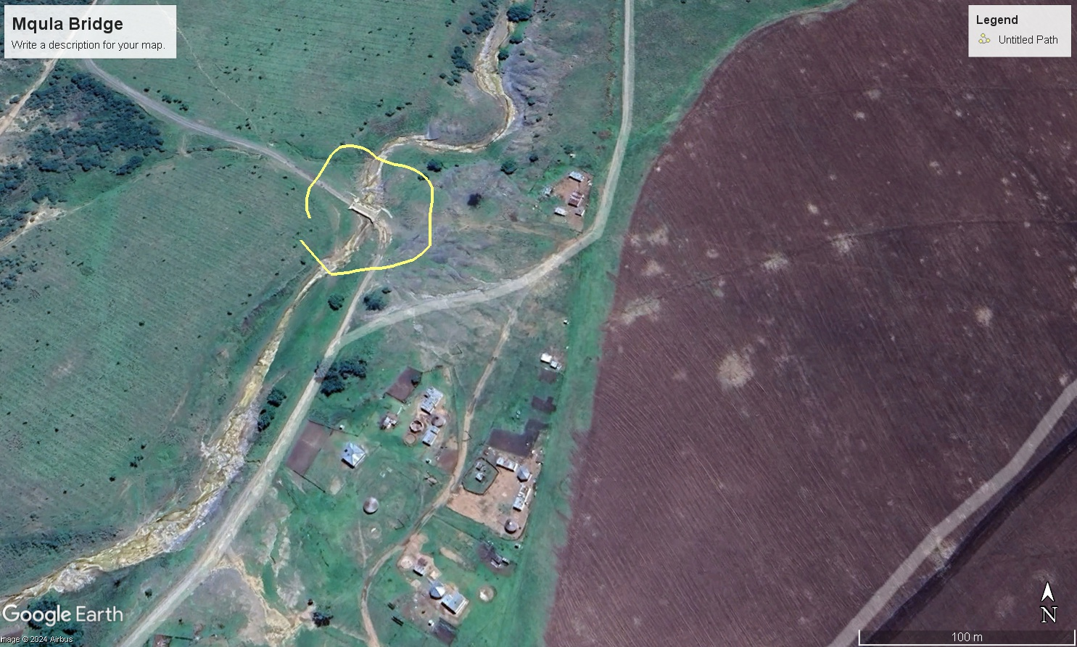
Location Coordinates:
29°01’58.1 S 30°13’40.2 E

C4.2 EXAMPLE OF CONTRACT SIGNBOARD DETAILS

2450mm


2100mm
Contractor:
Consultant:
ISIVIVANE ENGINEERS CC
Client
MPOFANA MUNICIPALITY
Project Funder:

MUNICIPAL DISASTER RECOVERY GRANT
CONTRACT NO. MPO/../2024
MQULA CULVERT BRIDGE IMPROVEMENT

NOTE:
The exact wording must be approved by the Engineer before ordering the contract name board
SPECIFICATION
- The board must comply with the diagram above
- The board must be made of minimum 0,6mm thick diameter chromadeck sheet (or similar approved)
- The board must be mounted on a steel frame and must be cross braced at the back to prevent it from deforming
- The board must be eretced with atleast two frimly planted poles
- The board must be erected with a minimum ground level clearance of 1800mm

APPROVAL STATUS

NAME CAPACITY SIGNATURE DATE

