Good day

Please see below response to queries that were received for you to quote accordingly.

Question:

ANNEXURE A , item no 8 - Web Based Email Service – 10 gigabytes
- How many email users do you have?
- Where are your emails currently hosted?

ANNEXURE A , item no 2
Do you have any other domain extensions other than co.za?
Please provide the list of your current +-30 domains, if possible.

Response:
We currently have 22 hosted exchange mailboxes.

The mailboxes are residing on the following hosted domains:
armscormail.co.za (1) - Administrator
ablogic.co.za (3)
defencecouncil.co.za (18)

The mailboxes are currently hosted at MTN (MTN Hosted Exchange) via seacom.com / clouhostafrica.com (Gary Davis - gary@seacom.com)

We also have .com TLD extensions if memory serves.

Below are our forward and reverse zones. We are the primary DNS server with MTN being the secondaries for all our zones. We will need to maintain this scenario where we host the primary DNS zones on our own DNS server and our ISP host our zones on 2 secondary DNS servers!

VERY IMPORTANT NOTE: We also have dedicated public IP address ranges which will have to be routed via our ISP of the day to our network (reverse zones).
196.4.100.x – 196.4.149.x. (HO)
196.4.30.x – 196.4.35.x (IMT)

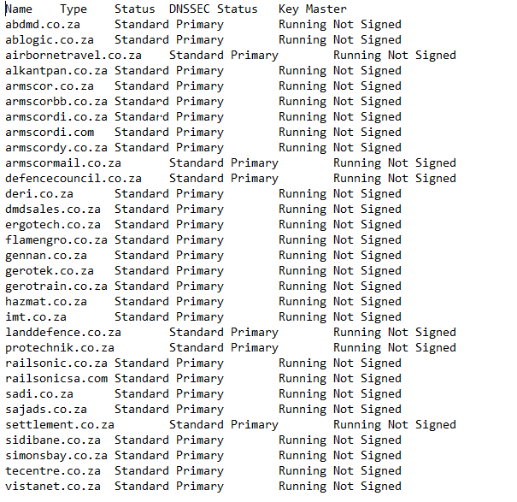
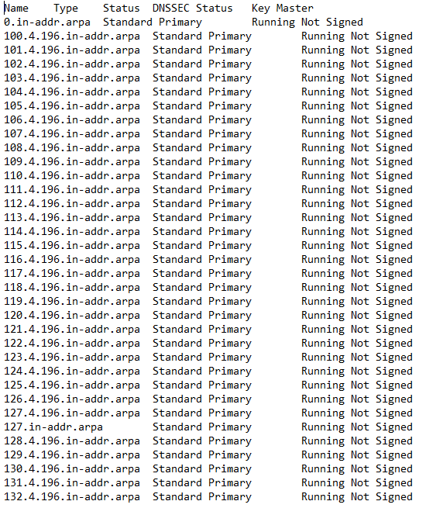
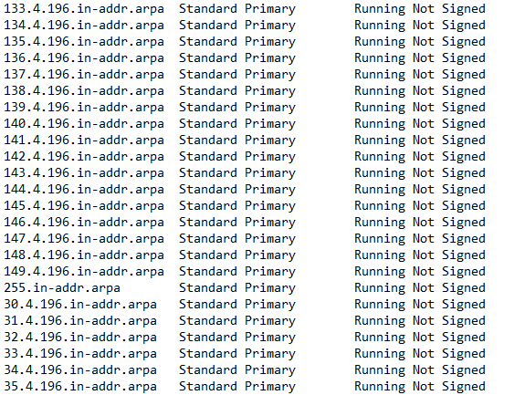
Yours faithfully
Samson Mahlangu
On behalf of Executive Manager: Supply Chain Management
ARMSCOR | 370 Nossob Street | c/o Delmas Avenue & Nossob Street | Erasmuskloof Ext 4 | Pretoria
E-mail: scmbids@armscor.co.za web www.armscor.co.za

