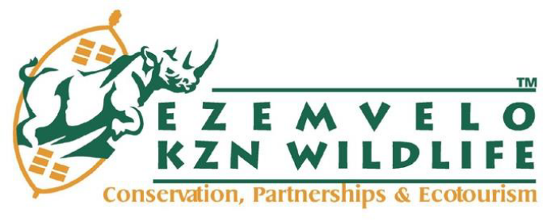`

INVITATION TO BID
BID NUMBER: | EKZNW 03/2024/25
DESCRIPTION OF GOODS/SERVICE/WORK REQUIRED: | SUPPLY, DELIVERY AND OFF-LOADING OF PRINTING PAPER AS AND WHEN REQUIRED AT EZEMVELO KZN WILDLIFE, QUEEN ELIZABETH PARK FOR A PERIOD OF THREE (3) YEARS.
CLOSING DATE AND TIME: | 30 May 2024  11:00am
BID VALIDITY PERIOD: | 120 calendar days (commencing from the Closing Date)
BID DOCUMENTS DELIVERY ADDRESS: | Ezemvelo KZN Wildlife, Head Office  Queen Elizabeth Park  No. 1 Peter Brown Drive  Montrose, Pietermaritzburg  3201

NAME OF BIDDER:
BID PRICE IN RSA CURRENCY WITH ALL APPLICABLE TAXES INCLUDED: | R
BID PRICE IN WORDS: | …………………………………………………………………………..  …………………………………………………………………………..  …………………………………………………………………………..
BIDDERS SIGNATURE:

