
DEPARTMENT: TECHNICAL SERVICES PROJECT DESCRIPTION:
APPOINTMENT OF A PANEL OF FOUR (4) SERVICE PROVIDERS
FOR THE SUPPLY & DELIVERY OF WATER & WASTEWATER
TREATMENT CHEMICALS,REAGENTS AND LABWARE FOR A PERIOD OF THREE (3) YEARS.
BID NO: PW 008/2024

BID SUBMITTED BY:

NAME OF BIDDING ENTITY : …………………………………………………..
ADDRESS | : | …………………………………………………..
CONTACT NUMBER | : | …………………………………………………..
CONTACT PERSON | : | …………………………………………………..
BID AMOUNT | : | …………………………………………………..

ISSUED BY:

Dihlabeng Local Municipality
9 Muller Street East BETHLEHEM
9700

Tel : (058) 303 5732
Fax : (058) 303 4703

CLOSING DATE : 10 NOVEMBER 2024
BIDDER’S QUESTIONNAIRE

NO. | QUESTION | BIDDER’S  RESPONS
1 | Have you initialed all the pages of the BID document? | *E YES / NO
2 | Have you completed and signed the Returnable Schedules? | * YES / NO
3 | Have you completed/signed and submitted all relevant information as requested by the Evaluation Schedules (as and | * YES / NO
4 | Have you submitted Tax Clearance reference number and tax compliance status pin? | * YES / NO
5 | Have you completed and signed the MBD 4 form - Declaration of | * YES / NO
6 | Have you completed the Questionnaire (MBD 5) regarding the
 | declaration for procurement above R10 million and submitted your Company’s latest three years audited financial statements (as and | * YES / NO
7 | whenHave yourequired)? taken note of the contents of part 5 of MBD 6.1 to
 | substantiate your B-BBEE rating claims, and have you submitted an original and valid or certified copy of your Company's B-BBEE certificate to qualify for preference points? | * YES / NO
8 | Have you completed and signed the following forms:
 | - MBD 7.1 Form – Contract form for purchase of goods/works?  - MBD 7.2 Form - Contract Form for rendering of Services?  (as and when required) | * YES / NO
9 | Have you completed and signed the MBD 8 – Declaration of bidder’s
 | past Supply Chain Management Practices and MBD 9 – Certificate of Independent Bid Determination? | * YES / NO
10 | Have you completed the Form of Offer (C1.1) in WORDS as well as in FIGURES? | * YES / NO
11 | Have you completed and signed Part 2 of C 1.2 (Contract Data)? | * YES / NO
12 | Have you completed the MBD 3.3 form and carried over your tendered price (Vat inclusive) to Form of offer (C 1.1)? | * YES / NO
*Delete whichever is not applicable

……………………………………………. …………………………………….
Signature Date

……………………………………………. ……………………………………. Position Name of Bidder

DIHLABENG LOCAL MUNICIPALITY CONTRACT NUMBER: PW008/2024

BID DOCUMENT

Appointment of a panel of four (4) service providers for the supply & delivery of water & wastewater treatment chemicals, reagents and lab ware for a period of three (3) years.

SUMMARY FOR BID OPENING PURPOSES

NAME OF BIDDING ENTITY: ………………………………………………………………………

PHYSICAL STREET ADDRESS: | POSTAL ADDRESS:

TELEPHONE NUMBER : ……………………………………………………………………………………

FAX NUMBER : ……………………………………………………………………………………

E-mail ADDRESS : ……………………………………………………………………………………

*BID PRICE : ……………………………………………………………………………………

*(Amount brought forward from the Form of Offer and Acceptance) Signed by authorised representative of Bidding Entity:

SIGNATURE : ………………………………………….

DATE : …………………………………………

Note: should any discrepancy occur between the above amounts and those stated in the Form of Offer and Acceptance, the latter shall take precedence and apply.

 | Contents
Number | Heading | Page No.
 | The Tender
 | Part T1: Bidding procedures
T1.1 | Tender Notice and Invitation to Tender (White) | T.1.2.6
T1.2 | Tender Data (Pink) | T1.2.1
 | Part T2: Returnable documents
T2.1 | List of Returnable Documents (White) | T2.1.1
 | MBD 1 – Invitation to Bid | T2.2.10
 | MBD 2 – Tax Clearance Certificate | T2.2.12
 | MBD 4 – Declaration of Interest | T2.2.13
 | MBD 5 – Declaration for procurement above R10 million (all applicable taxes included) | T2.2.15
 | MBD 6.1 - Preferential Procurement Policy Framework Act, 05 of 2000 and Regulation of 2017 | T2.2.17
 | MBD 8 – Declaration of Bidder’s past Supply Chain Management Practices | T2.2.36
 | MBD 9 – Certificate of Independent Bid Determination | T2.2.38
T2.2 | Returnable Schedules | T2.2.1
 | The Contract
 | Part C1: Agreement and Contract Data
C1.1 | Form of Offer and Acceptance (Yellow) | C1.1.2
C1.2 | Contract Data (Yellow) | C1.2.1
C1.3 | Form of Guarantee (Yellow) | C1.3.1
 | Part C2: Pricing data
C2.1 | Pricing Instructions (Yellow) | C2.1.1
C2.2 | Bill of Quantities (Yellow) | C2.2.1
 | Part C3: Scope of Work
C3 | Scope of Work (Blue) | C3.1.1
 | Part C4: Site information
C4 | Site Information (Green) | C3.2.1

INVITATION TO TENDER DIHLABENG LOCAL MUNICIPALITY

Suitable Bids are hereby invited for the following bid:
Bid Name | Bid No. | Compulsory  Briefing  Session | CIDB  Grading | Evaluation and  Adjudication  Criteria and  Preference Points | Closing Date | Enquiries
Appointment of a panel of four (4) service providers for the supply & delivery of water & wastewater treatment chemicals, reagents and lab ware for a period of three (3) | PW008/2024 | Municipal  Side Hall,  corner of  Huller and  High Streets,  Bethlehem on 24th  October 2024 at 10:00 | N/A | Bids will be evaluated on:  - Stage 1: Responsiveness  - Stage 2:  Functionality  - Stage 3: Financial Offer and Preference Evaluation  (90/10 Scoring Points)  • Stage 4: Risk Analysis | 10 November 2024 | Mr ML  Rmulwela  Tel.: 058  303 5732  lawrencer@dihl  abeng.co.za  or  ramulwelaml@ gmail.com

Bid documents will be available from 12:00 on Thursday 10 October 2024, upon payment of a cash non-refundable document fee of R1 000,00 per set, at the Dihlabeng Local Municipality, 9 Muller Street, Bethlehem, 9700.

Please note that tender document can also be accessed/download for free on the Dihlabeng Local Municipality website http://www.dihlabeng.gov.za/strategic-documents/bid-documents. And on eTender Portal.
Bids are to be completed in accordance with the conditions and bid rules contained in the bid documents and must be sealed together with supporting documents and externally endorsed WITH THE CONTRACT NUMBER AND DESCRIPTION and placed in bid box, on the Ground Floor, Dihlabeng Local Municipality, 9 Muller Street, Bethlehem, 9700 not later than 12:00 on or before the date stipulated above.

Bidders’ attention is specifically drawn to the provisions of the bid rules and evaluation criteria (including Functionality) which are included in the bid documents. The highest or any bid will not necessarily be accepted and the Council reserves the right not to consider any bid not suitably endorsed or comprehensively completed. Bids completed in pencil will be regarded as invalid bids. Bids may only be submitted on the documentation provided by the Dihlabeng Local Municipality.

The compulsory documents stated in the document must be submitted together with the Bid Document
With effect from 1 July 2016, Dihlabeng Local Municipality must use and verify suppliers registered on the Central Supplier Database - https://secured.csd.gov.za/.
Failure to register will result in Dihlabeng Local Municipality not being able to conduct business with your company/ entity.

Bids will be opened in public as soon as possible after the closing time. The municipality reserves the right to reject any and all bids

at any time

9 Muller Street
PO Box 551
BETHLEHEM, 9700
M Ntheli Website: www.dihlabeng.gov.za MUNICIPAL MANAGER E-mail: info@bethlehem.org.za

DIHLABENG LOCAL MUNICIPALITY

APPOINTMENT OF A SERVICE PROVIDER

APPOINTMENT OF A PANEL OF FOUR (4) SERVICE PROVIDERS FOR THE

SUPPLY & DELIVERY OF WATER & WASTEWATER TREATMENT
CHEMICALS,REAGENTS AND LABWARE FOR A PERIOD OF THREE (3) YEARS.

PART T1.2

TENDER DATA

DIHLABENG LOCAL MUNICIPALITY

APPOINTMENT OF A SERVICE PROVIDER

Appointment of a panel of four (4) service providers for the for the supply & delivery of water & wastewater treatment chemicals, reagents and lab ware for a period of three (3) years

T1.2 | Tender Data

The conditions of Tender are the Standard Conditions of Tender as contained in Annex F of the CIDB Standard for Uniformity in Construction Procurement (see www.cidb.org.za) which are reproduced without amendment or alteration for the convenience of tenderers as an Annex to this Tender Data.

The Standard Conditions of Tender makes several references to the Tender Data for details that apply specifically to this
Tender. The Tender Data shall have precedence in the interpretation of any ambiguity or inconsistency between it and the Standard Conditions of Tender. Each item of data provided below is cross-referenced to the clause in the Standard Conditions of Tender to which it mainly applies.

The additional Conditions of Tender are:

Clause Tender Data number

1. The Employer is the Dihlabeng Local Municipality.

F1.2 The Tender document issued by the Employer comprises:

T1.1 Tender Notice and Invitation to Tender
T1.2 Tender Data
T2.1 List of returnable documents
T2.2 Returnable schedules

Part 1 : Agreements and contract data
C1.1 Form of offer and acceptance
C1.2 Contract data
C1.3 Form of Guarantee
C1.4 Adjudicator’s appointment

Part 2 : Pricing data
C2.1 Pricing instructions
C2.2 Activity schedules / Bill of Quantities

Part 3 : Scope of work
C3 Scope of work

Part 4 : Site information
C4 Site information

The following submissions are the requirements for evaluating each bid for responsiveness. The Bidder who failed to submit the following results in immediate disqualification:

- Stage 1: Responsiveness
- Stage 2: Functionality
- Stage 3: Financial Offer and Preference Evaluation (90/10)
- Stage 4: Risk Analysis

Stage 1 – Responsiveness

- Certificate of Authority for Signatory.
- Joint Venture Agreement and Power of Attorney, in case of Joint Venture.
- Proof of payment (municipal account/statement) of Municipal Services, which is not more than three (3) months old and not more than ninety (90) days in arrears. If Municipal Services are paid by the Lessee, a copy of municipal account/statement and a valid Lease Agreement (indicating the municipal account payer and the validity period of the contract) must be attached, should the municipal services be paid by the Landlord/owner, a valid Lease Agreement (indicating the municipal account payer and the validity period of the contract) must be attached.
- Proof of CSD Registration Report which is Valid/Compliant from the date of availability of tender document.
- The document must be filled in Black Ink & corrections are countersigned.
- Bill of Quantities must be filled with black ink not pencil.
- A rate/amount is to be entered against all items in the schedule of fees/Bill of Quantities, an item against which no rate/amount is entered will lead to immediate disqualification due to unfair price advantage.
- The bidder must complete and sign all the prescribed and compulsory bid forms including Compulsory Briefing Session attendance register.
- The bidder must provide a valid copy of the company’s Quality Management System that is currently in implementation.
- The bidder must provide the recent 3 Years Financial Statements, preferably (2022 / 2023 / 2024).
- Copy/Copies of Identity document(s) (ID) of all the Directors.
- Proof of NSF International certificate/SABS approved certificate of Analysis for all proposed flocculants must be submitted with the tender document.
- Attached Material Safety Data Sheet for all tendered chemicals from accredited service provider or letter of intent accompanied by Material Safety Data Sheet (MSDS).
- Tender documents must be submitted as one (1) original, and one (1) scanned copy (PDF) of the original completed in a flash drive with all exhibits and forms required included in the returnable schedule.

Stage 2 – Functionality

The functionality points will only be used to pre-qualify the bids before consideration for preferences and price points. It must be noted that bids that score less than 60% (36 Points) will automatically be disqualified. The maximum obtainable points is 60 points (100%).

Stage 2 Evaluation: Minimum Threshold 60% (36pts)
Criteria |  | Max Points | Min Pts.  Required per criteria
1. Experience: Attach appointment letters/orders from where the service provider is currently rendering similar services and completion certificate or reference letter. |  | (30) | (18)
 | No appointment letters attached | 0
 | One appointments letters attached and reference for each project | 5
 | Two appointments letters attached | 10
 | Three appointment letters attached | 25
2. T echnical Skill: The tenderer has the ability to do plant optimisation and demonstrate to Dihlabeng Local Municipality on different plants. Attach  CV’s with qualifications of qualified and experienced personnel in the Water and Sanitation field. |  | (10) | (6)
 | No CV’s With Qualification | 0
 | CV’s with Qualification at least NDip Chemical engineering or equivalent qualification less than 3 years’ experience. | 3
 | CV’s with Qualification at least NDip Chemical engineering or equivalent qualification less than 8 years’ experience. | 5
 | CV’s with Qualification at least NDip Chemical engineering or equivalent qualification more than 10 years’ experience. | 10

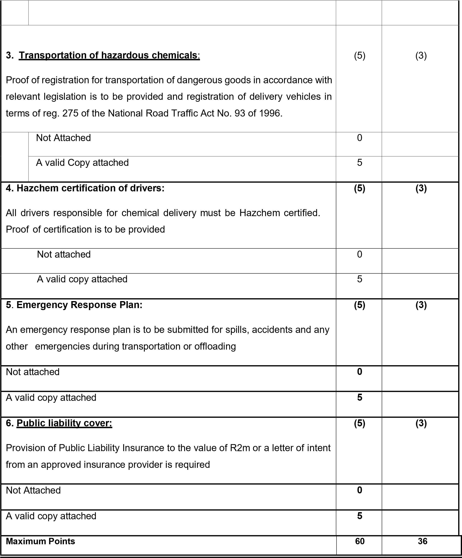

Stage 3: Financial Offer and Preference Evaluation

Each Bid will be evaluated in terms of price and preference in accordance with the Preferential Procurement Regulations 2022 (Government Gazette Vol 689, No. 47452 dated 4 November 2022).

The 90/10 preference point system for acquisition of services, works or goods up to a Rand value of R50 million

- The following formula must be used to calculate the points out 90 for price in respect of a tender with a Rand value above R50 million, inclusive of all applicable taxes:
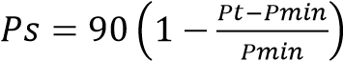

Where
Ps = Points scored for comparative price of tender under consideration; Pt = Comparative Price of tender under consideration, and; Pmin = Comparative Price of lowest acceptable tender.

  - A maximum of 10 points may be awarded to a tenderer for the specified goals for the tender.
  - The points scored for the specific goal must be added to the points scored for the price and the total must be rounded off to the nearest two decimal places.
  - A bidder must submit proof of its compliant B-BBEE status level of contributor in order to claim points for B-BBEE
  - Failure to submit proof of B-BBEE or compliant B-BBEE status level of contributor with quotation/tender, will lead to a score of zero (0) and not a disqualification
  - Proof of locality must be submitted in order to claim point(s) for locality
  - Failure to submit proof of locality with quotation/tender, will lead to a score of zero (0) and not a disqualification
  - A bidder that score 0 points for B-BBEE and/ or 0 points for locality must be score for price in addition to points for B-BBEE or locality
  - Subject to section 2(1)(f) of the Act, the contract must be awarded to the tendering scoring the highest points.

- Specific Contract Participation Goals
  - the tendering conditions will stipulate the specific goals, as contemplated in section 2(1)d(ii) of the preferential Procurement Act, to be attained
  - for any tenders a maximum of 20 points (80/20 preference points system) or 10 (90/10 preference points system), will be allocated for specific goals. These goals are:
2.2.1Contracting with persons, or categories of persons, historically disadvantaged by unfair discrimination on the basis of race, gender or disability
2.2.2Local labour, and/ or promotion of enterprise located in the municipal area
  - Regarding paragraph 6.3.1, 50% of the 20/10 points will be allocated to promoting this goal and points will be allocated in terms of the BBEEE scorecard as follows:

B-BBEE Status  Level of  Contributor | Number of points for preference (80/20 system) | Number of points for preference (90/10 system)
1 | 10 | 5
2 | 9 | 4.5
3 | 8 | 4
4 | 5 | 2.5
5 | 4 | 2
6 | 3 | 1.5
7 | 2 | 1
8 | 1 | 0.5
Non-compliant contributor | 0 | 0

  - A bidder must submit proof of its BBEEE status level contributor [scorecard]
  - A bidder failing to submit proof of BBEEE status level contributor - 2.5.1 may only score in terms of the 80/90-point formula for price; and
2.5.2 scores 0 points for BBEEE status level contributor, which is in line with section 2 (1) (d) (i) of the Act, where the supplier or service provider did not provide thereof.
  - Regarding paragraph 6.3.2, 50% of the 20/10 points will be allocated to promote this goal. Points will be allocated as follows:

Locality of supplier | Number of points for locality (80/20) | Number of points for locality (90/10)
Within the boundaries of Dihlabeng municipality | 6 | 3
Within the boundaries of Free State | 4 | 2
Historically Disadvantaged Individuals | 10 | 5

  - The policy should not include Pre-qualification goals.
  - Any specific goal for which a point may be awarded, must be clearly specified in the invitation to submit a tender.
  - A tenderer failing to submit proof of required evidence to claim preferences for other specified goals, which is in line with section 2 (1) (d) (ii) of the Act.
    - may only score in terms of the 80/90-point formula for price; and
    - scores 0 points for the relevant specific goals where the supplier or service provider did not stipulate locality.
  - The preference points scored by a bidder must be added to the points scored for price.
  - The points scored must be rounded off to the nearest two decimal places.
  - The contract must be awarded to the tenderer scoring the highest procurement points
  - (a)If the price offered by a tenderer scoring the highest points is not market related, the organ of state may not award the contract to that tenderer. (b) The organs of state may-
      - negotiate a market-related price with the tenderer scoring the highest points or cancel the tender;
      - if the tenderer does not agree to a market-related price, negotiate a market-related price with the tenderer scoring the second highest points or cancel the tender;
      - if the tenderer scoring the second highest points does not agree to a market-related organ of state must cancel the tender price, negotiate a market-related price with the tenderer scoring the third highest points or cancel the tender.
(c) If a market-related price is not agreed as envisaged in paragraph (b)(iii), the organ of state must cancel the tender.

Stage 4 – Risk Analysis

In addition to the evaluation of Responsiveness, Functionality and Financial Offer, a risk analysis will be performed on the bidders having the highest ranking/number of points to ascertain if any of the following, as relevant, present an unacceptable commercial risk to the employer in terms of:
- The bid of any bidder may be disregarded if that bidder, or any of its directors have –
        - Abused the institution’s supply chain management system;
        - Committed fraud or any other improper conduct in relation to such system; (c) Failed to perform on any previous contract.
- The bidder or any of its directors listed on the National Treasury’s Database of Restricted Suppliers as companies or persons prohibited from doing business with the public sector?
Companies or persons who are listed on this Database were informed in writing of this restriction by the Accounting Officer/Authority of the institution that imposed the restriction after the audi alteram partem rule was applied.
The Database of Restricted Suppliers is available on the National Treasury’s website (www.treasury.gov.za) and can be accessed by clicking on its link at the bottom of the home page.
- Is the bidder or any of its directors listed on the Register for Tender Defaulters in terms of section 29 of the Prevention and Combating of Corrupt Activities Act (No 12 of 2004)?
The Register for Tender Defaulters can be accessed on the National Treasury’s website
(www.treasury.gov.za) by clicking on its link at the bottom of the home page.
        - Was the bidder or any of its directors convicted by a court of law (including a court outside of the Republic of South Africa) for fraud or corruption during the past five years?
        - Was any contract between the bidder and any organ of state terminated during the past five years on account of failure to perform on or comply with the contract?
- This tender is and shall be implemented in accordance with all relevant and applicable legislation, which includes and is not limited to best practice guidelines of procurement, Engineering Profession Act (Engineering Council of South Africa – ECSA: Guideline for Services and Processes for Estimating Fees for Persons Registered in terms of the Engineering Professions (ECSA) for the typical services stages as listed), tender evaluations and etc.

F3.13.1 Tender offers will only be accepted if:

  - the tenderer has in his or her possession a certified copy of a valid Tax Clearance Certificate issued by the South African Revenue Services or has made arrangements to meet outstanding tax obligations;

  - the tenderer is registered with the Construction Industry Development Board with a grading of 4ME or higher;

  - the tenderer or any of its directors is not listed on the Register of Tender Defaulters in terms of the Prevention and Combating of Corrupt Activities Act of 2004 as a person prohibited from doing business with the public sector;

  - the tenderer has not:
      - abused the Employer’s Supply Chain management system; or

      - failed to perform on any previous contract and has been given a written notice to this effect; and

      - the tenderer has completed the Compulsory Enterprise Questionnaire and there is no conflict of interest which may impact on the tenderer’s ability to perform the contract in the best interests of the Employer or potentially compromise the tender process.

          - the tenderer does not have arrears on municipal rates and levies exceeding 3 months.

          - the tenderer has completed all forms.

F.3.17 The number of paper copies of the signed contract to be provided by the Employer is one.

The additional conditions of tender are:
All returnable schedules are to be completed and all relevant certificates attached where indicated.

ANNEX F: STANDARD CONDITIONS OF TENDER

(As published in Annex F of the CIDB Standards for Uniformity in Construction Procurement in Board Notice 136 of
2015 in Government Gazette No 38960 of 10 July 2015)

F.1 General

F.1.1 Actions

F.1.1.1 The Employer and each tenderer submitting a tender offer shall comply with these conditions of tender. In their dealings with each other, they shall discharge their duties and obligations as set out in F.2 and F.3, timeously and with integrity, and behave equitably, honestly and transparently, comply with all legal obligations and not engage in anticompetitive practices.

F.1.1.2 The Employer and the tenderer and all their agents and employees involved in the tender process shall avoid conflicts of interest and where a conflict of interest is perceived or known, declare any such conflict of interest, indicating the nature of such conflict. Tenderers shall declare any potential conflict of interest in their tender submissions. Employees, agents and advisors of the Employer shall declare any conflict of interest to whoever is responsible for overseeing the procurement process at the start of any deliberations relating to the procurement process or as soon as they become aware of such conflict, and abstain from any decisions where such conflict exists or recuse themselves from the procurement process, as appropriate.

Note: 1) A conflict of interest may arise due to a conflict of roles which might provide an incentive for improper acts in some circumstances. A conflict of interest can create an appearance of impropriety that can undermine confidence in the ability of that person to act properly in his or her position even if no improper acts result.

2) Conflicts of interest in respect of those engaged in the procurement process include direct, indirect or family interests in the tender or outcome of the procurement process and any personal bias, inclination, obligation, allegiance or loyalty which would in any way affect any decisions taken.

F.1.1.3 The Employer shall not seek and a tenderer shall not submit a tender without having a firm intention and the capacity to proceed with the contract.

F.1.2 Tender Documents

The documents issued by the Employer for the purpose of a tender offer are listed in the tender data.

F.1.3 Interpretation

F.1.3.1 The tender data and additional requirements contained in the tender schedules that are included in the returnable documents are deemed to be part of these conditions of tender.

F.1.3.2 These conditions of tender, the tender data and tender schedules which are only required for tender evaluation purposes, shall not form part of any contract arising from the invitation to tender.

F.1.3.3 For the purposes of these conditions of tender, the following definitions apply:

- conflict of interest means any situation in which:
              - someone in a position of trust has competing professional or personal interests which make it difficult to fulfill his or her duties impartially;
              - an individual or organisation is in a position to exploit a professional or official capacity in some way for their personal or corporate benefit; or iii) incompatibility or contradictory interests exist between an employee and the organisation which employs that employee.
- comparative offer means the tenderer’s financial offer after all tendered parameters that will affect the value of the financial offer have been taken into consideration in order to enable comparisons to be made between offers on a comparative basis
- corrupt practice means the offering, giving, receiving or soliciting of anything of value to influence the action of the
Employer or his staff or agents in the tender process; and
- fraudulent practice means the misrepresentation of the facts in order to influence the tender process or the award of a contract arising from a tender offer to the detriment of the Employer, including collusive practices intended to establish prices at artificial levels
- organization means a company, firm, enterprise, association or other legal entity, whether incorporated or not, or a public body

- quality (functionality) means the totality of features and characteristics of a product or service that bear on its
ability to satisfy stated or implied needs

    - Communication and Employer’s agent

Each communication between the Employer and a tenderer shall be to or from the Employer's agent only, and in a form that can be readily read, copied and recorded. Communications shall be in the English language. The Employer shall not take any responsibility for non-receipt of communications from or by a tenderer. The name and contact details of the Employer’s agent are stated in the tender data.

    - Cancellation and Re-invitation of Tenders

F.1.5.1 An organ of state may, prior to the award of the tender, cancel a tender if –
(a) due to changed circumstances, there is no longer a need for the service, works or goods requested; or (b) funds are no longer available to cover the total envisaged expenditure; or (c) no acceptable tenders are received.

F.1.5.2 The decision to cancel a tender must be published in the cidb website and in the government Tender Bulletin for the media in which the original tender invitation was advertised.

F.1.6 Procurement procedures

      - General

Unless otherwise stated in the tender data, a contract will, subject to F.3.13, be concluded with the tenderer who in terms of F.3.11 is the highest ranked or the tenderer scoring the highest number of tender evaluation points, as relevant, based on the tender submissions that are received at the closing time for tenders.

      - Competitive negotiation procedure

        - Where the tender data require that the competitive negotiation procedure is to be followed, tenderers shall submit tender offers in response to the proposed contract in the first round of submissions. Notwithstanding the requirements of F.3.4, the Employer shall announce only the names of the tenderers who make a submission. The requirements of F.3.8 relating to the material deviations or qualifications which affect the competitive position of tenderers shall not apply.

        - All responsive tenderers, or not less than three responsive tenderers that are highest ranked in terms of the evaluation method and evaluation criteria stated in the tender data, shall be invited in each round to enter into competitive negotiations, based on the principle of equal treatment and keeping confidential the proposed solutions and associated information. Notwithstanding the provisions of F.2.17, the Employer may request that tenders be clarified, specified and finetuned in order to improve a tenderer’s competitive position provided that such clarification, specification, fine-tuning or additional information does not alter any fundamental aspects of the offers or impose substantial new requirements which restrict or distort competition or have a discriminatory effect.

        - At the conclusion of each round of negotiations, tenderers shall be invited by the Employer to make a fresh tender offer, based on the same evaluation criteria, with or without adjusted weightings. Tenderers shall be advised when they are to submit their best and final offer.

        - The contract shall be awarded in accordance with the provisions of F.3.11 and F.3.13 after tenderers have been requested to submit their best and final offer.

F.1.6.3 Proposal procedure using the two stage-system

        - Option 1

Tenderers shall in the first stage submit technical proposals and, if required, cost parameters around which a contract may be negotiated. The Employer shall evaluate each responsive submission in terms of the method of evaluation stated in the tender data, and in the second stage negotiate a contract with the tenderer scoring the highest number of evaluation points and award the contract in terms of these conditions of tender.

        - Option 2

          - Tenderers shall submit in the first stage only technical proposals. The Employer shall invite all responsive tenderers to submit tender offers in the second stage, following the issuing of procurement documents.

          - The Employer shall evaluate tenders received during the second stage in terms of the method of evaluation stated in the tender data, and award the contract in terms of these conditions of tender.

F.2 Tenderer’s obligations

F.2.1 Eligibility

      - Submit a tender offer only if the tenderer satisfies the criteria stated in the tender data and the tenderer, or any of his principals, is not under any restriction to do business with Employer.

      - Notify the Employer of any proposed material change in the capabilities or formation of the tendering entity (or both) or any other criteria which formed part of the qualifying requirements used by the Employer as the basis in a prior process to invite the tenderer to submit a tender offer and obtain the Employer’s written approval to do so prior to the closing time for tenders.

F.2.2 Cost of tendering

      - Accept that, unless otherwise stated in the tender data, the Employer will not compensate the tenderer for any costs incurred in the preparation and submission of a tender offer, including the costs of any testing necessary to demonstrate that aspects of the offer complies with requirements.

      - The cost of the tender document charged by the Employer shall be limited to the actual cost incurred by the Employer for printing the documents. Employers must attempt to make available the tender documents on its website so as not to incur any costs pertaining to the printing of the tender documents.

    - Check documents

Check the tender documents on receipt for completeness and notify the Employer of any discrepancy or omission.

    - Confidentiality and copyright of documents

Treat as confidential all matters arising in connection with the tender. Use and copy the documents issued by the Employer only for the purpose of preparing and submitting a tender offer in response to the invitation.

    - Reference documents

Obtain, as necessary for submitting a tender offer, copies of the latest versions of standards, specifications, conditions of contract and other publications, which are not attached but which are incorporated into the tender documents by reference.

    - Acknowledge addenda

Acknowledge receipt of addenda to the tender documents, which the Employer may issue, and if necessary apply for an extension to the closing time stated in the tender data, in order to take the addenda into account.

    - Clarification meeting

Attend, where required, a clarification meeting at which tenderers may familiarize themselves with aspects of the proposed work, services or supply and raise questions. Details of the meeting(s) are stated in the tender data.

    - Seek clarification

Request clarification of the tender documents, if necessary, by notifying the Employer at least five working days before the closing time stated in the tender data.

    - Insurance

Be aware that the extent of insurance to be provided by the Employer (if any) might not be for the full cover required in terms of the conditions of contract identified in the contract data. The tenderer is advised to seek qualified advice regarding insurance.

    - Pricing the tender offer

F.2.10.1 Include in the rates, prices, and the tendered total of the prices (if any) all duties, taxes (except Value Added Tax (VAT), and other levies payable by the successful tenderer, such duties, taxes and levies being those applicable 14 days before the closing time stated in the tender data.

F2.10.2 Show VAT payable by the Employer separately as an addition to the tendered total of the prices.

      - Provide rates and prices that are fixed for the duration of the contract and not subject to adjustment except as provided for in the conditions of contract identified in the contract data.

      - State the rates and prices in Rand unless instructed otherwise in the tender data. The conditions of contract identified in the contract data may provide for part payment in other currencies.

    - Alterations to documents

Do not make any alterations or additions to the tender documents, except to comply with instructions issued by the Employer, or necessary to correct errors made by the tenderer. All signatories to the tender offer shall initial all such alterations.

    - Alternative tender offers

      - Unless otherwise stated in the tender data, submit alternative tender offers only if a main tender offer, strictly in accordance with all the requirements of the tender documents, is also submitted as well as a schedule that compares the requirements of the tender documents with the alternative requirements that are proposed.

      - Accept that an alternative tender offer may be based only on the criteria stated in the tender data or criteria otherwise acceptable to the Employer.

      - An alternative tender offer may only be considered in the event that the main tender offer is the winning tender.

F.2.13 Submitting a tender offer

      - Submit one tender offer only, either as a single tendering entity or as a member in a joint venture to provide the whole of the works, services or supply identified in the contract data and described in the scope of works, unless stated otherwise in the tender data.

      - Return all returnable documents to the Employer after completing them in their entirety, either electronically (if they were issued in electronic format) or by writing legibly in non-erasable ink.

      - Submit the parts of the tender offer communicated on paper as an original plus the number of copies stated in the tender data, with an English translation of any documentation in a language other than English, and the parts communicated electronically in the same format as they were issued by the Employer.

      - Sign the original and all copies of the tender offer where required in terms of the tender data. The Employer will hold all authorized signatories liable on behalf of the tenderer. Signatories for tenderers proposing to contract as joint ventures shall state which of the signatories is the lead partner whom the Employer shall hold liable for the purpose of the tender offer.

      - Seal the original and each copy of the tender offer as separate packages marking the packages as "ORIGINAL" and "COPY". Each package shall state on the outside the Employer's address and identification details stated in the tender data, as well as the tenderer's name and contact address.

      - Where a two-envelope system is required in terms of the tender data, place and seal the returnable documents listed in the tender data in an envelope marked “financial proposal” and place the remaining returnable documents in an envelope marked “technical proposal”. Each envelope shall state on the outside the Employer’s address and identification details stated in the tender data, as well as the tenderer's name and contact address.

      - Seal the original tender offer and copy packages together in an outer package that states on the outside only the Employer's address and identification details as stated in the tender data.

      - Accept that the Employer will not assume any responsibility for the misplacement or premature opening of the tender offer if the outer package is not sealed and marked as stated.

      - Accept that tender offers submitted by facsimile or e-mail will be rejected by the Employer, unless stated otherwise in the tender data.

    - Information and data to be completed in all respects

Accept that tender offers, which do not provide all the data or information requested completely and in the form required, may be regarded by the Employer as non-responsive.

    - Closing time

      - Ensure that the Employer receives the tender offer at the address specified in the tender data not later than the closing time stated in the tender data. Accept that proof of posting shall not be accepted as proof of delivery.

      - Accept that, if the Employer extends the closing time stated in the tender data for any reason, the requirements of these conditions of tender apply equally to the extended deadline.

F.2.16 Tender offer validity

      - Hold the tender offer(s) valid for acceptance by the Employer at any time during the validity period stated in the tender data after the closing time stated in the tender data.

      - If requested by the Employer, consider extending the validity period stated in the bid data for an agreed additional period with or without any conditions attached to such extension.

      - Accept that a tender submission that has been submitted to the Employer may only be withdrawn or substituted by giving the Employer’s agent written notice before the closing time for tenders that a tender is to be withdrawn or substituted.

      - Where a tender submission is to be substituted, submit a substitute tender in accordance with the requirements of F.2.13 with the packages clearly marked as “SUBSTITUTE”.

    - Clarification of tender offer after submission

Provide clarification of a tender offer in response to a request to do so from the Employer during the evaluation of tender offers. This may include providing a breakdown of rates or prices and correction of arithmetical errors by the adjustment of certain rates or item prices (or both). No change in the competitive position of tenderers or substance of the tender offer is sought, offered, or permitted.

    - Provide other material

      - Provide, on request by the Employer, any other material that has a bearing on the tender offer, the tenderer’s commercial position (including notarized joint venture agreements), preferencing arrangements, or samples of materials, considered necessary by the Employer for the purpose of a full and fair risk assessment. Should the tenderer not provide the material, or a satisfactory reason as to why it cannot be provided, by the time for submission stated in the Employer’s request, the Employer may regard the tender offer as non-responsive.

      - Dispose of samples of materials provided for evaluation by the Employer, where required.

    - Inspections, tests and analysis

Provide access during working hours to premises for inspections, tests and analysis as provided for in the tender data.

    - Submit securities, bonds, policies, etc.

If requested, submit for the Employer’s acceptance before formation of the contract, all securities, bonds, guarantees, policies and certificates of insurance required in terms of the conditions of contract identified in the contract data.

    - Check final draft

Check the final draft of the contract provided by the Employer within the time available for the Employer to issue the contract.

    - Return of other tender documents

If so instructed by the Employer, return all retained tender documents within 28 days after the expiry of the validity period stated in the tender data.

    - Certificates

Include in the tender submission or provide the Employer with any certificates as stated in the tender data.

F.3 The Employer’s undertakings

F.3.1 Respond to requests from the tenderer

      - Unless otherwise stated in the tender Data, respond to a request for clarification received up to five working days before the tender closing time stated in the Tender Data and notify all tenderers who drew procurement documents.

      - Consider any request to make a material change in the capabilities or formation of the tendering entity (or both) or any other criteria which formed part of the qualifying requirements used to prequalify a tenderer to submit a tender offer in terms of a previous procurement process and deny any such request if as a consequence:

            - an individual firm, or a joint venture as a whole, or any individual member of the joint venture fails to meet any of the collective or individual qualifying requirements;

            - the new partners to a joint venture were not prequalified in the first instance, either as individual firms or as another joint venture; or
            - in the opinion of the Employer, acceptance of the material change would compromise the outcome of the prequalification process.

    - Issue Addenda

If necessary, issue addenda that may amend or amplify the tender documents to each tenderer during the period from the date that tender documents are available until three days before the tender closing time stated in the Tender Data. If, as a result a tenderer applies for an extension to the closing time stated in the Tender Data, the Employer may grant such extension and, shall then notify all tenderers who drew documents.

    - Return late tender offers

Return tender offers received after the closing time stated in the Tender Data, unopened, (unless it is necessary to open a tender submission to obtain a forwarding address), to the tenderer concerned.

    - Opening of tender submissions

      - Unless the two-envelope system is to be followed, open valid tender submissions in the presence of tenderers’ agents who choose to attend at the time and place stated in the tender data. Tender submissions for which acceptable reasons for withdrawal have been submitted will not be opened.

      - Announce at the meeting held immediately after the opening of tender submissions, at a venue indicated in the tender data, the name of each tenderer whose tender offer is opened and, where applicable, the total of his prices, preferences claimed and time for completion for the main tender offer only.

      - Make available the record outlined in F.3.4.2 to all interested persons upon request.

F.3.5 Two-envelope system

      - Where stated in the tender data that a two-envelope system is to be followed, open only the technical proposal of valid tenders in the presence of tenderers’ agents who choose to attend at the time and place stated in the tender data and announce the name of each tenderer whose technical proposal is opened.

      - Evaluate the functionality of the technical proposals offered by tenderers, then advise tenderers who remain in contention for the award of the contract of the time and place when the financial proposals will be opened. Open only the financial proposals of tenderers, who score in the functionality evaluation more than the minimum number of points for functionality stated in the tender data, and announce the score obtained for the technical proposals and the total price and any points claimed on BBBEE status level. Return unopened financial proposals to tenderers whose technical proposals failed to achieve the minimum number of points for functionality.

    - Non-disclosure

Not disclose to tenderers, or to any other person not officially concerned with such processes, information relating to the evaluation and comparison of tender offers, the final evaluation price and recommendations for the award of a contract, until after the award of the contract to the successful tenderer.

    - Grounds for rejection and disqualification

Determine whether there has been any effort by a tenderer to influence the processing of tender offers and instantly disqualify a tenderer (and his tender offer) if it is established that he engaged in corrupt or fraudulent practices.

    - Test for responsiveness

F.3.8.1 Determine, after opening and before detailed evaluation, whether each tender offer properly received:

- complies with the requirements of these Conditions of Tender,
- has been properly and fully completed and signed, and
- is responsive to the other requirements of the tender documents.

F.3.8.2 A responsive tender is one that conforms to all the terms, conditions, and specifications of the tender documents without material deviation or qualification. A material deviation or qualification is one which, in the Employer's opinion, would:

- detrimentally affect the scope, quality, or performance of the works, services or supply identified in the Scope of
Work,
- significantly change the Employer's or the tenderer's risks and responsibilities under the contract, or
- affect the competitive position of other tenderers presenting responsive tenders, if it were to be rectified.

Reject a non-responsive tender offer, and not allow it to be subsequently made responsive by correction or withdrawal of the non-conforming deviation or reservation.

F.3.9 Arithmetical errors, omissions and discrepancies

F.3.9.1 Check the highest ranked tender or tenderer with the highest number of tender evaluation points after the evaluation of tender offers in accordance with F.3.11 for:

- the gross misplacement of the decimal point in any unit rate;
- omissions made in completing the pricing schedule or bills of quantities; or
- arithmetic errors in:
  - line item totals resulting from the product of a unit rate and a quantity in bills of quantities or schedules of prices; or
  - the summation of the prices.

F.3.9.2 The Employer must correct the arithmetical errors in the following manner:

- Where there is a discrepancy between the amounts in words and amounts in figures, the amount in words shall govern.
- If bills of quantities or pricing schedules apply and there is an error in the line item total resulting from the product of the unit rate and the quantity, the line item total shall govern and the rate shall be corrected. Where there is an obviously gross misplacement of the decimal point in the unit rate, the line item total as quoted shall govern, and the unit rate shall be corrected.
- Where there is an error in the total of the prices either as a result of other corrections required by this checking process or in the tenderer's addition of prices, the total of the prices shall govern and the tenderer will be asked to revise selected item prices (and their rates if bills of quantities apply) to achieve the tendered total of the prices.
- Consider the rejection of a tender offer if the tenderer does not correct or accept the correction of the arithmetical error in the manner described above.

F.3.10 Clarification of a tender offer

Obtain clarification from a tenderer on any matter that could give rise to ambiguity in a contract arising from the tender offer.

F.3.11 Evaluation of tender offers

F.3.11.1 General

Appoint an evaluation panel of not less than three persons. Reduce each responsive tender offer to a comparative offer and evaluate them using the tender evaluation methods and associated evaluation criteria and weightings that are specified in the tender data.

F.3.11.2 Method 1: Price and Preference

In the case of a price and preference:

- Score tender evaluation points for price
- Score points for BBBEE contribution
- Add the pointed scored for price and BBBEE.

F.3.11.3 Methods 2: Functionality, Price and Preference

In the case of a functionality, price and preference:

- Score functionality, rejecting all tender offers that fail to achieve the minimum number of points for functionality as stated in the Tender Data.
- No tender must be regarded as an acceptable tender if it fails to achieve the minimum qualifying score for functionality as indicated in the tender invitation.
- Tenders that have achieved the minimum qualification score for functionality must be evaluated further in terms of the preference points system prescribed in paragraphs 4 and 5 below.

The 90/10 preference point system for acquisition of services, works or goods up to a Rand value of R1 million

- (a)(i) The following formula must be used to calculate the points out of 80 for price in respect of tenders (including price quotation) with a Rand value equal to or above R30 000 and up to a Rand value of R50 million, (inclusive of all applicable taxes):

Where
Ps = Points scored for comparative price of tender under consideration; Pt = Comparative Price of tender under consideration, and; Pmin = Comparative Price of lowest acceptable tender.

(4)(a)(ii) An Employer of state may apply the formula in paragraph (a)(i) for price quotations with a value of less than R30 000, if and when appropriate.

(4)(b) Subject to subparagraph (4)(c), points must be awarded to a tender for attaining the B-BBEE status level of contributor in accordance with the table below:

B-BBEE STATUS LEVEL OF CONTRIBUTOR | NUMBER OF POINTS
1 | 20
2 | 18
3 | 14
4 | 12
5 | 8
6 | 6
7 | 4
8 | 2
Non-compliant contributor | 0

(4)(c) A maximum of 20 points may be allowed in accordance with subparagraph (4)(b)

(4)(d) the points scored by tender in respect of B-BBEE contribution contemplated in subparagraph (4)(b) must be added to the points scored for price as calculated in accordance with subparagraph (4)(a).

(4)(e) Subject to paragraph 4.3.8 the contract must be awarded to the tender who scores the highest total number of points.

The 90/10 preference point system for acquisition of services, works or goods up to a Rand value of R50 million

(5)(a) The following formula must be used to calculate the points out of 90 for price in respect of tenders (including price quotation) with a Rand value equal to or above R50 000 000 (inclusive of all applicable taxes):
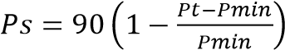

Where
Ps = Points scored for comparative price of tender under consideration; Pt = Comparative Price of tender under consideration, and; Pmin = Comparative Price of lowest acceptable tender.

(5)(b) Subject to subparagraph (5)(c), points must be awarded to a tender for attaining the B-BBEE status level of contributor in accordance with the table below:

B-BBEE STATUS LEVEL OF CONTRIBUTOR | NUMBER OF POINTS
1 | 10
2 | 9
3 | 8
4 | 5
5 | 4
6 | 3
7 | 2
8 | 1
Non-compliant contributor | 0

(5)(c) A maximum of 10 points may be allowed in accordance with subparagraph (5)(b)

(5)(d) The points scored by tender in respect of B-BBEE contribution contemplated in subparagraph (5)(b) must be added to the points scored for price as calculated in accordance with subparagraph (5)(a).

(5)(e) Subject to paragraph 4.3.8 the contract must be awarded to the tender who scores the highest total number of points.

F.3.11.6 Decimal places

Score price, preference and functionality, as relevant, to two decimal places.

F.3.11.7 Scoring Financial Offers

Score price of remaining responsive tender offers using the following formula:

N_{FO} = W₁ x A
where: N_{FO} is the number of tender evaluation points awarded for the financial offer.
W₁ is the maximum possible number of tender evaluation points awarded for the financial offer as stated in the Tender Data.
A is a number calculated using the formula and option described in Table F.1 as stated in the Tender Data.

Table F.1: Formulae for calculating the value of A

Formula | Compensation aimed at achieving | Option 1ª | Option 2ª
1 | Highest price or discount | A = (1 + (P – Pm))  Pm | A = P / Pm
2 | Lowest price or percentage commission / fee | A = (1 - (P – Pm))  Pm | A = Pm / P
a Pm | is the comparative offer of the most favourable comparative offer.
P | is the comparative offer of the tender under consideration.

F.3.11.8 Scoring preferences

Confirm that tenderers are eligible for the preferences claimed in accordance with the provisions of the tender data and reject all claims for preferences where tenderers are not eligible for such preferences.

Calculate the total number of tender evaluation points for preferences claimed in accordance with the provisions of the tender data.

F.3.11.9 Scoring functionality

Score each of the criteria and subcriteria for quality in accordance with the provisions of the Tender Data.

Calculate the total number of tender evaluation points for quality using the following formula:

N_{Q} = W₂ x S_{O} / M_{S}

where: S_{O} is the score for quality allocated to the submission under consideration;
M_{S} is the maximum possible score for quality in respect of a submission; and
W₂ is the maximum possible number of tender evaluation points awarded for the quality as stated in the tender data

F.3.12 Insurance provided by the Employer

If requested by the proposed successful tenderer, submit for the tenderer's information the policies and / or certificates of insurance which the conditions of contract identified in the contract data, require the Employer to provide.

F.3.13 Acceptance of tender offer

Accept the tender offer, if in the opinion of the Employer, it does not present any unacceptable commercial risk and only if the tenderer:

- is not under restrictions, or has principals who are under restrictions, preventing participating in the Employer’s procurement,
- can, as necessary and in relation to the proposed contract, demonstrate that he or she possesses the professional and technical qualifications, professional and technical competence, financial resources, equipment and other physical facilities, managerial capability, reliability, experience and reputation, expertise and the personnel, to perform the contract,
- has the legal capacity to enter into the contract,
- is not insolvent, in receivership, bankrupt or being wound up, has his affairs administered by a court or a judicial officer, has suspended his business activities, or is subject to legal proceedings in respect of any of the foregoing,
- complies with the legal requirements, if any, stated in the tender data, and
- is able, in the opinion of the Employer, to perform the contract free of conflicts of interest.

F.3.14 Prepare contract documents

F.3.14.1 If necessary, revise documents that shall form part of the contract and that were issued by the Employer as part of the tender documents to take account of:

- addenda issued during the tender period,
- inclusion of some of the returnable documents, and
- other revisions agreed between the Employer and the successful tenderer.

F.3.14.2 Complete the schedule of deviations attached to the form of offer and acceptance, if any.

F.3.15 Complete adjudicator's contract

Unless alternative arrangements have been agreed or otherwise provided for in the contract, arrange for both parties to complete formalities for appointing the selected adjudicator at the same time as the main contract is signed.

F.3.16 Notice to unsuccessful tenderers

F.3.16.1 Notify the successful tenderer of the Employer's acceptance of his tender offer by completing and returning one copy of the form of offer and acceptance before the expiry of the validity period stated in the tender data, or agreed additional period.

F.3.16.2 After the successful tenderer has been notified of the Employer’s acceptance of the tender, notify other tenderers that their tender offers have not been accepted.

F.3.17 Provide copies of the contracts

Provide to the successful tenderer the number of copies stated in the Tender Data of the signed copy of the contract as soon as possible after completion and signing of the form of offer and acceptance.

F.3.18 Provide written reasons for actions taken

Provide upon request written reasons to tenderers for any action that is taken in applying these conditions of tender, but withhold information which is not in the public interest to be divulged, which is considered to prejudice the legitimate commercial interests of tenderers or might prejudice fair competition between tenderers.

F.3.19 Transparency in the procurement process

F3.19.1 | The CIDB prescripts require that tenders must be advertised and be registered on the i.Tender system.
F3.19.2 | The Employer must adopt a transparency model that incorporates the disclosure and accountability as transparency requirements in the procurement process.
F3.19.3 | The transparency model must identify the criteria for selection of projects, project information template and the threshold value of the projects to be disclosed in the public domain at various intervals of delivery of infrastructure projects.
F3.19.4 | The client must publish the information on a quarterly basis which contains the following information:  - Procurement planning process  - Procurement method and evaluation process  - Contract type  - Contract status  - Number of firms tendering  - Cost estimate  - Contract title  - Contract firm (s)  - Contract price  - Contract scope of work  - Contract start date and duration  - Contract evaluation report
F3.19.5 | The Employer must establish a Consultative Forum which will conduct a random audit in the implementation of transparency requirements in the procurement process.
F3.19.6 | Consultative Forum must be an independent structure from the bid committees.
F3.19.7 | The information must be published on the Employer’s website
F3.19.8 | Records of such disclosed information must be retained for audit purposes.

DIHLABENG LOCAL MUNICIPALITY

APPOINTMENT OF A SERVICE PROVIDER

FOR THE SUPPLY & DELIVERY OF WATER & WASTEWATER TREATMENT

CHEMICALS, REAGENTS AND LAB WARE FOR A PERIOD OF THREE (3) YEARS.

PART T2
RETURNABLE DOCUMENTS AND SCHEDULES

DIHLABENG LOCAL MUNICIPALITY

APPOINTMENT OF A SERVICE PROVIDER

FOR THE SUPPLY & DELIVERY OF WATER & WASTEWATER TREATMENT

CHEMICALS, REAGENTS AND LAB WARE FOR A PERIOD OF THREE (3) YEARS.

PART T2.1
LIST OF RETURNABLE DOCUMENTS
DIHLABENG LOCAL MUNICIPALITY

APPOINTMENT OF A SERVICE PROVIDER

FOR THE SUPPLY & DELIVERY OF WATER & WASTEWATER TREATMENT

CHEMICALS, REAGENTS AND LAB WARE FOR A PERIOD OF THREE (3) YEARS.

T2.1. List of Returnable Documents

Bidders are required to submit the following returnable documents with their bids, neatly bound in a separate file.

Returnable Documents

- Original valid tax clearance certificate (in terms of the Preferential Procurement Regulations, 2001 published in Government Gazette No 22549 dated 10 August 2001),
- Certified copy of Certificate of Incorporation (if Bidder is a Company)
- Certified copy of Founding Statement (if Bidder is a Closed Corporation)
- Certified copy of Partnership Agreement (if Bidder is a Partnership)
- Certified copy of Identity Document (if Bidder is a One-man concern),
- Joint venture agreement (if the Bidder is a Joint Venture).
- B-BBEE Status Level Verification Certificate (main and sub-contractors)

- Proof of registration with Central Supplier Datatbase

DIHLABENG LOCAL MUNICIPALITY

APPOINTMENT OF A SERVICE PROVIDER

APPOINTMENT OF A PANEL OF FOUR (4) SERVICE PROVIDERS FOR THE FOR THE SUPPLY & DELIVERY OF WATER & WASTEWATER TREATMENT CHEMICALS, REAGENTS AND LAB WARE FOR A PERIOD OF THREE (3) YEARS.

PART T2.2
RETURNABLE SCHEDULES

DIHLABENG LOCAL MUNICIPALITY

APPOINTMENT OF A SERVICE PROVIDER

APPOINTMENT OF A PANEL OF FOUR (4) SERVICE PROVIDERS FOR THE SUPPLY & DELIVERY OF
WATER & WASTEWATER TREATMENT CHEMICALS, REAGENTS AND LAB WARE FOR A PERIOD OF THREE (3) YEARS.

T2.2 List of Returnable Schedules
The bidder must complete the following returnable schedules:

- Returnable Schedules required only for bid evaluation purposes
  - Schedule A: Record of Addenda to Bid Documents
  - Schedule B: Proposed Amendments and Qualifications
  - Schedule C: Present Work Commitments
  - Schedule D: Proposed Subcontractors
  - Schedule E: Compliance with OHSA (Act 85 of 1993)
  - Schedule F: Authority of Signatory
  - Schedule G: Invitation to Bid (MBD 1)
  - Schedule H: Tax Clearance Requirements (MBD 2)
  - Schedule I: Declaration of Interest (MBD 4)
  - Schedule J: Declaration for procurement above R10 million (all applicable taxes included) (MBD 5)
  - Schedule K: Preferential Procurement Policy Framework Act, 05 of 2000 and Regulation of 2017 (MBD 6.1)
  - Schedule L: Declaration of Bidder’s past Supply Chain Management Practices (MBD 8)
  - Schedule M: Certificate of Independent Bid Determination (MBD 9)
  - Schedule N: Municipal Services, Rates and Taxes Clearance Certificate for Supply Chain Management Purposes
  - Schedule O: Certificate of Authority of an Entity
  - Schedule P: Certificate of Bidder’s Attendance at the Compulsory Clarification Meeting
  - Schedule Q: Certificate of Registration of entity (CIDB and B-BBEE)
  - Schedule R: Workmen’s Compensation registration certificate
  - Schedule S: UIF Registration Certificate
  - Schedule T: Compulsory Enterprise Questionnaire
  - Schedule U: Affidavit of Good Standing that will be incorporated into contract.
  - Schedule V: Schedule of all work Provided for an organ of the state over the last 5 years
  - Schedule W: Banking Details
  - Schedule X: Declaration of Financial Capacity
  - Schedule Y: Schedule of the Tenders Experience
  - Schedule Z: Competency of Key Personnel
  - Schedule AA: Declaration of Available Plant and Equipment to execute the works
  - Schedule BB: Tender Programme
  - Schedule CC: National Treasury’s Central Suppliers Database
  - Schedule DD: Declaration of Solvency or Liquidity
Schedule EE: Public Liability Cover and Quality Management System

- Other documents required only for bid evaluation purposes 1. All returnable schedules will be incorporated into the Contract.

- Returnable Schedules that will be incorporated into the contract
  - The offer portion of the C1.1 Offer and Acceptance
  - C1.2 Data provided by the Contractor
  - C2.2 Schedule of Quantities
  - C2.3 Summary of Schedules
  - Part C3: Scope of Works

Supply and delivery of the water treatment chemicals, testing equipment and lab ware which are SANS or NSF approved. The objective of this tender is to appoint suitably experienced and qualified suppliers for the supply and delivery of the above mentioned items on a consignment stock basis to Dihlabeng Local Municipality Water Treatment works as detailed in this tender document.

The following is covered in the scope of work:

  - Ensuring that Dihlabeng Local Municipality (DLM) receives uninterrupted supply of water purification chemicals, testing equipment and lab ware to various sites as detailed in the tender document. The successful Tenderers/Bidders will sign agreement contracts stating all the conditions of the tender.
  - Supply, delivery, offloading, stock control and assurance of performance of water purification chemicals, testing equipment and lab ware to various water treatment plants in Dihlabeng Local Municipality.
  - The supplied water purification chemicals shall be able to produce drinking water which complies with SANS 241:2015 Drinking Water Quality standards.
  - The tenderer must have Quality Standard Systems and all products must have “Drinking water Approval” by accredited body e.g. NSF Accreditation or SABS accreditation certificate Quality Standard System with a maximum allowable dosing rate.
  - The Tenderer shall provide a letter of support if the Tenderer is not the manufacture. If the Tenderer fails to submit a letter of support, the attachments will be considered invalid and such bid will be disqualified.
  - The Tenderer shall comply with lead times and delivery times to be specified in the tender document.
  - The Tenderer shall be duty bound to supply a certificate of analysis for each batch of delivery.
  - The Tenderer must use transport that complies with safety requirements for transportation of hazardous chemicals.
  - The Driver of the hazardous chemical transport must be a certified Hazardous Chemical deliver.
  - The Tenderer must comply with the Occupational Health and Safety Act 85 of 1993, a SHE plan shall be provided with the tender document. Failure to submit such plan with the tender document will results in the Tenderer being disqualified.
  - The Tenderer shall provide training services to Dihlabeng Local Municipality personnel with specific regard to safe use, and handling of water purification chemicals at no cost to the municipality.
  - The Tenderer shall ensure that all holding tanks supplied must be compatible with the existing Dihlabeng Local Municipality equipment/systems. All receptacles and or vessels for containing chemicals supplied such as tankers, cylinders or drums, must be delivered in Leak proof/Undamaged containers.
  - The Tenderer shall submit an Emergency Response Plan for spills, accidents and any other emergencies during transportation or offloading of chemicals. Failure to submit such plan with the tender document will results to the Tenderer being disqualified.
  - The Tenderer shall provide Public Liability insurance cover to the value of R2 million or a letter of intent from an approved insurance provider.
  - The Tenderer shall provide Manufacturer Safety Data Sheet for each tendered chemical. MSDS provided should include the following information but not limited to: Hazardous ingredients, Hazardous identification, Physical and
Chemical characteristics, Firefighting measures, Health and first aid, exposure controls/personal protection, Accident release measures, Disposal considerations, transportation, Toxicology, Regulatory and other information. Failure to submit MSDS documents with the tender document will results to the Tenderer being disqualified.
  - The Tenderer shall make compulsory site visits by qualified technical staff, to each of the plants to carry out performance tests. i.e. jar test and plant optimisations.
  - The Tenderer shall provide the necessary qualification documents of technical staff that will be carrying out the tests and performance work at the plants.
  - The short listed Tenderers will be requested to submit flocculants samples during the live jar tests which will be conducted during the evaluation stage of the tender. The samples will be kept and used for future reference by the Municipality.
  - The appointed Tenderers must carry out plant jar tests and trials as per the provision in the tender document to determine the best chemical with respect to performance and cost effectiveness.
  - All tendered prices should be exclusive of the destination delivery cost.
  - The approved Tenderer shall under no circumstances interrupt the operations as a result of his/her activities in, or around the plant structure.
  - Appointment of the panel is not a guarantee that orders will be placed or that a minimum contract value will apply.
  - No goods shall be delivered or order processed without an authorization from Dihlabeng Local Municipality and any goods delivered without the approval is at the supplier’s own risk.
  - Dihlabeng Local Municipality reserves the right to increase or decrease quantities based on business requirements.
  - The tenders must have adequate experience or proven track record supplying water treatment chemicals.
  - If the tenderer is a distributor or manufacturer, the municipality must be furnished with guarantee that tenderer has a local warehouse for repairs and calibrations of equipment.
  - The tenderer must submit qualifications of the technicians that will attend to any malfunctions.

Plant trials:
  - Plant trials for flocculants will be performed by all appointed tenderers after the jar test evaluation process. Dihlabeng Local Municipality will only purchase volume of chemicals required to conduct the trial. It will be expected that the chemicals used during the trails must be able to produce water that meets the SANS 241:2015 Drinking water quality standards. If the tenderer/Bidder’s chemicals fails to produce water that meets SANS
241:2015 Drinking water quality standards during trial run, Dihlabeng Local Municipality have the right to stop the Plant trial and the tenderer/bidder will only be allowed to supply other chemicals with the exception of the flocculants.
  - It will be expected from the Tenderer to determine the optimum dosing of their product at various Water Treatment Works during the plant trials period. The Tenderer will supply its own equipment for the plant trials. The water quality results during this period will be recorded by both parties and the Plant Supervisor/Water technician will sign them off as witness on the sheet provided.
  - All plant trials will be closely monitored by the water technical team and tenders will be expected to demonstrate their calculations related to preparations of sample and actual dosing to the plant.
  - A CV of a person (mentioned in functionality stage 2 under technical skills) performing the plant trials must be attached to the tender document. Kindly take note that this Person must be qualified to operate a Class B Water Treatment Works in terms of the Department of Water and Sanitation regulation 813 or 17 as a Class V Process Controller. (Rephrase to include the technical skill criteria).

  - The Plant Trials will be a maximum of one week (7 days) including Saturdays and Sundays per appointed Tenderers for all schemes identified. Tenderers may choose to run trials at more than one Plant simultaneously.

Flocculants:
  - The Flocculants shall be suitable for treating raw water to meet SANS 214:2015 Drinking Water Quality Standards. The MSDS and or COA shall provide the following but not limited to: Nature of compound, product characteristics (pH min/max), density (min/max), total solids @ 150°C, shelf life @40°C etc

Submission of flocculants samples:
  - Flocculants will be requested from all short listed tenderers.
  - Flocculants Samples must be clearly labeled with name of product, name of supplier and the expiry date and to be accompanied by MSDS and COA.
  - Samples must be submitted in duplicate (i.e. 2x500ml) in temper proof sealed bottles, one of the samples will be submitted for tests and evaluation to the accredited laboratory at the discretion of the Municipality. The other sample will be submitted and retained by Dihlabeng Local Municipality and used as a reference sample should any dispute arise regarding quality and product performance. Dihlabeng Local Municipality will not pay for the samples submitted.

A: RECORD OF ADDENDA TO BID DOCUMENTS
We confirm that the following communications received from the Employer or his Agent before the submission of this Tender Offer, amending the tender documents, have been taken into account in this tender offer:
 | Date | Title or Details
1.
2.
3.
4.
5.
6.
7.
8.
Attach additional pages if more space is required.

Signature ........................................................................ Date ....................................................

Name ..................................................................... Position....................................................

Tenderer .......................................................................................................................................................
B: PROPOSED AMENDMENTS AND QUALIFICATIONS
Should the Tenderer desire to make any departures from, or modifications to the General Conditions of Contract, Specifications, Bill of Quantities or Drawings, or to qualify his tender in any way; he shall set out his proposal clearly hereunder or alternatively state them in a covering letter attached to the tender, and referred to hereunder. Falling to comply with the aforesaid will deem the tender unqualified. If no departures or modifications are desired the Schedule hereunder is to be marked NIL and, in any case, signed by the Tenderer.

The Tenderers attention is drawn to clause F.3.8 of the Standard Conditions of Tender referenced in the Tender Data regarding the employer’s handling of material deviations and qualifications.
 | Page | Clause or item | Proposal

Signature ........................................................................ Date ....................................................

Name ..................................................................... Position....................................................

Tenderer ......................................................................................................................................................
C: PRESENT WORK COMMITMENTS
 | Consulting Engineer / Employer contact person and telephone number. | Description of works | Value of work inclusive of VAT (Rand) | Duration and completion date

Signature ........................................................................ Date ....................................................

Name ..................................................................... Position....................................................

Tenderer ......................................................................................................................................................

D: PROPOSED SUBCONTRACTORS

We notify you that it is our intention to employ the following Subcontractors for work in this contract.

If we are awarded a contract, we agree that this notification does not change the requirement for us to submit the names of proposed Subcontractors in accordance with requirements in the contract for such appointments. If there are no such requirements in the contract, then your written acceptance of this list shall be binding between us.
 | Name and address of proposed Subcontractor | Nature and extent of work to be Subcontracted | Previous experience with  Subcontractor or recent work Executed by the Subcontractor.
1.
2.
3.
4.
5.

Signature ........................................................................ Date ....................................................

Name ..................................................................... Position....................................................

E: COMPLIANCE WITH OHSA (ACT 85 OF 1993)

Tenderers are required to satisfy the Employer and the Engineer as to their ability and available resources to comply with the above by answering the following questions and providing the relevant information required below:

- Is the Tenderer familiar with the OHSA (Act 85 of 1993) and its regulations? YES / NO

- Who will prepare the Tender’s Health and Safety Plan (Provide a copy of the persons/s curriculum vitae/s or company profile).

_
- Does the Tenderer have a health and safety policy? (If yes, provide a copy). YES / NO How is this policy communicated to all employees?

- Does the Tenderer keep records of safety aspects of each construction site? YES / NO If yes, what records are kept?

- Does the Tenderer conduct monthly safety meetings? YES / NO
If yes, who is the chairperson of the meeting and who attend these meetings?

- Does the Tenderer have a safety officer in his employment, responsible for the overall YES / NO safety of his company?

If yes, please explain his duties and provide a copy of his CV.

- Does the Tenderer have trained first aid employees? If yes, indicate who. YES / NO

- Does the Tenderer have a safety induction training programme in place? YES / NO
If yes, provide a copy.

Signature ........................................................................ Date ....................................................

Name ..................................................................... Position....................................................

F: AUTHORITY OF SIGNATORY

We, the undersigned, hereby authorize Mr / Mrs ................................................. acting in his/her capacity

as …………………………………. of the business trading as ....................................... to sign all

documentation in connection with Tender …………………………………………………………………………….

NAME OF MEMBERS /
DIRECTORS | SIGNATURE | DATE

Note: If bidders attached a copy of their Authorised Signatory is it not necessary to complete this form

Signature ........................................................................ | Date ....................................................
Name ..................................................................... | Position....................................................
MBD1
SCHEDULE G: INVITATION TO BID

PART A

INVITATION TO BID
YOU ARE HEREBY INVITED TO BID FOR REQUIREMENTS OF THE DIHLABENG LOCAL MUNICIPALITY
BID NUMBER: | PW007/2024 | CLOSING DATE: | 10 November 2020 | CLOSING TIME: | 12:00
DESCRIPTION | APPOINTMENT OF A PANEL OF FOUR (4) SERVICE PROVIDERS FOR THE SUPPLY & DELIVERY OF WATER & WASTEWATER TREATMENT CHEMICALS, REAGENTS AND LAB WARE FOR A PERIOD OF THREE (03) YEARS.
THE SUCCESSFUL BIDDER WILL BE REQUIRED TO FILL IN AND SIGN A WRITTEN CONTRACT FORM (MBD7).
BID RESPONSE DOCUMENTS MAY BE DEPOSITED IN THE BID

BOX SITUATED AT (STREET ADDRESS
9 Muller Street East
Bethlehem
9700
SUPPLIER INFORMATION
NAME OF BIDDER
POSTAL ADDRESS
STREET ADDRESS
TELEPHONE NUMBER | CODE |  |  |  |  |  |  | NUMBER
CELLPHONE NUMBER
FACSIMILE NUMBER | CODE |  |  |  |  |  |  | NUMBER
E-MAIL ADDRESS
VAT REGISTRATION NUMBER
TAX COMPLIANCE STATUS | TCS PIN: |  |  |  |  |  | OR | CSD No:
ARE YOU THE ACCREDITED  REPRESENTATIVE IN SOUTH AFRICA FOR THE GOODS /SERVICES OFFERED? |  |  |  |  |  |  | ARE YOU A FOREIGN  BASED SUPPLIER FOR  THE GOODS  /SERVICES OFFERED? |  |  |  |  |  | Yes  IF YES, ANSWER PART |  | No
 |  |  | Yes  IF YES ENCLOSE PR |  |  | No  OOF] |  |  |  |  |  | [  B:3 ] | Yes  IF YES, ANSWER PART |  | No
 |  | [
TOTAL NUMBER OF ITEMS OFFERED |  |  |  |  |  |  | TOTAL BID PRICE |  |  |  | R
SIGNATURE OF BIDDER
 | ……………………………… |  |  |  |  |  | DATE
CAPACITY UNDER WHICH THIS BID IS SIGNED
BIDDING PROCEDURE ENQUIRIES MAY BE DIRECTED TO: |  |  |  |  | TECHNICAL INFORMATION MAY BE DIRECTED TO:
DEPARTMENT | Finance |  |  |  | CONTACT PERSON |  |  |  |  | Lawrence Ramulwela
CONTACT PERSON | Supply Chain |  |  |  | TELEPHONE NUMBER |  |  |  |  | 058 303 5732
TELEPHONE NUMBER | 058 303 5732 |  |  |  | FACSIMILE NUMBER |  |  |  |  | 058 303 4703
FACSIMILE NUMBER | 058 303 4703 |  |  |  | E-MAIL ADDRESS |  |  |  |  | lawrencer@dihlabeng.co.za
E-MAIL ADDRESS

PART B

TERMS AND CONDITIONS FOR BIDDING

1. BID SUBMISSION:
1.1. BIDS MUST BE DELIVERED BY THE STIPULATED TIME TO THE CORRECT ADDRESS. LATE BIDS WILL NOT BE ACCEPTED FOR CONSIDERATION.
1.2. ALL BIDS MUST BE SUBMITTED ON THE OFFICIAL FORMS PROVIDED (NOT TO BE RE-TYPED) OR ONLINE
1.3. THIS BID IS SUBJECT TO THE PREFERENTIAL PROCUREMENT POLICY FRAMEWORK ACT AND THE PREFERENTIAL PROCUREMENT REGULATIONS THE GENERAL CONDITIONS OF CONTRACT (GCC) AND, IF APPLICABLE, ANY OTHER SPECIAL CONDITIONS OF CONTRACT.

2. TAX COMPLIANCE REQUIREMENTS
2.1 BIDDERS MUST ENSURE COMPLIANCE WITH THEIR TAX OBLIGATIONS.
2.2 BIDDERS ARE REQUIRED TO SUBMIT THEIR UNIQUE PERSONAL IDENTIFICATION NUMBER (PIN) ISSUED BY SARS TO ENABLE THE ORGAN OF STATE TO VIEW THE TAXPAYER’S PROFILE AND TAX STATUS.
2.3 APPLICATION FOR THE TAX COMPLIANCE STATUS (TCS) CERTIFICATE OR PIN MAY ALSO BE MADE VIA E-FILING. IN ORDER TO USE THIS PROVISION, TAXPAYERS WILL NEED TO REGISTER WITH SARS AS E-FILERS THROUGH THE WEBSITE WWW.SARS.GOV.ZA.
2.4 FOREIGN SUPPLIERS MUST COMPLETE THE PRE-AWARD QUESTIONNAIRE IN PART B:3.
2.5 BIDDERS MAY ALSO SUBMIT A PRINTED TCS CERTIFICATE TOGETHER WITH THE BID.
2.6 IN BIDS WHERE CONSORTIA / JOINT VENTURES / SUB-CONTRACTORS ARE INVOLVED, EACH PARTY MUST SUBMIT A SEPARATE TCS CERTIFICATE / PIN / CSD NUMBER.
2.7 WHERE NO TCS IS AVAILABLE BUT THE BIDDER IS REGISTERED ON THE CENTRAL SUPPLIER DATABASE (CSD), A CSD NUMBER MUST BE PROVIDED.
3. QUESTIONNAIRE TO BIDDING FOREIGN SUPPLIERS
3.1. IS THE ENTITY A RESIDENT OF THE REPUBLIC OF SOUTH AFRICA (RSA)? YES NO
3.2. DOES THE ENTITY HAVE A BRANCH IN THE RSA? YES NO
3.3. DOES THE ENTITY HAVE A PERMANENT ESTABLISHMENT IN THE RSA? YES NO
3.4. DOES THE ENTITY HAVE ANY SOURCE OF INCOME IN THE RSA? YES NO
3.5. IS THE ENTITY LIABLE IN THE RSA FOR ANY FORM OF TAXATION? YES NO

IF THE ANSWER IS “NO” TO ALL OF THE ABOVE, THEN IT IS NOT A REQUIREMENT TO REGISTER FOR A TAX COMPLIANCE STATUS SYSTEM PIN CODE FROM THE SOUTH AFRICAN REVENUE SERVICE (SARS) AND IF NOT REGISTER AS PER 2.3 ABOVE.

NB: FAILURE TO PROVIDE ANY OF THE ABOVE PARTICULARS MAY RENDER THE BID INVALID. NO BIDS WILL BE CONSIDERED FROM PERSONS IN THE SERVICE OF THE STATE.

SIGNATURE OF BIDDER: ……………………………………………

CAPACITY UNDER WHICH THIS BID IS SIGNED: ……………………………………………

DATE:

MBD2 SCHEDULE H: TAX CLEARANCE CERTIFICATE REQUIREMENTS

It is a condition of bid that the taxes of the successful bidder must be in order, or that satisfactory arrangements have been made with South African Revenue Service (SARS) to meet the bidder’s tax obligations.

In order to meet this requirement bidders are required to complete in full form TCC 001 “Application for a Tax Clearance Certificate” and submit it to any SARS branch office nationally. The Tax Clearance Certificate Requirements are also applicable to foreign bidders / individuals who wish to submit bids.

SARS will then furnish the bidder with a Tax Clearance Certificate that will be valid for a period of 1 (one) year from the date of approval.

The certified copy of the Tax Clearance Certificate must be submitted together with the bid. Failure to submit the original and valid Tax Clearance Certificate will result in the invalidation of the bid. Certified copies of the Tax Clearance Certificate will not be acceptable.

In bids where Consortia / Joint Ventures / Sub-contractors are involved; each party must submit a separate Tax Clearance Certificate.

Copies of the TCC 001 “Application for a Tax Clearance Certificate” form are available from any SARS branch office nationally or on the website www.sars.gov.za.

Applications for the Tax Clearance Certificates may also be made via eFiling. In order to use this provision, taxpayers will need to register with SARS as eFilers through the website www.sars.gov.za.

Signature ........................................................................ Date ....................................................

Name ..................................................................... Position....................................................

Tenderer ......................................................................................................................................................
MBD 4
SCHEDULE I: DECLARATION OF INTEREST

- No bid will be accepted from persons in the service of the state.

- Any person, having a kinship with persons in the service of the state, including a blood relationship, may make an offer or offers in terms of this invitation to bid. In view of possible allegations of favouritism, should the resulting bid, or part thereof, be awarded to persons connected with or related to persons in service of the state, it is required that the bidder or their authorised representative declare their position in relation to the evaluating/adjudicating authority.

- In order to give effect to the above, the following questionnaire must be completed and submitted with the bid.

  - Full Name of bidder or his or her representative:……………………………………………..

  - Identity Number: ………………………………………………………………………………….

  - Position occupied in the Company (director, trustee, shareholder²):………………………..

  - Company Registration Number: ……………………………………………………………….

  - Tax Reference Number:…………………………………………………………………………

  - VAT Registration Number: ……………………………………………………………………

  - The names of all directors / trustees / shareholders / members, their individual identity numbers and state employee numbers must be indicated in paragraph 4 below.

  - Are you presently in the service of the state? YES / NO

    - If yes, furnish particulars. ….……………………………………………………………

……………………………………………………………………………………………..

  - Have you been in the service of the state for the past twelve months? ………YES / NO

    - If yes, furnish particulars.………………………...……………………………………..

…………………………………………………………………………………………….

  - Do you have any relationship (family, friend, other) with persons in the service of the state and who may be involved with
the evaluation and or adjudication of this bid? ………………………………… YES / NO

    - If yes, furnish particulars.………………………………………………

………………………………………………………………………………

MSCM Regulations: “in the service of the state” means to be –
- a member of –
  - any municipal council;
  - any provincial legislature; or
  - the national Assembly or the national Council of provinces;

- a member of the board of directors of any municipal entity;
- an official of any municipality or municipal entity;
- an employee of any national or provincial department, national or provincial public entity or constitutional institution within the meaning of the Public Finance Management Act, 1999 (Act No.1 of 1999); 13 a member of the accounting authority of any national or provincial public entity; or 14 an employee of Parliament or a provincial legislature.

Shareholder” means a person who owns shares in the company and is actively involved in the management of the company or business and exercises control over the company.

3.11 Are you, aware of any relationship (family, friend, other) between any other bidder and any persons in the service of the state who
may be involved with the evaluation and or adjudication of this bid? YES / NO

3.11.1 If yes, furnish particulars
…………………………………………………………………………………
……………………………….……............................................................

3.12 Are any of the company’s directors, trustees, managers, principle shareholders or stakeholders in service of the state? YES / NO

3.12.1 If yes, furnish particulars.
……………………………………………………………………………….
……………………………………………………………………………….

3.13 Are any spouse, child or parent of the company’s directors trustees, managers, principle shareholders or stakeholders in service of the state? YES / NO
3.13.1 If yes, furnish particulars.
……………………………………………………………………………….
……………………………………………………………………………….

3.14 Do you or any of the directors, trustees, managers, principle shareholders, or stakeholders of this company have any interest in any other related companies or
business whether or not they are bidding for this contract. YES / NO

3.14.1 If yes, furnish particulars:
……………………………………………………………………………..
……………………………………………………………………………..
4. Full details of directors / trustees / members / shareholders.

Full Name | Identity Number | State Employee Number

Signature ........................................................................ Date ....................................................

Name ..................................................................... Position....................................................

Tenderer ......................................................................................................................................................
MBD 5
SCHEDULE J: DECLARATION FOR PROCUREMENT ABOVE R10 MILLION (ALL APPLICABLE TAXES INCLUDED)

For all procurement expected to exceed R10 million (all applicable taxes included), bidders must complete the following questionnaire:
- Are you by law required to prepare annual financial statements *YES / NO for auditing?

  - If yes, submit audited annual financial statements for the past *YES / NO
three years or since the date of establishment if established during the past three years.

………………………………………………………………

………………………………………………………………

- Do you have any outstanding undisputed commitments for municipal services *YES / NO
towards any municipality for more than three months or any other service provider in respect of which payment is overdue for more than 30 days?

  - If no, this serves to certify that the bidder has no undisputed commitments for municipal services towards any municipality for more than three months or other service provider in respect of which payment is overdue for more than 30 days.

  - If yes, provide particulars.

………………………………………………………………

……………………………………………………………….

……………………………………………………………….

……………………………………………………………..

- Has any contract been awarded to you by an organ of state during the past *YES / NO five years, including particulars of any material non-compliance or dispute concerning the execution of such contract?

  - If yes, furnish particulars

……………………………………………………………….

……………………………………………………

5. Will any portion of goods or services be sourced from outside *YES / NO the Republic, and, if so, what portion and whether any portion of payment from the municipality / municipal entity is expected to be transferred out of the Republic?

4.1 If yes, furnish particulars

……………………………………………………..

……………………………………………………..

* Delete if not applicable

CERTIFICATION

I, THE UNDERSIGNED (NAME) ………………………………………………………………………

CERTIFY THAT THE INFORMATION FURNISHED ON THIS DECLARATION FORM IS CORRECT.

I ACCEPT THAT THE STATE MAY ACT AGAINST ME SHOULD THIS DECLARATION PROVE TO BE FALSE.

Signature ........................................................................ Date ....................................................

Name ..................................................................... Position....................................................

Tenderer ......................................................................................................................................................
MBD 6.1
SCHEDULE K: PREFERENCE POINTS CLAIM FORM IN TERMS OF THE PREFERENTIAL PROCUREMENT REGULATIONS 2022

This preference form must form part of all tenders invited. It contains general information and serves as a claim form for preference points for specific goals.

NB: BEFORE COMPLETING THIS FORM, TENDERERS MUST STUDY THE GENERAL CONDITIONS,
DEFINITIONS AND DIRECTIVES APPLICABLE IN RESPECT OF THE TENDER AND PREFERENTIAL PROCUREMENT REGULATIONS, 2022

- GENERAL CONDITIONS
  - The following preference point systems are applicable to invitations to tender:
        - the 80/20 system for requirements with a Rand value of up to R50 000 000 (all applicable taxes included); and
        - the 90/10 system for requirements with a Rand value above R50 000 000 (all applicable taxes included).

  - To be completed by the organ of state
(delete whichever is not applicable for this tender).
        - The applicable preference point system for this tender is the 90/10 preference point system.

        - The applicable preference point system for this tender is the 80/20 preference point system.

        - Either the 90/10 or 80/20 preference point system will be applicable in this tender. The lowest/ highest acceptable tender will be used to determine the accurate system once tenders are received.

  - Points for this tender (even in the case of a tender for income-generating contracts) shall be awarded for:
        - Price; and
        - Specific Goals.

  - To be completed by the organ of state:
The maximum points for this tender are allocated as follows:
 | POINTS
PRICE | 80
SPECIFIC GOALS | 20
Total points for Price and SPECIFIC GOALS | 100

  - Failure on the part of a tenderer to submit proof or documentation required in terms of this tender to claim points for specific goals with the tender, will be interpreted to mean that preference points for specific goals are not claimed.

  - The organ of state reserves the right to require of a tenderer, either before a tender is adjudicated or at any time subsequently, to substantiate any claim in regard to preferences, in any manner required by the organ of state.

- DEFINITIONS
      - “tender” means a written offer in the form determined by an organ of state in response to an invitation to provide goods or services through price quotations, competitive tendering process or any other method envisaged in legislation;
      - “price” means an amount of money tendered for goods or services, and includes all applicable
taxes less all unconditional discounts;
      - “rand value” means the total estimated value of a contract in Rand, calculated at the time of bid invitation, and includes all applicable taxes;
      - “tender for income-generating contracts” means a written offer in the form determined by an organ of state in response to an invitation for the origination of income-generating contracts through any method envisaged in legislation that will result in a legal agreement between the organ of state and a third party that produces revenue for the organ of state, and includes, but is not limited to, leasing and disposal of assets and concession contracts, excluding direct sales and disposal of assets through public auctions; and
      - “the Act” means the Preferential Procurement Policy Framework Act, 2000 (Act No. 5 of 2000).

- FORMULAE FOR PROCUREMENT OF GOODS AND SERVICES

  - POINTS AWARDED FOR PRICE

    - THE 80/20 OR 90/10 PREFERENCE POINT SYSTEMS
A maximum of 80 or 90 points is allocated for price on the following basis:

80/20 or 90/10

 or 
Where
Ps = Points scored for price of tender under consideration
Pt = Price of tender under consideration
Pmin = Price of lowest acceptable tender

  - FORMULAE FOR DISPOSAL OR LEASING OF STATE ASSETS AND INCOME GENERATING PROCUREMENT

    - POINTS AWARDED FOR PRICE

A maximum of 80 or 90 points is allocated for price on the following basis:

80/20 or 90/10

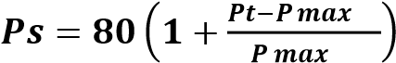 or 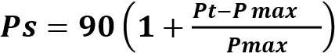

Where
Ps = Points scored for price of tender under consideration
Pt = Price of tender under consideration Pmax = Price of highest acceptable tender

- POINTS AWARDED FOR SPECIFIC GOALS

  - In terms of Regulation 4(2); 5(2); 6(2) and 7(2) of the Preferential Procurement Regulations, preference points must be awarded for specific goals stated in the tender. For the purposes of this tender the tenderer will be allocated points based on the goals stated in table 1 below as may be supported by proof/ documentation stated in the conditions of this tender:
  - In cases where organs of state intend to use Regulation 3(2) of the Regulations, which states that, if it is unclear whether the 80/20 or 90/10 preference point system applies, an organ of state must, in the tender documents, stipulate in the case of—
            - an invitation for tender for income-generating contracts, that either the 80/20 or 90/10 preference point system will apply and that the highest acceptable tender will be used to determine the applicable preference point system; or

            - any other invitation for tender, that either the 80/20 or 90/10 preference point system will apply and that the lowest acceptable tender will be used to determine the applicable preference point system,
then the organ of state must indicate the points allocated for specific goals for both the 90/10 and 80/20 preference point system.

Table 1: Specific goals for the tender and points claimed are indicated per the table below.
(Note to organs of state: Where either the 90/10 or 80/20 preference point system is applicable, corresponding points must also be indicated as such.
Note to tenderers: The tenderer must indicate how they claim points for each preference point system.)
The specific goals allocated points in terms of this tender | Number of points  allocated  (90/10 system)  (To be completed by  the organ of state) | Number of points  allocated  (80/20 system)  (To be completed by  the organ of state) | Number of points  claimed  (90/10 system)  (To be completed by the tenderer) | Number of points  claimed  (80/20 system)  (To be completed by the tenderer)
Locality of Supplier
Within the boundaries of Dihlabeng Municipality | 6 | 3
Within the boundaries of the Free State | 4 | 2
Historically Disadvantaged Individuals | 10 | 5

DECLARATION WITH REGARD TO COMPANY/FIRM

  - Name of company/firm…………………………………………………………………….
  - Company registration number: …………………………………………………………...
  - TYPE OF COMPANY/ FIRM
 Partnership/Joint Venture / Consortium
 One-person business/sole propriety
 Close corporation
 Public Company
 Personal Liability Company
 (Pty) Limited
 Non-Profit Company
 State Owned Company
[TICK APPLICABLE BOX]

  - I, the undersigned, who is duly authorised to do so on behalf of the company/firm, certify that the points claimed, based on the specific goals as advised in the tender, qualifies the company/ firm for the preference(s) shown and I acknowledge that:
i) The information furnished is true and correct; ii) The preference points claimed are in accordance with the General Conditions as indicated in paragraph 1 of this form;
          - In the event of a contract being awarded as a result of points claimed as shown in paragraphs 1.4 and 4.2, the contractor may be required to furnish documentary proof to the satisfaction of the organ of state that the claims are correct;
          - If the specific goals have been claimed or obtained on a fraudulent basis or any of the conditions of contract have not been fulfilled, the organ of state may, in addition to any other remedy it may have –

            - disqualify the person from the tendering process;
            - recover costs, losses or damages it has incurred or suffered as a result of that person’s conduct;
            - cancel the contract and claim any damages which it has suffered as a result of having to make less favourable arrangements due to such cancellation;
            - recommend that the tenderer or contractor, its shareholders and directors, or only the shareholders and directors who acted on a fraudulent basis, be restricted from obtaining business from any organ of state for a period not exceeding 10 years, after the audi alteram partem (hear the other side) rule has been applied; and
            - forward the matter for criminal prosecution, if deemed necessary.

………………………………………. SIGNATURE(S) OF TENDERER(S)
SURNAME AND NAME: ……………………………………………………….

DATE: ………………………………………………………
ADDRESS: ………………………………………………………
……………………………………………………… ………………………………………………………

MBD 8
SCHEDULE M: DECLARATION OF BIDDER’S PAST SUPPLY CHAIN MANAGEMENT PRACTICES

      - This Municipal Bidding Document must form part of all bids invited.

      - It serves as a declaration to be used by municipalities and municipal entities in ensuring that when goods and services are being procured, all reasonable steps are taken to combat the abuse of the supply chain management system.

1. The bid of any bidder may be rejected if that bidder, or any of its directors have:

          - abused the municipality’s / municipal entity’s supply chain management system or committed any improper conduct in relation to such system;
          - been convicted for fraud or corruption during the past five years;
          - willfully neglected, reneged on or failed to comply with any government, municipal or other public sector contract during the past five years; or
          - been listed in the Register for Tender Defaulters in terms of section 29 of the Prevention and Combating of Corrupt Activities Act (No 12 of 2004).

2. In order to give effect to the above, the following questionnaire must be completed and submitted with the bid.

Item | Question |  |  | Yes |  |  | No
4.1 | Is the bidder or any of its directors listed on the National Treasury’s database as a company or person prohibited from doing business with the public sector? (Companies or persons who are listed on this database were informed in writing of this restriction by the National Treasury after the audi alteram partem rule was applied).  The Database of Restricted Suppliers now resides on the National  Treasury’s website(www.treasury.gov.za) and can be accessed by clicking on its link at the bottom of the home page. |  |  | Yes |  |  | No
4.1.1 | If so, furnish particulars:
4.2 | Is the bidder or any of its directors listed on the Register for Tender Defaulters in terms of section 29 of the Prevention and Combating of Corrupt Activities Act (No 12 of 2004)? |  |  | Yes |  |  | No
4.2 | The Register for Tender Defaulters can be accessed on the Nati Treasury’s website (www.treasury.gov.za) by clicking on its link at the bo of the home page. |  | al  m |  |  |  | No
4.2 |  | on  tto | al  m |  |  |  | No
4.2.1 | If so, furnish particulars:
4.3 | Was the bidder or any of its directors convicted by a court of law (includi ng a court of law outside the Republic of South Africa) for fraud or corruption d uring |  |  | Yes |  |  | No
4.3 | the past five years? |  |  |  |  |  | No

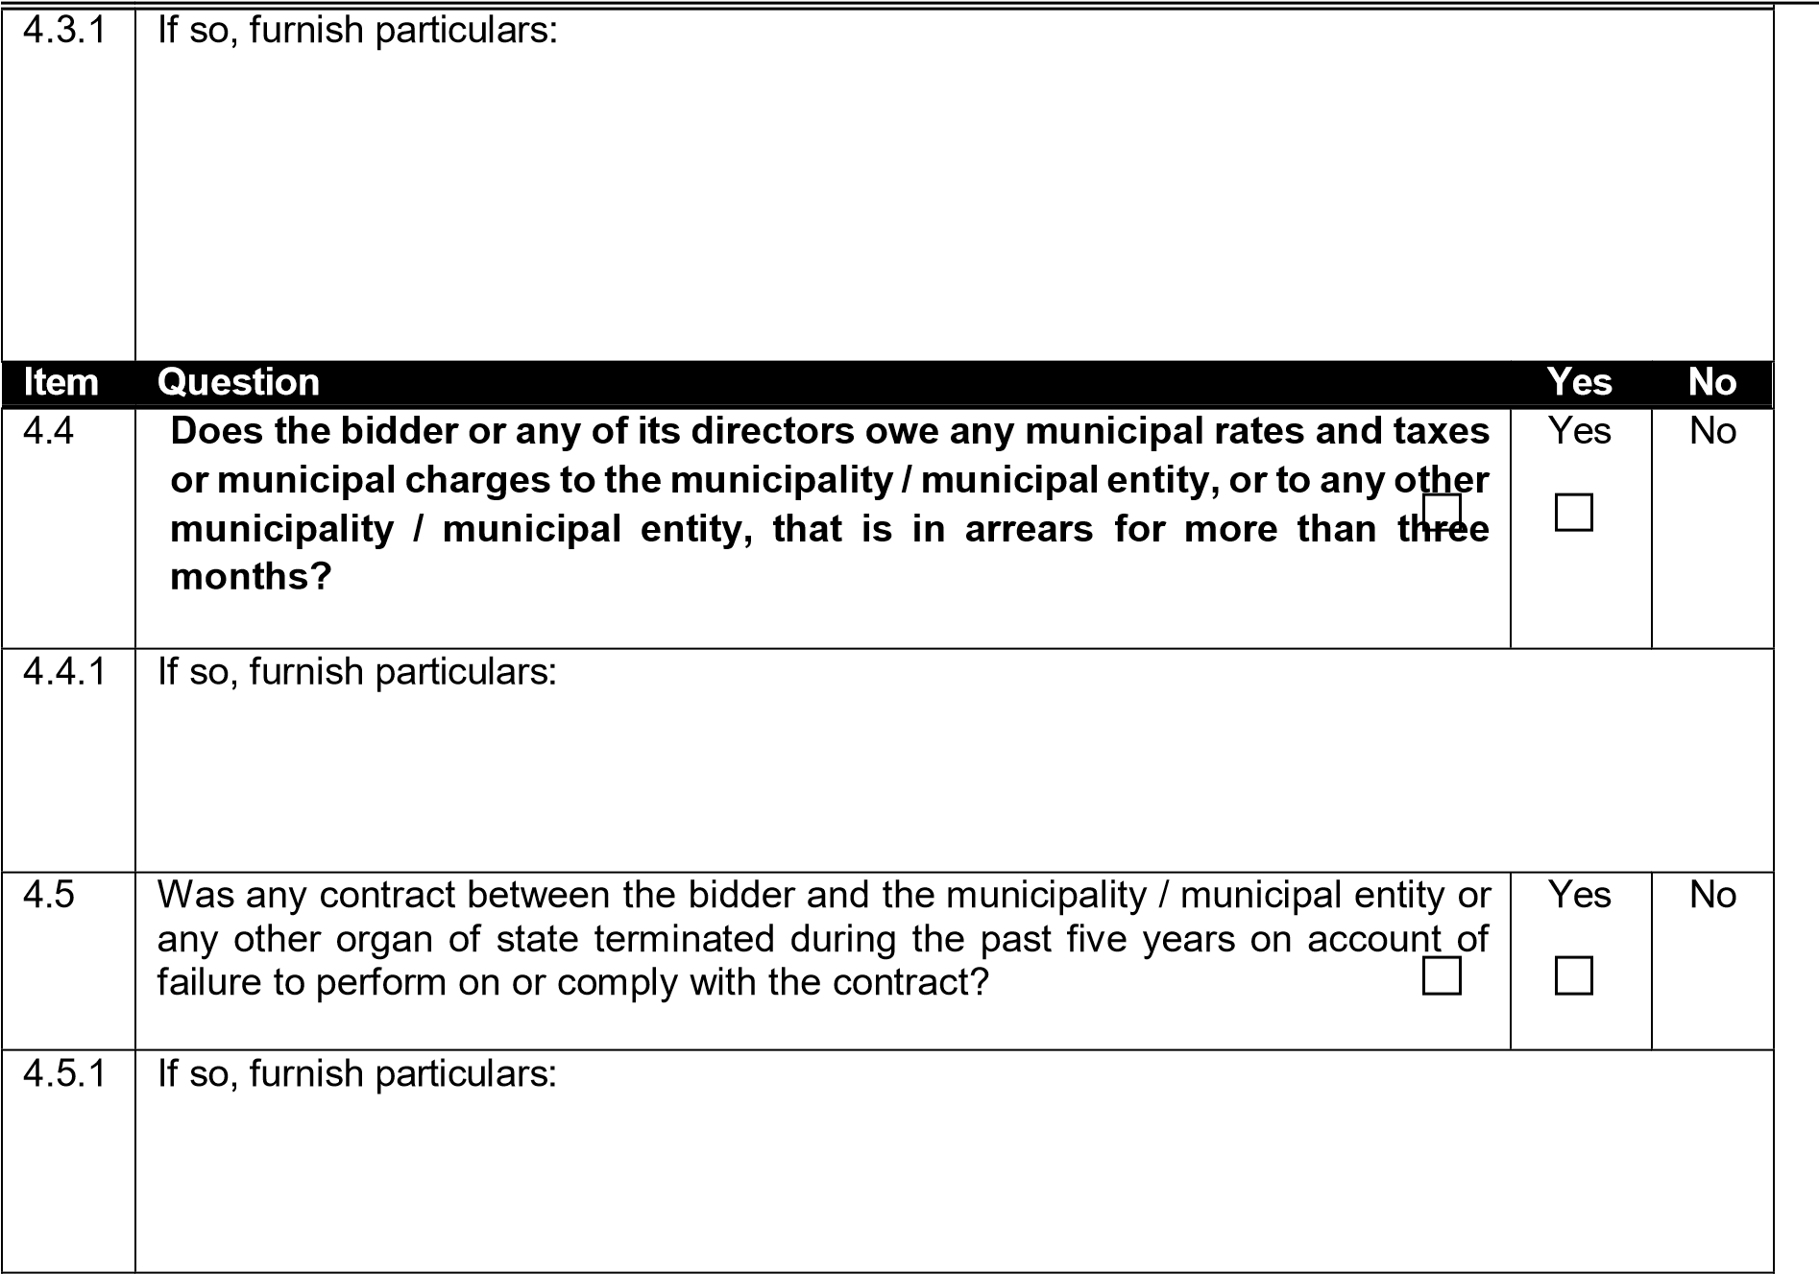
CERTIFICATION

I, THE UNDERSIGNED (FULL NAME)
…………...………………………………………………………...……
CERTIFY THAT THE INFORMATION FURNISHED ON THIS DECLARATION FORM TRUE AND CORRECT.

I ACCEPT THAT, IN ADDITION TO CANCELLATION OF A CONTRACT, ACTION
MAY BE TAKEN AGAINST ME SHOULD THIS DECLARATION PROVE TO BE FALSE.

Signature ................................................................. Date ....................................................

Name ............................................................... Position....................................................

Tenderer
......................................................................................................................................................
MBD 9
SCHEDULE N: CERTIFICATE OF INDEPENDENT BID DETERMINATION

- This Municipal Bidding Document (MBD) must form part of all bids¹ invited.
- Section 4 (1) (b) (iii) of the Competition Act No. 89 of 1998, as amended, prohibits an agreement between, or concerted practice by, firms, or a decision by an association of firms, if it is between parties in a horizontal relationship and if it involves collusive bidding (or bid rigging).² Collusive bidding is a pe se prohibition meaning that it cannot be justified under any grounds.
- Municipal Supply Regulation 38 (1) prescribes that a supply chain management policy must provide measures for the combating of abuse of the supply chain management system, and must enable the accounting officer, among others, to:

  - take all reasonable steps to prevent such abuse;

  - reject the bid of any bidder if that bidder or any of its directors has abused the supply chain management system of the municipality or municipal entity or has committed any improper conduct in relation to such system; and

  - cancel a contract awarded to a person if the person committed any corrupt or fraudulent act during the bidding process or the execution of the contract.

- This MBD serves as a certificate of declaration that would be used by institutions to ensure that, when bids are considered, reasonable steps are taken to prevent any form of bid rigging.

- In order to give effect to the above, the attached Certificate of Bid Determination (MBD 9) must be completed and submitted with the bid:

¹ Includes price quotations, advertised competitive bids, limited bids and proposals.

² Bid rigging (or collusive bidding) occurs when businesses, that would otherwise be expected to compete, secretly conspire to raise prices or lower the quality of goods and / or services for purchasers who wish to acquire goods and / or services through a bidding process. Bid rigging is, therefore, an agreement between competitors not to compete.
CERTIFICATE OF INDEPENDENT BID DETERMINATION

I, the undersigned, in submitting the accompanying bid:

________________________________________________________________________________
(Bid Number and Description)

in response to the invitation for the bid made by:

________________________________________________________________________________
(Name of Municipality / Municipal Entity)

do hereby make the following statements that I certify to be true and complete in every respect:

I certify, on behalf of: _____________________________________________________________ that: (Name of Bidder)

- I have read and I understand the contents of this Certificate.

- I understand that the accompanying bid will be disqualified if this Certificate is found not to be true and complete in every respect.

- I am authorized by the bidder to sign this Certificate, and to submit the accompanying bid, on behalf of the bidder.

- Each person whose signature appears on the accompanying bid has been authorized by the bidder to determine the terms of, and to sign, the bid, on behalf of the bidder.

- For the purposes of this Certificate and the accompanying bid, I understand that the word “competitor” shall include any individual or organization, other than the bidder, whether or not affiliated with the bidder, who:

  - has been requested to submit a bid in response to this bid invitation;

  - could potentially submit a bid in response to this bid invitation, based on their qualifications, abilities or experience; and

  - provides the same goods and services as the bidder and/or is in the same line of business as the bidder.

- The bidder has arrived at the accompanying bid independently from, and without consultation, communication, agreement or arrangement with any competitor. However, communication between partners in a joint venture or consortium³ will not be construed as collusive bidding.

- In particular, without limiting the generality of paragraphs 6 above, there has been no consultation, communication, agreement or arrangement with any competitor regarding:

  - prices;
  - geographical area where product or service will be rendered (market allocation);
  - Methods, factors or formulas used to calculate prices;
  - The intention or decision to submit or not to submit a bid;
  - The submission of a bid which does not meet the specifications and conditions of the bid; or (f) Bidding with the intention not to win the bid.

- In addition, there have been no consultations, communications, agreements or arrangements with any competitor regarding the quality, quantity, specifications and conditions or delivery particulars of the products or services to which this bid invitation relates.

- The terms of the accompanying bid have not been, and will not be, disclosed by the bidder, directly or indirectly, to any competitor, prior to the date and time of the official bid opening or of the awarding of the contract.

³ Joint venture or Consortium means an association of persons for the purpose of combining their expertise, property, capital, efforts, skill and knowledge in an activity for the execution of a contract.

- I am aware that, in addition and without prejudice to any other remedy provided to combat any restrictive practices related to bids and contracts, bids that are suspicious will be reported to the Competition Commission for investigation and possible imposition of administrative penalties in terms of section 59 of the Competition Act No 89 of 1998 and or may be reported to the National Prosecuting Authority (NPA) for criminal investigation and or may be restricted from conducting business with the public sector for a period not exceeding ten (10) years in terms of the Prevention and Combating of Corrupt Activities Act No 12 of 2004 or any other applicable legislation.

Signature ........................................................................ Date ....................................................

Name ..................................................................... Position....................................................

Tenderer ......................................................................................................................................................

SCHEDULE O: MUNICIPAL SERVICES, RATES AND TAXES CLEARANCE CERTIFICATE FOR SUPPLY CHAIN MANAGEMENT PURPOSES
DIHLABENG LOCAL MUNICIPALITY



9 Muller Street East PO Box 551
Bethlehem Bethlehem
9700 9700
Tel: 058 303 5732 Fax: 058 303 4731

Enquiries : Supply Chain Management Unit

MUNICIPAL SERVICES, RATES AND TAXES CLEARANCE CERTIFICATE FOR SUPPLY CHAIN MANAGEMENT PURPOSE

The purpose of this form is to obtain prove that municipal services, rates and taxes of the service provider are not more than three months in arrears with the relevant municipality / landlord in the municipal area where the service provider conducts his / her business. This form is to be completed only if the service provider’s rates and taxes are not in arrears for more than three months.

PART A – to be completed by the relevant municipality in the case where the service provider is the registered owner of the site / owner pays for municipal services / tenant pays for municipal services

OR

PART B – to be completed by the landlord in the case where the service provider is renting the premises / rental paid by tenant include municipal services.

PART A (TO BE COMPLETED BY THE RELEVANT MUNICIPALITY)
Name of the Municipality:
Property Physical Address:
Registered Name:
Official’s Name: __ Municipality Stamp Here Signature :

Date:
Please tick whether in arrears or up-to-date

Rates and taxes : Up-to-date / in arrears for more than 3 months
Water: Up-to-date / in arrears for more than 3 months
Electricity: Up-to-date / in arrears for more than 3 months
Refuse : Up-to-date / in arrears for more than 3 months
Other services: Up-to-date / in arrears for more than 3 months

PART B ( TO BE COMPLETED BY THE LANDLORD)
Name of the Landlord:
Property Physical Address:
Landlord Signature:
Date: Landlord’s business stamp here
Or an Affidavit from SAPS

( in the event the landlord does not have a business stamp)

Please tick whether up-to-date or in arrears

Rental: Up-to-date / in arrears for more than 3 months Municipal services: Up-to-date / in arrears for more than 3 months

SCHEDULE P: CERTIFICATE OF AUTHORITY OF AN ENTITY

This Returnable Schedule is to be completed by companies and close corporations.
Indicate the status of the tenderer by ticking the appropriate box hereunder. The tenderer must complete the certificate set out below for the relevant category.

(i)  Company | (ii)  Close Corporation | (iii)  Partnership | (iv)  Joint Venture | (v)  Sole Proprietor

- Certificate for company

I,. . . . . . . . . . . . . . . . . . . . . . . . . . . . . . . . . . . . . . . . . . . . . . . . , chairperson of the board of directors of . . . . . . . . . . . . . . . . . . . . . . . . . . . . . . . . . . . . . . . . . . . . . . . . . . . . . . . . . . . . . . . . . . . . . . ., hereby confirm that
by resolution of the board taken on …………………… 20…., Mr/Ms . . . . . . . . . . . . . . . . . . .. . . . . . . ., has been duly authorized to sign all documents in connection with the tender for Contract No. ……………. and any contract resulting from it on behalf of the company.

 | As witnesses:-
 | 1.. . . . . . . . . . . . . . . . . . . . . . . . . . . . . . . . . . . . . . . |  | . . . . . . . . . . . . . . . . . . . . . .
 |  |  | Managing director/Chairman
 | 2.. . . . . . . . . . . . . . . . . . . . . . . . . . . . . . . . . . . . . . . |  | . . . . . . . . . . . . . . . . . . . . . .
 |  |  | Date

- Certificate for Close Corporation

We, the undersigned, being the key members in the business trading as . . . . . . . . . . . . . . . . . . . . . . . . . .
. . . . . . . . . . . . . . . . . . . . . . . . . . . . . . . . . . . . . . . . . . . . . .. . . . . . . . . . .. .hereby authorize Mr/Ms . . . . . .
. . . . . . . . . . . . . . . . . . . . . . . . . . . . . . . . . . . . . . . . . acting in the capacity
of,……………………………………………………….to sign all documents in connection with the tender for Contract No. …………………………… and any contract resulting from it, on our behalf.
NAME | ADDRESS | SIGNATURE | DATE
NOTE: This certificate is to be completed and signed by all of the key members upon whom rests the direction of the affairs of the Close Corporation as a whole.

(iii). Certificate for Partnership

We, the undersigned, being the key partners in the business trading
as…………………………………………………………………………………………………………………here
by authorize Mr/Ms . . . . . . . . . . . . . . . . . . . . . . . . . . . . . . . . . . . . . . . . . . . . . . . acting in the capacity of,……………………………………………………….to sign all documents in connection with the tender for Contract No. …………………………… and any contract resulting from it, on our behalf.

NAME | ADDRESS | SIGNATURE | DATE

NOTE: This certificate is to be completed and signed by all of the key members upon whom rests the direction of the affairs of the Close Corporation as a whole.

(iv). Certificate for Joint Venture

We, the undersigned, are submitting this tender offer in Joint Venture and hereby authorize Mr/Ms . . . . .
. . . . . . . . . . . . . . . . . . . . . . . . . . . . . . . . . . . . , authorized signatory of the company . . . . . . . . . . . . . . . . . . . . . . . . . . . . . . . . . . . . . . . . . . . . . . . . . . . . . . . . , acting in the capacity of lead partner, to sign all
documents in connection with the tender offer for Contract No. ……………………………………..and any contract resulting from it on our behalf. This authorization is evidenced by the attached power of attorney signed by legally authorized signatories of all the partners to the Joint Venture.

NAME OF FIRM | ADDRESS | AUTHORISING SIGNATURE,  NAME & CAPACITY
Lead partner

NOTE: This certificate/Agreement is to be completed and signed by all the key partners upon whom rests the direction of the affairs of the Partnership as whole.

(v). Certificate for Sole Proprietor

I, ……………………………………………., hereby confirm that I am the sole owner of the business trading
as………………………………………………………………………………

Signature of sole owner:
As Witness
1.
2.

REGISTRATION CERTIFICATE / AGREEMENT / ID DOCUMENT

Important note to Bidder:

The following documents must be attached here:

Important note to Tenderer: Registration Certificates for Companies, Close Corporations and Partnerships and ID documents for Sole Proprietors, must be inserted here. In the case of a Joint Venture, a copy of a duly signed Joint Venture Agreement clearly setting out the roles and responsibilities of the parties must be included with particular reference to the guarantees required in terms of the Contract Data. The Joint Venture Agreement must also clearly indicate how payment is to be affected to the entity and distributed to the parties.

SCHEDULE Q: CERTIFICATE OF BIDDER’S ATTENDANCE AT THE COMPULSORY CLARIFICATION MEETING

A compulsory site inspection will be held on Friday, ____________________.

The meeting point for the site inspection will be at Saulspoort Water Treatment Works, Bethlehem.

Compulsory Site Inspection Certificate

It is hereby certified that I have attended the Compulsory Site Inspection and have satisfied myself of the conditions and circumstances which may influence the Works and the cost thereof.

This is to certify that I, (Name in print)

______________________________________________________

Representative of (Bidder)

_______________________________________________________________

Of (Address) _________________________________________________________________________

____________________________________________________________________________________

____________________________________________________________________________________

Telephone number ____________________________________________________________________

Fax number _________________________________________________________________________

Attended the Clarification Meeting on (date) ________________________________________________

SIGNATURE OF BIDDER’S REPRESENTATIVE ____________________________________________

SIGNATURE OF DIHLABENG LOCAL MUNICIPALITY REPRESENTATIVE

Signature: __________________________________ Date:______________________

Contract No: PW008/2024 T1.2: Tender Data
POINTMENT OF A PANEL OF FOUR (4) SERVICE PROVIDERS FOR THE SUPPLY & DELIVERY OF WATER & WASTEWATER TREATMENT CHEMICALS, REAGENTS AND LAB WARE FOR A PERIOD OF THREE (3) YEARS.

SCHEDULE R: CERTIFICATE OF REGISTRATION OF AN ENTITY (CIDB & B-BBEE)

CIDB REGISTRATION:

Tenderers must also indicate their CIDB registration details in the space provided.
(If not registered, attach proof that the enterprise can be registered with the CIDB within 10 days).

Registered Name | Registration Number

BEE CERTIFICATE

The Tenderer must also attach hereto a certified copy of their B-BBEE verification Certificate from a Verification Agency accredited by the South African Accreditation System (SANAS), or a sworn affidavit confirming annual turnover and level of black ownership in case of all EMEs and QSEs.

Signature ................................................................ Date ...................................................

Name ................................................................ Position...................................................

Tenderer ......................................................................................................................................................

SCHEDULE S: WORKMEN’S COMPENSATION REGISTRATION CERTIFICATE

Attach original (or certified copy) of the Workmen’s Compensation Letter of Good Standing to this page. When applicable the option to submit an original or certified copy of the letter from the Agent authorized by the Workmen’s Compensation Commissioner will be accepted.

NOTE: Failure to do so will lead to your tender being disqualified.

Signature ...................................................................... Date ................................................................

Name ..................................................................... Position................................................................

Tenderer ......................................................................................................................................................

SCHEDULE T: UIF REGISTRATION CERTIFICATE

[The Tenderer’s Unemployment Insurance Fund (UIF) Registration Certificate to be inserted here]
SCHEDULE U: COMPULSORY ENTERPRISE QUESTIONNAIRE

The following particulars must be furnished. In the case of a joint venture, separate enterprise questionnaires in respect of each partner must be completed and submitted.

Section 1: Name of enterprise:

Section 2: VAT registration number, if any:

Section 3: CIDB registration number, if any:

Section 4: Particulars of sole proprietors and partners in partnerships

Name* | Identity number * | Personal income tax number *
*Complete only if sole proprietor or partnership and attach separate page if more than 6 partners.

Section 5: Particulars of companies and close corporations

Company registration number
Close corporation number
Tax reference number

Attach a certified copy of valid CIPC Certificate to this page.

Section 6: Record of service of the state

Indicate by marking the relevant boxes with a cross, if any sole proprietor, partner in a partnership or director, manager, principal shareholder or stakeholder in a company or close corporation is currently or has been within the last 12 months in the service of any of the following:

a member of any municipal council | an employee of any provincial department, national or provincial public entity or constitutional institution  within the meaning of the Public Finance Management Act, 1999 (Act 1 of 1999)
a member of any provincial legislature | a member of an accounting authority of any national or provincial public entity.
a member of the National Assembly or the National Council of Province | an employee of Parliament or a provincial legislature
a member of the board of directors of any municipal entity. | an official of any municipality or municipal entity

If any of the above boxes are marked, disclose the following:

Name of sole proprietor, partner, director, manager, principal shareholder or stakeholder | Name of institution, public office, board or organ of state and position held | Status of service (tick appropriate column)
 |  | Current | Within last 12 months
* insert separate page if necessary

Section 7: Record of spouses, children and parents in the service of the state

Indicate by marking the relevant boxes with a cross, if any spouse, child or parent of a sole proprietor, partner in a partnership or director, manager, principal shareholder or stakeholder in a company or close corporation is currently or has been within the last 12 months been in the service of any of the following:

a member of any municipal council |  | an employee of any provincial department, national or provincial public entity or constitutional institution  within the meaning of the Public Finance Management Act, 1999 (Act 1 of 1999)
a member of any provincial legislature |  | a member of an accounting authority of any national or provincial public entity.
a member of the National Assembly or the National Council of Province |  | an employee of Parliament or a provincial legislature
a member of the board of directors of any municipal entity. |  | an official of any municipality or municipal entity
Name of sole proprietor, partner, director, manager, principal shareholder or stakeholder | Name of institution, public office, board or organ of state and position held |  | Status of service (tick appropriate column)
 |  |  | Current | Within last 12 months
* insert separate page if necessary

The undersigned, who warrants that he/she is duly authorized to do so on behalf of the enterprise:

- authorizes the Employer to obtain a tax clearance certificate from the South African Revenue Services that my / our tax matters are in order;

- confirm that the neither the name of the enterprise or the name of any partner, manager, director or other person, who wholly or partly exercises, or may exercises, or may exercise, control over the enterprise appears on the Register of Tender Defaulters established in terms of the Prevention and Combating of Corrupt Activities Act of 2004;

- confirms that no partner, member, director or other person, who wholly or partly exercises, or may exercise, control over the enterprise appears, has within the last five years been convicted of fraud or corruption;

- confirms that I/we are not associated, linked or involved with any other Tendering entities submitting Tender offers and have no other relationship with any of the Tenderers or those responsible for compiling the scope of works that could cause or be interpreted as a conflict of interest;

- confirms that the contents of this questionnaire are within my personal knowledge and are to the best of my belief both true and correct.

Signature ...................................................................... Date: .............................................................

Name ..................................................................... Position................................................................

Tenderer ......................................................................................................................................................

SCHEDULE V: AFFIDAVIT OF GOOD STANDING THAT WILL BE INCORPORATED INTO THE CONTRACT

The Tenderer hereby certifies that neither it nor any of the principals of the enterprise is listed on the register of Tender Defaulters in terms of the Prevention and Combating of Corrupt Activities Act of 2004 as a person prohibited from doing business with the public sector. The Tenderer further certifies that none of its principals have ever been convicted of fraud.

DECLARATION (to be signed in the presence of a Commissioner of Oaths)

The undersigned, who warrants that he / she is duly authorised to do so on behalf of the firm, confirms that the contents of this Affidavit are within my personal knowledge, and save where stated otherwise to the best of my belief both true and correct.

Signature: …………………………………………………………………………….

Duly authorized to sign on behalf: …………………………………………………

Address: ………………………………………………………………………………

……………………………………………………………………………….

……………………………………………………………………………….
Telephone: ………………………………………………………………………

Signed and sworn to before me at… .............................................................................................. on

this the …………………………………day of ........................................................... by the Deponent, who

has acknowledged that he/she knows and understands the contents of this Affidavit, that its true and correct to the best of his/her knowledge and that he/she has no objection to taking the prescribed oath, and that the prescribed oath will be binding on his/her conscience.

Commissioner of oaths ………………………………………………………………………………………….

NOTE: This affidavit comprises one (1) page all of which must be initialled by both the Deponent and the Commissioner of Oaths

SCHEDULE W: SCHEDULE OF ALL WORK PROVIDED FOR AN ORGAN OF THE
STATE OVER THE LAST FIVE YEARS

[Tenderers are to attach a schedule detailing the name of each project, the organ of state for which the project was undertaken and the date the project was completed. If not complete list the project as “current”]
SCHEDULE X: BANKING DETAILS

Tenderers financial capacity to finance and undertake a contract of this nature will also be checked and consequently it is a requirement that the details below be provided.

NAME OF TENDERER
NAME OF ACCOUNT HOLDER AT BANK
TYPE OF ACOUNT (Please tick) | CURRENT/CHEQUE |  | SAVINGS |  | TRANSMISSION
BANK
BRANCH NAME
ACCOUNT NUMBER
BRANCH CODE
BANK TELEPHONE NO
BANK ADDRESS
NAME OF BANK MANAGER
TELEPHONE NUMBER
FAX NUMBER
NO OF YEARS ABOVE ACCOUNT HAS BEEN WITH BANK
CREDIT FACILITIES AVAILABLE (State Amount)

Signature ...................................................................... Date ................................................................

Name ..................................................................... Position................................................................

Tenderer ............................................................................................................................................

SCHEDULE Y: DECLARATION OF FINANCIAL CAPACITY

The following particulars must be furnished in support of the preceding returnable to test financial capacity.

- No bid will be accepted from persons who cannot prove adequate financial capacity to execute the contract according to the specifications and scope of work and withing the stipulated timeframe.

- In order to prove financial capacity, the tenderer must attach the following:

- A letter from the bank with bank stamp confirming that the tenderer has an active bank account.

- Proof of bank account and letter of good standing with a credit rating.

If the tenderer is unable to demonstrate sufficient credit facility available, the tenderer must at least provide written undertaking/proof of guarantee or financial capacity from a reputable and accredited financial service provider/lender.

CERTIFICATION

I, THE UNDERSIGNED (NAME): ……………………………………………….

CERTIFY THAT THE INFORMATION FURNISHED ON THIS DECLARATION FORM IS CORRECT. I ACCEPT THAT THE STATE MAY ACT AGAINST ME SHOULD THE DECLARATION PROVE TO BE FALSE.

Signature ...................................................................... Date ................................................................

Name ..................................................................... Position..........................................................

Tenderer .................................................................................................................................................

SCHEDULE Z: SCHEDULE OF THE TENDERER’S EXPERIENCE

Tenderers are to provide references for FIVE (5) other recent projects (last five years) of a similar nature with which the company has been involved.

The information provided here will be used to evaluate the Tenderer’s eligibility to undertake the contract. It is important that the Tenderer ensure that sufficient and legible information is provided to enable the Employer to evaluate the criteria noted in the table in F3.11.2.

Name and  Telephone  Number of Client | Project | Name and Telephone  Number of Consulting  Engineer / Implementing Agent | Details of service provided

Signature ...................................................................... Date ................................................................

Name ..................................................................... Position................................................................

Tenderer ....................................................................................................................................................

SCHEDULE AA: COMPETENCY OF KEY PERSONNEL

Tenderers shall provide details of the Contracts Manager, Construction Manager, Construction Supervision and Construction Health & Safety Officer’s experience in work of a similar nature to that for which their tender is submitted.

- Contracts Manager

CONTRACTS MANAGER |  | NAME: ……………………………………
NB:
- Attached a detailed CV and Proof of Qualification and Proof of Professional Registration
- Qualification, Professional Registration and Experience must be of same caliber as proposed during pre-qualification to panel of contractors of better
CLIENT & NATURE OF WORK | POSITION HELD | VALUE OF WORK | PROJECT DURATION

- Construction Manager – To be appointed in line with 8(1) of the Construction Regulations, 2014

CONSTRUCTION MANAGER |  | NAME: ……………………………………
NB:
Minimum Qualification shall be National Diploma in Civil Engineering Attach proof of Qualification
• Attach a detailed CV indicating training and promotion through the ranks up to the position of Construction Manager
CLIENT & NATURE OF WORK | POSITION HELD | VALUE OF WORK | PROJECT DURATION
- Construction Supervisor – To be appointed in line with 8(7) of the Construction Regulations, 2014

CONSTRUCTION SUPERVISOR (Foreman) |  | NAME: ……………………………………
NB:
- Attach a detailed CV
- The experience must be of same caliber as proposed during pre-qualification to panel of contractors of better
CLIENT & NATURE OF WORK | POSITION HELD | VALUE OF WORK | PROJECT DURATION
- Construction Health & Safety Officer – To be appointed in line with 8(5) of the Construction Regulations, 2014

CONSTRUCTION HEALTH & SAFETY OFFICER |  | NAME: ……………………………………
CLIENT & NATURE OF WORK | POSITION HELD | VALUE OF WORK | PROJECT DURATION

Signature ...................................................................... Date ................................................................

Name ..................................................................... Position................................................................

Tenderer ......................................................................................................................................................

BB: DECLARATION OF AVAILABLE PLANT AND EQUIPMENT TO
EXECUTE THE WORK

The bid of any bidder may be rejected if that bidder fails to provide surety within 14 days of intention to award, either owned or hired plant and equipment as may be required to fully execute the works:
This Clause is applicable even after the bid is awarded.
The undersigned bidder, declare that they will fully provide all plant and equipment as may be required before the work can be awarded to them, failing within the contract intention or after award may be terminated.

No | Name of Available Plant & Equipment | Owned  by the Bidder | Hired by the Bidder
No | Name of Available Plant & Equipment | (Tick appro priate column)

DECLARATION
The undersigned, who warrants that he/she is duly authorized to do so on behalf of the enterprise and hereby declare that, the bidder of this bid PW026/2023, will make all necessary plant and equipment available within 14 days of intention to award of this contract, failing within the contract intention or after award, this contract may be terminated.

The undersigned, who warrants that he / she is duly authorized to do so on behalf of the firm, confirms that the contents of this Declaration are within my personal knowledge, and save where stated otherwise to the best of my belief both true and correct.

NAME:…………………………………………………………….…………………

SIGNATURE: ................................................................................................................

DATE: …………………..…

Duly authorized to sign on behalf of (Bidder Name):…………………………………………………………..

NOTE: This declaration comprises one (1) page all of which must be also initialed.

CC: TENDER PROGRAMME

The Tenderer shall detail below or attach a preliminary programme reflecting the proposed sequence and tempo of execution of the various activities comprising the work for this tender in Gantt Chart or similar format.

The programme must indicate all key activities, time frames and must clearly demonstrate the Tenderer’s understanding of the scope of works.

The competency and clarity of the programme will help to inform the Employer’s assessment of the Tenderer’s eligibility to execute the contract.

[Attach Gantt Chart Programme to this page.]

DD: NATIONAL TREASURY’S CENTRAL SUPPLIER DATABASE

Tenderers are required to self-register on National Treasury’s Central Supplier Database (CSD) which has been established to centrally administer supplier information for all organs of state and facilitate the verification of certain key supplier information. Dihlabeng is required to ensure that price quotations are invited and accepted from prospective bidders listed on the CSD. Business may not be awarded to a Tenderer who has failed to register on the CSD. Only foreign suppliers with no local registered entity need not register on the CSD. The CSD can be accessed at https://secure.csd.gov.za/. Tenderers are required to provide the CSD summary form and the information below to Dihlabeng in order to enable it to verify information on the CSD:

Supplier Number:

Unique registration reference number: __________________________

[PLEASE ATTACH THE RESENT CERTIFICATE TO THIS PAGE. IT MAY NOT BE OLDER THAN THREE MONTHS]

EE: DECLARATION OF SOLVENCY OR LIQUIDITY

The bid of any bidder may be rejected if that bidder, or any of its directors are: Under liquidation
Sequestration
Insolvency.

This Clause is applicable even after the bid is awarded.

We, the undersigned directors, declare that they are not under liquidation, sequestration or insolvent.

No | Name of Director | ID number | Signature

(a) DECLARATION OF SOLVENCY/ LIQUIDITY

- All tenderers attention is drawn to this Form (declaration of Solvency or Liquidity of the tenderer).
- All tenderers are therefore required to complete It.
- Failure to complete the form or attempt to falsify or hide this information may render the tender non-responsive.

T1.2: Tender Data POINTMENT OF A PANEL OF FOUR (4) SERVICE PROVIDERS FOR THE SUPPLY & DELIVERY OF WATER & WASTEWATER TREATMENT CHEMICALS, REAGENTS AND LAB WARE FOR A PERIOD OF THREE (3) YEARS.

SCHEDULE FF: PUBLIC LIABILITY COVER AND QUALITY MANAGEMENT SYSTEM

PUBLIC LIABILITY COVER

Provision of Public Liability Insurance to the value of R 1 million or a letter of intent from an approved provider is required. Please attach documentation to this page in order to obtain points under the functionality criteria.

QUALITY MANAGEMENT SYSTEM

Provision of a Quality Management system is required. Please attach relevant certification to this page.

APPOINTMENT OF A SERVICE PROVIDER

APPOINTMENT OF A PANEL OF FOUR (4) SERVICE PROVIDERS FOR
THE FOR THE SUPPLY & DELIVERY OF WATER & WASTEWATER
TREATMENT CHEMICALS, REAGENTS AND LAB WARE FOR A PERIOD OF THREE (3) YEARS.

PART C1

AGREEMENT AND CONTRACT DATA

APPOINTMENT OF A SERVICE PROVIDER

APPOINTMENT OF A PANEL OF FOUR (4) SERVICE PROVIDERS FOR
THE FOR THE SUPPLY & DELIVERY OF WATER & WASTEWATER
TREATMENT CHEMICALS, REAGENTS AND LAB WARE FOR A PERIOD OF THREE (3) YEARS.

PART C1.1

FORM OF OFFER AND ACCEPTANCE

APPOINTMENT OF A SERVICE PROVIDER

APPOINTMENT OF A PANEL OF FOUR (4) SERVICE PROVIDERS FOR

THE FOR THE SUPPLY & DELIVERY OF WATER & WASTEWATER

TREATMENT CHEMICALS, REAGENTS AND LAB WARE FOR A PERIOD OF THREE (3) YEARS.

C1.1 Form of Offer and Acceptance

OFFER

The Employer, identified in the Acceptance signature block, has solicited offers to enter into a contract in respect of the following works:

APPOINTMENT OF A PANEL OF FOUR (4) SERVICE PROVIDERS FOR THE FOR THE SUPPLY &
DELIVERY OF WATER & WASTEWATER TREATMENT CHEMICALS, REAGENTS AND LAB WARE FOR A PERIOD OF THREE (3) YEARS.

The Bidder, identified in the Offer signature block below, has examined the documents listed in the Bid Data and addenda thereto as listed in the Returnable Schedules, and by submitting this Offer has accepted the Conditions of Bid.

By the representative of the Bidder, deemed to be duly authorized, signing this part of this Form of Offer and Acceptance, the Bidder offers to perform all of the obligations and liabilities of the Contractor under the Contract including compliance with all its terms and conditions according to their true intent and meaning for an amount to be determined in accordance with the Conditions of Contract identified in the Contract Data.

THE OFFERED TOTAL OF THE PRICES INCLUSIVE OF VALUE ADDED TAX IS:

. . . . . . . . . . . . . . . . . . . . . . . . . . . . . . . . . . . . . . . . . . . . . . . . . . . . . . . . . . . . . . . . . . . . . . . . . . . . . . . . . . . . . . . .
. . . . . . . . . . . . . . . . . . . . . . . . . . . . . . . . . . . . . . . . . . . . . . . . . . . . . . . . . . . . . . . . .. . . . . ……..Rand (in words);
R . . . . . . . . . . . . . . . . . . . . . . . . . . . . . . . . (in figures)

This Offer may be accepted by the Employer by signing the Acceptance part of this Form of Offer and Acceptance and returning one copy of this document to the Bidder before the end of the period of validity stated in the Bid Data, whereupon the Bidder becomes the party named as the Contractor in the Conditions of Contract identified in the Contract Data.

It is expressly agreed that no other matter whether in writing, oral communication or implied during the period between the issue of the Bid documents and the receipt by the Bidder of a completed signed copy of this agreement shall have any meaning or effect in the contract between the parties arising from this Agreement.

FOR THE BIDDER:

Signature (s) __________________________________________

Name (s) __________________________________________

Capacity __________________________________________

Name and address of organization

__________________________________________

__________________________________________

Signature and Name of Witness __________________________________________

Date __________________________________________

Acceptance

By signing this part of this Form of Offer and Acceptance, the Employer identified below accepts the Bidder’s
Offer. In consideration thereof, the Employer shall pay the Contractor the amount due in accordance with the
Conditions of Contract identified in the Contract Data. Acceptance of the Bidder’s Offer shall form an agreement between the Employer and the Bidder upon the terms and conditions contained in this Agreement and in the Contract that is the subject of this Agreement.
The terms of the contract, are contained in:

Part C1: Agreements and Contract Data, (which includes this Agreement) Part C2: Pricing Data Part C3: Scope of Work.
Part C4: Site Information

and drawings and documents or parts thereof, which may be incorporated by reference into Parts C1 to C4 above.

Deviations from and amendments to the documents listed in the Bid Data and any addenda thereto as listed in the Bid Schedules as well as any changes to the terms of the Offer agreed by the Bidder and the Employer during this process of offer and acceptance, are contained in the Schedule of Deviations attached to and forming part of this Agreement. No amendments to or deviations from said documents are valid unless contained in this Schedule, which must be duly signed by the authorised representative(s) of both parties.

The Bidder shall within two weeks after receiving a completed copy of this Agreement, including the Schedule of Deviations (if any), contact the Employer’s agent (whose details are given in the Contract Data) to arrange the delivery of any bonds, guarantees, proof of insurance and any other documentation to be provided in terms of the Conditions of Contract identified in the Contract Data. Failure to fulfil any of these obligations in accordance with those terms shall constitute a repudiation of this Agreement.

Notwithstanding anything contained herein, this Agreement comes into effect on the date when the Bidder receives one fully completed original copy of this document, including the Schedule of Deviations (if any). Unless the Bidder (now Contractor) within five days of the date of such receipt notifies the Employer in writing of any reason why he cannot accept the contents of this Agreement, this Agreement shall constitute a binding contract between the parties.

FOR THE EMPLOYER:

Signature (s) | __________________________________________
Name (s) | __________________________________________
Capacity | __________________________________________

Name and address of organization

Dihlabeng Local Municipality

Signature and Name of Witness | __________________________________________
Date | __________________________________________

SCHEDULE OF DEVIATIONS

Notes:

- The extent of deviations from the Bid documents issued by the Employer prior to the Bid closing date is limited to those permitted in terms of the Conditions of Bid,

- A Bidder’s covering letter shall not be included in the final contract document. Should any matter in such, letter, which constitutes a deviation as aforesaid become the subject of agreements reached during the process of, offer and acceptance, the outcome of such agreement shall be recorded here,

- Any other matter arising from the process of offer and acceptance either as a confirmation, clarification or change to Bid documents and which it is agreed by the Parties becomes and obligation of the contract shall also be recorded here,

- Any change or addition to the Bid documents arising from the above agreements and recorded here, shall also be incorporated into final draft or the Contract,

- Subject . . . . . . . . . . . . . . . . . . . . . . . . . . . . . . . . . . . . . .. . . . . . . . . . . . . . . . . . . . . . . . . . . . . . .
Details . . . . . . . . . . . . . . . . . . . . . . . . . . . . . . . . . . . . . .. . . . . . . . . . . . . . . . . . . . . . . . . . . . . . .
. . . . . . . . . . . . . . . . . . . . . . . . . . . . . . . . . . . . . . . . . . . . . . . . . . . . . . . . . . . . . . . . . . . . . . . . .
. . . . . . . . . . . . . . . . . . . . . . . . . . . . . . . . . . . . . . . . . . . . . . . . . . . . . . . . . . . . . . . . . . . . . . . . . . . . . . . . . . . . . . . . . . . . . . . . . . . . . . . . . . . . . . . . . . . . . . . . . . . . . . . . . . . . . . . . . . . . . . . . . .

- Subject . . . . . . . . . . . . . . . . . . . . . . . . . . . . . . . . . . . . . .. . . . . . . . . . . . . . . . . . . . . . . . . . . . . . .
Details . . . .. . . . . . . . . . . . . . . . . . . . . . . . . . . . . . . . . . . . . . . . . . . . . . . . . . . . . . . . . . . . . . . . .
. . . . . . . . . . . . . . . . . . . . . . . . . . . . . . . . . . . . . . . . . . . . . . . . . . . . . . . . . . . . . . . . . . . . . . . . .
. . . . . . . . . . . . . . . . . . . . . . . . . . . . . . . . . . . . . . . . . . . . . . . . . . . . . . . . . . . . . . . . . . . . . . . . .
. . . . . . . . . . . . . . . . . . . . . . . . . . . . . . . . . . . . . . . . . . . . . . . . . . . . . . . . . . . . . . . . . . . . . . . . .
By the duly authorised representatives signing this Schedule of Deviations, the Employer and the Bidder agree to and accept the foregoing Schedule of Deviations as the only deviations from and amendments to the documents listed in the Bid Data and addenda thereto as listed in the Bid Schedules, as well as any confirmation, clarification or changes to the terms of the offer agreed by the Bidder and the Employer during this process of offer and acceptance.

It is expressly agreed that no other matter whether in writing, oral communication or implied during the period between the issue of the Bid documents and the receipt by the Bidder of a completed signed copy of this Agreement shall have any meaning or effect in the contract between the parties arising from this Agreement.

For the Bidder: |  | For the Employer:
…………………………………… | Signature | ……………………………………
…………………………………… | Name | ……………………………………
…………………………………… | Capacity | ……………………………………

Name and address of organisation: Name and address of organisation:

…………………………………… ……………………………………

…………………………………… ……………………………………

…………………………………… ……………………………………

…………………………………… Witness Signature ……………………………………

…………………………………… Witness Name ……………………………………

…………………………………… Date ……………………………………

CONFIRMATION OF RECEIPT

The Bidder, (now Contractor), identified in the Offer part of this Agreement hereby confirms receipt from the Employer, identified in the Acceptance part of this Agreement, of one fully completed original copy of this Agreement, including Schedule of Deviations (if any) today:

the ………………………………………..(day) of …………………………………..(month) 20 ……(year)

at ………………………………………..(place)

For the Contractor:

. . . . . . . . . . . . . . . . . . . . . . . . . . . . . . . .
Signature

. . . . . . . . . . . . . . . . . . . . . . . . . . . . . . . .
Name

. . . . . . . . . . . . . . . . . . . . . . . . . . . . . . . .
Capacity

Signature and name of witness:

. . . . . . . . . . . . . . . . . . . . . . . . . . . . . . . .
Signature

. . . . . . . . . . . . . . . . . . . . . . . . . . . . . . . .
Name

DIHLABENG LOCAL MUNICIPALITY

APPOINTMENT OF A SERVICE PROVIDER

APPOINTMENT OF A PANEL OF FOUR (4) SERVICE PROVIDERS FOR THE FOR

THE SUPPLY & DELIVERY OF WATER & WASTEWATER TREATMENT CHEMICALS, REAGENTS AND LAB WARE FOR A PERIOD OF THREE (3) YEARS.

C1.2 CONTRACT DATA
C1.2.1 CONDITIONS OF CONTRACT

Dihlabeng Local Municipality is intending to appoint a panel of five service providers to supply water treatment chemicals, testing equipment and Lab ware for a period of three years. The panel will cover a range of water treatment chemicals, testing equipment and Lab ware across all Dihlabeng Local Municipality Treatment Works.

Scope:
Supply and delivery of the water treatment chemicals, testing equipment and lab ware which are SANS or NSF approved. The objective of this tender is to appoint suitably experienced and qualified suppliers for the supply and delivery of the above mentioned items on a consignment stock basis to Dihlabeng Local Municipality Water Treatment works as detailed in this tender document.

The following is covered in the scope of work:
- Ensuring that Dihlabeng Local Municipality (DLM) receives uninterrupted supply of water purification chemicals, testing equipment and lab ware to various sites as detailed in the tender document. The successful Tenderers/Bidders will sign agreement contracts stating all the conditions of the tender.
- Supply, delivery, offloading, stock control and assurance of performance of water purification chemicals, testing equipment and lab ware to various water treatment plants in Dihlabeng Local Municipality.
- The supplied water purification chemicals shall be able to produce drinking water which complies with SANS 241:2015 Drinking Water Quality standards.
- The tenderer must have Quality Standard Systems and all products must have “Drinking water Approval” by accredited body e.g. NSF Accreditation Quality Standard System with a maximum allowable dosing rate.
- The Tenderer shall provide a letter of support if the Tenderer is not the manufacture. If the Tenderer fails to submit a letter of support, the attachments will be considered invalid and such bid will be disqualified.
- The Tenderer shall comply with lead times and delivery times to be specified in the tender document.
- The Tenderer shall be duty bound to supply a certificate of analysis for each batch of delivery.
- The Tenderer must use transport that complies with safety requirements for transportation of hazardous chemicals.
- The Driver of the hazardous chemical transport must be a certified Hazardous Chemical deliver.
- The Tenderer must comply with the Occupational Health and Safety Act 85 of 1993, a SHE plan shall be provided with the tender document. Failure to submit such plan with the tender document will results in the Tenderer being disqualified.
- The Tenderer shall provide training services to Dihlabeng Local Municipality personnel with specific regard to safe use, and handling of water purification chemicals at no cost to the municipality.
- The Tenderer shall ensure that all holding tanks supplied must be compatible with the existing Dihlabeng Local Municipality equipment/systems. All receptacles and or vessels for containing chemicals supplied such as tankers, cylinders or drums, must be delivered in Leak proof/Undamaged containers.
- The Tenderer shall submit an Emergency Response Plan for spills, accidents and any other emergencies during transportation or offloading of chemicals. Failure to submit such plan with the tender document will results to the Tenderer being disqualified.
- The Tenderer shall provide Public Liability insurance cover to the value of R2 million or a letter of intent from an approved insurance provider.
- The Tenderer shall provide Manufacturer Safety Data Sheet for each tendered chemical. MSDS provided should include the following information but not limited to: Hazardous ingredients, Hazardous identification, Physical and Chemical characteristics, Fire fighting measures, Health and first aid, exposure controls/personal protection, Accident release measures, Disposal considerations, transportation, Toxicology, Regulatory and other information. Failure to submit MSDS documents with the tender document will results to the Tenderer being disqualified.
- The Tenderer shall make compulsory site visits by qualified technical staff, to each of the plants to carry out performance tests. i.e. jar test and plant optimisations.
- The Tenderer shall provide the necessary qualification documents of technical staff that will be carrying out the tests and performance work at the plants.
- The short listed Tenderers will be requested to submit flocculants samples during the live jar tests which will be conducted during the evaluation stage of the tender. The samples will be kept and used for future reference by the Municipality.
- The appointed Tenderers must carry out plant jar tests and trials as per the provision in the tender document to determine the best chemical with respect to performance and cost effectiveness.
- All tendered prices should be exclusive of the destination delivery cost.
- The approved Tenderer shall under no circumstances interrupt the operations as a result of his/her activities in, or around the plant structure.
- Appointment of the panel is not a guarantee that orders will be placed or that a minimum contract value will apply.
- No goods shall be delivered or order processed without an authorization from Dihlabeng Local Municipality and any goods delivered without the approval is at the supplier’s own risk.
- Dihlabeng Local Municipality reserves the right to increase or decrease quantities based on business requirements.
- The tenders must have adequate experience or proven track record supplying water treatment chemicals.
- If the tenderer is a distributor or manufacturer, the municipality must be furnished with guarantee that tenderer has a local warehouse for repairs and calibrations of equipment.
- The tenderer must submit qualifications of the technicians that will attend to any malfunctions.

Plant trials:
- Plant trials for flocculants will be performed by all appointed tenderers after the jar test evaluation process. Dihlabeng Local Municipality will only purchase volume of chemicals required to conduct the trial. It will be expected that the chemicals used during the trails must be able to produce water that meets the SANS 241:2015 Drinking water quality standards. If the tenderer/Bidder’s chemicals fails to produce water that meets SANS 241:2015 Drinking water quality standards during trial run, Dihlabeng Local Municipality have the right to stop the Plant trial and the tenderer/bidder will only be allowed to supply other chemicals with the exception of the flocculants.
- It will be expected from the Tenderer to determine the optimum dosing of their product at various Water Treatment Works during the plant trials period. The Tenderer will supply its own equipment for the plant trials. The water quality results during this period will be recorded by both parties and the Plant Supervisor/Water technician will sign them off as witness on the sheet provided.
- All plant trials will be closely monitored by the water technical team and tenders will be expected to demonstrate their calculations related to preparations of sample and actual dosing to the plant.
- A CV of a person performing the plant trials must be attached to the tender document. Kindly take note that this Person must be qualified to operate a Class B Water Treatment Works in terms of the Department of Water and Sanitation regulation 813 or 17 as a Class V Process Controller.

- The Plant Trials will be a maximum of one week (7 days) including Saturdays and Sundays per appointed Tenderers for all schemes identified. Tenderers may choose to run trials at more than one Plant simultaneously.

Flocculants:
- The Flocculants shall be suitable for treating raw water to meet SANS 214:2015 Drinking Water Quality Standards. The MSDS and or COA shall provide the following but not limited to: Nature of compound, product characteristics (pH min/max), density (min/max), total solids @ 150°C, shelf life @40°C etc

Submission of flocculants samples:
- Flocculants will be requested from all short-listed tenderers.

- Flocculants Samples must be clearly labeled with name of product, name of supplier and the expiry date and to be accompanied by MSDS and COA.
- Samples must be submitted in duplicate (i.e. 2x500ml) in temper proof sealed bottles, one of the samples will be submitted for tests and evaluation to the accredited laboratory at the discretion of the Municipality. The other sample will be submitted and retained by Dihlabeng Local Municipality and used as a reference sample should any dispute arise regarding quality and product performance. Dihlabeng Local Municipality will not pay for the samples submitted.

SIGNATURE: ..............................................…… DATE: ...............................
(of person authorised to sign on behalf of the Tenderer)

Contract No: PW008/2024 C1. CONTRACT DATA
POINTMENT OF A PANEL OF FOUR (4) SERVICE PROVIDERS FOR THE SUPPLY & DELIVERY OF WATER & WASTEWATER TREATMENT CHEMICALS, REAGENTS AND LAB WARE FOR A PERIOD OF THREE (3) YEARS.
C1.2.2 AGREEMENT IN TERMS OF SECTION 37(2) OF THE OCCUPATIONAL HEALTH AND SAFETY ACT No 85 OF 1993

THIS AGREEMENT is made between ......................................................................................................
(hereinafter called the Employer) of the one part, herein represented by: ..............................................
............................. .....................................................................................................................................
in his capacity as: .................................................................................................................................. ; AND: ................... .....................................................................................................................................
(hereinafter called the Contractor) of the other part, herein represented by .............................................
............................. ..................................................................................................................................... in his capacity as: ..................................................................................................................................... duly authorized to sign on behalf of the Contractor.

WHEREAS the Contractor is the Mandatory of the Employer in consequence of an agreement between the Contractor and the Employer in respect of
CONTRACT NO PW008/2024: APPOINTMENT OF A PANEL OF FOUR (4) SERVICE PROVIDERS FOR THE FOR THE SUPPLY & DELIVERY OF WATER & WASTEWATER TREATMENT CHEMICALS, REAGENTS AND LAB WARE FOR A PERIOD OF THREE (3) YEARS.

AND WHEREAS the Employer and the Contractor have agreed to enter into an agreement in terms of the provisions of Section 37(2) of the Occupational Health and Safety Act No 85 of 1993, as amended by OHSA Amendment Act No 181/1993 (hereinafter referred to as the Act);

NOW THEREFORE the parties agree as follows:
- The Contractor undertakes to acquaint the appropriate officials and employees of the Contractor with all relevant provisions of the Act and the regulations promulgated in terms thereof.

- The Contractor undertakes to fully comply with all relevant duties, obligations and prohibitions imposed in terms of the Act and Regulations: Provided that should the Employer have prescribed certain arrangements and procedures that same shall be observed and adhered to by the Contractor, his officials and employees. The Contractor shall bear the onus of acquainting himself/herself/itself with such arrangements and procedures.

- The Contractor hereby accepts sole liability for such due compliance with the relevant duties, obligations, prohibitions, arrangements and procedures, if any, imposed by the Act and Regulations, and the Contractor expressly absolves the Employer and the Employer’s Consulting Engineers from being obliged to comply with any of the aforesaid duties, obligations, prohibitions, arrangements and procedures in respect of the work included in the contract.

- The Contractor agrees that any duly authorized officials of the Employer shall be entitled, although not obliged, to take such steps as may be necessary to ensure that the Contractor has complied with his undertakings as more fully set out in paragraphs 1 and 2 above, which steps may include, but shall not be limited to, the right to inspect any appropriate site or premises occupied by the Contractor, or to take such steps it may deem necessary to remedy the default of the Contractor at the cost of the Contractor.

- The Contractor shall be obliged to report forthwith to the Employer any investigation, complaint or criminal charge which may arise as a consequence of the provisions of the Act and Regulations, pursuant to work performed in terms of this agreement, and shall, on written demand, provide full details in writing of such investigation, complaint or criminal charge.

Contract No: PW008/2024 C1. CONTRACT DATA
POINTMENT OF A PANEL OF FOUR (4) SERVICE PROVIDERS FOR THE SUPPLY & DELIVERY OF WATER & WASTEWATER TREATMENT CHEMICALS, REAGENTS AND LAB WARE FOR A PERIOD OF THREE (3) YEARS.

Thus signed at ...................................................................... for and on behalf of the

CONTRACTOR on this the ……………… day of ……......………..……… 20………

SIGNATURE: ........................................................................................................................................

NAME AND SURNAME: .....................................................................................................................

CAPACITY: .........................................................................................................................................

WITNESSES: 1. ........................................................................

2. ........................................................................

Thus signed at ................................................................... for and on behalf of the EMPLOYER on
This the …………………………... day of ……………..……… 20………

SIGNATURE: ........................................................................................................................................

NAME AND SURNAME: .....................................................................................................................

CAPACITY: .........................................................................................................................................

WITNESSES: 1. ........................................................................

2. ........................................................................

DIHLABENG LOCAL MUNICIPALITY

APPOINTMENT OF A SERVICE PROVIDER

APPOINTMENT OF A PANEL OF FOUR (4) SERVICE PROVIDERS FOR
THE FOR THE SUPPLY & DELIVERY OF WATER & WASTEWATER
TREATMENT CHEMICALS, REAGENTS AND LAB WARE FOR A PERIOD OF THREE (3) YEARS.

C1.3 FORM OF GUARANTEE

PRO FORMA PERFORMANCE GUARANTEE

For use with the General Conditions of Contract for Construction Works, Third Edition, 2015.

GUARANTOR DETAILS AND DEFINITIONS

“Guarantor” means: ………………………………………………………………..………..………...

Physical address ….………………………………………………………….………………………..

“Employer” means: ………………………..………………………………………………………….

“Contractor” means: ….………………………..……………………………………………………..

“Engineer” means: …………………………………………………………..………………………..

“Works” means: …………………………………………………………………...…………………..

“Site” means: …………………………………………………………………………………………..

“Contract” means: The Agreement made in terms of the Form of Offer and Acceptance and such amendments or additions to the Contracts as may be agreed in writing between the parties.

“Contract Sum” means: The accepted amount inclusive of tax of R ………………….…………

Amount in words: ……………………………………………………………………………………..

“Guaranteed Sum” means: The maximum aggregate of R ………………………………………

Amount in words: ……………………………………………………………………………………..

“Expiry Date” means “date of Practical Completion”

CONTRACT DETAILS

Engineer issues: Interim Payment Certificates, Final Payment Certificate and the Certificate Completion of the Works as defined in the Contract.

PERFORMANCE GUARANTEE

- The Guarantor’s liability shall be limited to the amount of the Guaranteed Sum.

- The Guarantor’s period of liability shall be from and including the date of issue of this Performance Guarantee and up to and including the Expiry Date or the date of issue by the Engineer of the Certificate of Completion of the Works or the date of payment in full of the Guaranteed Sum, whichever occurs first. The Engineer and/or the Employer shall advise the Guarantor in writing of the date on which the Certificate of Completion of the Works has been issued.

- The Guarantor hereby acknowledges that:

  - any reference in this Performance Guarantee to the Contract is made for the purpose of convenience and shall not be construed as any intention whatsoever to create an accessory obligation or any intention whatsoever to create a suretyship;

  - its obligation under this Performance Guarantee is restricted to the payment of money.

- Subject to the Guarantor’s maximum liability referred to in 1, the Guarantor hereby undertakes to pay the Employer the sum certified upon receipt of the documents identified in 4.1 to 4.3:

  - A copy of a first written demand issued by the Employer to the Contractor stating that payment of a sum certified by the Engineer in an Interim or Final Payment Certificate has not been made in terms of the Contract and failing such payment within seven (7) calendar days, the Employer intends to call upon the Guarantor to make payment in terms of 4.2;

  - A first written demand issued by the Employer to the Guarantor at the Guarantor’s physical address with a copy to the Contractor stating that a period of seven (7) days has elapsed since the first written demand in terms of 4.1 and the sum certified has still not been paid;

  - A copy of the aforesaid payment certificate which entitles the Employer to receive payment in terms of the Contract of the sum certified in 4.

- Subject to the Guarantor’s maximum liability referred to in 1, the Guarantor undertakes to pay to the Employer the Guaranteed Sum or the full outstanding balance upon receipt of a first written demand from the Employer to the Guarantor at the Guarantor’s physical address calling up this Performance Guarantee, such demand stating that:

  - the Contract has been terminated due to the Contractor’s default and that this Performance Guarantee is called up in terms of 5; or

  - a provisional or final sequestration or liquidation court order has been granted against the Contractor and that the Performance Guarantee is called up in terms of 5; and

  - the aforesaid written demand is accompanied by a copy of the notice of termination and/or the provisional/final sequestration and/or the provisional liquidation court order.

- It is recorded that the aggregate amount of payments required to be made by the Guarantor in terms
of 4 and 5 shall not exceed the Guarantor’s maximum liability in terms of 1.

- Where the Guarantor has made payment in terms of 5, the Employer shall upon the date of issue of the Final Payment Certificate submit an expense account to the Guarantor showing how all monies received in terms of this Performance Guarantee have been expended and shall refund to the Guarantor any resulting surplus. All monies refunded to Guarantor in terms of this Performance Guarantee shall bear interest at the prime overdraft rate of the Employer’s bank compounded monthly and calculated from the date payment was made by the Guarantor to the Employer until the date of refund.

- Payment by the Guarantor in terms of 4 or 5 shall be made within seven (7) calendar days upon receipt of the first written demand to the Guarantor.

- Payment by the Guarantor in terms of 5 will only be made against the return of the original Performance Guarantee by the Employer.

- The Employer shall have the absolute right to arrange his affairs with the Contractor in any manner which the Employer may deem fit and the Guarantor shall not have the right to claim his release from this Performance Guarantee on account of any conduct alleged to be prejudicial to the Guarantor.

- The Guarantor chooses the physical address as stated above for the service of all notices for all purposes in connection herewith.

- This Performance Guarantee is neither negotiable nor transferable and shall expire in terms of 2, where after no claims will be considered by the Guarantor. The original of this Guarantee shall be returned to the Guarantor after it has expired.

- This Performance Guarantee, with the required demand notices in terms of 4 or 5, shall be regarded as a liquid document for the purposes of obtaining a court order.

- Where this Performance Guarantee is issued in the Republic of South Africa the Guarantor hereby consents in terms of Section 45 of the Magistrate’s Courts Act No 32 of 1944, as amended, to the jurisdiction of the Magistrate’s Court of any district having jurisdiction in terms of Section 28 of the said Act, notwithstanding that the amount of the claim may exceed the jurisdiction of the Magistrate’s Court.

Signed at ……………………………………………………………………………………………..……….

Date …………………………………………………………………………………………………….……..

Guarantor’s signatory (1) …………………………………………………………………………………...

Capacity ……………………………………………………………………………………………………….

Guarantor’s signatory (2) ……………………………………………………………………………………

Capacity ………………………………………………………………………………………………............

Witness signatory (1) …………………………………………………………………………………..…….

Witness signatory (2) …………………………………………………………………………………………

DIHLABENG LOCAL MUNICIPALITY

APPOINTMENT OF A SERVICE PROVIDER

APPOINTMENT OF A PANEL OF FOUR (4) SERVICE PROVIDERS FOR
THE FOR THE SUPPLY & DELIVERY OF WATER & WASTEWATER
TREATMENT CHEMICALS, REAGENTS AND LAB WARE FOR A PERIOD OF THREE (3) YEARS.

PART C2

PRICING DATA
DIHLABENG LOCAL MUNICIPALITY

APPOINTMENT OF A SERVICE PROVIDER

APPOINTMENT OF A PANEL OF FOUR (4) SERVICE PROVIDERS FOR
THE FOR THE SUPPLY & DELIVERY OF WATER & WASTEWATER
TREATMENT CHEMICALS, REAGENTS AND LAB WARE FOR A PERIOD OF THREE (3) YEARS.

PART C2.1

PRICING INSTRUCTIONS
DIHLABENG LOCAL MUNICIPALITY

APPOINTMENT OF A SERVICE PROVIDER

APPOINTMENT OF A PANEL OF FOUR (4) SERVICE PROVIDERS FOR
THE FOR THE SUPPLY & DELIVERY OF WATER & WASTEWATER
TREATMENT CHEMICALS, REAGENTS AND LAB WARE FOR A PERIOD OF THREE (3) YEARS.

C2.1 Pricing Instructions

- The General Conditions of Contract, the Contract Data, and the Specifications (including the Project Specifications) shall be read in conjunction with the Schedule of Quantities.

- The schedule comprises items covering the Contractor's profit and costs of general liabilities and of the supply of all items.

Although the Tenderer is at liberty to insert a rate of his own choosing for each item in the schedule, he should note the fact that the Contractor is entitled, under various circumstances, to payment for additional work carried out and that the Municipality is obliged to base its assessment of the rates to be paid for such additional work on the rates the Contractor inserted in the schedule.

Clause 8 of each Standardized Specification, and the measurement and payment clause of each Particular Specification, read together with the relevant clauses of the Project Specifications, all set out which ancillary or associated activities are included in the rates for the specified operations.

- Descriptions in the Schedule of Quantities are abbreviated and may differ from those in the Standardized and Scope of Work. No consideration will be given to any claim by the Contractor submitted on such a basis. The schedule has been drawn up generally in accordance with the latest specifications from manufacturers.

- The amounts and rates to be inserted in the Schedule of Quantities shall be the full inclusive amounts to the Employer for the work described under the several items. Such amounts shall cover all the costs and expenses that may be required in and for the supply and delivery of the work described, and shall cover the costs of all general risks, profits, taxes (but excluding valueadded tax), liabilities and obligations set forth or implied in the documents on which the Tender is based.

- A rate/amount is to be entered against all items in the schedule of fees/Bill of Quantities, an item against which no rate/amount is entered will lead to immediate disqualification due to unfair price advantage.

The tendered rates, prices and sums shall, subject only to the provisions of the Conditions of Contract, remain valid irrespective of any change in the quantities during the execution of the Contract.

Where Provisional sums or Prime Cost sums are provided for items in the Bill of Quantities, payment for the work done under such items will be made in accordance with Clause 6.6 of the General Conditions of Contract 2015. The Employer reserves the right, during the execution of the works, to adjust the stated amounts upwards or downwards according to the work actually done under the item, or the item may be omitted altogether, without affecting the validity of the Contract.

The tenderer shall not under any circumstances whatsoever delete or amend any of the sums inserted in the “Amount” column of the Bill of Quantities and in the Summary of the Bill of
Quantities unless ordered or authorized in writing by the Employer before closure of tenders.
Any unauthorized changes made by the Tenderer to provisional items in the schedule, or to the provisional percentages and sums in the Summary of the Bill of Quantities, will be treated as arithmetical errors.

- The quantities of work as measured and accepted and certified for payment in accordance with the Conditions of Contract, and not the quantities stated in the Schedule of Quantities, will be used to determine payments to the Contractor. The validity of the Contract shall in no way be affected by differences between the quantities in the Schedule of Quantities and the quantities certified for payment.

The quantities given in the Bill of Quantities are estimates only, and subject to re-measuring during the execution of the work. The Contractor shall obtain the Engineer’s detailed instructions for all work before ordering any materials or executing work or making arrangements for it.

The works as finally completed in accordance with the General and Special Conditions of Contract, the Specifications and Project Specifications and the Drawings. Unless otherwise stated, items are measured net in accordance with the Drawings, and no allowance has been made for waste.

- For the purposes of this Schedule of Quantities, the following words shall have the meanings hereby assigned to them:
Unit : The unit of measurement for each item of work as defined in the Standardized,
Project or Particular Specifications

Quantity : The number of units of work for each item

Rate : The payment per unit of work at which the Tenderer tenders to do the work

Amount : The quantity of an item multiplied by the tendered rate of the (same) item

- The units of measurement indicated in the Schedule of Quantities are metric units. The following abbreviations may appear in the Schedule of Quantities:
Ml = milliliters Mm = millimeter
m = Metre L = Litres kg = Kilogram t = ton (1 000 kg)
% = per cent

- The Tenderer shall enter a rate or lump sum for each item in BLACK INK

- Incorrect entries shall not be erased or obliterated with correction fluid but must be crossed out neatly. The correct figures must be entered above or adjacent to the deleted entry, and the alteration must be initialed by the Tenderer.

- Arithmetical errors found in the Bill of Quantities as a result of faulty multiplication of addition, will be corrected by the Engineer at the tender evaluation stage, in accordance with the procedure set out in the Tender Data.

- All prices and rates shall exclude value added tax (VAT). The Tenderer shall calculate value
added tax and enter it at the end of the summary of the schedule of quantities.

- Unless otherwise specified in the Specifications and Project Specifications, progress payments in Interim Certificates, referred to in Clause 6.10 of the General Conditions of Contract 2015, in respect of “sum” items in the Bill of Quantities shall be by means of interim progress installments assessed by the Engineer and based on the measure in which the work actually carried out relates to the extent of the work to be done by the Contractor.

- The tenderer shall fill in rates for all items where the words “rate only” appears in the “Total”
column. “Rate Only” items have been included where:

  - an alternative item or material is contemplated;

  - variations of specified components in the make-up of a pay item may be expected; and

  - no work under the item is foreseen at tender stage by the possibility that such work may be required is not excluded.

For “Rate Only” items no quantities are given in the “Quantity” column but the quoted rate shall apply in the event of work under this item being required. The Tenderer shall however note that in terms of the Tender Data the Tenderer may be asked to reconsider any such rates which the Employer may regard as unbalanced.

- A rate/amount is to be entered against all items in the schedule/Bill of Quantities, an item against which no rate/amount is entered will lead to immediate disqualification due to unfair price advantage.

- Wherever reference has been made to product names, it also includes all similar Dihlabeng Local Municipality approved product names. Should alternative products be included, all relevant information to be supplied for approval by the Dihlabeng Local Municipality.

DIHLABENG LOCAL MUNICIPALITY

APPOINTMENT OF A SERVICE PROVIDER

APPOINTMENT OF A PANEL OF FOUR (4) SERVICE PROVIDERS FOR THE FOR THE SUPPLY & DELIVERY OF WATER & WASTEWATER TREATMENT CHEMICALS, REAGENTS AND LAB WARE FOR A PERIOD OF THREE (3) YEARS.

C2.2

Bill of Quantities

C2.3: MBD 3.3: SCHEDULE OF QUANTITIES
The following Schedule will be the basis of the tender
Tenderer is not permitted to change the basis upon which they have been asked to tender. Any variation from the Pricing Instructions will invalidate this tender.

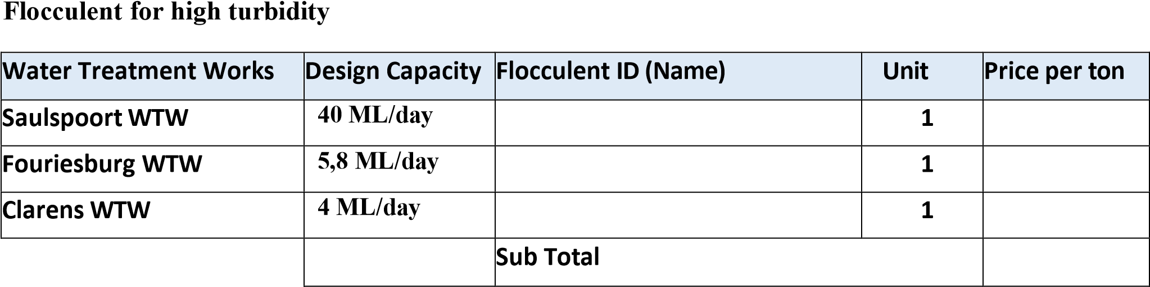

Flocculent for low turbidity

Water Treatment
Works

Flocculent
ID

)
(
Name

Unit

Price

per

ton

Saulspoort

WTW

1

Fouriesburg
WTW

1

Clarens

WTW

1

Sub

Total

DeadMac Monomer

Product

description

Flocculent
ID

(
)
Name

Unit

Price

per

ton

Appearance

:

Clear

Viscous

liquid
Odour

:
Slight

Viscosity

(
)
cps

:

6

–

10

cps

%
(2
solution)

SG

:

1.0

–

1.10

Ph

:

2.5

–

3.5

1

Sub

Total

Poly
Amine

description

Flocculent
ID

Name)
(

Unit

Price

per

ton

High

molecular

weight

liquid
polyelectrolyte

Appearance

Clear
:
Solution

Colour

:

Yellow to
Amber

SG

(
@

25
0
C)

:

1.03

–

1.10

Ph (as is at 25
0
C)

:

5
–

7

Viscosity

cps
(

@

25
0
C):

550

–

750

1

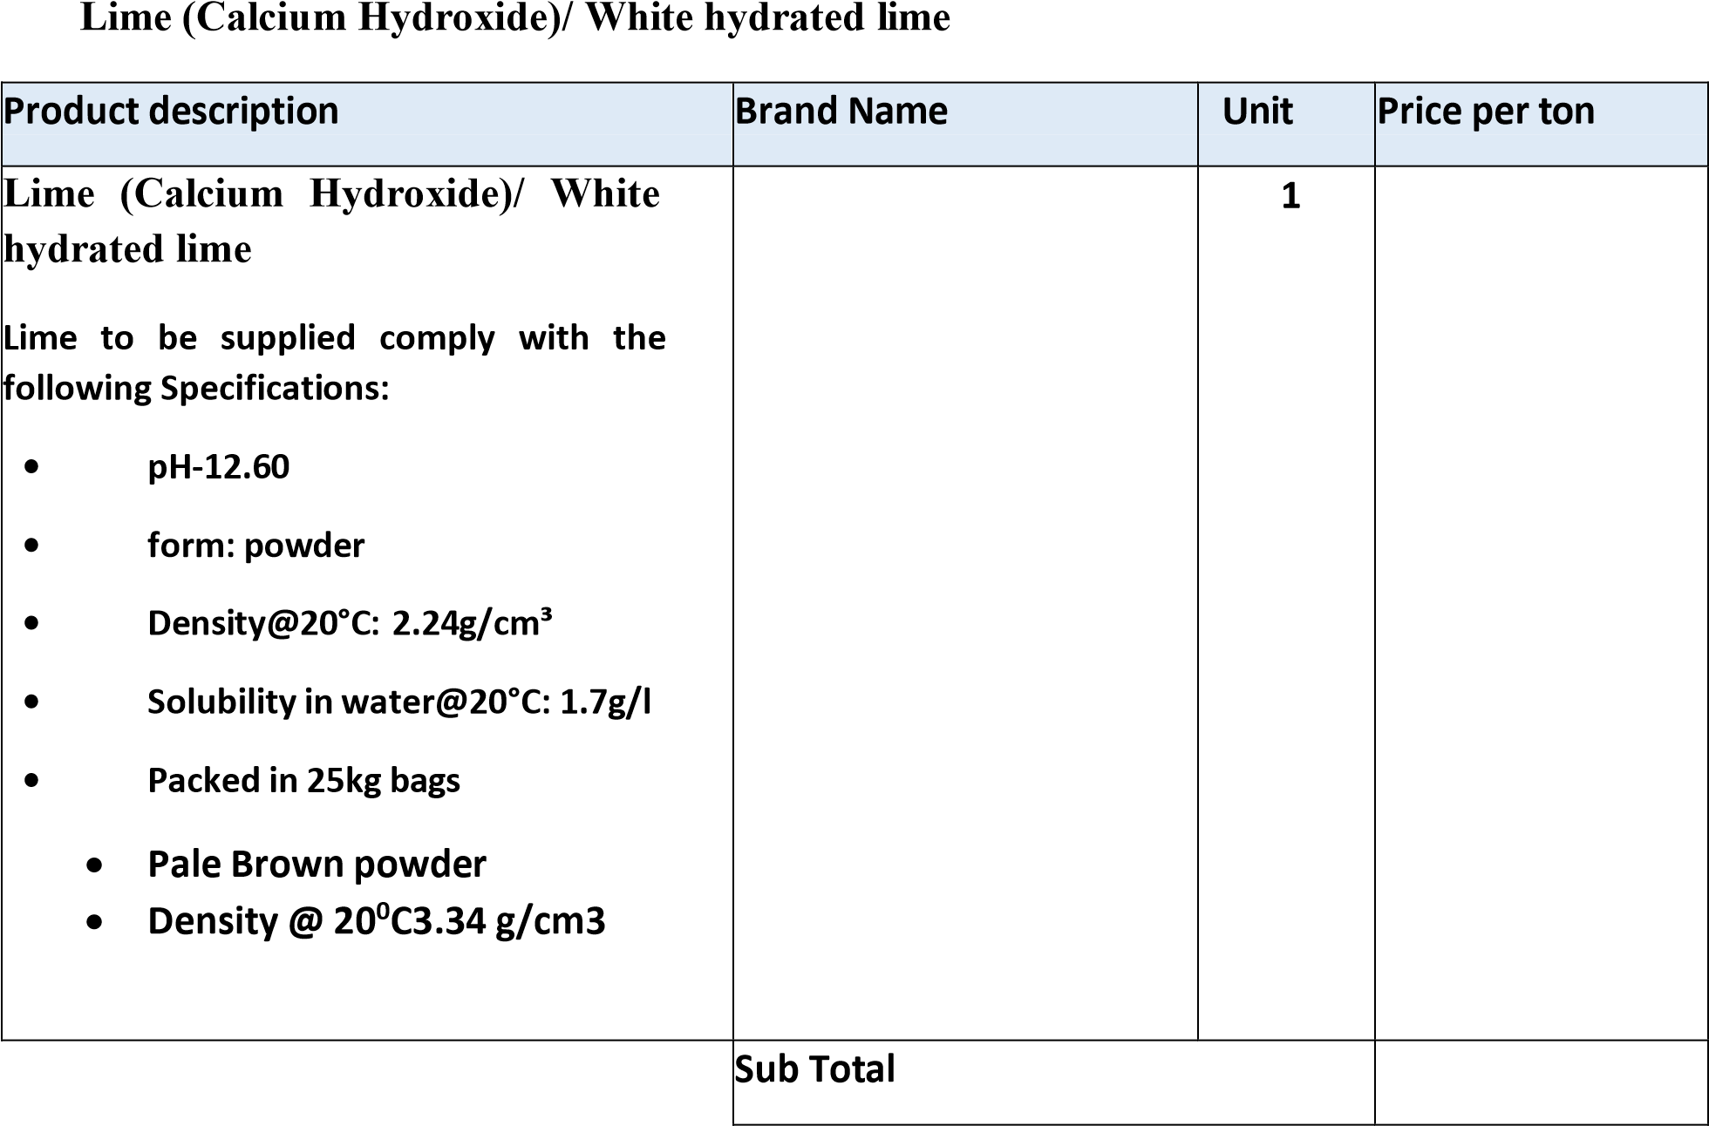

Sub

Total

Sodium

Hypochlorite

description

Brand

Name

Unit

Price

per

ton

Sodium

Hypochlorite

•

appearance

=
clear

liquid

•

Colour

yellow
=

•

Specific

Gravity

@

20
°C

1

Sub

Total

Lime

(
Calcium

Hydroxide)/

Brow

Product

description

Brand

Name

Unit

Price

per

ton

Lime

Calcium
(

Hydroxide)/

Brown

Lime

to

be

supplied

should

comply

with

the
following specifications:

•

%Ca
-
20.92

•

%CaO
-
0.0

•

%CaCO3
-
52.30

•

%Mg
-
1.92

•

%MgC03=6.70

•

%CCE
-
calcium
6.70(

carbonate
equivalence)

•

pH
-
12.60

•

form:

powder

•

Density@20°C:

g/cm³
2.24

•

Solubility

in

water@20°C:

g/l
1.7

•

Packed

in

kg
25

bags

1

Sub

Total

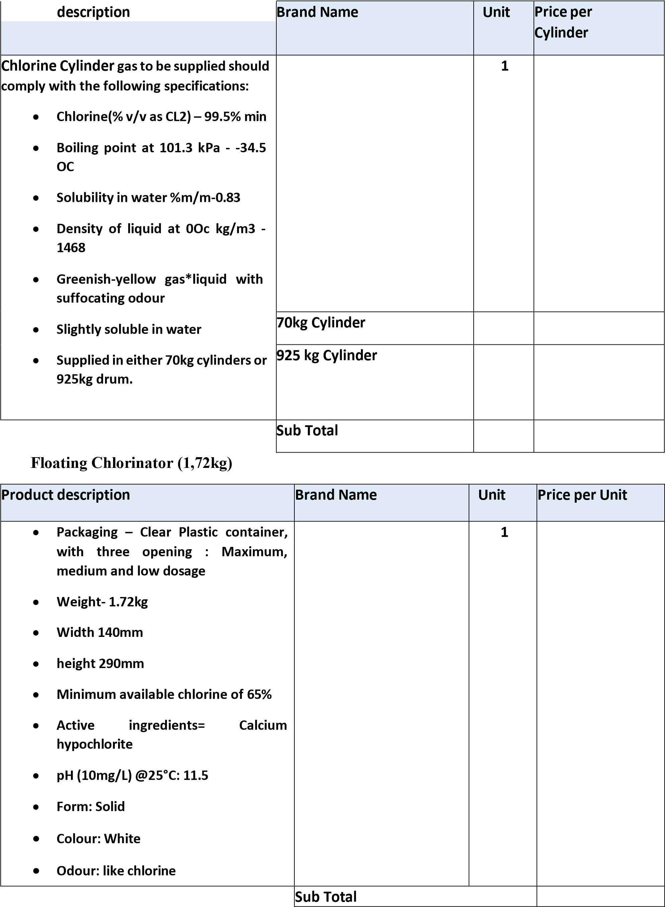
Chlorine Gas
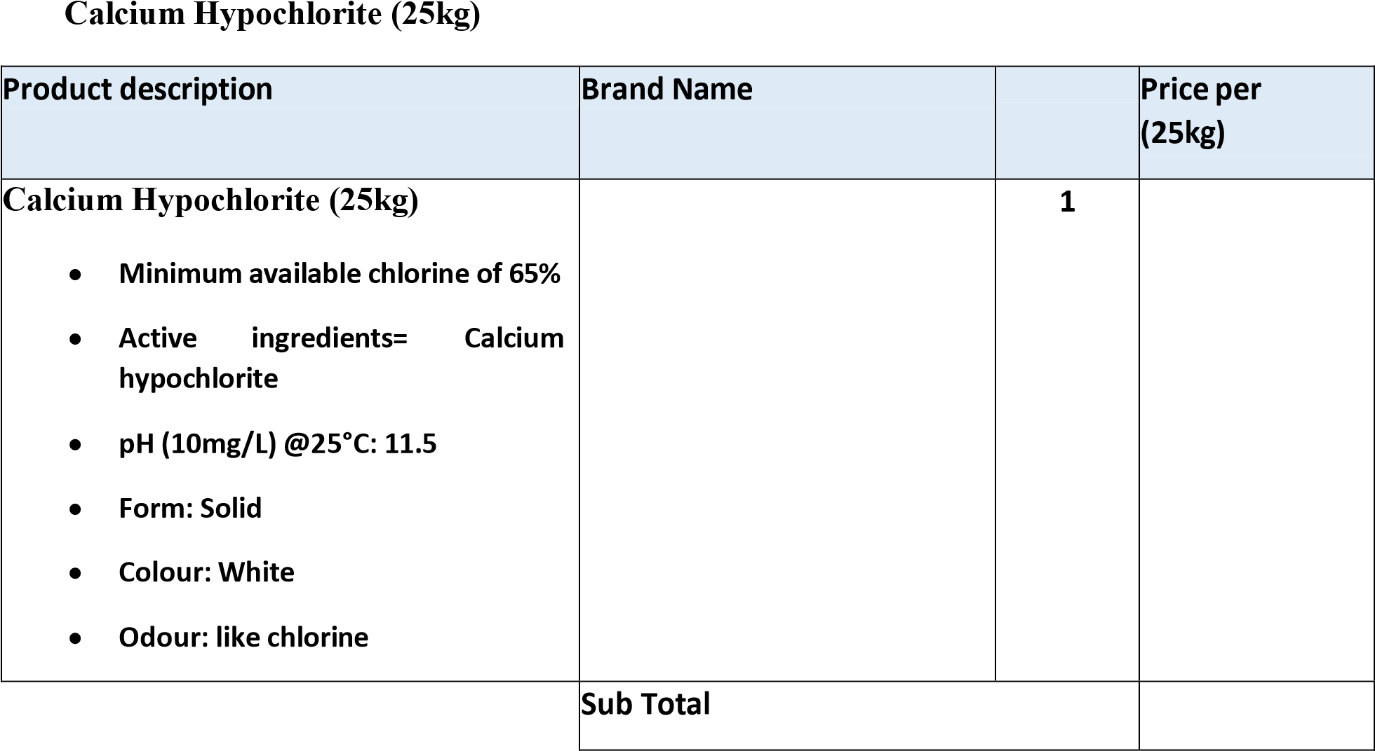
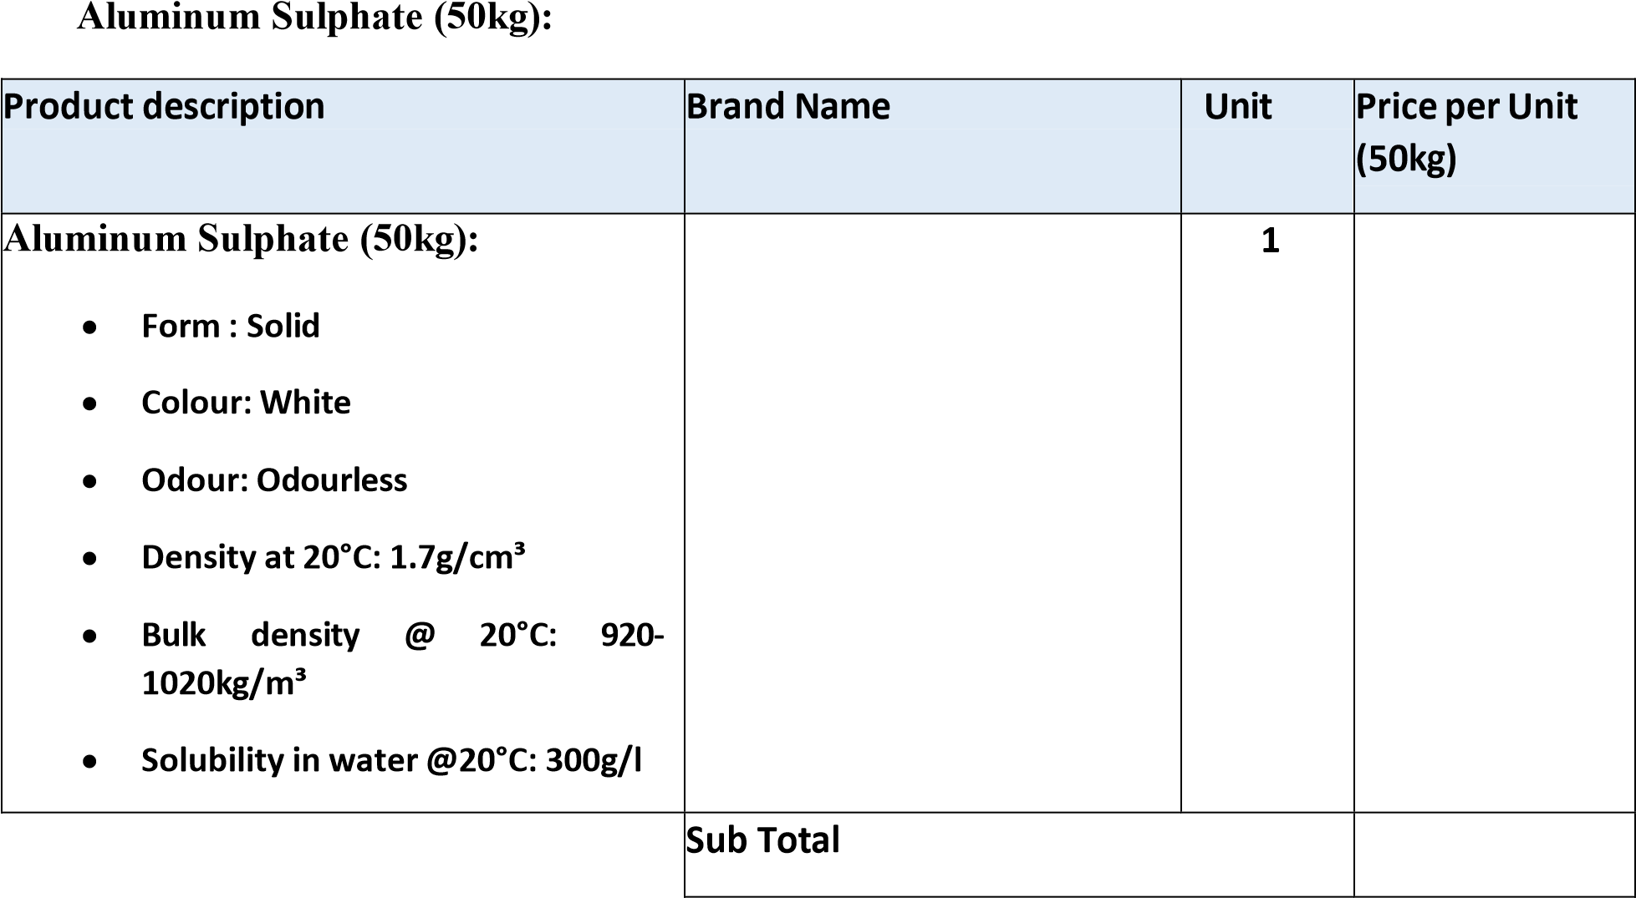

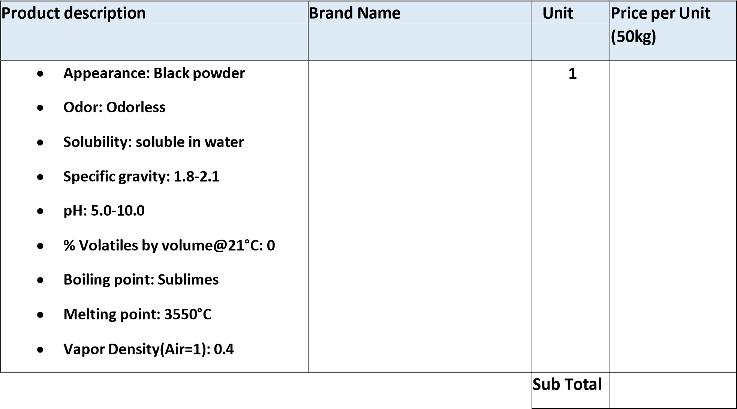
Powder Activated Carbon (50kg):

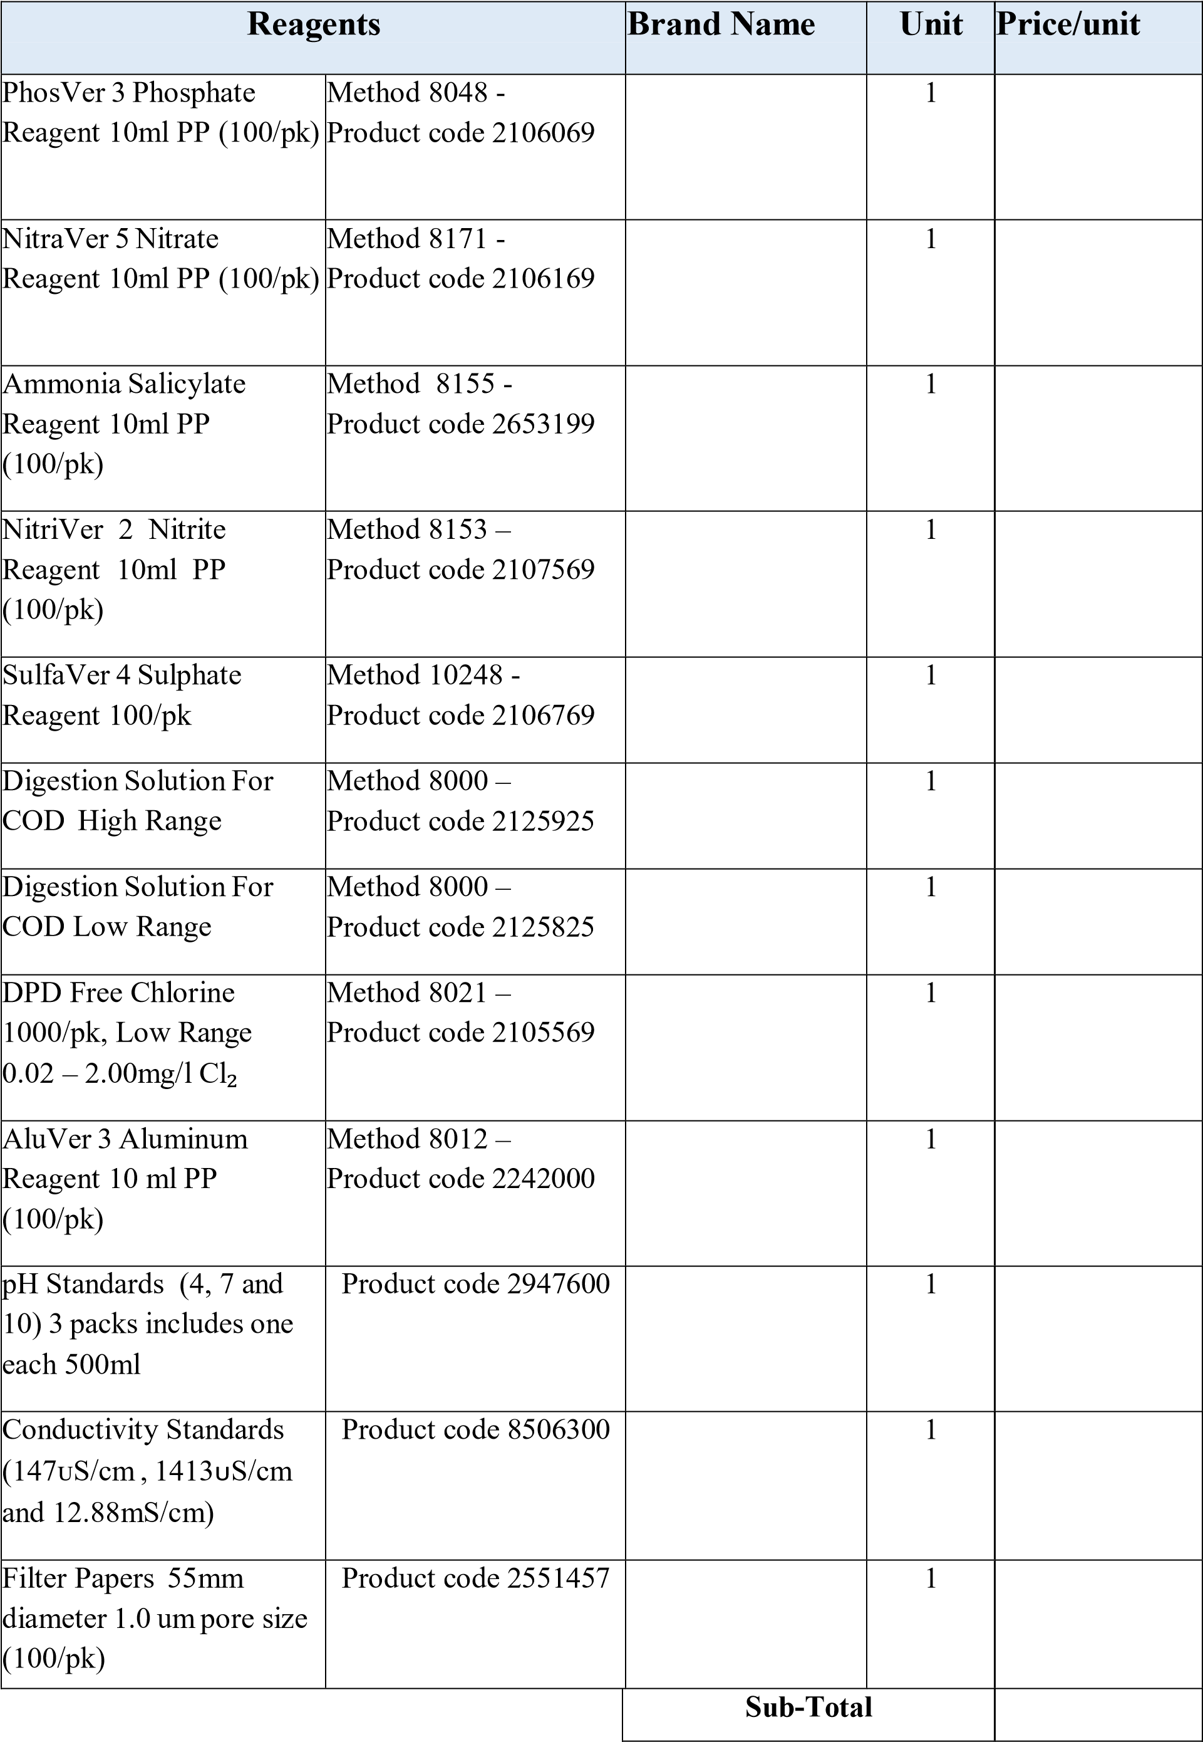

 | TESTING EQUIPMENTS
Equipment | Specifications | Brand name | Uni t | Price/unit
Floc Tester 8 Paddles | Specifications: RPM: Variable from 5 to 150 rpm''s with accuracy of +/- 1 rpm, Timer: 100 Hrs, display: 16 x 2 LCD, Jar: for 1000 ml x 6 nos, Paddles: Nos, Illumination: fluorescent white light. The stirrers must be in one line.
Floc Tester 8 Paddles | 4 paddles |  | 1
Floc Tester 8 Paddles | 6 paddles |  | 1
Floc Tester 8 Paddles | 8 paddles |  | 1
Calorimeter | 0 to 10mg/l |  | 1
Centrifuge | Specification: 6 tubes x 15 mL 300 rpm - 6,500 rpm; 4,000 x g 0.5 - 30 min Six-Place (fixed angle) |  | 1
Turbidity Meter Portable | 0 to 1000 NTU |  | 1
Turbidity Meter (Desk top) | 1000 NTU – 10 000 NTU |  | 1
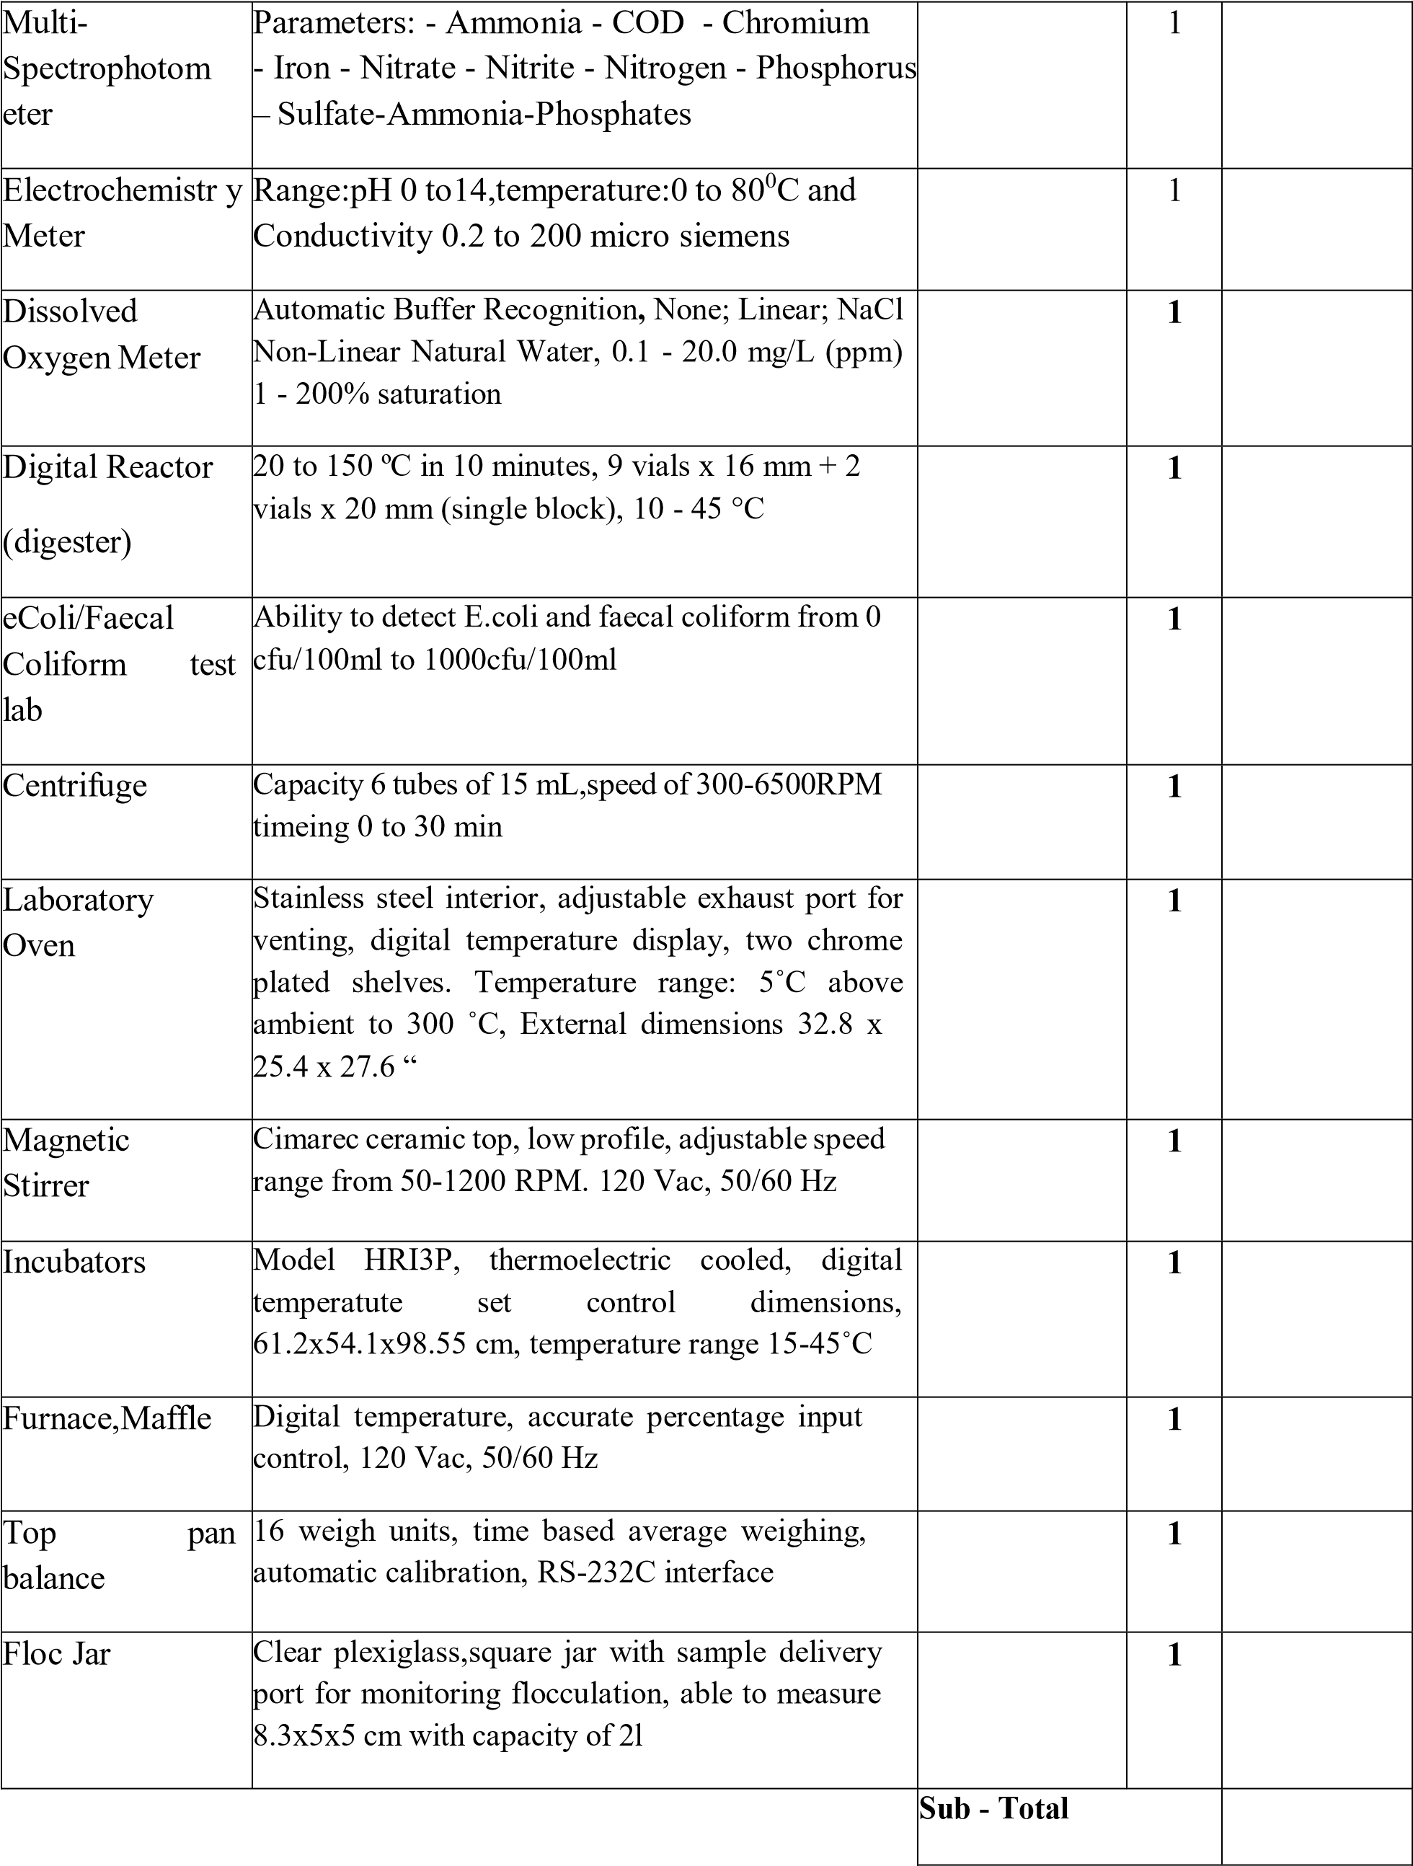

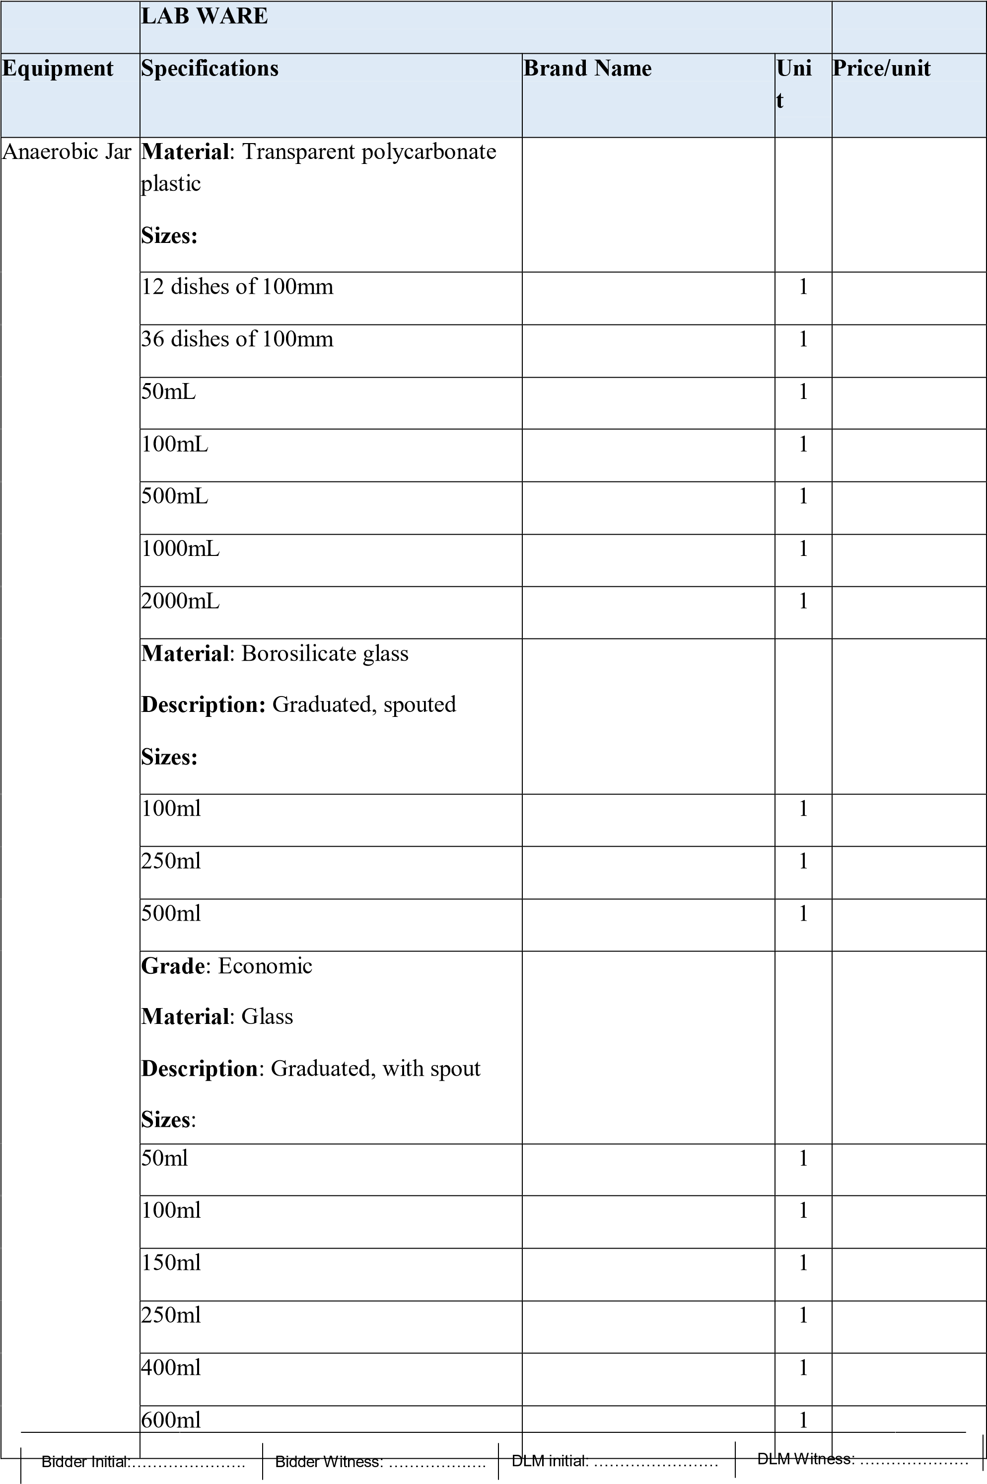
ml
800

1

1000
ml

1

Sub
Total

Equipment | Specifications | Brand Name | Unit | Price/unit
 | Material: borosilicate glass Description: graduated, with spout Sizes:
 | 5 ml |  | 1
 | 10 ml |  | 1
 | 25 ml |  | 1
 | 50 ml |  | 1
 | 100 ml |  | 1
 | 250 ml |  | 1
 | 600 ml |  | 1
 | 1000 ml |  | 1
Heavy duty
Material: borosilicate glass Description: graduated, with spout
Sizes:
 | 250ml |  | 1
 | 400ml |  | 1
 | 600ml |  | 1
 | 1000ml |  | 1
Lowform
Material: polypropylene
Description: graduated, with spout Sizes:
 | 25ml |  | 1
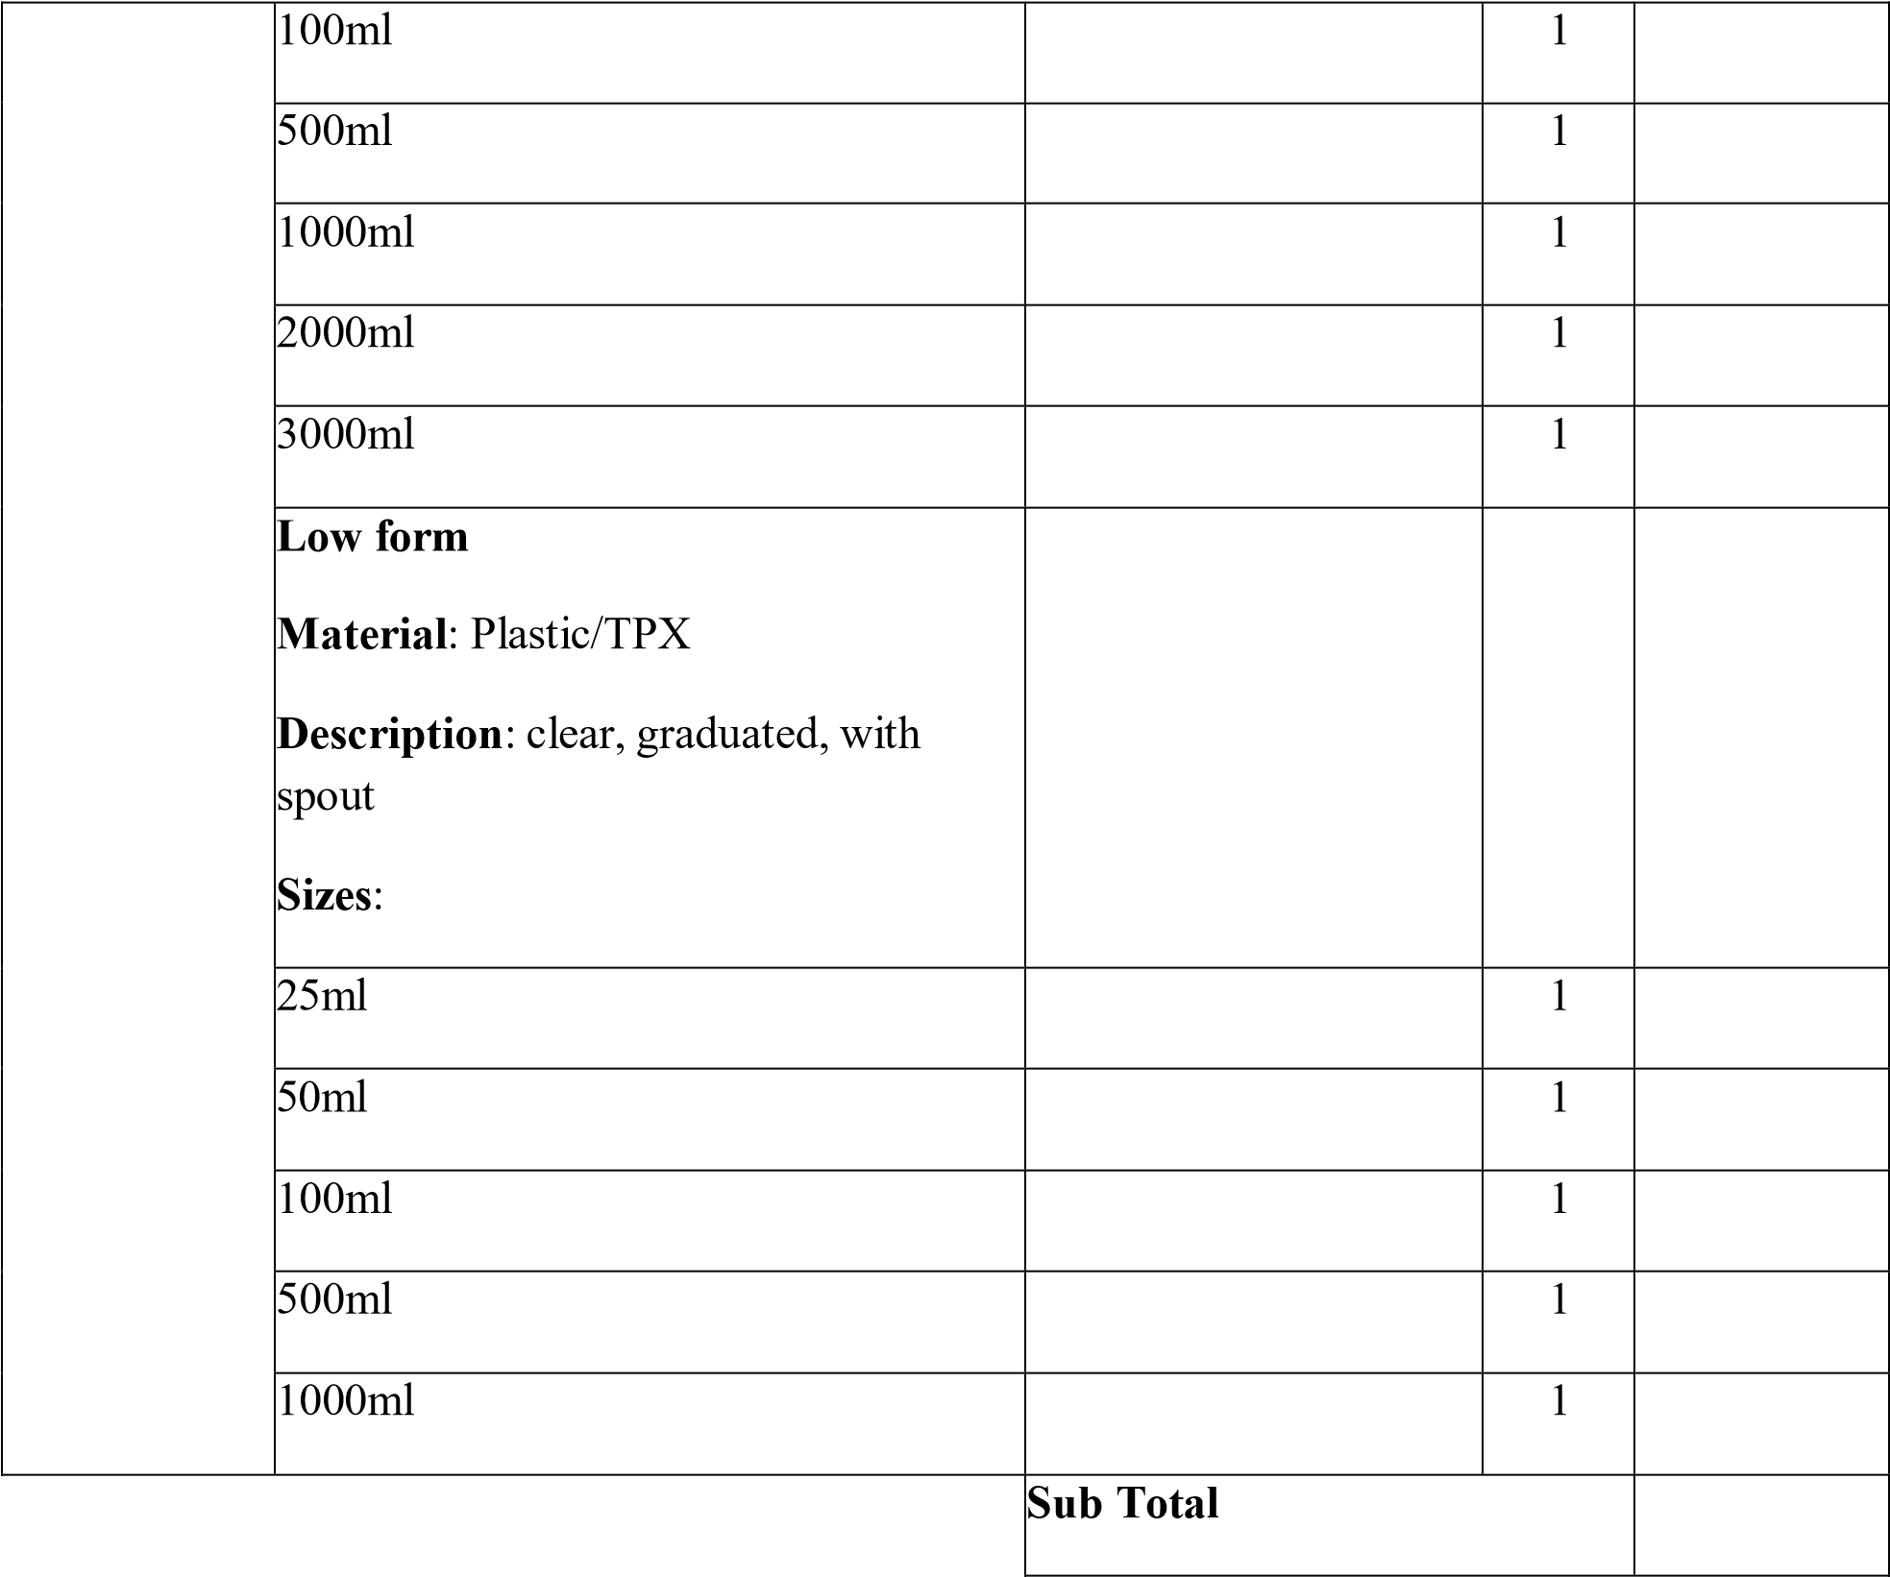
Equipment | Specifications |  | Brand Name | Unit | Price/unit
Low form Material: Teflon
Sizes:
 | 150ml |  |  | 1
 | 600ml |  |  | 1
 | Description: graduated, with spout Sizes:
 | 25 cm³/ml |  |  | 1
 | 50 cm³/ml, |  |  | 1
 | 1000 cm³/ml |  |  | 1
 | 600 cm³/ml |  |  | 1
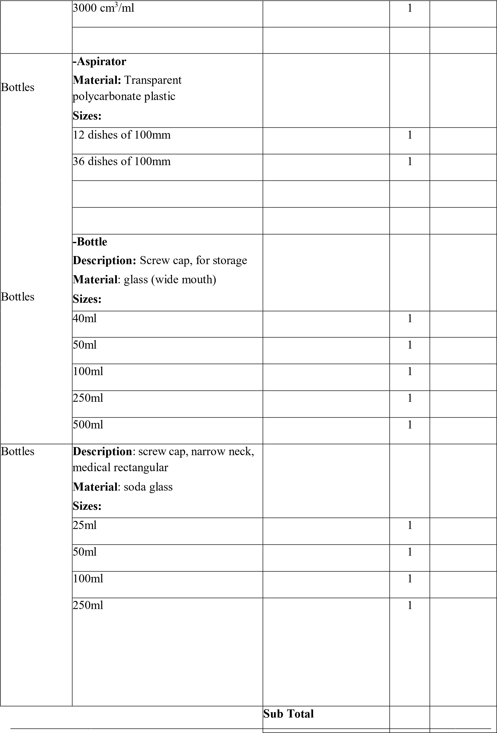

Equipment | Specifications | Brand Name | Uni t | Price/unit
bottle dropping type
Description: TK patterned, clear glass/ amber glass, with groove stopper, amber or clear.
Sizes:
 | 30 ml |  | 1
 | 50 ml |  | 1
 | 60 ml |  | 1
 | 125 ml |  | 1
Bottles | bottle-media(reagent)  Description: glass screw cap, with pouring ring, for steam sterilization.  Sizes:
Bottles | 50ml |  | 1
Bottles | 100ml |  | 1
Bottles | 250ml |  | 1
Bottles | 500ml |  | 1
Bottles | 1000ml |  | 1
Bottles | Bottle-reservoir Description:  clear or amber Material:  borosilicate glass Sizes:
Bottles | 500ml |  | 1
Bottles | 1000ml |  | 1
Bottles | 2000ml |  | 1
Bottles | Bottle -SG  Description: specific gravity, density, adjusted, with or without thermometers Sizes:
Bottles | 10 ml |  | 1
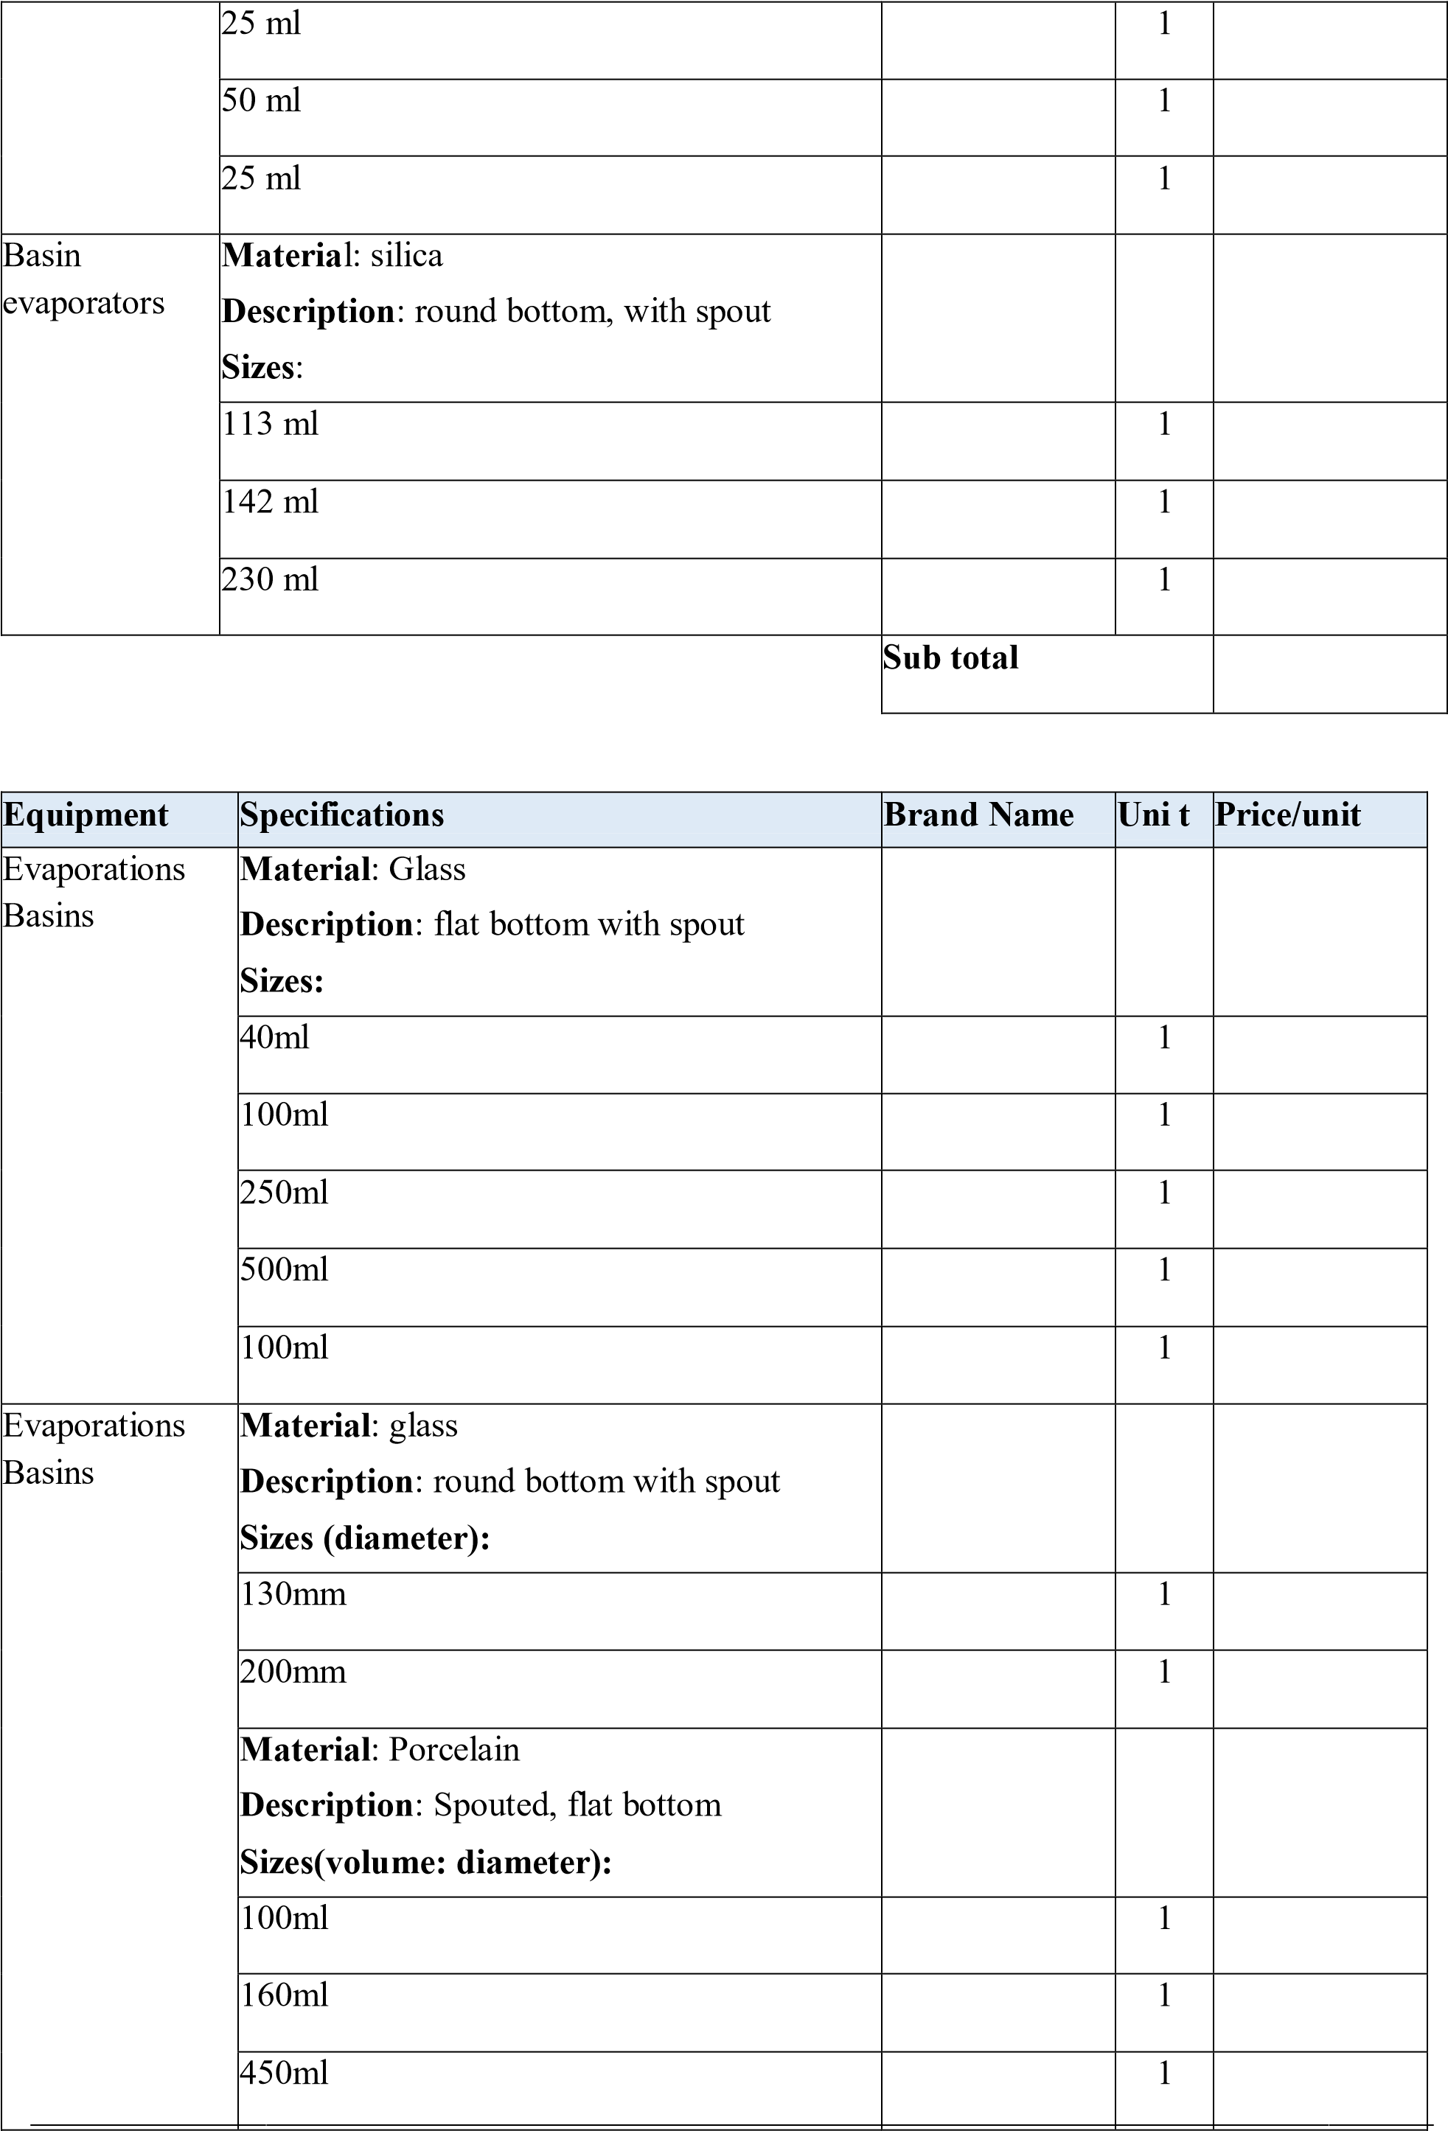
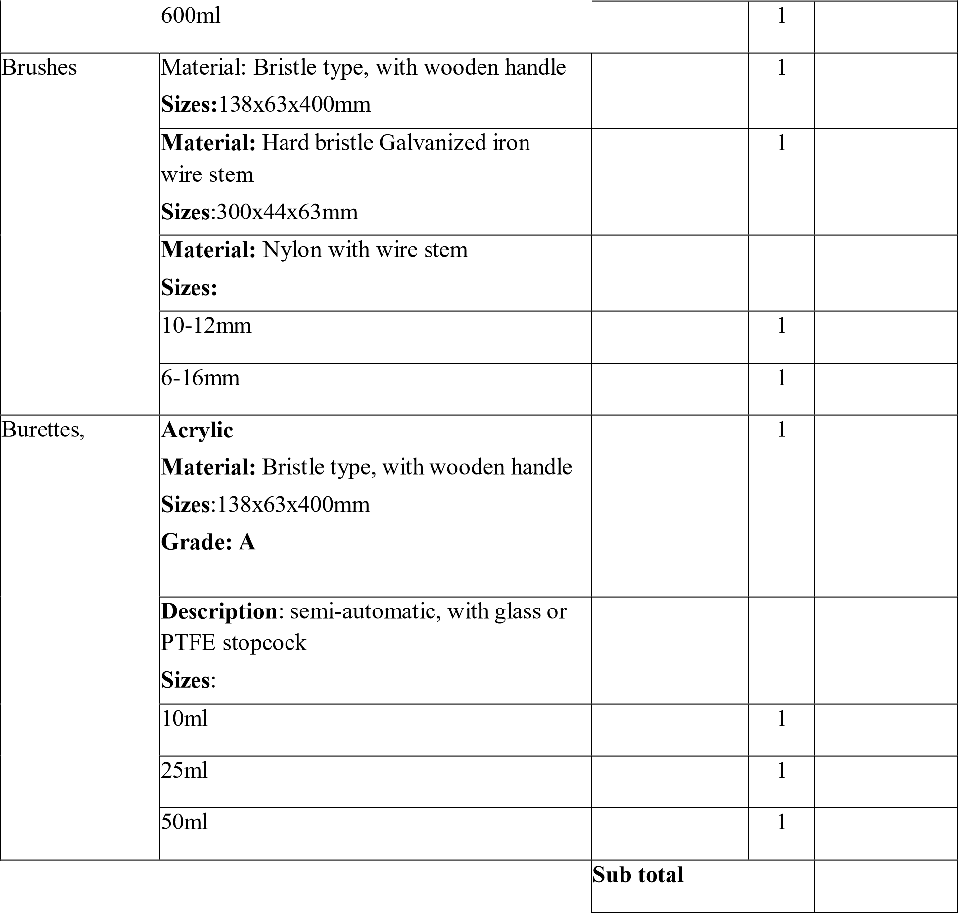
Equipment | Specifications | Brand Name | Unit | Price/unit
Burettes, | digital  Description: Large LCD readout, adjustable  Size: 10 ml – 999.9 ml |  | 1
Burettes, | -Glass  Description: amber graduations, stopcock glass or PTFE, Moulding screw thread for adjustment.  Sizes:
Burettes, | Capacity |  | 1
Burettes, | 10 cm³ (10 ml) |  | 1

 | 25 cm³ (25 ml) |  | 1

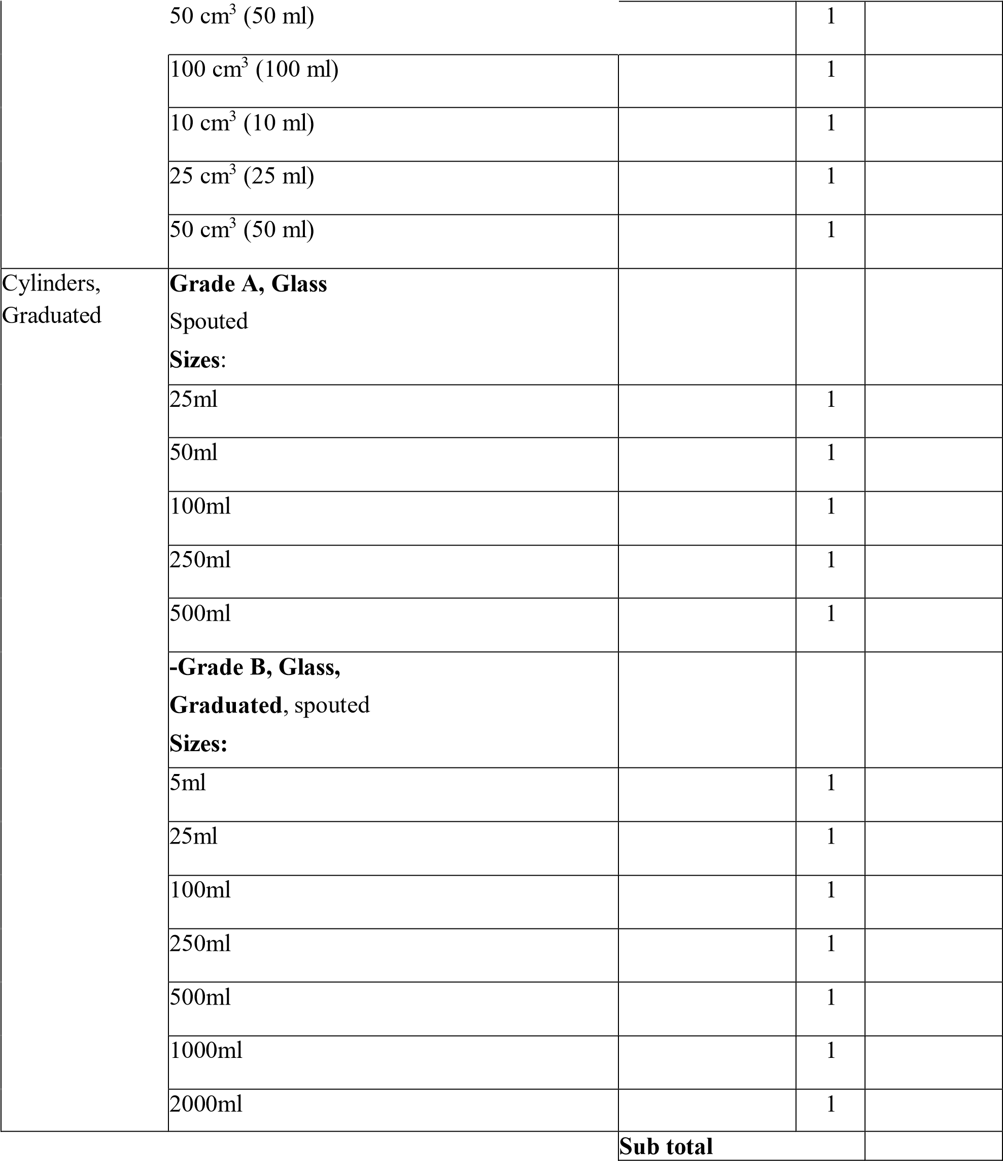

Equipment | Specifications | Brand Name | Unit | Price/uni t
 | Nessler, Glass Graduated Sizes:
 | 5ml |  | 1

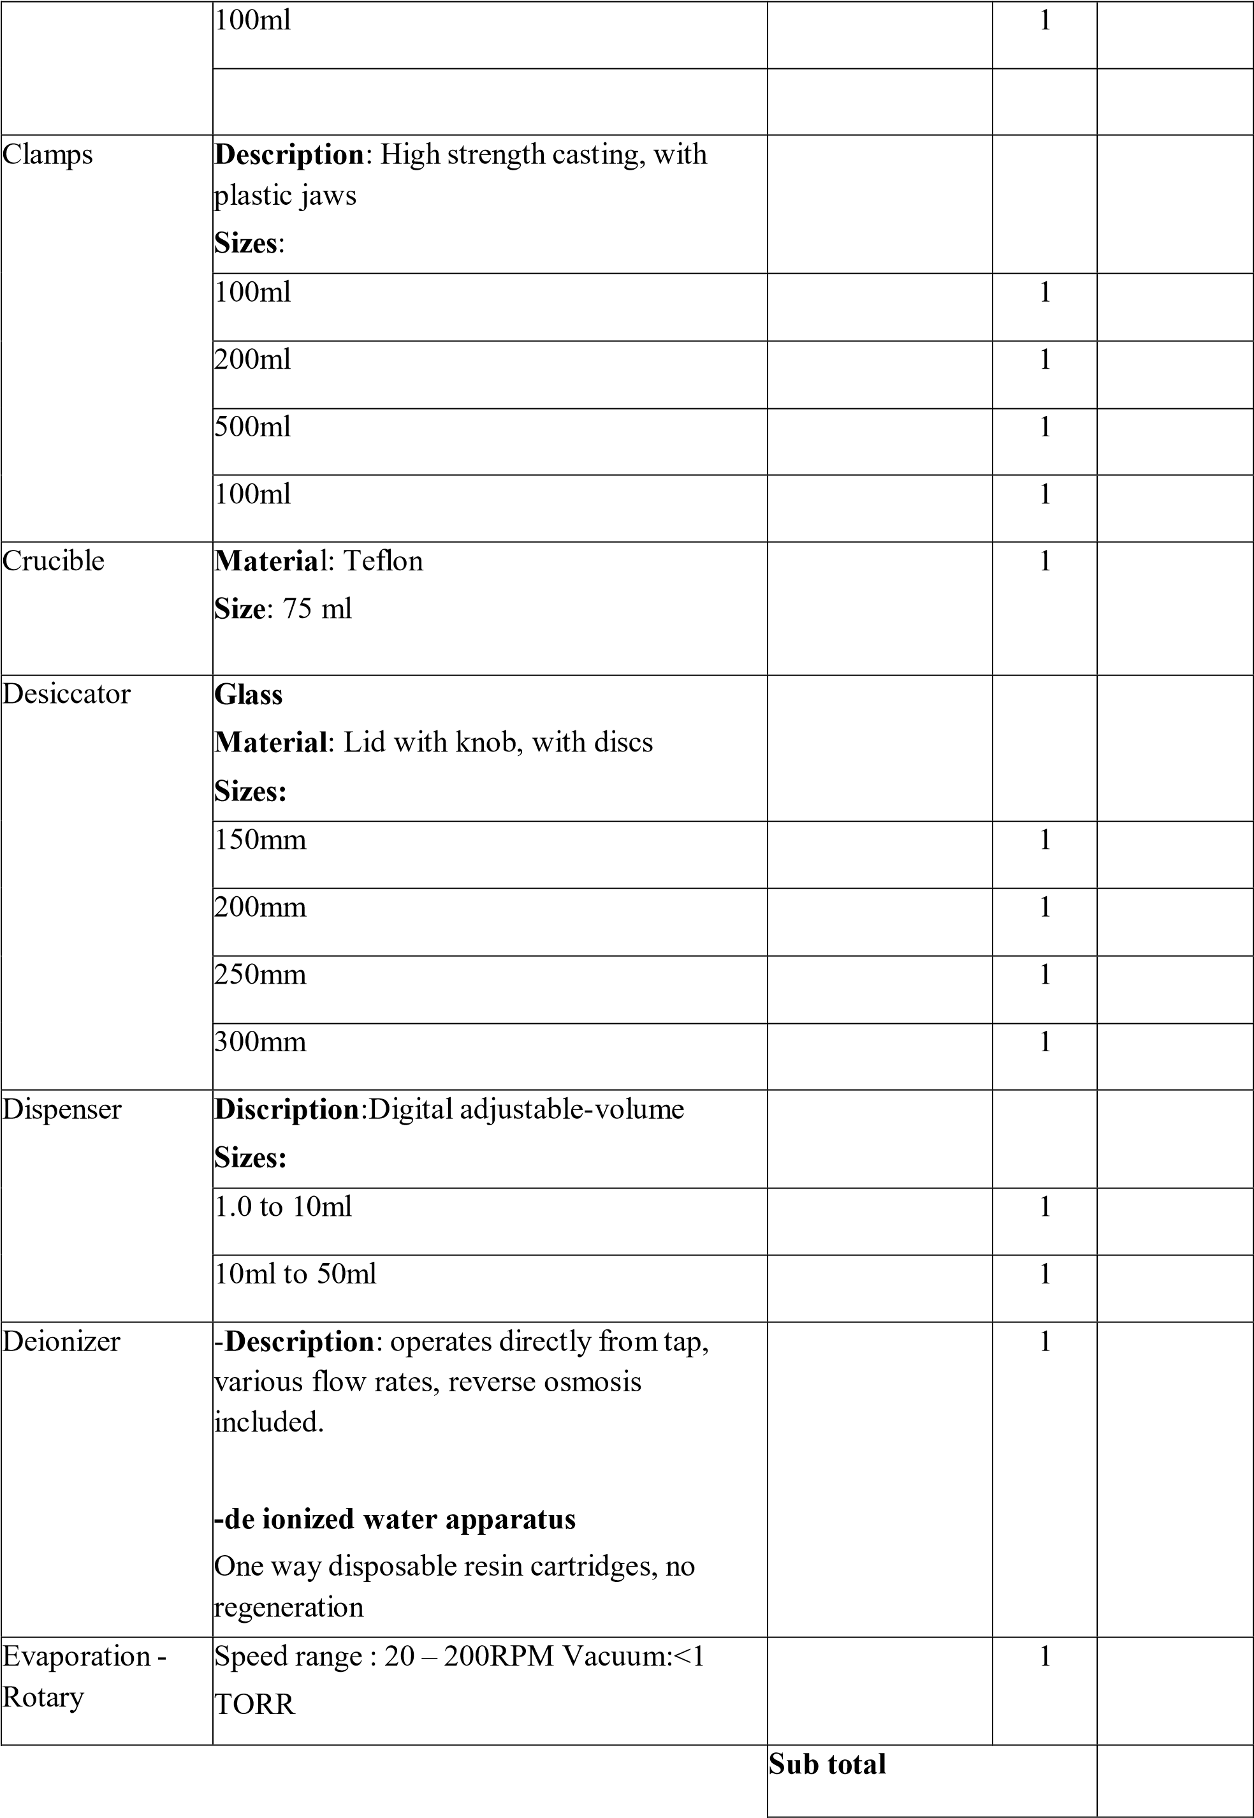

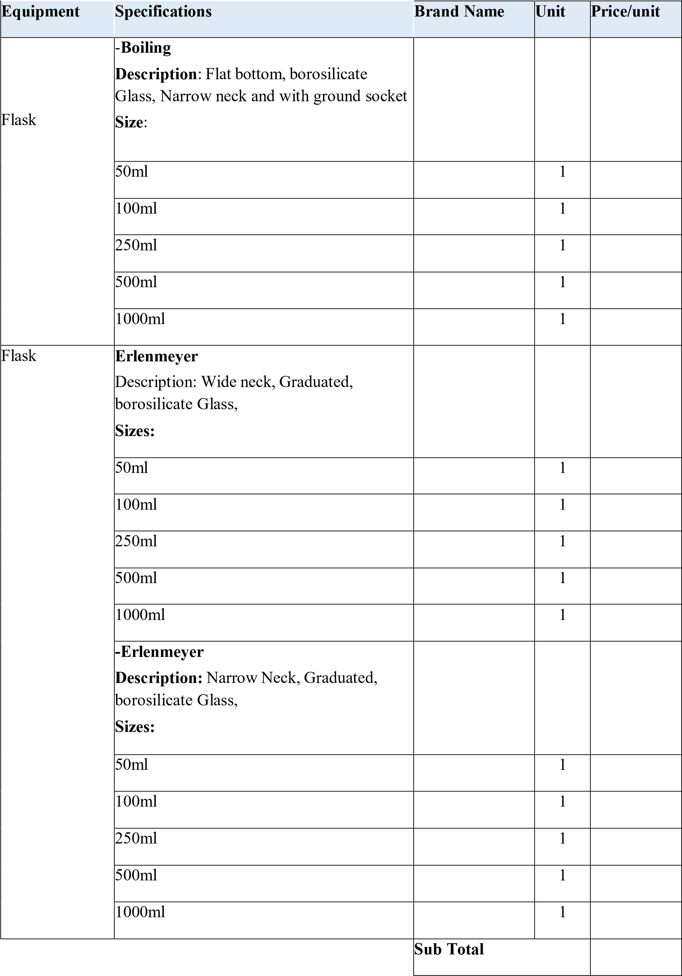
Equipment | Specifications | Brand Name | Unit | Price/uni t
Flask | -Filter  Description: Buchner, Heavy wall, borosilicate Glass, Sizes:
Flask | 50ml |  | 1
Flask | 100ml |  | 1
Flask | 250ml |  | 1
Flask | 500ml |  | 1
Flask | 1000ml |  | 1
Flask | -Kjeldahl  Description: Long neck, borosilicate Glass Sizes:
Flask | 50ml |  | 1
Flask | 100ml |  | 1
Flask | 250ml |  | 1
Flask | 500ml |  | 1
Flask | 1000ml |  | 1
Flask | Volumetric  Description: One Mark, interchangeable  PVC or Glass stopper  Grade: Economic Sizes:
Flask | 50ml |  | 1
Flask | 100ml |  | 1
Flask | 250ml |  | 1
Flask | 500ml |  | 1
Flask | 1000ml |  | 1
Flask | Volumetric  Description: One Mark, interchangeable  PVC or Glass stopper  Grade:A

50
ml

1

ml
100

1

250
ml

1

500
ml

1

ml
1000

1

Sub
total

Filters | Filter unit  Descriptions:Tisssue culture type,  Graduation on both upper and bottom  Sizes:200mm receiver |  | 1
filters | Filter papers  Descriptions:Tisssue culture type,  Graduation on both upper and bottom Sizes:
filters | 55mm |  | 1
filters | 70mm |  | 1
filters | 110mm |  | 1
Pipettes | Mohr pipet  Descriptions: Class B pipets calibrated, graduated scale, polypropylene material.  Sizes:
Pipettes | 1.0ml |  | 1
Pipettes | 5ml |  | 1
Pipettes | 10ml |  | 1
Pipettes | Serological pipet  Descriptions: Graduated glass pipet.  Sizes:
Pipettes | 1ml |  | 1
Pipettes | 10ml |  | 1
Pipettes | 25ml |  | 1
Pipettes | Volumetric pipet  Descriptions: Graduated glass pipet.  Sizes:
Pipettes | 0.5ml |  | 1
Pipettes | 1.0ml |  | 1
Pipettes | 5.0ml |  | 1
Pipettes | 10ml |  | 1
Pipettes | 25ml |  | 1

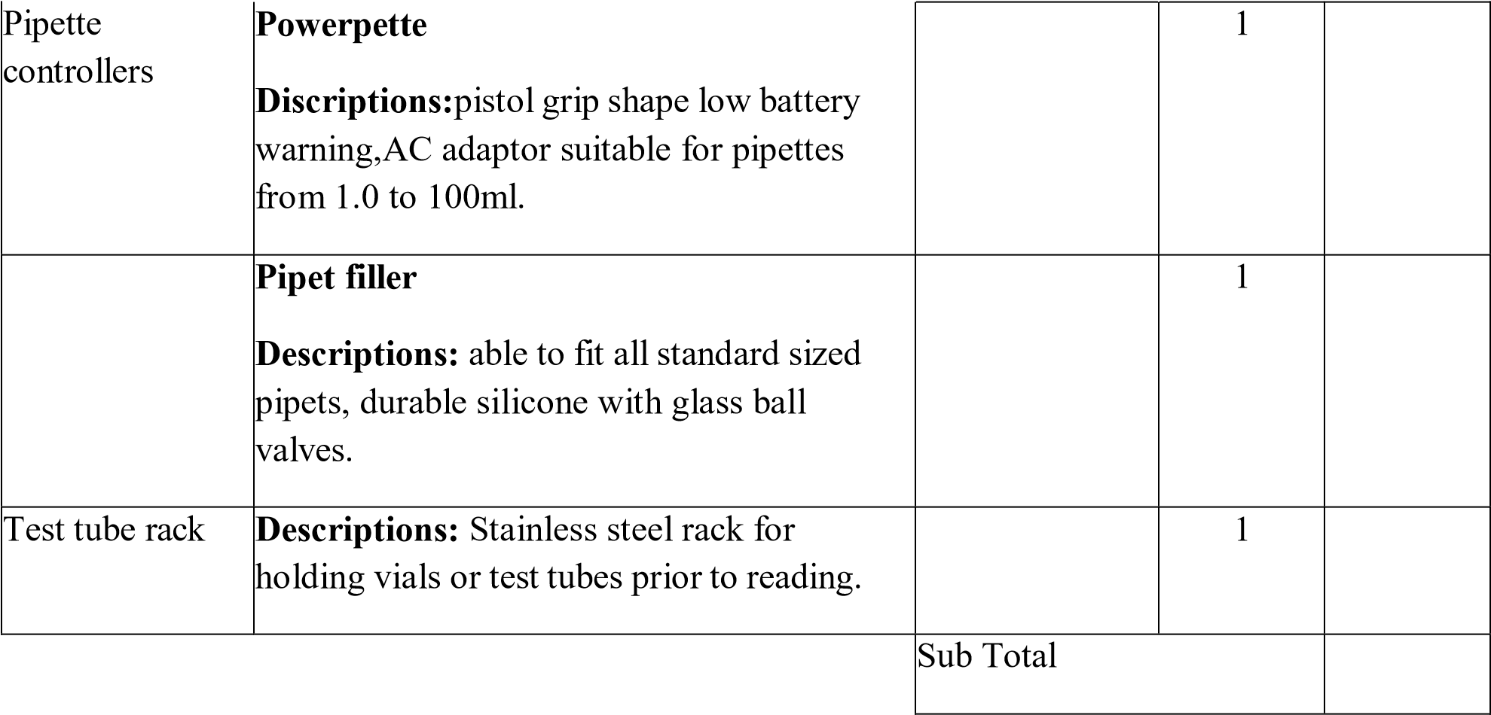
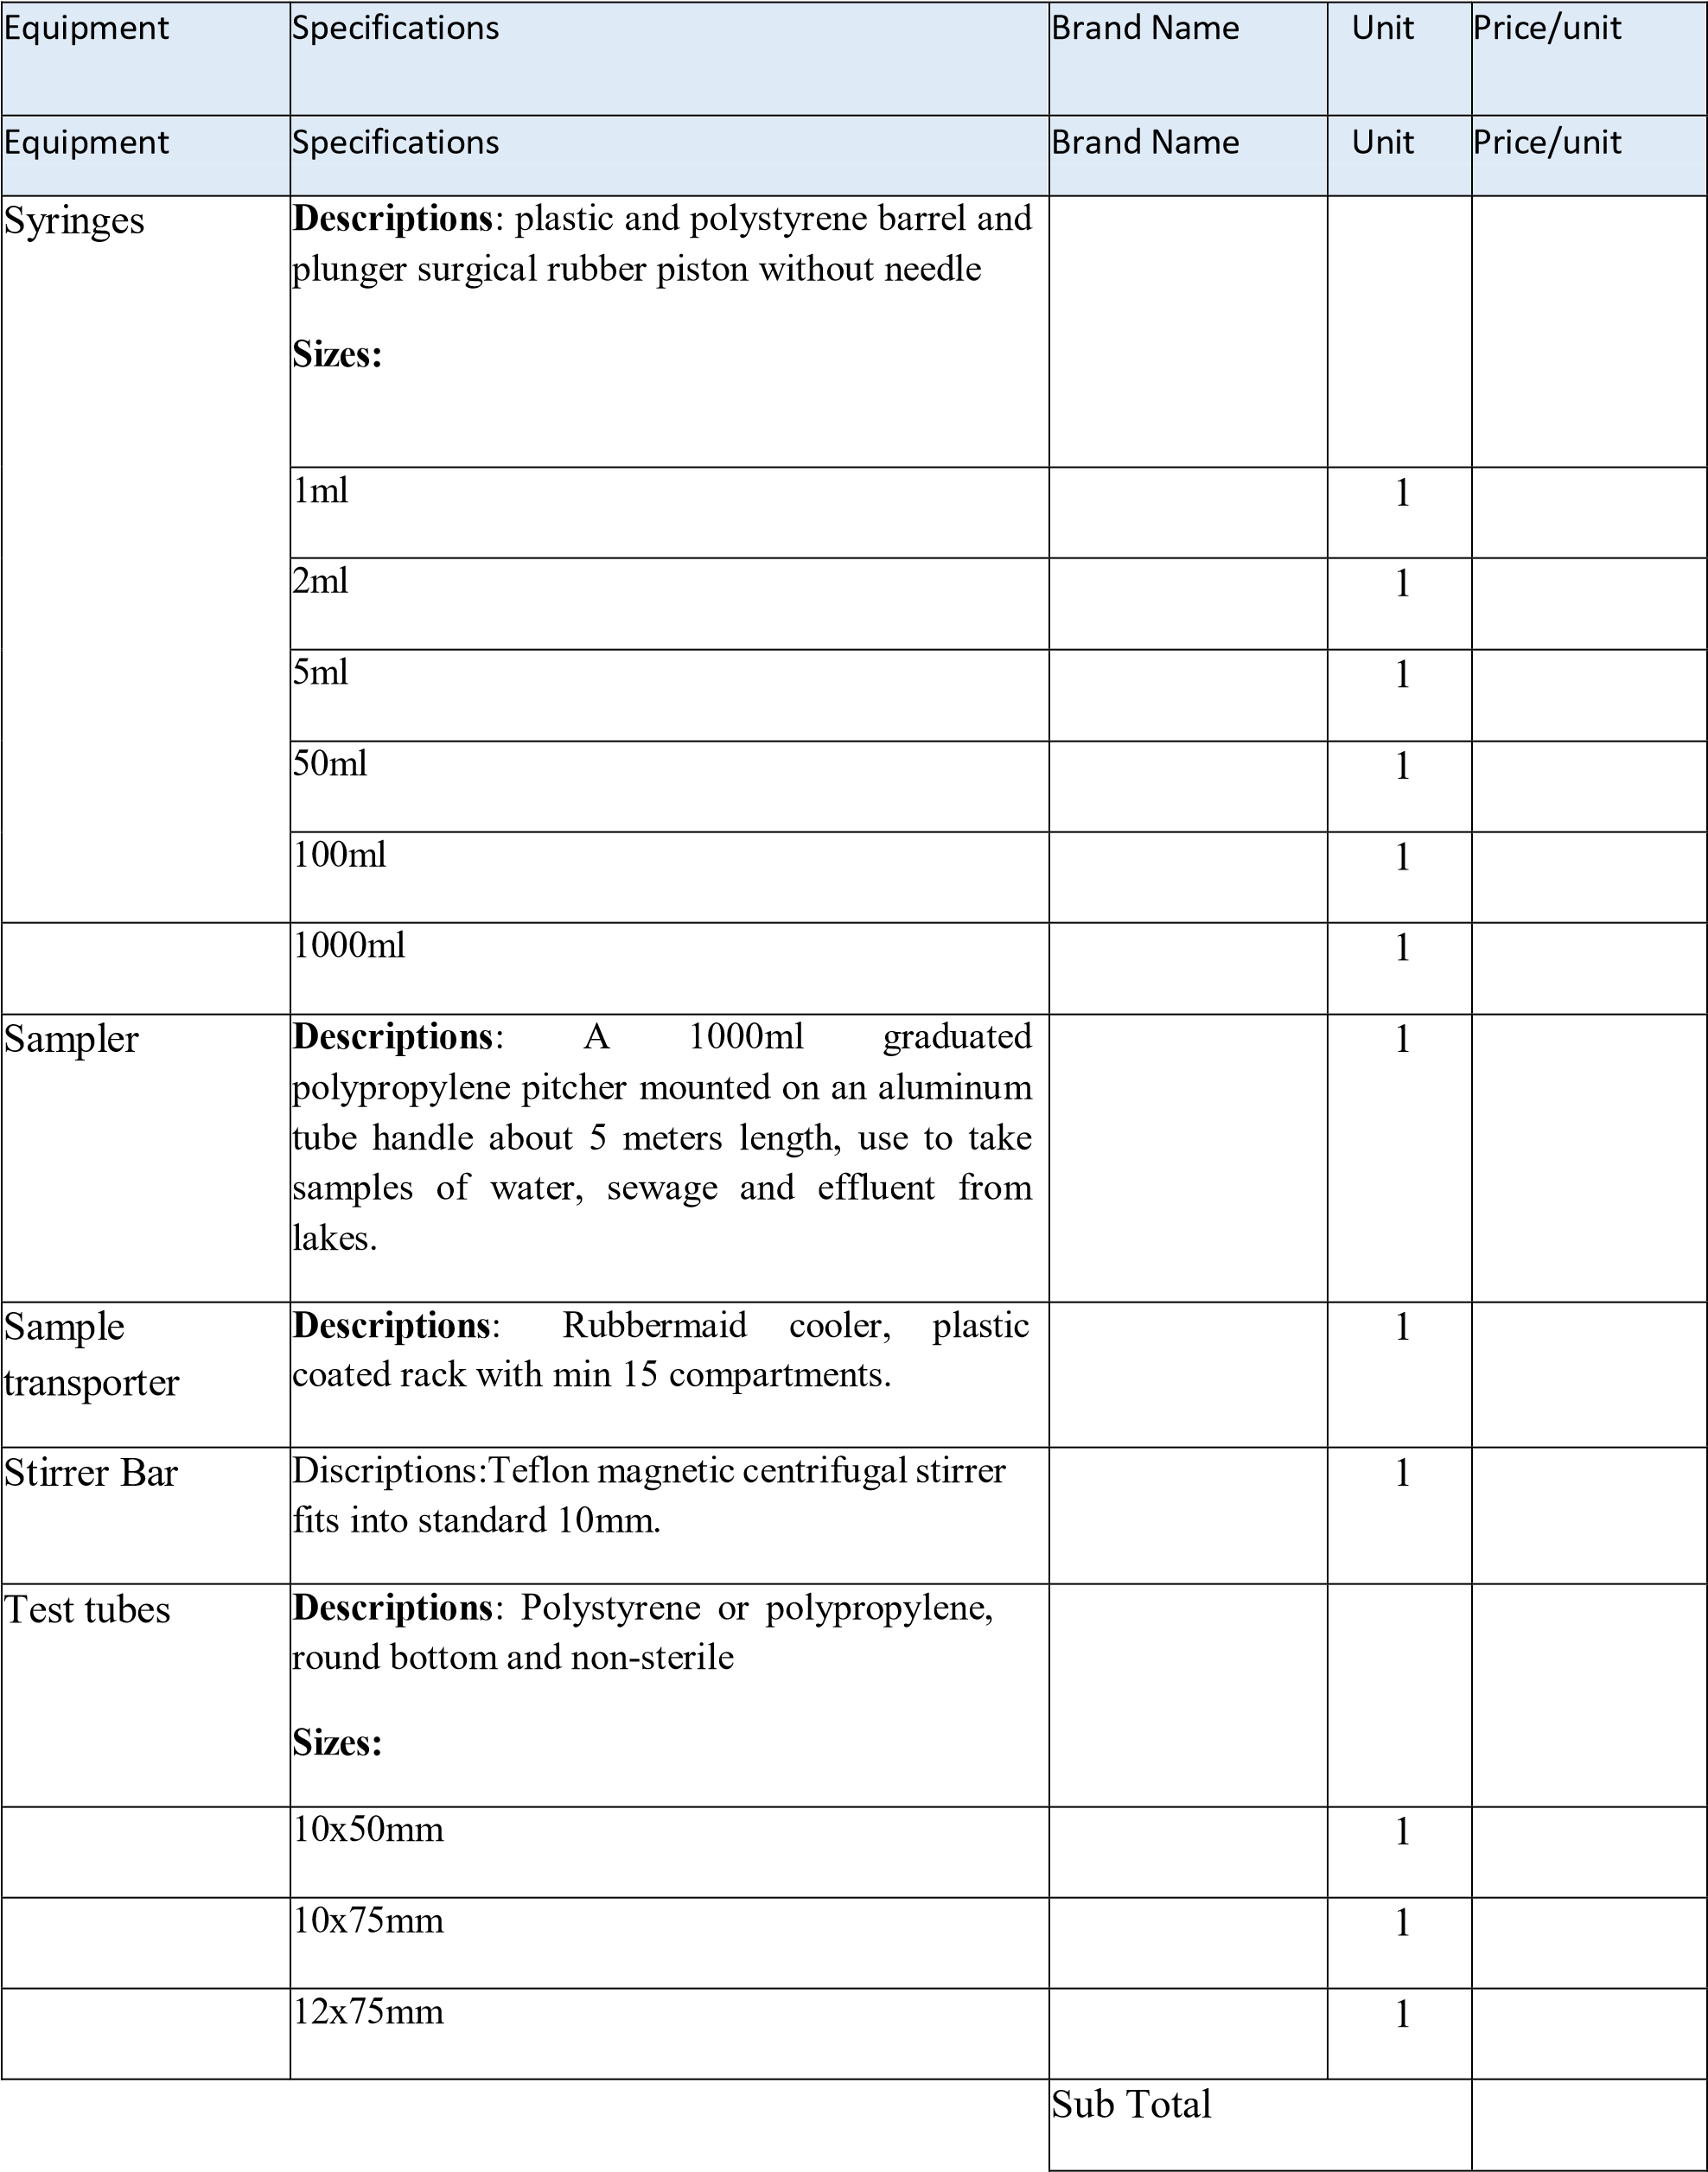
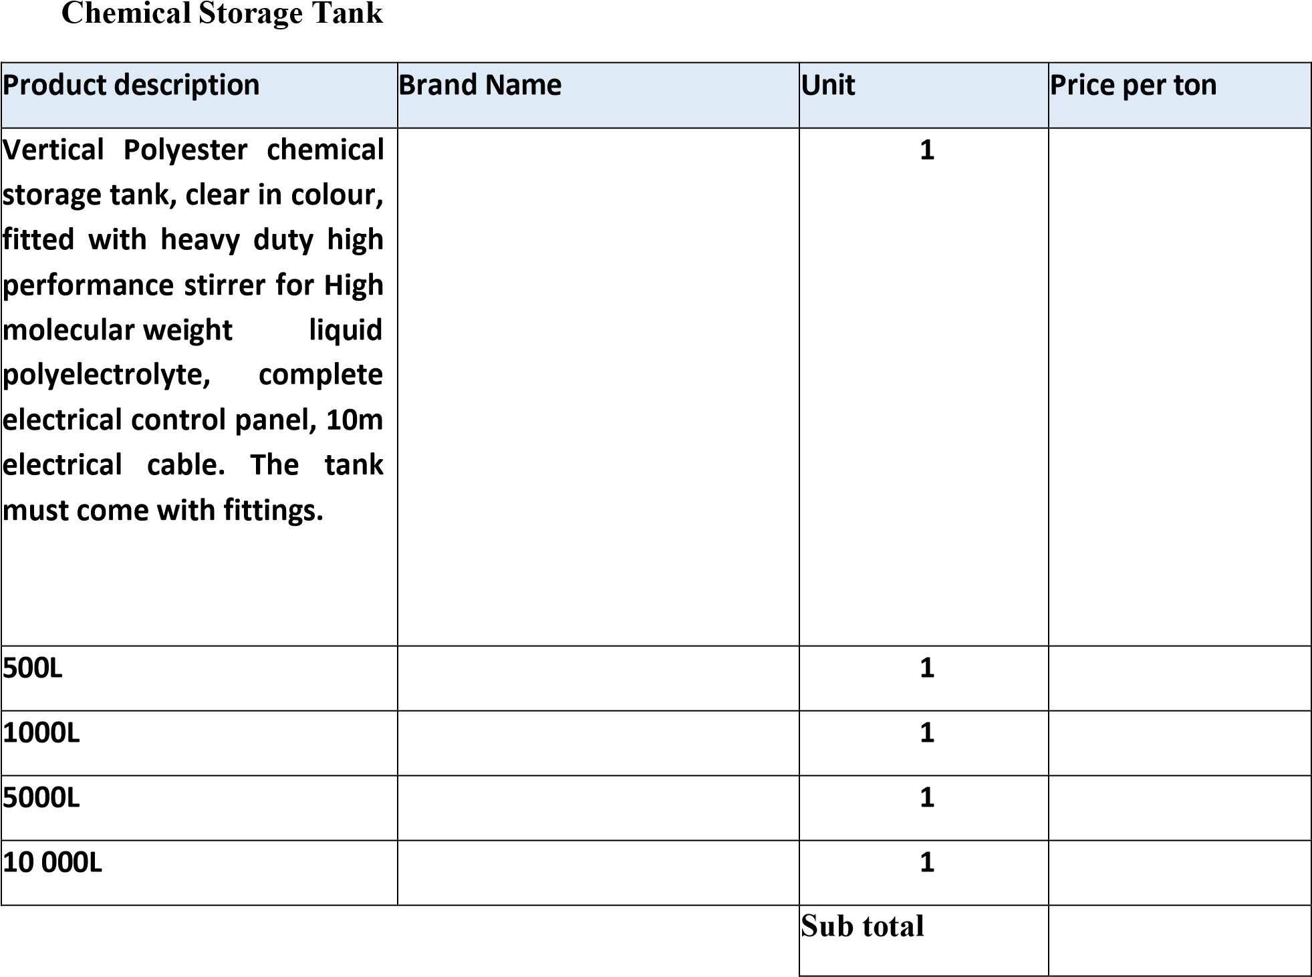
Chemical

Storage

Tank

Product

description

Brand

Name

Unit

Price

per

ton

Heavy
duty Agitator for large
m
maximum
tanks,
5
diameter
and
5
m
high.
5
m
long

shaft

including

support
fittings.
arms
m
20
and
with
cable
electrical
panel.
electrical
complete
For capacities between

20000
–

30 000

liters

1

Sub
total

C2.1.2
Contract No: PW008/2024 C4: Site Information
APPOINTMENT OF A PANEL OF FOUR (4) SERVICE PROVIDERS FOR THE FOR THE SUPPLY & DELIVERY OF WATER & WASTEWATER TREATMENT CHEMICALS, REAGENTS AND LAB WARE FOR A PERIOD OF THREE (3) YEARS

PLANT

OPTIMISATION

FEES

Design capacity

RATE/Hr

Bethlehem

WTW

40

kl/day
000

Clarens

WTW

000 kl/day
4

Fouriesburg

WTW

kl/day
5081

Sub
-
Total

TRANSPORTATION FEES FOR FLOCCULENT | RATE/km

TRANSPORTATION FEES FOR CHLORINE GAS | RATE/km
TRANSPORTATION FEES FOR ALL OTHER ITEMS | RATE/km

NB: The Grand Total pricing is only for the tendering evaluation purpose

Total
VAT @ 15%
GRAND TOTAL

Bidder

Initial:………………….

Bidder Witness: ...………….

DLM

initial:

……………………

DLM

Witness:

…………………

C4.1

