RFQ Number | Coffee Mach 03
Request for Quotation Date | 2025-05-07
RFQ Closing Date | 2025-05-09
RFQ Closing Time | 14:00
Compulsory Site Briefing | n/a
Contact Person | Joseph Rasakanya
Quotation Validity | 90 Days from the closing date
Submission Details | RFQ Response must be sent to: Joseph.Rasakanya@necsa.co.za
RFQ Description | Supply and delivery of 08 litter Coffee machine

Dear Service Provider

Kindly provide a quotation for goods and or services as outlined in section 2 of this document.

- Introduction

The South African Nuclear Energy Corporation Limited (Necsa) is a state-owned public company (SOC), registered in terms of the Companies Act, (Act No. 61 of 1973), registration number 2000/003735/06.

The Necsa Group engages in commercial business mainly through its wholly-owned commercial subsidiaries: NTP Radioisotopes SOC Ltd (NTP), which is responsible for a range of radiation-based products and services for healthcare, life sciences and industry, and Pelchem SOC Ltd (Pelchem), which supplies fluorine and fluorine-based products. Both subsidiaries, together with their subsidiaries, supply local and global markets, earning valuable foreign exchange for South Africa and are among the best in their field in their respective world markets.

Necsa’s safety, health, environment and quality policies provides for top management commitment to compliance with regulatory requirements of ISO 14001, OHSAS 18001 and RD 0034 (Quality and Safety Management Requirements for Nuclear Installations), ISO 9001 and ISO 17025.

Necsa promotes the science, technology and engineering expertise of South Africa and improves the public understanding of these through regular communications at various forums and outreach programmes to the community. We are a proudly South African company continuously striving, and succeeding in many respects, to be at the edge of science, technology and engineering related to the safe use of nuclear knowledge to improve our world.

For more information on Necsa, please visit: WWW.Necsa.co.za
- Scope of Work

Item Description | Quantity
Apollo 12 automatic bean to cup coffee machine ( or equivalent) single grinder 8 L plus 4 L milk fridge , see below features | 01
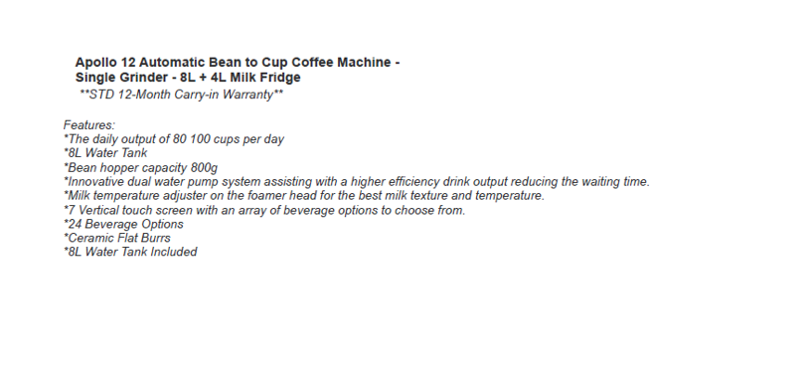

- Pricing

- All price quoted to include all applicable taxes.
- Price must be fixed and firm
- Price should include additional cost elements such as freight, insurance until acceptance, duty where applicable, disbursements etc.
- Quotation must be completed in full, incomplete quote could result in a quote being disqualified.
- Payment will be according to Necsa’s General Conditions of Purchase.

- Evaluation

  - Phase 1- Functionality Evaluation / Technical Evaluation
Where functional or technical evaluation criterion is applicable, assessment will be performed in terms of the criterion listed below and the criterion may include Technical, Performance, Quality and Risk.
If the Bidder’s response to the Technical templates does not indicate that the Bidder can support an acceptable technical solution, the Bidder’s response will be rejected and not evaluated further.
Together the Technical, Performance & Quality and Risk criteria make up the functionality criterion and a Bidder’s Proposal will be evaluated for functionality out of a possible 100 points. Only RFQ responses achieving an evaluation score of greater than the set threshold points out of the possible 100 points and which score a number of points for functionality that is greater than or equal to the set threshold points of the number of points achieved by the highest scoring Bid for functionality will be selected to progress to the second stage.
  - Phase 2 - Evaluation In Terms Of Preferential Procurement Policy Framework Act, 2022
This bid will be evaluated and adjudicated according to the 80/20 point system, in terms of which a maximum of 80 points will be awarded for price and 20 points will be allocated based on the specific goals ( B-BBE status level).

 | POINTS
PRICE | 80
SPECIFIC GOALS ( B-BBEE status level) | 20
Total points for Price and SPECIFIC GOALS | 100

Preference goal
B-BBEE status level contributor

B-BBEE Status Level of Contributor | Number of points  (80/20 system)
1 | 20
2 | 18
3 | 14
4 | 12
5 | 8
6 | 6
7 | 4
8 | 2
Non-compliant contributor | 0

- Required Documentation
- Tax Clearance Certificate ( Tax pin issued by SARS)
- Declaration of interest ( SBD 4)
- BEE Certificate / Applicable Affidavit if classified as EME
- Letter of Good Standing (COID) only if Applicable due to the nature of work required
- Any other document or certification that might have been requested on this RFQ

- Important

  - Quotation must be submitted on or before the RFQ closing date and time stated above.
  - Orders above R 30 000 will be evaluated according to the PPPFA 80/20-point system and a functionality scorecard where applicable and the ones above R 1 Million will be subjected to the tender process.
  - This RFQ is subjected to the Necsa’s General Conditions of Purchase, Preferential Procurement Policy Framework Act 2000 and the Preferential Procurement Regulations, 2022, the General Conditions of Contract (GCC) and, if applicable, any other legislation or special conditions of contract
  - Failure on the part of a bidder to submit proof of B-BBEE Status level of contributor together with the bid, will be interpreted to mean that preference points for specific goals are not claimed.
  - The purchaser reserves the right to require of a bidder, either before a bid is adjudicated or at any time subsequently, to substantiate any claim in regard to specific goals, in any manner required by the purchaser.
  - For a Bidder to obtain clarity on any matter arising from or referred to in this document, please refer queries, in writing, to the contact details provided above. Under no circumstances may any other employee within Necsa be approached for any information. Any such action might result in a disqualification of a response submitted in competition to this RFQ.
  - No goods and/or services should be delivered to Necsa without an official Necsa Purchase order.
  - Necsa reserves the right to; cancel or reject any quote and not to award the RFQ to the lowest Bidder or award parts of the RFQ to different Bidders, or not to award the RFQ at all.
  - The supplier shall under no circumstances offer, promise or make any gift, payment, loan, reward, inducement, benefit or other advantage, which may be construed as being made to solicit any favour, to any Necsa employee or its representatives. Such an act shall constitute a material breach of the Agreement and the Necsa shall be entitled to terminate the Agreement forthwith, without prejudice to any of its rights
  - By responding to this request, it shall be construed that: the bidder, hereby acknowledge to be fully conversant with the details and conditions set out in the Necsa’s General Conditions of Purchase, Preferential Procurement Policy Framework Act 2000 and the Preferential Procurement Regulations, 2022, the General Conditions of Contract (GCC), Technical Information and Specifications attached, and hereby agree to supply, render services or perform works in accordance therewith

