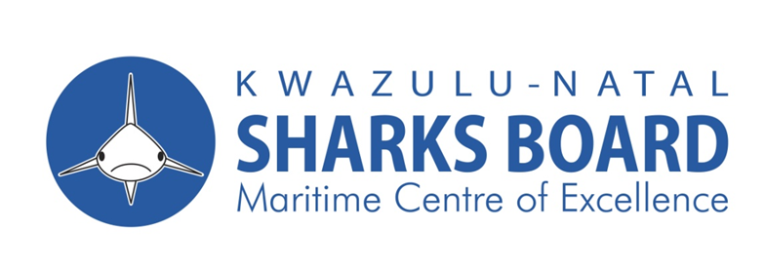
APPOINTMENT OF SERVIVE PROVIDER TO SUPPLY AND DELIVERY OF OUTBOARD MOTORS FOR THE KWAZULU-NATAL SHARKS BOARD MARITIME CENTRE OF EXCELLENCE.

NOTIFICATION OF TENDER
The KwaZulu-Natal Sharks Board Maritime Centre of Excellence invites tenders for the following:
Description | Tender No. | Compulsory Briefing Date | Tender Closing Date | Tender Closing Time
Appointment of service provider to supply and delivery of outboard motors for the Kwazulu-Natal Sharks Board Maritime Centre of Excellence.  Evaluation will be on administrative compliance and mandatory requirements, and 80/20-point on specific goals system. | ZNT26/27KZNSB01 | 10 June 2026 | 23 June 2026 | 11h00

- A compulsory briefing session with the representatives of the KwaZulu-Natal Sharks Board will take place at the Hall, 1a Herrwood Drive uMhlanga Rocks at 11:00 am.
- Tenders should provide the following:
- Valid BBBEE Certificate
- Proof of registration with the National Treasury Central Supplier Database (CSD): NB Proof to be printed from the National Treasury website
- Proof of registration with Companies Intellectual Property Commission (CIPC)
- Valid Tax Clearance Certification
- Original or certified copy of registration as an authorised outboard motor dealer
- All Supply Chain Management inquiries must be addressed to Ms Nonkululeko Khumalo on 031 566 0400 E-mail: nonkululeko@shark.co.za and all Technical queries to Mr. Wayne Harrison on 083 778 9838 E-mail:harrisonw@shark.co.za.
- Telegraphic, telephonic, telex, facsimile and late tenders will not be accepted.

- Bids Documents Available at KwaZulu – Natal Sharks Board, 1a Herrwood Drive, Umhlanga.
- Submission of Bids: Sealed envelopes clearly marked with the relevant bid number, closing date and time and Bidders name must be deposited into the bid box at the Sharks Board premises at the Ground Floor, 1a Herrwood Drive Mhlanga, 4320.
- NB: A non – refundable deposit of R300.00 for the tender document is payable into KwaZulu – Natal Sharks Board bank account as mentioned below with reference “Tender”.
- The Banking details are as follows: Bank: ABSA, Account Number 1012341080, Account Holder: KZN Sharks Board, Branch: La Lucia Ridge.
- The tender document will be available 29 June 2026 – 09 June 2026 during working hours from 08H00 to 15H30. and may be collected upon producing proof of payment (deposit slip: no cash will be accepted).
- Tender documents will not be issued on the date of the briefing and after briefing session.
- An original valid Tax Clearance Certificate and valid B-BBEE Status Level Verification Certificate must accompany the bid.

