

SUNDAYS RIVER VALLEY LOCAL MUNICIPALITY
BID INVITATION
RE-ADVERTISEMENT: COMPILATION OF MUNICIPAL VALUATION ROLL FOR
SUNDAYS RIVER VALLEY MUNICIPALITY
BID NO: SRVM 007/2024B

Sundays River Valley Municipality invites suitable qualified and experienced service providers for the following service: Compilation of Municipal Valuation Roll for Sundays River Valley Municipality.
The physical address for collection of tender documents is: SRVM Cashiers Office, No. 23 Middle Street, Kirkwood.Documents may be collected during working hours from 08:30AM till 16:00PM from 22nd of April 2025. A compulsory briefing session will be held at 10H00AM on the 24th April 2025 (Cut-Off 10:15AM), at the Sundays River Valley Council Chambers, 23 Middle Street, Kirkwood.
Tender documents will be available at a non-refundable deposit of R 300.00 each (no cash accepted) Bank details are as follow: First National Bank, Account Number 620 254 90856, Branch Number 210817, Reference – Tender Number. Proof of payment should be provided upon tender collection.
Bids are to be completed in accordance with the conditions and bid rules contained in the bid document and supporting documents must be placed in a sealed envelope and externally endorsed WITH THE BID NUMBER, DESCRIPTION AND CLOSING DATE OF THE BID, and be deposited in the Bid box, at the offices of the Sundays River Valley Municipality, Supply Chain Office, No. 23 Middle Street, Kirkwood not later than 13 May 2025 at 12h00 PM.
TENDERS WILL BE EVALUATED INTERMS OF THE 80/20 PREFERENTIAL POINT SYSTEM AS PER PREFERENTIAL PROCUREMENT REGULATION,2022.AS WELL AS FUNCTIONALITY.

Stage 1 Evaluation - Functionality
SECTION A:COMPANY PROFILE
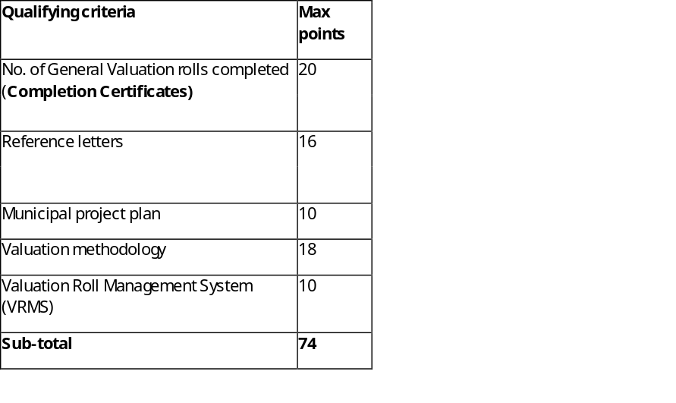
SECTION B: HUMAN RESOURCE
Item | Qualifying criteria | Max points
Municipal Valuer | Relevant Degree/Diploma | 5
Municipal Valuer | Experience of 1-4 years | 10
Municipal Valuer | Experience of 5-9 years | 10
Municipal Valuer | Experience of 10 or more | 10
Municipal Valuer | Registered with the relevant body (South African Council for the Property Valuers Profession) | 5
Human resources capacity | List of the team and its qualifications with Curriculum Vitae.  - Assistant Valuer  - Relevant Degree/diploma  - Be registered with the relevant body (South African Council for the Property Valuers Profession)  - Other team members  Qualifications and Curriculum Vitae | 2  4
 | Sub-total score | 26

A bidder that scored less than 70% out of 100 in respect of functionality will be regarded as submitting a non-responsive tender and will be disqualified and will not be evaluated further.

Stage 2 Evaluation - Price & Specific Goals
Evaluation Criteria | Points
Price | 80
Specific Goals – B-BBEE (Original or certified B-BBEE Certificate) | 10
LED (Proof of address signed by ward Councillor / Lease Agreement) | 10
Total | 100

SUPPLIERS/SERVICE PROVIDERS SHALL TAKE NOTE OF THE FOLLOWING BID CONDITIONS:
[a] Sundays River Valley Municipality Supply Chain Management Policy will apply;
[b] Sundays River Valley Municipality does not bind itself to accept the lowest BID or any other BID and reserves the right to accept the whole or part of the BID;
[c] Bids which are late, incomplete, unsigned or submitted by facsimile or electronically, will not be accepted.
[d] Price(s) quoted must be valid for at least ninety (90) days from the date of your offer.
[e] Price(s) quoted must be firm and must be inclusive of VAT.
[f] A firm delivery period must be indicated.
[h] The following compulsory documents must be submitted with the tender.
1. Valid Tax Clearance Certificate- OR Status Pin.
2. B-BBEE Certificate Original or Certified copy OR Sworn Affidavit Original or Certified Copy
3. Original certified ID Copies of Entity’s Director(s)
(Certification not older than 3 months before the closing date)
4.Completed MBD forms 1-9
5. Company registration Documents.
6. Municipal statement of Rates or Billing Clearance not older than three months or valid Lease Agreement
7. Proof of Central Supplier Database (CSD) registration- a full report printed

Failure to submit any of the above requested documents will invalidate your bid and it will not be evaluated further.

Technical enquiries related to this bid can be directed to ncediwej@srvm.gov.za or 042 230 7750.SCM enquiries related to this bid can be directed to phelokazin@srvm.gov.za or 042 230 7777.

MR T. KLAAS
MUNICIPAL MANAGER

