Deployment Test Results- 31 July 2026. As of 05 August 2026
- Evaluation notification must be displayed as a pop-up upon user login. ON UAT.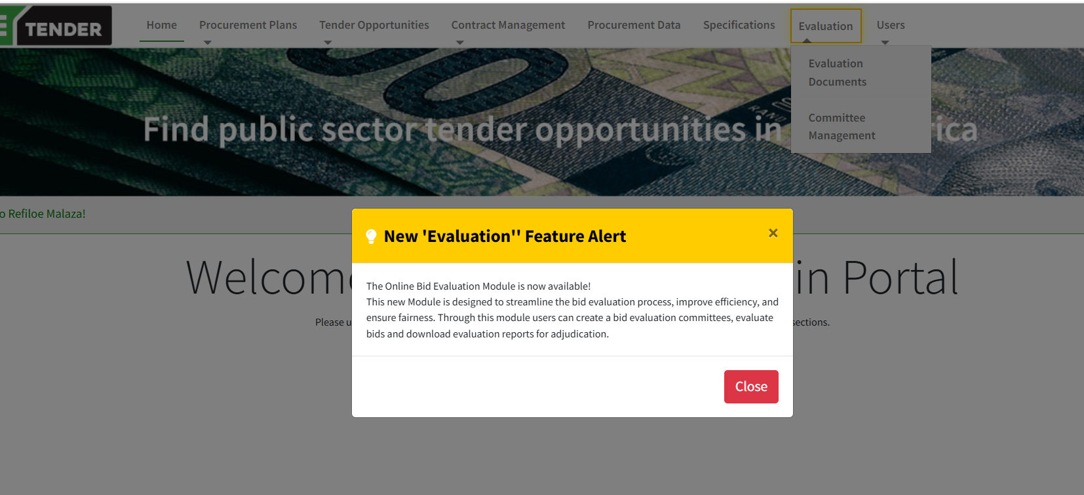

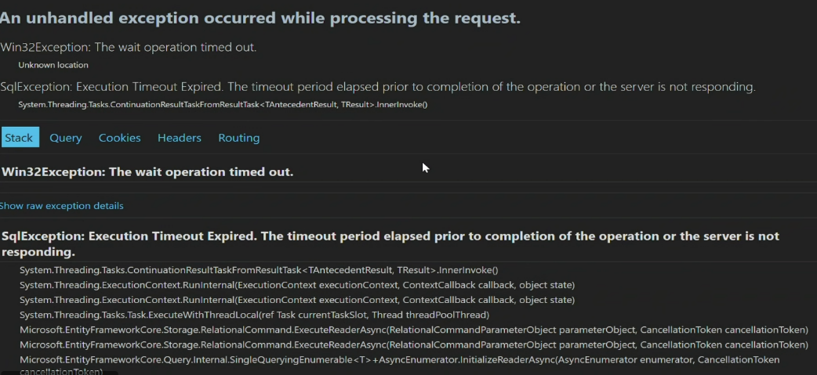
- Time out error when logging in. DATABASE ISSUE ADDRESSED DURING DEPLOYMENT

- SBD forms not appearing when capturing the tender. DATABASE ISSUE ADDRESSED DURING DEPLOYMENT
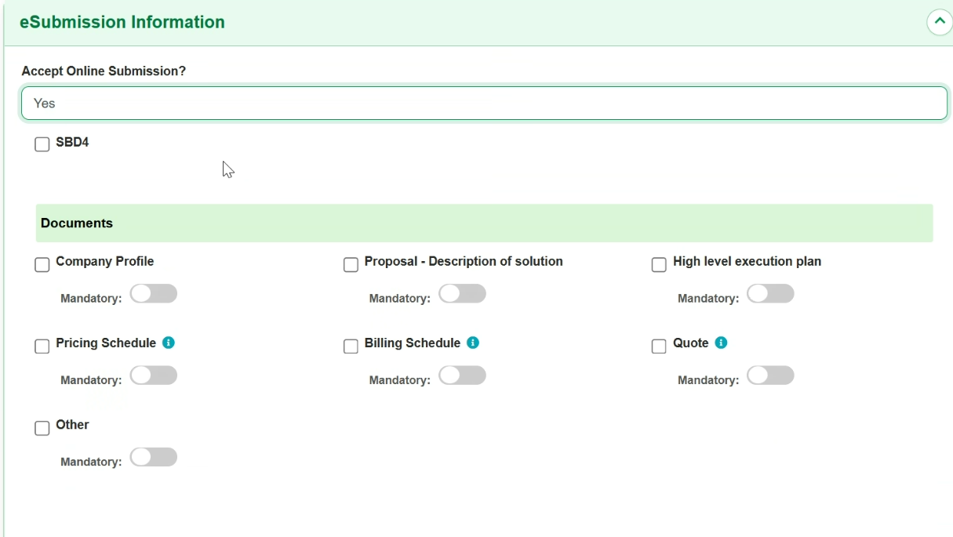

- Evaluation Notification: The evaluation notification is displayed successfully upon login. However, the notification alert title must be changed to "New Feature Alert." ON UAT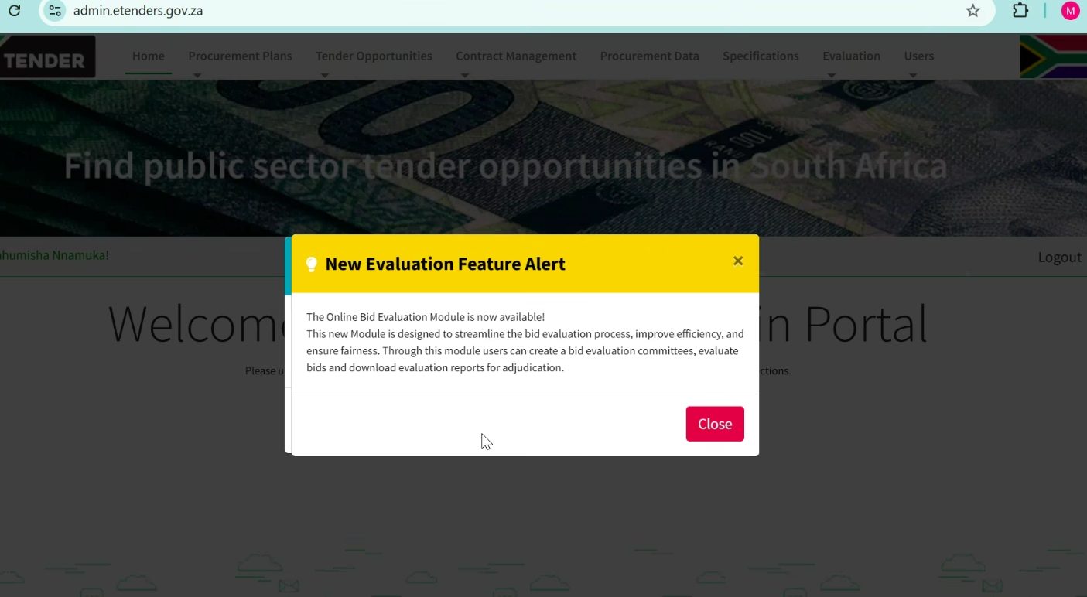

- Notification appearing on create price list as well – to be removed. ON UAT
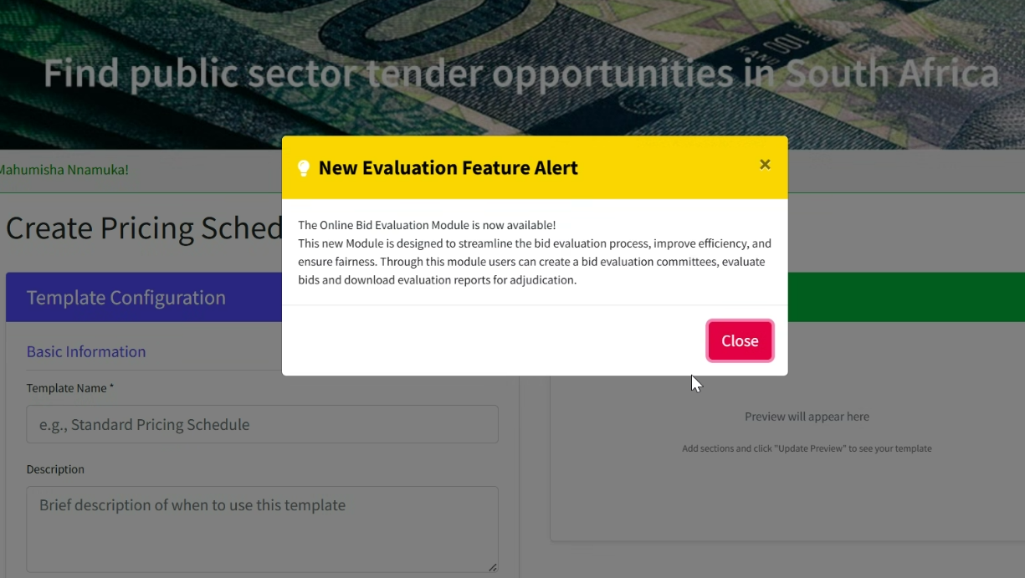

- Rename Goal Specific Criteria to Specific Goals. ON UAT
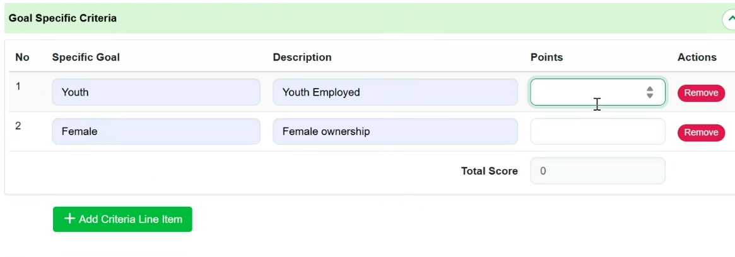
- Pricing schedule not appearing as a form- failed. ADDRESSED DURING DEPLOYMENT. FIXED ON UAT AND PROD.
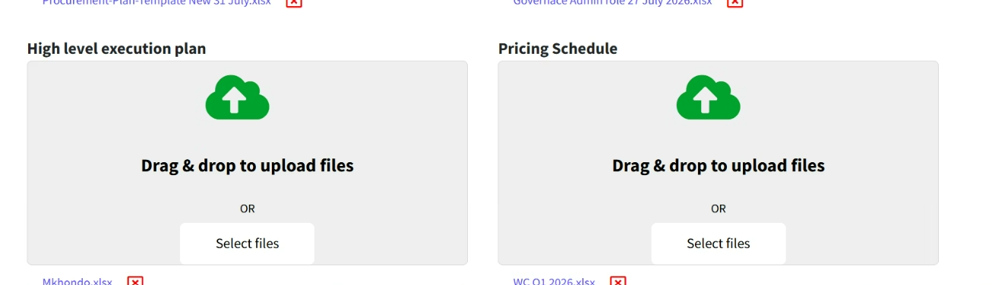
- Error. DATABASE ISSUE ADDRESSED DURING DEPLOYMENT
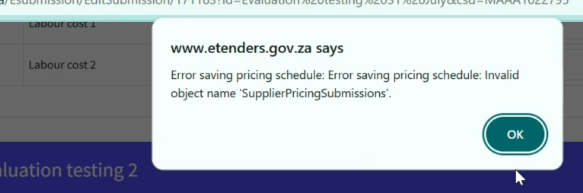

- Committee roles are not appearing. DATABASE ISSUE ADDRESSED DURING DEPLOYMENT.
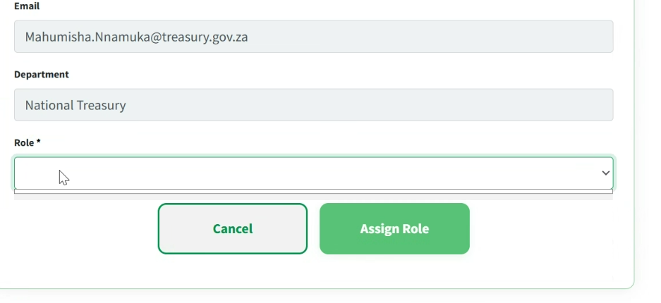
- Error when clicking evaluation. DATABASE ISSUE ADDRESSED DURING DEPLOYMENT
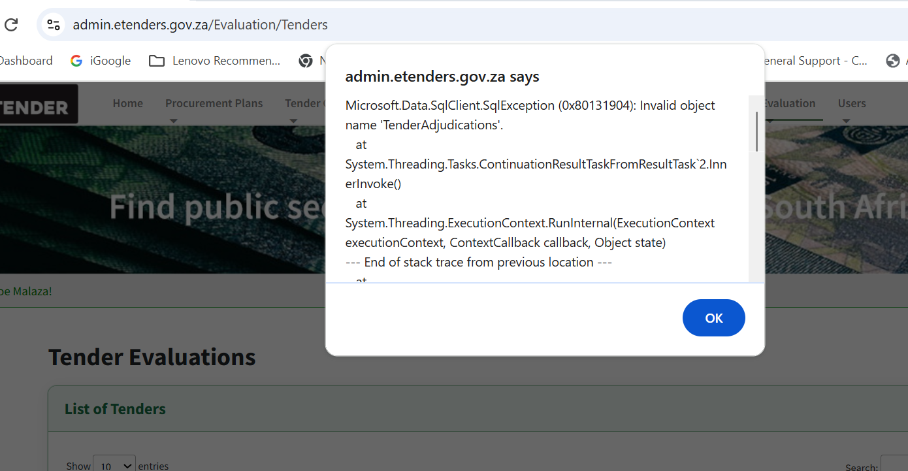

- Name of the evaluation documents are not appearing. DATABASE ISSUE ADDRESSED DURING DEPLOYMENT
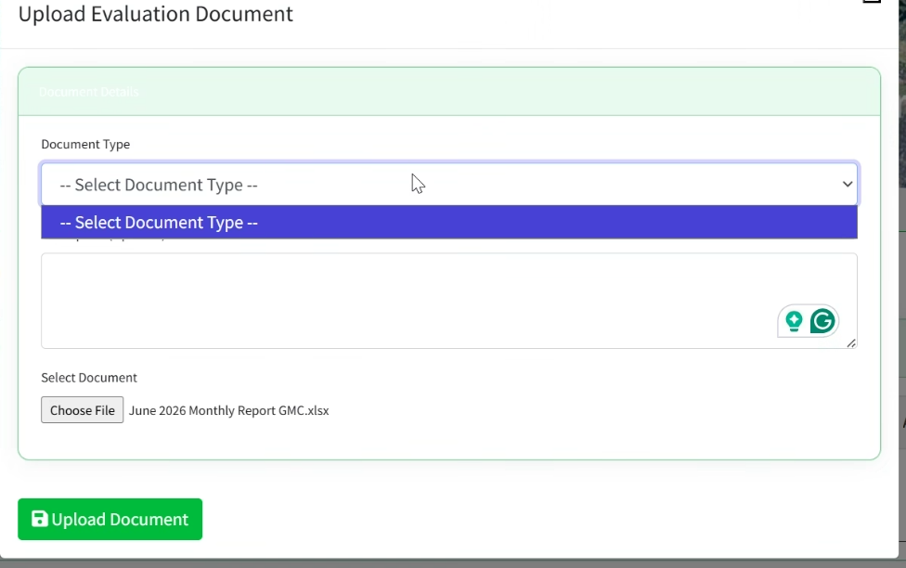
- Unable to export evaluation report to excel error messages appear below. ISSUE ADDRESSED DURING DEPLOYMENT.
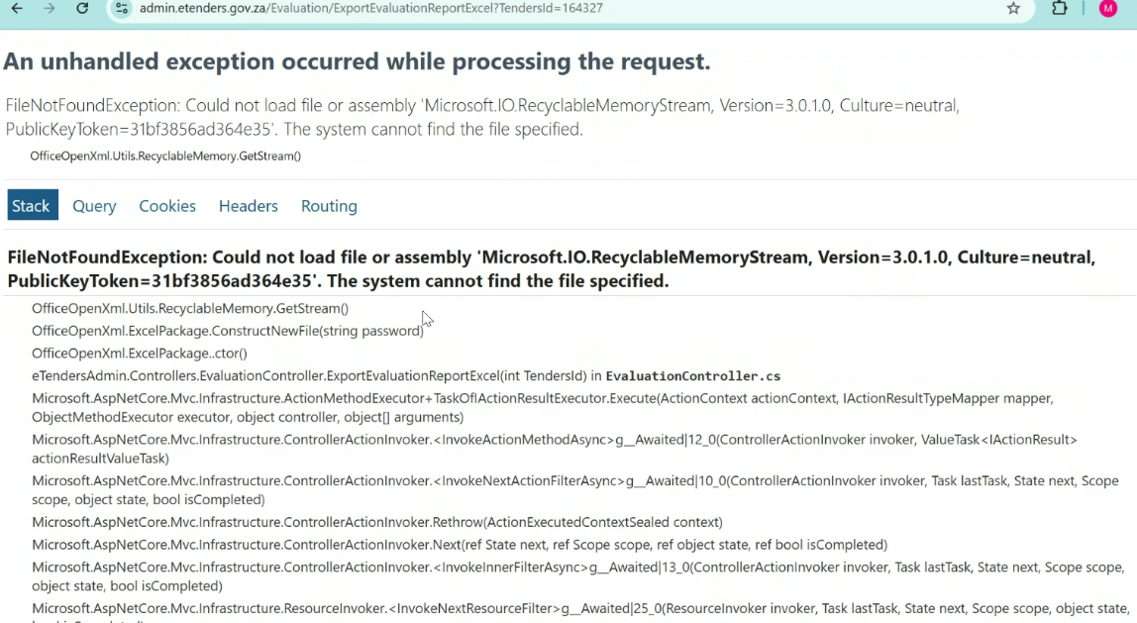
- The styling and font used for the Evaluation menu option are inconsistent with the other menu options. ON UAT
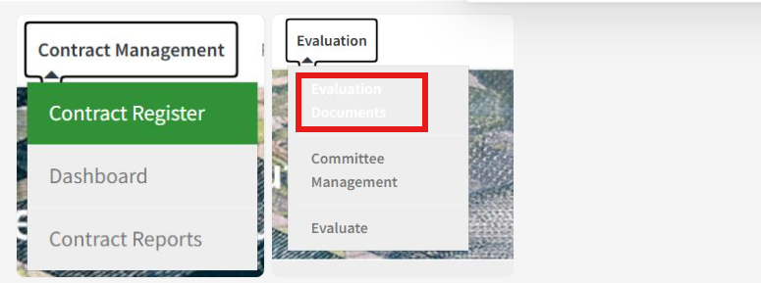

- The heading of the notification pop-up should be changed to "New Feature Alert." ON UAT.
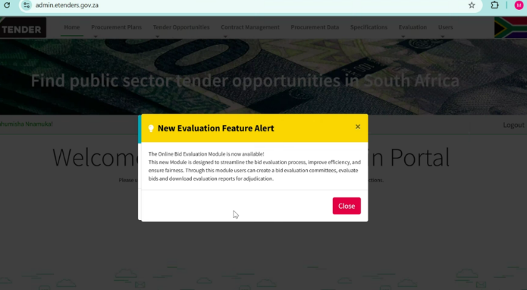

- Include evaluation status. ON UAT
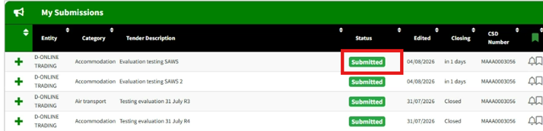

- Must be written as “Back to bidders”. ON UAT
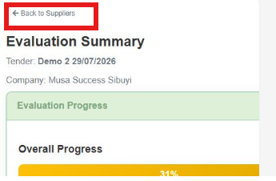

- Remove “allow supplier to attached supporting documents”. ON UAT

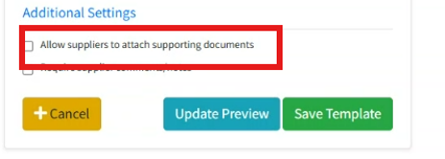
- The response documents - attachments being removed upon reload. ON UAT
- Adding ordering on the evaluation tables. ON UAT

