SCOPE OF WORK

OPTIC FIBRE RETICULATION AND LAN INSTALLATION
- Introduction.
Sentech is inviting quotations from qualified and accredited service providers for the Optical Fibre Reticulation and LAN Points Installation at its Durban Branch Campus.

The scope of work includes the supply, installation, and commissioning of optical fibre cabling (OM4 multimode) to interconnect four (4) buildings within the same campus, as well as the installation of network racks, patch panels, and LAN points in accordance with the specifications outlined below.

A mandatory site briefing session will be held, during which all potential bidders will be allowed to inspect the site and take measurements.

Note: Suppliers who do not attend the site briefing will not be permitted to submit quotations.

The successful bidder will be expected to:

- Provide a signed company letter on official letterhead confirming compliance with the specifications in this document.
- Supply and install all specified network and fibre equipment at Sentech Durban Branch.
- Install and run OM4 multimode optical fibre cabling as per specifications.
- Install and terminate LAN network points as per requirements.
- Provide test certificates for all installed fibre and copper (cat 6) terminations.
- Submit as-built documentation, including full diagrams and test results.
- Commission and hand over the installation in full working order.

- Scope of work

2.1. Installation Address
Site: Sentech Durban Branch
Address:
217 Umhlanga Rocks Drive
Durban North, Durban, 4051

2.2. Layout Diagrams

2.2.1. OM4 Multimode Fibre Reticulation Layout
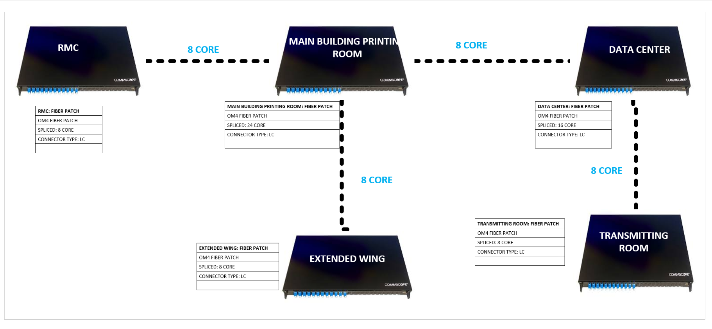

2.2.2. Network Rack Configuration
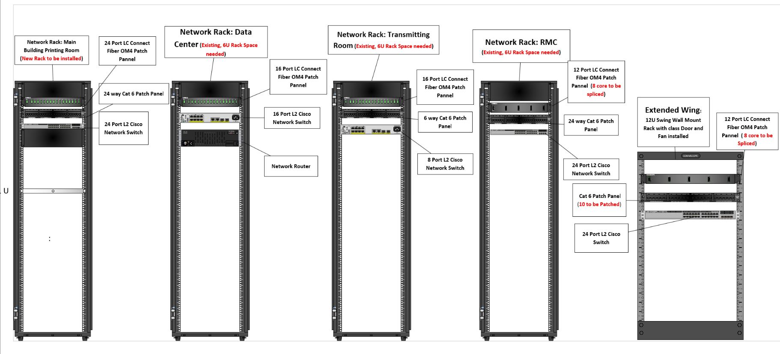

2.3. Technical Specifications
2.3.1. Main building
- 1 × 42U (1m deep) floor-standing network rack with perforated front and rear doors.
- 2 × 24-port Cat 6 patch panels, all ports patched.
- 1 × 24-core OM4 multimode fibre patch panel (LC connectors, fully spliced).
2.3.2. Regional Monitoring Centre (RMC)
- 1 × 24-port Cat 6 patch panel, 6 network points patched.
- 1 × 8-core OM4 multimode fibre patch panel (LC connectors, fully spliced).
2.3.3. Main Biulding Extended Wing
- 1 × 12U wall-mounted network rack with glass door and dual extraction fans.
- 1 × 8-core OM4 multimode fibre patch panel (LC connectors, fully spliced).
- 1 × 24-port Cat 6 patch panel, 10 network points patched.
2.3.4. Data Centre
- 1 × 16-core OM4 multimode fibre patch panel (LC connectors, fully spliced).
2.3.5. Transmitting Room
- 1 × 12U wall-mounted network rack with glass door and extraction fans.
- 1 × 6-port Cat 6 patch panel, 2 network points patched.
- 1 × 4-core OM4 multimode fibre patch panel (LC connectors, fully spliced).
2.4. Bill of Materials (BOM
A detailed Bill of Materials (BOM) must be submitted by the supplier and should include, but not be limited to, the following items:
- Network racks (as per site specification)
- Cat 6 patch panels and accessories
- OM4 multimode fibre (LC connectors, pre-terminated or fusion spliced)
- Patch leads (Cat 6 and LC-LC)
- Brush panels, cable managers, and cable trays
- Labelling and documentation materials

