REQUEST FOR QUOTATION (RFQ) NUMBER: | PR10115783 (Please use this number as reference when sending quotations and supporting documentation)
DESCRIPTION | The Road Accident Fund (RAF) wishes to appoint a suitable service provider to provide Servicing of Fire Suppression System at the Durban Office.
RFQ ISSUED DATE | 11 May 2026
RFQ VALIDITY PERIOD | 30 days from the closing date.
CLOSING DATE AND TIME | 20 May 2026 at 11h00 am.
EXPECTED DATE SERVICES IS REQUIRED | Once purchase order has been issued
COMPULSORY BRIEFING SESSION/  SITE VISIT/SITE INSPECTION | n/a
DELIVERY ADDRESS OF GOODS/SERVICES | RAF, 12TH Floor Embassy Building 199 Anton Lembede Street Durban 4000
RFQ RESPONSES MUST BE EMAILED TO: | For Durban all quotations should be emailed to  Rfq-durban.procurement@raf.co.za. Failure to follow these instructions will result in your quote not being considered.
ENQUIRIES REGARDING THIS RFQ SHOULD BE SUBMITTED VIA E-MAIL TO | Enquires can be directed at this e-mail address Phakamaniz@raf.co.za. For further enquiries, you may contact Phakamani on 031 365 2979.

Important Notes to this RFQ:
- Service providers/suppliers should ensure that RFQ responses are emailed to the correct email address;
(rfq-durban.procurement@raf.co.za.)
- If the quotation is late, it shall not be accepted for consideration.
- The RAF reception is generally accessible 8 hours a day (07h45 to 16h00); 5 days a week (Monday to Friday) for delivery of goods.
- All suppliers are required to complete and sign all Annexures to this document (Standard Bidding Documents and documents for submission under Mandatary Evaluation, where applicable).
- Points claimed for Preferential Procurement Specific Goals will be verified through CSD.
- Suppliers who have a disability must provide a valid medical certificate issued by a registered medical practitioner as proof of disability (RAF reserves the right to verify this information).
- RAF will ONLY conduct business with CSD Registered suppliers.
- Collusive behaviour by the bidder will result in disqualification. A bidder is not permitted to submit more than one proposals from more than one registered company with a common director / shareholder/s. This is deemed eroding the ethos of competition as prescribed. In addition, bidders may not respond to one invitation with more than one entity, if they do both/all companies will be disqualified.
- Should you not be contacted within 14 working days of an issued RFQ, consider your proposal/quotation unsuccessful.

Prohibition of Gifts & Hospitality:
“Except for the specific goods or service procured by the Road Accident Fund, service providers/suppliers are required not to offer any gift, hospitality or other benefit to any RAF official. To avoid doubt, branded marketing material is considered to be a gift. Furthermore, should any RAF official request a gift, hospitality or other benefit, the service providers must report the matter to our toll-free fraud line at 0800 005919.” If solicited bribery matters are not reported, service provider will be deemed an accomplice and will be restricted from conducting business with all Organs of State.
*HDI - means a South African Citizen who (a) due to the apartheid policy, had no franchise in national elections prior to the introduction of the Constitution of the Republic of South Africa, 1983(Act No.110 of 1983) or the Interim Constitution of the Republic of South Africa,1993 (Act No.200 of 1993); (b) is a female; or (c) has a disability.

CONTENTS

Annex A : TERMS AND CONDITIONS OF REQUEST FOR QUOTATION (RFQ) 3
Annex B : GENERAL CONDITIONS OF CONTRACT 4
Annex C : RFQ SPECIFICATION 5
Annex D : EVALUATION CRITERIA 6
Annex E : COST BREAK DOWN 8
Annex F : STANDARD BIDDING DOCUMENTS 9
- TERMS AND CONDITIONS OF REQUEST FOR QUOTATION (RFQ)
SERVICE PROVIDER/SUPPLIER: ………………………………………………………………………..
REGISTRATION NUMBER: ……………………………………………………………………….
CSD UNIQUE SUPPLIER REGISTRATION NUMBER: ……………………………………………………………………….
ADDRESS: ……………………………………………………………………….
CONTACT PERSON: ………………………………………………………………………..
TEL: …………………………………………………………………........
- RAF’s standard conditions of purchase shall apply.
- RAF will not conduct business with suppliers whose tax matters are not declared to be in order by SARS.
- Goods or services shall be delivered and accepted against an official and RAF Award Letter or Purchase Order (PO) signed and duly authorised RAF official.
- The RAF reserves the right to not make payment or accept the goods or services should the goods or services be delivered to the RAF before the RAF Award Letter or PO is issued. (An official authorised RAF PO should have the Supply Chain Management (SCM): Manager signature or such other official duly authorised in terms of the RAF’s Delegations of Authority and Approval Framework),Description of the item, Quantity of items purchased, Date of delivery of the item, Total amount of the items purchased inclusive of where applicable VAT and other applicable taxes.
- This RFQ will be evaluated based on the 80/20 preference point system applicable to bids with a Rand value equal to, or above R2 000.01 and up to a rand value of R1 000 000.00 (all applicable taxes included). The RAF may elect to apply the 80/20 preference point system to price quotations with a rand value less than R2 000.01.

I, the undersigned (NAME)……….………………………………………certify that:
I have read and understood the conditions of this RFQ.
I have supplied the required information, and the information submitted as part of this RFQ is true and correct.

Signature: ______________________________ Date: ______________

Capacity: _________________________
- GENERAL CONDITIONS OF CONTRACT

http://ocpo.treasury.gov.za/Resource_Centre/Legislation/General%20Conditions%20of%20Contract-%20Inclusion%20of%20par%2034%20CIBD.pdf

- RFQ SPECIFICATION

BACKGROUND TO THE ROAD ACCIDENT FUND
The Road Accident Fund (RAF) is a schedule 3A Public Entity established in terms of the Road Accident Fund Act, 1996 (Act No. 56 of 1996), as amended. Its mandate is the provision of compulsory social insurance cover to all users of South African roads, to rehabilitate and compensate persons injured as a result of the negligent driving of motor vehicles in a timely and caring manner, and to actively promote the safe use of our roads.

The customer base of the RAF comprises not only the South African public, but all foreigners who may have had accidents within the borders of the country. The RAF head office is in Centurion there will be other Customer Experience Centres in each province in the country.

BACKGROUND OF THE PROJECT
The Road Accident Fund (RAF) wishes to appoint a suitable service provider to provide Servicing of Fire Suppression System at the Durban Office (once off).

DETAILED SPECIFICATION
Requesting a service provider to provide Servicing of Fire Suppression System at the Durban Office.

- Servicing of 4x cylinders of 102.2 kg.

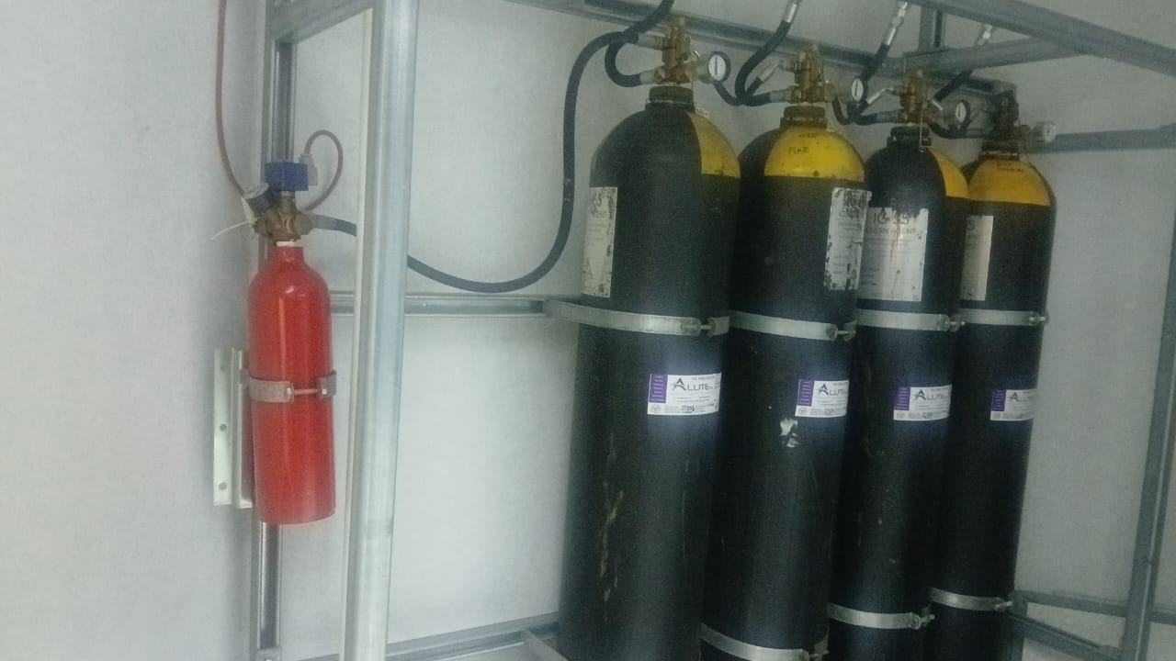

- Servicing of control panel, smoke detectors & sensors

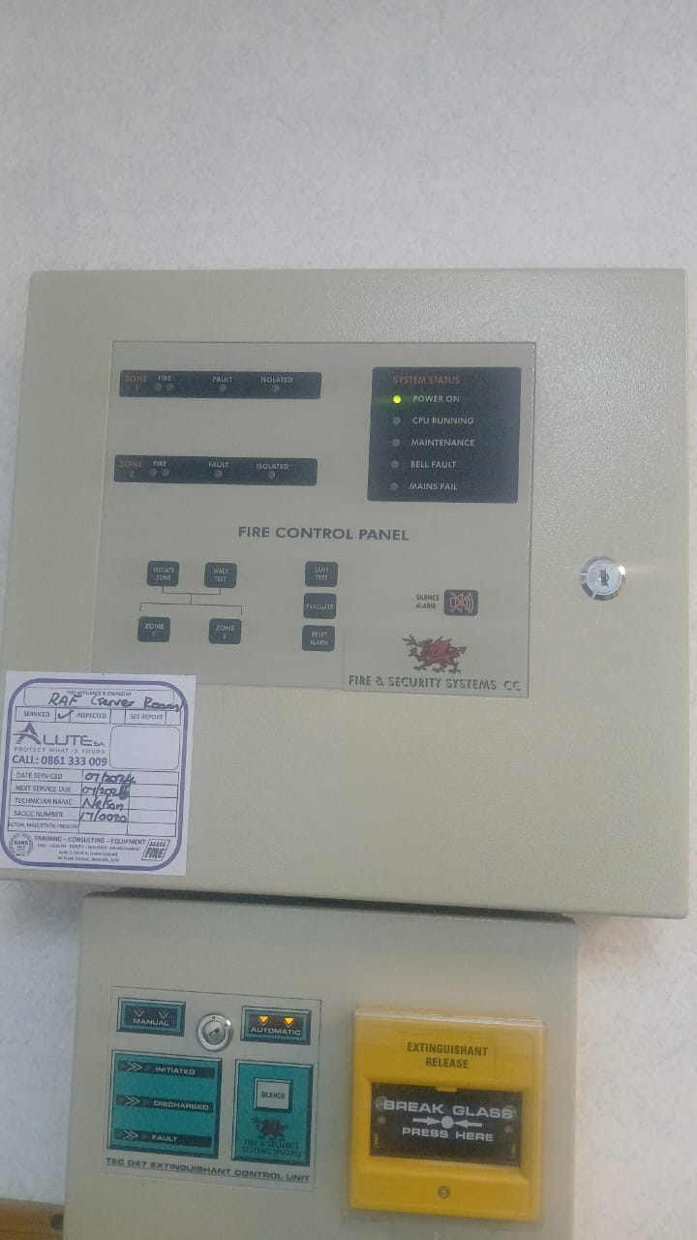

- Replace Rechargeable 2x Batteries VS7A-12 12v 7Ah
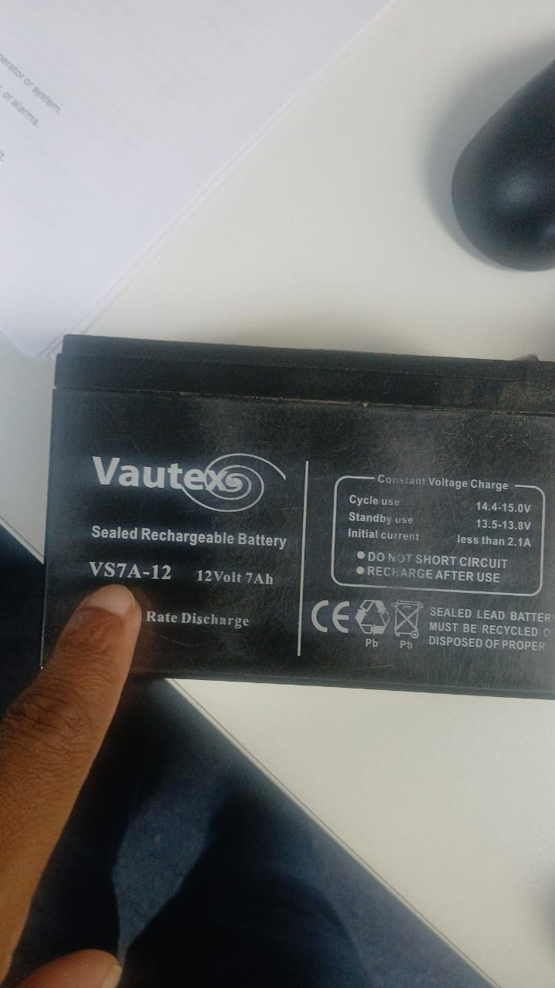

- Servicing of fire extinguishers x 15

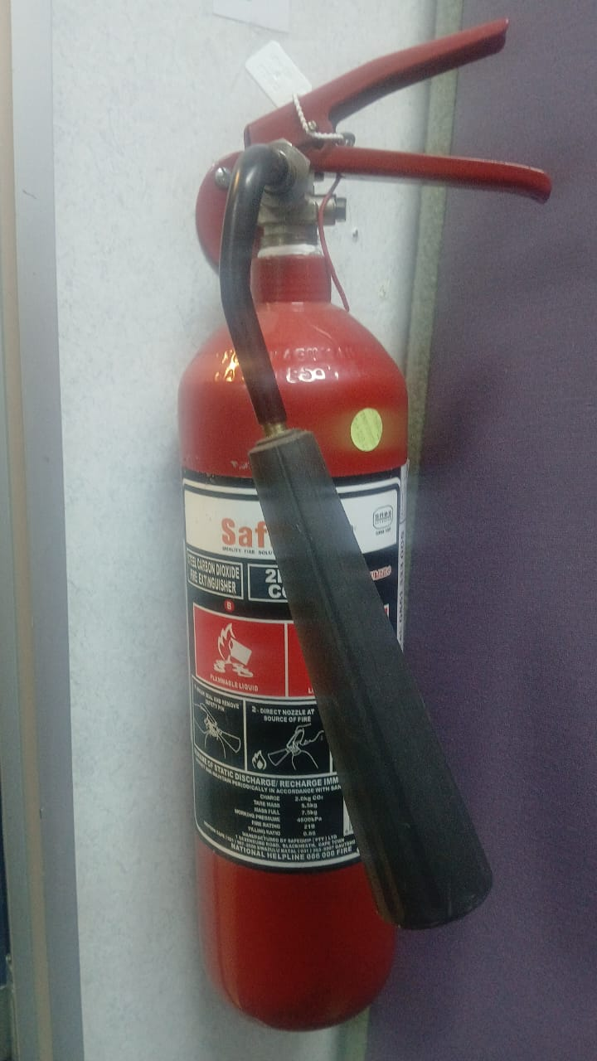

- One Pilot cylinder (140 bar) need to be upgraded or replaced with the modern version

- NB: Service certificate is required after completion.

- EVALUATION CRITERIA
- The evaluation criteria will be based on the following requirements:
- Mandatory Requirements.
- Evaluation for Price and Specific Goals based preference system on the 80/20.

All Bidders who do not meet Mandatory Requirements will be disqualified and will not be considered for further
evaluation on Price and Specific Goals based preference system on the 80/20

Phase 1. Mandatory Requirements

Service Providers must indicate by ticking (√) correct box indicating that they Comply OR do Not Comply.

Number | Description | Comply | Not Comply
1 | The bidder must submit Letter of Good Standing that complies with the Compensation for Occupational Injuries and Disease Act, Act 130 of 1993 (COIDA). The successful bidder will be required to comply with the requirements of Occupational Health and Safety Act, Act 85 of 1993.  The Letter of Good standing must comply where the Nature of Business is that for electrician / electrical contractors / building works & services / engineering / manufacturing and installation / mechanical engineering / Fire Equipment / Install and Service Fire extinguishers / Fire & Security / Security Equipment  Note: The COIDA certificate of good standing may not be older than twelve (12) months and can either be from the Department of Labour / RMA / FEM or the industry equivalent thereof.  The service provider must provide valid proof by the closing date and time of the RFQ.
Substantiate / Comment

- Price and Specific Goals Evaluations

The evaluation for Price and points claimed for Preferential Procurement Specific Goals, in terms of Preferential Procurement Policy Framework Act, 2022, shall be based on the 80/20 principle as follows:

Evaluation criteria |  | Points
1. | Price | 80
2. | Specific Goals | 20
  # | Specific Goal | Proof | Points Allocation
  1 | An HDI refers to a South African citizen who had no franchise in national elections prior to the introduction of the Constitution of the Republic of South Africa, (Act N0. 8 of 1996) or the Constitution of the Republic of South Africa, Act NO.5 of 2005. (Includes a minimum of 51% ownership or more) | CSD Report | 10
  2 | Women  (minimum 51% ownership or more) | ID copy / CSD report | 8
  3 | (Persons living with disabilities  (minimum 51% ownership or more) | Valid medical certificate issued by an accredited medical practitioner | 2
Total |  | 100

- COST BREAK DOWN

- All prices must be VAT inclusive (if VAT registered) and must be quoted in South African Rand (ZAR). All VAT vendors are required to include VAT on their proposed prices, should they fail to do so the actual quoted price will be deemed an all-inclusive price and will be accepted as such. No VAT amount will be included after the award.
- Should the service provider who is not VAT-registered charge VAT, the service provider will be automatically disqualified.
- Only prices completed on the RFQ document under Annexure E will be accepted for evaluation purposes, failure to provide price on the cost breakdown table will lead to disqualification.

- No price changes will be accepted after the official Award Letter / Purchase Order (PO) is issued.
NO. | ITEM DESCRIPTION | QUANTITIES | UNIT PRICE | TOTAL PRICE
1 | Servicing 4x RAF cylinders  as per the specification on Annexure C. | 4
2 | Servicing of 1x control panel, 2x smoke detectors & sensors.  as per the specification on Annexure C. | Sum
3 | Replace Rechargeable 2x Batteries VS7A-12 12v 7Ah  as per the specification on Annexure C. | 2
4 | Servicing of fire extinguishers  as per the specification on Annexure C. | 15
5 | Servicing of 1x Pilot cylinder  as per the specification on Annexure C. | 1
GRAND TOTAL
VAT (IF VAT REGISTERED)
GRAND TOTAL (VAT INCLUSIVE - IF VAT REGISTERED)

I, the undersigned (Name and Surname) ________________________________________ certify that I agree to render the services as per the specification and as per the above cost breakdown.

Signature of service provider: _____________________________.

- STANDARD BIDDING DOCUMENTS

SBD 4 Bidders Disclosure

SBD 6.1 in Terms of PPR 2022

Annexure A: Security Measures

