ENOCH MGIJIMA LOCAL MUNICIPALITY
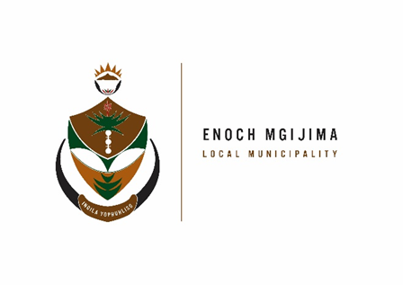
TENDER NOTICES

PROJECT NAME | NOTICE NUMBER | DOCUMENT PRICE | CIDB GRADING | PPPFA | COMPULSORY BRIEFING MEETING | ENQURIES | CLOSING DATE
(Re-advert) Construction of Molteno Cemetery | SCM02/01/2023 | R300.00 | 4CE or Higher | 80/20 | Time: 10h00  Venue: 39 Smith Street, Molteno, 5500  Date: 06 February 2023 | Mr. P Gamedala  PGanedela@enochmgijima.gov.za  0458076000 | 14 February 2023 at 12h00  Tender Closing register will be posted on the Municipal website
(Re-advert) Construction of Sterkstroom cemetery | SCM03/01/2023 | R300.00 | 4CE or Higher | 80/20 | Time: 10h00  Venue: Main Road, Municipal Building ,  Date: 07 February 2023 | Mr. P Gamedala  PGanedela@enochmgijima.gov.za  0458076000 | 15 February 2023 at 12h00  Tender Closing register will be posted on the Municipal website
(Re-advert) Construction of Tarkastad Cemetery | SCM04/01/2023 | R300.00 | 4CE or Higher | 80/20 | Time: 10h00  Venue: 12 Murray Street, Tarkastad  Date: 08 February 2023 | Mr. P Gamedala  PGanedela@enochmgijima.gov.za  0458076000 | 16 February 2023 at 12h00  Tender Closing register will be posted on the Municipal website
Upgrading Of Bells Road, Komani (Former Queenstown -Ward 09) | SCM05/01/2023 | R300.00 | 6CE or Higher | 80/20 | Time: 10h00  Venue:No.20 Brewery Street;Technical Services, Komani, 5320  Date: 09 February 2023 | Mr. Gamedala  PGanedela@enochmgijima.gov.za  0458076000 | 17 February 2023 at 12h00  Tender Closing register will be posted on the Municipal website

Bids are hereby invited from suitably qualified service providers for the projects listed above and must also take note of the following.
Bid documents containing detailed terms of reference will be available as from Monday, 30 January 2023 ; 08h00 - 16h00 week days, from the Supply Chain Management offices: Budget and treasury offices at No. 25-27 Owen Street; Queenstown upon payment of a non–refundable fee (either in cash or by means of an EFT made payable to the Enoch Mgijima Local Municipality) . Completed bid documents are to be place in a sealed envelope clearly marked the Bid number and Project Name and must be deposited in a bid Box situated at Budget and treasury offices at No. 25-27 Owen Street; Queenstown no later than 12h00pm on the closing date at which all bids will be opened in public. Banking details: Acc Name: Enoch Mgijima Local Municipality
Bank :FNB
Acc No :62438159809
Acc Type :Cheque
Branch Code : 250655 (internet Banking)
Ref : 3010142551022
More details about the adverts phone Mr. A Hoko on 045 807 2000

Issued By

D A VAN WYK KOMANI HOSPITAL
ACTING MUNICIPAL MANAGER N6 ROUTE
KOMANI

