To whom it may concern | Date | 28 September 2026
To whom it may concern | Enquiries | 2
To whom it may concern | E-mail address | lebekogb@eskom.co.za
Dear Sir/Madam
Request for Enquiry Number | E3508GXNOU
Description / Project Title | The supply and delivery of whole or part of the scope for various Control & Instrumentation consumables & components at Koeberg Operating Unit for a period of 1 year
Tender Questions Closing Date | 13 October 2026

Item | Questions | Answers | Clarity Published Dates
 | Meeting of 28 September 2026 | All questions are to be directed to Gift Lebeko email – Lebekogb@eskom.co.za as they need to be in written form. Clarification questions and answers will be published on the Eskom Tender Bulletin and National Treasury Website. No late submission will be accepted. Please make sure you have your company and the enquiry number.  Please include your CSD, B-BBEE Certificate, and SARS Certificate in the Commercial folder, together with the ITT. Please separate your submission documents as: Commercial, Exception sheet, Price Schedule, Quality, Technical Evaluation Criteria.  The pricing schedule has been uploaded on E tender and National Treasury, please include the price per unit and total price. CPA is not applicable as this tender is for a period of one year.  Background information  Technical and Quality Requirements  You may read about classification which is a generic term encompassing safety, seismic, quality, environmental and importance-level classifications, as well as the processes used to assign these designations.  These designations are used to establish the technical and quality-assurance requirements for items throughout the various stages of their lifecycle, including design, manufacture, procurement, operation, and, where applicable, demolition.  Importance categories indicate the importance of system, structure and component (SSC) functions, the applicable processes, and the software associated with those SSCs. Specification, as well as the associated quality evaluation criteria applied during the procurement processes.  For this inquiry, we refer specifically to the technical evaluation criteria rather than separate technical and quality evaluation criteria. This is because it spares, and the technical and quality requirements are therefore combined and referred to as the technical evaluation criteria.  Quality Levels  Indicates the level of confidence required by Eskom during the design, manufacturing and procurement phases based on nuclear and/or technical requirements.  The quality levels for products are graded and designated to:  - Quality Level 1 (Q1): Used for structures, components, parts, software, services and processes requiring the highest level of confidence in their design and manufacture, to ensure that safety class, seismic and environmental requirements are met.  - Quality Level 2 (Q2): Used for structures, components, parts, software, services and processes where less stringent but still comprehensive controls are required.  - Quality Level 3 (Q3): Used for structures, components, parts, software, services and processes where final inspection and test are sufficient  - Quality Level 4 (Q4): Used mainly for commercial grade items where certificate of conformance submittal is required  Safety Levels  RD-0034 is applicable to licensed facilities. Quality level 4 not only establishes quality requirements but also imposes safety-level requirements on the licence holder, together with additional management-system and quality-management requirements.  RD-0034 identifies three safety levels. For this inquiry, however, only Level 2 and Level 3 are applicable.  •Level 2 applies to products, structures, systems, components and services that are important to nuclear safety.  •Level 3 applies, using a graded approach, to those items that do not fall within Level 1 or Level 2.  At Koeberg, these requirements are applied in combination with the applicable quality level. Therefore, the safety level and quality level should not be viewed in isolation, they are used together to establish the applicable requirements.  Quality Assurance Requirements  Applicable quality requirements are specified on the 238-769T forms which were issued with the tender documents. All tenderers must sign their acceptance of the Eskom requirements and submit the signed form with their proposal.  The detailed quality requirements are contained in Quality Specification 238-103 “Supplier Quality General Requirements”, which was also published with the tender documentation.  Technical Evaluation Criteria is a Mandatory Returnable  The supplier's response to the technical evaluation criteria must address each requirement in sufficient detail to enable the reviewers to establish whether the requirement has been met. Simple “yes” or “no” responses are therefore not encouraged. Responses must be substantiated with sufficient detail to demonstrate compliance.  Tenderers should provide clear, concise responses addressing each requirement or question in the evaluation criteria. Where deliverables are requested, the relevant evidence, records or documented information must be provided.  Example of the Technical Evaluation Criteria  Q3/L3 and Q4/L3) Technical Evaluation Criteria is an example of one of the technical evaluation criteria issued with the inquiry. There are several evaluation criteria, and the Scope of Work will indicate which criteria are applicable to which item. The technical evaluation criteria are colour coded to align with the corresponding specification on the scope of works, making it easier for suppliers to identify which requirements apply to which item.  Where mandatory requirements apply, these are clearly separated from the remainder of the evaluation criteria. The applicable deliverable that must be submitted is also clearly identified.  Please ensure that any required certificate is current and valid at the time of submission.  For the detailed evaluation criteria, tenderers should pay particular attention to three elements:  1. The criterion – what requirement is being evaluated;  2. The deliverable – what evidence or documentation must be submitted; and  3. The scoring methodology – how the response will be evaluated.  Provision is also made for the tenderer to indicate where the supporting documentation is filed for each specific criterion.  This is important because we expect multiple tender responses containing significant volumes of documentation. Identifying the location of the supporting evidence will assist reviewers in locating the relevant documents and will help streamline the evaluation process.  Q3/L2 (Q3/1E) TECHNICAL EVALUATION CRITERIA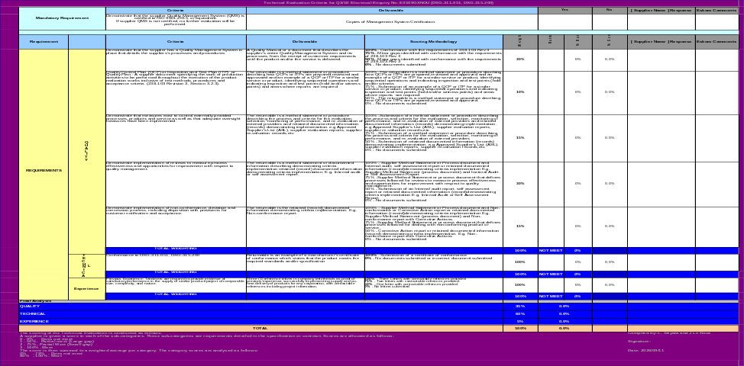  Technical Criteria for Q3/L3 - Enquiry: COMMODITIES DSG-312-123 C & I  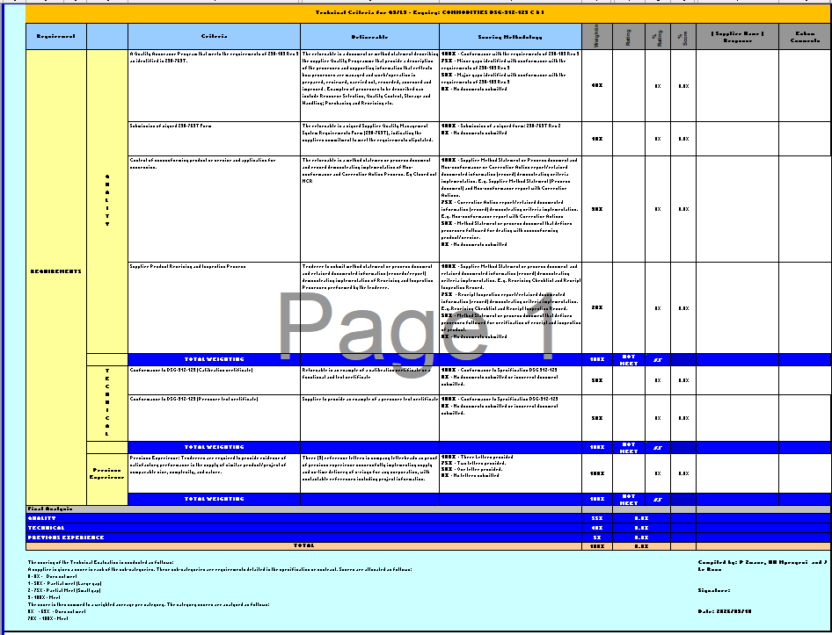  Technical Criteria for Q3L3 Enquiry COMMODITIES DSG-312-135  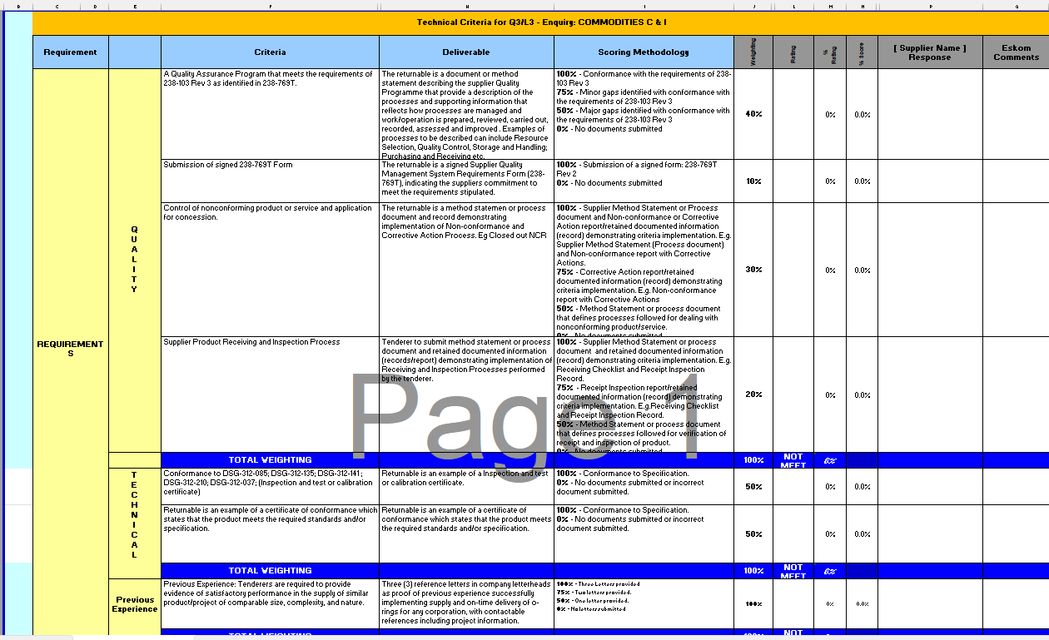  Technical Criteria for Q3/L3 Enquiry: COMMODITIES DSG-316-134 C & I  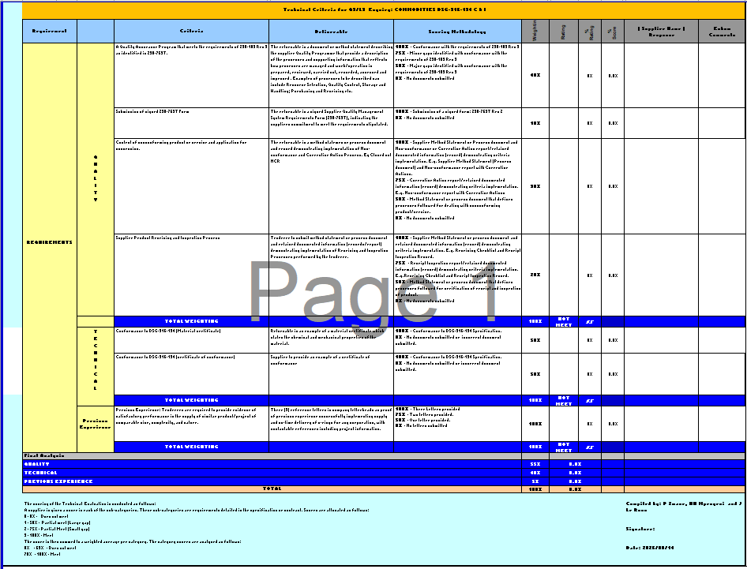  TECHNICAL CRITERIA for Q4L3 with COC - Enquiry COMMODITIES C&I  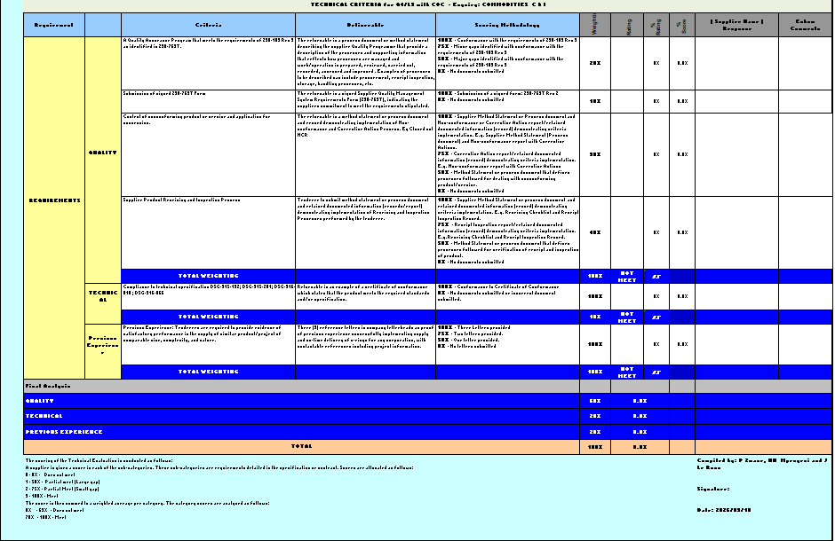  The above slides highlight that the technical evaluation criteria are mandatory and shows examples of the evaluation weighting structure.  The evaluation focuses on areas such as:  - Quality requirements  - Conformance to specifications  - Previous supply experience  SCOPE OF WORK  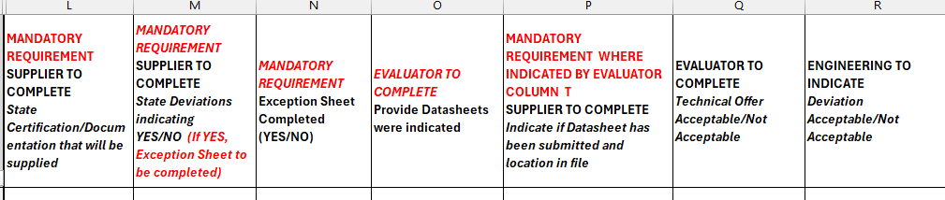  The Scope of Work spreadsheet contains several columns that must be completed by the tenderer. This is not a revision to the scope itself, two additional columns have simply been inserted for:  • Unit price; and  • Total price.  The tenderer must complete the relevant columns to indicate:  • What is being offered;  • Which requirements, standards or codes the item conforms to  • What documentation will be supplied with the item.  Tenderers are encouraged to complete all mandatory information because this assists in confirming that the main offer meets the specified requirements.  Tenderers should also carefully review the item descriptions provided in the Scope of Work and complete an exception sheet whenever a deviation is identified or considered necessary.  Exception Sheets  For this inquiry, exception sheets are included because it may not always be possible to obtain exactly what has been specified. This can occur as a result of technological developments, obsolescence, product changes or material changes.  Any such deviation must be properly configured, documented and controlled. The exception sheet provides the mechanism for managing deviations from the requirements.  Therefore, any deviation from the specified requirements must be documented, with the relevant details provided on the exception sheet.  An administrative change is acceptable only where there is no impact on the item's:  • Form, fit or function;  • Quality or safety classification;  • Regulatory compliance; or  • Technical requirements.  Typical changes, such as a part-number change, must be included in the tender submission for evaluation by Eskom. Furthermore, any clarification relating to obsolescence or a deviation must be supported by appropriate documentation confirming the status of the item. Where obsolescence is claimed, the supporting documentation must originate from the OEM. Documentation generated by an agent or distributor will not be sufficient. The tender may be submitted for all or part of the scope. However, alternative tenders are not permitted; only deviations are allowed. Administrative exceptions will not be regarded as alternative tenders. They will instead be assessed solely to confirm equivalence and continued compliance with the specified technical, quality-assurance and nuclear-safety requirements.  An alternative product may only be offered where the requested product is commercially obsolete. This must be supported by an official letter from the OEM confirming the obsolescence. Where an equivalent alternative product is proposed, the tenderer must provide the relevant data sheet or, at minimum, a catalogue reference to allow the equivalence to be evaluated.  Nuclear Commercial Exception Sheet  The first requirement is that the supplier to ensure that the supplier's name and the applicable RFQ number (Enquiry E3508GXNOU) ware correctly captured on the Exception Sheet. The supplier must also indicate the specific line numbers against which deviations are being raised. Pay particular attention to the three questions at the top of the form, these should be read carefully and answered comprehensively. As mentioned in the presentation, where the deviation relates to a part number change or administrative or documentation change, this must be clearly stated so that reviewer understands the reason for the exception request.  In cases where a part number change is proposed, the supplier must also indicate whether a Certificate of Interchangeability (COI) will be provided. Furthermore, confirmation from the OEM that the original item is obsolete must be submitted. This provides Eskom with assurance that the original product is no longer available and supports the justification for the proposed replacement item.  It has been noted that suppliers often overlook these questions. Suppliers are therefore requested to ensure that the form is completed accurately and in full, as this significantly assists the reviewer during the evaluation process.  Please note that these forms will be reviewed and accepted by Engineering. Providing sufficient detail and supporting justification on the form will facilitate a more efficient review process.  Qualification process  No supplier is excluded from tendering. The onus is on each supplier to verify that they meet the requirements before submitting a tender. If the preferred supplier is not on the approved supplier list for the supply of the relevant items, the supplier will then undergo a qualification process. An assessment will be conducted by means of; End-of-line inspections, surveillances, audits etc to provide the assurance that the supplier has the necessary capabilities to ensure that requirements for the works are met.  Important to note  - EXCEPTION SHEET GUIDE PROVIDED  - SUBMIT EXCEPTION SHEETS WHERE DEVIATIONS APPLY  - SCOPE OF WORKS COLOUR CODED WITH EVALUATION CRITERIA  - DATASHEETS TO BE PROVIDED WHERE APPLICABLE | 02/10/2026

