PREFERRED DESIGN ALTERNATIVE

Design Alternative 1 – ACCM (Aboveground Concrete Casks and Modules)
      - Description of alternative
Alternative 1 – an ACCM (Aboveground Concrete Casks and Modules) storage system – is an aboveground storage of spent fuel in vertical concrete casks and horizontal concrete modules. The alternative represents the current method of storage at most of the reactor-site independent spent fuel storage installations (ISFSIs) around the world. Dual-purpose casks are stored in a heavily reinforced vertical concrete overpack (large vertical cylindrical cask) or horizontal storage module (a rectangular prism) as shown in Figure 4.1.
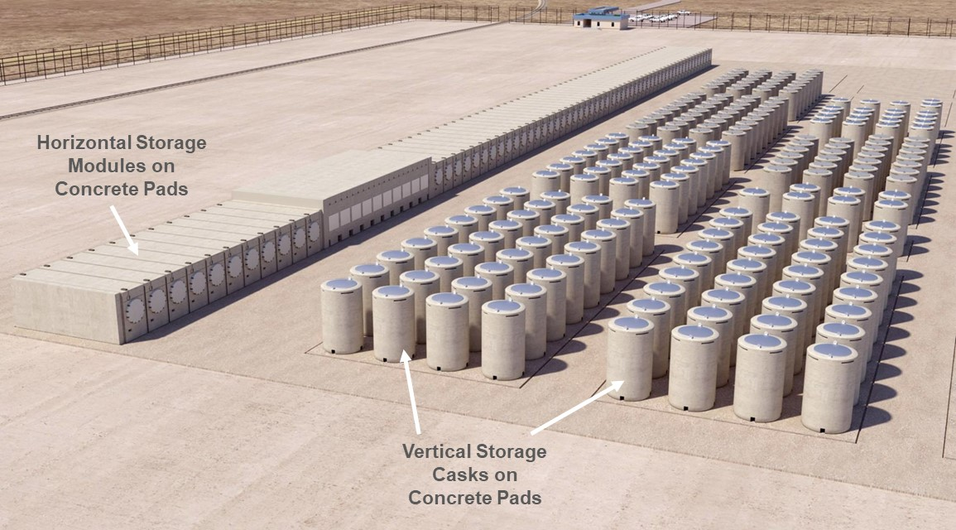
Figure 4.1: Conceptual Storage System Consisting of Concrete Casks and Modules
Both of these storage methods use a 45-cm to 90-cm thick reinforced concrete pad to provide a seismically stable platform for the overpacks or modules. The pads are designed to store multiple storage units. The conceptual plan for the proposed CISF is to use pads that can store up to 200 vertical overpacks and/or horizontal modules. Typical vertical and horizontal dry cask storage configurations are shown in Figure 4.2.
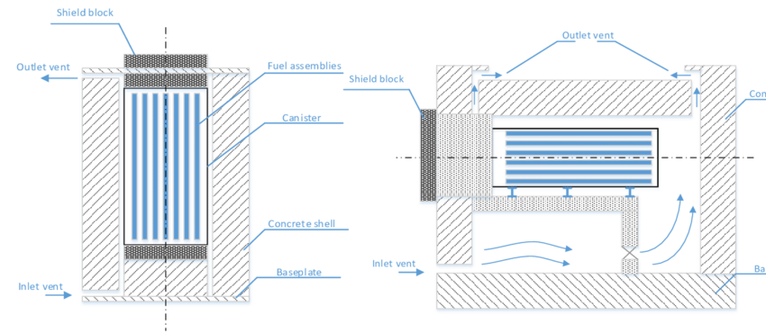
Source: [46]
Figure 4.2: Typical Vertical and Horizontal Dry Cask Storage Configurations
A typical site plan layout for the CISF based on the ACCM alternative is shown in Figure 4.3.
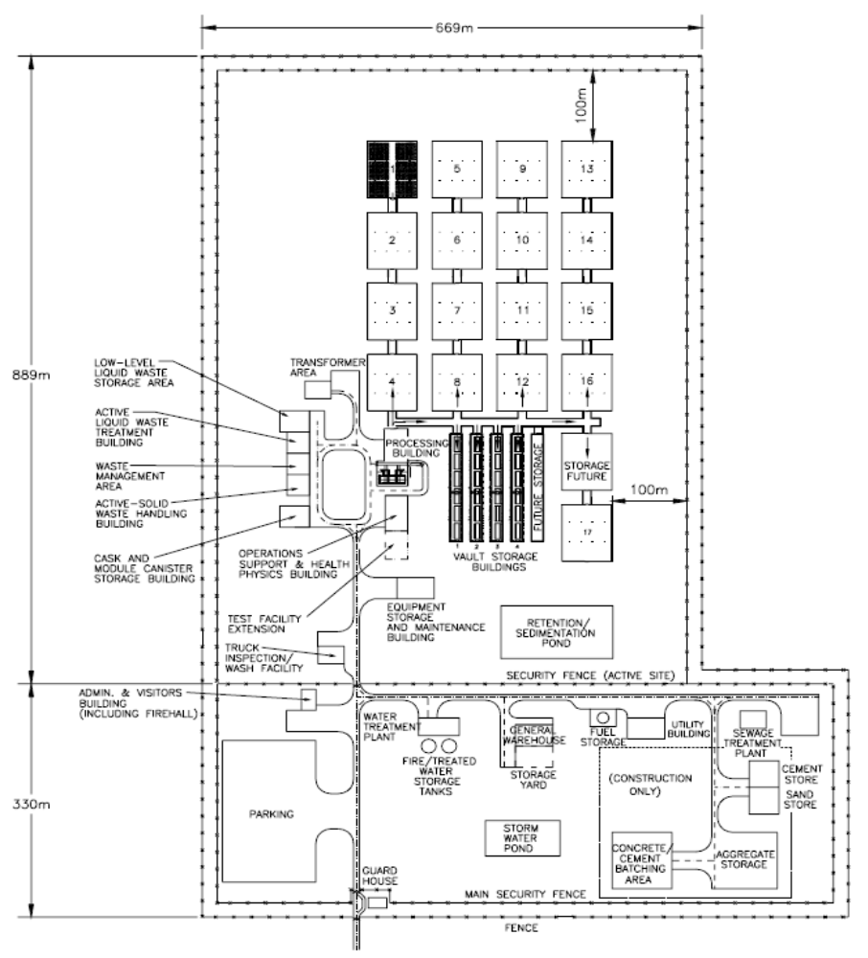
Source: [47]
Figure 4.3: Site Plan Layout for the CISF Based on the ACCM Alternative
      - Concept of operations
During the cask/canister handling operations, many supporting activities need to be performed by the CISF staff. The most directly related to the cask handling activities is the vertical storage overpack or horizontal storage overpack fabrication function. This is a full-time activity to complete the fabrication of overpacks necessary to support cask/canister placement activities. The steel components of the storage systems are fabricated by the original vendor or contractors under the original vendor’s control and shipped to the site. After receipt inspection to ensure that the components meet specifications, concrete is added to the steel components in accordance with the vendors’ specifications to complete the overpack design. Since VCHM uses the original storage systems, the overpack fabrication crew needs to coordinate closely with the operations manager to ensure that the proper vertical storage overpack or horizontal storage overpacks are prepared far enough in advance of cask/canister placement to permit the concrete to cure properly. As a result, the overpack fabrication crew needs to be operating well ahead of the spent fuel acceptance process with a minimum of 30 days after the arrival of the steel components from the manufacturer until the overpack is ready to accept spent fuel.
The procurement activities necessary to support the overpack production must be well ahead of the delivery of the spent fuel because the lead time for overpack components, delivery and final fabrication is on the order of 24 months. Orders must be placed with the appropriate overpack vendors well ahead of the need in order to ensure that there is time to fabricate and deliver the necessary components. Ideally, the system should support just-in-time delivery of all necessary overpack components so that they can be used directly by the cask handling crews. However, as a practical matter, the system should allow for buffer storage of these components in order to assure that spent fuel shipments are not held up by the lack of availability of overpacks. This means that the supply chain management must identify the correct vendor, the correct model of cask and the schedule for delivery, in order to issue the purchase orders necessary to ensure the flow of material to the site. No shipment of spent fuel should be undertaken unless there is an appropriate overpack available on site.
The procurement activities necessary to support the overpack production must be well ahead of the delivery of the spent fuel because the lead time for overpack components, delivery and final fabrication is on the order of 24 months. Orders must be placed with the appropriate overpack vendors well ahead of the need in order to ensure that there is time to fabricate and deliver the necessary components. Ideally, the system should support just-in-time delivery of all necessary overpack components so that they can be used directly by the cask handling crews. However, as a practical matter, the system should allow for buffer storage of these components in order to assure that spent fuel shipments are not held up by the lack of availability of overpacks. This means that the supply chain management must identify the correct vendor, the correct model of cask and the schedule for delivery, in order to issue the purchase orders necessary to ensure the flow of material to the site. No shipment of spent fuel should be undertaken unless there is an appropriate overpack available on site.
The cask handling operations staff is dedicated to the movement of spent fuel packages around the site. These operations are carried out by dedicated crews who focus on certain areas of the operation. This way, when multiple casks are processed each week, a crew learns specialised skills that will improve efficiency. The crews are: 1) the transport-bay crew, 2) the cask transfer crew and 3) the transporter crew.
The total CISF site organisation staff will consist of 200 workers to achieve the desired CISF throughput during the cask handling phase of the facility’s life cycle. The ACCM system throughput with all of the assumptions will be 5 full-sized casks placed into storage each week.
The largest operations challenge for the ACCM storage system alternative is controlling the supply chain to ensure that the proper storage system is available to match the cask being received from the generator. The licensability of the final spent fuel package is based on the conformance of the storage system with the original licensed dry storage system. As described above, the preparation time for a storage system is at least a month after receipt of the hardware from the storage system vendor. The lead time for this shipment could be eighteen to twenty-four months. Therefore, up to two years ahead of the receipt of the spent fuel at the site, the supply chain manager needs to place an order for the necessary storage system components. This means that the CISF staff needs to know well in advance of delivery what vendor and what model of cask system is needed. The coordination of the supply chain for the overpack Fabrication and the spent fuel storage operations will be the largest management challenge for this design alternative.
      - CISF expansion
Each of the alternative storage methods is evaluated to determine if there are any additional pros or cons due to the expanded storage area. For ACCM storage, no additional pros or cons are noted for the expanded CISF. The number of pads and storage units increase proportionally with the number of casks and/or modules. Figure 4.4 shows the layout of the expanded CISF based on the ACCM storage system.
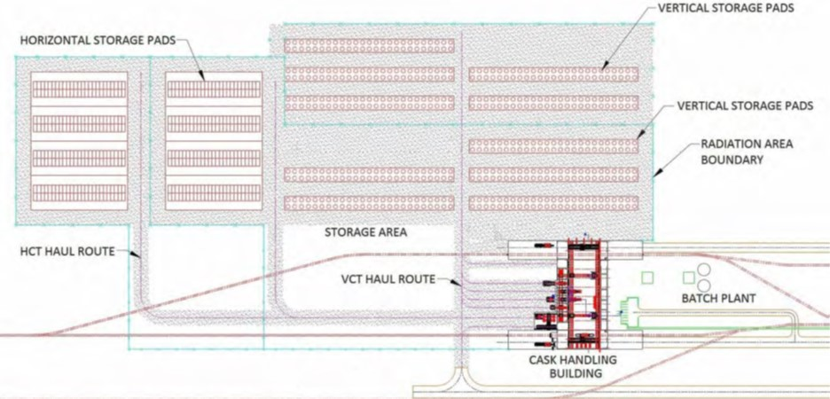
Source: [48]
Figure 4.4: CISF Layout Based on an ACCM Storage System
      - Summary of pros and cons for ACCM storage alternative
Pros
- The ACCM storage alternative is the quickest to implement with minimal effort. All of these storage systems are already designed and licensed either under a general license or a site-specific license for the location currently used. The CISF will use a site-specific license under NNR license regime. A site-specific license requires the initiation of a number of documents associated with the development of a new site such as a license application, environmental report, safety analysis report (SAR), emergency plan, security plan and technical specifications. Preparation of all these documents plus the NNR review takes time. However, the material from existing storage system existing FSARs could be incorporated by reference into the CISF site-specific license which would greatly streamline the licensing process.
- These systems performance capabilities are well known. There are no unknowns that would need to be studied, designed for, or debated. The US-NRC has even determined that over several years, with proper maintenance, these storage methods are safe.
- The systems can be implemented over time, reducing their initial capital costs. Nuclear power plants generate spent fuel over a 40-to-60-year typical life span. As it is generated, the spent fuel can be shipped to the CISF where concrete storage pads and vertical overpacks or horizontal modules housing the casks/canisters can be installed over several years.
Cons
- Vertical systems require a more extensive cask/canister transfer process that could require a canister transfer facility. This facility is a large structure that increases the cost of the pad storage alternative dramatically. There are methods of canister transfer that can be performed without such a structure but they are more involved with increased manual steps that increases transfer time and personnel radiation dose. The horizontal storage system does not need the canister transfer facility because the transfer takes place at the storage module itself. However, innovated means of transfer on a daily basis will be necessary to reduce dose in the horizontal systems.
- There are 13 different systems that need to be accommodated. Currently, each system has been designed to use its own specific equipment. This could affect lifting yokes, canister transfer adapters, transporters, etc. (some of the transport casks are designed for multiple canisters which could cut down the number of transport casks required). Employing 13 sets of equipment to lift and offload a transport cask, transfer the canister from the transport cask to a storage overpack or module and move the canister by crane or transporter could be burdensome. The creation of equipment that could be used for multiple systems would eventually come to pass to relieve much of the burden but probably not initially.
- Storing multiple systems will also affect the analysis (or increase the number of analyses) of the storage pads which need to consider size, weight, tipping potential, direct radiation, etc. The pad design would likely not change.
- On-site fabrication is affected. Vertical overpacks are too large and heavy for standard shipping so they are manufactured in a vendor’s plant in a lighter / smaller configuration so that the concrete can be applied at the site. Horizontal modules are typically manufactured in pieces that are shipped to the site and assembled there. The 13 storage systems require 7 different storage overpack or module designs. On-site fabrication of some sort will need to accommodate all 7 overpack designs.
- Although all of the storage systems are licensed, placing them at a specific location will require some licensing revisions and therefore, prolong the duration required to implement the CISF to some degree. These changes are most likely to result from seismic conditions and ambient temperature extremes. The probability that a system will not meet a specific site condition is very small but the process to re-analyse the system for the site-specific conditions and the regulator review of those analyses will take time and money.

