MHLONTLO LOCAL MUNICIPALITY



TENDER NO: MLM/BPS/Cons-2023-2026

PROJECT NAME: UPGRADING OF CHULUNCA BRIDGE

CLOSING DATE: 25th October 2023

NAME OF TENDERER: _____________________________________________________

TOTAL AMOUNT: _______________________________________________ (incl. VAT)

EMPLOYER:

The Municipality Manager
Mhlontlo Local Municipality
96 Church Street
Qumbu
5180
Tel: (047) 553 7000

CONTENTS
NUMBER HEADING PAGE COLOUR

Part T1: Tendering procedures

T1.1 Tender Notice and Invitation to Tender 1 - 6 White
T1.2 Tender Data 7 - 11 Pink
T1.3 Preferential Procurement Regulations 12 - 32 Pink

Part T2: Returnable documents

T2.1 List of Returnable Documents 33 Yellow
T2.2 Returnable Schedules 64 Yellow

Part C1: Agreement and Contract Data

C1.1 Form of Offer and Acceptance 64 White
C1.2 Contract Data 69 White
C1.3 Blasting Indemnity 70 White
C1.4 OHS Contract 71 - 73 White
C1.5 Environmental Contract 96 White

Part C2: Pricing data

C2.1 Pricing Instructions 97- 99 Yellow
C2.2 Bill of Quantities 100 - 123 Yellow
C2.3 Summary of Schedules 124 - 124 Yellow

Part C3: Scope of Work

C3.1 Description of Scope 125 Blue
C3.2 HIV/AIDS Requirements Blue
C3.3 Health and Safety Spec by Employer Blue
C3.4 Particular Specification 186 Blue

Part C4: Site Information

C4.1 Site Information 187 - 189 Green

PART T1

TENDERING PROCEDURES

MHLOnTLO LOCAL MUNICIPALITY

T1.1: tender INVITATION

PROJECT NAME | CIDB | CONTRACT NUMBER | ADVERT  DATE | BRIEFING  DATE | CLOSING  DATE
UPGRADING OF CHULUNCA BRIDGE | 5 CE or Higher | MHLM/BPS/CONS-2023-2026 | 03/10/2023 | There will be no Breifing | 25/10/2023  12h00 PM  Qumbu Foyer

Suitably qualified, capable and experienced tenderers are hereby invited to tender for the construction of the above projects. The above project is situated in Mhlontlo Local Municipality within O.R. Tambo District Municipality.
Tenderers must take particular note of the following:

- Tenderers are required to submit valid SARS Tax Clearance Pin with the tender in order to be considered.
- Tenders must declare performance guarantee as per contract
- Tenderers are required to submit the Company Profile.
- Tenderers are required to submit proof of registration with CIDB, for A Joint venture must submit a proof of registration with consolidated CIDB grading.
- A valid original B-BBEE status level verification certificate or a certified copy thereof, sustaining the BBBEE rating issued by a verification agency accredited by SANAS (South African Nation Accreditation system.
- A Joint venture must submit a consolidated valid original B-BBEE status level verification certificate or A certified copy thereof substantiating their B-BBEE rating issued by a verification agency accredited by the SANAS (South African Nation Accreditation system).
- Submit Joint Venture agreement in the case of joint venture.
- Tenderers are required to submit the methodology
- Tenderers must submit all the requirement as per returnable schedules and must be attached in a relevant page
- Submit Proof of Municipal rates no later than one month
- Submit Central Supplier Database Report not later than one month
- Failure to submit a comprehensive JV agreement (where applicable) individual partners are to comply and submit all relevant documents.
- A pre-qualification criterion for preferential is applicable, therefore a minimum appointed service provider would be required sub-contract part of their works to the designated groups contemplated in terms of regulations 2017.

Failure to supply all supplementary information may result in the tender being deemed an incomplete tender and will not be considered forward.

Tender documents will be available from www.etender.gov.za and www.mhlontlolm.gov.za .
Evaluation Criteria
Tenderers will be evaluated for functionality and those who score equal or more than 70% will be considered for price and equity.

COMPETENCE | TOTAL  SCORE | REQUIRED EVIDENCE | SCORE
Availability of Plant and  Equipment  Note: Proof of ownership in the form of vehicle registration that the firm’s equipment must be attached and failure to do so will result in forfeiting the plant  points  NB: If the bidder leases the plant then half points will be allocated on each plant provided. Bidder to attach original signed letter of intent to lease plant from owner with the certified registration documents of the owner | 25 | Grader X1 | 5
 | 25 | TLB X1 | 5
 | 25 | Tipper Truck X5 | 5
 | 25 | Excavator X1 | 5
 | 25 | Water TankerX2 | 5
 | 25 | Proof of ownership / Lease agreement for each of the and above as evidence. | 10
 | 25 | None of the above | 0
Company experiences in terms of projects completed (Attach appointment letters and Completion certificates for each project completed in relation to access roads and stormwater projects). A bidder assessment form will also be used as attached. | 25 | Five (5) projects upwards | 25
 | 25 | Four Projects | 20
 | 25 | Three projects | 15
 | 25 | Two projects | 10
 | 25 | One project | 5
 | 25 | None of the above | 0

Key Personnel and Qualification The company must provide the CV’s with copies of qualification and ID of the resources to be deployed on the project NB: Signed CV with Declaration of Authenticity by employee (Page RD 12) and less than (6) six Months Certified Copies of Qualification to Claim Points |  |  |  | Project Manager/Contract Manager: (ND Civil Eng/B -Tech.Civil Eng, BSC or equivalent) with 3-5 years’ relevant experience. References must traceable as they may be verified | 3
 |  |  |  | Project Manager/Contract Manager: (ND Civil Eng/B -Tech.Civil Eng or equivalent) with 1-3years relevant experience. References must traceable as they may be verified | 1
 |  |  |  | Project Manager/Contract Manager: With no experience, no qualification | 0
 |  |  |  | Site Agent (ND Civil Eng/B -Tech.Civil Eng or equivalent) with 5 years relevant experience and above. References must traceable as they may be verified | 4
 |  |  |  | Site Agent (ND Civil Eng/B -Tech.Civil Eng or equivalent) with 3-5 years relevant experience. References must traceable as they may be verified | 2
 |  |  |  | Site Agent :(ND Civil Eng/B Tech.Civil Eng or equivalent) with 13years relevant experience. References must traceable as they may be verified | 1
 |  |  |  | Site Agent:  With no experience, no qualification | 0
 |  |  |  | Health and Safety Officer (OHS  Certificate with registration to  SACPCMP) | 4
 |  |  |  | Site Foreman (Skill with relevant  experience for similar project/s 5 years and above | 6
 |  |  |  | None of the above | 0
Quality of methodology relevant to assignment step by step with time frames |  |  | 30 | A fully detailed methodology aligned to the Terms of Reference with clear milestones and time frames. | 30
 |  |  | 30 | Basic methodology with time frames | 10
 |  |  | 30 | Unclear methodology with no time frames | 0
TOTAL |  |  | 100 | Minimum | 70
Only Bidders who score 70% or more on Stage 1 would be evaluated further and eligible for award.
Preferential Procurement Regulations, 2011 Pertaining to the MFMA will apply.
80 points for price
20 points for Specific goals.
All tenders shall hold good for 90 days after tender closing date. The Council is not bound to accept the lowest or any tender and or part thereof and the Council reserves the right to accept any tender in whole or in part. All electronic, telegraphic, telefax, e-mail and late tenders will not be considered and tenders not deposited in the tender box as prescribe in this notice will not be considered as well.
For enquiries regarding bid documents, please contact Ms B Jara at 066 4857564.
For technical enquiries please contact the Technical Services of Mhlontlo Local Municipality, Ms Y.Nqatyelwa @ 076 790 9070
………………………………………
Municipal Manager
Mr. L. Ndabeni
Mhlontlo Local Municipality
P.O. Box 31
Qumbu
5180
T1.2 TENDER DATA

T1.2.1 Standard Conditions of Tender

The conditions of tender are the Standard Conditions of Tender as contained in Annex F of the CIDB Standard for Uniformity in Construction Procurement which are reproduced without amendment or alteration for the convenience of tenderers. The Standard Conditions of Tender make several references to the Tender Data for details that apply specifically to this tender. The Tender Data shall have precedence in the interpretation of any ambiguity or inconsistency between it and the Standard Conditions of Tender.

F.1 General

F.1.1 Actions

The Employer and each tenderer submitting a tender offer shall comply with these conditions of tender. In their dealings with each other, they shall discharge their duties and obligations as set out in F.2 and F.3, timeously and with integrity, and behave equitably, honestly and transparently.

F.1.2 Tender Documents

The documents issued by the Employer for the purpose of a tender offer are listed in the tender data. The tender documents issued by Mhlontlo Local Municipality comprise of the following:

Part T1: Tendering Procedures

T1.1 Tender notice and invitation to tender
T1.2 Tender Data
T1.3 Preferential Procurement Regulations – Mhlontlo Local Municipality

Part T2: Returnable Documents

T2.1 List of returnable documents
T2.2 Returnable schedules

Part C1: Agreements and Contract Data

C1.1 Form of offer and acceptance
C1.2 Contract Data
C1.3 Blasting Indemnity

Part C2: Pricing data

C2.1 Pricing instructions
C2.2 Activity schedules / Bills of Quantities
C2.3 Summary of schedule of works

Part C3: Scope of work

C3 .1 Description of work
C3. 2 HIV/AIDS Requirements
C3. 3 Health and Safety Specification by Employer
C3. 4 Particular Specification

Part C5 : Typical Standard Contract Administration Forms
C5. 1 Site Diary
C5. 2 Site Instruction Book
C5. 3 Monthly Progress Reporting Schedule

F.1.3 Interpretation

F.1.3.1 The Tender Data and additional requirements contained in the tender schedules that are included in the returnable documents are deemed to be part of these conditions of tender.

F.1.3.2 These conditions of tender, the Tender Data and tender schedules which are only required for tender evaluation purposes, shall not form part of any contract arising from the invitation to tender.

F.1.3.3 For the purposes of these conditions for the calling for expressions of interest, the following definitions apply:

(b) Comparative offer means the tenderer’s financial offer after the factors of non-firm prices, all unconditional discounts and any other tendered parameters that will affect the value of the financial offer have been taken into consideration

(c) corrupt practice means the offering, giving, receiving or soliciting of anything of value to influence the action of the Employer or his staff or agents in the tender process; and

(d) Fraudulent practice means the misrepresentation of the facts in order to influence the tender process or the award of a contract arising from a tender offer to the detriment of the Employer, including collusive practices intended to establish prices at artificial levels

(f) Quality (Functionality) means the totality of features and characteristics of a product of service that bear on its ability to satisfy stated or implied needs

F.1.5 the Employer’s right to accept or reject any tender offer

F.1.5.1 The Employer may accept or reject any variation, deviation, tender offer, or alternative tender offer, and may cancel the tender process and reject all tender offers at any time before the formation of a contract. The Employer shall not accept or incur any liability to a tenderer for such cancellation and rejection, but will give reasons for such action upon written request to do so.

F.1.5.2 The Employer may not subsequent to the cancellation or abandonment of a tender process or the rejection of all tender offers re-issue a tender covering substantially the same scope of work within a period of six months unless only one tender was received and such tender was returned unopened to the tenderer.

F.2 Tenderers obligation

F2.1 Eligibility

F2.1.1 Submit a tender offer only if the tenderer satisfies the criteria stated in the tender data and have in their employ management and supervisory staff satisfying the requirements of the Scope of Work for labour intensive competencies for supervisory, and the tenderer, or any of his principals, is not under any restriction to do business with employer.

F2.1.2 Notify the employer of any proposed material change in the capabilities or formation of the tendering entity (or both) or any other criteria which formed part of the qualifying requirements used by the employer as the basis in a prior process to invite the tenderer to submit a tender offer and obtain the employer’s written approval to do so prior to the closing time for tenders.

F2.1.2.1 The following tenderers who are registered with the CIDB, or are capable of being so registered prior to the evaluation of submissions, are eligible to submit tenders:

a) contractors who have a contractor grading designation equal to or higher than a contractor grading designation determined in accordance with the sum tendered for 5 CE class of construction work; and

b) contractors registered as potentially emerging enterprises with the CIDB who are registered in one contractor grading designation lower than that required in terms of a) above

F2.1.2.2 Joint ventures are eligible to submit tenders provided that:

- Every member of the joint venture is registered with the CIDB;
- Every member of the joint venture should have attended the briefing;
b) The lead partner has a contractor grading designation in the 5 CE class of Civil Engineering; and
c) The combined contractor grading designation calculated in accordance with the Construction Industry Development Regulations is equal to or higher than a contractor grading designation determined in accordance with the sum tendered for 5 CE class of construction work or two contractors registered in contractor grading designation 5 CE one contractor registered in contractor grading designation 5 CE and two registered in contractor grading designation 5 CE.
(d) A Joint Venture Agreement in line with CIDB Regulations and Mhlontlo Local Municipality Supply Chain Management Policy in MBD 6.1 (8).

(e) Tax Clearance Certificates of both Partners are attached in the Document.
(f) CIDB Certificates or CRS Numbers for both Joint Venture Partners are attached.

F.2.2 Cost of tendering

Accept that the Employer will not compensate the tenderer for any costs incurred in the preparation and submission of a tender offer, including the costs of any testing necessary to demonstrate that aspects of the offer satisfy requirements.

F.2.3 Check documents

Check the tender documents on receipt for completeness and notify the Employer of any discrepancy or omission.

F.2.4 Confidentiality and copyright of documents

Treat as confidential all matters arising in connection with the tender. Use and copy the documents issued by the Employer only for the purpose of preparing and submitting a tender offer in response to the invitation.

F.2.5 Reference documents

Obtain, as necessary for submitting a tender offer, copies of the latest versions of standards, specifications, Conditions of Contract and other publications, which are not attached but which are incorporated into the tender documents by reference.

F.2.6 Acknowledge addenda

Acknowledge receipt of addenda to the tender documents, which the Employer may issue, and if necessary apply for an extension to the closing time stated in the Tender Data, in order to take the addenda into account.

F.2.7 Site visit and clarification meeting

Attend, where required, a site visit and clarification meeting at which tenderers may familiarize themselves with aspects of the proposed work, services or supply and raise questions. Details of the meeting(s) are stated in the Tender Data.

F.2.8 Seek clarification

Request clarification of the tender documents, if necessary, by notifying the Employer at least five working days before the closing time stated in the Tender Data.

F.2.9 Insurance

Be aware that the extent of insurance to be provided by the Employer (if any) may not be for the full cover required in terms of the Conditions of Contract identified in the Contract Data. The tenderer is advised to seek qualified advice regarding insurance.

F.2.10 pricing the tender offer

F.2.10.1 Include in the rates, prices, and the tendered total of the prices (if any) all duties, taxes (except Value Added Tax (VAT), and other levies payable by the successful tenderer, such
duties, taxes and levies being those applicable 14 days before the closing time stated in the Tender Data.

F2.10.2 Show VAT payable by the Employer separately as an addition to the tendered total of the prices.

F.2.10.3 Provide rates and prices that are fixed for the duration of the contract and not subject to adjustment except as provided for in the Conditions of Contract identified in the Contract Data.

F.2.10.4 State the rates and prices in Rand unless instructed otherwise in the Tender Data. The Conditions of Contract identified in the Contract Data may provide for part payment in other currencies.

F.2.11 Alterations to documents

Not make any alterations or additions to the tender documents, except to comply with instructions issued by the Employer, or necessary to correct errors made by the tenderer. All signatories to the tender offer shall initial all such alterations. Erasures and the use of masking fluid are prohibited.

F.2.12 Alternative tender offers

F.2.12.1 Unless otherwise stated in the tender data, submit alternative tender offers only if a main tender offer, strictly in accordance with all the requirements of the tender documents, is also submitted as well as a schedule that compares the requirements of the tender documents with the alternative requirements that are proposed.

F.2.12.2 Accept that an alternative tender offer may be based only on the criteria stated in the Tender Data or criteria otherwise acceptable to the Employer.

F.2.13 submitting a tender offer

F.2.13.1 Submit a tender offer to provide the whole of the works, services or supply identified in the Scope of Work, unless stated otherwise in the Tender Data.

F.2.13.2 Return all returnable documents to the Employer after completing them in their entirety, either electronically (if they were issued in electronic format) or by writing in black ink.

F.2.13.3 Submit the parts of the tender offer communicated on paper as an original plus the number of copies stated in the Tender Data, with an English translation of any documentation in a language other than English, and the parts communicated electronically in the same format as they were issued by the Employer.

F.2.13.4 Sign the original and all copies of the tender offer where required in terms of the Tender Data. The Employer will hold all authorized signatories liable on behalf of the tenderer. Signatories for tenderers proposing to contract as joint ventures shall state which of the signatories is the lead partner whom the Employer shall hold liable for the purpose of the tender offer.

F.2.13.5 Seal the original and each copy of the tender offer as separate packages marking the packages as "ORIGINAL" and "COPY". Each package shall state on the outside the Employer's address and identification details stated in the Tender Data, as well as the tenderer's name and contact address.

F.2.13.6 Where a two-envelope system is required in terms of the Tender Data, place and seal the returnable documents listed in the Tender Data in an envelope marked “financial proposal” and place the remaining returnable documents in an envelope marked “technical proposal”. Each envelope shall state on the outside the employer’s address and identification details stated in the tender data, as well as the tenderer's name and contact address.

F.2.13.7 Seal the original tender offer and copy packages together in an outer package that states on the outside only the Employer's address and identification details as stated in the Tender Data.

F.2.13.8 Accept that the Employer shall not assume any responsibility for the misplacement or premature opening of the tender offer if the outer package is not sealed and marked as stated.

F.2.14 Information and data to be completed in all respects

Accept that tender offers, which do not provide all the data or information requested completely and in the form required, may be regarded by the Employer as non-responsive.

F.2.15 Closing time

F.2.15.1 Ensure that the Employer receives the tender offer at the address specified in the Tender Data not later than the closing time stated in the Tender Data. Proof of posting shall not be accepted as proof of delivery. The Employer shall not accept tender offers submitted by telegraph, telex, facsimile or e-mail, unless stated otherwise in the Tender Data.

F.2.15.2 Accept that, if the Employer extends the closing time stated in the Tender Data for any reason, the requirements of these conditions of tender apply equally to the extended deadline

F.2.16 Tender offer validity

F.2.16.1 Hold the tender offer(s) valid for acceptance by the Employer at any time during the validity period stated in the Tender Data after the closing time stated in the Tender Data.

F.2.16.2 If requested by the Employer, consider extending the validity period stated in the Tender Data for an agreed additional period.

F.2.17 Clarification of tender offer after submission

Provide clarification of a tender offer in response to a request to do so from the Employer during the evaluation of tender offers. This may include providing a breakdown of rates or prices and correction of arithmetical errors by the adjustment of certain rates or item prices (or both). No change in the total of the prices or substance of the tender offer is sought, offered, or permitted. The total of the prices stated by the tenderer shall be binding upon the tenderer.

F.2.18 Provide other material

F.2.18.1 Provide, on request by the Employer, any other material that has a bearing on the tender offer, the tenderer’s commercial position (including notarized joint venture agreements), pre-referencing arrangements, or samples of materials, considered necessary by the Employer for the purpose of a full and fair risk assessment. Should the tenderer not provide the material, or a satisfactory reason as to why it cannot be provided, by the time for submission stated in the Employer’s request, the Employer may regard the tender offer as non-responsive.

F.2.18.2 Dispose of samples of materials provided for evaluation by the Employer, where required.

F.2.19 Inspections, tests and analysis

Provide access during working hours to premises for inspections, tests and analysis as provided for in the Tender Data.

F.2.20. Submit securities, bonds, policies, etc.

If requested, submit for the Employer’s acceptance before formation of the contract, all securities, bonds, guarantees, policies and certificates of insurance required in terms of the Conditions of Contract identified in the Contract Data.

F.2.21 Check final draft

Check the final draft of the contract provided by the Employer within the time available for the Employer to issue the contract.

F.2.22 Return of other tender documents

If so instructed by the Employer, return all retained tender documents within 28 days after the expiry of the validity period stated in the Tender Data.

F.2.23 Certificates

Include in the tender submission or provide the Employer with any certificates as stated in the Tender Data.

F.3 The Employer’s undertakings

F.3.1 Respond to request from the tenderer

F.3.1.1 Unless otherwise stated in the tender Data respond to a request for clarification received up to five working days before the tender closing time stated in the Tender Data and notify all tenderers who drew procurement documents.

F.3.2 Issue Addenda

If necessary, issue addenda that may amend or amplify the tender documents to each tenderer during the period from the date of the Tender Notice until seven days before the tender closing time stated in the Tender Data. If, as a result a tenderer applies for an extension to the closing time stated in the Tender Data, the Employer may grant such extension and, will then notify it to all tenderers who drew documents.

F.3.3 Return late tender offers

Return tender offers received after the closing time stated in the Tender Data, unopened, (unless it is necessary to open a tender submission to obtain a forwarding address), to the tenderer concerned.

F.3.4 Opening of tender submissions

F.3.4.2 Announce at the opening held immediately after the opening of tender submissions, at a venue indicated in the Tender Data, the name of each tenderer whose tender offer is opened, the total of his prices, preferences claimed and time for completion, if any, for the main tender offer only.

F.3.4.3 Make available the record outlined in F.3.4.2 to all interested persons upon request if the employer deemed necessary.

F.3.5 Two-envelope system

F.3.5.1 Where stated in the Tender Data that a two-envelope system is to be followed, open only the technical proposal of valid tenders in the presence of tenderers’ agents who choose to attend at the time and place stated in the Tender Data and announce the name of each tenderer whose technical proposal is opened

F.3.5.2 Evaluate the quality of the technical proposals offered by tenderers, then advice tenderers who remain in contention for the award of the contract of the time and place when the financial proposals will be opened. Open only the financial proposals of tenderers, who score in the quality evaluation above the minimum number of points for quality stated in the Tender Data, and announce the score obtained for the technical proposals and the total price and any preferences claimed. Return unopened financial proposals to tenderers whose technical proposals failed to achieve the minimum number of points for quality.

F.3.6 Non-disclosure

Not disclose to tenderers, or to any other person not officially concerned with such processes, information relating to the evaluation and comparison of tender offers, the final evaluation price and recommendations for the award of a contract, until after the award of the contract to the successful tenderer.

F.3.7 Grounds for rejection and disqualification

Determine whether there has been any effort by a tenderer to influence the processing of tender offers and instantly disqualify a tenderer (and his tender offer) if it is established that he engaged in corrupt or fraudulent practices.

F.3.8 Test for responsiveness

F.3.8.1 Determine, on opening and before detailed evaluation, whether each tender offer properly received:

a) Meets the requirements of these Conditions of Tender,
b) Has been properly and fully completed and signed, and
C) is responsive to the other requirements of the tender documents
F.3.8.2 A responsive tender is one that conforms to all the terms, conditions, and specifications of the tender documents without material deviation or qualification. A material deviation or qualification is one which, in the Employer's opinion, would:

- detrimentally affect the scope, quality, or performance of the works, services or supply identified in the Scope of Work,
- change the Employer's or the tenderer's risks and responsibilities under the contract, or
- Affect the competitive position of other tenderers presenting responsive tenders, if it were to be rectified.

Reject a non-responsive tender offer, and not allow it to be subsequently made responsive by correction or withdrawal of the non-conforming deviation or reservation

F.3.9. Arithmetical errors, omissions and discrepancies.

F.3.9.1 Check responsive tenders for discrepancies between amounts in words and amounts in figures. Where there is a discrepancy between the amounts in figures and the amount in words, the amount in words shall govern.

F.3.9.2 Check the highest ranked tender or tenderer with the highest number of tender evaluation points after the evaluation of tender offers in accordance with F.3.11 for:

a) The gross misplacement of the decimal point in any unit rate;
b) Omissions made in completing the pricing schedule or bills of quantities; or
c) Arithmetic errors in:
I) Line item totals resulting from the product of a unit rate and a quantity in bills of quantities or schedules of prices; or
ii) The summation of the prices.

F.3.9.3 Notify the tenderer of all errors or omissions that are identified in the tender offer and either confirm the tender offer as tendered or accept the corrected total of prices.

F.3.9.4 Where the tenderer elects to confirm the tender offer as tendered, correct the errors as follows:

- If bills of quantities or pricing schedules apply and there is an error in the line item total resulting from the product of the unit rate and the quantity, the line item total shall govern and the rate shall be corrected. Where there is an obviously gross misplacement of the decimal point in the unit rate, the line item total as quoted shall govern, and the unit rate shall be corrected.
- Where there is an error in the total of the prices either as a result of other corrections required by this checking process or in the tenderer's addition of prices, the total of the prices shall govern and the tenderer will be asked to revise selected item prices (and their rates if bills of quantities apply) to achieve the tendered total of the prices.

F.3.10 Clarification of a tender offer

Obtain clarification from a tenderer on any matter that could give rise to ambiguity in a contract arising from the tender offer.

F.3.11 Evaluation of tender offers

F3.11.1 General

Appoint an evaluation panel of not less than three persons. Reduce each responsive tender offer to a comparative offer and evaluate it using the tender evaluation method that is indicated in the Tender Data and described below:

Method 1: Financial offer | 1) Rank tender offers from the most favourable to the least favourable comparative offer.  2) Recommend highest ranked tenderer for the award of the contract, unless there are compelling and justifiable reasons not to do so.
Method 2:  Financial offer and preferences | 1) Score tender evaluation points for financial offer.  2) Confirm that tenderers are eligible for the preferences claimed and if so, score tender evaluation points for referencing.  3) Calculate total tender evaluation points.  4) Rank tender offers from the highest number of tender evaluation points to the lowest.  5) Recommend tenderer with the highest number of tender evaluation points for the award of the contract, unless there are compelling and justifiable reasons not to do so.
Method 3:  Financial offer and quality | 1) Score quality, rejecting all tender offers that fail to score the minimum number of points for quality stated in the Tender Data.
Method 3:  Financial offer and quality | 2) Score tender evaluation points for financial offer.
Method 3:  Financial offer and quality | 3) Calculate total tender evaluation points.
Method 3:  Financial offer and quality | 4) Rank tender offers from the highest number of tender evaluation points to the lowest.
Method 3:  Financial offer and quality | 5) Recommend tenderer with the highest number of tender evaluation points for the award of the contract, unless there are compelling and justifiable reasons not to do so.

Method 4:  Financial offer, quality/Functionality and preferences | 1) Score quality/Functionality, rejecting all tender offers that fail to score the minimum number of points for quality/Functionality stated in the Tender Data.
 | 2) Score tender evaluation points for financial offer.
 | 3) Confirm that tenderers are eligible for the preferences claimed, and if so, score tender evaluation points for referencing.
 | 4) Calculate total tender evaluation points.
 | 5) Rank tender offers from the highest number of tender evaluation points to the lowest.
 | 6) Recommend tenderer with the highest number of tender evaluation points for the award of the contract, unless there are compelling and justifiable reasons not to do so.

NOTE: Method 4 will be used to evaluate this tender see below for evaluation criteria.

EVALUATION CRITERIA
Stage 1: Evaluation on Functionality
Under functionality, Bidders must achieve a minimum of 70% of functionality points in order to be considered for further evaluation in stage 2 (Evaluation on Price and Specific Goal).

Functionality will be evaluated based on the following criteria and bidders who failed to score a minimum functionally assessment of 70% will be considered non-responsive and will not be evaluated further.
COMPETENCE | TOTAL  SCORE | REQUIRED EVIDENCE | SCORE
Availability of Plant and  Equipment  Note: Proof of ownership in the form of vehicle registration that the firm’s equipment must be attached and failure to do so will result in forfeiting the plant  points  NB: If the bidder leases the plant then half points will be allocated on each plant provided. Bidder to attach original signed letter of intent to lease plant from owner with the certified registration documents of the owner | 25 | Grader X1 | 5
 | 25 | TLB X1 | 5
 | 25 | Tipper Truck X5 | 5
 | 25 | Excavator X1 | 5
 | 25 | Water TankerX2 | 5
 | 25 | Proof of ownership / Lease agreement for each of the and above as evidence. | 10
 | 25 | None of the above | 0
Company experiences in terms of projects completed (Attach appointment letters and Completion certificates for each project completed in relation to access roads and stormwater projects). A bidder assessment form will also be used as attached. | 25 | Five (5) projects upwards | 25
 | 25 | Four Projects | 20
 | 25 | Three projects | 15
 | 25 | Two projects | 10
 | 25 | One project | 5
 | 25 | None of the above | 0

Key Personnel and Qualification The company must provide the CV’s with copies of qualification and ID of the resources to be deployed on the project NB: Signed CV with Declaration of Authenticity by employee (Page RD 12) and less than (6) six Months Certified Copies of Qualification to Claim Points |  |  |  | Project Manager/Contract Manager: (ND Civil Eng/B -Tech.Civil Eng, BSC or equivalent) with 3-5 years’ relevant experience. References must traceable as they may be verified | 3
 |  |  |  | Project Manager/Contract Manager: (ND Civil Eng/B -Tech.Civil Eng or equivalent) with 1-3years relevant experience. References must traceable as they may be verified | 1
 |  |  |  | Project Manager/Contract Manager: With no experience, no qualification | 0
 |  |  |  | Site Agent (ND Civil Eng/B -Tech.Civil Eng or equivalent) with 5 years relevant experience and above. References must traceable as they may be verified | 4
 |  |  |  | Site Agent (ND Civil Eng/B -Tech.Civil Eng or equivalent) with 3-5 years relevant experience. References must traceable as they may be verified | 2
 |  |  |  | Site Agent :(ND Civil Eng/B Tech.Civil Eng or equivalent) with 13years relevant experience. References must traceable as they may be verified | 1
 |  |  |  | Site Agent:  With no experience, no qualification | 0
 |  |  |  | Health and Safety Officer (OHS  Certificate with registration to  SACPCMP) | 4
 |  |  |  | Site Foreman (Skill with relevant  experience for similar project/s 5 years and above | 6
 |  |  |  | None of the above | 0
Quality of methodology relevant to assignment step by step with time frames |  |  | 30 | A fully detailed methodology aligned to the Terms of Reference with clear milestones and time frames. | 30
 |  |  | 30 | Basic methodology with time frames | 10
 |  |  | 30 | Unclear methodology with no time frames | 0
TOTAL |  |  | 100 | Minimum | 70

ADMINISTRATIVE COMPLIANCE

Mandatorily requirements – Only bidders who have submitted the following documents will be considered, namely:
- A valid TAX PIN issued by SARS
- Letter of Good standing, COIDA
- Proof of CIDB registration and Grading of 5 CE.
- Company registration documents
- Completed MBD (All) forms
- Compulsory site briefing attendance (Fill attendance register, all JV members to attend and fill the register)
- All bid documents must be completed in full and in black ink (No tampering of bid documents with either correction fluid, sticky papers or any other thing which can indicate that the bid document has been tampered with)

Other Required Documents

- Municipal current rates account not more than three months old should be submitted (Proof of address similar to address of place of office operation. Lease agreement with account statement or shareholders address acceptable as proof of office address (conformation letter endorsed by commission of Oath, note that before appointment this will be verified)
- Proof of purchase for Bid documents
- Certified ID copies of the company shareholders
- Certified valid copy of BBB-EE Certificate
- Proof of registration on the Central Suppliers Database (CSD)

NOTE:

- The JV agreement for JV partners to be submitted indicating percentage split for partners to render agreement valid.
- The JV partners must submit both mandatory and other requirements for each Company.
- Preferred JV bidder will be required to submit a JV bank account and VAT number
- Please note that the above required documents will be deemed as mandatory to the preferred bidder. Required documents will be requested for submission within two working days and failure to submit will be deemed as non-responsive.
- The bidders must comply with all terms and condition including requirements as stipulated in the Tender Documents to be evaluated further.
- Mhlontlo Local Municipality reserves the right to verify any information provided by bidder.
- Mhlontlo Local Municipality is not compelled to accept the lowest or any bid

Stage 2: Evaluation on Price and 80/20

Financial offer and Specific Goals
1) Score tender evaluation points for financial offer.
2) Confirm that tenderers are eligible for the Specific goals claimed, and if so, score tender evaluation points for Specific goals.
3) Calculate total tender evaluation points.
4) Rank tender offers from the highest number of tender evaluation points to the lowest.
5) Recommend tenderer with the highest number of tender evaluation points for the award of the contract, unless there are compelling and justifiable reasons not to do so.

NB: NO BIDS WILL BE CONSIDERED FROM PERSONS IN THE SERVICE OF THE STATE
(see definition on MBD 4 attached)

Scoring functionality

Score functionality in each of the categories stated in the Tender Data and calculate total score for functionality.

Scoring Financial Offers

Score the financial offers of remaining responsive tender offers using the following formula:

N_{FO} = W₁ x A where:
N_{FO} = the number of tender evaluation points awarded for the financial offer.
W₁ = the maximum possible number of tender evaluation points awarded for the financial offer as stated in the Tender Data.
A = a number calculated using either formulas 1 or 2 below as stated in the Tender Data.

Formula | Basis for comparison | Option 1 | Option 2
1 | Highest price or discount | 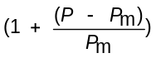 | P/P_{m}
2 | Lowest price or percentage commission/fee | 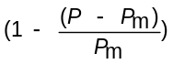 | P_{m}/P

where:

Pm = the comparative offer of the most favourable tender offer.
P = the comparative offer of tender offer under consideration.

The 80/20 Preferential Point System will be used to evaluate the bid.

Table 2: Preference Points Allocation (As per the Preferential Procurement regulations 2017)

 | Means of verification | Points allocation
HDI -Equity ownership | the municipality is going to use RACE OR NATIONALITY as means of verification and thus prospective service providers will be required to provide a copy of ID COPY as a proof in order to claim points for specific goals | 10
Youth-Enterprise 0-35 years (MLM) | the municipality is going to use AGE as means of verification and thus prospective service providers will be required to provide a copy of ID COPY AND CSD as a proof in order to claim points for specific goals | 2
Women-Equity ownership | the municipality is going to use GENDER OR SEX as means of verification and thus prospective service providers will be required to provide a copy of ID COPY, CK and CSD as a proof in order to claim points for specific goals | 2
Disability-Equity ownership | the municipality is going to use MEDICAL CERTIFICATE as means of verification and thus prospective service providers will be required to provide a copy of MEDICAL CERTIFICATE and CSD as a proof in order to claim points for specific goals | 2
Military veterans  36 & above years (MLM) | the municipality is going to use AGE as means of verification and thus prospective service providers will be required to provide a copy of ID COPY AND CSD as a proof in order to claim points for specific goals | 2
Rural Enterprise | the municipality is going to use PROOF OF RESIDENCE FROM TRADITIONAL LEADER OR WARD COUNCILLOR OR as means of verification and thus prospective service providers will be required to provide a copy of PROOF OF RESIDENCE AND CSD as a proof in order to claim points for specific goals | 2

The points scored by the tenderer in respect of the level of Specific goals must be added to the points scored for price.
8. Special Conditions
(a) (i) Bidders must take give a portion of the works to local subcontractors, the Subcontract or Joint Ventures that benefit from the preference system, must ensure that the work agreement is submitted as part of the tender document.
(ii) The responsibilities and liabilities of all parties in the Subcontract or Joint Ventures must be clearly defined
(b) The members of the Consortium or Joint Venture, formed in response to preferential procurement conditions, must share in the control and management as stated in a (ii) above.
(c) When completing bid documentation, each party to a Consortium or Joint Venture must;
(i) Complete a separate set of forms containing information regarding the preference points; and

(ii) Submit a separate valid and original Tax Clearance Certificate.
Contract Conditions

- The approved bidder shall under no circumstances interrupt the supply of water as a result of his/her activities in, or around the plant.
- Full adherence to the Occupational and Health and Safety Act, Act 85 of 1993 and other applicable Acts will be applicable during the course of the contract.
- Labour desk to be created for employing local labour. All unskilled labour will be from local communities, skills transfer to be considered and where skilled locals are available they are to be given first preference.

Proposed Employment – Construction
Description | Direct
Women | 30
Youth | 50
Male | 20
Total | 100

T1.3 PREFERENTIAL PROCUREMENT REGULATIONS

Supply Chain Management Procedures

Mhlontlo Local Municipality is committed to fair, equitable and transparent supply chain management procedures free of corruption of any nature. Should anybody suspect any irregularity of any sort they are requested to state their concerns in writing to the Chief Executive Officer of Mhlontlo Local Municipality without delay. Should a satisfactory explanation or action not be forthcoming from the Chief Executive Officer the matter should be reported to the office of the Public Protector.

This Request for Proposals has been compiled and approved by the Bid Specification Committee of Mhlontlo Local Municipality established in terms of the Public Finance Management Act and its Regulations.

The bids received will be evaluated by the Bid Evaluation Committee in terms of the bids evaluation criteria described in this document. The Committee will then submit a report on the bids received to the Bid Adjudication Committee.

The Bid Adjudication Committee will make a recommendation to the Accounting Officer or his delegate nominated in writing. The Accounting Officer will either accept the recommendation of the Bid Adjudication Committee, or refer it back to the Bid Adjudication Committee for further investigation or award the contract to a different bidder. In the event that the contract is awarded to a different bidder from the one recommended by the Bid Adjudication Committee, the Auditor-General shall be informed of the reasons for the decision.

The above process will, depending upon the complexity of the project and the number of bids received, take between 4 and 6 weeks. Bidders are requested to refrain from making queries on progress and/or from submitting unsolicited information regarding their bids and especially from commenting on other bidders’ proposals during this time. Mhlontlo Local Municipality will endeavor to keep bidders informed of the progress of the process.

PART T2

RETURNABLE DOCUMENTS

T2.1 LIST OF RETURNABLE DOCUMENTS
T2.1.1 The tenderer must complete the following returnable documents:

- TENDER DOCUMENT in its entirety and signed.

The information the tenderer shall supply in his tender or attached to his tender shall include, but not be limited to the documents and schedules as set out below.

- Certificate of Attendance of Site Meeting
- SARS Tax PIN
- Letter of Good Standing (COIDA)
- Company Profile
- CIDB Registration Certificate/s
- B-BBEE Certificate
- Municipal current rates accounts not more than one month in arrears should be submitted

The tenderer must complete the following returnable documents:

T2.1.2 Returnable Schedules required for tender evaluation purposes:

  - Schedule A – Compulsory Attendance certificate
  - Schedule B - Certificate for authority of companies
  - Schedule C - Record of Addenda to tender documents
  - Schedule D – Plant and Equipment
  - Schedule E– Relevant work experience carried out
  - Schedule F – Tenderer Key Personnel
  - Schedule G – List of Directors/Members/Partners
  - Schedule H – Company Banking Details
  - Schedule I – Contractors OHS Management system checklist
  - Schedule J – Contractors Estimated monthly expenditure
  - Schedule K – Contractors Labour Content

T2.1.3 Returnable Schedules that are incorporated into the contract

a) | MBD 1 – Invitation to Tender
b) | MBD 2–Tax Clearance Certificate
c) | MBD 3.1 – Pricing Schedule
b) | MBD 4 – Declaration of interest
c) | MBD 6.1 – Preference Points
d) | MBD 8 – Declaration of Past Supply Chain Management
e) | MBD 9 - Certificate of Independent bid determination
SCHEDULE A: | CERTIFICATE OF ATTENDANCE OF SITE INSPECTION

This is to certify that

(Tenderer)

of(Address)

was represented by the person (s) named below at the compulsory meeting held for all the Tenderers at (Location)

on (Date) starting at (Time)

I / We acknowledge that the purpose of the meeting was to acquaint myself / ourselves with the site of the works and / or matters incidental to doing the work specified in the Tender Documents in order for me / us to take account of everything necessary when compiling our rates and prices included in the Tender.

Particulars of person (s) attending the meeting:

- Name:

Capacity:

Signature:

- Name:

Capacity:

Signature:

Attendance of the above person (s) at the meeting is confirmed by the Employer’s Representative, namely:

Date and Time:

Name:

Capacity:

Signature:

STAMP

SCHEDULE B: CERTIFICATE OF AUTHORITY FOR COMPANIES

This Returnable Schedule is to be completed by companies and close corporations. Indicate the status of the tenderer by ticking the appropriate box hereunder. The tenderer must complete the certificate set out below for the relevant category.

A  Company | C  Joint Venture | E  Close Corporation

B.1 Certificate for company

I, …………………………………………………………………………, managing director of the board of directors of ………………………………………………………………………………………………. ….. hereby confirm that by resolution of the board taken on ……………20…..., Mr./Ms …………………………………………………….,
has been duly authorized to sign all documents in connection with this tender and any contract resulting from it on behalf of the company. As witnesses: -

- ………………………………………………………. …………....………………………………
Managing director

- ……………………………………………………… ……………………………………………
Date

B.2. Certificate for Joint Venture

We, the undersigned, are submitting this tender offer in Joint Venture and hereby authorise
Mr./Ms……………………………………………………………..., authorised signatory of the company
………………………………………………………………………………., acting in the capacity of lead partner, to sign all documents in connection with the tender offer and any contract resulting from it on our behalf of:
NAME OF FIRM | ADDRESS | AUTHORISING  SIGNATURE, NAME & CAPACITY
Lead partner

B.3 Certificate for close Corporation

We, the undersigned, being the key members in the business trading as
……………………………………………………………….............................................................................
hereby authorise Mr/Ms ……………………………………………………………………….………., to sign all documents in connection with the tender and any contract resulting from it on our behalf of:

NAME | ADDRESS | SIGNATURE | DATE

NOTE: This certificate is to be completed and signed by all of the key members upon whom rests the direction of the affairs of the Close Corporation as a whole.

SCHEDULE C: RECORD OF ADDENDA TO TENDER DOCUMENTS

We confirm that the following communications received from the Employer before the submission of this tender offer, amending the tender documents, have been taken into account in this tender offer:
 | Date | Title or Details
1.
2.
3.
4.
5.
6.
7.
8.
9.
NOTE: Attach additional pages if more space is required.

Signed: Date:

Name: Position:

Tenderer:

SCHEDULE D: PLANT AND EQUIPMENT

The following are lists of major items of relevant equipment that I/we presently own or lease and will have available for this contract or will acquire or hire for this contract if my/our tender is accepted.

- Details of major equipment that is owned by and immediately available for this contract.

Quantity | Description, size, capacity, etc.
Attach additional pages if more space is required.

- Details of major equipment that will be hired, or acquired for this contract if my/our tender is acceptable.

Quantity | Description, size, capacity, etc.
Attach additional pages if more space is required.

Signed: Date:

Name: Position:

Tenderer:

SCHEDULE E: RELEVANT WORK CARRIED OUT BY TENDERER

Previous experience

Provide the following information on relevant previous experience (indicate specifically projects of similar or larger size and/or which is similar with regard to type of work. In addition to any requirements, bidders must furnish particulars of:

- all consultancy services of similar nature of the assignment provided to an organ of state in the last five years;

- Any similar consultancy services provided to an organ of state in the last five years.

This information is material to the award of the Contract.

Project Description | Contract Value (VAT excl.) | Project Duration |  | Expenditure  @  Completion |  | Reference
Project Description | Contract Value (VAT excl.) | Start | Finish | Expenditure  @  Completion | Name: | Organisation: | Tel No:

Name of Tendering Entity:
___________________________________________________________________________________________________________

Signature: ___________________________________________________ DATE: ________________________________

SCHEDULE F: TENDERER’S KEY PERSONNEL

NAME | POSITION | NQF QUALIFICATION

TENDERER: ……………………………………………………………………………………………………………

SIGNATURE: ………………………………………………. DATE: ………………………………………

SCHEDULE G

FULL DETAILS OF DIRECTORS / TRUSTEES / MEMBERS / SHAREHOLDERS.

Full Name | Identity Number | Personal Tax Reference Number | State Employee  Number / Perusal Number

SCHEDULE H

COMPANY DETAIL REGARDING TENDERER / COMPANY / PARTNERSHIP

1. Complete Name : . . . . . . . . . . . . . . . . . . . . . . . . . . . . . . . . . . . . . . . . . . . . . . . . . . . . .
(Business)

Registered Address : . . . . . . . . . . . . . . . . . . . . . . . . . . . . . . . . . . . . . . . . . . . . . . . . . . .
. .

Registration No. : . . . . . . . . . . . . . . . . . . . . . . . . . . . . . . . . . . . . . . . . . . . . . . . . . . . . .

Type of Business : . . . . . . . . . . . . . . . . . . . . . . . . . . . . . . . . . . . . . . . . . . . . . . . . . . . . .

Indicate with an “X”
One-man Business | Partnership | Private  Company | Closed Corporation | Joint Venture | Consortium | Others

Date registered : . . . . . . . . . . . . . . . . . . . . . . . . . . . . . . . . . . . . . . . . . . . . . . . . . . . . .

Tel. No. : (W) Code: . . . . . . . No.: . . . . . . . . . . . . . . . . . . . . . . . . .

Cell No. : . . . . . . . . . . . . . . . .

Fax No. : Code: . . . . . . . . . . . No.: . . . . . . . . . . . . . . . . . . . . . . . . .

E-mail : . . . . . . . . . . . . . . . .

2. AUTHORIZED / CONTACT PERSON

Name : . . . . . . . . . . . . . . . . . . . . . . . . . . . . . . . . . . . . . . . . . . . . . . . . . . . . .

Title : . . . . . . . . . . . . . . . . . . . . . . . . . . . . . . . . . . . . . . . . . . . . . . . . . . . . .

3. FINANCIAL DETAIL

(1) Bank detail

Bank : . . . . . . . . . . . . . . . . . . . . . . . . . . . . . . . . . . . . . . . . . . . . . . . . . . . . .

Branch : . . . . . . . . . . . . . . . . . . . . . . . . . . . . . . . . . . . . . . . . . . . . . . . . . . . . .

Account Name: . . . . . . . . . . . . . . . . . . . . . . . . . . . . . . . . . . . . . . . . . . . . . . . . . . . . .

Account No. : . . . . . . . . . . . . . . . . . . . . . . . . . . . . . . . . . . . . . . . . . . . . . . . . . . . . .

Contact person: . . . . . . . . . . . . . . . . . . . . . . . . . . . . . . . . . . . . . . . . . . . . . . . . . . . . .

Tel No. : . . . . . . . . . . . . . . . . . . . . . . . .

Fax No. : . . . . . . . . . . . . . . . . . . . . . . . .

SCHEDULE I: CONTRACTORS' OHS MANAGEMENT SYSTEM CHECKLIST
YES / NO

1. OHS Policy and Management

1.1 Is there a written company health and safety policy?

1.2 Does the company have an OHS Management System?

1.3 Is there a company OHS Management System manual or plan?

1.4 Are health and safety responsibilities clearly identified for all levels of staff?

2. Safe Work Practices and Procedures

2.1 Has the company prepared safe operating procedures or specific safety instructions relevant to its operations?

2.2 Does the company have any permit to work systems?

2.3 Is there a documented incident investigation procedure?

2.4 Are there procedures for maintaining, inspecting and assessing the hazards of plant operated/ owned by the company?

2.5 Are there procedures for storing and handling hazardous substances?

2.6 Are there procedures for identifying, assessing and controlling risks associated with manual handling?

1. OHS Training

3.1 Is health and safety training conducted in the company

3.2 Is a record maintained of all training and induction programs undertaken for employees in the company?

2. Health and Safety Workplace Inspection

4.1 Are regular health and safety inspections at worksites undertaken?

4.2 Are standard workplace inspection checklists used to conduct health and safety inspections?

4.3 Is there a procedure by which employees can report hazards at workplaces?

5. Health and Safety Consultation

5.1 Is there a workplace health and safety committee?

5.2 Are employees involved in decision making over OHS matters?

5.3 Are there employee elected health and safety representatives?

3. OHS Performance Monitoring

6.1 Is there a system for recording and analysing health and safety performance statistics?

6.2 Are employees regularly provided with information on company health and safety performance?

6.3 Has the company ever been convicted of an occupational health and safety offence?

7. Health and Safety Plan for this specific contract

7.1 Does your company’s health and safety plan contain the following elements?

- Description of contract
- OHS structure for work undertaken under this contract
- Induction and safety training
- Safe work practices and procedures for specific work undertaken
- Risk assessment for specific work undertaken
- Workplace inspection schedule for duration of contract
- OHS consultative processes to be followed
- Emergency procedures for specific contract
- Incident recording and investigation procedures
- Health and safety performance monitoring arrangements to be implemented during contract

Signed: ………………………………………………………………..

Name: ………………………………………………………………

Position: ………………………………………………………………..

SCHEDULE J
CONTRACTORS' ESTIMATED MONTHLY EXPENDITURE

The tenderer shall state his estimated value of the work to be completed every month, based on his preliminary programme and his tendered unit rates, in the table below.

MONTH | VALUE
1:  2:  3:  4:  5:  6:  7:  8:  9:  TOTAL | R …………………………  R......................................  R......................................  R......................................  R......................................  R......................................  R......................................  R......................................  R......................................  R.........................................

SIGNED ON BEHALF OF TENDERER: ..............................................................................................

Note to tenderer:
If a tenderer wishes to submit an alternative tender then this form, appropriately completed, and shall be attached to the bill of quantities for the alternative proposal.

SCHEDULE K: CONTRACTOR LABOUR CONTENT

The tenderer shall complete the table below to reflect the labour force anticipated to be employed on this contract, including labour employed by sub-contractors.

The specified minimum target value is 15% of Tendered Sum
TYPE OF LABOUR | MAN-HOURS | TOTAL WAGE COST (EXCL. VAT)
Permanent Labour
Temporary Labour
SMME/BEE’s Labour
 | TOTAL PERCENTAGE (%)

Note to tenderer: Labour is defined as hourly paid personnel

SIGNED ON BEHALF OF THE TENDERER: ......................................................................................

MBD1
INVITATION TO BID YOU ARE HEREBY INVITED TO BID FOR REQUIREMENTS OF THE (MHLONTLO LOCAL MUNICIPALITY)

BID NUMBER: ……………………….. CLOSING DATE: ……………………………… CLOSING TIME: 12:00
DESCRIPTION………………………………………………………………………………………………………………………………

The successful bidder will be required to fill in and sign a written Contract Form (SBD 7).

BID DOCUMENTS MAY BE POSTED TO:……………………………………………………………………………………………...
…………………………………………………………………………………………………………………………………………………
OR
DEPOSITED IN THE BID BOX SITUATED AT (STREET ADDRESS)
………………………………………………………………………………………………………………………………………………… …………………………………………………………………………………………………………………………………………………

Bidders should ensure that bids are delivered timeously to the correct address. If the bid is late, it will not be accepted for consideration.

The bid box is generally open 24 hours a day, 7 days a week.

ALL BIDS MUST BE SUBMITTED ON THE OFFICIAL FORMS – (NOT TO BE RE-TYPED)

THIS BID IS SUBJECT TO THE PREFERENTIAL PROCUREMENT POLICY FRAMEWORK ACT AND THE PREFERENTIAL
PROCUREMENT REGULATIONS, 2011, THE GENERAL CONDITIONS OF CONTRACT (GCC) AND, IF APPLICABLE, ANY OTHER
SPECIAL CONDITIONS OF CONTRACT

THE FOLLOWING PARTICULARS MUST BE FURNISHED
(FAILURE TO DO SO MAY RESULT IN YOUR BID BEING DISQUALIFIED)

NAME OF BIDDER | ……………………………………………………………………………………………………………...
POSTAL ADDRESS | ………………………………………………………………………………………………………………
STREET ADDRESS | ………………………………………………………………………………………………………………
TELEPHONE NUMBER | CODE ……………NUMBER ………………………………………………………………..
CELLPHONE NUMBER | ………………………………………………………………………………………………………………
FACSIMILE NUMBER | CODE …………….. NUMBER ………………………………………………………………..
E-MAIL ADDRESS | ………………………………………………………………………………………………………………
VAT REGISTRATION NUMBER …………………………………………………………………………………………………..
SUBMITTED? (SBD 6.1) YES or NO IF YES, WHO WAS THE CERTIFICATE ISSUED BY?
AN ACCOUNTING OFFICER AS CONTEMPLATED IN THE CLOSE CORPORATION ACT(CCA)…….…………….…………..

A VERIFICATION AGENCY ACCREDITED BY THE SOUTH AFRICAN ACCREDITATION SYSTEM (SANAS); OR………….. A REGISTERED AUDITOR ………………………………...………..
[TICK APPLICABLE BOX]

ARE YOU THE ACCREDITED REPRESENTATIVE IN SOUTH AFRICA FOR THE GOODS / SERVICES / WORKS OFFERED?
YES or NO
[IF YES ENCLOSE PROOF]

SIGNATURE OF BIDDER ………………………………………………………………………………………………………
DATE ………………………………………………………………………………………………………
CAPACITY UNDER WHICH THIS BID IS SIGNED ……………………………………………………………………………….
TOTAL BID PRICE ……………………………………………………………………………………..(VAT Inclusive)
TOTAL NUMBER OF ITEMS OFFERED ………………………………………………………………………………
__________________________________________________________________________________________________________ ___________
ANY ENQUIRIES REGARDING THE BIDDING PROCEDURE MAY BE DIRECTED TO:
Department: Supply Chain Management
Contact Person: Ms. B. Jara
Tel: 047 553 7000

MBD 2 TAX CLEARANCE CERTIFICATE REQUIREMENTS

- It is a condition of bid that the taxes of the successful bidder must be in order, or that satisfactory arrangements have been made with South African Revenue Service (SARS) to meet the bidder’s tax obligations.

- In order to meet this requirement bidder are required to complete in full the attached form TCC 001 “Application for a Tax Clearance Certificate” and submit it to any SARS branch office nationally. The Tax Clearance Certificate Requirements are also applicable to foreign bidders / individuals who wish to submit bids.

- SARS will then furnish the bidder with a Tax Clearance Certificate that will be valid for a period of 1 (one) year from the date of approval.

- The original Tax Clearance Certificate must be submitted together with the bid. Failure to submit the original and valid Tax Clearance Certificate will result in the invalidation of the bid. Certified copies of the Tax Clearance Certificate will not be acceptable.

- In bids where Consortia / Joint Ventures / Sub-contractors are involved, each party must submit a separate Tax Clearance Certificate.

- Copies of the TCC 001 “Application for a Tax Clearance Certificate” form are available from any SARS branch office nationally or on the website www.sars.gov.za.

- Applications for the Tax Clearance Certificates may also be made via eFiling. In order to use this provision, taxpayers will need to register with SARS as eFilers through the website www.sars.gov.za.
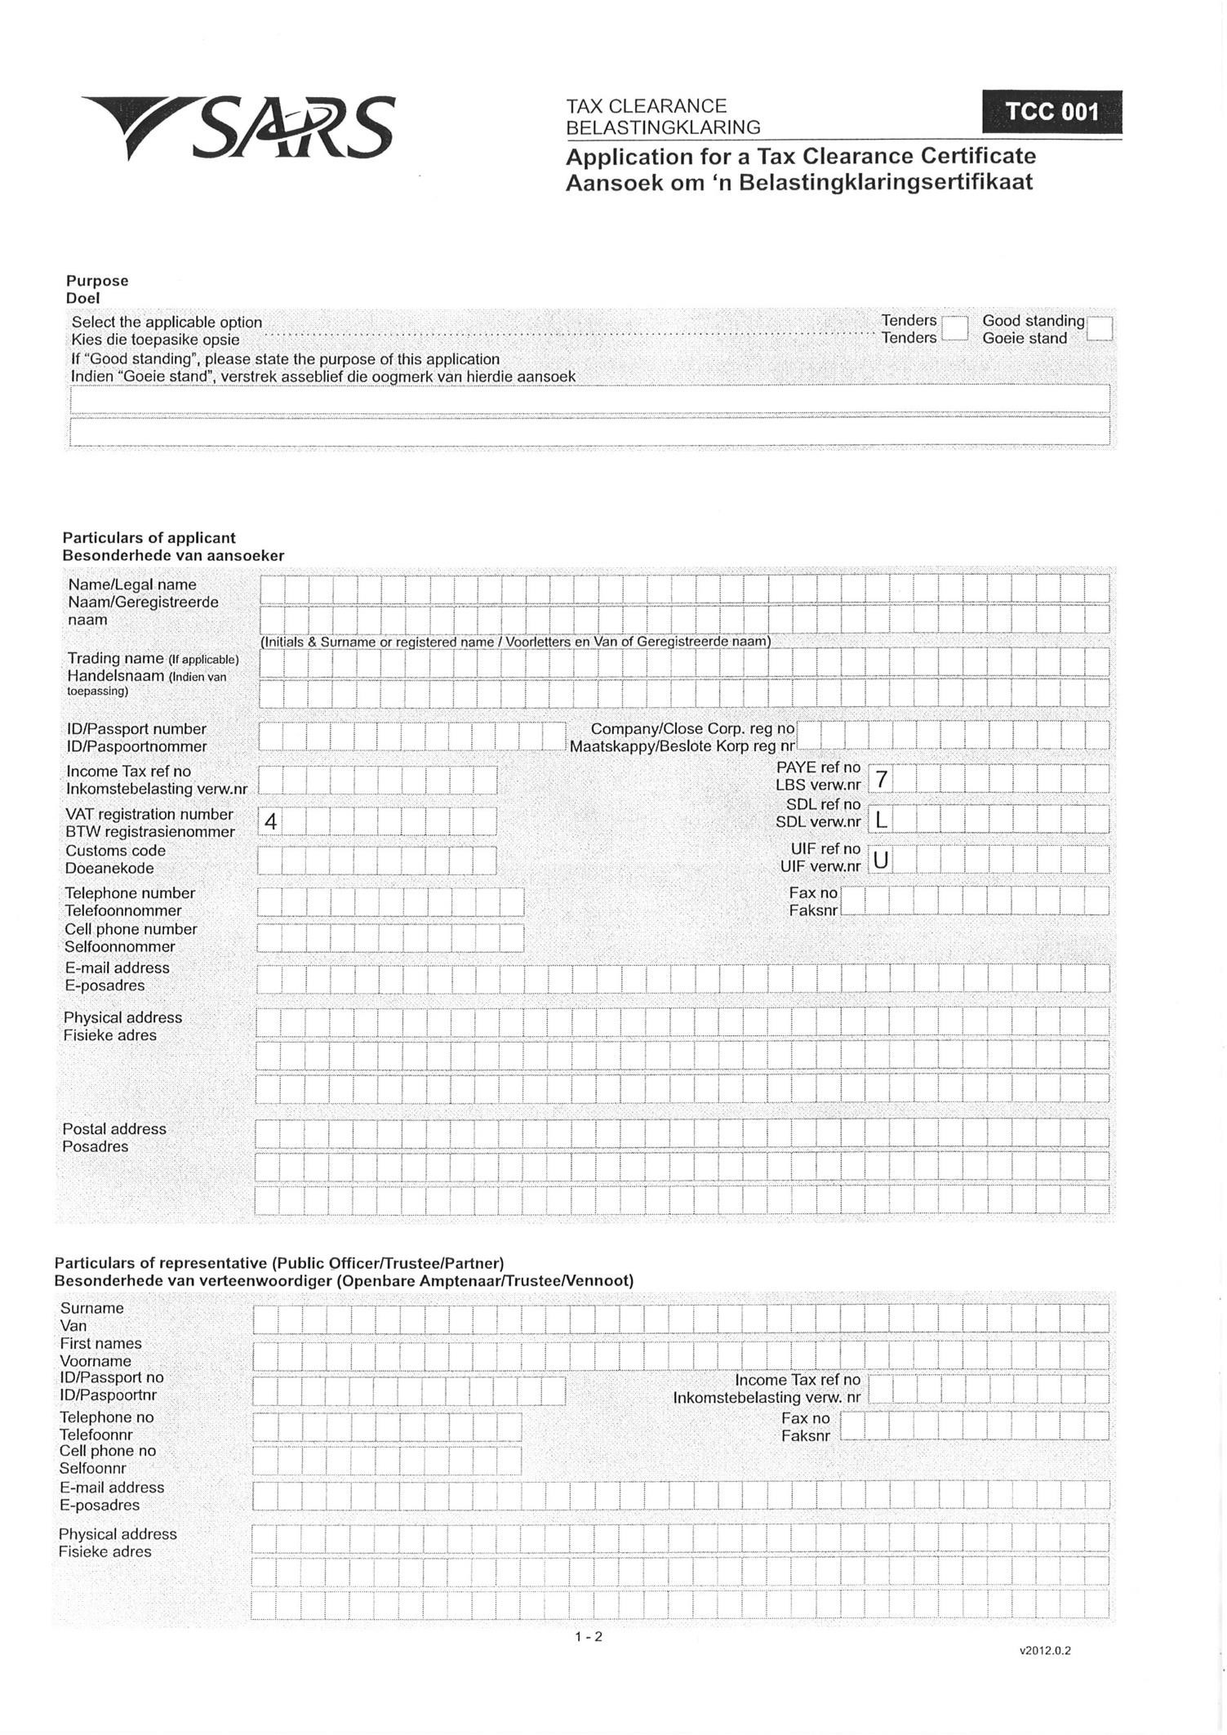
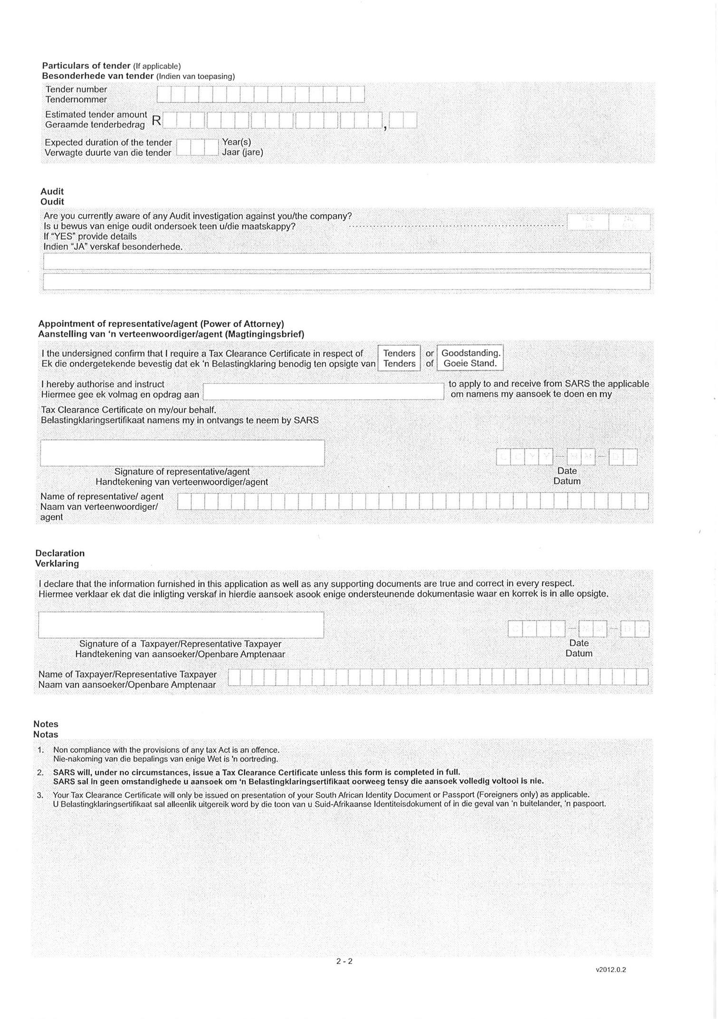

MBD 3.1 PRICING SCHEDULE – FIRM PRICES
(PURCHASES)

NOTE: ONLY FIRM PRICES WILL BE ACCEPTED. NON-FIRM PRICES (INCLUDING PRICES SUBJECT TO RATES OF EXCHANGE VARIATIONS) WILL NOT BE CONSIDERED

IN CASES WHERE DIFFERENT DELIVERY POINTS INFLUENCE THE PRICING, A SEPARATE PRICING SCHEDULE MUST BE SUBMITTED FOR EACH DELIVERY POINT

Name of bidder…………………………………… Bid number…………………...................................
Closing Time 10:00 Closing date…………………………………………...

OFFER TO BE VALID FOR………………….DAYS FROM THE CLOSING DATE OF BID.
_________________________________________________________________________________
ITEM QUANTITY DESCRIPTION BID PRICE IN RSA CURRENCY NO
** (ALL APPLICABLE TAXES INCLUDED)

- Required by: ………………………………………
- At: ………………………………………
- Brand and model ……………………………………… - Country of origin ………………….………………….
- Does the offer comply with the specification(s)? *YES/NO
- If not to specification, indicate deviation(s) ………………………………………
- Period required for delivery ………………………………………
*Delivery: Firm/not firm

- Delivery basis ………………………………………

Note: All delivery costs must be included in the bid price, for delivery at the prescribed destination.

** “all applicable taxes” includes value- added tax, pay as you earn, income tax, unemployment insurance fund contributions and skills development levies.

*Delete if not applicable

PRICING SCHEDULE – FIRM PRICES
(PURCHASES)

NOTE: PRICE ADJUSTMENTS WILL BE ALLOWED AT THE PERIODS AND TIMES SPECIFIED IN THE BIDDIND DOCUMENTS

IN CASES WHERE DIFFERENT DELIVERY POINTS INFLUENCE THE PRICING, A SEPARATE PRICING SCHEDULE MUST BE SUBMITTED FOR EACH DELIVERY POINT

Name of bidder…………………………………… Bid number…………………...................................
Closing Time 10:00 Closing date…………………………………………...

OFFER TO BE VALID FOR…………………. DAYS FROM THE CLOSING DATE OF BID.
_________________________________________________________________________________
ITEM QUANTITY DESCRIPTION BID PRICE IN RSA CURRENCY NO
** (ALL APPLICABLE TAXES INCLUDED)

- Required by: ………………………………………
- At: ………………………………………
- Brand and model ……………………………………… - Country of origin ………………….………………….
- Does the offer comply with the specification(s)? *YES/NO
- If not to specification, indicate deviation(s) ………………………………………
- Period required for delivery ………………………………………
*Delivery: Firm/not firm

- Delivery basis ………………………………………

Note: All delivery costs must be included in the bid price, for delivery at the prescribed destination.

** “all applicable taxes” includes value- added tax, pay as you earn, income tax, unemployment insurance fund contributions and skills development levies.

*Delete if not applicable

PRICE ADJUSTMENTS

A NON-FIRM PRICES SUBJECT TO ESCALATION

- IN CASES OF PERIOD CONTRACTS, NON FIRM PRICES WILL BE ADJUSTED (LOADED) WITH THE ASSESSED CONTRACT PRICE ADJUSTMENTS IMPLICIT IN NON FIRM PRICES WHEN
CALCULATING THE COMPARATIVE PRICES

- IN THIS CATEGORY PRICE ESCALATIONS WILL ONLY BE CONSIDERED IN TERMS OF THE FOLLOWING FORMULA:

Where:

Pa | = The new escalated price to be calculated.
(1-V) Pt | = 85% of the original bid price. Note that Pt must always be the original bid price and not an escalated price.
D1, D2 | = Each factor of the bid price e.g. labour, transport, clothing, footwear, etc. The of the various factors D1, D2…etc. must add up to 100%. | total
R1t, R2t | = Index figure obtained from new index (depends on the number of factors used)
R1o, R2o | = Index figure at time of bidding
VT | = 15% of the original bid price. This portion of the bid price remains firm i.e. it is not subject to any price escalations.

- The following index/indices must be used to calculate your bid price:

Index………. Dated………. Index………. Dated………. Index………. Dated……….
Index………. Dated………. Index………. Dated………. Index………. Dated……….
- FURNISH A BREAKDOWN OF YOUR PRICE IN TERMS OF ABOVE-MENTIONED FORMULA. THE TOTAL OF THE VARIOUS FACTORS MUST ADD UP TO 100%.

FACTOR  (D1, D2 etc. eg. Labour, transport etc.) | PERCENTAGE OF BID PRICE

B PRICES SUBJECT TO RATE OF EXCHANGE VARIATIONS

- Please furnish full particulars of your financial institution, state the currencies used in the conversion of the prices of the items to South African currency, which portion of the price is subject to rate of exchange variations and the amounts remitted abroad.

PARTICULARS OF FINANCIAL INSTITUTION | ITEM NO | PRICE | CURRENCY | RATE | PORTION OF PRICE  SUBJECT TO  ROE | AMOUNT IN FOREIGN  CURRENCY  REMITTED  ABROAD
 |  |  |  | ZAR=
 |  |  |  | ZAR=
 |  |  |  | ZAR=
 |  |  |  | ZAR=
 |  |  |  | ZAR=
 |  |  |  | ZAR=

- Adjustments for rate of exchange variations during the contract period will be calculated
by using the average monthly exchange rates as issued by your commercial bank for the periods indicated hereunder: (Proof from bank required)

AVERAGE MONTHLY EXCHANGE RATES FOR THE PERIOD: | DATE  DOCUMENTATION  MUST BE  SUBMITTED TO THIS OFFICE | DATE FROM WHICH  NEW CALCULATED  PRICES WILL  BECOME EFFECTIVE | DATE UNTIL WHICH  NEW CALCULATED  PRICE WILL BE EFFECTIVE

ANNEXURE B MBD 4

DECLARATION OF INTEREST

- Any legal person, including persons employed by the state¹, or persons having a kinship with persons employed by the state, including a blood relationship, may make an offer or offers in terms of this invitation to bid (includes an advertised competitive bid, a limited bid, a proposal or written price quotation). In view of possible allegations of favouritism, should the resulting bid, or part thereof, be awarded to persons employed by the state, or to persons connected with or related to them, it is required that the bidder or his/her authorised representative declare his/her position in relation to the evaluating/adjudicating authority where-

        - the bidder is employed by the state; and/or

        - the legal person on whose behalf the bidding document is signed, has a relationship with persons/a person who are/is involved in the evaluation and or adjudication of the bid(s), or where it is known that such a relationship exists between the person or persons for or on whose behalf the declarant acts and persons who are involved with the evaluation and or adjudication of the bid.

- In order to give effect to the above, the following questionnaire must be completed and submitted with the bid.

  - Full Name of bidder or his or her representative ……….………………………………………….

  - Identity Number:……….…………………………………………………..........................................

  - Position occupied in the Company (director, trustee, shareholder², member):
…………………………………………………………………………………………………………………

  - Registration number of company, enterprise, close corporation, partnership agreement or trust:
………………………………………………………………………………………………………………..
  - Tax Reference Number: ………………………………………………………………………………….

  - VAT Registration Number …………………………………………………………………………..........

    - The names of all directors / trustees / shareholders / members, their individual identity numbers, tax reference numbers and, if applicable, employee / PERSAL numbers must be indicated in paragraph 3 below.

¹ “State” means –
          - any national or provincial department, national or provincial public entity or constitutional institution within the meaning of the Public Finance Management Act, 1999 (Act No. 1 of 1999);
          - any municipality or municipal entity;
          - provincial legislature;
          - national Assembly or the national Council of provinces; or (e) Parliament.

²” Shareholder” means a person who owns shares in the company and is actively involved in the management of the enterprise or business and exercises control over the enterprise.

  - Are you or any person connected with the bidder YES / NO
presently employed by the state?

    - If so, furnish the following particulars:

Name of person / director / trustee / shareholder/ member ……………………………………….
Name of state institution at which you or the person
connected to the bidder is employed: ………………………………………. Position occupied in the state institution: ………………………………………….

Any other particulars:
………………………………………………………………
………………………………………………………………
………………………………………………………………

    - If you are presently employed by the state, did you obtain YES / NO
the appropriate authority to undertake remunerative work outside employment in the public sector?

      - If yes, did you attach proof of such authority to the bid YES / NO document?

(Note: Failure to submit proof of such authority, where applicable, may result in the disqualification of the bid.

      - If no, furnish reasons for non-submission of such proof:
…………………………………………………………………….
…………………………………………………………………….
…………………………………………………………………….

  - Did you or your spouse, or any of the company’s directors / YES / NO
trustees / shareholders / members or their spouses conduct business with the state in the previous twelve months?

    - If so, furnish particulars:
…………………………………………………………………..
…………………………………………………………………..
…………………………………………………………………..

  - Do you, or any person connected with the bidder, have YES / NO
any relationship (family, friend, other) with a person employed by the state and who may be involved with the evaluation and or adjudication of this bid?

    - If so, furnish particulars:
……………………………………………………………... …………………………………………………………..…. ………………………………………………………………

  - Are you, or any person connected with the bidder, YES/NO
aware of any relationship (family, friend, other) between any other bidder and any person employed by the state who may be involved with the evaluation and or adjudication of this bid?

    - If so, furnish particulars.
………………………………………………………………
………………………………………………………………
………………………………………………………………

  - Do you or any of the directors / trustees / shareholders / members YES/NO of the company have any interest in any other related companies whether or not they are bidding for this contract?

    - If so, furnish particulars:
…………………………………………………………………………….
……………………………………………………………………………. …………………………………………………………………………….

- Full details of directors / trustees / members / shareholders.

Full Name | Identity Number | Personal Income Tax Reference Number | State Employee  Number / Persal Number

4. DECLARATION

I, THE UNDERSIGNED (NAME)………………………………………………………………………
CERTIFY THAT THE INFORMATION FURNISHED IN PARAGRAPHS 2 and 3 ABOVE IS CORRECT. I ACCEPT THAT THE STATE MAY REJECT THE BID OR ACT AGAINST ME SHOULD THIS DECLARATION PROVE TO BE FALSE.

………………………………………….. ………………………………………….
Signature Date

………………………………………….. ………………………………………….
Position Name of bidder

JUNE 2020

MBD 6.1

1. GENERAL CONDITIONS

1.1 The following preference point systems are applicable to all bids:

- the 80/20 system for requirements with a Rand value of up to R50 000 000 (all applicable taxes included); and
- the 90/10 system for requirements with a Rand value above R50 000 000 (all applicable taxes included).

  - The value of this bid is estimated to exceed/not exceed R50 000 000 (all applicable taxes included) and therefore the ____________ system shall be applicable.

  - Preference points for this bid shall be awarded for:

- Price; and
- Specific Goals

1.3.1 The maximum points for this bid are allocated as follows:

POINTS

1.3.1.1 PRICE ………..…

1.3.1.2 SPECIFIC GOALS …………..

Total points for Price and Specific goals must not exceed 100

1.4 The 80/20 preference system will be used as per SCM policy, where 80 points will be for price and 20 for Specific Goals.

1.5. The purchaser reserves the right to require of a bidder, either before a bid is adjudicated or at any time subsequently, to substantiate any claim in regard to preferences, in any manner required by the purchaser.

2. DEFINITIONS

2.1 “all applicable taxes” includes value-added tax, pay as you earn, income tax, unemployment insurance fund contributions and skills development levies;

2.2 “B-BBEE” means broad-based black economic empowerment as defined in section 1 of the Broad Based Black Economic Empowerment Act;

2.3 “B-BBEE status level of contributor” means the B-BBEE status received by a measured entity based on its overall performance using the relevant scorecard contained in the Codes of Good Practice on Black Economic Empowerment, issued in terms of section 9(1) of the Broad-Based Black Economic Empowerment Act;

2.4 “bid” means a written offer in a prescribed or stipulated form in response to an invitation by an organ of state for the provision of services, works or goods, through price quotations,
advertised competitive bidding processes or proposals;

2.5 “Broad-Based Black Economic Empowerment Act” means the Broad-Based Black
Economic
Empowerment Act, 2003 (Act No. 53 of 2003);

2.6 “comparative price” means the price after the factors of a non-firm price and all unconditional discounts that can be utilized have been taken into consideration;

2.7 “consortium or joint venture” means an association of persons for the purpose of combining their
expertise, property, capital, efforts, skill and knowledge in an activity for the execution of a contract;

2.8 “contract” means the agreement that results from the acceptance of a bid by an organ of
state;

2.9 “EME” means any enterprise with an annual total revenue of R5 million or less.

2.10 “Firm price” means the price that is only subject to adjustments in accordance with the actual increase or decrease resulting from the change, imposition, or abolition of customs or excise duty and any other duty, levy, or tax, which, in terms of the law or regulation, is binding on the contractor and demonstrably has an influence on the price of any supplies, or the rendering costs of any service, for the execution of the contract;

2.11 “functionality” means the measurement according to predetermined norms, as set out in the bid documents, of a service or commodity that is designed to be practical and useful, working or operating, taking into account, among other factors, the quality, reliability, viability and durability of a service and the technical capacity and ability of a bidder;

2.12 “non-firm prices” means all prices other than “firm” prices;

2.13 “person” includes a juristic person;

2.14 “rand value” means the total estimated value of a contract in South African currency, calculated at the time of bid invitations, and includes all applicable taxes and excise duties;

2.15 “sub-contract” means the primary contractor’s assigning, leasing, making out work to, or employing, another person to support such primary contractor in the execution of part of a project in terms of the contract;

2.16 “total revenue” bears the same meaning assigned to this expression in the Codes of Good Practice on Black Economic Empowerment, issued in terms of section 9(1) of the Broad-Based Black Economic Empowerment Act and promulgated in the Government Gazette on 9 February 2007;

2.17 “trust” means the arrangement through which the property of one person is made over or bequeathed to a trustee to administer such property for the benefit of another person; and

2.18 “trustee” means any person, including the founder of a trust, to whom property is bequeathed in order for such property to be administered for the benefit of another person.

3. ADJUDICATION USING A POINT SYSTEM

3.1 The bidder obtaining the highest number of total points will be awarded the contract.

3.2 Preference points shall be calculated after prices have been brought to a comparative basis taking into account all factors of non-firm prices and all unconditional discounts;

3.3 Points scored must be rounded off to the nearest 2 decimal places.

3.4 In the event that two or more bids have scored equal total points, the successful bid must be the one scoring the highest number of preference points for Specific Goals.

3.5 However, when functionality is part of the evaluation process and two or more bids have scored equal points including equal preference points for Specific goals the successful bid must be the one scoring the highest score for functionality.

3.6 Should two or more bids be equal in all respects; the award shall be decided by the drawing of lots.

4. POINTS AWARDED FOR PRICE

4.1 THE 80/20 OR 90/10 PREFERENCE POINT SYSTEMS

A maximum of 80 or 90 points is allocated for price on the following basis:

80/20 or 90/10

Ps 801 Pt  Pmin  or Ps 901 Pt  Pmin 
 Pmin   Pmin 
Where

Ps = Points scored for comparative price of bid under consideration

Pt = Comparative price of bid under consideration

Pmin = Comparative price of lowest acceptable bid

5. Specific Goals

6. SUB-CONTRACTING

8.1 Will any portion of the contract be sub-contracted? YES / NO (delete which is not applicable)

8.1.1 If yes, indicate:

- what percentage of the contract will be subcontracted? .............……………….…%

- the name of the sub-contractor?………………………………………………………..

- the B-BBEE status level of the sub-contractor?……………………….……………..

- whether the sub-contractor is an EME? YES / NO (delete which is not applicable)

7 DECLARATION WITH REGARD TO COMPANY/FIRM

7.1 Name of firm : ..................................................................................
7.2 VAT registration number : ..................................................................................
7.3 Company registration number : .………………………………………………………….
7.4 TYPE OF COMPANY/ FIRM

 Partnership/Joint Venture / Consortium
 One-person business/sole propriety
 Close corporation
 Company
 (Pty) Limited
[TICK APPLICABLE BOX]

7.5 DESCRIBE PRINCIPAL BUSINESS ACTIVITIES

………….. ............................................................................................................................... ……………… .......................................................................................................................... …………….. ............................................................................................................................

7.6 | COMPANY CLASSIFICATION
 | Manufacturer
 | Supplier
 | Professional service provider
 | Other service providers, e.g. transporter, etc.
 | [TICK APPLICABLE BOX]
7.7 | Total number of years the company/firm | has | been | in | business?
………………………………………

7.8 I/we, the undersigned, who is / are duly authorised to do so on behalf of the company/firm, certify that the points claimed, based on the B-BBE status level of contribution indicated in paragraph 7 of the foregoing certificate, qualifies the company/ firm for the preference(s) shown and I / we acknowledge that:

- The information furnished is true and correct;

- The preference points claimed are in accordance with the General Conditions as indicated in paragraph 1 of this form.

- In the event of a contract being awarded as a result of points claimed as shown in
paragraph 7, the contractor may be required to furnish documentary proof to the satisfaction of the purchaser that the claims are correct;

- If the B-BBEE status level of contribution has been claimed or obtained on a fraudulent basis or any of the conditions of contract have not been fulfilled, the purchaser may, in addition to any other remedy it may have –

  - disqualify the person from the bidding process;

  - recover costs, losses or damages it has incurred or suffered as a result of that person’s conduct;

  - cancel the contract and claim any damages which it has suffered as a result of having to make less favourable arrangements due to such cancellation;

  - restrict the bidder or contractor, its shareholders and directors, or only the shareholders and directors who acted on a fraudulent basis, from obtaining business from any organ of state for a period not exceeding 10 years, after the audial-terampartem (hear the other side) rule has been applied; and

  - forward the matter for criminal prosecution

WITNESSES:
……………………………………
SIGNATURE(S) OF BIDDER(S)

- ………………………………………

- ………………………………………

DATE:………………………..

ADDRESS:…………………………..

….…………………………………….

……………………………………….

…………….…………………………

MBD 8
DECLARATION OF BIDDER’S PAST SUPPLY CHAIN MANAGEMENT
PRACTICES

- This Standard Bidding Document must form part of all bids invited.

- It serves as a declaration to be used by institutions in ensuring that when goods and services are being procured, all reasonable steps are taken to combat the abuse of the supply chain management system.

- The bid of any bidder may be disregarded if that bidder, or any of its directors have-

  - abused the institution’s supply chain management system;
  - committed fraud or any other improper conduct in relation to such system; or
  - failed to perform on any previous contract.

4 In order to give effect to the above, the following questionnaire must be completed and submitted with the bid.

Item | Question | Yes | No
4.1 | Is the bidder or any of its directors listed on the National Treasury’s Database of Restricted Suppliers as companies or persons prohibited from doing business with the public sector? (Companies or persons who are listed on this Database were informed in writing of this restriction by the Accounting Officer/Authority of the institution that imposed the restriction after the audialterampartem rule was applied)  The Database of Restricted Suppliers now resides on the National Treasury’s website (www.treasury.gov.za) and can be accessed by clicking on its link at the bottom of the home page. | Yes | No
4.1.1 | If so, furnish particulars
4.2 | Is the bidder or any of its directors listed on the Register for Tender Defaulters in terms of section 29 of the Prevention and Combating of Corrupt Activities Act (No 12 of 2004)?  The Register for Tender Defaulters can be accessed on the National Treasury’s website (www.treasury.gov.za) by clicking on its link at the bottom of the home page. | Yes | No
4.2.1 | If so, furnish particulars:
4.3 | Was the bidder or any of its directors convicted by a court of law (including a court outside of the Republic of South Africa) for fraud or corruption during the past five years? | Yes | No
4.3.1 | If so, furnish particulars:
4.4 | Was any contract between the bidder and any organ of state terminated during the past five years on account of failure to perform on or comply with the contract? | Yes | No
4.4.1 | If so, furnish particulars:

MBD 8

CERTIFICATION

I, THE UNDERSIGNED (FULL NAME)…………………………………………………………….. CERTIFY THAT THE INFORMATION FURNISHED ON THIS DECLARATION FORM IS TRUE AND CORRECT.

I ACCEPT THAT, IN ADDITION TO CANCELLATION OF A CONTRACT, ACTION MAY BE TAKEN AGAINST ME SHOULD THIS DECLARATION PROVE TO BE FALSE.

………………………………………….. ………………………………………….
Signature Date

…………………………………………. ………………………………………….
Position Name of Bidder

MBD 9 CERTIFICATE OF INDEPENDENT BID DETERMINATION

- This Standard Bidding Document (MBD) must form part of all bids¹ invited.

- Section 4 (1) (b) (iii) of the Competition Act No. 89 of 1998, as amended, prohibits an agreement between, or concerted practice by, firms, or a decision by an association of firms, if it is between parties in a horizontal relationship and if it involves collusive bidding (or bid rigging). ² Collusive bidding is a pe se prohibition meaning that it cannot be justified under any grounds.

- Treasury Regulation 16A9 prescribes that accounting officers and accounting authorities must take all reasonable steps to prevent abuse of the supply chain management system and authorizes accounting officers and accounting authorities to:

- disregard the bid of any bidder if that bidder, or any of its directors have abused the institution’s supply chain management system and or committed fraud or any other improper conduct in relation to such system.
- cancel a contract awarded to a supplier of goods and services if the supplier committed any corrupt or fraudulent act during the bidding process or the execution of that contract.

- This SBD serves as a certificate of declaration that would be used by institutions to ensure that, when bids are considered, reasonable steps are taken to prevent any form of bid-rigging.

- In order to give effect to the above, the attached Certificate of Bid Determination (SBD 9) must be completed and submitted with the bid:

¹ Includes price quotations, advertised competitive bids, limited bids and proposals.

² Bid rigging (or collusive bidding) occurs when businesses, that would otherwise be expected to compete, secretly conspire to raise prices or lower the quality of goods and / or services for purchasers who wish to acquire goods and / or services through a bidding process. Bid rigging is, therefore, an agreement between competitors not to compete.

MBD 9

CERTIFICATE OF INDEPENDENT BID DETERMINATION

I, the undersigned, in submitting the accompanying bid:

---------------------------------------------------------------------------------------------------------------------------------
(Bid Number and Description)

in response to the invitation for the bid made by:

---------------------------------------------------------------------------------------------------------------------------------
(Name of Institution)

do hereby make the following statements that I certify to be true and complete in every respect:

I certify, on behalf of: ________________________________________________that:(Name of Bidder)

- I have read and I understand the contents of this Certificate;
- I understand that the accompanying bid will be disqualified if this Certificate is found not to be true and complete in every respect;
- I am authorized by the bidder to sign this Certificate, and to submit the accompanying bid, on behalf of the bidder;
- Each person whose signature appears on the accompanying bid has been authorized by the bidder to determine the terms of, and to sign the bid, on behalf of the bidder;
- For the purposes of this Certificate and the accompanying bid, I understand that the word “competitor” shall include any individual or organization, other than the bidder, whether or not affiliated with the bidder, who:

- has been requested to submit a bid in response to this bid invitation; could potentially submit a bid in response to this bid invitation, based on
- their qualifications, abilities or experience; and
- provides the same goods and services as the bidder and/or is in the same line of business as the bidder

- The bidder has arrived at the accompanying bid independently from, and without consultation, communication, agreement or arrangement with any competitor. However communication between partners in a joint venture or consortium³ will not be construed as collusive bidding.
- In particular, without limiting the generality of paragraphs 6 above, there has been no consultation, communication, agreement or arrangement with any competitor regarding: a) prices;
  - geographical area where product or service will be rendered (market allocation)
  - methods, factors or formulas used to calculate prices;
  - the intention or decision to submit or not to submit, a bid;
  - the submission of a bid which does not meet the specifications and conditions of the bid; or
  - bidding with the intention not to win the bid.

- In addition, there have been no consultations, communications, agreements or arrangements with any competitor regarding the quality, quantity, specifications and conditions or delivery particulars of the products or services to which this bid invitation relates.

- The terms of the accompanying bid have not been, and will not be, disclosed by the tenderers, directly or indirectly, to any competitor, prior to the date and time of the official bid opening or of the awarding of the contract.

³ Joint venture or Consortium means an association of persons for the purpose of combining their expertise, property, capital, efforts, skill and knowledge in an activity for the execution of a contract.

- I am aware that, in addition and without prejudice to any other remedy provided to combat any restrictive practices related to bids and contracts, bids that are suspicious will be reported to the Competition Commission for investigation and possible imposition of administrative penalties in terms of section 59 of the Competition Act No 89 of 1998 and or may be reported to the National Prosecuting Authority (NPA) for criminal investigation and or may be restricted from conducting business with the public sector for a period not exceeding ten (10) years in terms of the Prevention and Combating of Corrupt Activities Act No 12 of 2004 or any other applicable legislation.

………………………………………………… …………………………………
Signature Date

…………………………………………………. …………………………………
Position Name of Bidder

PART C1

AGREEMENT AND CONTRACT DATA

C1.1 FORM OF OFFER AND ACCEPTANCE

OFFER

The Employer, identified in the acceptance signature block, has solicited offers to enter into a contract for the procurement of:

PROJECT NAME: UPGRADING OF CHULUNCA BRIDGE

The tenderer, identified in the offer signature block, has examined the documents listed in the Tender Data and addenda thereto as listed in the returnable schedules, and by submitting this offer has accepted the conditions of tender.

By the representative of the tenderer, deemed to be duly authorized, signing this part of this form of offer and acceptance, the tenderer offers to perform all of the obligations and liabilities of the contractor under the contract including compliance with all its terms and conditions according to their true intent and meaning for an amount to be determined in accordance with the Conditions of Contract identified in the Contract Data.

THE OFFERED TOTAL OF THE PRICES INCLUSIVE OF VALUE ADDED TAX IS:

………………………………………………………………………………………………………………………

…………………………………………………………………………………………………Rands (in words);

R……………………………………………………… (in figures)

This offer may be accepted by the Employer by signing the acceptance part of this form of offer and acceptance and returning one copy of this document to the tenderer before the end of the period of validity stated in the Tender Data, whereupon the tenderer becomes the party named as the contractor in the Conditions of Contract identified in the Contract Data.

Signature …………………………………………………

Date………………………………………………………………

Name ………………………………………………………….

Capacity…………………………………………………………

FOR THE TENDERER

(Name and address of organization) ………………………………………………………………………

Name and signature of witness ………………………………………………………………………

………………………………………………………………………
ACCEPTANCE

By signing this part of this form of offer and acceptance, the Employer identified below accepts the tenderer’s offer. In consideration thereof, the Employer shall pay the contractor the amount due in accordance with the Conditions of Contract identified in the Contract Data. Acceptance of the tenderer’s offer shall form an agreement between the Employer and the tenderer upon the terms and conditions contained in this agreement and in the contract that is the subject of this agreement.
The terms of the contract, are contained in:

Part C1: Agreements and Contract Data, (which includes this agreement)

Part C2: Pricing data

Part C3: Scope of work.

Part C4: Site information

Deviations from and amendments to the documents listed in the Tender Data and any addenda thereto as listed in the tender schedules as well as any changes to the terms of the offer agreed by the tenderer and the Employer during this process of offer and acceptance, are contained in the schedule of deviations attached to and forming part of this agreement. No amendments to or deviations from said documents are valid unless contained in this schedule.

The tenderer shall within two weeks after receiving a completed copy of this agreement, including the schedule of deviations (if any), contact the Employer’s agent (whose details are given in the Contract Data) to arrange the delivery of any bonds, guarantees, proof of insurance and any other documentation to be provided in terms of the Conditions of Contract identified in the Contract Data. Failure to fulfil any of these obligations in accordance with those terms shall constitute a repudiation of this agreement.

Notwithstanding anything contained herein, this agreement comes into effect on the date when the tenderer receives one fully completed original copy of this document, including the schedule of deviations (if any). Unless the tenderer (now contractor) within five working days of the date of such receipt notifies the Employer in writing of any reason why he cannot accept the contents of this agreement, this agreement shall constitute a binding contract between the parties.

Signature ………………………………………. Date ………………………………………….

Name ……………………………………….

Capacity ……………………………………….

FOR THE EMPLOYER

Name and signature of witness ………………………………………………….............................

……………………………………………………………………..

Date ……………………………………………………………………….

Schedule of Deviations (To be filled in if there are any Deviations or Alternatives accepted)

- Subject : _____________________________________________________________________

Details : _____________________________________________________________________

______________________________________________________________________

______________________________________________________________________

- Subject : _____________________________________________________________________

Details : _____________________________________________________________________

______________________________________________________________________

______________________________________________________________________

- Subject : _____________________________________________________________________

Details : _____________________________________________________________________

______________________________________________________________________

______________________________________________________________________

- Subject : _____________________________________________________________________

Details : _____________________________________________________________________

______________________________________________________________________

______________________________________________________________________

- Subject : _____________________________________________________________________

Details : _____________________________________________________________________

______________________________________________________________________

______________________________________________________________________

By the duly authorised representatives signing this agreement, the Employer and the tenderer agree to and accept the foregoing schedule of deviations as the only deviations from and amendments to the documents listed in the Tender Data and addenda thereto as listed in the tender schedules, as well as any confirmation, clarification or changes to the terms of the offer agreed by the tenderer and the Employer during this process of offer and acceptance.

It is expressly agreed that no other matter whether in writing, oral communication or implied during the period between the issue of the tender documents and the receipt by the tenderer of a completed signed copy of this Agreement shall have any meaning or effect in the contract between the parties arising from this agreement.

(To be signed only if there are any Deviations listed above)

Signature ………………………………………………. Date ……………………………………

Name ……………………………………………….

Capacity ……………………………………………….

FOR THE TENDERER

(Name and address of organization) ………………………………………………………………………….

Name and signature of witness ………………………………………………………………………….

…………………………………………………………………………..

Date ………………………………………………………………………….

Signature ………………………………………………………………………......

Date ………………………………………………………………………….

Name ………………………………………………………………………….

Capacity ………………………………………………………………………….

FOR THE EMPLOYER

Name and signature of witness ………………………………………………………………………….

…………………………………………………………………………..

Date ………………………………………………………………………….

C1.2 CONTRACT DATA

The General Conditions of Contract for Construction Works (2015) published by the South African Institution of Civil Engineering, Second Edition, print 3.1, is applicable to this contract.

Copies of these General Conditions of Contract may be obtained from the South African Institution of Civil Engineering:

Block 19, Thornhill Office Park
Bekker Street, Vorna Valley,
Midrand.

Private Bag X200,
Halfway House. 1685

Tel: 011-805 5947
Fax: 011-805 5971

C1.2.1 Contract Specific Data.
The contract is a re measurable contract.
The following contracts data are applicable to this contract:

REFERENCE TO: | CLAUSE. | DATA
Contractor. | 1.1.1.9 | To be appointed by Mhlontlo Local Municipality
Employer. | 1.1.1.15 | Mhlontlo Local Municipality
Year End break |  | 20 December 2023 to 05 January 2024
Contract Cessions | 5.1 | Contract Cessions will be approved by the Employer on this Project
Sub-Contracting | 4.4 | A portion of contract value may be sublet to non HDI if contract has been obtained with HDI points
Contract Guarantee | 6.2.3 | Within 14 days after appointment letter has been issued.
Commencement of Works | 5.3.1 | Within 28 days of Appointment Date
Programme of Works | 5.6.1 | Within 14 days of Commencement Date
Insurances | 8.6.1 | Construction Insurance equal to Contract amount should be submitted within 28 days of appointment
Limit of indemnity | 8.4.2 | Claims unlimited
Other Insurances | 8.6.1.3 | Liability Insurances
Daywork percentages | 6.5.1.1 | 15%

REFERENCE TO: | CLAUSE. | DATA
Special non-working days | 5.1.1.1 | All public holidays including Clause 5.8.2
Time for Completion | 5.6.2.1 | 3 months from Commencement Date EXCLUDING YEAR END BREAK
Penalty for Delay | 5.13.1 | 1% of the total contract value per day
Contract Price Adjustment | 6.8.2 | Not Applicable
Special Materials | 6.9.1  6.9.2 | See Attached Schedule
Materials on Site | 6.9.1  6.9.2 | 80%
Retention Money | 6.10.5 | 10% of the Contract amount
Retention Guarantee | 6.10.3 | A Retention Guarantee is compulsory for the defects liability period
Defects Liability Period | 7.8.1 | 06 Months
Dispute Resolution | 10.5.1, 10.5.3 | Adjudication, Arbitration and the Court will be acceptable dispute resolution mechanisms
- N.B It is critical to note that the bidder shall be subjected to monthly performance assessment inline with section 116 2b of the Municipal Finance Management Act 32 of 2000

………………………………………….. …………………………………………. …………………………………………..
Signature Date

………………………………………….. ………………………
Position Name of bidder

C1.2.2 Data provided by the Contractor

Clause 46.3 of the GCC:

Special Materials | Unit on which variation will be determined* | Price (ex-factory) for the base month (exc. Vat)**

Notes:

* Indicate whether the material will be delivered in bulk or in containers.

** The price for special materials is only the price for the material ex-factory and does not include the cost of transport, labour or any other costs. When called upon to do so, the tenderer shall substantiate the above prices with acceptable documentary evidence for the base month and the month in which the increase is claimed.

………………………………………….. ………………………………………….
Signature Date

………………………………………….. ………………………………………….
Position Name of bidder

C1.2.3. EPWP specific Conditions of Contract.

NOTE THAT THIS PROJECT HAS NOT BEEN REGISTERED AS AN EPWP PROJECT, BUT WILL BE EXECUTED ACCORDING TO THE EPWP PRINCIPLES.

Payment for the labour-intensive component of the works

Payment for works identified in the Scope of Work as being labour-intensive shall only be made in accordance with the provisions of the Contract if the works are constructed strictly in accordance with the provisions of the Scope of Work. Any non-payment for such works shall not relieve the Contractor in any way from his obligations either in contract or in delict.

Applicable labour laws

The Ministerial Determination, Extended Public Works Programmes, issued in terms of the Basic Conditions of Employment Act of 1997 by the Minister of Labour in Government Notice N° R63 of 25 January 2002, as reproduced below, shall apply to works described in the scope of work as being labour intensive and which are undertaken by unskilled or semi-skilled workers.

- Introduction

  - This document contains the standard terms and conditions for workers employed in elementary occupations on an Extended Public Works Programme (EPWP). These terms and conditions do NOT apply to persons employed in the supervision and management of an EPWP.

  - In this document –

(a) "Department" means any department of the State, implementing agent or contractor;
(b) "employer" means any department, implementing agency or contractor that hires workers to work in elementary occupations on an EPWP;
(c) "Worker" means any person working in an elementary occupation on an EPWP;
(d) Elementary occupation" means any occupation involving unskilled or semi-skilled work;
(e) "Management" means any person employed by a department or implementing agency to administer or execute an EPWP;
(f) "Task" means a fixed quantity of work;
(g) "task-based work" means work in which a worker is paid a fixed rate for performing a task;
(h) "task-rated worker" means a worker paid on the basis of the number of tasks completed;
(i) "time-rated worker" means a worker paid on the basis of the length of time worked.

- Terms of Work

2.1 Workers on an EPWP are employed on a temporary basis.
2.2 A worker may NOT be employed for longer than 24 months in any five-year cycle on an EPWP
2.3 Employment on an EPWP does not qualify as employment as a contributor for the purposes of the Unemployment Insurance Act 30 of 1966.

3. Normal Hours of Work

3.1 An employer may not set tasks or hours of work that require a worker to work–

(a) More than forty hours in any week
(b) On more than five days in any week; and
(c) For more than eight hours on any day.

3.2 An employer and worker may agree that a worker will work four days per week. The worker may then work up to ten hours per day.

3.3 A task-rated worker may not work more than a total of 55 hours in any week to complete the tasks allocated (based on a 40-hour week) to that worker.

4 Meal Breaks

4.1 A worker may not work for more than five hours without taking a meal break of at least thirty minutes’ duration.

4.2 An employer and worker may agree on longer meal breaks.

4.3 A worker may not work during a meal break. However, an employer may require a worker to perform duties during a meal break if those duties cannot be left unattended and cannot be performed by another worker. An employer must take reasonable steps to ensure that a worker is relieved of his or her duties during the meal break.

4.4 A worker is not entitled to payment for the period of a meal break. However, a worker who is paid on the basis of time worked must be paid if the worker is required to work or to be available for work during the meal break.
7
5 Special Conditions for Security Guards

5.1 A security guard may work up to 55 hours per week and up to eleven hours per day.

5.2 A security guard who works more than ten hours per day must have a meal break of at least one hour or two breaks of at least 30 minutes each.

6 Daily Rest Period

Every worker is entitled to a daily rest period of at least eight consecutive hours. The daily rest period is measured from the time the worker ends work on one day until the time the worker starts work on the next day.

7 Weekly Rest Period

Every worker must have two days off every week. A worker may only work on their day off to perform work which must be done without delay and cannot be performed by workers during their ordinary hours of work ("emergency work").

8 Work on Sundays and Public Holidays

8.1 A worker may only work on a Sunday or public holiday to perform emergency or security work.

8.2 Work on Sundays is paid at the ordinary rate of pay.

8.3 A task-rated worker who works on a public holiday must be paid –

(a) The worker’s daily task rate, if the worker works for less than four hours;
(b) Double the worker’s daily task rate, if the worker works for more than four hours.

8.4 A time-rated worker who works on a public holiday must be paid –

(a) The worker’s daily rate of pay, if the worker works for less than four hours on the public holiday
(b) Double the worker’s daily rate of pay, if the worker works for more than four hours on the public holiday.

9 Sick Leave

9.1 Only workers who work four or more days per week have the right to claim sick pay in terms of this clause.

9.2 A worker who is unable to work on account of illness or injury is entitled to claim one day’s paid sick leave for every full month that the worker has worked in terms of a contract.

9.3 A worker may accumulate a maximum of twelve days’ sick leave in a year.

9.4 Accumulated sick-leave may not be transferred from one contract to another contract.

9.5 An employer must pay a task-rated worker the worker’s daily task rate for a day’s sick leave.

9.6 An employer must pay a time-rated worker the worker’s daily rate of pay for a day’s sick leave.

9.7 An employer must pay a worker sick pay on the worker’s usual payday.

9.8 Before paying sick-pay, an employer may require a worker to produce a certificate stating that the
worker was unable to work on account of sickness or injury if the worker is –

(a) Absent from work for more than two consecutive days; or
(b) Absent from work on more than two occasions in any eight-week period.
8
9.9 A medical certificate must be issued and signed by a medical practitioner, a qualified nurse or a clinic staff member authorised to issue medical certificates indicating the duration and reason for incapacity.

9.10 A worker is not entitled to paid sick-leave for a work-related injury or occupational disease for which the worker can claim compensation under the Compensation for Occupational Injuries and Diseases Act.

10 Maternity Leave

10.1 A worker may take up to four consecutive months’ unpaid maternity leave.

10.2 A worker is not entitled to any payment or employment-related benefits during maternity leave.

10.3 A worker must give her employer reasonable notice of when she will start maternity leave and when she will return to work.

10.4 A worker is not required to take the full period of maternity leave. However, a worker may not work for four weeks before the expected date of birth of her child or for six weeks after the birth of her child, unless a medical practitioner, midwife or qualified nurse certifies that she is fit to do so.

10.5 A worker may begin maternity leave –

- four weeks before the expected date of birth; or

(b) On an earlier date –

(i) If a medical practitioner, midwife or certified nurse certifies that it is necessary for the health of the worker or that of her unborn child; or
(ii) If agreed to between employer and worker; or

(c) On a later date, if a medical practitioner, midwife or certified nurse has certified that the worker is able to continue to work without endangering her health.

10.6 A worker who has a miscarriage during the third trimester of pregnancy or bears a stillborn child may take maternity leave for up to six weeks after the miscarriage or stillbirth.

10.7 A worker who returns to work after maternity leave has the right to start a new cycle of twenty-four months’ employment, unless the EPWP on which she was employed has ended.

11 Family responsibility leave

11.1 Workers, who work for at least four days per week, are entitled to three days paid family responsibility leave each year in the following circumstances -

(a) when the employee’s child is born;
(b) when the employee’s child is sick;
(c) in the event of a death of –
(i) the employee’s spouse or life partner;
(ii) the employee’s parent, adoptive parent, grandparent, child, adopted child,
grandchild or sibling.

12 Statement of Conditions

12.1 An employer must give a worker a statement containing the following details at the start of employment

(a) the employer’s name and address and the name of the EPWP;
(b) the tasks or job that the worker is to perform; and
(c) the period for which the worker is hired or, if this is not certain, the expected duration of the contract;
(d) the worker’s rate of pay and how this is to be calculated;
(e) the training that the worker will receive during the EPWP.

12.2 An employer must ensure that these terms are explained in a suitable language to any employee who is unable to read the statement.

12.3 An employer must supply each worker with a copy of these conditions of employment.

13 Keeping Records

13.1 Every employer must keep a written record of at least the following –

(a) the worker’s name and position;
(b) in the case of a task-rated worker, the number of tasks completed by the worker;
(c) in the case of a time-rated worker, the time worked by the worker;
(d) Payments made to each worker.

13.2 The employer must keep this record for a period of at least three years after the completion of the EPWP.

14 Payment

14.1 An employer must pay all wages at least monthly in cash or by cheque or into a bank account.

14.2 A task-rated worker will only be paid for tasks that have been completed.

14.3 An employer must pay a task-rated worker within five weeks of the work being completed and the work having been approved by the manager or the contractor having submitted an invoice to the employer.

14.4 A time-rated worker will be paid at the end of each month.

14.5 Payment must be made in cash, by cheque or by direct deposit into a bank account designated by the worker.

14.6 Payment in cash or by cheque must take place –

(a) at the workplace or at a place agreed to by the worker;
(b) during the worker’s working hours or within fifteen minutes of the start or finish of work;

- in a sealed envelope which becomes the property of the worker.

14.7 An employer must give a worker the following information in writing –

(a) the period for which payment is made;
(b) the numbers of tasks completed or hours worked;
(c) the worker’s earnings;
(d) any money deducted from the payment;
(e) the actual amount paid to the worker.

14.8 If the worker is paid in cash or by cheque, this information must be recorded on the envelope and the worker must acknowledge receipt of payment by signing for it.

14.9 If a worker’s employment is terminated, the employer must pay all monies owing to that worker within one month of the termination of employment.

15 Deductions

15.1 An employer may not deduct money from a worker’s payment unless the deduction is required in terms of a law.

15.2 An employer must deduct and pay to the SA Revenue Services any income tax that the worker is required to pay.

15.3 An employer who deducts money from a worker’s pay for payment to another person must pay the money to that person within the time period and other requirements specified in the agreement law, court order or arbitration award concerned.

15.4 An employer may not require or allow a worker to –

(a) repay any payment except an overpayment previously made by the employer by mistake;
(b) state that the worker received a greater amount of money than the employer actually paid to the worker or
(c) pay the employer or any other person for having been employed.

16 Health and Safety

16.1 Employers must take all reasonable steps to ensure that the working environment is healthy and safe.

16.2 A worker must –

(a) work in a way that does not endanger his/her health and safety or that of any other person;
(b) obey any health and safety instruction;
(c) obey all health and safety rules of the EPWP;
(d) use any personal protective equipment or clothing issued by the employer;
(e) report any accident, near-miss incident or dangerous behaviour by another person to their employer or manager.

17 Compensation for Injuries and Diseases

17.1 It is the responsibility of the employers (other than a contractor) to arrange for all persons employed on a EPWP to be covered in terms of the Compensation for Occupational Injuries and Diseases Act, 130 of 1993.

17.2 A worker must report any work-related injury or occupational disease to their employer or manager.

17.3 The employer must report the accident or disease to the Compensation Commissioner.

17.4 An employer must pay a worker who is unable to work because of an injury caused by an accident at work 75% of their earnings for up to three months. The employer will be refunded this amount by the Compensation Commissioner. This does NOT apply to injuries caused by accidents outside the workplace such as road accidents or accidents at home.

18 Termination

18.1 The employer may terminate the employment of a worker for good cause after following a fair procedure.

18.2 A worker will not receive severance pay on termination.

18.3 A worker is not required to give notice to terminate employment. However, a worker who wishes to resign should advise the employer in advance to allow the employer to find a replacement.

18.4 A worker who is absent for more than three consecutive days without informing the employer of an intention to return to work will have terminated the contract. However, the worker may be re-engaged if a position becomes available for the balance of the 24-month period.

18.5 A worker who does not attend required training events, without good reason, will have terminated the contract. However, the worker may be re-engaged if a position becomes available for the balance of the 24-month period.

19 Certificate of Service

19.1 On termination of employment, a worker is entitled to a certificate stating –

(a) the worker’s full name;
(b) the name and address of the employer;
(c) the EPWP on which the worker worked;
(d) the work performed by the worker;
(e) any training received by the worker as part of the EPWP;
(f) the period for which the worker worked on the EPWP;
(g) any other information agreed on by the employer and worker.

C1.3 BLASTING INDEMNITY

Contract No. MHLM/BPS/CONS-2023-2026
Given by ___________________________________________________________________________

*Company Registration No. ___________________________

Address ___________________________________________________________________________

a *Company incorporated with limited liability according to the company laws of the Republic of South Africa, *Partnership, *Close Corporation, *Public Company (hereinafter called the Contractor), represented herein by ___________________________________ in his capacity as the Contractor’s _______________________________________ duly authorized hereto by a resolution of the Contractor dated ________________________________ a certified copy of which resolution is attached to this Indemnity.

WHEREAS the Contractor has entered into a Contract with the MHLONTLO LOCAL MUNICIPALITY (hereinafter called the Company) for,
_________________________________________________________________________________
and the Company requires this Indemnity from the Contractor

NOW THEREFORE THIS DEED WITNESSETH that the Contractor does hereby indemnify and hold harmless the Company in respect of all loss or damage that may be incurred or sustained by the Company by reason of or in any way arising out of or caused by blasting operations that may be carried out by the Contractor in connection with the aforementioned Contract and also in respect of all claims that may be made against the Company in consequence of such blasting operations, by reason of or in any way arising out of any accidents or damage to persons, life or properly or any other cause whatsoever, and also in respect of all legal or other expenses that may be incurred by the Company in examining, resisting or settling any such claims; for the due performance of which the Contractor binds itself according to law.

THUS DONE AND SIGNED for and on behalf of the Contractor at _______________ on the ________________ day of ______________________ 20____ in the presence of the subscribing witnesses.

AS WITNESSES
1.
SIGNATURE
2.
DESIGNATION OF SIGNATORY
*Delete which does not apply

C1.4 HEALTH AND SAFETY CONTRACT: GENERAL INFORMATION

- The Occupational Health and Safety Act comprises Sections 1 to 50 and all un-repealed regulations promulgated in terms of the former Machinery and Occupational Safety Act No 6 of 1983 as amended, as well as other regulations which may be promulgated in terms of the OHS Act.

- ‘Mandatory’ is defined as including an agent, a contractor or a subcontractor for work, but without derogating from his status in his own right as an employer or user of plant and machinery.

- Section 37 of the Occupational Health and Safety Act potentially punishes employers (principals) for the unlawful acts or omissions of mandataries (contractors) save where a written agreement between the parties has been concluded containing arrangements and procedures to ensure compliance with the said Aid by the mandatory.

- All documents attached or referred to in the above agreement from an integral part of the agreement.\

- To perform in terms of this agreement mandataries must be familiar with the relevant provisions of the Act.

- Mandataries who utilise the services of their own mandataries (subcontractors) are advised to conclude a similar written agreement.

- Be advised that this agreement places the onus on the mandatory to contact the employer in the event of inability to perform as per this agreement. The employer, however, reserves the right to unilaterally take any steps as may be necessary to enforce this agreement.

- The contractor shall be responsible for the full and proper implementation of the terms and provisions of the Act and its regulations in the area in which the work is to be undertaken by the contractor.

- The contractor shall be responsible for the well-being, in relation to health and safety, of all persons coming upon or into such area in accordance with that legislation, including the implementation of any directives issued by management of Johannesburg Water in this respect.

- The work to be done is ________________________________________________________

- The area in which the work is to be conducted is _______________________________________

- The contractor shall familiarise himself with such area and all risks existing thereon and undertakes to report to the representative of any hazard or risk to health and safety which arises during the contract work in the area concerned and over which the contractor may have no control. All necessary and appropriate safety / health equipment shall be issued by the contractor to all persons working on or coming into the area.

C1.5.1 HEALTH AND SAFETY CONTRACT BETWEEN EMPLOYER AND CONTRACTOR IN TERMS OF SECTION 37(2) OF THE OCCUPATIONAL HEALTH AND SAFETY ACT NO 85 OF 1993.

Written agreement between Mhlontlo Local Municipality (hereinafter referred to as “the Employer) and ________________________________________________ (hereinafter referred to as “the mandatory”) as envisaged by Section 37(2) of the Occupational Health and Safety Act, No. 85, of 1993 as amended.

I _______________________________________________________ representing _____________________________________________ (mandatory) do hereby acknowledge that ________________________________________ (mandatory) is an employer in its own right and shall be regarded as the employer for purposes of the contract work specified in the body of the principal agreement with duties as prescribed in the Occupational Health and Safety Act, No. 85 of 1993 as amended so as to ensure that all work will be performed or machinery and plant used in accordance with the provisions of the said Act. I furthermore agree to comply with the requirements of the Employer as contained in the Occupational Health and Safety Specification included with the principal agreement and to liaise with the employer should I, for whatever reason, be unable to perform in terms of this agreement.

Signed this |  |  | day of |  |  |  |  |  | at
Signature on behalf of mandatory
Signature on behalf of Employer
Compensation Fund Registration No. of mandatory
Good Standing Certificate : |  |  |  | yes |  |  | no (tick one box)

C1.5.2 OCCUPATIONAL HEALTH AND SAFETY INDEMNITY UNDERTAKING

I, the undersigned: _________________________________________________________________

in my capacity as: __________________________________________________________________

of the firm: ________________________________________________________________________

1.0 hereby undertake to ensure that I/my firm and/or employees and/or subcontractors and/or his employees -
1.1 comply strictly with the provisions of the Occupational Health and Safety Act of 1993 (as amended) and/or the regulations promulgated in terms thereof, with specific reference to section 37(2) of the said act, as well as any relevant legislation, in the course of the performance/execution of any service and/or work in, to or on any Mhlontlo Local Municipality buildings, construction sites and/or premises;

1.2 ensure that consultants and/or visitors comply with any instructions and measures relating to occupational health and safety, as prescribed by Mhlontlo Local Municipality; and

1.3 comply strictly with the statutorily prescribed work systems, operational equipment, machinery and occupational health and safety conditions;

2.0 and as an independent employer and contractor, hereby indemnify, in terms of the above undertakings, Mhlontlo Local Municipality -
2.1 in respect of any costs that I/my firm and/or employees and/or subcontractors and their employees may incur of necessity in compliance with the above undertakings; and

2.2 against any claims that may be instituted against Mhlontlo Local Municipality and/or any liability that Mhlontlo Local Municipality may incur, whether instituted and/or caused by me/my firm's employees, agents, consultants, subcontractors and/or their employees and visitors or Mhlontlo Local Municipality clients or neighbours in respect of any incidents related to my/my firm's activities and as a result of which the occupational health and safety of the persons involved have been detrimentally affected; and

2.3 against similar claims that I, managers or directors of my firm may have against Mhlontlo Local Municipality and any damages for which I, managers or directors of my firm hold Mhlontlo Local Municipality liable.

3.0 My firm's compensation commissioner number is and I confirm that my firm and its subcontractors' fees have been paid up and obligations in respect of the compensation commissioner have been complied with and further that I shall furnish proof thereof in writing on request.

4.0 I hereby confirm that I have the authority to sign this indemnity undertaking and that Mhlontlo Local Municipality is not obliged to confirm such confirmation.

Signed at ________________________________ this __________________________day

Of ________________________________ _____________________________

________________________________ _____________________________
Signature Capacity

As witnesses:
1 ____________________________ _____________________________
Name Signature

2 ____________________________ _____________________________

Name Signature

ENVIRONMENTAL SPECIFICAIONS FOR MLM PROJECTS

- Specification
The application for Environmental Authorization is a legal requirement in terms of the National Environmental Management Act, No. 107 of 1998, Environmental Impact Assessment Regulations which may trigger other legislative required such as the National Water Act, No. 36 of 1998.
There are different types of projects that may require Environmental Authorization prior commencement, such as development or construction that may impact on natural resources (dam constructions, river crossings, wetland impacts), protected species( fauna and flora), roads, heritage sites/graveyard or activities that may harm the environment such as releases to the atmosphere.

- Part A- Exemption Process
If an application for Exemption from a provision of the Environmental Impact Assessment (EIA) regulations is being intended, the Environmental Assessment Practitioner (EAP) must comply, as a minimum, with Chapter 5 (regulation 50-51) of the EIA regulations (Government Notice No. R543 of 10 June 2010) and/or any other amendments thereto, as may be promulgated by Department of Environmental Affairs from time to time.

Exemption Process – (1). An application in terms of regulation 50 must be in writing and must be accompanied by- (a) an explanation of the reasons for the application, (b) any applicable supporting documents and (c) The prescribed application fee.
(2) The applicant or EAP must communicate his or her intention to apply for exemption in terms of regulation 50 by giving notice in the manner of public participation process (section 54(2) (a), (b), (c) or (d) as agreed with minister or land owner or person in control of the land and all potential or registered interested and affected parties.

- Part B- applications subject to Basic Assessment in terms of the EIA regulations.
If a Basic Assessment is required for a proposed project, the EAP must comply as a minimum with regulations 21, 22 and 23 of the EIA Regulations (Government Notice No. R543 of 10 June 2010) and/or any other amendments there, as may be promulgated by Department of Environmental Affairs from time to time.

- Part C: applications subject to Scoping and environmental impact assessment in terms of the EIA regulations.
If Scoping and Environmental Impact Assessment is required for a proposed project, the EAP must comply, as a minimum, with regulations 26, 27, 28, 29, 31, 32, and 33 of the EIA regulations.

- Part D: Amendment of environmental authorisations in terms of the EIA regulations.
If an amendment to an existing environmental authorization is intended, the EAP must comply, as a minimum, under chapter 4 with regulations 38, 39 and 40 of the EIA Regulations (Government Notice No. R543 of 10 June 2010) and/or any other amendments there, as may be promulgated by Department of Environmental Affairs from time to time.

- Part E: Public and Stakeholder participation process in terms of the EIA regulations.
Public and stakeholder participation process in terms of the EIA regulations with respect to public participation, the EAP must, as a minimum, comply with regulations promulgated under Chapter 6 (regulations 54-57) of the EIA Regulations. Public participation must be conducted by the EAP or an Independent Public Participation Practitioner (PPP) and/or specialist appointed by the EAP. Public meetings where deemed necessary, must be conducted directly by the EAP/PPP. All stakeholders must be identified and informed.

- Part F: General Requirements.
Independence during the EIA process
1. The EAP must comply with the General Requirements of EAPs as contained in regulation 17 of the EIA Regulations the (Government Notice No. R543 of 10 June 2010) and/or any other amendments thereto, as may be promulgated by Department of Environmental Affairs from time to time.
2. The EAP must be independent, and have no business, financial, personal or other interest (inclusive of project design and/or implementation) in the activity or application in respect of which the EAP has been appointed, other than remuneration for work performed in connection with the activity or application.
3. The objectivity of the EAP performing work under this appointment must not be compromised under any circumstances.

- Background Information Documents
- Background Information Documents / Information Packets must be produced for every application in terms of the EIA regulations (Basic Assessment, EIA etc.) in order to conduct the public participation process as set out in Chapter 6 of the EIA Regulations (Government Notice No. R543 of 10 June 2010) and/or any other amendments thereto, as may be promulgated by Department of Environmental Affairs from time to time.
- Background Information Documents / Information Packets must be produced for use in the public and stakeholder participation process, prior to the preparation of the relevant reports (Basic Assessment Report, Scoping Report etc.)
- Background Information Documents / Information Packets must, as a minimum, contain:
3. 1 Description of the project proposal and alternatives
3. 2 Details of the proponent and EAP
3. 3 The application or regulatory process involved
3. 4 An initial list of impacts (positive and negative)
3.5 Maps and/or drawings, and
3.6 Any other material or references to enable the public to understand what is being proposed.
3.7 Due date for comments from stakeholders/interested and affected parties.
- Maps
Maps must be provided with every application/report and must meet the following minimum requirements:
An Ortho photo or aerial photo at an appropriate scale, preferably 1:5000. Indicating the footprint of the development and associated infrastructure (such as access roads, etc.) in relation to the existing (including adjacent) environment. Indicating proposed alignments of route(s), in the case of linear projects.
- Environmental Setting
- An adequate representation of the existing and surrounding environment and its attributes including (but not limited to) the following:
a) Existing vegetation
b) Existing and/or proposed infrastructure
c) Drainage lines and watercourses (surface water)
d) Ground water resources, aquifers etc.
e) Wetlands
f) Residential areas, sensitive nodes (schools, hospitals etc.) and major hazardous installations/areas.
g) Other environmentally sensitive areas impact assessment
h) Potential impacts associated with the proposed development and its alternatives on the receiving environment must be described and assessed, including inter alia the following:
- Site specific impacts, as well as impacts to the surrounding environment(s)
- Cumulative impacts on the affected environment/site
- Direct and indirect impacts of the proposed development
- Short, medium and long term impacts of the proposed development
- A comparative assessment of all feasible alternatives (inclusive of the “no go‟ alternative) in terms of positive and negative impacts must be conducted during the impact assessment phase.
- Potential impacts of the existing environment on the proposed development (and/or its potential beneficiaries/residents/occupants) must be described and assessed, especially in cases where the development proposal is in close proximity or adjacent to the following structures/infrastructure and/or environments:
3.1 Electrical substations, transmission and distribution power lines
3.2 Dams and reservoirs
3.3 Pipelines transporting gas, oil and any other hazardous or toxic substance
3.4 Waste disposal site (hazardous, domestic, etc.)
3.5 Major Hazardous Installations
3.6 Mines and quarries
3.7 Coastal dune areas
3.8 Wetlands, Marshes
  - Water courses, rivers and floodplains

- Submission of reports
The EAP is responsible for ensuring that the relevant application forms (from relevant competent authorities, depending on the nature of the project) are completed. The EAP is responsible for providing copies of the following completed documentation (where relevant) to the EMP:
a) Signed application forms
b) Exemption application forms
c) Basic assessment reports (BAR‟s)
d) Scoping reports
e) Environmental management programs (EMP‟s)
f) Environmental impact assessment reports (EIAR‟s)
g) Specialist studies
h) Water Use Licence Applications (Section 21, National Water Act)
i) The EAP must deliver 7 copies of all reports/applications
j) All reports (Basic Assessment, Exemption, Scoping, and Environmental Impact Assessment, Water Use License Applications) submitted to LDEAT and Department of Water and Sanitation in terms of the EIA regulations must:
k) Have a cover page containing the project name and reference numbers as a minimum.
l) Contain the date of publication of the report for reference purposes.
m) Potential impacts of the existing environment on the proposed development (and/or its potential beneficiaries/residents/occupants) must be described and assessed, especially in cases where the development proposal is in close proximity or adjacent to the following structures/infrastructure and/or environments:
1. Electrical substations, transmission and distribution power lines
2. Dams and reservoirs
3. Pipelines transporting gas, oil and any other hazardous or toxic substance
4. Waste disposal site (hazardous, domestic, etc.)
5. Major Hazardous Installations
6. Mines and quarries
7 .Coastal dune areas
8. Wetlands, Marshes
9. Water courses, rivers and floodplains.
12. Activities without Environmental Authorisation.
Any work done on behalf of MLM that does not require environmental authorization prior commencement should have the following documents submitted to MLM before work can start.
- An Environmental Management Plan; That identified environmental activities and impacts within the project and propose mitigation measures aligned to legal requirements set monitoring conditions to avoid or minimise such.
- A Waste Management plan; that identifies environmental activities and impacts within the project and propose mitigation measures aligned to legal requirements and set monitoring conditions to avoid and minimise such,
- A rehabilitation Plan; that states the current environmental setting and conditions prior excavation, removal, demolishing or changes to be made as per project specification. The plan should mention any trade-offs or replacement to be implemented and the final environmental conditions and state, following the completion of the project for approval by MLM.

PART C2

PRICING DATA

C2.1 PRICING INSTRUCTIONS

- Measurement and payment shall be in accordance with the relevant provisions of the COLTO Standard Specification, The General Conditions of Contract, the Contract Data, the Scope of Work (including the Specifications), the Site Information and the Drawings are to be read in conjunction with the Bill of Quantities

2. The units of measurement described in the Bill of Quantities are metric units. Abbreviations used in the Bill of Quantities are as follows:

% = percent
h = hour
ha = hectare
kg = kilogram
kl = kiloliter
km = kilometer
km-pass = kilometre-pass
kappa = kilopascal
kW = kilowatt
l = liter
m = meter
mm = millimeter
m² = square meter
m²-pass = square meter-pass
m³ = cubic meter
m³-km = cubic meter-kilometer
MN = mega newton
MN.m = mega newton-meter
MPa = mega Pascal
No. = number
Prov sum = Provisional sum
PC sum = Prime Cost sum
R/only = Rate only
sum = lump sum
t = ton (1000 kg)
W/day = Work day

3. For the purpose of the Bill of Quantities, the following words shall have the meanings hereby assigned to them:
Unit: The unit of measurement for each item of work as defined in the SANS Standard Specification, The General Conditions of Contract, the Contract Data, the Scope of Work (including the Specifications).
Quantity: The number of units of work for each item.
Rate: The payment per unit of work at which the Tenderer tenders to do the work..
Amount: The product of the quantity and the rate tendered for an item.
Lump sum: An amount tendered for an item, the extent of which is described in the Bill of Quantities, the Specifications or elsewhere but of which the quantity of work is not measured in units.

4. Unless otherwise stated, items are measured net in accordance with the drawings, and no allowance is made for waste.

5. It will be assumed that prices included in the Bill of Quantities are based on Acts, Ordinances, Regulations, By-laws, International Standards and National Standards that were published 28 days before the closing date for tenders. (Refer to www.stanza.org.za or www.iso.org for information on standards)

6. The prices and rates in the Bill of Quantities are fully inclusive prices for the work described under the items. Such prices and rates cover all costs and expenses that may be required in and for the execution of the Works described in accordance with the provisions of the Scope of Work, and shall cover the cost of all general risks, liabilities, and obligations set forth or implied in the Contract Data, as well as overhead charges and profit. These prices will be used as a basis for assessment of payment for additional work that may have to be carried out.

7. Where the Scope of Work requires detailed drawings and designs or other information to be provided, all costs associated therewith are deemed to have been provided for and included in the unit rates and sum amounts tendered under such items.

8. An item against which no price is entered will be considered to be covered by the other prices or rates in the Bill of Quantities. A single lump sum will apply should a number of items be grouped together for pricing purposes.

9. The quantities set out in the Bill of Quantities are approximate and do not necessarily represent the actual amount of work to be done. The quantities of work accepted and certified for payment will be used for determining payments due and not the quantities given in the Bill of Quantities.

10. The short descriptions of the items of payment given in the Bill of Quantities are only for the purposes of identifying the items. More details regarding the extent of the work entailed under each item appear in the Scope of Work.

11. The item numbers appearing in the Bill of Quantities refer to the corresponding item numbers in the SABS 1200 applicable specification. The work scheduled payment should be referred to the applicable payment items in SABS 1200, which must receive preference to the reference given in the Schedule of Quantities or if any such reference is not indicated.

12. Those parts of the contract to be constructed using labour-intensive methods have been marked in the Bill of Quantities with the letters LI in a separate column filled in against every item so designated. The works, or parts of the Works so designated are to be constructed using labour-intensive methods only. The use of plant to provide such Works, other than plant specifically provided for in the Scope of Work, is a variation to the contract. The items marked with the letters LI are not necessarily an exhaustive list of all the activities which must be done by hand, and this clause does not over-ride any of the requirements in the generic labour intensive specification in the Scope of Works.

13 Payment for items, which are designated to be constructed labour-intensively (either in this schedule or in the Scope of Works), will not be made unless they are constructed using labour-intensive methods. Any unauthorised use of plant to carry out work which was to be done labour-intensively will not be condoned and any works so constructed will not be certified for payment.

C2.2 BILL OF QUANTITIES/SCHEDULE OF ACTIVITIES

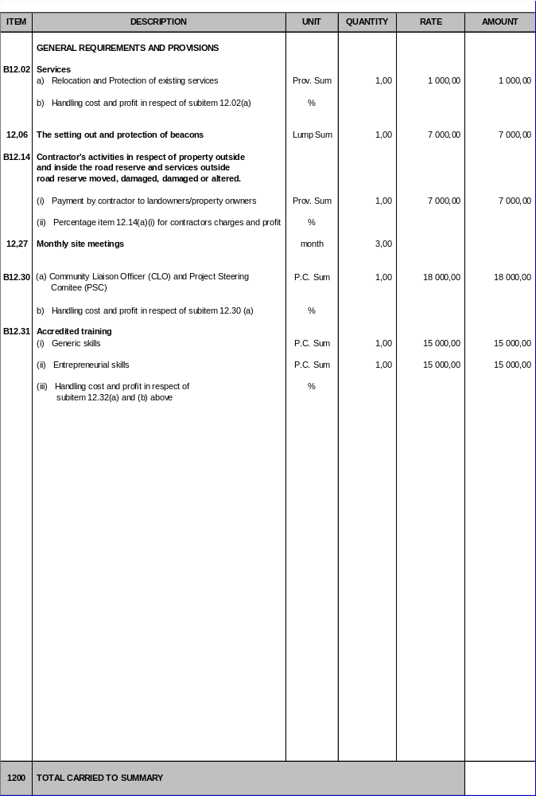
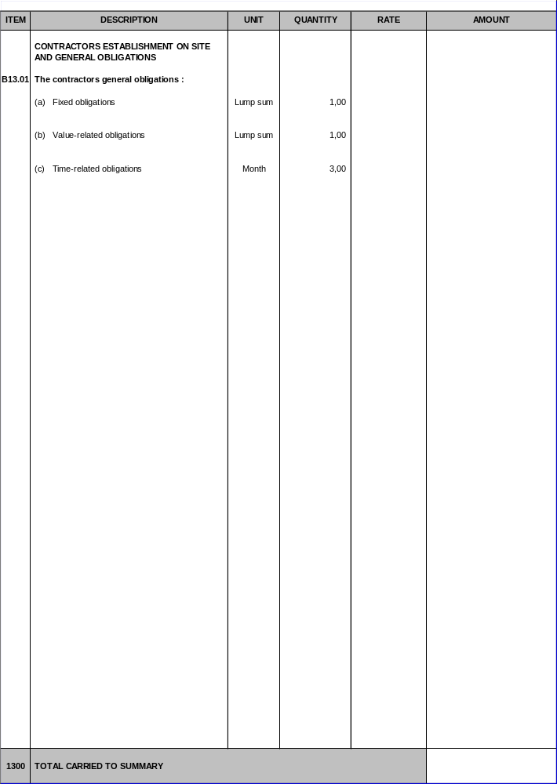

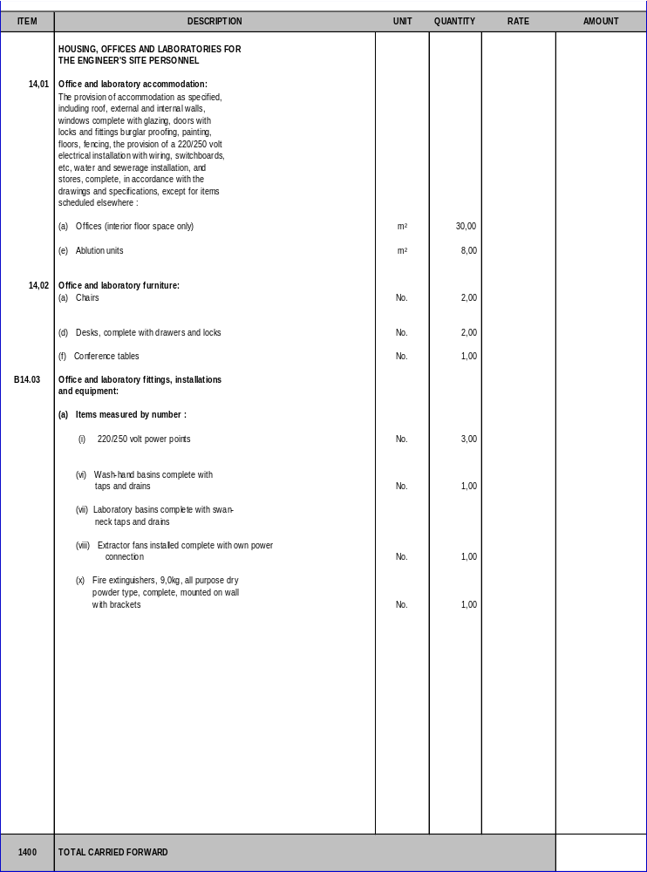

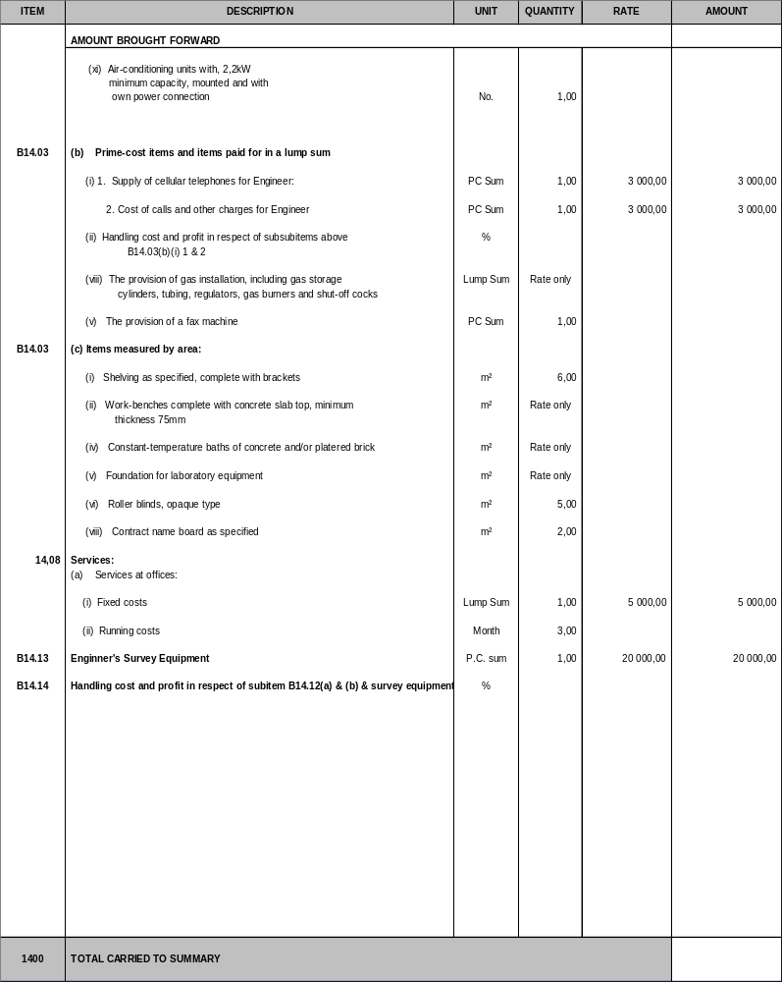

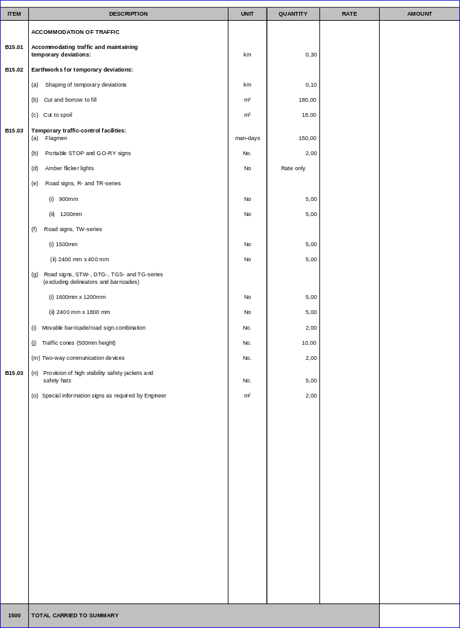

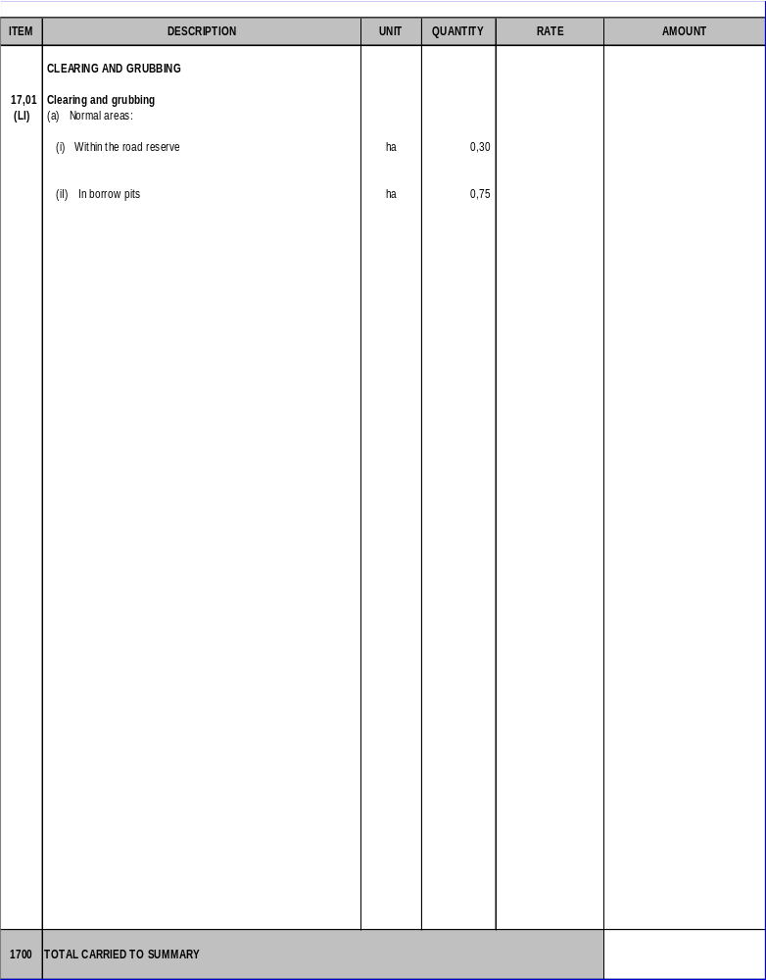

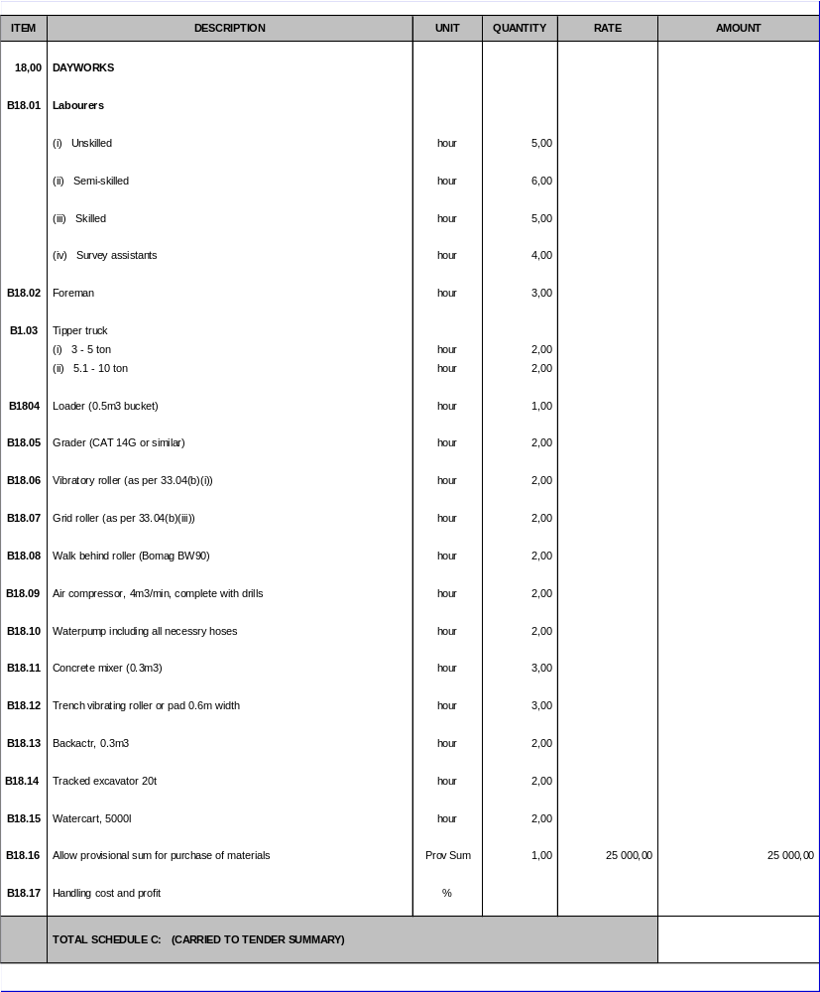

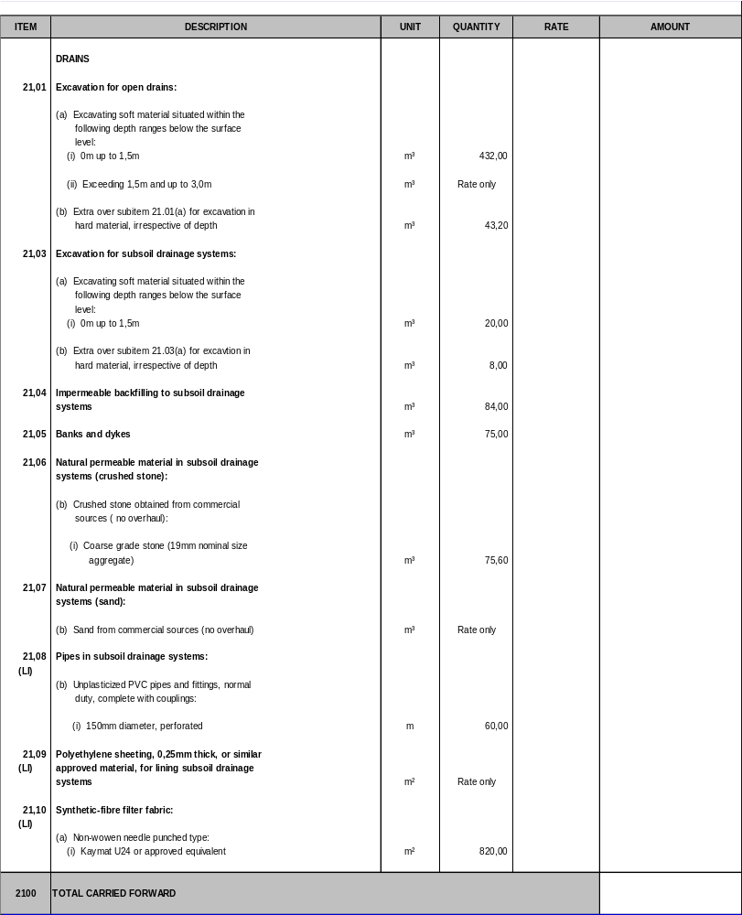

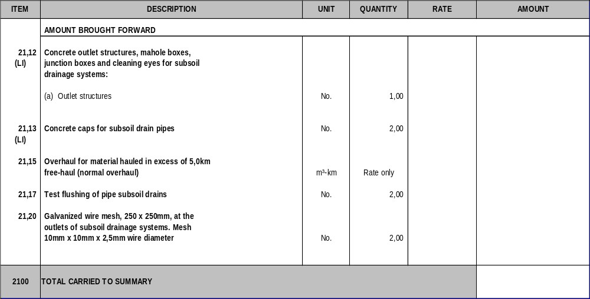

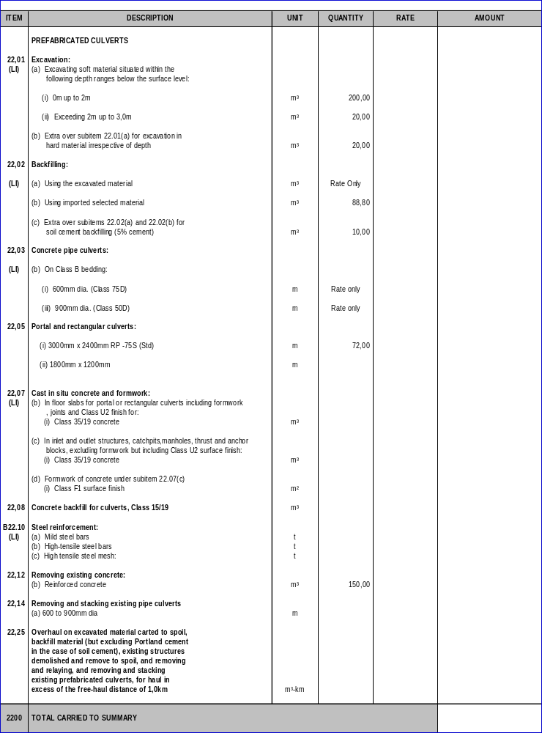
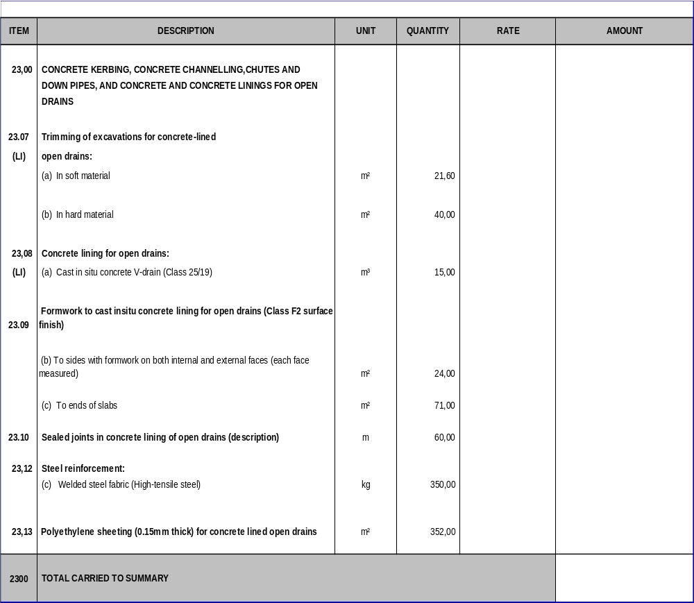

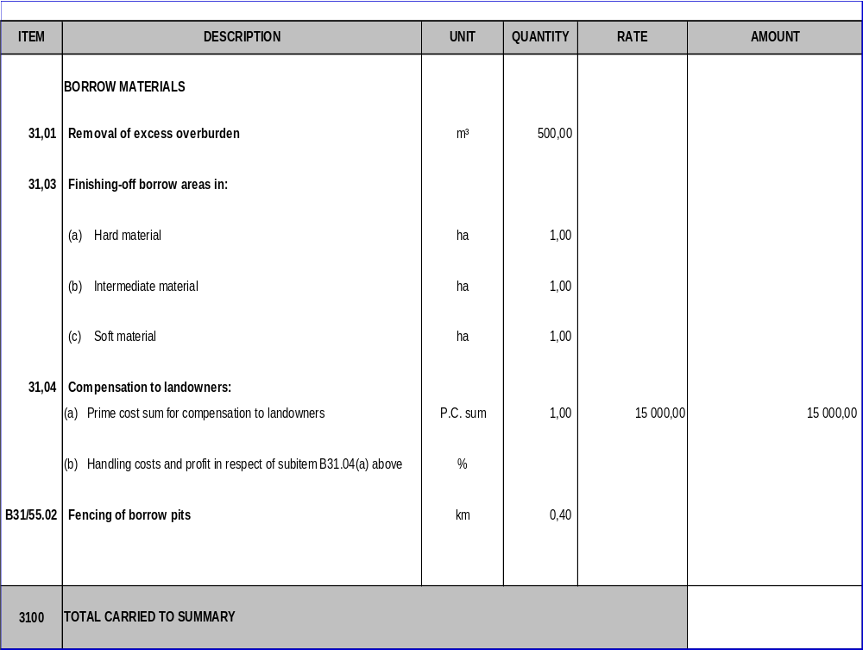

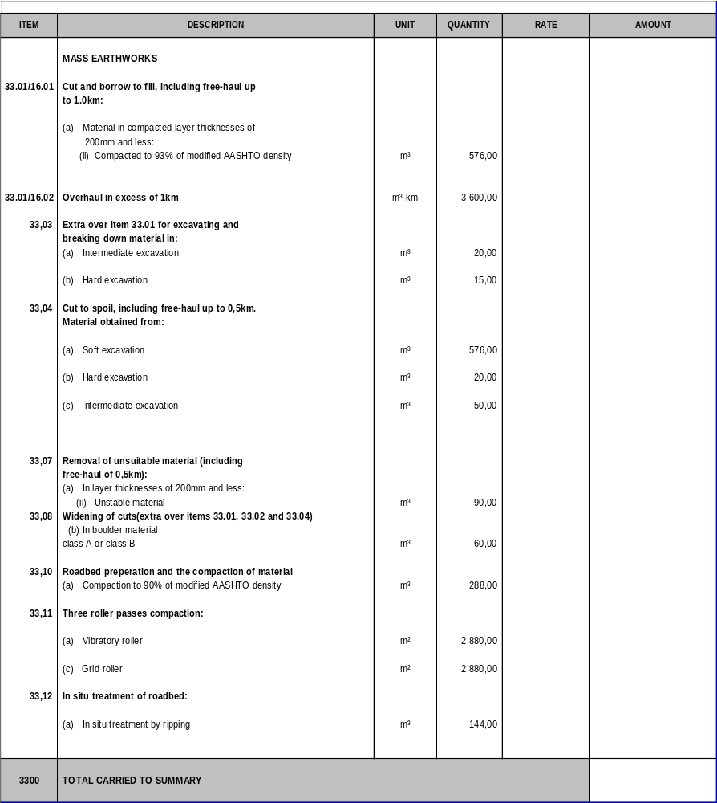

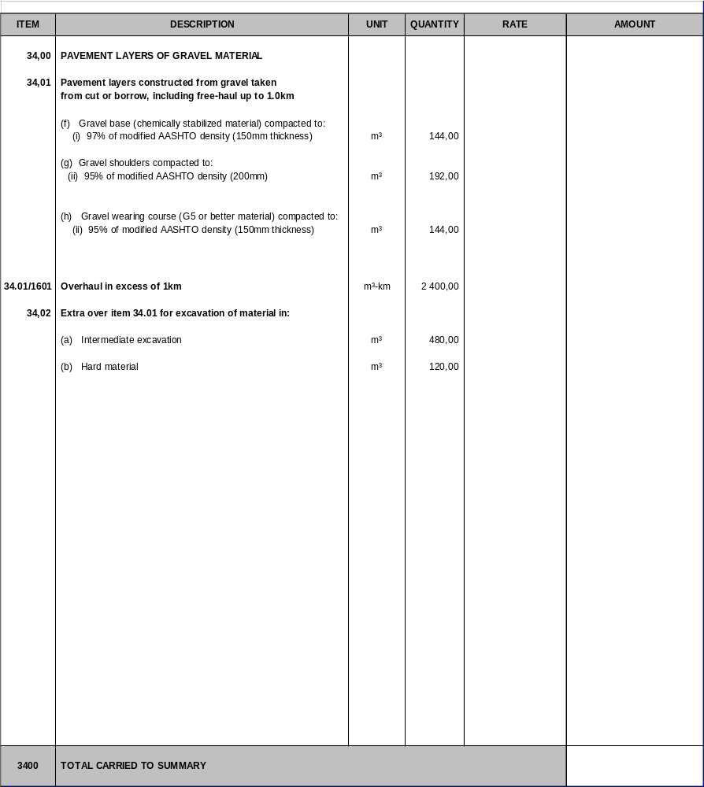

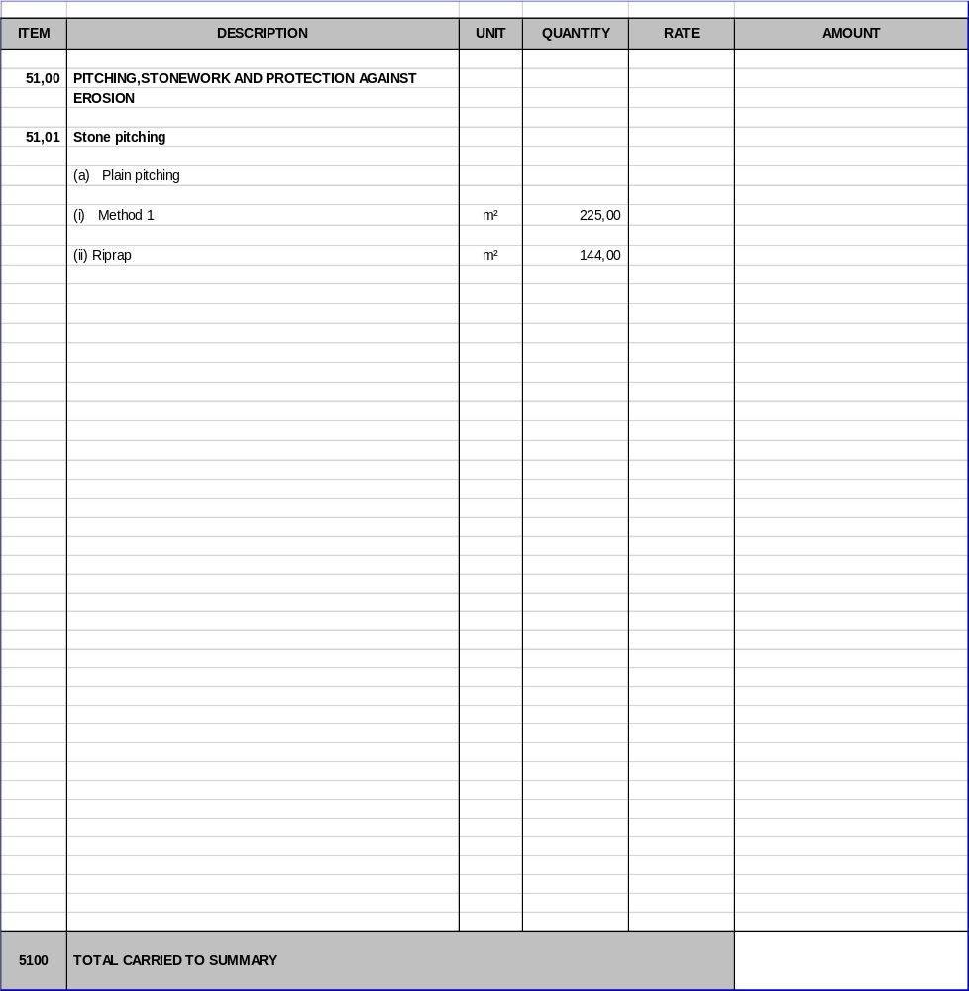

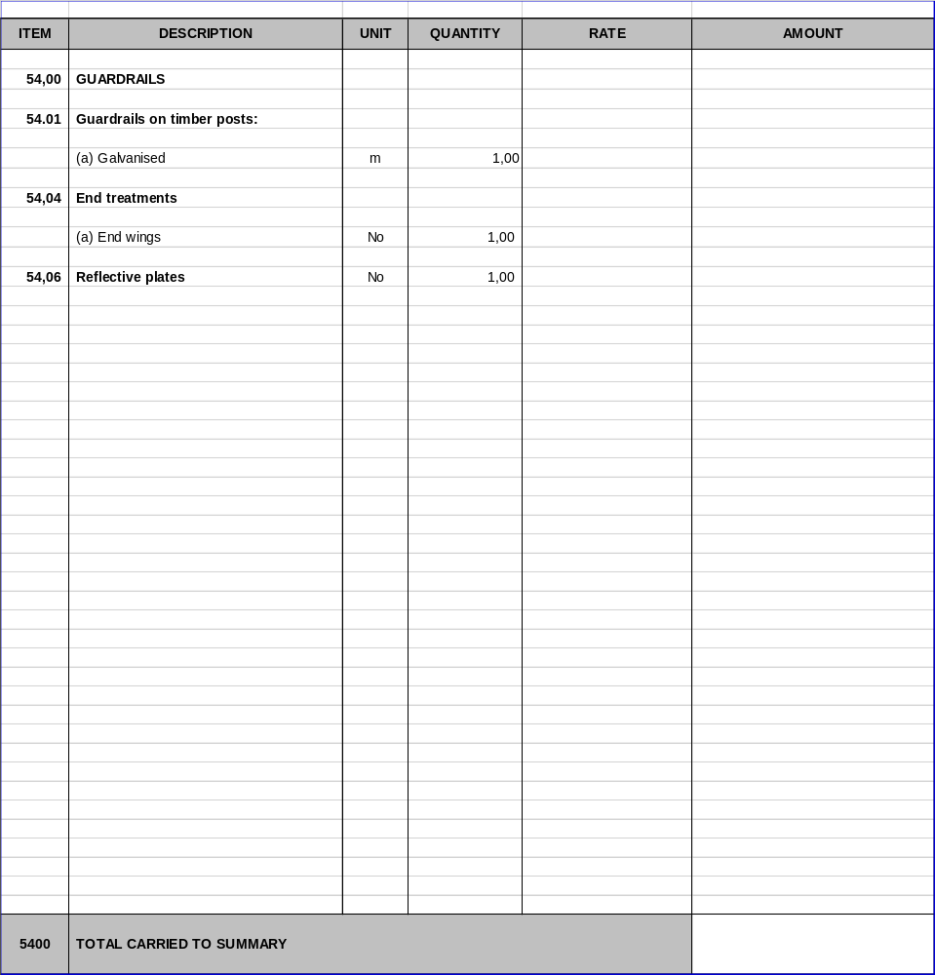

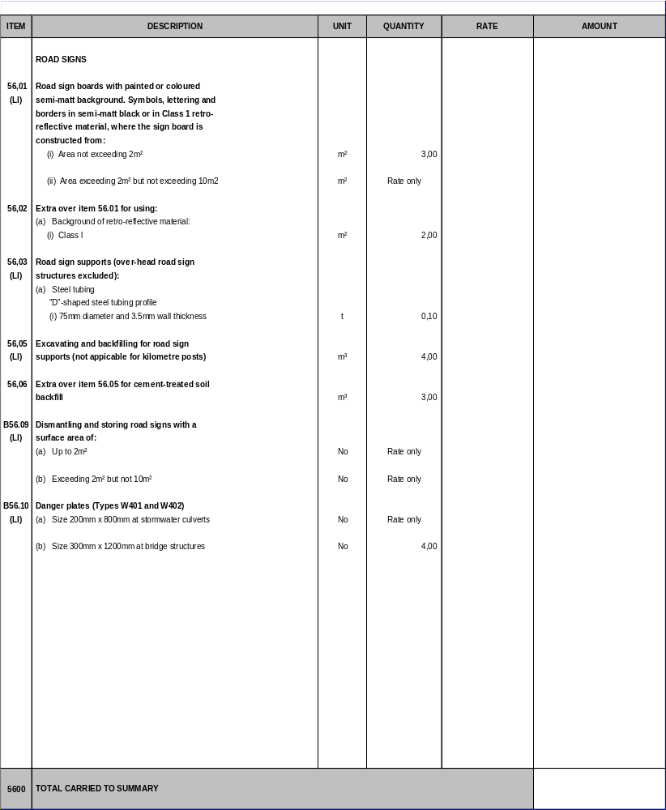

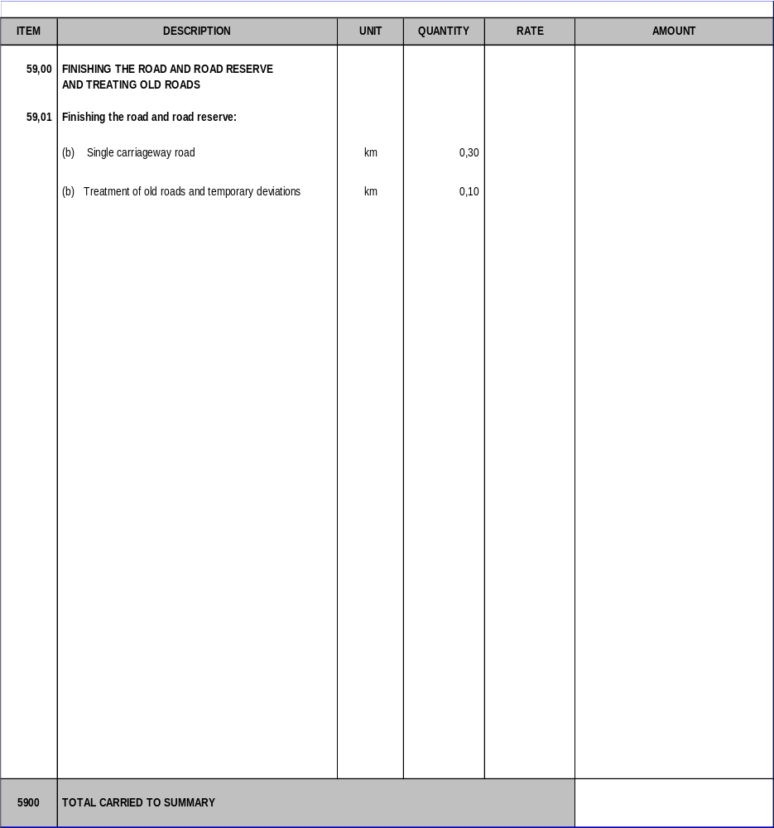

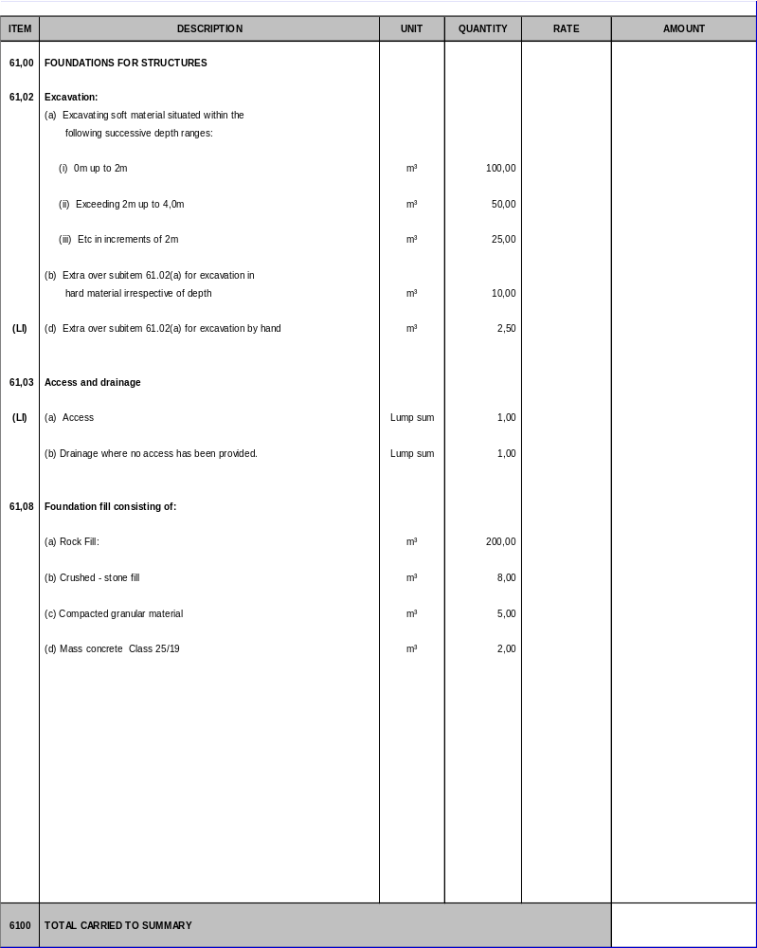

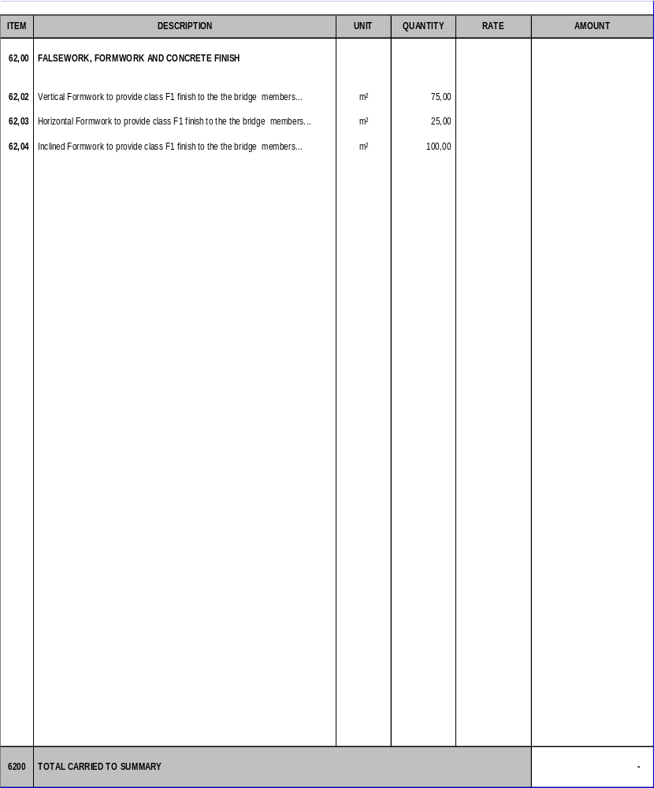

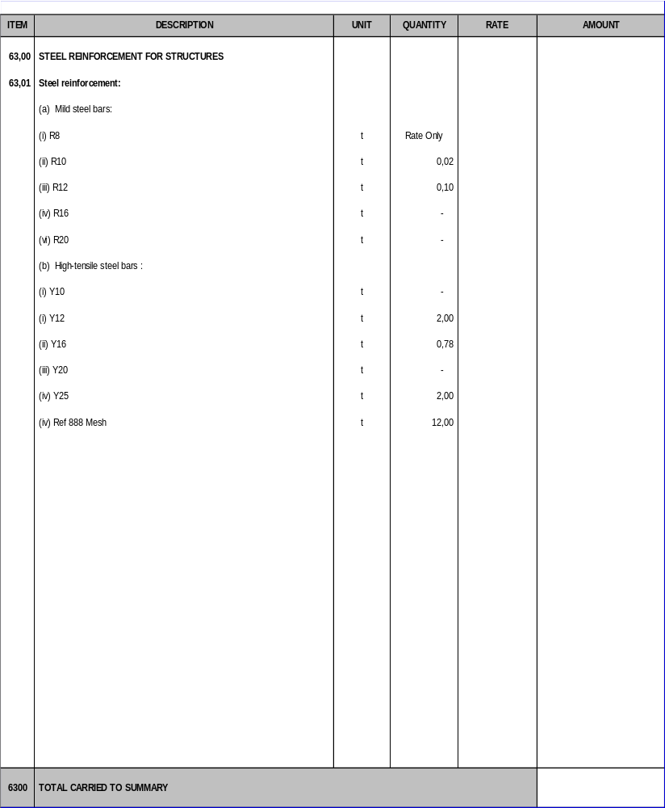

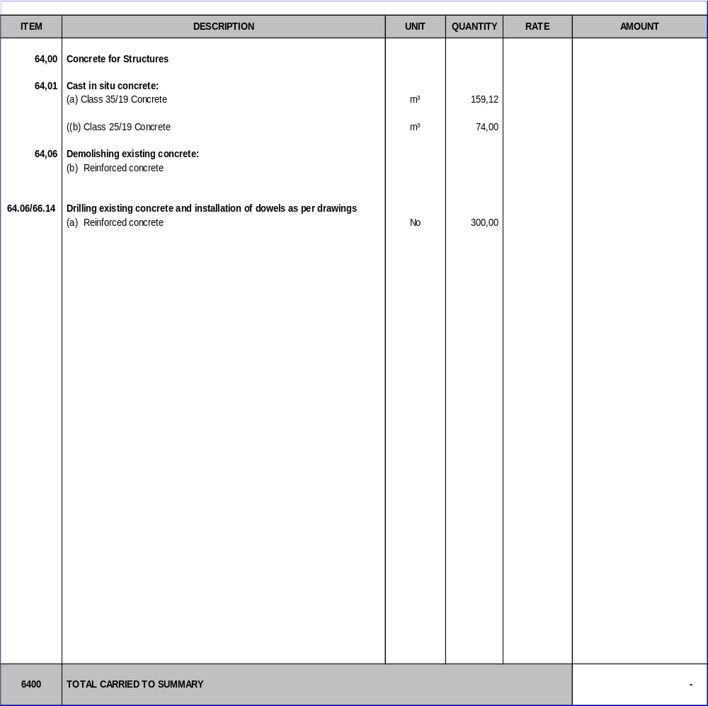

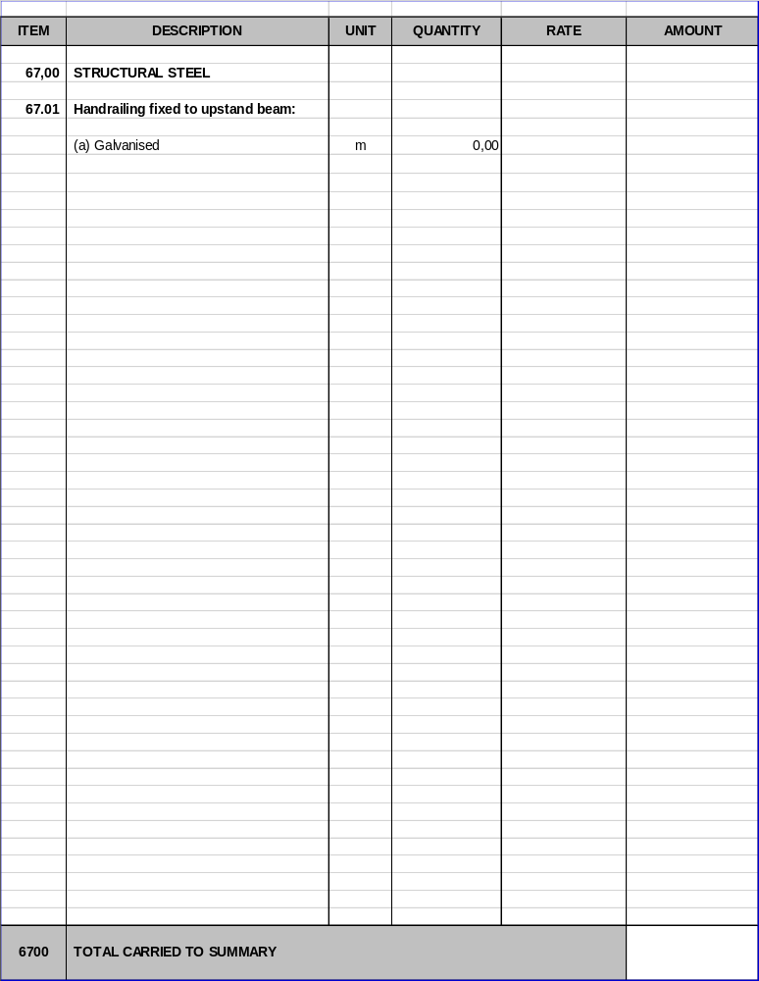



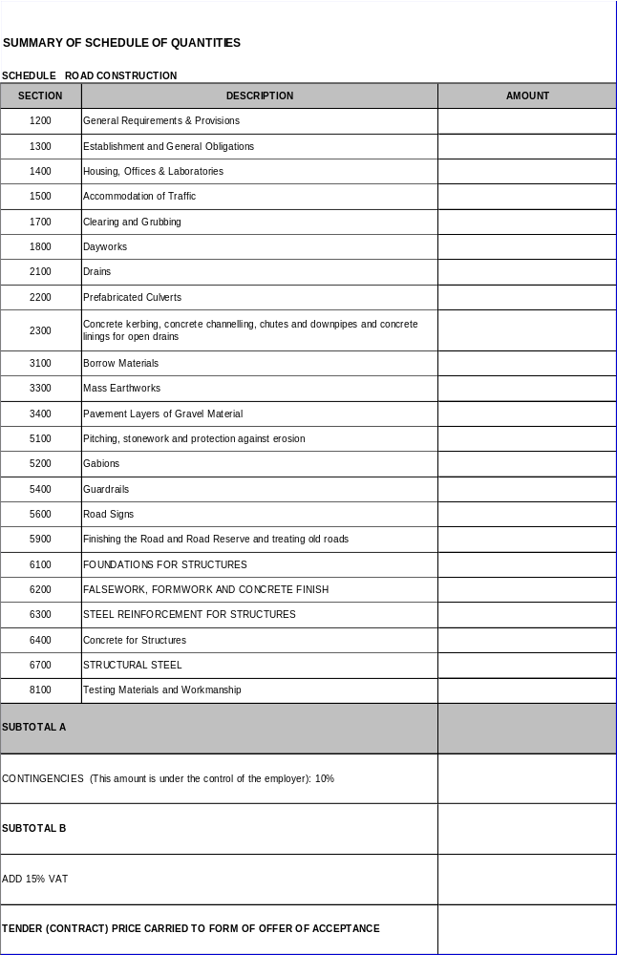

PART C3

SCOPE OF WORK

PART C3: SCOPE OF WORK
PART A - GENERAL 128
C3.1 Description of Works 128
c3.1.1 Scope 128
c3.1.2 location of Works 128
C3.1.3 NATURE OF WORKS 128
c3.1.4 DETAILED DESCRIPTION OF THE PROJECT 129
c3.1.5 TIME FOR COMPLETION 129
c3.1.6 general information 129
c3.1.7 ENGINEERING 130
PART B–MATTERS RELATING TO THE STANDARD SPECIFICATIONS 137
C3.2 stAndard specifications 137
C3.3 general conditions of contract 139
C3.4 amendments to the standard specifications 140
PART C – ADDitional Specifications 167

PART A - GENERAL
  - Description of Works

c3.1.1 Scope
This section provides the description of the project and the general requirements for executing the work. The work of UPGRADING OF CHULUNCA BRIDGE of Mhlontlo Local Municipality.

C3.1.1.1 Employer’s Objectives
The employer’s objectives are to deliver public infrastructure using labour intensive methods.
C3.1.1.2 Labour Intensive Works

Labour-intensive works comprise the activities described in SANS 1921-5, Earthworks activities which are to be performed by hand, and its associated specification data. Such works shall be constructed using local workers who are temporarily employed in terms of this Scope of Work.

c3.1.2 location of Works
Location of Site:
UPGRADING OF CHULUNCA BRIDGE is located under the jurisdiction of Mhlontlo Local Municipality of OR Tambo District Municipality, in the Eastern Cape province of South Africa.
Access to Site:
55km, from Qumbu

C3.1.3 NATURE OF WORKS
The description of the project contained in this section is merely an outline of the contract works and shall not limit the work to be carried out by the Contractor under this contract. Approximate quantities of each type of work to be carried out in accordance with the contract documents are listed in the Bill of Quantities bound in this volume.
The nature of work to be carried out under this contract includes inter alia the following:
- Establishment and General Obligations
- Prefabricated Culverts
- Concrete kerbing, concrete channelling, chutes and downpipes and concrete linings for open drains
- Borrow Materials
- Mass Earthworks
- Pavement Layers of Gravel Material
- Pitching, stonework and protection against erosion
- Gabions
- Guardrails
- Road Signs
- Finishing the Road and Road Reserve and treating old roads
- FOUNDATIONS FOR STRUCTURES
- FALSEWORK, FORMWORK AND CONCRETE FINISH
- STEEL REINFORCEMENT FOR STRUCTURES
- Concrete for Structures
- STRUCTURAL STEEL
- Testing Materials and Workmanship
The contractor shall be required to attend meetings relating to the Works and the site, inter alia Incident Management System, Disaster Management Forum, Public Liaison Committee, Farmers’ Association, and Fire Protection Association.

c3.1.4 DETAILED DESCRIPTION OF THE PROJECT

The works for this current contract is mainly the following:
- General Requirements & Provisions
- Establishment and General Obligations
- Housing, Offices & Laboratories
- Accommodation of Traffic
- Clearing and Grubbing
- Dayworks
- Drains
- Prefabricated Culverts
- Concrete kerbing, concrete channelling, chutes and downpipes and concrete linings for open drains
- Borrow Materials
- Mass Earthworks
- Pavement Layers of Gravel Material
- Pitching, stonework and protection against erosion
- Gabions
- Guardrails
- Road Signs
- Finishing the Road and Road Reserve and treating old roads
- FOUNDATIONS FOR STRUCTURES
- FALSEWORK, FORMWORK AND CONCRETE FINISH
- STEEL REINFORCEMENT FOR STRUCTURES
- Concrete for Structures
- STRUCTURAL STEEL
- Testing Materials and Workmanship

c3.1.5 TIME FOR COMPLETION
The construction period is 3 months.

c3.1.6 general information
C 3.1.6.1 Drawings
The reduced drawings contained in Part C4.2 that form part of the tender document shall be used for tender purposes only. Working drawings will be provided on or before site handover and additional drawings may be issued during construction by the Engineer.
Any information in the possession of the contractor, which the resident engineer requires to complete the as-built drawings, shall be supplied to the resident engineer before a certificate of completion will be issued.
Only figured dimensions shall be used and drawings shall not be scaled unless so instructed by the engineer. The engineer will supply all figured dimensions omitted from the drawings.
C 3.1.6.2 Power, Water Supply and Other Services
The contractor shall make his own arrangements concerning the supply of electrical power and all other services. No direct payment will be made for the provision of electrical and other services. The cost of providing these services will be deemed to be included in the rates and amounts tendered for the various items of work for which these services are required.
C 3.1.6.3 Contractor’s Camp Site and Security
The contractor shall make his own arrangements regarding the establishment of a camp site and housing for his construction personnel and all regulations stipulated by the local authority shall be adhered to.
It is anticipated that the contractor’s choice of a camp site will be influenced by the availability of telephone and electrical connections as well as the supply of potable water.
Provision is made in these specifications for the erection of a security fence around the site offices. The contractor shall be responsible for the security of his personnel and constructional plant on and around the site of the works and for the security of his camp, and the employer will consider no claims in this regard.
C 3.1.6.4 Additional Requirements for Construction Activities
C 3.1.6.5 The contractor may not commence constructional activities before adequate provision has been made to accommodate traffic in accordance with the requirements of this document and the South African Road Traffic Signs Manual.
C 3.1.6.6 The contractor shall submit proposals in connection with directional signs to the engineer for approval.
C3.1.6.7 Programme Requirements for Construction Activities
The contractor shall programme his activities to be suitable in terms of his resources to complete the contract inside the stipulated time period.
C3.1.6.8 Construction in Confined Areas
It may be necessary for the contractor to work in confined areas. The method of construction in these confined areas depends on the contractor’s construction plant. However, the contractor must note that measurement and payment will be in accordance with the specified cross-sections and dimensions, irrespective of the method used to achieve these cross-sections and dimensions, and that the rates and amounts tendered will be deemed to include full compensation for any special equipment or construction methods or for any difficulty encountered in working in confined areas and narrow widths, and at or around obstructions, and that no extra payment will be made nor will any claim for payment be considered on account of these difficulties.

c3.1.7 ENGINEERING
C3.1.7.1 Design
(a) The Employer is responsible for the design of the permanent Works as reflected in these Contract Documents unless otherwise stated.
(b) The Contractor is responsible for the design of the temporary Works and their compatibility with the permanent Works.
(c) The Contractor shall supply all details necessary to assist the engineer in the compilation of the as-built drawings.

C3.1.7.2 Employer’s Design
(a) Detail description of Works
(b) General Works
C3.1.7.3 Contractor’s Design
Where contractor is to supply the design of designated parts of the permanent Works or temporary Works he shall supply full working drawings supported by a professional engineer’s design certificate.
C3.1.7.4 Design procedures
All designs and modifications thereto shall be communicated in writing and the contractor and engineer shall maintain master lists to record and track all transactions.

C3.1.8 LABOUR RELATIONS

A27 Payment for the labour-intensive component of the works
Payment for works identified in clause 2.3 “the Extent of the Project” in the Project Specifications as being labour-intensive shall only be made in accordance with the provisions of the Contract if the works are constructed strictly in accordance with the provisions of the scope of work. Any non-payment for such works shall not relieve the Contractor in any way from his obligations either in contract or in delict.

A28 Applicable labour laws
The Ministerial Determination for Special Public Works Programmes, issued in terms of the Basic Conditions of Employment Act of 1997 by the Minister of Labour in Government Notice R347 in Government Gazette 33310 of 4 May 2012, available at: http://www.sabinet.co.za as reproduced below, shall apply to works described in the scope of work as being labour intensive and which are undertaken by unskilled or semi-skilled workers.
All the provisions of the Ministerial Determination: Expanded Public Works Programme published under Government Notice R949 in Government Gazette 33665 of 22 October 2010 will be suspended by this Ministerial determination with effect from the date of implementation.
A29 Introduction
This document contains the standard terms and conditions for workers employed in elementary occupations on an Expanded Public Works Programme (EPWP). These terms and conditions do NOT apply to persons employed in the supervision and management of a SPWP.
In this document —
- "department" means any department of the State, implementing agent or contractor;
- "employer" means any department, implementing agency or contractor that hires workers to work in elementary occupations on a EPWP;
- "worker" means any person working in an elementary occupation on a EPWP;
- "elementary occupation" means any occupation involving unskilled or semi-skilled work;
- "management" means any person employed by a department or implementing agency to administer or execute an EPWP;
- "task" means a fixed quantity of work;
- "task-based work" means work in which a worker is paid a fixed rate for performing a task;
- "task-rated worker" means a worker paid on the basis of the number of tasks completed;
- "time-rated worker" means a worker paid on the basis of the length of time worked.

A30 Terms of Work
A30.1 Workers on an EPWP are employed on a temporary basis or contract basis.
A31 Normal Hours of Work
A31.1 An employer may not set tasks or hours of work that require a worker to work—
- more than forty hours in any week;
- on more than five days in any week; and
- for more than eight hours on any day.

A31.2 An employer and worker may agree that a worker will work four days per week. The worker may then work up to ten hours per day.

A31.3 A task-rated worker may not work more than a total of 55 hours in any week to complete the tasks allocated (based on a 40-hour week) to that worker.
A32 Meal Breaks
A32.1 A worker may not work for more than five hours without taking a meal break of at least thirty minutes duration

A32.2 An employer and worker may agree on longer meal breaks.

A32.3 A worker may not work during a meal break. However, an employer may require a worker to perform duties during a meal break if those duties cannot be left unattended and cannot be performed by another worker. An employer must take reasonable steps to ensure that a worker is relieved of his or her duties during the meal break.

A32.4 A worker is not entitled to payment for the period of a meal break. However, a worker who is paid on the basis of time worked must be paid if the worker is required to work or to be available for work during the meal break.
A33 Special Conditions for Security Guards
A33.1 A security guard may work up to 55 hours per week and up to eleven hours per day.

A33.2 A security guard who works more than ten hours per day must have a meal break of at least one hour or two breaks of at least 30 minutes each.
A34 Daily Rest Period
Every worker is entitled to a daily rest period of at least twelve consecutive hours. The daily rest period is measured from the time the worker ends work on one day until the time the worker starts work on the next day.
A35 Weekly Rest Period
Every worker must have two days off every week. A worker may only work on their day off to perform work which must be done without delay and cannot be performed by workers during their ordinary hours of work ("emergency work").
A36 Sick Leave
A36.1 Only workers who work more than 24 hours per month have the right to claim sick-pay in terms of this clause.
A36.2 A worker who is unable to work on account of illness or injury is entitled to claim one day's paid sick leave for every full month that the worker has worked in terms of a contract.
A36.3 A worker may accumulate a maximum of twelve days' sick leave in a year.
A36.4 Accumulated sick-leave may not be transferred from one contract to another contract.

A36.5 An employer must pay a task-rated worker the worker's daily task rate for a day's sick leave.
A36.6 An employer must pay a time-rated worker the worker's daily rate of pay for a day's sick leave.

A36.7 An employer must pay a worker sick pay on the worker's usual payday.

A36.8 Before paying sick-pay, an employer may require a worker to produce a certificate stating that the worker was unable to work on account of sickness or injury if the worker is —
- absent from work for more than two consecutive days; or
- absent from work on more than two occasions in any eight-week period.

A36.9 A medical certificate must be issued and signed by a medical practitioner, a qualified nurse or a clinic staff member authorised to issue medical certificates indicating the duration and reason for incapacity.

A36.10 A worker is not entitled to paid sick-leave for a work-related injury or occupational disease for which the worker can claim compensation under the Compensation for Occupational Injuries and Diseases Act.
A37 Maternity Leave
A37.1 A worker may take up to four consecutive months' unpaid maternity leave.

A37.2 A worker is not entitled to any payment or employment-related benefits during maternity leave.

A37.3 A worker must give her employer reasonable notice of when she will start maternity leave and when she will return to work.

A37.4 A worker is not required to take the full period of maternity leave. However,
a worker may not work for four weeks before the expected date of birth of her child or for six weeks after the birth of her child, unless a medical practitioner, midwife or qualified nurse certifies that she is fit to do so.
A37.5 A worker may begin maternity leave four weeks before the expected date of birth; or an earlier date —
(i) if a medical practitioner, midwife or certified nurse certifies that it is necessary for the health of the worker or that of her unborn child; or
(ii) if agreed to between employer and worker; or
on a later date, if a medical practitioner, midwife or certified nurse has certified that the worker is able to continue to work without endangering her health.

A37.6 A worker who has a miscarriage during the third trimester of pregnancy or bears a stillborn child may take maternity leave for up to six weeks after the miscarriage or stillbirth.
A38 Family responsibility leave
A38.1 Workers, who work for at least four days per week, are entitled to three days paid family responsibility leave each year in the following circumstances -
- when the employee's child is born;
- when the employee's child is sick;
- in the event of a death of —
(i) the employee's spouse or life partner;
(ii) the employee's parent, adoptive parent, grandparent, child, adopted child, grandchild or sibling.
A39 Statement of Conditions
A39.1 An employer must give a worker a statement containing the following details at the start of employment —
- the employer's name and address and the name of the EPWP;
- the tasks or job that the worker is to perform; and
- the period for which the worker is hired or, if this is not certain, the expected duration of the contract;
- the worker's rate of pay and how this is to be calculated;
- the training that the worker will receive during the EPWP.

A39.2 An employer must ensure that these terms are explained in a suitable language to any employee who is unable to read the statement.

A39.3 An employer must supply each worker with a copy of these conditions of employment.

A40 Keeping Records
A40.1 Every employer must keep a written record of at least the following —
(a) the worker's name and position;
- copy of an acceptable worker identification
- in the case of a task-rated worker, the number of tasks completed by the worker;
- in the case of a time-rated worker, the time worked by the worker;
- payments made to each worker.

A40.2 The employer must keep this record for a period of at least three years after the completion of the EPWP.

A41 Payment

A41.1 An employer must pay all wages at least monthly in cash or by cheque or into a bank account.
A41.2 A worker may not be paid less than the minimum EPWP wage rate of R90….per day or per task, This will be adjusted annually on the is of November in-line with inflation (available CPI as provided by Stats SA six (6) weeks before implementation),
A41.3 A task-rated worker will only be paid for tasks that have been completed.
A41.4 An employer must pay a task-rated worker within five weeks of the work being completed and the work having been approved by the manager or the contractor having submitted an invoice to the employer.
A41.5 A time-rated worker will be paid at the end of each month,
A41.6 Payment must be made in cash, by cheque or by direct deposit into a bank account designated by the worker.
A41.7 Payment in cash or by cheque must take place -
- at the workplace or at a place agreed to by the worker;
- during the worker's working hours or within fifteen minutes of the start or finish of work;
- in a sealed envelope which becomes the property of the worker.
A41.8 An employer must give a worker the following information in writing --
- the period for which payment is made;
- the numbers of tasks completed or hours worked;
- the worker's earnings;
- any money deducted from the payment;
- the actual amount paid to the worker.

A41.9 If the worker is paid in cash or by cheque, this information must be recorded on the envelope and the worker must acknowledge receipt of payment by signing for it.
A41.10 If a worker's employment is terminated, the employer must pay all monies owing to that worker within one month of the termination of employment.
A42 Deductions
A42.1 An employer may not deduct money from a worker's payment unless the deduction is required in terms of a law.
A42.2 An employer must deduct and pay to the SA Revenue Services any income tax that the worker is required to pay.
A42.3 An employer who deducts money from a worker's pay for payment to another person must pay the money to that person within the time period and other requirements specified in the agreement law, court order or arbitration award concerned.
A42.4 An employer may not require or allow a worker to —
- repay any payment except an overpayment previously made by the employer by mistake;
- state that the worker received a greater amount of money than the employer actually paid to the worker; or
- pay the employer or any other person for having been employed.
A43 Health and Safety
A43.1 Employers must take all reasonable steps to ensure that the working environment is healthy and safe.
A43.2 A worker must —
- work in a way that does not endanger his/her health and safety or that of any other person;
- obey any health and safety instruction;
- obey all health and safety rules of the EPWP;
- use any personal protective equipment or clothing issued by the employer;
- report any accident, near-miss incident or dangerous behaviour by another person to their employer or manager.

A44 Compensation for Injuries and Diseases
A44.1 It is the responsibility of the employers (other than a contractor) to arrange for all persons employed on a EPWP to be covered in terms of the Compensation for Occupational Injuries and Diseases Act, 130 of 1993.
A44.2 A worker must report any work-related injury or occupational disease to their employer or manager.
A44.3 The employer must report the accident or disease to the Compensation Commissioner.
A44.4 An employer must pay a worker who is unable to work because of an injury caused by an accident at work 75% of their earnings for up to three months. The employer will be refunded this amount by the Compensation Commissioner. This does NOT apply to injuries caused by accidents outside the workplace such as road accidents or accidents at home.
A45 Termination
A45.1 The employer may terminate the employment of a worker for good cause after following fair procedure.
A45.2 A worker will not receive severance pay on termination.
A45.3 A worker is not required to give notice to terminate employment. However, a worker who wishes to resign should advise the employer in advance to allow the employer to find a replacement.
A45.4 A worker who is absent for more than three consecutive days without informing the employer of an intention to return to work will have terminated the contract, However, the worker may be re-engaged if a position becomes available.
A45.3 A worker who does not attend required training events, without good reason, will have terminated the contract. However, the worker may be re-engaged if a position becomes available.

A46 Certificate of Service
On termination of employment, a worker is entitled to a certificate stating —
- the worker's full name;
- the name and address of the employer;
- the EPWP on which the worker worked;
- the work performed by the worker;
- any training received by the worker as part of the EPWP;
- the period for which the worker worked on the EPWP; and
- any other information agreed on by the employer and worker.

PART B–MATTERS RELATING TO THE STANDARD SPECIFICATIONS

  - stAndard specifications
The following specifications shall apply for the construction of the Works:
(a) The COLTO Standard Specifications for Road and Bridge Works for State Road
Authorities(1998).
The contractor may purchase copies of above mentioned document from the South African Institution of Civil Engineering (SAICE):

SAICE House, Block 19, Thornhill Office Park, Bekker Street, Vorna Valley X21, Midrand
Private Bag X200, Halfway House, 1685
Tel: (011) 805 5947/48/53
Fax: (011) 805 5971

- SANS or BS Specifications and Codes of Practice
Wherever any reference is made to the South African Bureau of Standards (SABS)in either the Bill of Quantities, this reference shall be deemed to read “SANS standard”
(c) Various other specifications specified in the COLTO Standard Specifications or the Project Specifications.
(d) Generic Labour Intensive Specification

The Generic Labour-intensive specification below is the same as SANS 1921-5, Construction and management requirement for works contracts- Part 5: Earthworks activities which are to be performed by hand and should be included in the scope of works without amendment or modification as set out below.

Scope
This specification establishes general requirements for activities which are to be executed by hand involving the following:
a) trenches having a depth of less than 1.5 metres
b) stormwater drainage
c) low-volume roads and sidewalks

PRECEDENCE
Where this specification is in conflict with any other standard or specification referred to in the Scope of Works to this Contract, the requirements of this specification shall prevail.

Hand excavateable material
Hand excavatable material is material:
a) granular materials:
i) whose consistency when profiled may in terms of table 1 be classified as very loose, loose, medium dense, or dense; or
ii) where the material is a gravel having a maximum particle size of 10mm and contains no cobbles or isolated boulders, no more than 15 blows of a dynamic cone penetrometer is required to penetrate 100mm;
b) cohesive materials:
i) whose consistency when profiled may in terms of table 1 be classified as very soft, soft, firm, stiff and stiff / very stiff; or
6
Note:
1) A boulder, a cobble and gravel is material with a particle size greater than 200mm, between 60 and 200mm.
2) A dynamic cone penetrometer is an instrument used to measure the insitu shear resistance of a soil comprising a drop weight of approximately 10 kg which falls through a height of 400mm and drives a cone having a maximum diameter of 20mm (cone angle of 60° with respect to the horizontal) into the material being used.
Table 1: Consistency of materials when profiled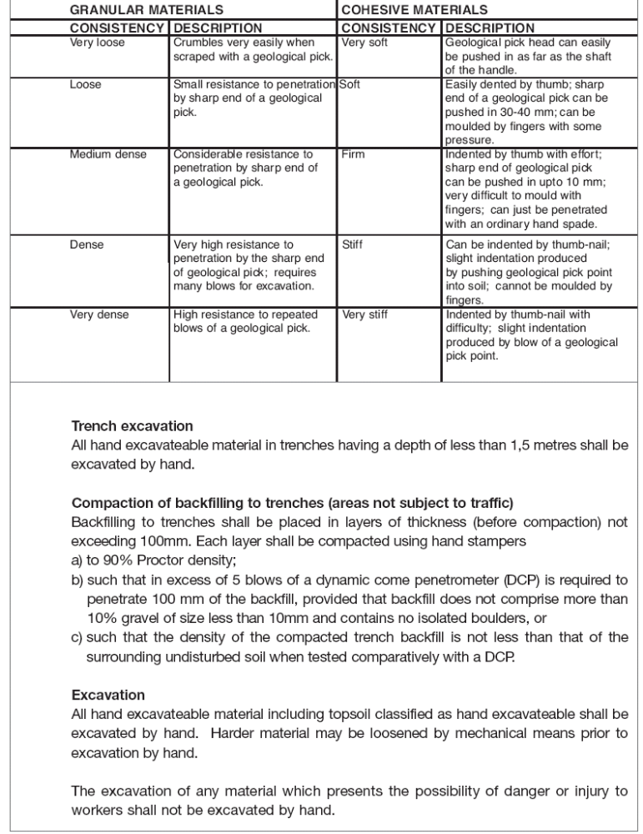

  - general conditions of contract
The Conditions of Contract are the General Conditions of Contract for Construction Works 2010, Second Edition published by the South African Institution of Civil Engineering, Private Bag X200, Halfway House, 1685, are applicable to this contract.
  - amendments to the standard specifications
This part of the project specifications deals with matters relating to the standard specifications. Where reference is made in the standard specifications to the project specifications this part shall also contain the relevant information e.g. the requirements where a choice of materials or construction methods are provided for the standard specifications.
In certain clauses the standard specifications allow a choice to be specified in the project specifications between alternative materials or methods of construction and for additional requirements to be specified to suit a particular contract. Details of such alternatives or additional requirements applicable to this contract are contained in this part of the project specifications. It also contains some additional specifications and amendments of the standard specifications required for this particular contract.
The number of each clause and each payment item in this part of the project specifications consists of the prefix B followed by a number corresponding to the number of the relevant clause or payment item in the standard specifications. The number of a new clause or a new payment item, which does not form part of a clause or a payment item in the standard specifications and is included here, is also prefixed by B followed by a new number. The new numbers follow on the last clause or item number used in the relevant section of the standard specifications.
Clauses and pay items referring to labour intensive methods are prefixed by LI in the project specifications.
Clauses and pay items referring to emerging contractors are prefixed by E in the project specifications.

B SECTION 1200 : GENERAL REQUIREMENTS AND PROVISIONS
B 1202 SERVICES
ADD THE FOLLOWING:
"Before work commences, the Contractor shall contact all private owners or public authorities controlling services to allow them to protect, move or relocate a service as required, or to confirm that all such work has been completed.
No payment will be made for inconvenience to the Contractor due to services crossing the Site or any authority working on such services, nor will delays caused by such workings be accepted as a basis for claiming an extension of time for completing the Works."
B 1209 PAYMENT
(b) Rates to be inclusive
ADD THE FOLLOWING TO THE FIRST PARAGRAPH:
"VAT shall be excluded from the tendered rates and sums and provided for as a lump sum in the summary of the Schedule of Quantities."
ADD THE FOLLOWING SUBCLAUSE:
"(g) Payment certificates
With reference to Clause 6.10.1 of the General Conditions of Contract, the Engineer's Certificate will only be issued after he has received a draft certificate prepared by the Contractor at his own expense in the form prescribed by the Engineer. The cost of duplicating and delivering copies of the certificate to the Contractor, the Engineer and the Employer shall be borne by the Contractor. The Engineer and the Employer require a total of three sets of A4-sized paper copies."

B 1215 EXTENSION OF TIME RESULTING FROM ABNORMAL RAINFALL
ADD THE FOLLOWING:
"Time is an essential element of this contract. The contract period shall only be extended to make provision for variation orders and loss of time due to abnormal rainfall and wet conditions.

The contractor shall submit his extension of time in accordance with the General Conditions of Contract, 2010.

The Contractor shall supply a rain gauge on site to measure rainfall. The amount of rainfall shall be recorded daily by the Contractor and Engineer’s Representative.

The extension of time due to abnormal rainfall shall be calculated using Method (i) (Rainfall formula)
E = (N_{w} –N_{n}) + (R_{w} –_{Rn})/20 if (N_{w}-N_{n})>0
WHERE:
E = Extension of time in calendar days in respect of the calendar month under consideration
N_{w} = Actual number of days during the calendar month under consideration on which a rainfall of 10mm or more had been recorded
N_{n} = Average number of days in the relevant calendar month as derived from existing rainfall records provided in the project specification on which a rainfall of 10mm or more had been recorded
R_{w} = Actual rainfall in mm for the calendar month under consideration.
R_{n} = Average rainfall in mm for the calendar month as derived from the rainfall records supplied in the project specification.
The total extension of time shall be the algebraic sum of the monthly total for the period under consideration. But if the grand total is negative, the time for completion shall not be reduced on account of abnormal rainfall. Extension of time for parts of a month shall be calculated by pro-rata values of N_{n} and R_{n} being used.
The factor (N_{w}-N_{n}) shall be considered to represent a fair allowance from the average number of days during which rainfall exceeds 10mm. The factor (R_{w}-R_{n}) shall be considered to represent a fair allowance for variations from the average for the number of days during which rainfall does not exceed 10, but when wet condition prevented or disrupted work. This formula does not take into accounts any flood damage, which could cause further or concurrent delays and should be treated separately in so far as extension of time concerned.
Accurate rain gauges shall be taken at a suitable point on the site, and the contractor shall, at his own expenses, take all necessary precautions to ensure that the rain gauges cannot be interfered with by unauthorised persons.
Should N_{w} for any month be smaller than N_{n}, the following formula shall be used:
E1 = (N_{n} _ N_{w})
Therefore, the total extension of completion will be different between E and E1.
The most reliable figures of N_{n} and R_{n} available from the nearest Weather Station by the Weather Bureau shall be used. The nearest weather station is that of Letaba (station number 0679164 3).
Below are the most reliable values of N_{n} and R_{n} available and will be used unless other values are jointly agreed beforehand.

The rainfall records from the nearest weather station at Letaba, Rainfall Station No 0679164 3, for the period 1960 to 2012 are reproduced in the table below and the monthly averages (N_{n} and R_{n}) for this period will be taken as the normal rainfall for the purposes of this Contract. The appropriate values of the constants X and Y in the rainfall formula are those stated in the Standard Specifications.

Duration  (Days) |  | Return Period /Rainfall (mm)
Duration  (Days) | 1:2 Year | 1:5 Year | 1:10 Year | 1:20 Year | 1:50 Year | 1:100 Year | 1:200 Year
1 | 61.2 | 83.6 | 100.4 | 118.3 | 144.1 | 165.8 | 189.6
2 | 79.7 | 108 | 128.7 | 150.2 | 180.5 | 205.2 | 231.9
3 | 89.6 | 121.5 | 145.1 | 169.5 | 204.5 | 233 | 264
4 | 97.1 | 131.5 | 156.6 | 182.6 | 219.4 | 249.5 | 281.8
5 | 104.1 | 140.5 | 167 | 194.4 | 232.8 | 264 | 297.5
6 | 110.7 | 148.6 | 175.8 | 203.8 | 242.6 | 273.9 | 307
7 | 116.9 | 155.9 | 183.7 | 212 | 251.1 | 282.5 | 315.6

B1230 COMMUNITY LIASON OFFICER (CLO) AND SAFETY OFFICER (SO)
The contractor or his appointed agent will appoint a Community Liaison Officer (CLO) after consultation with the local communities, the engineer and the employer. The contractor shall direct all his liaison effort with the local communities through the appointed officer. The contractor shall however, accept the appointed CLO as part of his management personnel.

      - Duties of the Community Liaison Officer
The Community Liaison Officer’s duties will be:

- To be available on site daily between the hours of 07:15 and 10:30 and other times as the need arises. His normal working day will be extending from 07:15 in the morning until 15:15 in the afternoon.

- To determine, in consultation with the contractor, the needs of the temporary labour for relevant skills training. He will be responsible for the identification of suitable disputes and will attend one of each of the training sessions.

- To communicate daily with the contractor and the engineer to determine the labour requirements with regard to numbers and skills, to facilitate in labour dispute and assist in their resolution.

- To assist in and facilitate in the recruitment of suitable temporary labour and the establishment of a “labour desk”

- To attend all meetings in which the community and/or labour are present or are required to be represented.

- To assist in the identification, and screening of labourers from the community in accordance with the contractors requirements.

- To inform temporary labour of their conditions of temporary employment and to inform temporary labourers as early as possible when their period of employment will be terminated.

- To attend disciplinary proceedings to ensure that hearings are fair and reasonable.

- To keep a daily written record of his interviews and community liaison.

- To attend monthly site meeting to report on labour and RDP matters.

- All such other duties as agreed upon between all parties concern.

- To submit monthly returns regarding community liaison as illustrated in section 9 of this document (form RDP 14(E))

      - Payment for the Community Liaison Officer and Safety Officer.

Special pay items are incorporated in section 1200 of the schedule of quantities relating to payment of the liaison officer and the safety officer on a prime cost sum basis. These payments shall only be made for the period for which the duties of the respective officers are required and not necessarily for the full duration of the contract. The remuneration of the CLO shall be determined jointly by the contractor engineer and employer.

      - Period of employment of the Community Liaison Officer and Safety Officer

The period of employment of the community liaison officer and the safety officer shall be as decided upon jointly by the contractor, engineer and employer.

B1231 PROVISION OF STRUCTURED TRAINING

CONTENT
- SCOPE

- GENERIC TRAINING

- ENTREPRENEURIAL SKILLS TRAINING

- MEASUREMENT AND PAYMENT

      - SCOPE
This specification covers the requirements for the provision of structured training to be arranged by the contractor over the period over the period of this contract.

      - GENERIC TRAINING

- The contractor shall, from the commencement of the contract, implement a structured progressive training programme.
- The generic training will inter alia comprise, but not be limited to the following subjects:
COURSE DESCRIPTION | ESTIMATED No. OF TRAINEEES | ESTIMATED DURATION (DAYS)
- ROAD SAFETY FOR CONSTRUCTION WORKERS | 6 | 5
- FLAGMAN/FLAGWOMAN | 8 | 2
- CONCRETE HANDLING, PLACING AND FINISHING | 6 | 5
- GUARDRAILS | 2 | 5
- PAVING | 6 | 5
- Training should be conducted by an approved accredited organisation and shall be delivered by suitable qualified and experienced trainer.
- The tender shall provide with his tender full details of the structured training programme he intends to implement, which details shall include the following:
The name of the training institution and programme
- The manner in which the training is to be delivered.
- The number and details of the trainers

Such details shall be entered on or attached to form RDP 11(E) included herein.

- The contractor shall be responsible for the provision of everything necessary for the delivery of the generic training programme, including the following:
- A suitable venue with sufficient furniture, lighting and power
- All necessary stationery consumables and study material
- Transport of the student (as necessary)

- Generic training courses shall commence within one month of possession of site and be completed before the end of the contract period.

- The contractor’s training programme shall be subject to the approval of the engineer, and the contractor shall if so instructed by the engineer alter or amend the programme and course content if a need is identified once the contract commences
The contractor shall keep comprehensive records of the training given to each student and whenever required shall provide copies of such records to the engineer. At the successful completion of each course each student shall be issued with a certificate indicating the course contents as proof of attendance and completion
In addition to the above, a monthly return shall be submitted by the contractor. An example of the form is illustrated in section 9 of this document (form RDP 11 (E))

      - ENTREPRENEURIAL SKILLS TRANING

- Small contractors and subcontractors will be entitled to receive a structured training programme, which will compromise both management skills as well as business development skills.

- The contractor shall closely monitor the performance of all small subcontractors in the execution of their contracts and shall identify all such subcontractors who, in his opinion, display the potential to benefit from structured training as may be provided for in the contract and where required by the engineer, shall make recommendation in this regard. The final list of candidates will be decided between the contractor and the engineer.

- The training will be delivered by trainers who are accredited by the Civil Engineering Training scheme (CEITS) or other instructions recognised by the Department of Labour Accredited training refers to both the trainers as well as to the training material .
- The contractor shall facilitate in the delivery thereof, by instructing and motivating subcontractors regarding attendance and participation.

- The contractor shall further make all reasonable efforts to co-ordinate the programming of the subcontractors’ work with that of the delivery of the structured training.

- The structured training will comprise out of the following as decided by the employer.

COURSE DESCRIPTION | ESTIMATED DURATION (DAYS)
- BASIC BUSINESS PRINCIPLES | To be determined
- BASIC SUPERVISION | To be determined
- RUNNING A BUSINESS | To be determined
- LEGAL PRINCIPLES | To be determined
- ACHIEVING STANDARDS | To be determined

- The contractor shall provide with his tender, full details of the structured training programme, which he intends to implement, which details shall include the following.

- The name of the training institution and programme.
- The various aspects of each type of training comprised in the programme.
- The manner in which the training is to be delivered.
- The numbers and details of the trainers to be utilised.
Such details of the proposed entrepreneurial training programme shall be entered on or attached to (form RDP 12(E)) of the forms to be completed by the tenderer.

- The contractor shall be responsible for the provision of everything necessary for the delivery of the entrepreneurial training programme, including the following:

- A suitably furnished venue (if required) with lighting and power.
- All necessary consumables, stationary and study material
- Transport of the sub-contractors (as necessary).

- All entrepreneurial training shall take place within normal working hours.

- The contractor’s training programme shall be subject to the approval of the engineer, and the contractor shall if so instructed by the engineer alter or amend the programme and course content if a need is identified once the contractor commences.

- The contractor shall keep comprehensive records of the training given to each subcontractor and whenever required shall provide copies of such records to the engineer. At the successful completion of each course each subcontractor shall be issued with a certificate indicating the course as proof of attendance and completion.

In addition to the above, a monthly return shall be submitted by the contractor. An example of the form to be used is illustrated in section 9 of this document, (form RDP 12(E)).

      - MEASUREMENT AND PAYMENT

Item Unit
B1231 i. Generic skills prime cost (PC) sum
- Entrepreneurial skills prime cost (PC) sum
- Handling cost and profit in respect of
sub-item (i) and (ii) above percentage (%)
- Training venue (only if required) lump sum

The prime cost sums are provided to cover the actual costs (including wages) for attendance of accredited training courses as agreed with the engineer and shall be expended in accordance with the provisions of sub-clause 6.6.2 of the general condition of contract. The tendered percentage in sub-item d (iii) is a percentage of the amount actually spent under sub-items (i) and (ii) which shall include full compensation for the contractors handling cost, profit, mentoring record keeping, reporting and all other cost in connection therewith.
The lump sum tendered for d(iv) shall include full compensation for the provision of the training venue, for all necessary lighting, power, furnisher, stationary, consumables and study material and for transportation of the students to and from the training venue. Payment of the lump sum will be made in two instalments as follows:
- The first instalment, 75% of the lump sum, will be paid after the contractor has met all his obligations regarding the provision of the training venue as specified.
- The second and final instalment, 25% of the lump sum, will be paid after the provision of all the accredit training as specified in the document are completed.

B1232 SPECIALIST SERVICES ENGAGED BY ENGINEER
The Client through the Engineer engaged the specialist services for purposes of planning, design and construction of this project. The specialist services included geotechnical investigation, environmental management, social consulting and topographical survey. These specialist services will be remunerated from the contract.
      - MEASUREMENT AND PAYMENT
ITEM UNIT

- Geotechnical investigation P.C. sum
- Environmental Management P.C. sum
- Social Consulting P.C. sum
- Topographical Survey P.C. sum

The amounts in the tender shall include full compensation for the provision of the specialist services (including Geotechnical investigation, Environmental Management, Social Consulting and Topographical Survey). The payment shall be made by the Contractor directly to the Engineer’s account in accordance with the quotations for specialist services submitted to the Client by the Engineer.

B SECTION 1300 : CONTRACTOR'S ESTABLISHMENT ON SITE AND GENERAL OBLIGATIONS
B 1303 PAYMENT

Item
B13.01 The Contractor's general obligations

ADD THE FOLLOWING AFTER THE FOURTH PARAGRAPH:

"The combined total tendered for sub-items (a), (b) and (c) shall not exceed 12% of the Tender Sum."

SECTION 1400: HOUSING, OFFICES AND LABORATORIES FOR THE ENGINEER'S SITE PERSONNEL

B 1403 OFFICE AND LABORATORY FITTINGS, INSTALLATIONS AND EQUIPMENT
B14.03 (a) (xi) Steel plan cabinets shall be able to accommodate one hundred and fifty A0-sized drawings hanging vertically from approved holders."

(xvi): "The refrigerator shall have a capacity of at least 200l."

ADD THE FOLLOWING SUBCLAUSE:

B 1410 Provision of Printer/Photocopier/Scanner/Fax Machine

All equipment provided shall be kept fully serviceable at all times by the Contractor. The Contractor shall repair/replace any defective equipment within 12 hours after notification by the Engineer's staff. The Contractor shall also provide all paper and black ink cartridges required by the Engineer."

SECTION 1500 : ACCOMMODATION OF TRAFFIC
B 1502 GENERAL REQUIREMENTS
(b) Providing temporary deviations

ADD THE FOLLOWING PARAGRAPH:
"The Contractor shall keep the provincial traffic police; the municipal traffic department and the Engineer fully informed of changes in the normal traffic flow and obtain their approval for these changes."

ADD THE FOLLOWING SUBCLAUSES:
"(j) Handing over the Site
The road reserves of all the roads to be constructed under this Contract will be handed over to the Contractor at commencement of the Contract. The Contractor will be permitted to work on any structure or service provided that a free and safe flow of traffic is maintained at all times and that the requirements of the Specifications are complied with.
The Contractor's programme for the accommodation of traffic and any proposed deviation from the approved programme shall be subject to the Engineer's approval.

B 1503 TEMPORARY TRAFFIC-CONTROL FACILITIES

Replace the first paragraph with the following:
"The Contractor shall supply, erect and maintain all necessary temporary road signs in accordance with Road Signs Note 13 (September 1988) as compiled by the Committee of State Road Authorities (CSRA) and the Committee of Urban Transport Authorities (CUTA) Road Signs Subcommittee. Road Signs Note 13 replaces all temporary sign details in the existing Road Traffic Signs Manual of August 1981. Note 13 was published in the Government Gazette No 12 441 on 26 April 1990.
All temporary road signs, devices, sequences, layouts and spacing shall also comply with the requirements set out in the Road Traffic Act, 1989 (Act 29 of 1989) and its Regulations, the requirements of the relevant authority, Road Signs Note 13 and the Drawings.
The Contractor shall indemnify the Employer against all proceedings, claims, actions, damages and costs which may arise from or be related to the absence or improper functioning or placement of road-traffic signs, barricades, traffic-control facilities, channelization devices and warning devices.
Should the Contractor park any of his vehicles within the road reserve at night, it shall be done in such a way that the vehicle is not less than 4 m away from the edge of the road and it shall be properly illuminated and signposted to ensure safe passing by motorists."

Replace the third paragraph with the following:
"The type of construction, spacing and positioning of traffic-control facilities shall be in accordance with the above-mentioned Road Signs Note 13."

Add the following subclause:

"(g) Safety jackets
All flagmen and construction workers who work on or directly adjacent to the roadway, the Engineer, his personnel and visitors shall wear safety jackets at all times when they move on to the Site. The Contractor shall provide the Engineer with four (4) safety jackets. The safety jackets shall be orange in colour and shall be submitted for the Engineer's approval before they are purchased. No separate payment will be made for the safety jackets."

B 1507 GRAVELLING OF TEMPORARY DEVIATIONS OR OF EXISTING ROADS USED AS TEMPORARY DEVIATIONS

Add the following to the second paragraph:
"The gravel material laid on existing roads used as diversions shall comply with the following:
Maximum size : 37,5 mm
Oversize index (Io) : 0 (% retained on 37,5 mm sieve)
Shrinkage products (Sp) : 100 - 240 (linear shrinkage x % passing 0,425 mm sieve)
Grading coefficient (Gc) : 16 - 34 [(% passing 26,5 mm - % passing 2,0 mm) x % passing 4,75 mm/100]
CBR : ≥ 15 at 93% of modified AASHTO density."

"B 1518 RETRO-REFLECTIVE MATERIAL
Retro-reflective material for temporary signs shall comply with the requirements of SABS 1519. Tests shall be carried out with a field retro-reflectometer and the testing procedure and classification are described in Clause B 8116."

B 1517 MEASUREMENT AND PAYMENT
Item
B15.01 Accommodating of traffic and maintaining temporary deviations

Add the following after the second paragraph:
"The accommodation of traffic and the maintenance of diversions shall be measured once only along the centre line of the road, irrespective of the type of work to be executed or the number of times necessary to accommodate traffic over any particular part of the road.
The limits for any particular part of road over which traffic has to be accommodated and diversions have to be maintained shall be the distance measured between the two furthermost temporary road signs on either side of the particular part of road under consideration."
Item Unit
B15.03 Temporary traffic-control facilities
Replace subitem (c)with the following:
"(c) Temporary traffic-control signals as specified or as
shown on the Drawings:
(i) TGS series number
(ii) TG series number
(iii) TW series number
(iv) TIN series number"

SECTION 1700 : CLEARING AND GRUBBING
B 1702 DESCRIPTION OF WORK
(a) Clearing

Add the following to the third paragraph:
"Boulders exceeding 0,15 m³ in volume adjacent to the tops of cuts within the road reserve that are considered by the Engineer to be unstable, shall be removed by the Contractor and disposed of at approved dumping sites provided by the Contractor."

Add the following subclause:
"(e) Clearing household refuse from the road reserve
Where household refuse has been deposited within the road reserve, it shall be removed to approved dumping sites provided by the Contractor."

B 1703 EXECUTION OF WORK
(a) Areas to be cleared and grubbed
Delete "normally" in the second line of the second paragraph.

add the following:
A penalty of R1000 shall be imposed for every tree which is unnecessarily removed or damaged."

(c) Disposal of material

Replace the second paragraph with the following:
"The Contractor shall dispose of all trees, tree stumps, rubble, undesirable material removed from hydraulic structures, refuse, and all non-combustible rubbish at approved dumping sites provided by the Contractor."

B SECTION 2200 : PREFABRICATED CULVERTS

B2204 CONSTRUCTION METHODS

Add the following:
"When instructed by the Engineer, measures shall be taken to reduce the effect of unsuitable material at the positions of prefabricated culverts. This will entail the additional excavation of a minimum of 1 m of in situ material, the even chamfering of the sides of the excavation to a grade of 1:4 and backfilling the excavation with imported fill material compacted to 90% of modified AASHTO density."

B 2210 LAYING AND BEDDING OF PREFABRICATED CULVERTS
(a) Concrete pipe culverts
Add the following after the first paragraph:
"When instructed by the Engineer or when measures are required to reduce the effect of unsuitable material below culverts, the pipe joints shall be sealed with a 500 mm wide strip of Bituthene 3000 or an approved equivalent material glued symmetrically around the joint, using an adhesive recommended by the manufacturer of Bituthene. A 150 mm wide strip of adhesive shall be applied to the edges of the Bituthene. An overlap of 150 mm shall be provided and the two layers of Bituthene at the overlap shall be glued together over the full area of 150 mm x 500 mm."
(i) Class A bedding

Add the following:
"12 mm thick Flexcell or an approved equivalent material shall be placed in the concrete bedding below all pipe joints."

(b) Portal and rectangular culverts
(iii) Placing the portal portions of culverts

Add the following:
"When instructed by the Engineer or when measures are required to reduce the effect of unsuitable material below culverts, the culvert joints shall be sealed with a 500 mm wide strip of Bituthene 3000 or an approved equivalent material glued symmetrically around the joint, using an adhesive recommended by the manufacturer of Bituthene. A 150 mm wide strip of adhesive shall be applied to the edges of the Bituthene."

B SECTION 2300 : CONCRETE KERBING, CONCRETE CHANNELLING, CHUTES AND DOWNPIPES, AND CONCRETE LININGS FOR OPEN DRAINS
B 2304 CONSTRUCTION

(g) Concrete-lined open drains
Add the following:
"When instructed by the Engineer, the surfaces on which concrete lining is to be cast shall be sprayed with invert bituminous emulsion as soon as possible after the excavations have been trimmed. The sprayed surfaces shall be maintained until the concrete lining is cast. The nominal rate of application of the emulsion shall be 0,5 litre/m² unless otherwise instructed by the Engineer. The tolerance in the rate of application shall be ± 5% of the specified rate."

B SECTION 3400 : PAVEMENT LAYERS OF GRAVEL MATERIAL
B 3402 MATERIALS

(a) General
Replace the first paragraph with the following:
"Gravel material shall be obtained from approved commercial sources or approved sources provided by the Contractor."

B 3403 CONSTRUCTION
Add the following subclauses:
"(f) Treatment of in situ material or existing pavement layers as new pavement layers
Where the in situ material or existing pavement layers are classified as suitable for new pavement layers and have to be reconstructed as prescribed by the Engineer, the material or layers shall be scarified, watered and compacted to a percentage of modified AASHTO density. The density and compaction depth will be prescribed by the Engineer.
When additional material has to be imported to obtain the required level and layer thickness, and when the thickness of the layer of imported material would be less than the specified layer thickness after compaction, the in situ material or existing pavement layers shall be scarified, the necessary imported material placed, and this combined material mixed and compacted to the full specified depth of the layer.
The imported material will be measured and paid for under item 34.01 and the in situ material will be measured and paid for under item B34.04.

(g) Temporary stockpiling of material
The Contractor shall plan his activities so that materials excavated from borrow areas and cuttings or imported from commercial sources can be directly transported to and placed at the designated points.
The temporary stockpiling of material will not be paid for separately unless instructed by the Engineer, and full compensation will be deemed to have been included in the rates tendered for the various payment items for work in which the material is to be used.
This subclause does not apply to the excavation and temporary stockpiling of existing pavement layers as instructed by the Engineer, as these will be measured and paid for separately.

B 3405 CONSTRUCTION TOLERANCES
(a) Level
Add the following:
H₉₀ H_{max}
"Subbases and shoulders below precast concrete
interlocking paving blocks 15 mm 20 mm"

Add the following at the end of the clause:
"If a selected subcontractor lays the precast concrete interlocking block paving, the Contractor shall nevertheless be responsible for ensuring that the top levels of the subbases comply with the Specifications. This could entail removing high spots and filling in depressions as specified in Clause B 7304."

B 3406 QUALITY OF MATERIALS AND WORKMANSHIP

Replace the second paragraph with the following:
"Test results and measurements will be assessed in accordance with the provisions of Section 8200 / 8300."
B SECTION 3500 : STABILIZATION

B 3502 MATERIALS

(a) Chemical stabilizing agents
Add the following:
"The stabilizing agents for the gravel selected layer, the gravel subbase and the gravel base, and the modifying agent for the gravel base shall be as indicated on the borrow-pit design sheets. The quantities of stabilizing and modifying agents indicated in the Schedule of Quantities are based on the percentages indicated on the borrow-pit design sheets.
The upper selected layer in cuts shall be stabilized with lime or cement if necessitated by moisture or other conditions.
The Engineer may instruct the Contractor to alter the type or percentage of stabilizing or modifying agent after tests on the Site during construction."

B 3503 CHEMICAL STABILIZATION

(d) Mixing in the stabilizing agent
Add the following:
"The Contractor shall prepare a trial section for each type of material without any extra payment to demonstrate his proposed mixing process before extensive mixing commences.
After approval has been obtained, the mixing process and equipment shall remain unaltered unless otherwise instructed by the Engineer.
The fact that the Engineer has approved the mixing process shall not relieve the Contractor of his obligations in respect of the mixing specified elsewhere in the Specifications. It will serve only as a guideline to ensure that the specified mixing requirements can actually be met."
(f) Compaction
Add the following:
"Where the gravel base is chemically modified with road lime to modify certain physical properties of the gravel material and not for purposes of cementation, the base shall be compacted by means of two roller passes with a heavy pneumatic roller after the stabilizing agent has been mixed in and the material watered as specified in Subclauses 3503(d) and (e) respectively. After twenty-four (24) hours the base shall be loosened by ploughing to its full depth, and be shaped, compacted and finished in accordance with the Specifications."

(i) Construction limitations
Add the following:
"No stabilization shall be carried out during falling temperatures when the ambient air temperature falls below 7 °C or during rising temperatures when the ambient air temperature is below 3 °C.
The surface temperature of a compacted stabilized layer shall not be allowed to fall below 1 °C during the first three (3) days after stabilization. The Contractor shall be responsible for taking the necessary measures in this connection, and especially to refrain from stabilizing when such temperatures become probable.
When a sudden unforeseen temperature drop to a level below this limit occurs, the stabilized layer shall be covered with the material required for the next layer to be constructed.
All stabilized layers damaged by frost or by the formation of ice in the layer shall be removed and replaced by the Contractor at his own expense.
The Contractor shall make allowance for these requirements in his construction programme, and no claims in this connection will be considered."

B 3506 TOLERANCES
(b) Uniformity of mix
Add the following:
"The coefficient of variation shall not exceed 0,3 (30%) for mixing in place and 0,2 (20%) for plant-mixed material."

B 3509 QUALITY OF MATERIALS AND WORKMANSHIP
Replace the second paragraph with the following:
"Test results and measurements will be assessed in accordance with the provisions of Section 8200 / 8300."
Add the following:
"The Engineer shall be notified in good time to enable him to conduct tests himself.
Where the stabilizing agent is to be spread by hand, pockets of the stabilizing agent shall be placed on the layer at regular intervals. However, spreading shall only commence when the Engineer is satisfied that the correct quantity of stabilizing agent has been placed on the layer and has given permission that the stabilizing agent may be spread."

B 3510 MEASUREMENT AND PAYMENT
Item
B35.01 Chemical stabilization extra over unstabilized compacted layers
Add the following to the payment paragraph:
"The tendered rate shall also include full compensation for working in restricted areas on top of and alongside culverts where necessary."

B SECTION 5500 : FENCING
B 5501 SCOPE

This scope covers the moving of existing fences where necessary and the erection of new fences along the road boundaries and elsewhere as indicated by the Engineer.

B 5514 MEASUREMENT AND PAYMENT
Item Unit
B55.04 Moving existing fences and gates:
(a) Fences:
ADD THE FOLLOWING SUBSUBITEM:
"(v) Game-proof fences kilometre (km)"
ADD THE FOLLOWING ITEMS:
"Item Unit
B55.10 Gravel drainage layer below post footings cubic metre (m³)
The unit of measurement is the cubic metre of compacted gravel placed below post footings in accordance with the details on the Drawings. The quantity will be calculated from the authorised dimensions and gravel placed outside the authorised dimensions will not be measured for payment.
The tendered rate shall include full compensation for procuring, furnishing and placing the gravel.
Item Unit

B SECTION 5600 : ROAD SIGNS
B 5602 MATERIALS

(a) Structural steel
REPLACE THE SECOND PARAGRAPH WITH THE FOLLOWING:
"All structural steel, including tubes, shall be galvanized in accordance with the requirements of SABS 763 for type A1 or B1 articles, as applicable."

REPLACE THE SECOND SENTENCE OF THE FIRST PARAGRAPH WITH THE FOLLOWING:
"Channels, square tubes, angle irons and other steel members on the reverse side of the sign boards and steel tubes for sign supports shall be painted in accordance with the following specifications : SABS 926 for a two-pack zinc-rich epoxy primer, SABS 681 for the undercoat, and SABS 1413 for a chloro-rubber finishing coat."

(g) Retro-reflective material
REPLACE THE THIRD LAST PARAGRAPH WITH THE FOLLOWING:
"The Contractor shall provide proof that classes I and III of the retro-reflective commercial products to be used have been generally and successfully used in South Africa during the last three years.
Classes I and III retro-reflective materials shall be warranted against any abnormalities as described in SABS 1519 for 7 and 10 years respectively."

ADD THE FOLLOWING TO THE LAST PARAGRAPH:
"Reflective sheeting shall be applied to sign faces strictly in accordance with the retro-reflective material manufacturer's specifications. Legend and background materials shall be supplied by the same manufacturer. Every batch of material used for signs on the Contract shall be identified by a batch number. A certificate of all materials' compliance with SABS 1519 shall be submitted to the Engineer within 3 months of the material being used. An outdoor weathering test will not be required."

ADD THE FOLLOWING:
"Retro-reflective materials shall comply with the requirements of SABS 1519 but the requirements of Clauses 3 and 4 of CKS 191 shall take precedence.
Mixing 3M Scotchlite, Kiwalite or any other approved products on the same sign will not be permitted. The Contractor will also be required to produce lifespan guarantees as well as SABS approved certificates with regard to the retro-reflective material specified or tendered for.
When measured in accordance with SABS 1519, the coefficient of retro-reflection of a retro-reflective material shall not be less than the appropriate value given in table 1 of SABS 1519.
The colour of the retro-reflective material shall match the specified colour and shall not be faded to such an extent that its effectiveness is unacceptably impaired in the opinion of the Engineer. The surface of the material shall be undamaged and free from scratches, stains or other marks.
When, in the opinion of the Engineer, the retro-reflective material does not comply with the above requirements, the Contractor shall replace the defective material at his own cost, to the satisfaction of the Engineer."

ADD THE FOLLOWING SUBCLAUSES:
"(l) Chromadek sections
Chromadek sections shall be 1,2 mm thick and shall comply with the details on the drawings.

SECTION 5900 : FINISHING THE ROAD AND ROAD RESERVE AND TREATING OLD ROADS
B 5901 SCOPE
ADD THE FOLLOWING:
"Where reference is made in this section to 'the road and road reserve', this shall also be deemed a reference to 'the Site of the Works'."

B 5904 MEASUREMENT AND PAYMENT
Item Unit
B59.01 Finishing the road and road reserve

REPLACE SUBITEM (b) WITH THE FOLLOWING:
"(b) Single-carriageway road:

(i) Roads with bituminous surfacing kilometre (km)
(ii) Gravel roads (including service
and access roads) kilometre (km)"

Item Unit
B59.02 Treatment of old roads and temporary deviations
ADD THE FOLLOWING SUBITEMS:

"(a) Roads with bituminous surfacing kilometre (km)
(b) Gravel roads (including service and access
roads) kilometre (km)"

SECTION 8100 : TESTING MATERIAL AND WORKMANSHIP
B 8117 MEASUREMENT AND PAYMENT

Item

B81.02 Other special tests requested by the Engineer

ADD THE FOLLOWING TO THE PAYMENT PARAGRAPH:
"The Contractor shall appoint a reputable company to perform the applicable tests with a field retro-reflectometer. This company is subject to the Engineer's approval and his approval must be obtained before any test results will be accepted."

PART C – ADDitional Specifications

SJ: LABOUR INTENSIVE SPECIFICATION

CONTENTS
SJ 01 SCOPE
SJ 02 PRECEDENCE
SJ 03 HAND EXCAVATABLE MATERIAL
sj 04 Trench excavation
sj 05 Compaction of backfilling to trenches
sj 06 Excavation
sj 07 Clearing and grubbing
sj 08 Shaping
sj 09 Loading
sj 10 Haul
sj 11 Offloading
sj 12 Spreading
sj 13 Compaction
sj 14 Grassing
sj 15 Stone pitching and rubble concrete masonry
sj 16 Manufactured Elements

sj 01 Scope
This specification establishes general requirements for activities which are to be executed by hand involving the following:
- trenches having a depth of less than 1.5 metres
- stormwater drainage
- low-volume roads and sidewalks

sj 02 Precedence
Where this specification is in conflict with any other standard or specification referred to in the Scope of Works to this Contract, the requirements of this specification shall prevail.

sj 03 Hand excavateable material
Hand excavatable material is material:
a) granular materials:
i) whose consistency when profiled may in terms of table 1 be classified as very loose, loose, medium dense, or dense; or
ii) where the material is a gravel having a maximum particle size of 10mm and contains no cobbles or isolated boulders, no more than 15 blows of a dynamic cone penetrometer is required to penetrate 100mm;

b) cohesive materials:
i) whose consistency when profiled may in terms of table 1 be classified as very soft, soft, firm, stiff and stiff / very stiff; or
ii) where the material is a gravel having a maximum particle size of 10mm and contains no cobbles or isolated boulders, no more than 8 blows of a dynamic cone penetrometer is required to penetrate 100mm;
Note: 1) A boulder, a cobble and gravel is material with a particle size greater than 200mm, between 60 and 200mm.
2) A dynamic cone penetrometer is an instrument used to measure the insitu shear resistance of a soil comprising a drop weight of approximately 10 kg which falls through a height of 400mm and drives a cone having a maximum diameter of 20mm (cone angle of 60° with respect to the horizontal) into the material being used.
Table SJ1: Consistency of materials when profiled

GRANULAR MATERIALS |  | COHESIVE MATERIALS
CONSISTENCY | DESCRIPTION | CONSISTENCY | DESCRIPTION
Very loose | Crumbles very easily when scraped with a geological pick. | Very soft | Geological pick head can easily be pushed in as far as the shaft of the handle.
Loose | Small resistance to penetration by sharp end of a geological pick. | Soft | Easily dented by thumb; sharp end of a geological pick can be pushed in 30-40 mm; can be moulded by fingers with some pressure.
Medium dense | Considerable resistance to penetration by sharp end of a geological pick. | Firm | Indented by thumb with effort; sharp end of geological pick can be pushed in upto 10 mm; very difficult to mould with fingers; can just be penetrated with an ordinary hand spade.
Dense | Very high resistance to penetration by the sharp end of geological pick; requires many blows for excavation. | Stiff | Can be indented by thumb-nail; slight indentation produced by pushing geological pick point into soil; cannot be moulded by fingers.
Very dense | High resistance to repeated blows of a geological pick. | Very stiff | Indented by thumb-nail with difficulty; slight indentation produced by blow of a geological pick point.

sj 04 Trench excavation
All hand excavatable material in trenches having a depth of less than 1,5 metres shall be excavated by hand.

sj 05 Compaction of backfilling to trenches (areas not subject to traffic)
Backfilling to trenches shall be placed in layers of thickness (before compaction) not exceeding 100mm. Each layer shall be compacted using hand stampers
- to 90% Proctor density;
- such that in excess of 5 blows of a dynamic come penetrometer (DCP) is required to penetrate 100 mm of the backfill, provided that backfill does not comprise more than 10% gravel of size less than 10mm and contains no isolated boulders, or
- such that the density of the compacted trench backfill is not less than that of the surrounding undisturbed soil when tested comparatively with a DCP.

sj 06 Excavation
All hand excavateable material including topsoil classified as hand excavateable shall be excavated by hand. Harder material may be loosened by mechanical means prior to excavation by hand.
The excavation of any material which presents the possibility of danger or injury to workers shall not be excavated by hand.

sj 07 Clearing and grubbing
Grass and small bushes shall be cleared by hand.

sj 08 Shaping
All shaping shall be undertaken by hand.

sj 09 Loading
All loading shall be done by hand, regardless of the method of haulage.

sj 10 Haul
Excavation material shall be hauled to its point of placement by means of wheelbarrows where the haul distance is not greater than 150 m.

sj 11 Offloading
All material, however transported, is to be off- loaded by hand, unless tipper-trucks are utilised for haulage

sj 12 Spreading
All material shall be spread by hand.

sj 13 Compaction
Small areas may be compacted by hand provided that the specified compaction is achieved.

sj 14 Grassing
All grassing shall be undertaking by sprigging, sodding, or seeding by hand.

sj 15 Stone pitching and rubble concrete masonry
All stone required for stone pitching and rubble concrete masonry, whether grouted or dry, must to be collected, loaded, off loaded and placed by hand.
Sand and stone shall be hauled to its point of placement by means of wheelbarrows where the haul distance is not greater than 150m.
Grout shall be mixed and placed by hand.

sj 16 Manufactured Elements
Elements manufactured or designed by the Contractor, such as manhole rings and cover slabs, precast concrete planks and pipes, masonry units and edge beams shall not individually, have a mass of more than 320kg. In addition the items shall be large enough so that four workers can conveniently and simultaneously acquire a proper hand hold on them.

PART C: ADDITIONAL SPECIFICATIONS

PD ENVIRONMENTAL PROTECTION AND CONTROL SPECIFICATIONS

CONTENTS
PD1 PLANS
PD2 USE OF LAND
PD3 VEGETATION CLEARANCE
PD4 PROTECTION OF VEGETATON
PD5 PROTECTION OF FAUNA
PD6 ARCHAEOLOGICAL ARTEFACTS
PD7 SCENIC QUALITY
PD8 WORING AREA
PD9 ACCESS ROADS
PD10 FIRES
PD11 FENCING
PD12 TOPSOIL
PD13 BORROW PITS AND QUARRIES
PD14 EROSION PREVENTOIN
PD15 EARTHWORKS
PD16 SPOIL AND WASTE MATERIAL
PD17 BLASTING
PD18 PREVENTION OF OIL POLLUTION
PD19 REFUSE DISPOSAL
PD20 ABLUTION FACITIES
PD21 CLEARANCE OF SITE ON COMPLETION
PD22 ENVIRONMENTAL AWARENESS OF EMPLOYEES
PD23 COMPLIANCE WITH ENVIRONMENTAL PROTECTION SPECIFICATIONS
PD24 SUBCONTRACTED WORK
PD25 MEASUREMENT AND PAYMENT

PD1 PLANS
Prior to establishment of the site camp(s), the Contractor shall produce a plan showing the positions of all buildings, laydown yards, vehicle wash areas, fuel storage areas, batching areas and other infrastructure for approval by the Engineer or the Environmental Officer.

PD2 USE OF LAND
The Contractor shall not use the land forming the Site of, or connected with the Works, for any purpose whatsoever other than for the proper carrying out of the Works under the Contract and shall place any camps that may be required for himself and his employees only on sites approved by the Engineer. No trees or bushes shall be damaged or cut down by the Contractor or by any of his employees whether for use on the works or otherwise without the written consent of the Engineer or the Environmental Officer and then only where and in the manner as they may direct.

PD3 VEGETATION CLEARANCE

PD3.1 Woody vegetation
Prior to the start of construction, woody vegetative matter shall be stripped. This material shall either be spread randomly throughout the surrounding veld so as to provide blomass for the other micro organisms and habitats for small mammals and birds, or it may be stockpiled for later redistribution over the reinstated topsoiled surface.
No vegetative matter shall be burnt or remove for firewood.

PD3.2 Herbaceous vegetation
During clearing of woody vegetation no basal cover or grass and topsoil shall be removed and damage to this layer shall be minimized as far as possible.

PD3 PROTECTION OF VEGETATION
The Contractor shall ensure that all works are undertaken in such a manner that vegetation outside the Works area is not damaged under any circumstances.

PD4.1 Vegetation outside the Works area
The following provisions shall apply with respect to the protection of areas of vegetation adjacent to the marked Works areas.
No tree or shrub outside the Works area shall be felled, lopped, cut or pruned until it has been clearly marked for this purpose by the Engineer or the Environmental Officer. The method of marking will be specified by the Engineer or the Environmental Officer, and the Contractor will be informed in writing.
No tree outside the Works area shall be burned for any reason.
For every tree protected by these specifications which is removed or, in the opinion of the Engineer or Environmental Officer, is unduly damaged by the Contractor, the Contractor shall pay a penalty of R5 000.00 per tree to the client.

PD4.2 Vegetation within or adjacent to the Works area
No tree or shrub within the works area shall be felled, lopped, cut or pruned without the prior written approval of the Engineer or the Environmental Officer.
Trees which have been selected for preservation by the Engineer or the Environmental Officer within or adjacent to the Works area shall be fenced around their drip line. The fence shall be clearly marked with danger tape. No open fires shall be allowed within this fenced area, nor shall vehicles be parked underneath these trees.
If trees are located within the working width of the pipeline, the pipeline shall be aligned to avoid these trees wherever possible.
PD4.3 Transplantation of rare and endangered plant species
Prior to vegetation clearing any rare or endangered plant species which have been identified by the Environmental Officer or Engineer must be removed and transplanted as instructed by these persons.
PD4.3.1 Transplanting of small trees (1 to 1,5m height) and shall shrubs (0,5 to 1m
height).
- Trees and shrubs shall only be transplanted between the months April and September. Deciduous trees and shrubs shall be transplanted only when they are in leafless conditions.

- Holes for transplanting trees and shrubs shall be dug before these plants are dug out. Trees shall be planted in holes of 1m x 1m x 1m and shrubs shall be transplanted in holes of 600mm x 600mm.

- Trees and shrubs shall be planted so that their stems or trunks are at the same depth as in their original location. The orientation of the transplanted plants must be the same as in their original location (i.e. the north-facing side must remain north facing).

- Transplanted plants shall be pruned to limit transpiration. Plants shall also be sprayed with an evapo-transpiration retardant liquid if they are evergreen.

- Transplanted plants shall be watered once a week for 5 weeks and thereafter once every 2 weeks.
PD4.3.2 Transplanting of Aloes, succulents and bulbous plants
- Aloes, succulents and evergreen bulbous plants may be transplanted at any time of the year. Deciduous bulbous plants shall be transplanted when they are leafless.

- Aloes and bulbous plants shall be planted in similar soil conditions and to the same depth as they were before removal.

- Transplanted aloes and bulbs shall be watered once directly after transplanting to settle the soil.
PD4.4 Alien vegetation
The Contractor shall remove all alien vegetation from the works area for the duration of construction. Such vegetation will be identified by the Environmental Officer and the method of eradication will be specified by him.

PD5 PROTECTION OF FAUNA
The Contractor shall ensure that all Works are undertaken in a manner which minimizes the impact on the local fauna and shall apply the following specifications with respect to fauna management and protection.
Under no circumstances shall any animals be handled, removed, killed or interfered with by the Contractor, his employees, his subcontractors or his subcontractor’s employees.
The Contractor and his employees shall not bring any domestic animals onto the site.
The Contractor shall ensure that the work site is kept clean and tidy and free from rubbish which would attract animal pest species.
There shall be no feeding of animals.
The Contractor shall ensure that domestic and native animals belonging to the local community are kept away from unprotected works.

PD6 ARCHAEOLOGICAL ARTEFACTS
The Contractor shall engage an archaeologist to demarcate archaeological sites identified during the impact study.
Archaeological sites shall be protected by a three strand fence which will be at least 2m outside the extremities of the site. The fence shall be clearly marked with danger tape.
Should the Contractor expose any archaeological artifacts during excavation, work on the area where the artifacts were found shall cease immediately and the Engineer or the Environmental Officer shall be notified as soon as possible.
Upon receipt of such notification, the Engineer or the Environmental Officer will arrange for the excavation to be examined by an Archaeologist as soon as practicable. Aching upon advice from the Archaeologist, the Engineer will advise the Contractor of necessary actions to be taken. The Engineer will take all necessary actions to ensure that delays are minimized.
Under no circumstances shall archaeological artifacts be removed, destroyed or interfered with by the Contractor, his employees, his subcontractors or his subcontractor’s employees.
The Contractor shall ensure that none of his employees gain access to any archaeological areas (whether fenced or unfenced), except when authorized to do so by the Engineer or the Environmental Officer.

PD7 SCENIC QUALITY
The Contractor shall not establish or undertake any activities which, in the opinion of the Resident Engineer or Environmental Officer, are likely to adversely affect the scenic quality of the area. The Engineer may direct the Contractor to refrain from such activities or to take ameliorative actions to reduce the adverse effect of such activities on the scenic quality of the environment.
No painting or marking of natural features shall be done. Marking for surveying and other purposes shall only be done with pegs and beacons.
All cut and fill forms shall be rounded at the edges to blend then with the surrounding landforms.
All packed rock and exposed rock cuttings shall be treated in order to blend their colour with the colour of the natural weathered rocks of the adjacent environment.

PD8 WORKING AREA
The area of construction along the pipelines shall be contained within 5m servitude. Any work done outside the servitude, e.g. stockpiling of excavated material, use for access, etc shall only be done after discussion with and obtaining the written approval of the affected land owners.
The servitude shall be temporarily fenced for the portion under construction at anyone time. The fence shall be progressively erected and removed as the work proceeds. The location and extent of the fence shall be determined by the Engineer or the Environmental Officer.

PD9 ACCESS ROADS
No new permanent access roads shall be developed by the Contractor other than those determined or approved by the Engineer.
Existing roads shall be used as far as possible for inspection purposes.
Topsoil shall be stripped as described under item PD12 “Topsoil” prior to construction and reinstated on completion of use of the road.

PD10 FIRES
No open fires shall be permitted except in areas specifically prepared and controlled for this purpose.

PD11 FENCING
Fencing shall be erected around sensitive natural or cultural elements to protect them from damage. No pedestrian or vehicular access shall be allowed to such fenced areas.
In places where temporary fencing is required, the Contractor shall erect such fencing when and where required by the Site Engineer, and re-erect and maintain temporary fencing as necessary. Temporary fencing shall remain in position either until it is replaced by permanent fencing or until completion of the whole of the Works, unless the Contractor requires, or the Engineer or the Environmental Officer directs, its earlier removal. The Contractor shall erect and maintain the aforementioned temporary fencing in the locations and for the period described in the Contract.
If temporary fencing is removed temporarily for the execution of any part of the Works it shall be reinstated as soon as practicable by the Contractor.
The clearing for permanent fencing shall be limited to the removal of trees and shrubs within 1m of the fence line. There shall be no removal of the grass cover or topsoil within this width.
Any fences damaged by the Contractor shall be repaired as soon as practicable at his cost.

PD12 TOPSOIL
PD12.1 Source of topsoil
Topsoil shall be stripped from all areas that are to be utilized during the construction period and where permanent structures and access is required. These areas will include all areas to be excavated, temporary and permanent access roads, construction camps and borrow pits.
Topsoil shall be stripped after clearing of woody vegetation and before excavation or construction commences.
The topsoil is regarded as the top 300mm of the soil profile irrespective of the fertility and composition of the soil.

PD12.2 Topsoil stripping
Soil shall be stripped to a minimum depth of 150mm or to the depth of bedrock where soil is shallower than 150mm. herbaceous vegetation, overlying grass and other fine organic matter shall not be removed from the stripped soil.
The topsoil is regarded as the top 300mm of the soil profile irrespective of the fertility and composition of the soil.

PD12.3 Topsoil stockpiling
Stripped topsoil shall be stockpiled on sites adjacent to where it has been stripped which have been approved by the Engineer. Soil stockpile shall not take the form of windrows, unless this can be placed far enough away from the working area. This is to prevent the soil from being spread out or mixed with the other spoil during construction.
Topsoil stripped from different soil zones shall be stockpiled separately and clearly identified as such. Topsoil obtained from different sites shall not be mixed.
Soil stockpiles shall not be higher than 2,5m, and the slopes of soil stockpiles shall not have a vertical horizontal gradient exceeding 1:2,5.
No vehicles shall be allowed access onto the stockpiles after they have been placed. Topsoil stockpiles shall be clearly demarcated in order to prevent vehicle access and later identification as the resource for rehabilitation and vegetation establishment.
Soil stockpiles shall not be allowed to become contaminated with oil, diesel, petrol, garbage or any other material which may inhibit the later growth of vegetation in the soil.
After topsoil stockpiling has been completed, the Contractor shall apply soil conservation measure to the stockpiles to the approval of the Engineer or Environment Officer.

PD12.4 Topsoil placement
Topsoil shall be placed to a minimum depth of 150mm over all areas where it has been stripped and over disused borrow pits after construction in those areas has ceased. Topsoil placement shall be done concurrent with construction as soon as construction in an area has ceased.
All areas onto which topsoil is to be spread shall be graded to the approximate original landform wit maximum slopes of 1:2,5 and shall be ripped prior to topsoil placement. The entire area to be topsoiled shall be ripped parallel to the contours to a minimum depth of 150mm.
Topsoil shall be placed in the same soil zone from which it had been stripped. However, if there is insufficient topsoil available from a particular soil zone to produce minimum specified depth, topsoil of similar quality may be brought from other reservoir sites.
Where insufficient topsoil that has been stripped by the Contractor to provide the minimum specified depth, the Contractor shall obtain suitable material from other sources at no cost to the employer. The suitability of the substitute material shall be determined by means of a soil analysis which is acceptable to the Engineer or the Environmental Officer.
No vehicles shall be allowed access onto topsoil after it has been placed.
After topsoil placement is complete, cleared and stockpiled vegetation matter shall be spread randomly by hand over the topsoil area as instructed by the Environmental Officer.

PD13 BORROW PITS AND QUARRIES
If a borrow pit is to be developed or an existing one is to be extended, all topsoil from the area that is to be quarried must be stripped and stored for later rehabilitation of the pit.
Stripping and excavation actions shall be progressive in such manner that those parts of a borrow pit or quarry where work is complete can be rehabilitated while other areas are still being quarried.
Cut slopes of borrow pits and quarries shall not have a vertical horizontal gradient of not steeper than 1:3, preferably 1:5.
Borrow pits shall be used as dump sites for excess rock spoil. On completion of spoiling the pits shall be reshaped and covered with a layer of topsoil. On no account may spoil or rock be placed in drainage ways without prior consent being obtained from the Engineer.
Stormwater cut off drains shall be provided at the top of the cut slope, where identified as necessary by the Engineer, to prevent erosion of the rehabilitated surface of the borrow pit or quarry.
No borrow pit shall be used as a dump site for refuse material or for toxic material ego cement, oil, diesel, rubber and similar materials.

PD14 EROSION PREVENTION
The Contractor shall take measures, to the approval of the Engineer, to ensure that there is no undue stormwater damage and soil erosion resulting from the construction activities inside and outside the construction camp and Works areas.
Surface stormwater shall, where possible, not be allowed to be concentrated and to flow down cut or fill slopes without erosion protection measures being in place.
Overflow and/or scour channels shall be lined with stone pitching along their length and at their points of discharge to prevent soil erosion. The point of discharge shall be at a point where there is dense natural grass cover. These channels shall not discharge straight down the contours but shall be aligned at such an angle to the contours that they have the least possible gradient.

PD15 EARTHWORKS
All cut and fill forms should be rounded on the edges to allow them to blend with the surrounding landforms.

PD16 SPOIL AND WASTE MATERIAL
The Contractor shall load and haul excess spoil to fill in the borrow pits or to dump sites approved by the Engineer. The dumped material must be finally rounded off to have slopes not steeper than 1:3.
The Contractor shall remove all foundations and similar waste and transport all such waste material off site to dump areas which have been approved by the Engineer.

PD17 BLASTING
Contractor shall take measure to limit flying rock during blasting operations.
Fly rock 150mm and larger which falls beyond and cleared working area shall be collected and removed together with the rock spill.
When blasting under power lines the Contractor shall arrange for power to be temporarily switched off or have the lines moved or comply with the requirements of ESCOM who will be advised in reasonable time of the intention to blast.

PD18 PREVENTION OF OIL POLLUTION
Waste run-off water from the vehicle wash bays, workshops and diesel/fuel tan areas shall be collected in a series of covered conservancy tanks with oil baffles/oil traps. The oil sludge
thus collected shall be disposed of at an approved toxic waste disposal site. Water from conservancy tanks shall be drained to retention areas to allow silt settlement.
Above mentioned areas should be dished concrete floor slabs which drain into the conservancy tanks.
All spillage of oil onto concrete surfaces shall be controlled by the used of an approved absorbent material such as Oclansorb or Drizit.
All old oils shall be retained for re-cycling by the supplier.
All soil contaminated by oil, fuel, etc. shall be collected immediately and disposed of at an acceptable disposal site to the approval of the Engineer or the Environmental Officer.

PD19 REFUSE DISPOSAL
The Contractor shall dispose of all refuse generated by him or his subcontractor on a weekly basis at an approved refuse disposal site.

PD20 ABLUTION FACILITIES
Portable toilets shall be placed within easy access of the Contractor’s employees. These shall be moved to follow the progression of the works.

PD21 CLEARANCE OF SITE ON COMPLETION
On completion of the Works the Contractor shall clear away and remove from the works areas all constructional plant, surplus rock and other materials, foundations, plumbing and other fixtures, rubbish and temporary works of every kind. Areas thus cleared shall be graded and scarified to restore the ground to its original profile as near as practicable before topsoil placement.

PD22 ENVIRONMENTAL AWARENESS OF EMPLOYEES
The Contractor shall arrange that all his employees and those of his subcontractors receive environmental training before the commencement of construction to the satisfaction of the Engineer or Environmental Officer, in order that these employees:-

- Acquire a basic understanding of the key environmental features of the work site and environs;

- Are thoroughly familiar with the requirements of the Environmental Protection and Control Specifications as they apply to the Works;

- Receive basic training in the identification of archaeological artifacts, and rare and endangered flora and fauna that may be encountered along the route;

- Are made aware of any other environmental matters which are deemed to be necessary by the Engineer or the Environmental Officer.

PD2 3 COMPLIANCE WITH ENVIRONMENTAL PROTECTION SPECIFICATIONS
All persons employed by the Contractor or his subcontractors shall abide by the requirements of these Specifications as they apply to the works.
Any employees of the Contractor or his subcontractors found to be in breach of any of the Environmental Protection Specifications may be ordered by the Engineer to leave the site forthwith. The order may be given orally or in writing. Confirmation of an oral order will be given as soon as practicable but lack of confirmation in writing shall not be a cause for theoffender to remain on site. No extension of time will be granted for any delay or impediment to “. Contractor brought about by a person ordered to leave the site.
Supervisory staff of the Contractor or his subcontractors shall not direct any person to undertake any activities which would place such person in contravention of the Environmental Protection and Control Specifications.
For every tree protected by these specifications which is removed or, in the opinion of the Engineer or the Environmental Officer, is unduly damaged by the Contractor, the Contractor shall pay a penalty of R5 000.00 per tree.

PD24 SUBCONTRACTED WORK
Subcontractors and their employees shall comply with all the requirements of the Environmental Protection and Control Specifications that apply to the Contractor. Absence of specific reference to the subcontractor in any specification does not imply that the subcontractor is not bound by that specification.

PD25 MEASUREMENT AND PAYMENT
The reinstatement of borrow pits, pipe trenches and work areas shall be included in the contractor’s rates for earthworks and excavations. Erosion protection such as construction of berms for stormwater drainage shall be included in the rates for pipe trenches and excavations of earthworks. Only gabions, where instructed by the Engineer will be paid separately.

ADDITIONAL SPECIFICATION

PF OCCUPATIONAL HEALTH AND SAFETY

CONTENTS
PF 1 SCOPE
PF 2 INTERPRETATIONS
PF 3 GENERAL
PF 4 GENERAL REQUIREMENTS
PF 5 SPECIAL REQUIREMENTS
PF 6 MEASUREMENT AND PAYMENT

PF 1 SCOPE
This specification details the health and safety requirements associated with the Works.
This specification is drawn up in accordance with the Construction Regulations. This specification must be read in conjunction with the other sections of this document.

PF 2 INTERPRETATIONS
PF 2.1 Legislation and Regulations
The following legislation is applicable:-
- Occupational Health and Safety Act, Act 85 of 1993 (hereinafter referred to as “the
Act”).
b) Construction Regulations promulgated on 18 July 2003 and incorporated into the
said Act by Government Notice R.1010, published in Government Gazette 25207, (hereinafter referred to as “the Regulations”).

PF 2.2 Legislation and Regulations
- Construction work is defined as:-
- The erection, maintenance, alteration, renovation, repair, demolition or dismantling of or addition to a building or any similar structure;

- The installation, erection, dismantling or maintenance of a fixed plant where such work includes the risk of a person falling;

- The construction, maintenance, demolition or dismantling of any bridge, dam, canal, road, railway, runway, sewer or water reticulation system or any similar civil engineering structure; or

- The moving of earth, clearing of land, the making or an excavation, pilling, or any similar type of work”.

PF 3 GENERAL
PF3.1 The Contractor shall ensure that all work is executed in accordance with work
procedures, which comply to accepted safety practices with the Act and the Regulations.
PF3.2 The Employer will appoint the Contractor in writing for execution of the Works. The
Contractor shall accept its appointment under the terms and Conditions of Contract. The Contractor shall sign and agree to those terms and conditions and shall, before commencing work, notify the Department of Labour in writing of the intended construction work in terms of Regulation 3 of the Regulations.
PF3.3 The Contractor shall not engage in any construction work until confirmation has been
received in writing on behalf of the Employer that the Contractor’s health and safety plan is deemed suitable.
PF3.4 The Contractor shall inform the Engineer in writing of the name and address of the
Contractor’s construction safety officer (CSO) and of any subsequent changes in the name and address of the officer, together with the scope and limitations of the CSO’s authority to act for the Contractor. The Contractor’s CSO shall make available to the Employer an all-hours telephone number at which the CSO can be contacted at any time in the event of an emergency involving any of the Contractor’s employees, or other persons at the Works.
PF3.5 The location of the Works specific to this Contract is clearly described in the Scope of
Work of this document.
The Contractor shall, in preparation of his Health and Safety Plan, familiarize himself with emergency services in the location of the Works and with the local infrastructure, e.g. clinics, hospitals, police services, ambulance services, fire protection services and disaster management centres, to such extent that he is conversant with these, should the need therefore arise.
Telephone numbers of all emergency services to be permanently displayed at the site camp, in a convenient and prominent position, wherever possible, close to a telephone.
PF3.6 Should the Contractor at any stage in execution of the Works:-
- Fail to implement or maintain his health and safety plan;

- Execute construction work which is not in accordance with his health and safety plan; or

- Act in any way which may pose a threat to the health and safety of persons, the Employer, his Agent or the Engineer will, by written order, suspend the progress of the Works. The Contractor shall, during such suspension, properly protect the Works so far as is necessary.
PF3.7 The Contractor shall provide proof of his registration and good standing with the
Compensation Fund, or with a licensed compensation insurer, prior to commencement with the Works.
PF3.8 The Contractor shall, in submitting his tender, demonstrate that he has made provision for the cost of compliance with the specified health and safety requirements, the Act and the Construction Regulations, all in terms of sub-clause 4(1)h of the Construction Regulations. The costs of compliance shall clearly be demonstrated separately under the appropriate items of measurement, both under “fixed charge items” and “time related items”.
PF3.9 The Contractor shall consistently demonstrate his competence and adequacy of
resources to perform the duties imposed on the Contractor in terms of his Specification, the Act and the Construction Regulations.
PF3.10 The Contractor shall, throughout execution of the Contract, ensure that all
conditions imposed on his sub-contractors in terms of the Act and the Construction Regulations are complied with, as if they were the Contractor.

PF 4 GENERAL REQUIREMENTS

PF4.1 Health and Safety Plan
The Contractor shall provide and demonstrate to the Employer a suitable and sufficiently documented health and safety plan, in compliance with the Act and the Regulations, which shall be applied from the date of commencement of and for the duration of execution of the Works.
- The Contractor’s health and safety plan shall include the following principles:-

- A Health and Safety Policy authorized by the Contractor’s executive corps that clearly states overall health and safety objectives and commitment to improving health and safety performance.
- A proper risk assessment of the construction work.
- Pro-active identification of potential hazards and unsafe working conditions.
- Informing and or training of employees working in hazardous and risk areas.
- Provision of a safe working environment and safety equipment.
- Ensure the safety of sub-contractors through their safety plans.
- Monitoring health and safety on the construction works on a regular basis.
- Use of competent construction safety officers.

- The Contractor’s health and safety plan should cover the following detail:-
(i) Health and Safety Policy.
(ii) Indication of competent supervision on site.
(iii) Competencies of persons (scaffold supervisors, first aiders, etc.)
(iv) Duties and responsibilities of all appointed persons on the project.
(v) Indication of condition and availability of high-risk equipment, tools &
equipment.
(vi) Monitoring mechanisms.
(vii) Risk assessments of hazards identified.
(viii) Arrangements for continuous risk assessments on the project.
- Medical and first air arrangements.
- Emergency preparedness arrangements.
- Accident / incident reporting and investigation arrangements.
- Personal protective equipment arrangements.
- Site health and safety meeting arrangements.
- Audit arrangements.
- Selection, procurement & management of other contractors.
- Maintenance arrangements of machinery and equipment.
- Designer / Engineer interaction arrangements.
- Workers welfare facilities.
- Induction arrangements.
- Training arrangements.
- Performance review and improvements on the project.
- Past health and safety performance statistics of the Contractor.

PF4.2 Health and Safety File
- The Contractor shall ensure that a health and safety file, which shall include all documentation required in terms of the provisions of this specification, the Act and the Regulations, is opened and kept on site and made available to the Employer or inspector upon request.

- The Contractor’s health and safety file should inter alia cover the following detail:-

(i) A copy of the health and safety plan.
(ii) All inspection reports as indicated in PF4.4.
(iii) Accident and incident reports.
(iv) Minutes of monthly health and safety meetings.
(v) Contact details of the CSO.
(vi) Inventory of safety and first aid equipment.
(vii) Method statements and procedures not included in the health and safety
plan.
(viii) Continuous risk assessments on the project.
(ix) Toxic and hazardous material data sheets.

- Upon completion of the works, the Contractor shall hand over a consolidated health and safety file to the Employer.
PF4.3 Appointments
PF4.3.1 Construction Supervisor (CS)
The Contractor shall in writing appoint a full time competent employee as the construction supervisor, with the duty of supervising construction of the Works.
PF4.3.2 Construction Safety Officer (CSO)
Before commencing with the Works, the Contractor shall designate in writing a competent construction safety officer who shall be acceptable to the Agent, to represent and act for the Contractor in health and safety and related matters.
PF4.3.3 Other Appointments
The Contractor shall in writing appoint competent supervisors, suitable and accomplished, as identified in the health and safety plan.
PF4.4 Monitoring Mechanisms
Inspections as required by the Act must be conducted and the records thereof kept in the health and safety file.
PF4.4.1 Weekly inspections of first aid boxes.
PF4.4.2 Weekly inspections of ladders.
PF4.4.3 Weekly inspections of fire-fighting equipment.
PF4.4.4 Names and address of its employees who are registered as trained fire fighting
personnel as well as a duty roster.
PF4.4.5 Monthly inspections of welding machines.
PF4.4.6 Monthly inspections of oxy-acetylene equipment.
PF4.4.7 Monthly inspections of builder’s hoists.
PF4.4.8 Monthly inspections of mobile and tower cranes.
PF4.4.9 Monthly inspections of lifting gear.
PF4.4.10 Monthly inspections of electrical equipment.
PF4.4.11 Monthly tests of earth leakage units.
PF4.4.12 Inspections of formwork and support work on a routine basis as specified in PF 5.1(d).
PF4.5 First Aid
PF4.5.1 Safety Notice Board
The Contractor shall provide a safety notice board where safety notices, site regulations concerning safe working practice and information on the location of the nearest first aid station, can be conspicuously displayed to its entire staff. The size of the notice board shall be at least 600mm x 800mm.
PF4.5.2 First Aid Equipment
The Contractor shall provide a stretcher for emergencies and a first aid box with the minimum contents as prescribed by the General Safety Regulations as published by mean of Government Notices.
PF4.5.3 Hazard Notices
The Contractor shall display hazard notices in all areas where hazardous conditions prevail or may occur. Areas so demarcated shall be deemed to be “designated areas”.
PF4.5.4 Reporting of incidents and / or injuries
All incidents in respect of damage to Works, property or machinery or injury to persons shall be reported by the CSO or Site Representative to the Employer as soon as possible.
A mandatory incident report form, containing full details of the incident, shall be completed and submitted to the Employer within twenty four (24) hours of the occurrence of the incident.
The Employer shall have the right to make all or any enquiries as to the cause and result of any such incident. The Contractor shall provide the Employer with full facilities for carrying out such enquiries.
PF4.6 Good Housekeeping
The Contractor shall at all time carry out the Works in as manner to avoid the risk of bodily harm to persons or risk of damage to any property. The contractor shall take all precautions, which are necessary and adequate to eliminate any conditions, which contribute to the risk of injury to persons or damage to property. The Contractor shall continuously inspect all work, materials and equipment to discover and determine any such conditions and shall be solely responsible for the discovery, determination and elimination of such conditions.
The Contractor shall keep the construction site neat and tidy and shall dispose of all waste material is an orderly manner.
All materials and equipment on the construction site shall be stored neatly and safely.
PF4.7 Reporting of incidents and / or injuries
The Contractor shall provide the necessary personal protective clothing for his employees in hazardous areas, appropriate to the nature of the hazard.
PF4.7.1 Hard Hats
All employees of the Contractor shall wear hard hats in designated areas. The Contractor shall keep enough hard hats available, of a contrasting colour to that of his employees, for the use of visitors to the Works. Hard hats not be painted or otherwise defaced.
PF4.7.2 Eye & Ear Protection
Suitable eye and / or ear protection shall be worn in designated areas or when grinding, chipping, breaking, drilling, arc-welding, cutting with oxy-acetylene equipment or similar activities are taking place.
PF4.7.3 Footwear
All employees of the Contractor shall wear serviceable, laced-up safety footwear suitable for the intended purpose in designated areas.
PF4.7.4 Gloves
All employees of the Contractor shall wear suitable protective gloves in designated areas or when handling hot or hazardous materials or chemicals. Reflective vests shall be worn when working in or close to areas where traffic or movement of vehicles, earth moving equipment and poor visibility occur. Persons working over an accumulation of water e.g. reservoirs, rivers, dams or harbours, where a danger exists of falling into the water, shall war life belts.
PF4.7.5 Clothing
PF 4.8 Road Traffic and Transportation
PF 4.8.1 The Contractor shall ensure that vehicles are maintained in a roadworthy condition.
PF 4.8.2 The Contractor shall ensure that drivers of vehicles are in possession of an
appropriate and valid driver’s licence.
PF 4.8.3 The Contractor shall not permit any driver to be in control of a vehicle on the works
while under the influence of intoxicating liquor or narcotic drugs.
PF 4.8.4 All vehicles of the Contractor shall display a name board bearing the Contractor’s
name hired vehicles shall bear an identifying sticker.
PF 4.9 Overhead Powerlines
Regulations of the electricity supply authority in connection with prohibition of operations in the vicinity of overhead power lines shall be complied with by the Contractor at all times.
PF 4.10 Machinery, Tools and Equipment
The Contractor shall ensure that all machinery, tools and equipment are safe to use and maintained in a good condition. All tools and equipment are to be regularly inspected and such registers are to be kept on site.
PF 4.11 Welfare Facilities
PF 4.11.1 The Contractor shall provide and maintain at or within reasonable access of the
Works, the following clean facilities:-
  - At least one(1) shower for every fifteen (15) workers of each gender.
  - At least one(1) sanitary facility for every thirty (30) workers of each gender.
  - Changing facilities for each gender, and
  - Sheltered eating areas.

PF 5 SPECIAL REQUIREMENTS

PF 5.1 Formwork and Support Work

The Contractor shall ensure that:-
- all formwork and support work operations are carried out under the supervision of a
competent person who has been appointed by the Contractor in writing for that purpose that no loads are imposed onto the structure that the structure is not designed to withstand.
b) all formwork and support work structures are adequately designed, erected,
supported, braced and maintained so that they will be capable of supporting all anticipated vertical and lateral loads that may be applied to them and also that no loads are imposed onto the structure that the structure is not designed to withstand.
c) the foundation conditions are and remain suitable to withstand the load caused by
the framework and support structure and any imposed loads such that the framework and support work structure are stable.
- all formwork and support work structures are inspected by a competent person, who has been appointed by the Contractor in writing for that purpose, immediately before, during and after the placement of concrete or any other imposed load and thereafter on a daily basis until the formwork and support work structure has been removed and the results have been recorded in a register, kept in the health and safety file.

- Upon casting concrete, the support work or formwork structure should be left in place until the concrete has acquired sufficient strength to support safely, not only its own load, but also any imposed loads and not removed until authorization has been given by the competent person contemplated in sub paragraph (a).

PF 5.2 Prevention of Uncontrolled Collapse
The Contractor shall ensure that:-
- all reasonable practicable steps are taken to prevent the uncontrolled collapse on
any new or existing structure or any part thereof, which may become unstable or is in a temporary state of weakness or instability due to the carrying out of construction work; and
- no structure or part of a structure is loaded in a manner that would render it unsafe.

PF 5.3 Scaffolding
- when using access scaffolding the Contractor shall ensure that such scaffolding,
when used, complies with the Regulations under section 44 of the Act.
- the Contractor shall ensure that all scaffolding operations are carried out under the
supervision of a competent person who has been appointed in writing and that all scaffold erectors, team leaders and inspectors are competent to carry out their work.
- all scaffolding shall comply to SABS 085 “The design, erection, use and inspection of access scaffolding” of which a copy shall be kept in the health and safety file.

PF 5.4 Safe Working Loads
The Contractor shall ensure that:-
- the safe working loads of hoists, load bearing beams and cranes are prominently
at all times;
- the safe working loads are not exceeded under any circumstances; and

- all lifting gear is marked with a unique identity number and recorded in a register kept in the health and safety file.

PF5.5 Commission Safety Precautions
The Contractor shall ensure that wherever repairs, adjustments or any other work are undertaken on any plant or machinery, the power supply is switched off, disconnected or the plant/machinery disengaged until the work or repairs have been completed.

PF5.6 Use and Storage of Toxic, Hazardous Chemical and Flammable Materials
- The Contractor shall take adequate safety precautions with the handling and storage of any toxic, hazardous chemicals and flammable materials.

- The contractor shall provide suitable and adequate protective equipment when working in areas where toxic, hazardous chemicals and flammable materials are being used.

- The Contractor shall ensure that its employees have familiarized themselves with the toxic and hazardous material data sheets applicable as well as the location of firefighting equipment, safety showers/baths and other washing facilities, prior to commencement of work.

PF5.7 Work on Elevated Positions

- Whenever persons are required to work in an elevated position, every possible and practicable mean shall be adopted to provide such persons with effective safeguards.

- The Contractor shall stop all persons working on the erection of steelwork during periods of inclement weather or if the possibility of lightning strikes is present.

- Safety belts shall be worn when working at an elevation of 2 metres or more.

- Working on elevated positions shall only be carried out under the supervision of a competent person, appointed in writing by the Contractor.

- Under no circumstances may safety belts be used as fall arrest equipment but only as a fall prevention device. Full body harnesses with appropriate arrest mechanisms are to be used for all arrest purposes.

- Lifelines are to be used with safety harnesses or safety belts when doing steel erection and other similar activities such that persons are not exposed to danger by continuously attaching and detaching the lanyards from the structure.

PF5.8 Excavations
- Digging or excavation operations may not commence without the written authorization from the competent supervisor appointed by the Contractor in writing.

- Adequate precautions shall be taken by the Contractor to prevent slumping of excavations, as well as to prevent rocks and loose material falling onto workers.

- All excavations by the Contractor are to be clearly demarcated to prevent accidental access. Solid barricading shall be used at areas where there is a fall hazard present (save for pipe trenches). Danger tape may only be used to make the solid barricading more visible.

PF5.9 Indemnity of Employer and His Agents
- The annexure to this Contract Document contains a declaration pertaining to the Health and Safety Plan which shall be duly completed and signed by the Tenderer.

- Any acceptance, approval, check, certificate, consent, examination, inspection, instruction, notice, observation, proposal, request, test or similar act by either the Employer or any of his Agents (including absence of disapproval) shall not relieve the Contractor from any responsibility he has under the Contract, the Act and the Construction Regulations, including responsibility for errors, omissions, discrepancies and not-compliances.

PF6 MEASUREMENT AND PAYMENT
The Contractor shall clearly demonstrate that he has indeed made provision for the cost of health and safety measures during the construction process, as required in terms of Subclause 4(1)(h) of the Construction Regulations (2003) proclaimed under section 43 of the Occupational Health and Safety Act. (Act No 85 of 1993).
- The tendered price shall include for compliance to the following legislation:-

- Compensation for Occupational Injuries and Diseases Act, 130 of 1993;

- Occupational Health and Safety Act, 85 of 1993 and Regulations promulgated there under; and

- Construction Regulations, 2003.
Differentiation shall be made in the Schedule of Quantities between the following two payment items:-
- Establishment by the contractor of facilities on site; and
- Operations and maintenance by the Contractor of facilities on site to ensure that all work is executed in accordance with above mentioned legislation and this Specification.

PART C4

SITE INFORMATION

C4 SITE INFORMATION

A topographical survey of the site was undertaken and its information is contained on the Tender Drawings supplied with this document.

The material encountered in the area of the proposed road is dominated by slightly moist, stiff, with residual dolerite in other sections.

The above paragraph is only given as a guideline and prospective Tenderers shall also acquaint themselves with the nature of ground and subsoil conditions.

Tenderers are expected to make their own assessment of the site, site access, geotechnical conditions, services etc. before submitting tenders. No claims for extension of time or additional compensation of any kind will be entertained if it is found (in the opinion of the Engineer) that such claims are the result of a lack of knowledge of the site conditions where such conditions could and would have been reasonably foreseen by a suitably qualified and competent person carrying out an investigation of the site.

Site Map

