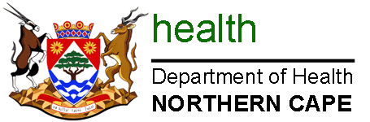

NORTHERN CAPE DEPARTMENT OF HEALTH

DIRECTORATE: HIV/AIDS, STIs&TB

PROJECT FUNDING APPLICATION FORM:
FUNDING PERIOD: APRIL 2026 – MARCH 2029

1. PARTICULARS OF THE ORGANISATION

1.1. Project details
Name of Organisation:
Contact Person’s name:
Physical Address:
Postal Address:
Telephone:
Fax:
E-mail:
NPO Registration No:
Names of Board members (minimum of 3) i.e. Chairperson, Secretary, Treasurer | Name | Designation | ID number
 | 1.
 | 2.
 | 3.
1.2. Project amount requested:__________________________________________________

2. PROGRAMME INFORMATION.
2.1. STATE THE ORGANIZATION’S CORE PROGRAMME, (e,g, HTS, MMC, PMTCT, Key Populations, Treatment Adherence Support and Retention, ACSM, etc)
2.2. PLEASE STATE YOUR ORGANIZATION’S AREAS OF OPERATION (PROVINCE, DISTRICT
AND PHC FACILITIES)
Provinces | Districts | Operational sites | Intended project reach
1.
2.
3.
4.
5.

3. SOURCES OF FUNDING
Indicate your sources of funding in the past 2 years | Government: | Source | Amount funded | Programme areas | Operational areas/districts
Indicate your sources of funding in the past 2 years | Government: | 1.
Indicate your sources of funding in the past 2 years | Government: | 2.
Indicate your sources of funding in the past 2 years | Other: | 1.
Indicate your sources of funding in the past 2 years | Other: | 2.
Indicate your sources of funding in the past 2 years | Other: | 3.

4. AUDIT INFORMATION:

TICK
Has your organization been audited before?  Name of Auditing Firm  Contact Details of Auditors  Date of latest audit report | YES | NO | If yes, provide details.  1.  2.  3.

5. YOUR PROPOSAL (BUSINESS PLAN) MUST INCLUDE THE

FOLLOWING:
Executive summary : 2 pages (Include organization’s expertise and staff complement)
Statement of Need : 1 page
Project description : 3 pages (Goal, Objectives, Project activities, time frames, targets
& costs)
Budget : 1 page

___________________________ ____________________________ ________________
Signature of Applicant Designation Date

