To whom it may concern | Date | 06/10/2026
To whom it may concern | Enquiries | 5
To whom it may concern | E-mail address | lebekogb@eskom.co.za
Dear Sir/Madam
Request for Enquiry Number | E3507GXNOU
Description / Project Title | The Supply and delivery of whole or part of the scope of various Mechanical  Consumables and Components at Koeberg Operating Unit for a period of 1 year.
Tender Questions Closing Date | 13 October 2026

Item | Questions | Answers | Clarity Published Dates
 | STEM VLV:GLOBE PLUG;40 MM;AISI 304L (65031) Additional information. | 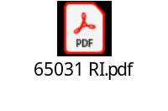 | 06/10/2026

