

Specifications for Engineering Student PPE is as follows:

- Work suit – 2 Piece Overalls
Work suit
Design:  - Total guard Classic D59 Flame & Acid Retardant Jacket and pant.  - It must enhance visibility and come with 50mm silver reflective tape on the legs and arms and have bar tracks on all pressure points to ensure strength and durability, branded college logo, and DHET Logo embroided, screen-printing of the programme name at the back  - Non-woven fabric  - SABS Approved  - Colour: Navy Blue  Sizes range: 24 - 58 UK | 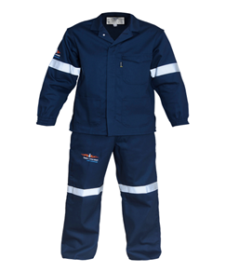

- Safety Boots Male
Safety Boots Male
Design:  - Steel toe cap; slip-resistant sole; electrical hazard protection; Puncture resistance and ankle support.  - Additional features: Waterproofing; breathability and durability Chelsea safety boot, full grain leather, elastic side gussets and 2 pull straps for ease of entering and exiting boot, anti-static, non-woven in sock. sole made of hardwearing, polyurethane, with a shore hardness of 0.64mm to 0.65mm. shank reinforcement support. Black  Sizes range: 1-12 UK | 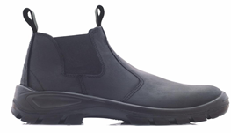

- Safety Boots Female
Safety Boots Female
Design:  - Steel toe cap; slip-resistant sole; electrical hazard protection; Puncture resistance and ankle support.  - Additional features: Comfortable feet; Lightweight; Waterproofing; breathability and durability, upper bartan print leather inner sole, Chelsea safety boot, full grain leather, elastic side gussets and 2 pull straps for ease of entering and exiting boot, anti-static, non-woven in sock. sole made of hardwearing, polyurethane, with a shore hardness of 0.45mm to 0.5mm shank to reinforcement support. black  - Sizes: 1-12 UK | 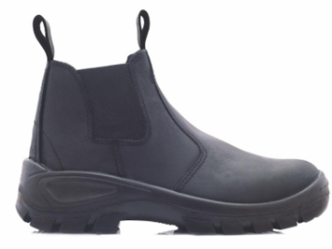

NB:
- The DHET logo should be ⅓ larger than the SEDCOL logo.
- All logos should be branded in full colour.
- All logos should be embroidered.
- Branding should be in line with the DHET Corporate Identity & Branding Guidelines.
- SEDCOL logo font must always be in Arial MT Regular Light Italic

Pricing Table – Student PPE

No. | Description of Item | Quantity | Price (Incl. VAT)
1 | Work suit - 2 Piece | 1 | R
2 | Safety Boots - Male | 1 | R
3 | Safety Boots - Female | 1 | R
TOTAL PRICING FOR ALL ITEMS (INCLUDING VAT) AND DELIVERY |  |  | R

SUPPLIER ARE ADVISED TO STICK TO THE SPECIFICATION
NB: Only suppliers who are shortlisted will be required to submit samples of the items.

Specifications for Engineering Lecturer PPE is as follows:

Work Suit
Design: WORKSUIT(TWO PIECE)
- Flame & Acid Retardant Jacket and Pants.
- Unisex
- SABS Approved
- Navy blue colour, branded college logo, DHET Logo embroided, Material Spandex blend 2%, Oxford Polyester 300D, 33% cotton, polycotton canvas. With 6 pockets pants

Sizes range: 24 - 58 UK

- Safety Boots Unisex
Safety Boots for lecturers
Design:  - 200J Steel toe cap; slip-resistant sole; electrical hazard protection; Puncture resistance and ankle support.  - Toe bumper for added scuff protection  - Additional features: Comfortable feet; Waterproofing; breathability and durability, full grain leather, elastic side gussets and 2 pull straps for ease of entering and exiting boot, anti-static, Dark brown  - Sizes: 2-12 UK | 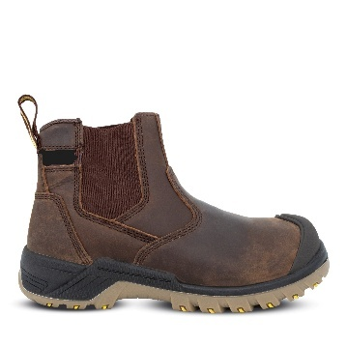

NB:
- The DHET logo should be ⅓ larger than the SEDCOL logo.
- All logos should be branded in full colour.
- All logos should be embroidered.
- Branding should be in line with the DHET Corporate Identity & Branding Guidelines.
- SEDCOL logo font must always be in Arial MT Regular Light Italic

Pricing Table – Engineering Lecturer PPE

No. | Description of Item | Quantity | Price (Incl. VAT)
1 | Work suit - 2 Piece | 1 | R
2 | Safety Boots - Unisex | 1 | R
TOTAL PRICING FOR ALL ITEMS (INCLUDING VAT) AND DELIVERY |  |  | R

Specifications for Hospitality Student PPE is as follows:

Chef Jacket, Pants, Bistro Apron and Chef Beanie

Design: Chef Jacket  - 100% COTTON  - White  - Long Sleeve  - Double breasted  - Branding: left pocket, DHET logo and SEDCOL on the opposite side (Embroided)  - Size: Small to XXL | 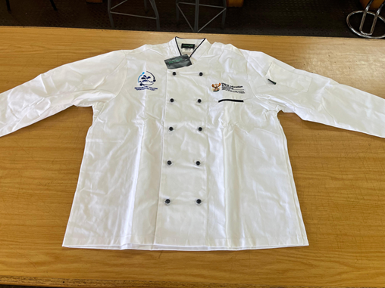
Design: Pants  - Pants unisex,  - Elastic waist  - Draw string  - Inseam slanted front pockets  - Back right patch pocket  - 210gsm, 65/35 polycotton, machine or hand wash.  - Size:Small to XXL | 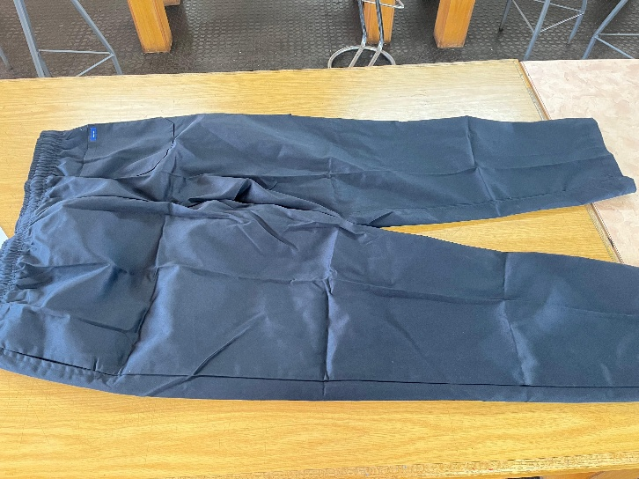
Design: Bistro Apron  - Knee length(long) apron  - 100% cotton  - Colour: white  - Two front pockets | 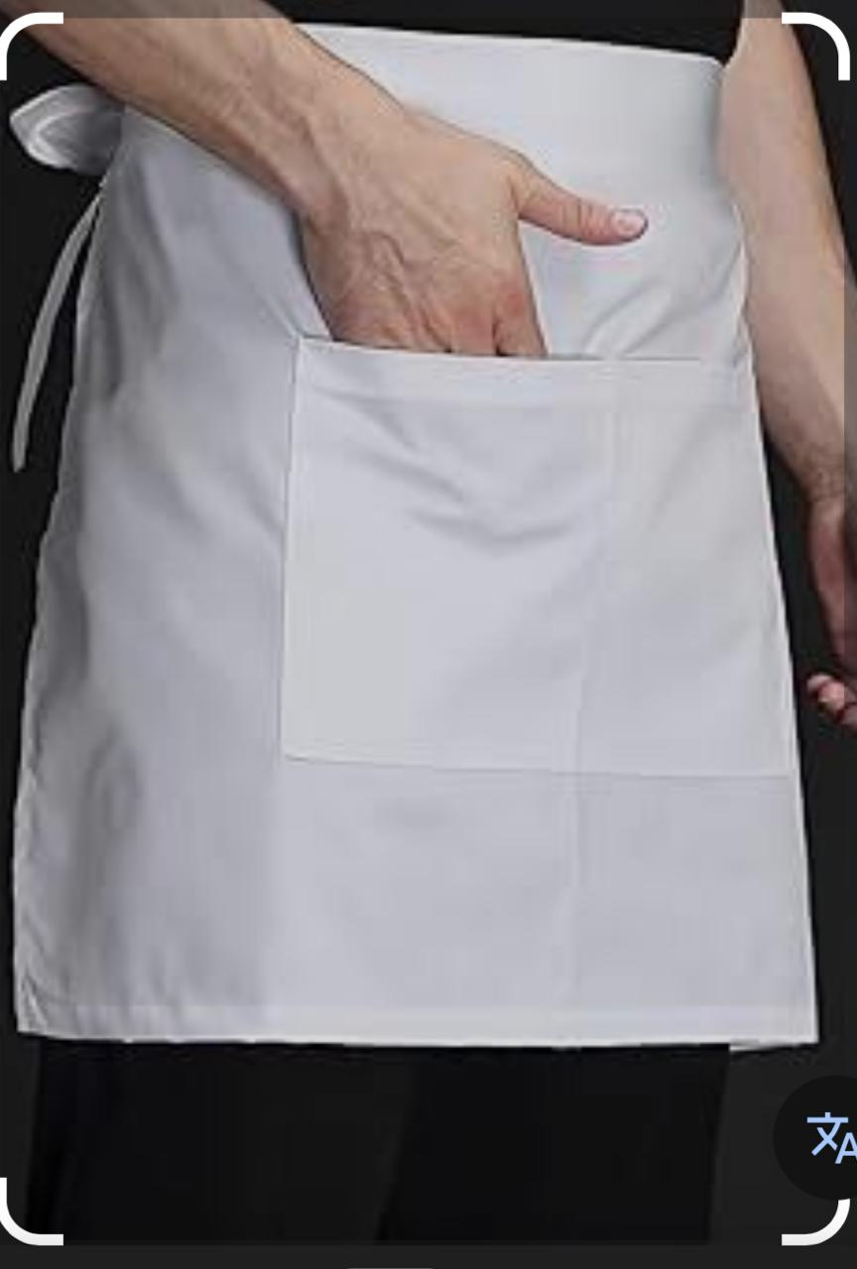
Design: Chef Beanie  - 100% cotton,  - Mushroom chef beanie with a patch  - Colour: white | 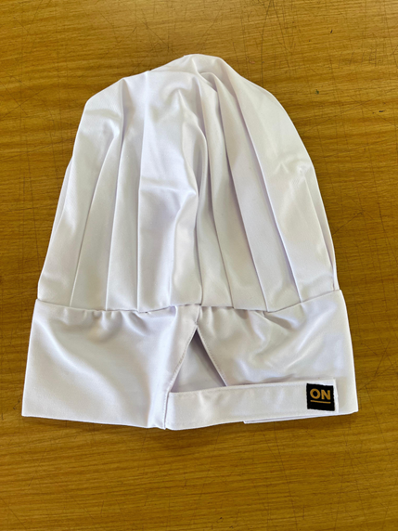

Safety Boots Male
Safety Boots Male
Design:
- Steel toe cap; slip-resistant sole; electrical hazard protection; Puncture resistance and ankle support.
- Additional features: Waterproofing; breathability and durability Chelsea safety boot, full grain leather, elastic side gussets and 2 pull straps for ease of entering and exiting boot, anti-static, non-woven in sock. sole made of hardwearing, polyurethane, with a shore hardness of 0.64mm to 0.65mm. shank reinforcement support. Black
Sizes range: 1-12 UK

- Safety Boots Female
Safety Boots Female
Design:
- Steel toe cap; slip-resistant sole; electrical hazard protection; Puncture resistance and ankle support.
- Additional features: Comfortable feet; Lightweight; Waterproofing; breathability and durability, upper bartan print leather inner sole, Chelsea safety boot, full grain leather, elastic side gussets and 2 pull straps for ease of entering and exiting boot, anti-static, non-woven in sock. sole made of hardwearing, polyurethane, with a shore hardness of 0.45mm to 0.5mm shank to reinforcement support. black
- Sizes: 1-12 UK

NB:
- The DHET logo should be ⅓ larger than the SEDCOL logo.
- All logos should be branded in full colour.
- All logos should be embroidered.
- Branding should be in line with the DHET Corporate Identity & Branding Guidelines.
- SEDCOL logo font must always be in Arial MT Regular Light Italic

