 | Section/division | Supply Chain Management | Form Number: CA 183-515
 | REQUEST FOR QUOTES (RFQ)

Description of Goods/ Service required | Large Gala Event Hall/ Arena in Gauteng within a 60km radius of Midrand
ITEM/ SERVICE |  |  | QUANTITY
Name of event: Mens Mentorship  Date: 29 September 2023  Overall Event Time: 07:00 – 16:00  Guest Arrival: 8:00 – 9:00  GENERAL VENUE REQUIREMENTS  - A 3 - 4 Star venue in the Midrand area. Must be secured.  - A meeting hall with additional space to serve as entertainment area preferably next to, or if not possible, inside the meeting hall.  - Ideal – Access to outdoor space would be preferred, provided that the function can continue in case of rain.  - Secure parking area for 200-250 vehicles  CONFERENCE ROOM/HALL REQUIREMENTS  Main Venue Capacity  - 250 people, informal set up (refer to the proposed hall set up below)  - Accommodate a stage (size and capacity as detailed under Audio visual requirements)  CATERING REQUIREMENTS  Drinks  - 250 pax  - Welcome drinks on arrival to include tea, coffee and juice.  - Tea break - coffee, tea, juice and non-alcoholic drinks (cold drink tins)  - Cash bar to be available from lunch (estimated time, 12:20). Bar to include beers and ciders only, no hard liquor.  - Water to be availed in the meeting hall for delegates.  Arrival snacks  - Finger breakfast, such as sandwiches, muffins, sweet and savoury pastries, etc.  Morning tea break snacks  - Sweet and savoury biscuits with spreads only.  Lunch  - Main meal only  - A minimum of two starch and 2 meats choices and two salads  - Meat to be in the form of either braai meat or spit braai meat or;  - Provision of braai stands, prepared fires, braai packs, braai tongs, spices and plates for dishing meat.  - Beverage allocation of 3 x non-alcoholic drinks per person (a variety of sodas, juice, appletizers and cordials)  - Cash bar to be available.  - 2 pax Halaal options for all meals  AUDIO VISUAL, STAGE, LAYOUT & DECOR REQUIREMENTS: (A mood board should be submitted with the quote)  THEME: The SACAA Man Cave – Where Men Think Together and Work Together (use your creativity to help SACAA showcase appreciation to its staff members)  HALL LAYOUT AND STAGE POSITIONING GUIDELINES  - Provision to be made for an entertainment area that will include pool tables, soccer tables, darts, and so on. Size requirement 210m².  - Considering that the event is for men and will include an entertainment area, please do a “bar-like” set up that will include square tables and cocktail tables, along with appropriate chairs.  - All necessary audio-visual equipment to be included (projector and screen).  - Stage with set up for a panel discussion (5) along with a podium.  - Microphones for a panel discussion to include 5 men and podium mic.  - 2 Roving mics.  - Décor to be masculine, more informal and include elements of a man cave.  - Space and power supply for a DJ in the entertainment area  TABLE LAYOUT  Welcome and Arrival  - Welcome area must give easy access to the entertainment area.  CLOSE OF DAY  - The programme is estimated to end at 14:30. However we would prefer that the entertainment area and cash bar will be available until 17:00 should some attendees choose to stay behind.  Entertainment Equipment:  Please outsource/ hire equipment for entertainment below for this event.  10 x regular size Pool tables, with 10 triangles, balls, 10 pieces of chalk, and 4 pool cues per table.  10 x Table tennis tables, with 4 paddles per table, 10 x nets and 10 ping pong balls.  10 x Soccer tables, with 1 ball per table (Similar to the image below)  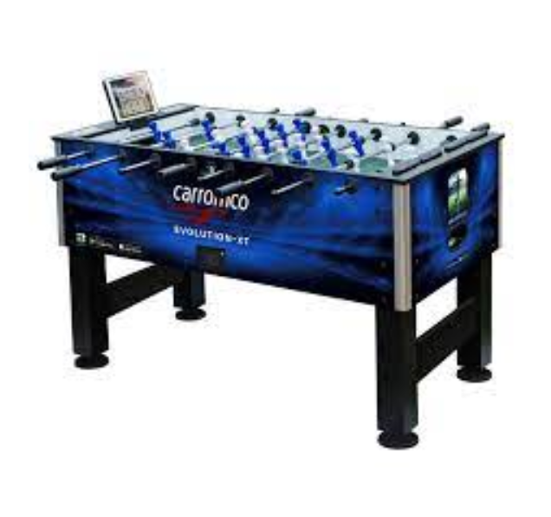  2 x classic Pinball machines (similar to the image below)  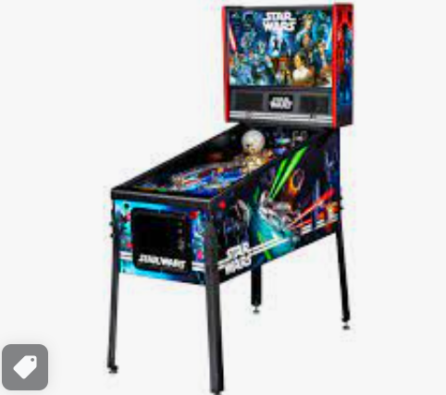  4 x standalone Dartboards (Similar to the image below), with three darts per board and chalk for writing scores on the board.  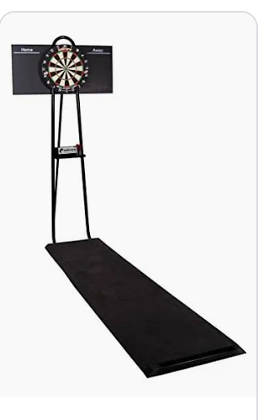  NB: The entertainment equipment might be reduced subject to the event requirements or venue space which you must allocate next to the event venue. |  |  | 250ppl  With an agreement that the numbers may be reduced to no less than 200 one week before the event
GENERAL/ COMMENTS:
Budget: |  | Cost Centre Code: 01-00-100

