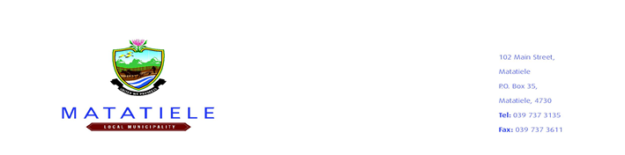
ERRATUM

This notice serves to advise all prospective bidders about the changes for the tenders: Below, which was advertised on Intsikayethu News Paper on the 09 May 2025 and municipal website www.matatiele.gov.za. Below are the details:

Bid Number | Project Name | Old Closing Date | New Closing date
MATAT/2024/2025-27 | SUPPLY AND DELIVERY OF MAYORAL CUPPRIZES | 23/05/2025 | 06/06/2025
MATAT/2023/2024-28 | APPOINTMENT OD SERVIXE PROVIDER FOR A ACQUISITION OF ELECTRICAL CHERRY PICKER | 23/05/2025 | 06/06/2025

The municipality would like to apologize for any inconvenience caused. Please note that all other information remains unchanged.

Technical enquiries and SCM enquiries should be directed and to Ms. M. Sabasaba (Acting Manager: SCM) at MSabasaba@matatiele.gov.za during office hours.

______________________
MR. L MATIWANE
MUNICIPAL MANAGER

