AIR TRAFFIC AND NAVIGATION SERVICES SOC. LTD

REPUBLIC OF SOUTH AFRICA



APPOINTMENT OF A SERVICE PROVIDER FOR SUPPLY, DELIVERY, INSTALLATION AND COMMISSIONING OF 36m LATTICE MAST FOR THE DME-DME PROJECT IN GEORGE TMA SEDGIEFIELD SITE (FAGG4)

REQUEST FOR PROPOSAL: ATNS/HO/RFP008/FY22.23/SEDGEFIELD DME MAST (FAGG4)

VOLUME 2,3 and 4

JUNE 2022

The information contained within this document is confidential to ATNS in all respects and it is hereby acknowledged that the information as provided shall only be used for the preparation of a response to this document. The information furnished will not be used for any other purpose than stated and that the information will not directly or indirectly, by agent, employee or representative, be disclosed either in whole or in part, to any other third party without the express written consent by the Company or its representative.

TABLE OF CONTENTS

TABLE OF CONTENTS 2
ABBREVIATIONS 3
1. INTRODUCTION 4
2. Response to this document 5
CHAPTER 1: TECHNICAL SPECIFICATIONS FOR DME Mast 6
1 Technical Specifications 6-17
CHAPTER 2: PROJECT MANAGEMENT SPECIFICATIONS 18
2 Project Management Specifications 18-20
CHAPTER 3: INTEGRATED LOGISTIC SUPPORT SPECIFICATIONS 21
3 Logistics Specifications 21-22

ABBREVIATIONS

ANSP | Air Navigation Service Provider
ASBU | Aviation System Block Upgrades
ATC | Air Traffic Controller
ATM | Air Traffic Management
ATNS | Air Traffic and Navigation Services
ATS | Air Traffic Service
BC | Business Case
CAATS | Collaborative Advanced Air Traffic System
CAPEX | Capital Expenditure
DME  ECSA | Distance Measuring Equipmement  Engineering Council of South Africa
PBU | Period of Beneficiary Use
SAAATS | South African Air Traffic System
SACAA | South African Civil Aviation Authority
SAT | Site Acceptance Test
SLA | Service Level Agreement
EOL | End of Life
OEM | Original Equipment Manufacturer
LORA | Level of Repair Analysis

INTRODUCTION
Distance measuring equipment (DME) is a radio navigation technology that measures the slant range (distance) between an aircraft and a ground station by timing the propagation delay of radio signals. Line-of-visibility between the aircraft and ground station is required.
Stand-alone DME transponders can be either used alone or part of the network. DME transponders are usually paired with an azimuth guidance system to provide aircraft with a two-dimensional navigation capability.

These facilities are pivotal to air traffic service provision as they support Air Traffic Service (ATS) routes and some operational procedures. Furthermore, they are used as backup navigation system for the Global Navigation Satellite System (GNSS) during disruptions and outages.

This document outlines the functional and technical specification for the acquisition of the DME Mast Project.

Document Structure

This document is divided into four sections. The first section defines the general information and instructions for bidders, the second section, which is Chapter 1 presents the Technical Specifications (VOLUME 2), the third section, Chapter 2 presents the Project Management specifications (VOLUME 3), and the fourth section, Chapter 3 presents the Integrated Logistic Support Specifications (VOLUME 4).

Response to this document
The Tenderer shall submit all responses, diagrams, project management documentation and drawings according to the GENERAL INFORMATION AND INSTRUCTIONS TO TENDERERS document and in the English language.

ALL RESPONSES TO THE REQUIREMENTS IN THIS DOCUMENT SHALL BE PROVIDED AS FOLLOWS:
TENDERERS SHALL RESPOND IN FULL TO EACH ITEM IN THE FORMAT PROVIDED AND REFERENCES TO DOCUMENTS AND RELEVANT INFORMATION SUPPORTING THE RESPONSES SHALL BE INDICATED IN THE SPACE PROVIDED. THIS INFORMATION WILL BE THE ONLY RESPONSE USED FOR THE EVALUATION AND ASSESSMENT.

Responses, provided in the space allowed, that are not clear or inadequate or the lack thereof shall be interpreted as “Not Compliant” even though the compliance column is declared as “Comply” and/or the Tenderer’s offer meets the requirement. Tenderers shall ensure that each response correctly addresses the requirement stated. Responses not addressing the requirement of the specific paragraph shall be interpreted as “Not Compliant”.

Tenderers shall declare compliance to each and every paragraph of this document in the column labelled “Compliance” as follows:

C: fully compliant = 2 points:
PC: partly compliant = 1 points;
NC: not compliant = 0 points.

For paragraphs marked “PC” or “NC”, Tenderer’s shall include a statement as to the nature of the variation and may additionally supply supporting information in the space provided to demonstrate how the proposal meets the needs of ATNS.

TECHNICAL SPECIFICATIONS FOR DME MAST

Technical Specifications

GENERAL REQUIREMENTS

The Bidder shall cater to the design, manufacturing, supply, delivery and Installation of a Galvanised or stainless steel Lattice Mast (i.e. Atleast 3 or 4 Legged Mast, Angular or Tubular Mast) in Segdefield, Western Cape.

Bidder shall provide a response such as Data Sheets or design document detailing how their offered Lattice Mast meets this requirement.

COMPLIANCE (C/PC/NC/Noted)
[INSERT FULL RESPONSE FOR EVALUATION HERE]

[INSERT REFERENCE TO ADDITIONAL INFORMATION HERE]

The Bidder responses shall be clear and neat for ease of understanding.
COMPLIANCE (C/PC/NC/Noted)
[INSERT FULL RESPONSE FOR EVALUATION HERE]

[INSERT REFERENCE TO ADDITIONAL INFORMATION HERE]

The Bidder response references shall be clearly marked.
COMPLIANCE (C/PC/NC/Noted)
[INSERT FULL RESPONSE FOR EVALUATION HERE]

[INSERT REFERENCE TO ADDITIONAL INFORMATION HERE]

SITE ENVIRONMENTAL INFORMATION

The Bidder shall provide a self supporting lattice mast that will comply with weather conditions that are listed in Table 1 and 2 below. Bidders shall provide data sheets to indicate compliance to values and tolerances in Table 1 and 2 below.

Table 1: Environmental Conditions

Ambient Temperature | -5 °C to +55 °C
Relative humidity | 10% to 90%.
Ambient Temperature | -20 °C to +55°C
Altitude tolerance | 0 to 2000 meters
Relative humidity | 0% to 100%.
Annual rainfall range | 400 mm to 2000 mm
Average Wind and Gust speed | Refer to table 2 below
Lightning flash density (flashes/km²/year) | 0-1

Table 2: Average Wind Speed and Wind Gust Speed Data from 2017 to 2020
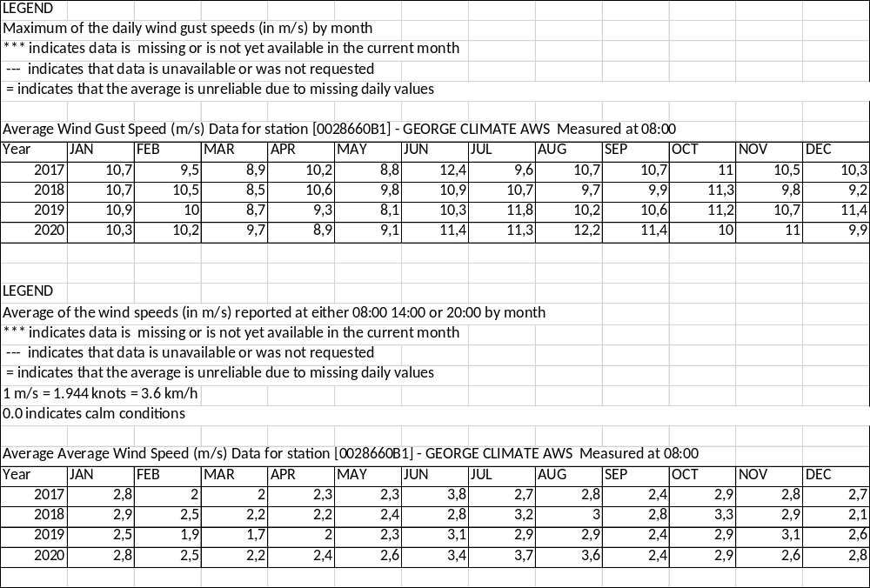

COMPLIANCE (C/PC/NC/Noted)
[INSERT FULL RESPONSE FOR EVALUATION HERE]

[INSERT REFERENCE TO ADDITIONAL INFORMATION HERE]

The Bidder shall provide the Lattice Mast at the geographical and ground elevation (164.6m , a zero datum point) information listed in Table 2 below. The Bidder shall provide a design document with dimensions verifying that their Lattice Mast will fit within 70 square meters.

Surveyed coordinates:
FAGG SEDGEFIELD MAST
WG 23
NAME | Y | X | Z | DESCRIPTION
MAST POSITION | 23145.05 | 3766284 | 197.414 | Mast Position
P2 | 23141.06 | 3766285 | 197.691 | Corner Fence
P3 | 23145.49 | 3766290 | 197.428 | Corner Fence
P4 | 23151.73 | 3766285 | 197.556 | Corner Fence
P5 | 23147.26 | 3766280 | 197.394 | Corner Fence
Table 4: Mast Coordinates

Site Area: 7m X 10m = 70 square meters
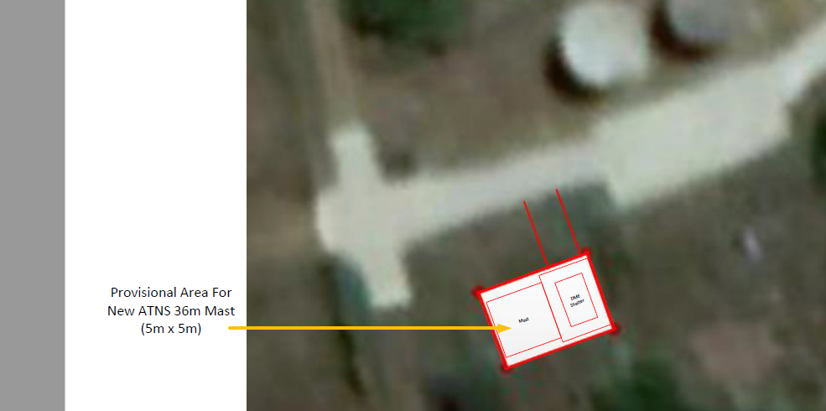

COMPLIANCE (C/PC/NC/Noted)
[INSERT FULL RESPONSE FOR EVALUATION HERE]

[INSERT REFERENCE TO ADDITIONAL INFORMATION HERE]

MAST FOUNDATION REQUIREMENTS

The Bidder shall provide the mast foundation with specifications listed below. Bidders shall use 50Kpa as a baseline for their foundation design for now until the soil testing is conducted by the winning Bidder.

Soil testing is required to identify the characteristics of the soil to determine its ability to support the structure. The Bidder shall provide proof/supporting documents for any previous soil testing services completed in the last five years.
COMPLIANCE (C/PC/NC/Noted)
[INSERT FULL RESPONSE FOR EVALUATION HERE]

[INSERT REFERENCE TO ADDITIONAL INFORMATION HERE]

The Bidder shall provide a copy of the Geo-technical’s report and the foundation design calculations to the engineer at least four weeks before site work is due to commence.
COMPLIANCE (C/PC/NC/Noted)
[INSERT FULL RESPONSE FOR EVALUATION HERE]

[INSERT REFERENCE TO ADDITIONAL INFORMATION HERE]

The Bidder is required to clear any trees, rocks and debris and level the site for building foundation. The cleared material shall be spread out around the site and be levelled out properly.
COMPLIANCE (C/PC/NC/Noted)
[INSERT FULL RESPONSE FOR EVALUATION HERE]

[INSERT REFERENCE TO ADDITIONAL INFORMATION HERE]

The foundation of the Mast shall fit within a 25 m² area. The Bidder shall provide a foundation design document detailing how their Mast foundation meets this requirement.
COMPLIANCE (C/PC/NC/Noted)
[INSERT FULL RESPONSE FOR EVALUATION HERE]

[INSERT REFERENCE TO ADDITIONAL INFORMATION HERE]

The foundation shall comply with the following standards.
- SANS 1200 G - Standardized specification for civil engineering construction Section G: Concrete (Structural)
- SANS 1200 GA - Standardized specification for civil engineering construction Section GA: Concrete (small works)

The Bidder shall provide a compliance document from either previous work completed or approved foundation design document detailing how their offered Mast foundation meets this requirement.

COMPLIANCE (C/PC/NC/Noted)
[INSERT FULL RESPONSE FOR EVALUATION HERE]

[INSERT REFERENCE TO ADDITIONAL INFORMATION HERE]

MAST STRUCTURE REQUIREMENTS

The Bidder shall provide a self-supporting Galvanized or stainless-steel 36m lattice Mast. The Bidder shall provide a design document detailing how their offered Mast meets this requirement.
COMPLIANCE (C/PC/NC/Noted)
[INSERT FULL RESPONSE FOR EVALUATION HERE]

[INSERT REFERENCE TO ADDITIONAL INFORMATION HERE]

The Mast foundation shall take into account the respective soil properties and external load forces of the mast. The Bidder shall provide a response such as Data Sheets or design document detailing how their offered Lattice Mast meets this requirement.
COMPLIANCE (C/PC/NC/Noted)
[INSERT FULL RESPONSE FOR EVALUATION HERE]

[INSERT REFERENCE TO ADDITIONAL INFORMATION HERE]

The base plate of the Mast shall be welded to the bottom end of the lowest section suitable drilled for foundation bolts. The Bidder shall provide design document detailing how their offered Lattice Mast meets this requirement.

COMPLIANCE (C/PC/NC/Noted)
[INSERT FULL RESPONSE FOR EVALUATION HERE]

[INSERT REFERENCE TO ADDITIONAL INFORMATION HERE]

All the bolts and nut shall be manufactured from stainless steel. The Bidder shall provide a response such as Data Sheets detailing how their offered Lattice Mast meets this requirement.
COMPLIANCE (C/PC/NC/Noted)
[INSERT FULL RESPONSE FOR EVALUATION HERE]

[INSERT REFERENCE TO ADDITIONAL INFORMATION HERE]

The height of the mast shall be 36 meters above ground level (i.e. measured from the ground or zero datum point which is 164.6m Elevation). The cross-section and wall thickness of the mast must be determined on the basis of the working loads and wind conditions. The weight of the DME Antenna system is :22 lbs.( 9.97903 kg) excluding obstruction light, lightning rod assembly,and mounting fixtures. The Mast shall cater for a standard spare capacity used in the market. The Bidder shall provide a response such as Data Sheets or design document detailing how their offered Lattice Mast meets this requirement.
COMPLIANCE (C/PC/NC/Noted)
[INSERT FULL RESPONSE FOR EVALUATION HERE]

[INSERT REFERENCE TO ADDITIONAL INFORMATION HERE]

Three full working platforms with railings and safety trapdoors must be provided. The three platforms can be spaced as follows:
- Lower platform at 10 meter from ground.
- Middle platform at 20 meter from ground.
- Upper platform at 30 meter from ground.
The Bidder shall provide a response detailing how their offered Mast meets this requirement.

COMPLIANCE (C/PC/NC/Noted)
[INSERT FULL RESPONSE FOR EVALUATION HERE]

[INSERT REFERENCE TO ADDITIONAL INFORMATION HERE]

An internal safety climbing ladder shall be provided throughout the length of Mast. The Bidder shall provide a response such as Data Sheets and design document detailing how their offered Lattice Mast meets this requirement.
COMPLIANCE (C/PC/NC/Noted)
[INSERT FULL RESPONSE FOR EVALUATION HERE]

[INSERT REFERENCE TO ADDITIONAL INFORMATION HERE]

The Mast shall have a cable carrier for supporting obstruction light power and earth cables (or flat bar), and shall be mounted to the safety ladder frame. The Bidder shall provide a response such as Data Sheets or design document detailing how their offered Lattice Mast meets this requirement.
COMPLIANCE (C/PC/NC/Noted)
[INSERT FULL RESPONSE FOR EVALUATION HERE]

[INSERT REFERENCE TO ADDITIONAL INFORMATION HERE]

The Masts shall be designed in accordance with SABS 0160, SANS 10225 and any Lattice Mast SABS/SANS standards not mentioned in this document. The design, including calculation details, shall be approved by the Bidder’s Professional Structural Engineer before commencing manufacture. The Bidder shall provide a technical design document complying to the SANS and SABS standards and supporting documents for their Professional Structural Engineer.
COMPLIANCE (C/PC/NC/Noted)
[INSERT FULL RESPONSE FOR EVALUATION HERE]

[INSERT REFERENCE TO ADDITIONAL INFORMATION HERE]

The relevant structural documents must be signed by the Professional Structural Engineer and the technical design calculations and specification shall be submitted with the tender document.
COMPLIANCE (C/PC/NC/Noted)
[INSERT FULL RESPONSE FOR EVALUATION HERE]

[INSERT REFERENCE TO ADDITIONAL INFORMATION HERE]

The fully equipped Mast must be designed for a minimum lifespan of 20 years or according to a standard design life/return period of 50 years used by structural engineers. The Bidder shall provide a response/ data sheets detailing how their offered Lattice Mast meets this requirement.
COMPLIANCE (C/PC/NC/Noted)
[INSERT FULL RESPONSE FOR EVALUATION HERE]

[INSERT REFERENCE TO ADDITIONAL INFORMATION HERE]

The Mast shall be corrosion resistant as the installation shall be in a coastal area. Supporting documentation shall be provided to prove compliance to this requirement.
COMPLIANCE (C/PC/NC/Noted)
[INSERT FULL RESPONSE FOR EVALUATION HERE]

[INSERT REFERENCE TO ADDITIONAL INFORMATION HERE]

It is the responsibility of the Bidder to obtain the site terrain specifications before commencing design of the Mast.

COMPLIANCE (C/PC/NC/Noted)
[INSERT FULL RESPONSE FOR EVALUATION HERE]

[INSERT REFERENCE TO ADDITIONAL INFORMATION HERE]

LIGHTNING PROTECTION AND EARTHING SYSTEM REQUIREMENTS

Lightning Protection and Earthing of the Mast shall comply with, but not limited to SANS 10142 and SANS 10313. Supporting documentation shall be provided to prove compliance to this requirement.
COMPLIANCE (C/PC/NC/Noted)
[INSERT FULL RESPONSE FOR EVALUATION HERE]

[INSERT REFERENCE TO ADDITIONAL INFORMATION HERE]

A lightning Arrestor (Air Terminal) shall be fitted on top of the mast structure. The Bidder shall provide a response detailing how their offered Mast meets this requirement.
COMPLIANCE (C/PC/NC/Noted)
[INSERT FULL RESPONSE FOR EVALUATION HERE]

[INSERT REFERENCE TO ADDITIONAL INFORMATION HERE]

- The Bidder shall provide full details of the proposed Lightning Arrestor (Air Terminal). The Company reserves the right to approve the offered devices or revert to the Company favoured devices.

COMPLIANCE (C/PC/NC/Noted)
[INSERT FULL RESPONSE FOR EVALUATION HERE]

[INSERT REFERENCE TO ADDITIONAL INFORMATION HERE]

The Lightning Arrestor (Air Terminal) shall be securely bolted (mounted) to the mast, ensuring a good conductive connection to the mast metal structure. The connection shall be protected from any water or moisture ingress by way of a suitable waterproof solution. The Bidder shall provide a response detailing how their offered Mast meets this requirement.
COMPLIANCE (C/PC/NC/Noted)
[INSERT FULL RESPONSE FOR EVALUATION HERE]

[INSERT REFERENCE TO ADDITIONAL INFORMATION HERE]

The Bidder shall provide an electrical Earth Mat design with an impedance of 5 ohms or less.
COMPLIANCE (C/PC/NC/Noted)
[INSERT FULL RESPONSE FOR EVALUATION HERE]

[INSERT REFERENCE TO ADDITIONAL INFORMATION HERE]

All parts of the mast, not specified as manufactured from stainless steel, shall be hot dip galvanised in compliance with the requirements of SANS 121 and test certificates or supporting documentation shall be provided.
COMPLIANCE (C/PC/NC/Noted)
[INSERT FULL RESPONSE FOR EVALUATION HERE]

[INSERT REFERENCE TO ADDITIONAL INFORMATION HERE]

The Mast earth system must be bonded to the Electrical Earth mat. The Bidder shall provide a design document detailing how their offered Mast meets this requirement.
COMPLIANCE (C/PC/NC/Noted)
[INSERT FULL RESPONSE FOR EVALUATION HERE]

[INSERT REFERENCE TO ADDITIONAL INFORMATION HERE]

OBSTRUCTION LIGHTS REQUIREMENTS

Two red Obstruction light holders and lamps shall be installed at the top of mast in accordance with ICAO Annex 14 Chapter 6 and Annex 14 Appendix 1 requirements. The Bidder shall provide a response detailing how their offered Mast meets this requirement.
COMPLIANCE (C/PC/NC/Noted)
[INSERT FULL RESPONSE FOR EVALUATION HERE]

[INSERT REFERENCE TO ADDITIONAL INFORMATION HERE]

Obstruction light cables shall first terminate into a waterproof enclosure mounted 1,5 meter above the mast base, that will contain suitable surges protection units. A copper bar shall be connected from the mast earth to the waterproof enclosure to ensure a short decoupling path for any lightning surges entering the cables via the obstruction light connections. The Bidder shall provide a response detailing how their offered Mast meets this requirement.
COMPLIANCE (C/PC/NC/Noted)
[INSERT FULL RESPONSE FOR EVALUATION HERE]

[INSERT REFERENCE TO ADDITIONAL INFORMATION HERE]

The armoured cables will then feed from the surge protection waterproof enclosure to the building essential distribution panel. Surge protection units similar to those dedicated for the waterproof enclosure will be installed in the electrical distribution panel.
COMPLIANCE (C/PC/NC/Noted)
[INSERT FULL RESPONSE FOR EVALUATION HERE]

[INSERT REFERENCE TO ADDITIONAL INFORMATION HERE]

The luminaire housing shall be robustly constructed of marine grade high pressure die cast aluminium and shall be weatherproof, hail proof, corrosion proof and vandal resistant. The housing shall have an IP55 rating. Bidders shall provide supporting documentation proving compliance.
COMPLIANCE (C/PC/NC/Noted)
[INSERT FULL RESPONSE FOR EVALUATION HERE]

[INSERT REFERENCE TO ADDITIONAL INFORMATION HERE]

ICAO AERODROME OBSTACLES PAINT SPECIFICATIONS.

The Mast shall be painted in accordance with ICAO specification for Aerodrome obstacles. The colour pattern shall alternate between Bright (Airport) Orange and White. The Bidder shall provide a response detailing how their offered Mast meets this requirement.
COMPLIANCE (C/PC/NC/Noted)
[INSERT FULL RESPONSE FOR EVALUATION HERE]

[INSERT REFERENCE TO ADDITIONAL INFORMATION HERE]

All Galvanised steel Mast sections shall be properly treated and painted to ensure a 20 year maintenance free period. The Bidder shall provide a data sheets detailing how their offered Mast meets this requirement.
COMPLIANCE (C/PC/NC/Noted)
[INSERT FULL RESPONSE FOR EVALUATION HERE]

[INSERT REFERENCE TO ADDITIONAL INFORMATION HERE]

Details of the intended paint specification shall be provided as part of the quotation.

COMPLIANCE (C/PC/NC/Noted)
[INSERT FULL RESPONSE FOR EVALUATION HERE]

[INSERT REFERENCE TO ADDITIONAL INFORMATION HERE]

PROJECT MANAGEMENT SPECIFICATIONS

PROJECT MANAGEMENT SPECIFICATIONS

Project Management Plan and Schedule

The Bidder shall provide a schedule, with detailed proposed timelines for the milestones that will ensure the successful completion of the project.
COMPLIANCE (C/PC/NC/Noted)
[INSERT FULL RESPONSE FOR EVALUATION HERE]

[INSERT REFERENCE TO ADDITIONAL INFORMATION HERE]

The schedule shall highlight the Bidder’s understanding of the scope of the project.
COMPLIANCE (C/PC/NC/Noted)
[INSERT FULL RESPONSE FOR EVALUATION HERE]

[INSERT REFERENCE TO ADDITIONAL INFORMATION HERE]

The Bidder shall provide a list of all personnel and their qualifications that will be involved in the execution of the project.
COMPLIANCE (C/PC/NC/Noted)
[INSERT FULL RESPONSE FOR EVALUATION HERE]

[INSERT REFERENCE TO ADDITIONAL INFORMATION HERE]

Site Acceptance Test

A formal Site Acceptance Test (SAT) will be required.
COMPLIANCE (C/PC/NC/Noted)
[INSERT FULL RESPONSE FOR EVALUATION HERE]

The implementation of the project will be deemed successful once the SAT has been completed by the Bidder and accepted by ATNS.
COMPLIANCE (C/PC/NC/Noted)
[INSERT FULL RESPONSE FOR EVALUATION HERE]

[INSERT REFERENCE TO ADDITIONAL INFORMATION HERE]

The Bidder shall provide tests and inspections documentation listed below.

Issuing of a certificate of compliance (COC) in terms of SANS 0142 Code of Practice.
COMPLIANCE (C/PC/NC/Noted)
[INSERT FULL RESPONSE FOR EVALUATION HERE]

[INSERT REFERENCE TO ADDITIONAL INFORMATION HERE]

The quality of the galvanising shall be tested in accordance with SANS 121. The Bidder shall provide a response detailing how this test will be conducted.
COMPLIANCE (C/PC/NC/Noted)
[INSERT FULL RESPONSE FOR EVALUATION HERE]

[INSERT REFERENCE TO ADDITIONAL INFORMATION HERE]

The Bidder’s quality assurance system shall be approved in terms of SANS 9001. The Bidder shall provide a response detailing compliance with this requirement.
COMPLIANCE (C/PC/NC/Noted)
[INSERT FULL RESPONSE FOR EVALUATION HERE]

[INSERT REFERENCE TO ADDITIONAL INFORMATION HERE]

Welding test certificates according to appropriate SANS standards shall be provided.

COMPLIANCE (C/PC/NC/Noted)
[INSERT FULL RESPONSE FOR EVALUATION HERE]

[INSERT REFERENCE TO ADDITIONAL INFORMATION HERE]

INTEGRATED LOGISTIC SUPPORT SPECIFICATIONS

LOGISTICS SPECIFICATIONS

Configuration Management Plan

The Bidder shall provide the following documents in English.

Operator and Datasheet Manuals
COMPLIANCE (C/PC/NC/Noted)
[INSERT FULL RESPONSE FOR EVALUATION HERE]

[INSERT REFERENCE TO ADDITIONAL INFORMATION HERE]

All hardware (documentation) provided under the execution of this tender shall be ATNS property.
COMPLIANCE (C/PC/NC/Noted)
[INSERT FULL RESPONSE FOR EVALUATION HERE]

[INSERT REFERENCE TO ADDITIONAL INFORMATION HERE]

Packaging, Handling, Storage and Transportation (PHS&T)

The Bidder shall be responsible for the provision of all PHS&T of all items with regard to this project.
COMPLIANCE (C/PC/NC/Noted)
[INSERT FULL RESPONSE FOR EVALUATION HERE]

[INSERT REFERENCE TO ADDITIONAL INFORMATION HERE]

Warranty

As the fully equipped Mast is required to have a minimum 20-year maintenance free design life, ATNS requires a long warranty. The Bidder shall provide a long warranty, of NOT shorter than 2 years, for this Lattice Mast project. Bidders to indicate their proposed warranty.
COMPLIANCE (C/PC/NC/Noted)
[INSERT FULL RESPONSE FOR EVALUATION HERE]
[INSERT REFERENCE TO ADDITIONAL INFORMATION HERE]

