DEPARTMENT/ INSITUTION | BID NUMBER & PROJECT DESCRIPTION | CONTACT PERSON
DEPT OF TRANSPORT | ADDENDUM No.2  DOT-HO-2425- [SCMU10–2425–0008]-(A-F)  APPOINTMENT OF A PANEL OF SERVICE PROVIDERS TO PROVIDE PLANT HIRE SERVICES AND MAINTENANCE OF GRAVEL ROADS IN THE EASTERN CAPE PROVINCE FOR THIRTY-SIX [36] MONTHS.  REASONS FOR ADDENDUM  This addendum serves to extend the closing date, provide clarities on queries raised by several bidders and to provided corrected documents where applicable.  CLOSING DATE IS EXTENDED TO MONDAY 19 AUGUST 2024 AT 11:00 AM IN RESPECTIVE DISTRICTS | TECHNICAL / PROJECT ENQUIRIES  Mrs. Z. Zuzile  Cell no: 082 576 3984  Email address: zezethu.zuzile@ectransport.gov.za  SCM SPECIFIC ENQUIRIES  Mr. Nqikashe  Cell no: 067 419 8001  Email address: philasande.Nqikashe@ectransport.gov.za

NO | QUERY DESCRIPTION | RESPONSE / AMENDMENT
1 | TENDER SUBMISSION –  Do bidders need to submit in each districts if bidding for multiple districts? | Bidders may submit at a stipulated addresses at a district closest to them. Bidders need not submit multiple documents if bidding for multiple districts. Bidders must indicate on page T2.8 the district(s) for which they wish to be considered.  If bidding for multiple districts, bidders must ensure to provide different key personnel and minimum required plant items for each district.
2 | TENDER BRIEFING -  I would like to enquire about the briefing attendance and choice of tender district.  Can we attend any of the briefings dates and still tender at any district?  Will an unsigned certificate of tender briefing certificate render my bid non-responsive. | Bidders are required to attend only one briefing and may attend any of the briefings and may tender for any of the districts.  NO – Bidder’s signature in the attendance register will suffice as proof of attendance of a briefing.  The briefings sessions are non-compulsory
3 | KEY PERSONNEL -  On page T1.6, it stipulates that the Contract Manager should only have a NQF Level 7 Civil Engineering qualification.  Then on page T1.9 is states that the Contract Manager should be registered as a Professional Engineer or Engineering Technologist. | The Contracts Manager, who will be the single point accountable and responsible person for the oversight management of the construction works on site, shall:  • have a minimum NQF level 7 Civil Engineering qualification and be suitably and verifiably experienced with a minimum of 5 years’ experience in road maintenance and / or construction.
4 | PREFERRED ADDRESS FOR LOCALITY POINTS –  Document currently stipulates that:  Preferred Address and satellite offices not edited within on and after date of publishing this tender on latest CSD report of the Bidder company. | Amended to:  Preferred Address and satellite offices not edited in the last 12 months on latest CSD report of the Bidder company.
5 | PROVISION OF PLANT –  Can I use the same plant for tendering in multiple districts? | Minimum plant required for eligibility can only be used for one district. If a bidder wishes to bid for multiple districts, different plant items stipulated as minimum requirements must be used for tendering in different districts.  Additionally, functionality points can only be awarded to eligible bidders for a single plant item once, therefore if a bidder uses same plant items, stipulated in the full complement list, in different districts they will only be awarded points in the district of their preferred office as indicated on CSD.

6 | PROVISION OF PLANT –  Consideration will be given for plant and equipment Owned or hired (with letter of intent from plant hire company within the district for which the Tenderer is bidding) | The restriction to only source plant within the district for which a bidder wishes to be considered is revoked. Bidders may source plant anywhere and provide a letter of intent signed by a commissioner of oath stipulating that the plant item will be leased to the bidder and availed for the duration of the contract.
7 | PANEL AWARD  How many districts will a tenderer be awarded. | A tenderer may be awarded into all panels for which they have scored a minimum 70 functionality points.
8 | SIMILAR PROJECTS VERIFICATION  For each similar project listed by the tenderer in TABLE A, the tenderer must attach:  a) the COMPLETION CERTIFICATE of the project; and  b) a completed and signed returnable schedule C(A) and returnable schedule C(B): SIMILAR PROJECT COMPLETED VERIFICATION FORM. | For each similar project listed by the tenderer in TABLE A, the tenderer must attach:  a) the COMPLETION CERTIFICATE of the project clearly indicating the value of the project completed. If the completion certificate does not reflect the value, then an appointment letter which indicates the award value must be attached as well.
9 | ALLOCATION METHOD  Allocation preference in the implementation of the project will be based on the functionality points. The highest point scoring bidder per district will be the first preferred bidder for allocation and allocations will be awarded rotationally from the highest point scoring to the lowest point scoring bidder.  The department reserves the right not to award any bidder in more than one district. | AMENDED TO:  Allocation will be made according to the Guidelines for Framework Agreements for Infrastructure and Non-Infrastructure goods works and services.
10 | RATES  Are Provisional sums on the bid document are they monthly or package (task) based. | All rates are package based.
11 | BILL OF QUANTITIIES is amended in Annexure A Below.

ANNEXURE 1
BILL OF QUANTIES HEREBY REPLACED

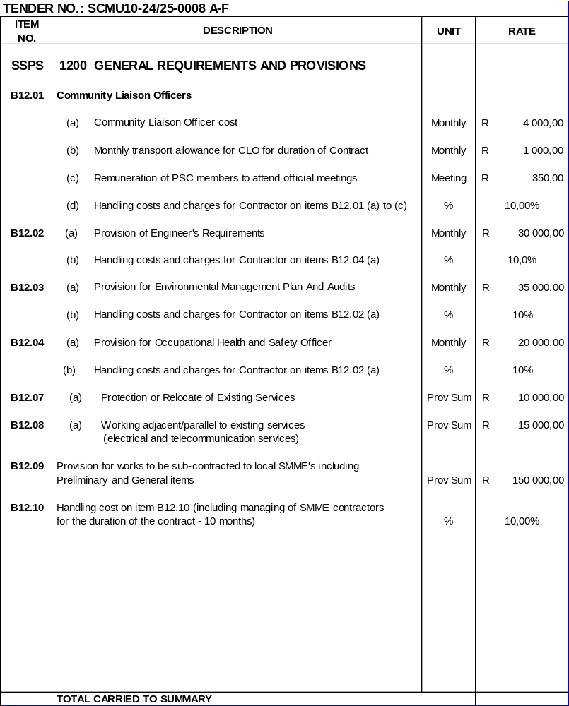

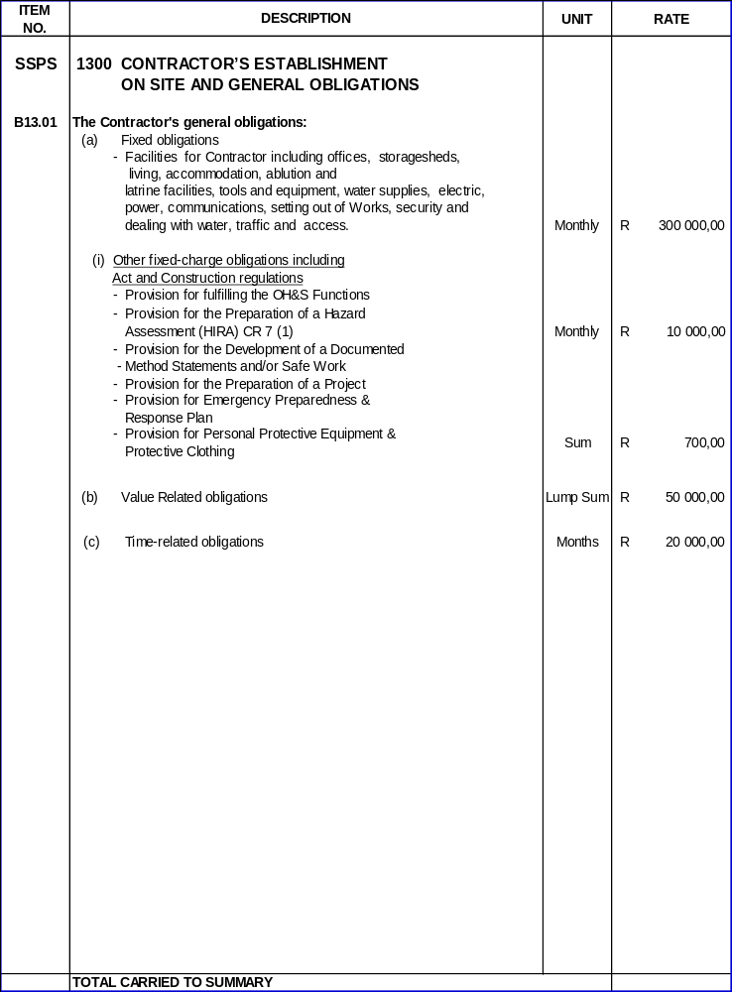
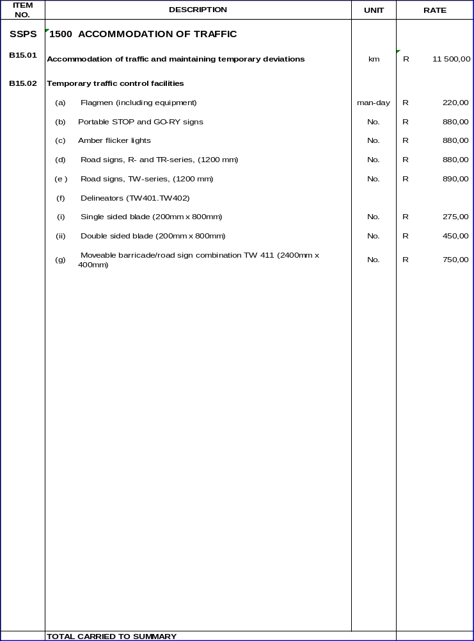

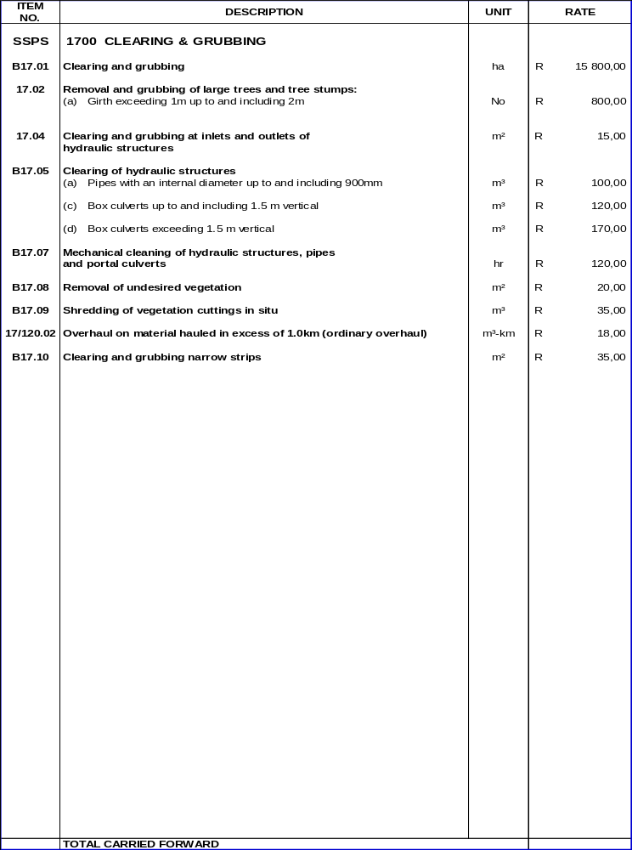

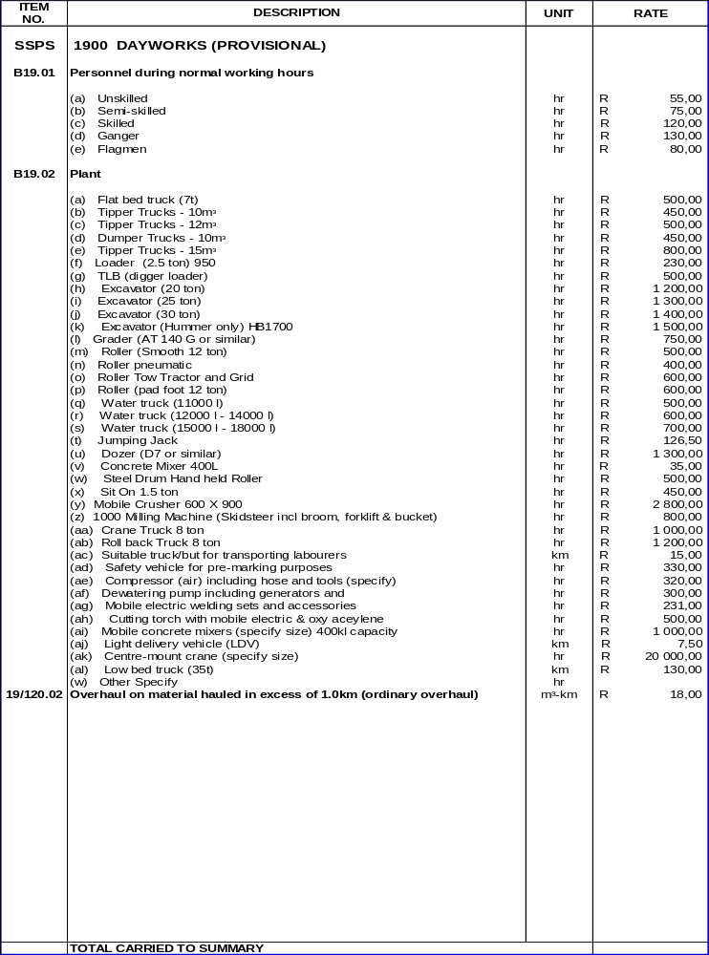

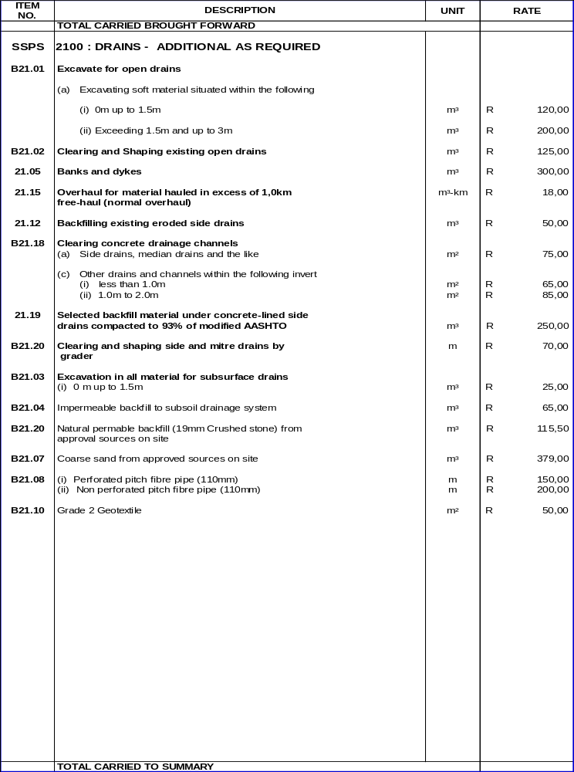

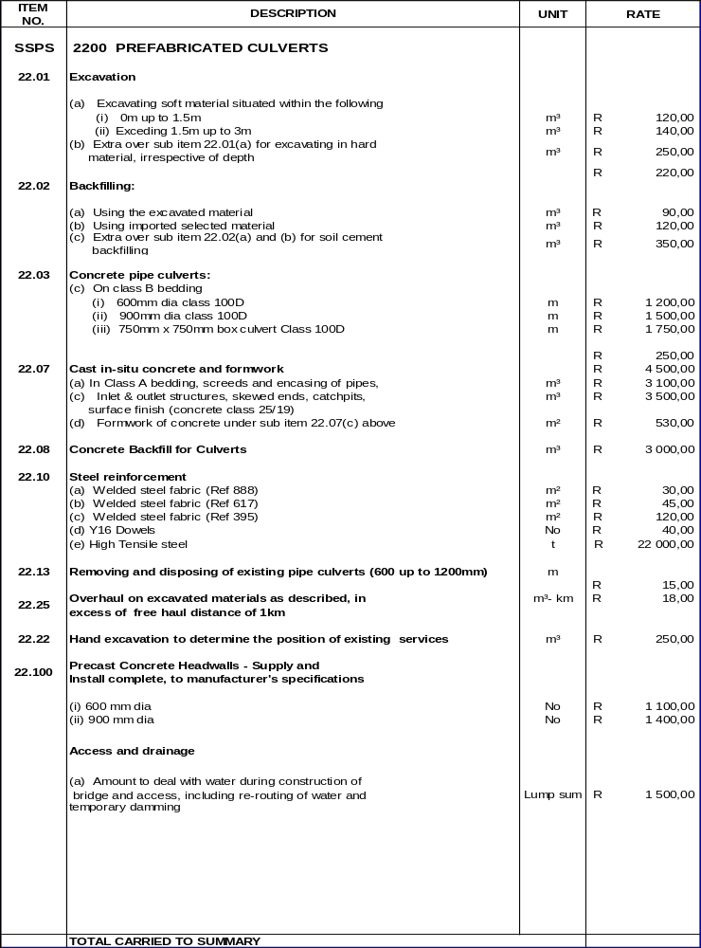

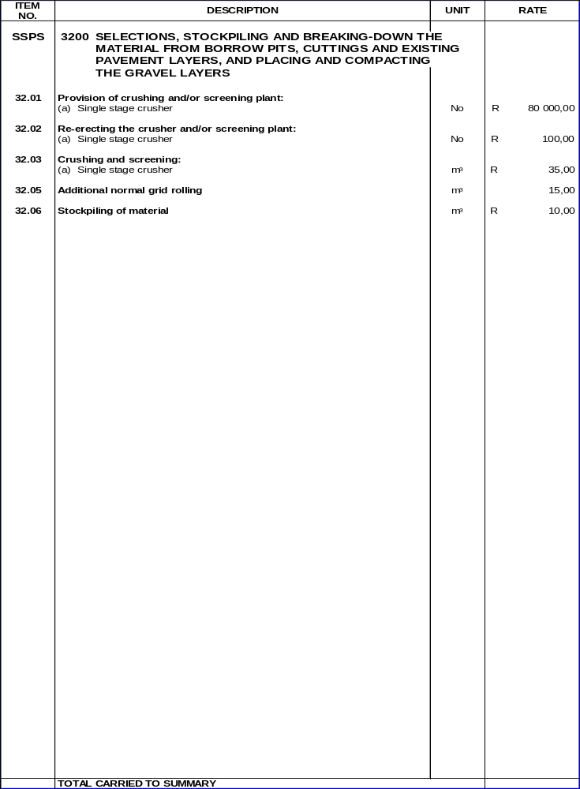

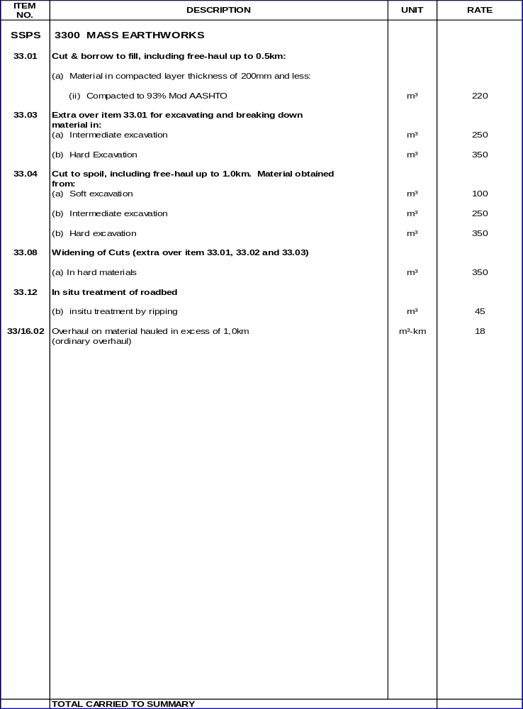

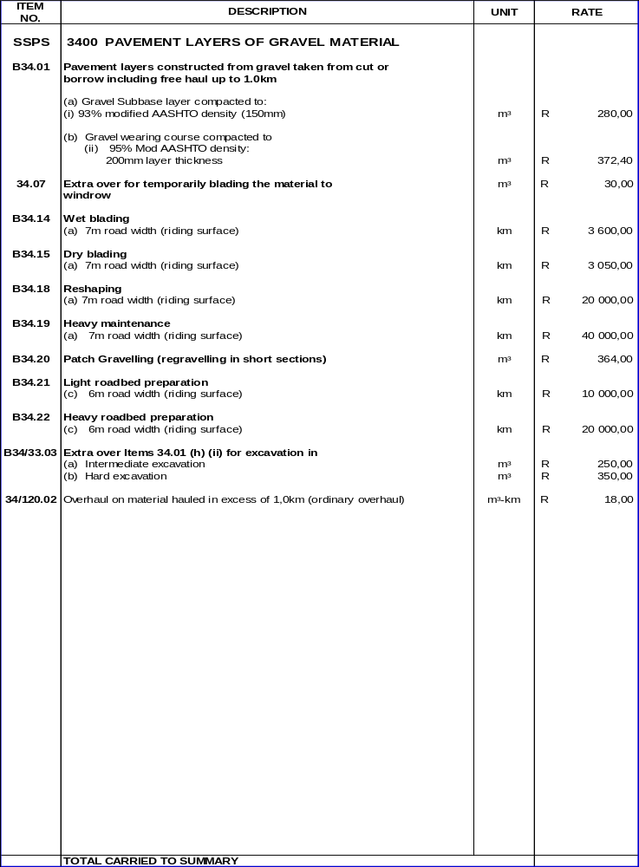

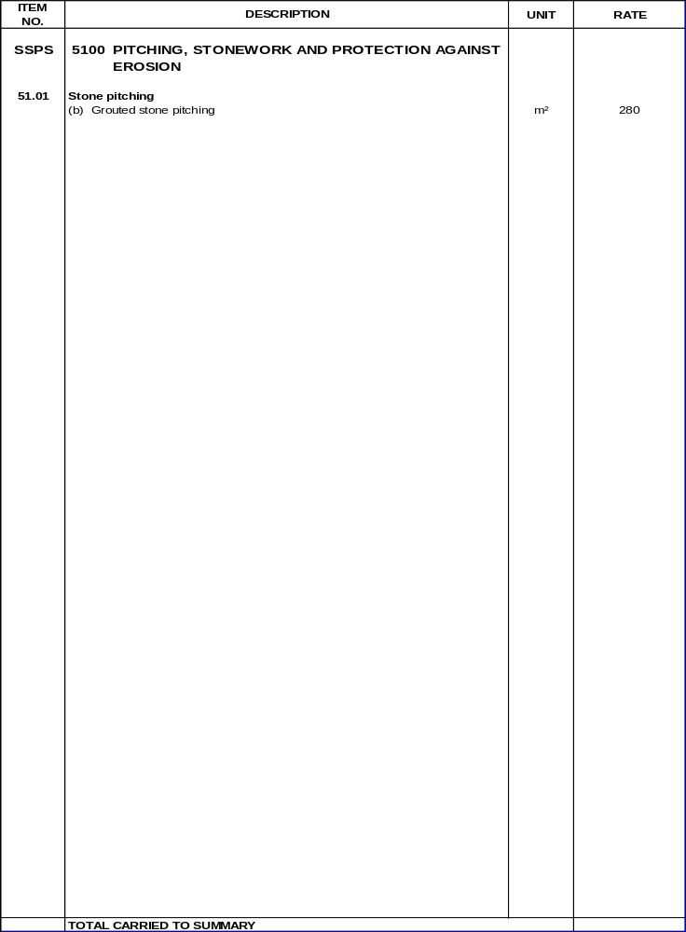

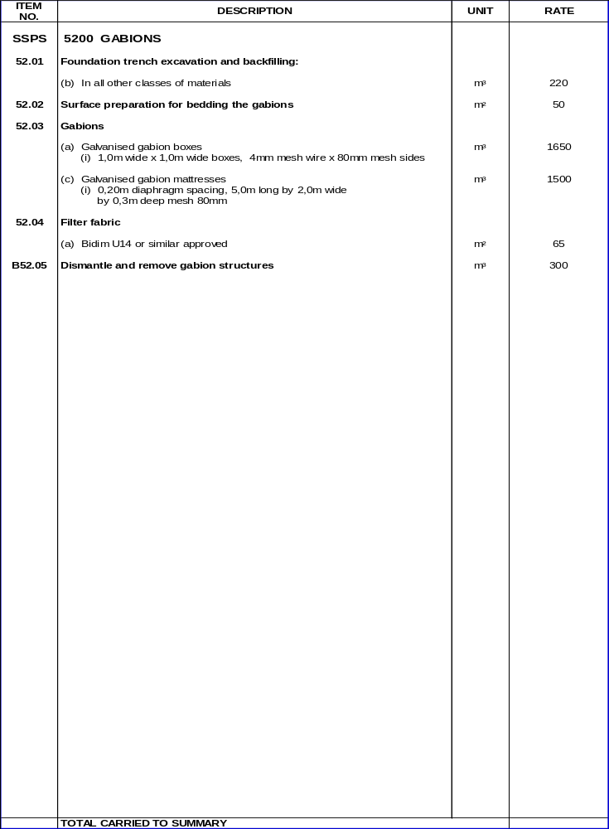

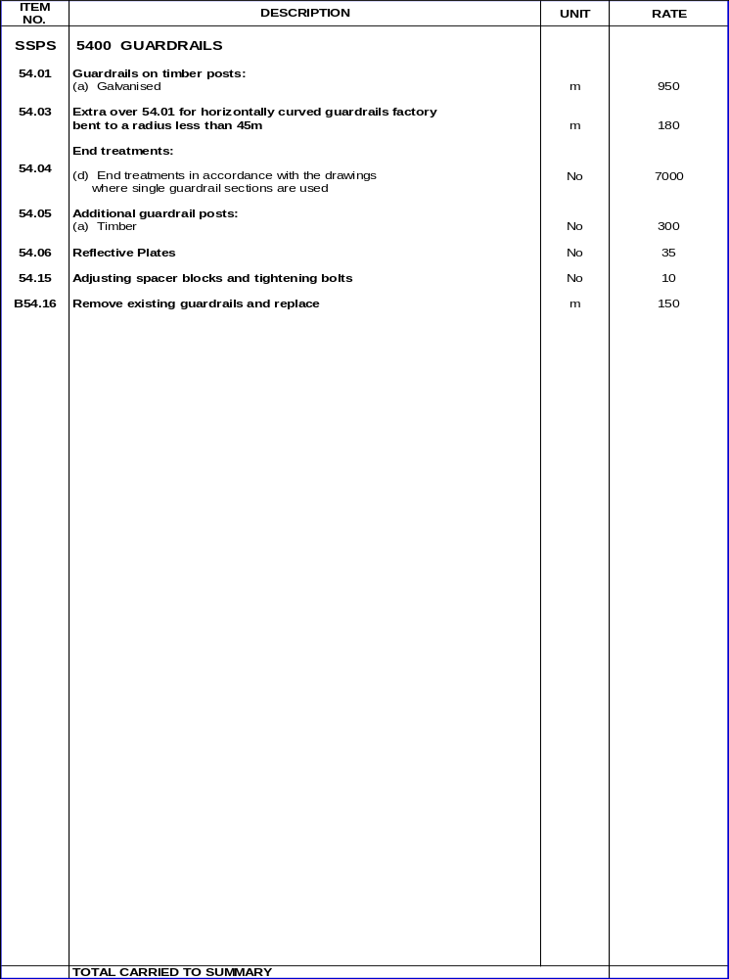

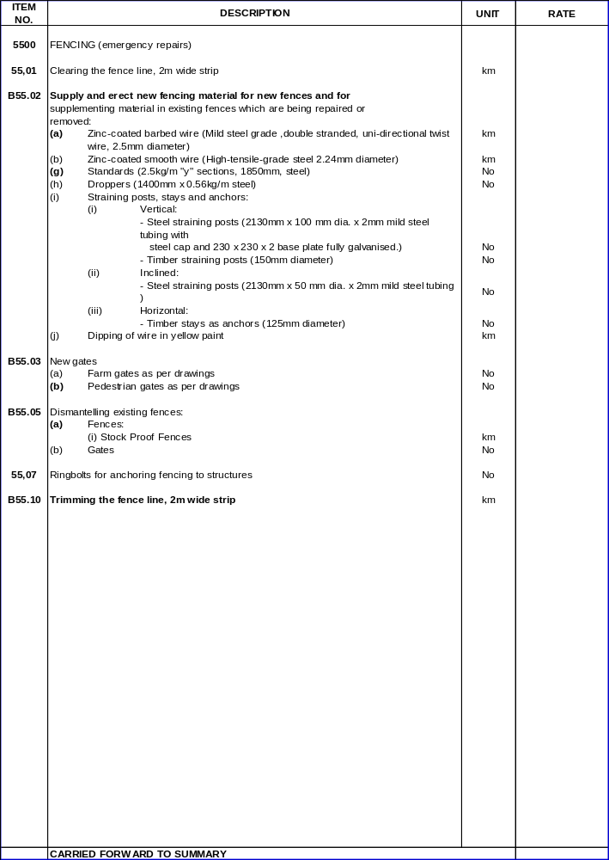
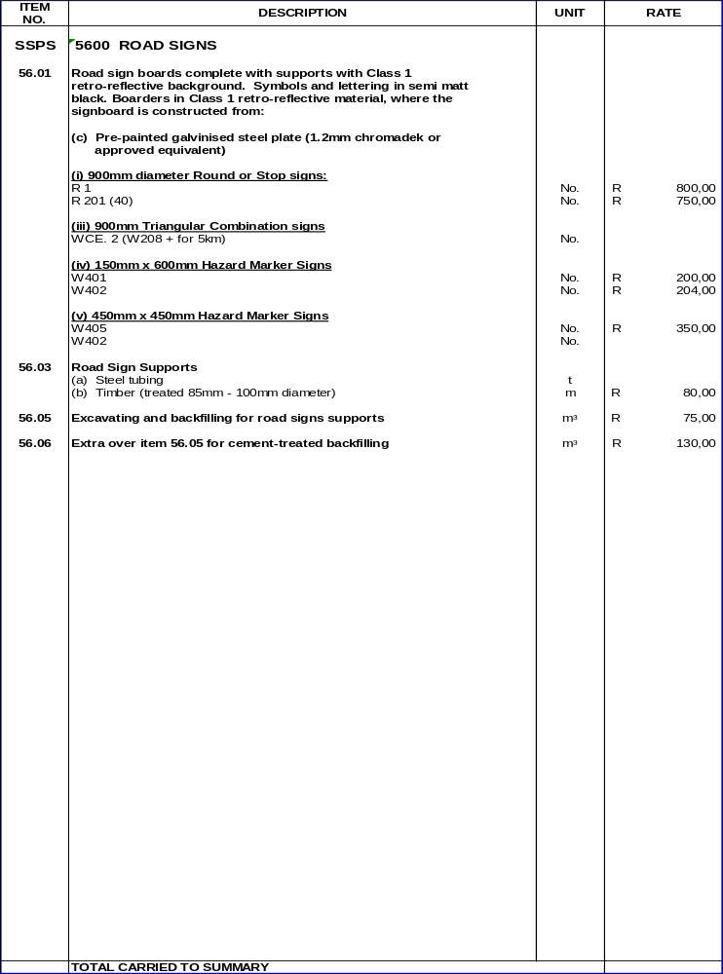


SUMMARY OF THE SCHEDULE OF QUANTITIES.
SECTION | DESCRIPTION
1200 | GENERAL REQUIREMENTS AND PROVISIONS
1300 | CONTRACTOR’S ESTABLISHMENT ON SITE AND GENERAL OBLIGATIONS
1500 | ACCOMMODATION OF TRAFFIC
1700 | CLEARING & GRUBBING
1900 | DAYWORKS (PROVISIONAL)
2100 | DRAINS
2200 | PREFABRICATED CULVERTS
3200 | SELECTIONS, STOCKPILING & BREAKING-DOWN THE MATERIAL FROM BORROW PITS,
 | CUTTING & EXISTING PAVEMENT LAYERS, AND PLACING & COMPACTING THE
 | GRAVEL LAYERS
3300 | MASS EARTHWORKS
3400 | PAVEMENT LAYERS OF GRAVEL MATERIAL
3500 | STABILIZATION
5100 | PITCHING, STONEWORK AND PROTECTION AGAINST EROSION
5200 | GABIONS
5400 | GUARDRAILS
5500 | FENCING
5600 | ROADSIGNS
8100 | TESTING WORKMANSHIP AND MATERIALS
SUB TOTAL
ADD CONTINGENCIES AT 10%
SUB TOTAL
VALUE ADDED TAX (15%)
TENDER SUM CARRIED TO FORM OF TENDER

SIGNATURE OF TENDERER: .....................................................................

ON BEHALF OF: .........................................................................................

DATE: ...........................................................................................................

