REQUEST FOR BIDS

APPOINTMENT OF A SERVICE PROVIDER TO PROVIDE OFFICE ACCOMODATION AND STORAGE OF PRODUCTS TO THE NRCS IN CAPE TOWN FOR A PERIOD OF NINE (09) YEARS, ELEVEN (11) MONTHS-(NRCS 012-2025/2026)

COMPULSORY BRIEFING SESSION TO BE HELD AT THE NRCS CAPE TOWN OFFICE ON 25 MAY 2026 @ 11H00,
14 B RAILWAY ROAD, MONTAGUE GARDENS, CAPE TOWN

CLOSING DATE: 17 JUNE 2026 @ 11:00

CONTENTS | PAGE
Invitation to bid | 1
Terms and conditions of bidding | 3
Pricing schedule | 4
Bidders’ disclosure | 6
Preference points claim form | 8
Certificate of attendance of briefing session | 12
Authority for signatory | 13
General conditions of contract | 15
Supplier declaration form | 24
Terms of reference | 30
Evaluation criteria | 43
Site visit functionality | 46

- PART A

INVITATION TO BID
DESCRIPTION | APPOINTMENT OF A SERVICE PROVIDER TO PROVIDE OFFICE ACCOMODATION AND STORAGE OF PRODUCTS TO THE NRCS IN CAPE TOWN FOR A PERIOD OF NINE (09) YEARS, ELEVEN (11) MONTHS
BID RESPONSE DOCUMENTS MAY BE DEPOSITED IN THE BID BOX SITUATED AT (STREET ADDRESS)
NRCS TENDER BOX, NRCS
SABS CAMPUS, 1 DR LATEGAN ROAD
GROENKLOOF PRETORIA
BIDDING PROCEDURE ENQUIRIES MAY BE DIRECTED TO |  |  |  | TECHNICAL ENQUIRIES MAY BE DIRECTED TO:
CONTACT PERSON |  | Thobela Mqikela |  | CONTACT PERSON |  |  | Edward Matemba/Ivan Willis
TELEPHONE NUMBER |  | 012-482-8831 |  | TELEPHONE NUMBER |  |  | 069 902 4369/082 715 3721
FACSIMILE NUMBER |  | - |  | FACSIMILE NUMBER |  |  | -
E-MAIL ADDRESS |  | thobela.mqikela@nrcs.org.za |  | E-MAIL ADDRESS |  |  | Edward.matemba@nrcs.org.za/ivan.willis@nrcs.org.za
SUPPLIER INFORMATION
NAME OF BIDDER
POSTAL ADDRESS
STREET ADDRESS
TELEPHONE NUMBER |  | CODE |  |  | NUMBER
CELLPHONE NUMBER
FACSIMILE NUMBER |  | CODE |  |  | NUMBER
E-MAIL ADDRESS
VAT REGISTRATION NUMBER
SUPPLIER COMPLIANCE STATUS |  | TAX COMPLIANCE SYSTEM PIN: |  | OR |  | CENTRAL SUPPLIER DATABASE No: |  | MAAA
B-BBEE STATUS LEVEL VERIFICATION CERTIFICATE |  | TICK APPLICABLE BOX]  Yes No |  | B-BBEE STATUS LEVEL SWORN AFFIDAVIT |  |  |  |  | [TICK APPLICABLE BOX]  Yes No
[A B-BBEE STATUS LEVEL VERIFICATION CERTIFICATE/ SWORN AFFIDAVIT (FOR EMES & QSEs) MUST BE SUBMITTED IN ORDER TO QUALIFY FOR PREFERENCE POINTS FOR B-BBEE]
- ARE YOU THE ACCREDITED REPRESENTATIVE IN SOUTH AFRICA FOR THE GOODS /SERVICES /WORKS OFFERED? |  | Yes No  [IF YES ENCLOSE PROOF] |  | - ARE YOU A FOREIGN BASED SUPPLIER FOR THE GOODS /SERVICES /WORKS OFFERED? |  |  |  |  | Yes No  [IF YES, ANSWER THE QUESTIONNAIRE BELOW]
QUESTIONNAIRE TO BIDDING FOREIGN SUPPLIERS
IS THE ENTITY A RESIDENT OF THE REPUBLIC OF SOUTH AFRICA (RSA)? YES NO
DOES THE ENTITY HAVE A BRANCH IN THE RSA? YES NO
DOES THE ENTITY HAVE A PERMANENT ESTABLISHMENT IN THE RSA? YES NO
DOES THE ENTITY HAVE ANY SOURCE OF INCOME IN THE RSA? YES NO
IS THE ENTITY LIABLE IN THE RSA FOR ANY FORM OF TAXATION? YES NO
IF THE ANSWER IS “NO” TO ALL OF THE ABOVE, THEN IT IS NOT A REQUIREMENT TO REGISTER FOR A TAX COMPLIANCE STATUS SYSTEM PIN CODE FROM THE SOUTH AFRICAN REVENUE SERVICE (SARS) AND IF NOT REGISTER AS PER 2.3 BELOW.

PART B
TERMS AND CONDITIONS FOR BIDDING

- BID SUBMISSION:
  - BIDS MUST BE DELIVERED BY THE STIPULATED TIME TO THE CORRECT ADDRESS. LATE BIDS WILL NOT BE ACCEPTED FOR CONSIDERATION.
  - ALL BIDS MUST BE SUBMITTED ON THE OFFICIAL FORMS PROVIDED– (NOT TO BE RE-TYPED) OR IN THE MANNER PRESCRIBED IN THE BID DOCUMENT.
  - THIS BID IS SUBJECT TO THE PREFERENTIAL PROCUREMENT POLICY FRAMEWORK ACT, 2000 AND THE PREFERENTIAL PROCUREMENT REGULATIONS, 2022, THE GENERAL CONDITIONS OF CONTRACT (GCC) AND, IF APPLICABLE, ANY OTHER SPECIAL CONDITIONS OF CONTRACT.
  - THE SUCCESSFUL BIDDER WILL BE REQUIRED TO FILL IN AND SIGN A WRITTEN CONTRACT FORM (SBD7).

- TAX COMPLIANCE REQUIREMENTS
- BIDDERS MUST ENSURE COMPLIANCE WITH THEIR TAX OBLIGATIONS.
- BIDDERS ARE REQUIRED TO SUBMIT THEIR UNIQUE PERSONAL IDENTIFICATION NUMBER (PIN) ISSUED BY SARS TO ENABLE THE ORGAN OF STATE TO VERIFY THE TAXPAYER’S PROFILE AND TAX STATUS.
- APPLICATION FOR TAX COMPLIANCE STATUS (TCS) PIN MAY BE MADE VIA E-FILING THROUGH THE SARS WEBSITE WWW.SARS.GOV.ZA.
- BIDDERS MAY ALSO SUBMIT A PRINTED TCS CERTIFICATE TOGETHER WITH THE BID.
- IN BIDS WHERE CONSORTIA / JOINT VENTURES / SUB-CONTRACTORS ARE INVOLVED, EACH PARTY MUST SUBMIT A SEPARATE TCS CERTIFICATE / PIN / CSD NUMBER.
- WHERE NO TCS PIN IS AVAILABLE BUT THE BIDDER IS REGISTERED ON THE CENTRAL SUPPLIER DATABASE (CSD), A CSD NUMBER MUST BE PROVIDED.
- NO BIDS WILL BE CONSIDERED FROM PERSONS IN THE SERVICE OF THE STATE, COMPANIES WITH DIRECTORS WHO ARE PERSONS IN THE SERVICE OF THE STATE, OR CLOSE CORPORATIONS WITH MEMBERS PERSONS IN THE SERVICE OF THE STATE.”

NB: FAILURE TO PROVIDE / OR COMPLY WITH ANY OF THE ABOVE PARTICULARS MAY RENDER THE BID INVALID.

SIGNATURE OF BIDDER: ……………………………………………

CAPACITY UNDER WHICH THIS BID IS SIGNED: ……………………………………………
(Proof of authority must be submitted e.g. company resolution)

DATE:

PRICING SCHEDULE
SBD 3.3
PRICING SCHEDULE

NAME OF BIDDER: ……………………………………………………………………………BID NO.: NRCS 012-2025/2026

CLOSING TIME 11:00 CLOSING DATE: 17 JUNE 2026

OFFER TO BE VALID FOR 180 DAYS FROM THE CLOSING DATE OF BID.
ITEM DESCRIPTION BID PRICE IN RSA CURRENCY
NO ** (ALL APPLICABLE TAXES INCLUDED)

PRICING SCHEDULE – OFFICE LEASE
Description  (Annual costs) | Year 1 | Year 2 | Year 3 | Year 4 | Year 5 | Year 6 | Year 7 | Year 8 | Year 9 | Year 10 (11 months)
Office rental

Storage rental
Maintenance Costs

Rates & Taxes (indicate if it is included in annual rental)

Parking Bays

Security Services
Gardening services, sanitary bin disposal and pest control

Relocation costs
Installation allowance
Other
TOTAL (Excl. VAT)
(Excl. VAT)
TOTAL (Incl. VAT)
Rental escalation %
Notes:
- All prices must be in South African Rand (ZAR).
- Quantities and unit prices should be clearly stated.
- Any escalation clauses (e.g., annual rental increase %) should be specified separately.
- If applicable, attach a floor plan and breakdown of rentable vs. usable area

Any enquiries regarding bidding procedures may be directed to the –

Thobela Mqikela
Tel: 012 482- 8831
E-mail: thobela.mqikela@nrcs.org.za

Or for technical information –

Contact Person: Edward Matemba/Ivan Willis
Tel: 069 902 4369/082 715 3721
E-mail address: edward.matemba@nrcs.org.za/ivan.willis@nrcs.org.za

3. SBD 4

BIDDER’S DISCLOSURE

- PURPOSE OF THE FORM
Any person (natural or juristic) may make an offer or offers in terms of this invitation to bid. In line with the principles of transparency, accountability, impartiality, and ethics as enshrined in the Constitution of the Republic of South Africa and further expressed in various pieces of legislation, it is required for the bidder to make this declaration in respect of the details required hereunder.

Where a person/s are listed in the Register for Tender Defaulters and / or the List of Restricted Suppliers, that person will automatically be disqualified from the bid process.

- Bidder’s declaration
2.1 Is the bidder, or any of its directors / trustees / shareholders / members / partners or any person having a controlling interest in the enterprise,
employed by the state? YES/NO
2.1.1 If so, furnish particulars of the names, individual identity numbers, and, if applicable, state employee numbers of sole proprietor/ directors / trustees / shareholders / members/ partners or any person having a controlling interest in the enterprise, in table below.
Full Name | Identity Number | Name of State institution

2.2 Do you, or any person connected with the bidder, have a relationship with any person who is employed by the procuring institution? YES/NO

2.2.1 If so, furnish particulars:
……………………………………………………………………………………
……………………………………………………………………………………

2.3 Does the bidder or any of its directors / trustees / shareholders / members / partners or any person having a controlling interest in the enterprise have any interest in any other related enterprise whether or not they are bidding for this contract? YES/NO

    - If so, furnish particulars:
…………………………………………………………………………….
…………………………………………………………………………….

- DECLARATION

I, the undersigned, (name)……………………………………………………………………. in submitting the accompanying bid, do hereby make the following statements that I certify to be true and complete in every respect:

3.1 I have read and I understand the contents of this disclosure;
3.2 I understand that the accompanying bid will be disqualified if this disclosure is found not to be true and complete in every respect;
3.3 The bidder has arrived at the accompanying bid independently from, and without consultation, communication, agreement or arrangement with any competitor. However, communication between partners in a joint venture or consortium will not be construed as collusive bidding.
3.4 In addition, there have been no consultations, communications, agreements or arrangements with any competitor regarding the quality, quantity, specifications, prices, including methods, factors or formulas used to calculate prices, market allocation, the intention or decision to submit or not to submit the bid, bidding with the intention not to win the bid and conditions or delivery particulars of the products or services to which this bid invitation relates.
3.4 The terms of the accompanying bid have not been, and will not be, disclosed by the bidder, directly or indirectly, to any competitor, prior to the date and time of the official bid opening or of the awarding of the contract.

3.5 There have been no consultations, communications, agreements or arrangements made by the bidder with any official of the procuring institution in relation to this procurement process prior to and during the bidding process except to provide clarification on the bid submitted where so required by the institution; and the bidder was not involved in the drafting of the specifications or terms of reference for this bid.

  - I am aware that, in addition and without prejudice to any other remedy provided to combat any restrictive practices related to bids and contracts, bids that are suspicious will be reported to the Competition Commission for investigation and possible imposition of administrative penalties in terms of section 59 of the Competition Act No 89 of 1998 and or may be reported to the National Prosecuting Authority (NPA) for criminal investigation and or may be restricted from conducting business with the public sector for a period not exceeding ten (10) years in terms of the Prevention and Combating of Corrupt Activities Act No 12 of 2004 or any other applicable legislation.

I CERTIFY THAT THE INFORMATION FURNISHED IN PARAGRAPHS 1, 2 and 3 ABOVE IS CORRECT.
I ACCEPT THAT THE STATE MAY REJECT THE BID OR ACT AGAINST ME IN TERMS OF PARAGRAPH 6 OF PFMA SCM INSTRUCTION 03 OF 2021/22 ON PREVENTING AND COMBATING ABUSE IN THE SUPPLY CHAIN MANAGEMENT SYSTEM SHOULD THIS DECLARATION PROVE TO BE FALSE.

……………………………… ..……………………………………………
Signature Date

……………………………… ………………………………………………
Position Name of bidde

4. SB 61

PREFERENCE POINTS CLAIM FORM IN TERMS OF THE PREFERENTIAL PROCUREMENT REGULATIONS 2022

This preference form must form part of all tenders invited. It contains general information and serves as a claim form for preference points for specific goals.

NB: BEFORE COMPLETING THIS FORM, TENDERERS MUST STUDY THE GENERAL CONDITIONS, DEFINITIONS AND DIRECTIVES APPLICABLE IN RESPECT OF THE TENDER AND PREFERENTIAL PROCUREMENT REGULATIONS, 2022

- GENERAL CONDITIONS
  - The following preference point systems are applicable to invitations to tender:
- the 80/20 system for requirements with a Rand value of up to R50 000 000 (all applicable taxes included); and
- the 90/10 system for requirements with a Rand value above R50 000 000 (all applicable taxes included).

  - To be completed by the organ of state
- The applicable preference point system for this tender is the 80/20 preference point system.

  - Points for this tender (even in the case of a tender for income-generating contracts) shall be awarded for:
- Price; and
- Specific Goals.

  - To be completed by the organ of state:
The maximum points for this tender are allocated as follows:
 | POINTS
PRICE | 80
SPECIFIC GOALS:
B-BBEE Level 1 | 20
B-BBEE Level 2 | 18
B-BBEE Level 3 | 14
B-BBEE Level 4 | 12
B-BBEE Level 5 | 8
B-BBEE Level 6 | 6
B-BBEE Level 7 | 4
B-BBEE Level 8 | 2
Non-compliant contributor | 0
Total points for Price and SPECIFIC GOALS | 100

  - Failure on the part of a tenderer to submit proof or documentation required in terms of this tender to claim points for specific goals with the tender, will be interpreted to mean that preference points for specific goals are not claimed.

  - The organ of state reserves the right to require of a tenderer, either before a tender is adjudicated or at any time subsequently, to substantiate any claim in regard to preferences, in any manner required by the organ of state.

- DEFINITIONS
- “tender” means a written offer in the form determined by an organ of state in response to an invitation to provide goods or services through price quotations, competitive tendering process or any other method envisaged in legislation;
- “price” means an amount of money tendered for goods or services, and includes all applicable taxes less all unconditional discounts;
- “rand value” means the total estimated value of a contract in Rand, calculated at the time of bid invitation, and includes all applicable taxes;
- “tender for income-generating contracts” means a written offer in the form determined by an organ of state in response to an invitation for the origination of income-generating contracts through any method envisaged in legislation that will result in a legal agreement between the organ of state and a third party that produces revenue for the organ of state, and includes, but is not limited to, leasing and disposal of assets and concession contracts, excluding direct sales and disposal of assets through public auctions; and
- “the Act” means the Preferential Procurement Policy Framework Act, 2000 (Act No. 5 of 2000).

- FORMULAE FOR PROCUREMENT OF GOODS AND SERVICES

  - POINTS AWARDED FOR PRICE

3.1.1 THE 80/20 OR 90/10 PREFERENCE POINT SYSTEMS
A maximum of 80 or 90 points is allocated for price on the following basis:

80/20 or 90/10

$Ps=80\left(1-\frac{Pt-P\min{}}{P\min{}}\right)$ or $Ps=90\left(1-\frac{Pt-P\min{}}{P\min{}}\right)$
Where
Ps = Points scored for price of tender under consideration
Pt = Price of tender under consideration
Pmin = Price of lowest acceptable tender
RRE2
  - FORMULAE FOR DISPOSAL OR LEASING OF STATE ASSETS AND INCOME GENERATING PROCUREMENT

    - POINTS AWARDED FOR PRICE
A maximum of 80 or 90 points is allocated for price on the following basis:

80/20 or 90/10

$Ps=80\left(1+\frac{Pt-P\max{}}{P\max{}}\right)$ or $Ps=90\left(1+\frac{Pt-P\max{}}{Pmax}\right)$

Where
Ps = Points scored for price of tender under consideration
Pt = Price of tender under consideration
Pmax = Price of highest acceptable tender

- POINTS AWARDED FOR SPECIFIC GOALS
  - In terms of Regulation 4(2); 5(2); 6(2) and 7(2) of the Preferential Procurement Regulations, preference points must be awarded for specific goals stated in the tender. For the purposes of this tender the tenderer will be allocated points based on the goals stated in table 1 below as may be supported by proof/ documentation stated in the conditions of this tender:
  - In cases where organs of state intend to use Regulation 3(2) of the Regulations, which states that, if it is unclear whether the 80/20 or 90/10 preference point system applies, an organ of state must, in the tender documents, stipulate in the case of—
- an invitation for tender for income-generating contracts, that either the 80/20 or 90/10 preference point system will apply and that the highest acceptable tender will be used to determine the applicable preference point system; or

- any other invitation for tender, that either the 80/20 or 90/10 preference point system will apply and that the lowest acceptable tender will be used to determine the applicable preference point system,
then the organ of state must indicate the points allocated for specific goals for both the 90/10 and 80/20 preference point system.

Table 1: Specific goals for the tender and points claimed are indicated per the table below.
(Note to organs of state: Where either the 90/10 or 80/20 preference point system is applicable, corresponding points must also be indicated as such.
Note to tenderers: The tenderer must indicate how they claim points for each preference point system.)
The specific goals allocated points in terms of this tender | Number of points  allocated  (80/20 system)  (To be completed by the organ of state) | Number of points claimed (80/20 system)  (To be completed by the tenderer)
B-BBEE Level 1 | 20
B-BBEE Level 2 | 18
B-BBEE Level 3 | 14
B-BBEE Level 4 | 12
B-BBEE Level 5 | 8
B-BBEE Level 6 | 6
B-BBEE Level 7 | 4
B-BBEE Level 8 | 2
Non-compliant contributor | 0

DECLARATION WITH REGARD TO COMPANY/FIRM

  - Name of company/firm…………………………………………………………………….
  - Company registration number: …………………………………………………………...
  - TYPE OF COMPANY/ FIRM
Partnership/Joint Venture / Consortium
One-person business/sole propriety
Close corporation
Public Company
Personal Liability Company
(Pty) Limited
Non-Profit Company
State Owned Company
[Tick applicable box]
  - I, the undersigned, who is duly authorised to do so on behalf of the company/firm, certify that the points claimed, based on the specific goals as advised in the tender, qualifies the company/ firm for the preference(s) shown and I acknowledge that:
- The information furnished is true and correct;
- The preference points claimed are in accordance with the General Conditions as indicated in paragraph 1 of this form;
- In the event of a contract being awarded as a result of points claimed as shown in paragraphs 1.4 and 4.2, the contractor may be required to furnish documentary proof to the satisfaction of the organ of state that the claims are correct;
- If the specific goals have been claimed or obtained on a fraudulent basis or any of the conditions of contract have not been fulfilled, the organ of state may, in addition to any other remedy it may have –
  - disqualify the person from the tendering process;
  - recover costs, losses or damages it has incurred or suffered as a result of that person’s conduct;
  - cancel the contract and claim any damages which it has suffered as a result of having to make less favourable arrangements due to such cancellation;
  - recommend that the tenderer or contractor, its shareholders and directors, or only the shareholders and directors who acted on a fraudulent basis, be restricted from obtaining business from any organ of state for a period not exceeding 10 years, after the audi alteram partem (hear the other side) rule has been applied; and
  - forward the matter for criminal prosecution, if deemed necessary.

……………………………………….
SIGNATURE(S) OF TENDERER(S)

SURNAME AND NAME: ……………………………………………………….
DATE: ………………………………………………………
ADDRESS: ………………………………………………………
………………………………………………………
………………………………………………………
………………………………………………………

- CERTIFICATE OF ATTENDANCE OF BRIEFING SESSION/SITE MEETING

NRCS 012-2025/2026

This is to certify that I, ……………………………………………………………………………

Representative of (Bidder)

of (address)

Telephone number

Fax number

Email

Attended the briefing session / site meeting (date) conducted by

(Employer’s representative)

SIGNATURE OF PERSON AUTHORISED TO SIGN THE BID/ TENDER: ……………………………………………………….

DATE: ………………………………………………………..

6. AUTHORITY FOR SIGNATORY

Signatories for close corporations and companies shall confirm their authority by attaching to this form a duly signed and dated copy of the relevant resolution of their members or their board of directors, as the case may be.

An example for a company is shown below:

“ By resolution of the board of directors passed on _____________________________ 20_______________

Mr _____________________________________________________ has been duly authorized to sign all

documents in connection with the Tender for Contract ______________________________________

No___________________________ and any Contract, which may arise there from on behalf of

______________________________________________________________________________

SIGNED ON BEHALF OF THE COMPANY:___________________________________________________

IN HIS CAPACITY AS:___________________________________________________________________

DATE:_________________________________________________________________________

SIGNATURE OF SIGNATORY: _____________________________________________________________

AS WITNESSES: 1______________________________________

2______________________________________

7 REQUEST FOR BID

INVITATION FOR PROSPECTIVE BIDDERS

National Regulator for Compulsory Specifications (NRCS) hereby invites prospective bidders with proven record to tender for the bids as follows:
BID
RFB No. | Service Description | Evaluation Criteria | Collection Dates for documents | Compulsory briefing session | Closing Date
NRCS 012-2025/2026 | APPOINTMENT OF A SERVICE PROVIDER TO PROVIDE OFFICE ACCOMODATION AND STORAGE OF PRODUCTS TO THE NRCS IN CAPE TOWN FOR A PERIOD OF NINE (09) YEARS, ELEVEN (11) MONTHS | Minimum requirement,  Functionality & 80/20 points scoring system | 15 MAY 2026  To 12 JUNE 2026  (www.nrcs.org.za) | N/A | 17 JUNE 2026 @ 11h00

NOTE: BID DOCUMENTS COULD BE DOWNLOADED ON THE NRCS WEBSITE (WWW.NRCS.ORG.ZA) OR/AND THE NATIONAL TREASURY E-PORTAL WEBSITE. SHOULD A BIDDER OPT TO COLLECT THE DOCUMENTS FROM THE NRCS AND AMOUNT OF R 250.00 SHOULD BE PAID INTO THE FOLLOWING ACCOUNT AND PROOF OF PAYMENT (RECEIPT) BE PRODUCED:

Account Name: National Regulator for Compulsory Specifications
Bank: ABSA

Branch Name: Brooklyn

Branch Code: 335345

Account No: 4072161682

Account Type: Current

Sealed documents individually marked the above reference, and description must be placed in the Tender box situated at ground floor, SABS Campus by the closing date and time. All Suppliers are encouraged to make their submission before the closing date and time. Bids will be publicly opened at SABS Campus 1 Dr Lategan Road, Groenkloof, Pretoria. No tenders will be accepted after the closing time. No tender per facsimile, posted or e-mailed will be accepted.

All Suppliers are encouraged to make their submission before the closing date and time. Bids will be publicly opened at the addresses mentioned above. No tenders will be accepted after closing time. No tender per facsimile, posted or e-mailed will be accepted.

Administrative enquiries can be directed to Ms. Thobela Mqikela (Thobela.mqikela@nrcs.org.za)

Technical Enquiries: Mr. Edward Matemba/Ivan Willis (Edward.matemba@nrcs.org.za/ivan.willis@nrcs.org.za)

NRCS is not obliged to appoint the cheapest tenderer and reserves the right not to accept any submission and to re-advertise if it so wishes. Service providers will be adjudicated according to the Supply Chain Management Policy using the point system mentioned above, based on the Preferential Procurement Policy Framework Act, Act 5 of 2005, preferential procurement regulations 2022, Public Finance Management Act, Act 1 of 1999, as well as the Broad Based Black Economic Employment Act, Act 53 of 2003.

8 GENERAL CONDITIONS OF CONTRACT

THE NATIONAL TREASURY
Republic of South Africa

GOVERNMENT PROCUREMENT
GENERAL CONDITIONS OF CONTRACT
July 2010

NOTES
The purpose of this document is to:

(i) Draw special attention to certain general conditions applicable to government bids, contracts and orders; and
(ii) To ensure that clients be familiar with regard to the rights and obligations of all parties involved in doing business with government.

In this document words in the singular also mean in the plural and vice versa and words in the masculine also mean in the feminine and neuter.

• The General Conditions of Contract will form part of all bid documents and may not be amended.
• Special Conditions of Contract (SCC) relevant to a specific bid, should be compiled separately for every bid (if (applicable) and will supplement the General Conditions of Contract. Whenever there is a conflict, the provisions in the SCC shall prevail.

TABLE OF CLAUSES

1. Definitions
2. Application
3. General
4. Standards
5. Use of contract documents and information; inspection
6. Patent rights
7. Performance security
8. Inspections, tests and analysis
9. Packing
10. Delivery and documents
11. Insurance
12. Transportation
13. Incidental services
14. Spare parts
15. Warranty
16. Payment
17. Prices
18. Contract amendments
19. Assignment
20. Subcontracts
21. Delays in the supplier’s performance
22. Penalties
23. Termination for default
24. Dumping and countervailing duties
25. Force Majeure
26. Termination for insolvency
27. Settlement of disputes
28. Limitation of liability
29. Governing language
30. Applicable law
31. Notices
32. Taxes and duties
33. National Industrial Participation Programme (NIPP)
34. Prohibition of restrictive practices

General Conditions of Contract

1. Definitions
1. The following terms shall be interpreted as indicated:

1.1 “Closing time” means the date and hour specified in the bidding documents for the receipt of bids.

  - “Contract” means the written agreement entered into between the purchaser and the supplier, as recorded in the contract form signed by the parties, including all attachments and appendices thereto and all documents incorporated by reference therein.

  - “Contract price” means the price payable to the supplier under the contract for the full and proper performance of his contractual obligations.

  - “Corrupt practice” means the offering, giving, receiving, or soliciting of anything of value to influence the action of a public official in the procurement process or in contract execution.

  - "Countervailing duties" are imposed in cases where an enterprise abroad is subsidized by its government and encouraged to market its products internationally.

  - “Country of origin” means the place where the goods were mined, grown or produced or from which the services are supplied. Goods are produced when, through manufacturing, processing or substantial and major assembly of components, a commercially recognized new product results that is substantially different in basic characteristics or in purpose or utility from its components.

  - “Day” means calendar day.

  - “Delivery” means delivery in compliance of the conditions of the contract or order.

  - “Delivery ex stock” means immediate delivery directly from stock actually on hand.

  - “Delivery into consignees store or to his site” means delivered and unloaded in the specified store or depot or on the specified site in compliance with the conditions of the contract or order, the supplier bearing all risks and charges involved until the supplies are so delivered and a valid receipt is obtained.

  - "Dumping" occurs when a private enterprise abroad market its goods on own initiative in the RSA at lower prices than that of the country of origin and which have the potential to harm the local industries in the RSA.
  - ” Force majeure” means an event beyond the control of the supplier and not involving the supplier’s fault or negligence and not foreseeable. Such events may include, but is not restricted to, acts of the purchaser in its sovereign capacity, wars or revolutions, fires, floods, epidemics, quarantine restrictions and freight embargoes.

  - “Fraudulent practice” means a misrepresentation of facts in order to influence a procurement process or the execution of a contract to the detriment of any bidder and includes collusive practice among bidders (prior to or after bid submission) designed to establish bid prices at artificial non-competitive levels and to deprive the bidder of the benefits of free and open competition.

  - “GCC” means the General Conditions of Contract.

  - “Goods” means all of the equipment, machinery, and/or other materials that the supplier is required to supply to the purchaser under the contract.

  - “Imported content” means that portion of the bidding price represented by the cost of components, parts or materials which have been or are still to be imported (whether by the supplier or his subcontractors) and which costs are inclusive of the costs abroad, plus freight and other direct importation costs such as landing costs, dock dues, import duty, sales duty or other similar tax or duty at the South African place of entry as well as transportation and handling charges to the factory in the Republic where the supplies covered by the bid will be manufactured.

  - “Local content” means that portion of the bidding price which is not included in the imported content provided that local manufacture does take place.

  - “Manufacture” means the production of products in a factory using labour, materials, components and machinery and includes other related value-adding activities.

  - “Order” means an official written order issued for the supply of goods or works or the rendering of a service.

  - “Project site,” where applicable, means the place indicated in bidding documents.

  - “Purchaser” means the organization purchasing the goods.

  - “Republic” means the Republic of South Africa.

  - “SCC” means the Special Conditions of Contract.

  - “Services” means those functional services ancillary to the supply of the goods, such as transportation and any other incidental services, such as installation, commissioning, provision of technical assistance, training, catering, gardening, security, maintenance and other such obligations of the supplier covered under the contract.

  - “Written” or “in writing” means handwritten in ink or any form of electronic or mechanical writing.

2. Application
2.1 These general conditions are applicable to all bids, contracts and orders including bids for functional and professional services, sales, hiring, letting and the granting or acquiring of rights, but excluding immovable property, unless otherwise indicated in the bidding documents.

2.2 Where applicable, special conditions of contract are also laid down to cover specific supplies, services or works.

2.3 Where such special conditions of contract are in conflict with these general conditions, the special conditions shall apply.

3. General
3.1 Unless otherwise indicated in the bidding documents, the purchaser shall not be liable for any expense incurred in the preparation and submission of a bid. Where applicable a non-refundable fee for documents may be charged.

3.2 With certain exceptions, invitations to bid are only published in the Government Tender Bulletin. The Government Tender Bulletin may be obtained directly from the Government Printer, Private Bag X85, Pretoria 0001, or accessed electronically from www.treasury.gov.za

4. Standards
4.1 The goods supplied shall conform to the standards mentioned in the bidding documents and specifications.

5. Use of contract documents and information; inspection.
5.1 The supplier shall not, without the purchaser’s prior written consent, disclose the contract, or any provision thereof, or any specification, plan, drawing, pattern, sample, or information furnished by or on behalf of the purchaser in connection therewith, to any person other than a person employed by the supplier in the performance of the contract. Disclosure to any such employed person shall be made in confidence and shall extend only so far as may be necessary for purposes of such performance.

5.2 The supplier shall not, without the purchaser’s prior written consent, make use of any document or information mentioned in GCC clause 5.1 except for purposes of performing the contract.

5.3 Any document, other than the contract itself mentioned in GCC clause 5.1 shall remain the property of the purchaser and shall be returned (all copies) to the purchaser on completion of the supplier’s performance under the contract if so required by the purchaser.

5.4 The supplier shall permit the purchaser to inspect the supplier’s records relating to the performance of the supplier and to have them audited by auditors appointed by the purchaser, if so required by the purchaser.

6. Patent rights
6.1 The supplier shall indemnify the purchaser against all third-party claims of infringement of patent, trademark, or industrial design rights arising from use of the goods or any part thereof by the purchaser.

7. Performance security
    - Within thirty (30) days of receipt of the notification of contract award, the successful bidder shall furnish to the purchaser the performance security of the amount specified in SCC.

    - The proceeds of the performance security shall be payable to the purchaser as compensation for any loss resulting from the supplier’s failure to complete his obligations under the contract.

7.3 The performance security shall be denominated in the currency of the contract, or in a freely convertible currency acceptable to the purchaser and shall be in one of the following forms:
(a) a bank guarantee or an irrevocable letter of credit issued by a reputable bank located in the purchaser’s country or abroad, acceptable to the purchaser, in the form provided in the bidding documents or another form acceptable to the purchaser; or
(b) a cashier’s or certified cheque

7.4 The performance security will be discharged by the purchaser and returned to the supplier not later than thirty (30) days following the date of completion of the supplier’s performance obligations under the contract, including any warranty obligations, unless otherwise specified in SCC.

8. Inspections, tests and analyses
8.1 All pre-bidding testing will be for the account of the bidder.

8.2 If it is a bid condition that supplies to be produced or services to be rendered should at any stage during production or execution or on completion be subject to inspection, the premises of the bidder or contractor shall be open, at all reasonable hours, for inspection by a representative of the Department or an organization acting on behalf of the Department.

8.3 If there are no inspection requirements indicated in the bidding documents and no mention is made in the contract, but during the contract period it is decided that inspections shall be carried out, the
purchaser shall itself make the necessary arrangements, including payment arrangements with the testing authority concerned.

8.4 If the inspections, tests and analyses referred to in clauses 8.2 and 8.3 show the supplies to be in accordance with the contract requirements, the cost of the inspections, tests and analyses shall be defrayed by the purchaser.

8.5 Where the supplies or services referred to in clauses 8.2 and 8.3 do not comply with the contract requirements, irrespective of whether such supplies or services are accepted or not, the cost in connection with these inspections, tests or analyses shall be defrayed by the supplier.

8.6 Supplies and services which are referred to in clauses 8.2 and 8.3 and which do not comply with the contract requirements may be rejected. 8.7 Any contract supplies may on or after delivery be inspected, tested or analyzed and may be rejected if found not to comply with the requirements of the contract. Such rejected supplies shall be held at the cost and risk of the supplier who shall, when called upon, remove them immediately at his own cost and forthwith substitute them with supplies which do comply with the requirements of the contract. Failing such removal the rejected supplies shall be returned at the suppliers cost and risk. Should the supplier fail to provide the substitute supplies forthwith, the purchaser may, without giving the supplier further opportunity to substitute the rejected supplies, purchase such supplies as may be necessary at the expense of the supplier.

8.8 The provisions of clauses 8.4 to 8.7 shall not prejudice the right of the purchaser to cancel the contract on account of a breach of the conditions thereof, or to act in terms of Clause 23 of GCC.

9. Packing
9.1 The supplier shall provide such packing of the goods as is required to prevent their damage or deterioration during transit to their final destination, as indicated in the contract. The packing shall be sufficient to withstand, without limitation, rough handling during transit and exposure to extreme temperatures, salt and precipitation during transit, and open storage. Packing, case size and weights shall take into consideration, where appropriate, the remoteness of the goods’ final destination and the absence of heavy handling facilities at all points in transit.
9.2 The packing, marking, and documentation within and outside the packages shall comply strictly with such special requirements as shall be expressly provided for in the contract, including additional requirements, if any, specified in SCC, and in any subsequent instructions ordered by the purchaser.

10. Delivery and documents
10.1 Delivery of the goods shall be made by the supplier in accordance with the terms specified in the contract. The details of shipping and/or other documents to be furnished by the supplier are specified in SCC.

10.2 Documents to be submitted by the supplier are specified in SCC.

11. Insurance

11.1 The goods supplied under the contract shall be fully insured in a freely convertible currency against loss or damage incidental to manufacturer acquisition, transportation, storage and delivery in the manner specified in the SCC.

12. Transportation
12.1 Should a price other than an all-inclusive delivered price be required, this shall be specified in the SCC.

13. Incidental services
13.1 The supplier may be required to provide any or all of the following services, including additional services, if any, specified in SCC:
(a) performance or supervision of on-site assembly and/or commissioning of the supplied goods.
(b) furnishing of tools required for assembly and/or maintenance of the supplied goods.
(c) furnishing of a detailed operations and maintenance manual for each appropriate unit of the supplied goods.
(d) performance or supervision or maintenance and/or repair of the supplied goods, for a period agreed by the parties, provided that this service shall not relieve the supplier of any warranty obligations under this contract; and
(e) training of the purchaser’s personnel, at the supplier’s plant and/or on-site, in assembly, start-up, operation, maintenance, and/or repair of the supplied goods.
13.2 Prices charged by the supplier for incidental services, if not included in the contract price for the goods, shall be agreed upon in advance by the parties and shall not exceed the prevailing rates charged to other parties by the supplier for similar services.

14. Spare parts
14.1 As specified in SCC, the supplier may be required to provide any or all the following materials, notifications, and information pertaining to spare parts manufactured or distributed by the supplier:
(a) such spare parts as the purchaser may elect to purchase from the supplier, provided that this election shall not relieve the supplier of any warranty obligations under the contract; and
(b) in the event of termination of production of the spare parts:
(i) Advance notification to the purchaser of the pending termination, in sufficient time to permit the purchaser to procure needed requirements; and
(ii) following such termination, furnishing at no cost to the purchaser, the blueprints, drawings, and specifications of the spare parts, if requested.
15. Warranty
15.1 The supplier warrants that the goods supplied under the contract are new, unused, of the most recent or current models, and that they incorporate all recent improvements in design and materials unless provided otherwise in the contract. The supplier further warrants that all goods supplied under this contract shall have no defect, arising from design, materials, or workmanship (except when the design and/or material is required by the purchaser’s specifications) or from any act or omission of the supplier, that may develop under normal use of the supplied goods in the conditions prevailing in the country of final destination.
15.2 This warranty shall remain valid for twelve (12) months after the goods, or any portion thereof as the case may be, have been delivered to and accepted at the final destination indicated in the contract, or for eighteen (18) months after the date of shipment from the port or place of loading in the source country, whichever period concludes earlier, unless specified otherwise in SCC.
15.3 The purchaser shall promptly notify the supplier in writing of any claims arising under this warranty.
15.4 Upon receipt of such notice, the supplier shall, within the period specified in SCC and with all reasonable speed, repair or replace the defective goods or parts thereof, without costs to the purchaser.
15.5 If the supplier, having been notified, fails to remedy the defect(s) within the period specified in SCC, the purchaser may proceed to take such remedial action as may be necessary, at the supplier’s risk and expense and without prejudice to any other rights which the purchaser may have against the supplier under the contract.

16. Payment
16.1 The method and conditions of payment to be made to the supplier under this contract shall be specified in SCC.
16.2 The supplier shall furnish the purchaser with an invoice accompanied by a copy of the delivery note and upon fulfillment of other obligations stipulated in the contract.
16.3 Payments shall be made promptly by the purchaser, but in no case later than thirty (30) days after submission of an invoice or claim by the supplier.
16.4 Payment will be made in Rand unless otherwise stipulated in SCC.

17. Prices
17.1 Prices charged by the supplier for goods delivered and services performed under the contract shall not vary from the prices quoted by the supplier in his bid, with the exception of any price adjustments authorized in SCC or in the purchaser’s request for bid validity extension, as the case may be.

18. Contract amendments

18.1 No variation in or modification of the terms of the contract shall be made except by written amendment signed by the parties concerned.

19. Assignment
19.1 The supplier shall not assign, in whole or in part, its obligations to perform under the contract, except with the purchaser’s prior written consent.

20. Subcontracts
20.1 The supplier shall notify the purchaser in writing of all subcontracts awarded under this contracts if not already specified in the bid. Such notification, in the original bid or later, shall not relieve the supplier from any liability or obligation under the contract.

21. Delays in the supplier’s performance
21. Delivery of the goods and performance of services shall be made by the supplier in accordance with the time schedule prescribed by the purchaser in the contract.
21.2 If at any time during performance of the contract, the supplier or its subcontractor(s) should encounter conditions impeding timely delivery of the goods and performance of services, the supplier shall promptly notify the purchaser in writing of the fact of the delay, its likely duration and its cause(s). As soon as practicable after receipt of the supplier’s notice, the purchaser shall evaluate the situation and may at his discretion extend the supplier’s time for performance, with or without the imposition of penalties, in which case the extension shall be ratified by the parties by amendment of contract.
21.3 No provision in a contract shall be deemed to prohibit the obtaining of supplies or services from a national department, provincial department, or a local authority.
21.4 The right is reserved to procure outside of the contract small quantities or to have minor essential services executed if an emergency arises, the supplier’s point of supply is not situated at or near the place where the supplies are required, or the supplier’s services are not readily available.
21.5 Except as provided under GCC Clause 25, a delay by the supplier in the performance of its delivery obligations shall render the supplier liable to the imposition of penalties, pursuant to GCC Clause 22, unless an extension of time is agreed upon pursuant to GCC Clause 21.2 without the application of penalties.
21.6 Upon any delay beyond the delivery period in the case of a supplies contract, the purchaser shall, without canceling the contract, be entitled to purchase supplies of a similar quality and up to the same quantity in substitution of the goods not supplied in conformity with the contract and to return any goods delivered later at the supplier’s expense and risk, or to cancel the contract and buy such goods as may be required to complete the contract and without prejudice to his other rights, be entitled to claim damages from the supplier.

22. Penalties
22.1 Subject to GCC Clause 25, if the supplier fails to deliver any or all of the goods or to perform the services within the period(s) specified in the contract, the purchaser shall, without prejudice to its other remedies under the contract, deduct from the contract price, as a penalty, a sum calculated on the delivered price of the delayed goods or unperformed services using the current prime interest rate calculated for each day of the delay until actual delivery or performance. The purchaser may also consider termination of the contract pursuant to GCC Clause 23.

23. Termination for default
23.1 The purchaser, without prejudice to any other remedy for breach of contract, by written notice of default sent to the supplier, may terminate this contract in whole or in part:
(a) if the supplier fails to deliver any or all of the goods within the period(s) specified in the contract, or within any extension thereof granted by the purchaser pursuant to GCC Clause 21.2;
(b) if the Supplier fails to perform any other obligation(s) under the contract; or
(c) if the supplier, in the judgment of the purchaser, has engaged in corrupt or fraudulent practices in competing for or in executing the contract.
23.2 In the event the purchaser terminates the contract in whole or in part, the purchaser may procure, upon such terms and in such manner as it deems appropriate, goods, works or services similar to those undelivered, and the supplier shall be liable to the purchaser for any excess costs for such similar goods, works or services. However, the supplier shall continue performance of the contract to the extent not terminated.
23.3 Where the purchaser terminates the contract in whole or in part, the purchaser may decide to impose a restriction penalty on the supplier by prohibiting such supplier from doing business with the public sector for a period not exceeding 10 years.
23.4 If a purchaser intends imposing a restriction on a supplier or any person associated with the supplier, the supplier will be allowed a time period of not more than fourteen (14) days to provide reasons why the envisaged restriction should not be imposed. Should the supplier fail to respond within the stipulated fourteen (14) days the purchaser may regard the intended penalty as not objected against and may impose it on the supplier.

23.5 Any restriction imposed on any person by the Accounting Officer / Authority will, at the discretion of the Accounting Officer / Authority, also be applicable to any other enterprise or any partner, manager, director or other person who wholly or partly exercises or exercised or may exercise control over the enterprise of the first-mentioned person, and with which enterprise or person the first-mentioned person, is or was in the opinion of the Accounting Officer / Authority actively associated.
23.6 If a restriction is imposed, the purchaser must, within five (5) working days of such imposition, furnish the National Treasury, with the following information:
(i) the name and address of the supplier and / or person restricted by the purchaser.
(ii) the date of commencement of the restriction
(iii) the period of restriction; and
(iv) the reasons for the restriction.
These details will be loaded in the National Treasury’s central database of suppliers or persons prohibited from doing business with the public sector.
23.7 If a court of law convicts a person of an offence as contemplated in sections 12 or 13 of the Prevention and Combating of Corrupt Activities Act, No. 12 of 2004, the court may also rule that such person’s name be endorsed on the Register for Tender Defaulters. When a person’s name has been endorsed on the Register, the person will be prohibited from doing business with the public sector for a period not less than five years and not more than 10 years. The National Treasury is empowered to determine the period of restriction, and each case will be dealt with on its own merits. According to section 32 of the Act the Register must be open to the public. The Register can be perused on the National Treasury website.

24. Anti-dumping and countervailing duties and rights
24.1 When, after the date of bid, provisional payments are required, or antidumping or countervailing duties are imposed, or the amount of a provisional payment or anti-dumping or countervailing right is increased in respect of any dumped or subsidized import, the State is not liable for any amount so required or imposed, or for the amount of any such increase. When, after the said date, such a provisional payment is no longer required or any such anti-dumping or countervailing right is abolished, or where the amount of such provisional payment or any such right is reduced, any such favourable difference shall on demand be paid forthwith by the contractor to the State or the State may deduct such amounts from moneys (if any) which may otherwise be due to the contractor in regard to supplies or services which he delivered or rendered, or is to deliver or render in terms of the contract or any other contract or any other amount which may be due to him.

25. Force Majeure
25.1 Notwithstanding the provisions of GCC Clauses 22 and 23, the supplier shall not be liable for forfeiture of its performance security, damages, or termination for default if and to the extent that his delay in performance or other failure to perform his obligations under the contract is the result of an event of force majeure.
25.2 If a force majeure situation arises, the supplier shall promptly notify the purchaser in writing of such condition and the cause thereof. Unless otherwise directed by the purchaser in writing, the supplier shall continue to perform its obligations under the contract as far as is reasonably practical, and shall seek all reasonable alternative means for performance not prevented by the force majeure event.

26. Termination for insolvency
26.1 The purchaser may at any time terminate the contract by giving written notice to the supplier if the supplier becomes bankrupt or otherwise insolvent. In this event, termination will be without compensation to the supplier, provided that such termination will not prejudice or affect any right of action or remedy which has accrued or will accrue thereafter to the purchaser.

27. Settlement of Disputes
27.1 If any dispute or difference of any kind whatsoever arises between the purchaser and the supplier in connection with or arising out of the contract, the parties shall make every effort to resolve amicably such dispute or difference by mutual consultation.
27.2 If, after thirty (30) days, the parties have failed to resolve their dispute or difference by such mutual consultation, then either the purchaser or the supplier may give notice to the other party of his intention to commence with mediation. No mediation in respect of this matter may be commenced unless such notice is given to the other party.
27.3 Should it not be possible to settle a dispute by means of mediation, it may be settled in a South African court of law.
27.4 Mediation proceedings shall be conducted in accordance with the rules of procedure specified in the SCC.
27.5 Notwithstanding any reference to mediation and/or court proceedings herein,
(a) the parties shall continue to perform their respective obligations under the contract unless they otherwise agree; and
(b) the purchaser shall pay the supplier any monies due the supplier.

28. Limitation of liability
28.1 Except in cases of criminal negligence or willful misconduct, and in the case of infringement pursuant to Clause 6;
(a) the supplier shall not be liable to the purchaser, whether in contract, tort, or otherwise, for any indirect or consequential loss or damage, loss of use, loss of production, or loss of profits or interest costs, provided that this exclusion shall not apply to any obligation of the supplier to pay penalties and/or damages to the purchaser; and
(b) the aggregate liability of the supplier to the purchaser, whether under the contract, in tort or otherwise, shall not exceed the total contract price, provided that this limitation shall not apply to the cost of repairing or replacing defective equipment.

29. Governing language
29.1 The contract shall be written in English. All correspondence and other documents pertaining to the contract that is exchanged by the parties shall also be written in English.

30. Applicable law
30.1 The contract shall be interpreted in accordance with South African laws, unless otherwise specified in SCC.

31. Notices
31.1 Every written acceptance of a bid shall be posted to the supplier concerned by registered or certified mail and any other notice to him shall be posted by ordinary mail to the address furnished in his bid or to the address notified later by him in writing and such posting shall be deemed to be proper service of such notice
31.2 The time mentioned in the contract documents for performing any act after such aforesaid notice has been given, shall be reckoned from the date of posting of such notice.

32. Taxes and duties
32.1 A foreign supplier shall be entirely responsible for all taxes, stamp duties, license fees, and other such levies imposed outside the purchaser’s country.
32.2 A local supplier shall be entirely responsible for all taxes, duties, license fees, etc., incurred until delivery of the contracted goods to the purchaser.
32.3 No contract shall be concluded with any bidder whose tax matters are not in order. Prior to the award of a bid the Department must be in possession of a tax clearance certificate, submitted by the bidder. This certificate must be an original issued by the South African Revenue Services.

33. National Industrial Participation (NIP) Programme
33.1 The NIP Programme administered by the Department of Trade and Industry shall be applicable to all contracts that are subject to the NIP obligation.

34 Prohibition of Restrictive practices
34.1 In terms of section 4 (1) (b) (iii) of the Competition Act No. 89 of 1998, as amended, an agreement between, or concerted practice by, firms, or a decision by an association of firms, is prohibited if it is between parties in a horizontal relationship and if a bidder (s) is / are or a contractor(s) was / were involved in collusive bidding (or bid rigging).
34.2 If a bidder(s) or contractor(s), based on reasonable grounds or evidence obtained by the purchaser, has / have engaged in the restrictive practice referred to above, the purchaser may refer the matter to the Competition Commission for investigation and possible imposition of administrative penalties as contemplated in the Competition Act No. 89 of 1998.
34.3 If a bidder(s) or contractor(s), has / have been found guilty by the Competition Commission of the restrictive practice referred to above, the purchaser may, in addition and without prejudice to any other remedy provided for, invalidate the bid(s) for such item(s) offered, and / or terminate the contract in whole or part, and / or restrict the bidder(s) or contractor(s) from conducting business with the public sector for a period not exceeding ten (10) years and / or claim damages from the bidder(s) or contractor(s) concerned.

Js General Conditions of Contract (revised July 2010

9. SUPPLIER DECLARATION FORM

NRCS SUPPLIER DECLARATION FORM

The Financial Director or Company Secretary

NRCS Vendor Management has received a request to load your company on to the NRCS vendor database. Please furnish us with the following to enable us to process this request:

- Complete the “Supplier Declaration Form” (SDF) on page 2 of this letter
- Original cancelled cheque OR letter from the bank verifying banking details (with bank stamp)
- Certified copy of Identity document of Shareholders/Directors/Members (where applicable)
- Certified copy of certificate of incorporation, CM29 / CM9 (name change)
- Certified copy of share Certificates of Shareholders, CK1 / CK2 (if CC)
- A letter with the company’s letterhead confirming physical and postal addresses
- Original or certified copy of SARS Tax Clearance certificate and Vat registration certificate
- A sworn affidavit confirming most recent annual turnover and percentage black ownership in the company AND/OR BBBEE certificate and detailed scorecard from a SANAS accredited verification agency.

NB: ▪ Failure to submit the above documentation will delay the vendor creation process.
▪ Where applicable, the respective NRCS business unit processing your application may request further information from you. E.g. proof of an existence of a Service/Business contract between your business and the respective NRCS business unit etc.

IMPORTANT NOTES:

- If your annual turnover is less than R5 million, then in terms of the DTI codes, you are classified as an Exempted Micro Enterprise (EME). If your company is classified as an EME, please include in your submission, sworn affidavit confirming your company’s most recent annual turnover is less than R5 million and percentage of black ownership and black female ownership in the company AND/OR BBBEE certificate and detailed scorecard from a SANAS accredited verification agency, should you feel you will be able to attain a better BBBEE score.

- If your annual turnover is between R5 million and R35million, then in terms of the DTI codes, you are classified as a Qualifying Small Enterprise (QSE) and you claim a specific BBBEE level based on any 4 of the 7 elements of the BBBEE score-card, please include your BEE certificate in your submission as confirmation of your status.
NB: BBBEE certificate and detailed scorecard should be obtained from a SANAS accredited verification agency).

- If your annual turnover is in excess of R35million, then in terms of the DTI codes, you are classified as a Large Enterprise and you claim a specific BEE level based on all seven elements of the BBBEE generic score-card. Please include your BEE certificate in your submission as confirmation of your status.
NB: BBBEE certificate and detailed scorecard should be obtained from a SANAS accredited verification agency.

- To avoid PAYE tax being automatically deducted from any invoices received from you, you must also contact the NRCS person who lodged this request on your behalf, so as to be correctly classified in terms of Tax legislation.

- Unfortunately, No payments can be made to a vendor until the vendor has been registered, and no vendor can be registered until the vendor application form, together with its supporting documentation, has been received and processed.

- Please return the completed Supplier Declaration Form (SDF) together with the required supporting documents mentioned above to the NRCS Official who is intending to procure your company’s services/products in order that he/she should complete and Internal NRCS Departmental Questionnaire before referring the matter to the appropriate NRCS Vendor Master Office.

Regards,
NRCS Vendor/Supplier Management [please substitute this with your relevant NRCS department before sending this document out]

Supplier Declaration Form
Company Trading Name
Company Registered Name
Company Registration Number Or ID Number If A Sole Proprietor
Form of entity |  | CC | Trust |  |  | Pty Ltd |  |  | Limited |  |  | Partnership |  |  |  |  | Sole Proprietor
VAT number (if registered)
Company Telephone Number
Company Fax Number
Company E-Mail Address
Company Website Address
Bank Name |  |  |  |  |  |  | Bank Account Number
Postal Address
Postal Address |  |  |  |  |  |  |  |  |  |  |  |  |  |  | Code
Physical Address
Physical Address |  |  |  |  |  |  |  |  |  |  |  |  |  |  | Code
Contact Person
Designation
Telephone
Email
Annual Turnover Range (Last Financial Year) |  |  |  |  | < R5 Million |  |  |  |  | R5-35 million |  |  |  |  |  | > R35 million
Does Your Company Provide |  |  |  |  | Products |  |  |  |  | Services |  |  |  |  |  | Both
Area Of Delivery |  |  |  |  | National |  |  |  |  | Provincial |  |  |  |  |  | Local
Is Your Company A Public Or Private Entity |  |  |  |  |  |  |  |  |  | Public |  |  |  |  |  | Private
Does Your Company Have A Tax Directive Or IRP30 Certificate |  |  |  |  |  |  |  |  |  | Yes |  |  |  |  |  | No
Main Product Or Service Supplied (E.G.: Stationery/Consulting)

BEE Ownership Details
% Black Ownership |  | % Black women ownership |  |  | % Disabled person/s ownership
Does your company have a BEE certificate |  |  |  | Yes |  | No
What is your broad-based BEE status (Level 1 to 9 / Unknown)
How many personnel does the firm employ |  |  | Permanent |  |  | Part time

NRCS Contact Person
Contact number
NRCS operating division

Duly Authorised To Sign For And On Behalf Of Firm / Organisation
Name |  | Designation
Signature |  | Date

Stamp And Signature Of Commissioner Of Oath
Name |  | Date
Signature |  | Telephone No.

NB: Please return the completed Supplier Declaration Form (SDF) together with the required supporting documents mentioned above to the NRCS Official who is intending to procure your company’s services/products.

2. VENDOR TYPE OF BUSINESS

(Please tick as applicable) (* - Minimum requirements)

2.1 | Indicate the business sector in which your company is involved/operating:
Agriculture |  |  | Mining and Quarrying
Manufacturing |  |  | Construction
Electricity, Gas and Water |  |  | Finance and Business Services
Retail, Motor Trade and Repair Services |  |  | Wholesale Trade, Commercial Agents and Allied Services
Catering, accommodation and Other Trade |  |  | Transport, Storage and Communications
Community, Social and Personal Services |  |  | Other (Specify)
Principal Business Activity *
Types of Services Provided
Since when has the firm been in business?

2.2 | What is your company’s annual turnover (excluding VAT)? *
<R20k | >R20k <R0.3m | >R0.3m  <R1m | >R1m  <R5m | >R6m  <R10m | >R11m  <R15m | >R16m  <R25m | >R26m  <R30m | >R31m  <R34m | >R35m

2.3 | Where are your operating/distribution centres situated *

3. VENDOR OWNERSHIP DETAIL

(Please tick as applicable) (* - Minimum requirements)

3.1 | Did the firm previously operate under another name? *
YES |  | NO

3.2 | If Yes state its previous name:*
Registered Name
Trading Name

3.3 | Who were its previous owners / partners / directors?*
SURNAME & INITIALS |  | ID NUMBERS

3.4 | List Details of current partners, proprietors and shareholders by name, identity number, citizenship, status and ownership as relevant: *
SURNAME  & INITIALS | IDENTITY NUMBER | CITI-  ZENSHIP | HDI | DIS -ABLED | GENDER | DATE OF OWNERSHIP | % OWNED | % VOTING

3.5 | List details of current directors, officers, chairman, secretary etc.  of the firm: *
SURNAME  & INITIALS |  | IDENTITY NUMBER | TITLE | DIS –ABLED | GENDER | % OF TIME DEVOTED TO THE FIRM | CONTACT NUMBER

3.6 | List details of firms personnel who have an ownership interest in  another firm: *
SURNAME  & INITIALS |  | IDENTITY NUMBER | NAME & ADDRESS OF OTHER FIRM | TITLE IN OTHER FIRM | % OWNED | TYPE OF BUSINESS OF OTHER FIRM

4. VENDOR DETAIL
(Please tick as applicable) (* - Minimum requirements)

4.1 | How many personnel does the firm employ? *

 | BLACK | WHITE | COLOURED | INDIAN | OTHER | TOTAL
Permanent
Part Time

4.1.1 | In terms of above kindly provide numbers on women and disabled personnel? *

 | BLACK | WHITE | COLOURED | INDIAN | OTHER | TOTAL
Women
Disabled

4.2 | Provide Details of Contact Person/s Responsible for Broad Based Black Economic Empowerment (BBBEE) in the Company *
SURNAME |  | INITIALS | DESIGNATION | TELEPHONE NO.

4.2.1 | Is your company a value adding supplier (i.e. registered as a vendor under the VAT Act of 1991, where NPAT + total labour cost > 25% of total revenue)?

YES |  | NO

4.2.2 | Is your company a recipient of Enterprise Development Contributions?*
YES |  | NO

4.2.3 | May the above-mentioned information be shared and included in NRCS Supplier Database for  future reference? *
YES |  | NO

4.2.4 | If you are successful in the tender/contract (where applicable) and this is awarded to your company / organisation, will this have a positive impact on your employment plans? *

YES |  | NO

4.2.5 | If yes (above) kindly provide the following information:

 | BLACK | WHITE | COLOURED | INDIAN | OTHER | TOTAL
Permanent
Part Time

4.2.6 | In terms of above kindly provide numbers on woman and disabled personnel:
 | BLACK | WHITE | COLOURED | INDIAN | OTHER | TOTAL
Women
Disabled

4.2.7 | Are any of your members/shareholders/directors ex employees of NRCS?
YES |  | NO

4.2.8 | Are any of your family members employees of NRCS?
YES |  | NO

4.2.9 | If Yes to points 4.2.7 & 4.2.8, list details of employees/ex-employees
SURNAME  & INITIALS |  | IDENTITY NUMBER | NAME & ADDRESS OF OTHER FIRM |  | TITLE IN OTHER FIRM | % OWNED | TYPE OF BUSINESS OF OTHER FIRM
DECLARATION
I, the undersigned hereby declare, in my capacity as
and duly authorised thereto, that the information furnished is true and correct and I hereby indemnify the South African NRCS from any loss and/or damages howsoever caused that I or any other party may suffer as a result of the said information being incorrect.

DULY AUTHORISED TO SIGN FOR AND ON BEHALF OF ENTERPRISE/ORGANISATION:
Name: | Signature: | Date: | Telephone
Address:

ANNEXURE A

TERMS OF REFERENCE

APPOINTMENT OF A SERVICE PROVIDER TO PROVIDE OFFICE ACCOMODATION AND STORAGE OF PRODUCTS TO THE NRCS IN CAPE TOWN FOR A PERIOD OF NINE (09) YEARS, ELEVEN (11) MONTHS-(NRCS 012-2025/202)

COMPULSORY BRIEFING SESSION TO BE HELD AT THE NRCS CAPE TOWN OFFICE ON 25 MAY 2026 @ 11:00, 14 RAILWAY ROAD, MONTAGUE GARDENS, CAPE TOWN (OFFICE TELEPHONE 021-526-3400)

CLOSING DATE: 17 JUNE 2026 @ 11:00

Enquiry: Edward Matemba
Telephone: 069 902 4369
E-mail:edward.matemba@nrcs.org.za

And

Enquiry: Ivan Willis
Telephone: 082 715 3721
E-mail:ivan.willis@nrcs.org.za

10. TERMS OF REFERENCE

  - BACKGROUND
The National Regulator for Compulsory Specification (NRCS) was established on the 1st of September 2008, under the auspices of the National Regulator for Compulsory Specifications Act (NRCS Act), Act 5 of 2008.
The NRCS is primarily responsible for the administration of three Acts that reside under its jurisdiction, namely the NRCS Act, the Legal Metrology Act, 2014 (Act 9 of 2014) hereinafter called the LM Act, and the National Building Regulations and Building Standards Act, 1977 (Act 103 of 1977) hereinafter NBR Act. The NRCS also administers regulations that fall under the jurisdiction of other governments departments, as per agreements.
10.2 OBJECTIVE
The NRCS is embarking on a process to lease a building/s in Cape Town to house the NRCS Regional Offices, laboratories and storage of products in Cape Town. It is incumbent on the bidder to interpret the NRCS’ requirements as outlined in the specifications provided in this document and at the briefing Session.
The office building should preferably be an A-grade building which will be able to accommodate 50 employees. The building must provide for a Reception Area and allow for enough parking for employees, customers and small vehicle trailers. The office accommodation should at least be close to major public transport routes, if possible, that would suit both the needs of the employees and customers. The intention is to appoint a Bidder who manages commercial properties or own commercial properties for leasing. Bidders must propose buildings that will suit the NRCS requirements. The premises should be suitable for a typical administrative office environment on date of occupation of the building by the NRCS. The building must be suitably fitted out to NRCS’s requirements. As it is not part of the NRCS’s core functions, the NRCS would not be involved in appointing a Professional Team and Contractors to fit out the office accommodation and expects the Landlord to do this. The Landlord must specify the tenant installation allowance. The storage must be fit for purpose.

The location of the NRCS Office must be easily accessible from existing freeways/main roads, preferably within walking distance from public transport services. Parking for visitors must be available on the proposed premises.
A security infrastructure for the offices will be required, and it is imperative that cognizance is given to any risk/s attached to the prospective buildings of the NRCS employees, staff and visitors. The building must be disabled friendly.

10.3TECHNICAL BUILDING REQUIREMENTS
    - Office building
10.3.1.1 Office building Location
- Areas of Cape Town 25 kilometre within Central Business District (CBD area). Safety and security, prominence of the location and opportunity to expose the corporate regional office will be treated as an advantage.
10.3.1.2 Site Accessibility
    - Close proximity of public transport nodes and amenities
    - Preferably single tenant building in a Secure Area
    - Wheelchair access to building required
    - Accommodation on consecutive floors from ground floor up must have a lift for above ground floor level and other tenants may not have access to NRCS offices/space.
10.3.1.3 Building
- Minimum Grade B office accommodation (As per South African Property Owners Associations definitions)
- Storage facility must be a minimum of Grade B and have adequate security with access control area.
The following square meters (1645 m²) for office space are required below:
Space Areas
Office size | Gross Rentable Office Area of 1645- 1900 sq. Comprising of the following below:
Area required | m² | Specification / special needs | Details
Reception Area | 40 | Reception desk/Seating leading to meeting rooms | Disabled friendly  Tiled/Air conditioning
Meeting/Conference room  Electronic conferencing | 100 | 100 m² to be subdivided into two smaller units when required  Air-conditioned/Toilet facilities/ Catering area attached | Multi-purpose venue  Partitioned excl facilities  Carpet/Air conditioning
Meeting rooms (x3) glass partitions | 40 | Air-conditioned/interlinked with the reception area | Carpet/Air conditioning
Catering area | 10 | Dedicated Catering support servicing conferencing room | Tiled floor
ICT Strong room | 9 | Server/strong room with CAT 5/6 cabling and fixed shelving | Tiled/independent air conditioning and fire extinguisher
Network points | 100 points | One per small office/ Two for midsize office/Four for big office/8 for boardrooms/ 20 for open area offices | Cat 5/6 cabling
Strong room | 20 | At least one hour fire rated door and fixed shelving | Tiled floor/Air conditioning
Staff Canteen / Rest area | 90 | Food prep/seating to cater for 50 people
Recreation Area | 12 | Preferably linked with staff canteen | Possible braai area
Sick bay | 12 | OHSA requirements | Tiled floor
Cleaning staff rest room | 15 | Cleaning staff with male and female shower and locker facilities | Tiled Floor
Offices
Area required | m² | Specification / special needs | Details
Regional Manager office | 25 | One separate office required | Carpeted/Air conditioning
Manager/Technical Specialist offices | 160 | 8 separate offices each 20 square meter are required | Carpeted/Air conditioning
Office plan office staff space | 380 | Open plan to be advised by space planning | Workstations  Carpeted/Air conditioning
Document storage area | 60 | Five separate rooms each of 12 square meters, for document storage | Tiled floor/Air conditioning

Storage areas
Area required | m² | Specification / special needs | Details
Equipment Stores (Food and Associated Industries) | 20 | Laboratory/Hygiene storage with shelving | VA floor/Naturally Ventilated
The following areas should comply to the relevant South African National Standards:
Lockable Chiller ⁶and freezer ⁹for processed meat (Food and Associated Industries) | 9 | Floor concrete and sloped 1:80 and epoxy painted. Floor drainage required for cleaning. Isolated and to maintain product temperatures at 0 degrees C. | Close to Laboratories Epoxy coated
 | 6 | Isolated and to maintain product temperatures at minus 18 degrees C. Fitted with accurate gauges to measure temperatures at any given time. Leads off from the chiller room as described above. | Close to Laboratories Epoxy coated
Lockable Chiller (Food and Associated Industries), acting as a foyer area for the freezers described below | 27 | Floor concrete and sloped 1:80 and epoxy painted. Floor drainage required for cleaning. Isolated and to maintain product temperatures at 0 degrees C. | Close to Laboratories Epoxy coated
Lockable Freezer/Holding Room (Food and Associated Industries) | 9 | Isolated and to maintain product temperatures at minus 18 degrees C. Fitted with accurate gauges to measure temperatures at any given time. Leads off from the chiller room as described above. | Close to Laboratories  Epoxy coated
Lockable Freezer/Holding Room (Food and Associated Industries) | 9 | Isolated and to maintain product temperatures at minus 18 degrees C. Fitted with accurate gauges to measure temperatures at any given time. Leads off from the chiller room as described above. | Close to Laboratories Epoxy coated
Lockable Freezer/Holding Room (Food and Associated Industries) | 9 | Isolated and to maintain product temperatures at minus 18 degrees C. Fitted with accurate gauges to measure temperatures at any given time. Leads off from the chiller room as described above. | Close to Laboratories Epoxy coated

LABORATORIES

Legal Metrology Laboratories

Area required | m² | Specification / special needs
Calibration Lab (LM), consisting of a 12 square meter entrance foyer and 28 square meter Laboratory  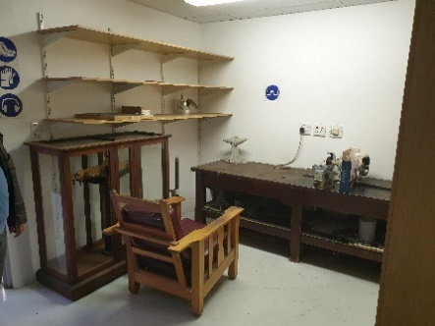  Calibration Laboratory Entrance foyer  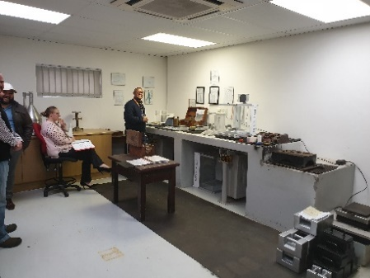  Calibration Laboratory | 40 | - At least 4 x plug points on kitchen cupboards installed on two walls providing work tops. The air conditioner should be placed close to ground level  - Concrete workbench/top (4m x 1m x 1m high) with 6 x electrical plug points installed above work bench height.  - Plumbing, hot and cold-water with threaded tap for fittings. A 110 mm drain provided in a corner of the laboratory. Lab temperature to remain at a constant 19 degrees (Aircon services by a separate split unit)  - Access control
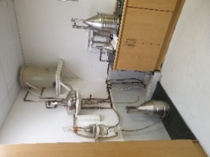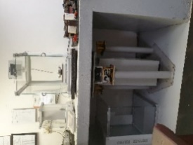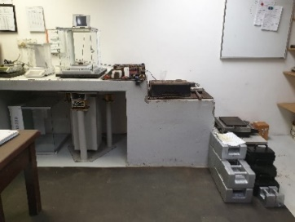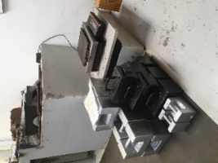
High Cap. Floor drain in corner Anti vibration table Working bench for Calibration Weight calibration
Inspection Lab (LM) | 30 | - 6 x plug points on kitchen cupboards installed on two walls providing work tops + aircon  - Plumbing, hot and cold water with threaded tap for fittings + stainless steel basin top.  - Access control
High accuracy mass Lab (LM) | 30 | - 2 x plug points on kitchen cupboards installed on two walls providing work tops + aircon(to blow from ground up).  - Access control  - Concrete workbench/top (4m x 1m x 1m high) with 6 x electrical plug points installed above work bench height.  - Access control
- Equipment Store room (LM)  - Access control | 40 | - 2 x plug points  - Steel shelving  - Access control
Warehouse receiving / test area  Workshop (LM)  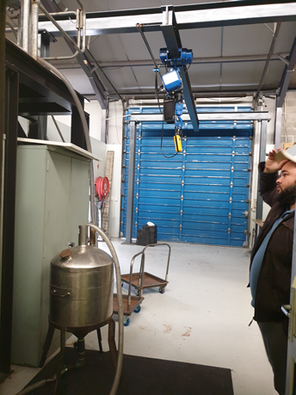  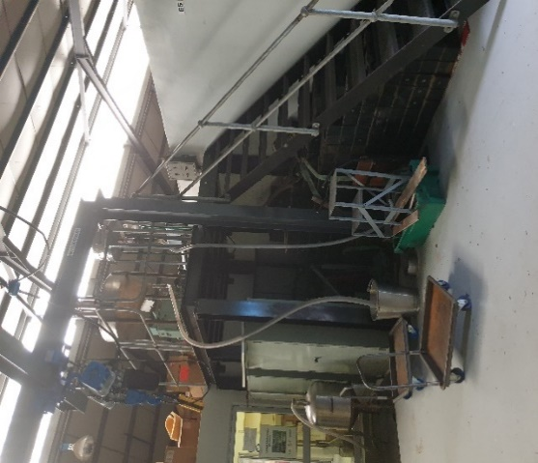  Raised Steel Platform image | 80 (minimum 65) | - Minimum 4m high roller shutter-door entrance to warehouse (To accommodate large truck/ trailer bodies and deliveries of large test measures).  - Minimum 2-ton, 2 speed overhead crane(Pendant control fitted with emergency stop switch), with height of 4m (minimum 3.5m), with emergency stop switch fitted to hoist across the length of the open warehouse area.  - 110mm floor inlet drain to allow high flow water removal. With the centre 4m x 4m for slopped floor area covered with a mentis grid  - Adequate ventilation for minor spray/painting  - 1 x internal compressed air point, to be serviced from secure external compressor point.  - 2 x plumbing point (Hot and cold water with threaded tap for fittings), one of which is to be installed on top of the raised steel platform. (gantry)  - 3 x electrical plug points. One on top of the gantry, one for compressor and two in the general area.  - 1 x 1.5 t raised steel platform 4 m high and 3 m x 4 m in size (minimum size).  - The platform can be constructed such that it is joined/close to one or more walls from the existing structure. Labs/workshop etc so as to maximise available space. (see image “Raised Steel Platform image”)  - Spacious Stairway access to raised steel platform (approx. 1m wide or bigger, as per image “Raised Steel Platform image”)  - Safety railings to be fitted to the raised structure as per OHS regulations.

Foods Associated Industries Laboratories
Product Receiving Area (Food and Associated Industries)  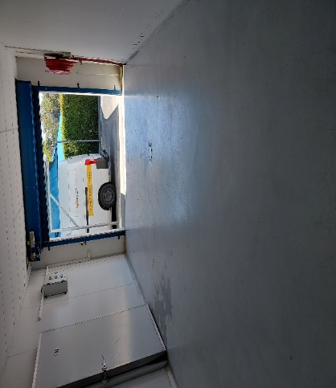  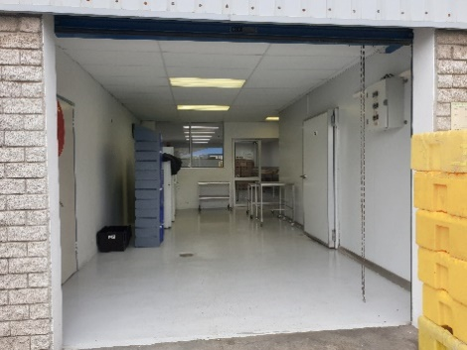 | 32 | - Access for delivery vehicles and removal of samples. Located near freezing facilities and refuse area. Floor drainage double sealed accessible water trap required for cleaning. This is a wet floor area. | Epoxy coated/ Air conditioning
Access controlled Export Laboratory (Food and Associated Industries)  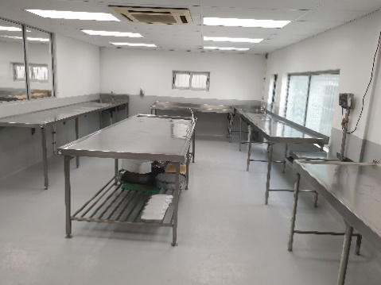 | 55 | - Floor concrete and sloped 1:80 and epoxy painted. Floor drainage required for cleaning.  - Walls smoothly plastered and epoxy painted.  - Filtered air and controlled to 15 Celsius. Daylight tubes 540 lux in all inspection facilities Water points for additional taps.  - Cold and warm water available at each water point in each laboratory. Inside of the laboratories should be visible from the service passage.  - Three electrical points above 1.5 meter for scales.  - Wall to floor junctions coved.  - Floor drainage double sealed accessible water trap required for cleaning.  - This is a wet floor area.  - Two Industrial wash trough supplied by the NRCS to be connected into the sewage system. | Epoxy coated/ Air conditioning
Access controlled Import Laboratory (Food and Associated Industries)  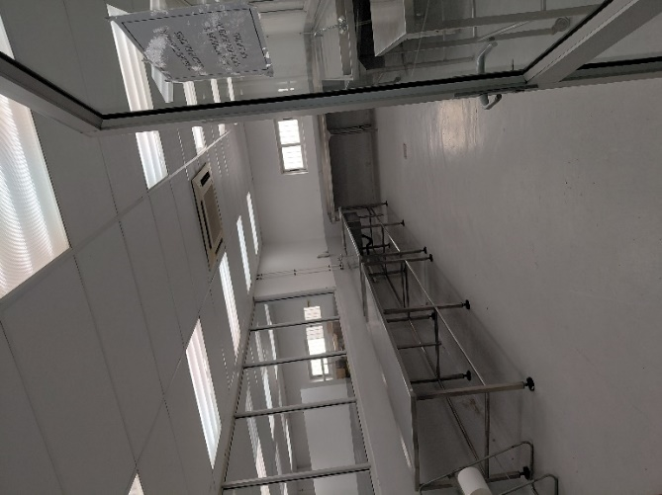 | 55 | - Floor concrete and sloped 1:80 and epoxy painted.  - Floor drainage required for cleaning. Walls smoothly plastered and epoxy painted.  - Filtered air and controlled to 15 Celsius.  - Daylight tubes 540 lux in all inspection facilities Water points for additional taps.  - Cold and warm water available at each water point in each laboratory. Inside of the laboratories should be visible from the service passage.  - Three electrical points above 1.5 meter for scales. Wall to floor junctions coved.  - Floor drainage double sealed accessible water trap required for cleaning.  - This is a wet floor area.  - Two Industrial wash trough supplied by the NRCS to be connected into the sewage system. | Epoxy coated/ Air conditioning
Access controlled Canning Laboratory (Food and Associated Industries)  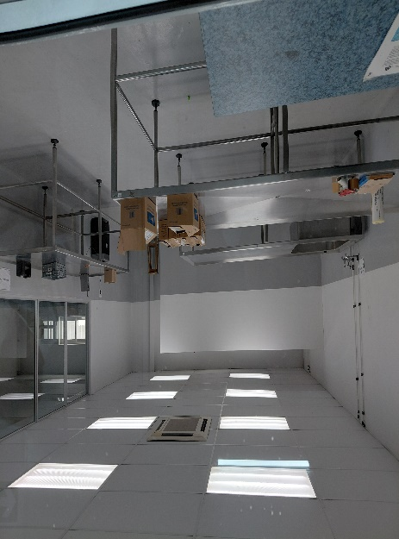 | 55 | - Floor concrete and sloped 1:80 and epoxy painted.  - Floor drainage required for cleaning. Walls smoothly plastered and epoxy painted.  - Filtered air and controlled to 15 Celsius.  - Daylight tubes 540 lux in all inspection facilities Water points for additional taps.  - Cold and warm water available at each water point in each laboratory. Inside of the laboratories should be visible from the service passage.  - Three electrical points above 1 Floor drainage double sealed accessible water trap required for cleaning.  - Five meter for scales. Wall to floor junctions coved.  - This is a wet floor area.  - Two Industrial wash trough supplied by the NRCS to be connected into the sewage system. | Epoxy coated/ Air conditioning
Access controlled processed meat Laboratory (Food and Associated Industries)  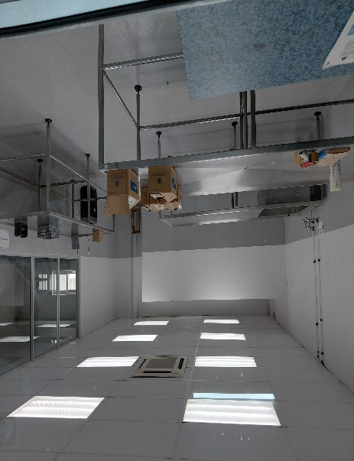 | 55 | - Floor concrete and sloped 1:80 and epoxy painted.  - Floor drainage required for cleaning. Walls smoothly plastered and epoxy painted.  - Filtered air and controlled to 15 Celsius.  - Daylight tubes 540 lux in all inspection facilities Water points for additional taps.  - Cold and warm water available at each water point in each laboratory.  - Inside of the laboratories should be visible from the service passage.  - Three electrical points above 1.5 meter for scales.  - Wall to floor junctions coved.  - Floor drainage double sealed accessible water trap required for cleaning.  - This is a wet floor area.  - Two Industrial wash trough supplied by the NRCS to be connected into the sewage system. | Epoxy coated/ Air conditioning
Sample Prep Lab (Kitchen)  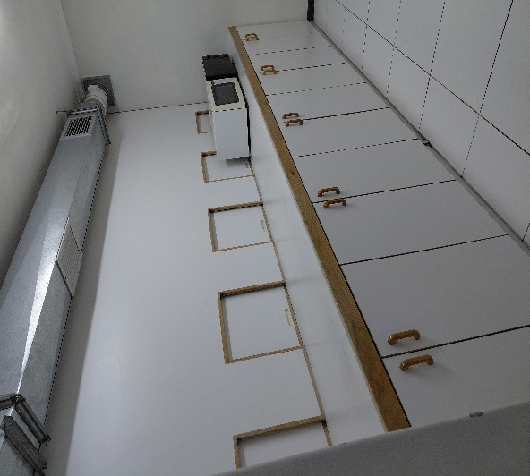 | 12 | - Equipped with cupboards for safe storage utensils and equipment.  - Electrical points for a stove and other electrical equipment (5).  - Extractor fan for the removal of odours. Floor drainage double sealed accessible water trap required for cleaning. | Epoxy coated/ Air conditioning
Sensory Room  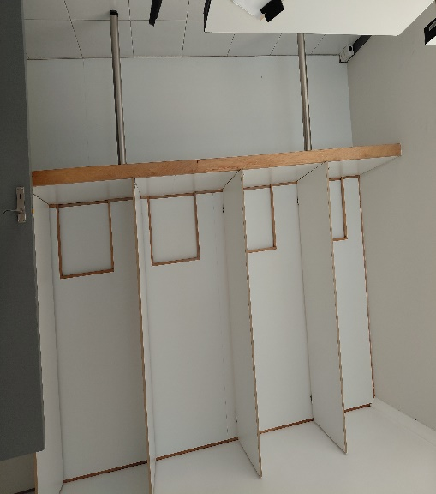 | 20 | - Adjacent to kitchen with openings leading to kitchen.  - Filtered and air replacement lights (Daylight tubes 540 lux) Air-conditioned with clear separations between the prep and sensory room.  - Individual cubicles portioned for sensory analysis. | Epoxy coated/ Air conditioning
Industrial Wash up area (Food and Associated Industries) | 16 | - Situated close to Laboratories. Floor concrete and sloped 1:80 and epoxy painted.  - Floor drainage required for cleaning. | Epoxy coated floor/Air conditioning
Service passage  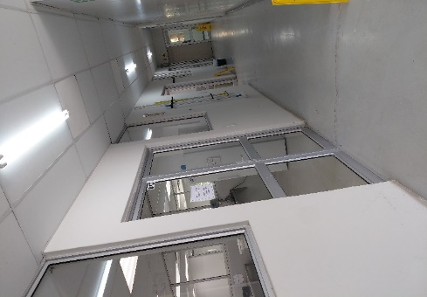 |  | - Connecting all Food and associated industry and Legal Metrology labs and freezers.  - Floor concrete and epoxy painted.  - Walls smoothly plastered and epoxy painted.  - Wall to floor junctions coved.
Freezer  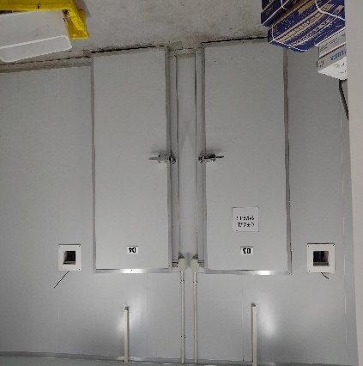 |  | - 3 x Freezer rooms  - Situated close to Laboratories  - Close to service passage | Epoxy coated floor/Air conditioning
Chiller  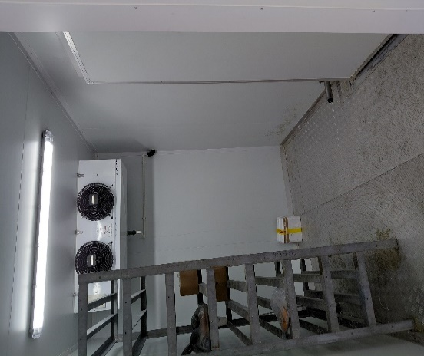 |  | - 2x Chiller rooms  - Situated close to Laboratories  - Close to service passage | Epoxy coated floor/Air conditioning

Workshop area
Area required | m² | Specification / special needs | Details
Workshop (Legal Metrology) | 20 | Ventilation for minor spray/painting  1 x compressed air point  2 x electrical points  floor drain, with 3m x 1m of sloped floor leading to drain to aid draining.  1 x plumbing point (Hot and cold water) with threaded tap for fittings). | Epoxy coated floor

10.3.1.4 Security
- The proposed building must have a fully functional security and access control system.
- The system should allow for the safe entering and exiting of NRCS staff and visitors, a safe working environment and the protection of vehicles and assets.
- Access control into the building
- Armed Response Alarm System
- The landlord must provide physical security guards

10.3.1.5 Parking Facilities
- Bid proposal should have a detailed layout of the parking areas as detailed in functionality. Parking should ideally accommodate approximately 45 (Forty-Five) parking bays to accommodate both the NRCS staff and visitor’s vehicles, preferably be sheltered.
- These parking bays provided shall be made available to the NRCS on a 24-hour basis. Allowance should be made for at least 2 (Two) parking bays to accommodate persons with disabilities.
- All parking is to be provided within access-controlled area.
      - Water and Electricity Supply
- The municipal water and electricity supply should be metered separately for the NRCS billing.
- The building must have a 10 000L water reservoir tank
NOTE: The NRCS will only reimburse against Municipal or Eskom bill
      - Health & Safety
- Building must comply with the required standards, OHS etc.; and should have Firefighting equipment in terms of the Fire Requirements (fire extinguishers, fire hoses, fire escape doors and smoke detectors etc.) and these should be maintained and serviced regularly by the Landlord.

      - Technology and Communication
- Power supply to be connected and distributed through the building. Provision to be made for telecommunication lines within the building. Provision of LAN, WAN and Fibre Optical Cabling.
- Server room with suitable fire-resistant storage space and dedicated air conditioning, as well as a 9m2 with raised floor to prevent potential water damage in the event of any water leakage in the building.
- Ablutions male and female facilities to adhere to the National Building Regulations Act.
- The bidder shall provide fully functional new or fully refurbished ablution facilities that meet the Legislative requirements.
Male and Female Staff ablutions to include:
- Waste container
- Female bathrooms to be provided with sanitary bins
- Hot and cold water to be provided in all ablutions
- One female and one male shower to be provided if available
- A mirror of 900 x 1200 mm to be provided above each wash-hand basin
NOTE: FACILITIES FOR PEOPLE WITH DISABILITIES WILL BE A REQUIREMENT.

10.3.1.9 Standby generator/backup power
- The building must have a generator/backup power system
- The standby generator or backup power system must be able to supply power at the minimum to the freezers, ICT servers and switches laboratories and emergency lighting during loadshedding.

10.3.1.10 Relocation
- Landlord to provide for movement of NRCS furniture and equipment from current premises
Landlord to provide for upliftment from current premises and installation of the following equipment:
- Foods laboratories
- Freezers and chillers
- Legal Metrology

10.3.1.11 General
- Landlord must maintain the garden and ensure the grounds are clean
- Landlord is responsible for pest control
- Landlord is responsible for disposal of sanitary bins

      - Storage facility location
- The storage facility should ideally be in the same location as the office or alternately within a 15kms radius from the office

10.3.1.13 Site Accessibility
- Close proximity of public transport nodes and amenities
- Storage facility may not be shared.

10.3.1.14 Storage Building
- Minimum Grade B storage facility (As per South African Property Owners Associations definitions)
- Storage facility must be in an access-controlled area
- Physical security

10.3.1.15 Storage facility size
- The storage facility must double volume and a minimum of 500m2
- The storage facility must provide for the following lockable area:
Area required | m² | Specification / special needs
Sample storage area | 80 | Four Lockable secured area each compromising of 20 square meter supplied with fixed shelving
Sample storage area | 20 | Chemicals and Occupational requirements
Sample storage area (Flammable) | 20 | Flame producing devices with steel shelving

11. SPECIAL CONDITION
The following special conditions are to be adhered to by the bidders:
11.1. Property Information to include:
11.1.1. Physical address, stand number
11.1.2. Details of all partners to the offer
11.1.3. Rental option, tenant installation allowance
11.1.4. Bid proposal to have a detailed building layout drawings/ plans preferably in CAD format
11.1.5. Building insurance information, including rates and taxes to be provided and if multi tenants provide detail of business.
11.2. Maintenance responsibilities of the landlord.
11.2.1 Air conditioning units, health and safety signage, fire equipment, lifts, electricity, fumigation, plumbing work and day-to-day maintenance of the building. The office premises (interior and exterior) to be fully serviced and maintained by the Landlord. Turn-around time to be clearly stated on maintenance and repair work by the Landlord. The NRCS reserves the right to negotiate the turn-around times should it not be satisfactory.
11.2.2. Maintenance and servicing of freezer and chiller equipment.
11.3. The NRCS reserves the right to make a selection solely on the information received in the bids or to negotiate further with one or more bidder/s.
11.4. The NRCS will visit the buildings of the prospective bidders that meet the requirements provided by the NRCS.
  - The NRCS reserves the right:
11.5.1To award this bid in whole or in part.
11.5.2 Not to accept any bids, and/or to cancel this bid anytime.
11.5.3. To accept one or more bids for further negotiation.
11.5.4. To contact any bidder during evaluation period, to clarify information only, without informing any other bidder.
11.5.5 The bidder accepts that the NRCS will have the right to contract with any other service provider/s for provision of services not covered by this specification.
    - The General Conditions of Contract (GCC) must be signed or initial on every page by the bidder as included in the bid document.
    - Government procedures will be followed in appointing the prospective bidder.
    - The NRCS will not award the bid to any prospective bidder who has not registered on the Central Supplier Database as regulated by the National Treasury Department. The bidder will provide the NRCS with its supplier number and unique number.
    - Tenant and Landlord installations - The Landlord must specify the Tenant Installation allowance in either a fixed amount or the equivalent monthly rentals.

    - The building shall comply with all the applicable laws of South Africa and the by-laws of the local authority, including the certification of compliance:
    - Mechanical, Electrical, Municipal approved building plans, Occupation Certificate and Fire Clearance.
    - The NRCS reserves the right to request proof of such documentation, prior to signing the lease agreement.
11.5.13 Bidders are advised that submission of bid proposals give rise to no contractual obligations on the part of the NRCS.
11.5.14 The NRCS reserves the right not to accept any bid, which does not comply with the specifications, and conditions set out in the bid documents (office building, storage facility and security).
11.5.15 The NRCS will not be liable for costs incurred during the site visits or any other cost related to the submission and preparation of the bid.
11.5.16 The preferred bidder is expected to ensure that the building is insured and proof of such should be provided to the NRCS.

12.CONTRACT PERIOD
12.1 NRCS will take occupancy of the premises on 1 March 2027
12.2 The office space accommodation will be for the duration of nine (09) years, eleven (11) months (five) years with the NRCS.

13.MANDATORY REQUIREMENTS
Please note that failure to adhere to the following requirements will lead to an immediate disqualification:
  - Late submission will not be accepted
  - Provide Proof of Ownership of the building (Copy of Title Deed) and Mandate if the bidder is an agent,
  - Zoning Certificate for the purpose in which the property is intended for
  - -Minimum 30 parking bays – (Attach proof e.g site plan or photos of the parking area)
  - Building must be available for occupation on or before 1 March 2027
  - Grade B building or Higher
NB: Bidders are required to complete and sign SBD forms 1,3.1,4 and 6.1. Failure to submit these forms as required may lead to disqualification or non-allocation of preference points where applicable.
Bidders must ensure that:
- Registration on Central Supplier Database (CSD)
- Tax compliance status

- EVALUATION CRITERIA

NOTE: For the purpose of comparison and in order to ensure a meaningful evaluation, bidders must submit detailed information in
substantiation of compliance to the evaluation criteria mentioned.

Minimum Required Score for functionality is 70 points out of 100 points and any bidder scoring less than 70 points will not be considered for further evaluation. Bidders meeting the minimum score of 70 points out of 100 points a site visit evaluation will be conducted, and a minimum required score is 70 out of 100 points.

Phases of SCM processes | Minimum qualification criteria for this phase | Total Points | Minimum requirement to qualify for next phase
- Desktop evaluation | Confirm responsiveness of bids and verify documents submitted | 100 | 70% or more of functionality evaluation
- Site visit evaluation | Bidder must have achieved 70% on functionality evaluation | 100 | Score of 70% or more on overall functionality assessment

Service Providers that then qualify in terms of the overall functionality assessment cut-off points of 70 points will then be evaluated on sites visits will be conducted at the time provided by the NRCS. Bidders should look at the site visits guidelines.

DESKTOP FUNCTIONALITY (PHASE 1)
 | DESCRIPTION | POINTS
 | Property information and building grading
Bid proposal should clearly outline the following:  - Physical address, Erf number, GPS Location = 1 point  - Details of all role players to the offer (i.e. Property Manager, Owner, Leasing Agent etc.) = 1 point  - Market Value of the property, Breakdown of Monthly Rental Rate Calculation = 3 points  - Breakdown on detail of Tenant installation allowance. Bidder to specify whether it is included on the monthly rate if not shown on the Pricing Schedule) = 1 point  - If Single Tenant = 2 points  - If multi tenants, provide names and detail of such tenants and their businesses = 2 points  Note: In order to qualify for points in this section a minimum of three items need to attract a point score. |  | 10

 | Parking facilities
 | 45 parking bays are required. It is required that 2 disabled parking is either already included in the minimum parking bays or sufficient space is available for conversion to Disabled Parking. NRCS however would prefer 30 dedicated bays for staff and visitors, within a secure environment (walled/fenced in area) Bid proposal should have a detailed layout showing the types of parking offered.  - 45+ Parking bays= 10 points  - 35 – 44 Parking bays= 7 points  - 30 – 34 Parking bays parking bays = 4 points  - Less than 29 = 0  Bidder to submit proof thereof for point’s allocation e.g. Photographs, etc. | 10
 | Security
 | Bidder should provide security measures to ensure that the premises is adequately secured.  Bid proposal should clearly outline the provision of security features of the building.  - Perimeter fence, Access control, Physical security guards and Armed response =10 points  - Perimeter fence, Access control, Physical security guards=5 points  - Anything below=0 | 10
 | Technology & Communication
 | Power supply is to be connected to the building and distributed to all parts to accommodate easy tenant fit out. Provision is made for the connection of telecommunication so that this can easily be distributed through the office areas.  Provision of standby power will be an advantage but not mandatory.  Points:  Power connected and facilities provided:  - Standby power supply connected to the building and distributed to specified areas as mentioned in this document=4 points  - Standby power Supply connected to the building and distributed to all parts of the premises to be leased = 4 points  - Provision for Telecommunication connection = 1 point  - Provision of LAN, WAN and Fibre Optical Cable =1 point  If there is no Power Supply connected to the building and distributed to all parts of the premises to be leased the Bidder will be scored zero for this section regardless of whether telecommunication and standby power requirement is met.  Bidder is to indicate in the bid proposal the four items. No indication, no scoring. | 10
 | Space requirements
 | The space needs to be suitable for the intended use. The usable office area needs to be in an appropriate shape that can accommodate the required offices. All spaces will need contact with natural light and ventilation.  Points:  Suitability of required Space:  - The space is of suitable proportions in relation to NRCS’s needs = 10 points  - The space is of an appropriate shape that can accommodate required offices = 4 points  - Adequate ventilation either by natural/mechanical means = 2 points  - Existing Boardroom that can accommodate 40-50 people = 2 points  - NRCS dedicated Male and Female Ablutions = 2 points  - Laboratories as per specification = 10 points  - Suitability of required storage=10 points  Note: Above points will be allocated for proposed buildings that meet the above requirements at the time of bid submission. Submit proof thereof | 40
 | Health & safety
 | Building must comply with the required legislation, Occupational Health and Safety etc.; accessibility of the building for people with disability (e,g wheelchair ramps, accessible restrooms, etc) and should have firefighting equipment in terms of the fire requirements (fire extinguishers, fire hoses, fire escape doors, smoke detectors) and these should be maintained and serviced regularly by the Landlord. Prior to occupation, the building is to be fumigated by a specialist against any kind of pests, insects, etc. and the landlord must provide proof that the building was fumigated.  Confirmation provided:  Points:  - Yes = 5 points  - No = 0 points | 5
 | Maintenance
 | Proposals should include a clearly defined maintenance plan, setting out the Landlord’s responsibility around maintenance issues (chillers and freezers, air conditioning units, fire equipment, lifts, electricity, fumigation, plumbing work, day-to-day maintenance of the building, geyser, pest control, cleaning services etc.)  The office premises to be fully serviced and maintained by the Landlord Turn-around time to be clearly stated on maintenance and repair work by the landlord.  Proposals to allow NRCS to do its own repairs in cases where the Landlord’s turn-around time was not met and to have the expenses reimbursed by the landlord.  Submission of a clearly defined Maintenance Plan itemizing the role and responsibility of the Landlord and whether the costs are included in the rate per month or whether NRCS will be charged over and above  Points:  - Yes = 5 points  - No = 0 points | 5
 | Draft schedule of expenses or shared expenses (Municipal, security,maintenance)  Points  - Yes = 5 points  - No = 0 points | 5
 | Occupation
 | NRCS will take occupancy of the premises on 1 March 2027 (Provide confirmation of property readiness for the NRCS to occupy.  If occupancy is provided on or before 1 March 2027:  Points:  - Yes = 5 points  - No = 0 points | 5
 | Minimum Threshold | 70
 | Total Points | 100

Bidders that fail to meet the minimum threshold of 70 on Phase 1 Functionality evaluation criteria will be disqualified. Bidders that meet the minimum threshold of 70 on Phase 1 Functionality evaluation criteria will be evaluated under Phase 2 Functionality evaluation criteria (SITE VISIT).

SITE VISITS FUNCTIONALITY (PHASE 2)

Sub-Criteria | Description | Weightings
Site Visit | Suitability of the building | 20
Site Visit | Accessibility | 20
Site Visit | Security | 20
Site Visit | Amenities | 20
Site Visit | Parking | 20
Minimum Threshold |  | 70
Total Points |  | 100

Bidders that fail to meet the minimum threshold of 70 on Phase 2 Functionality evaluation criteria (SITE VISIT) will be disqualified. Bidders that meet the minimum threshold of 70 Functionality evaluation criteria (SITE VISIT) will be evaluated on Price and Preference (Specific Goals) 80:20 points scoring system as outlined in the SBD6.1 attached to this bid document.

- PACKAGING OF BID

Bid No. NRCS 012-2025/2026

Description: APPOINTMENT OF A SERVICE PROVIDER TO PROVIDE OFFICE ACCOMODATION AND STORAGE OF PRODUCTS TO THE NRCS IN CAPE TOWN FOR A PERIOD OF NINE (09) YEARS, ELEVEN (11) MONTHS

Bid closing date and time: 17 JUNE 2026 at 11H00 (Submission of late bids will not be accepted)

Name and address of the bidder: _____________________________

NB: The bid proposal envelope shall contain one original hard copy document, clearly marked “original”, and three (3) hard copies, clearly marked “Copy” (i.e. three documents to be included in each envelope.

Note: The bids are to be delivered at the following addresses:

Sealed documents individually marked the above reference, and description must be placed in the Tender box situated at ground floor, SABS Campus by the closing date and time. All Suppliers are encouraged to make their submission before the closing date and time. Bids will be publicly opened at SABS Campus 1 Dr Lategan Road, Groenkloof, Pretoria. No tenders will be accepted after the closing time. No tender per facsimile, posted or e-mailed will be accepted.

All Suppliers are encouraged to make their submission before the closing date and time. Bids will be publicly opened at the addresses mentioned above. No tenders will be accepted after the closing time. No tender per facsimile, posted or e-mailed will be accepted.

- BID DOCUMENT CHECKLIST

A completed and signed bid document must be submitted in a file. The bid/tender documentation must be placed into a file with dividers between every schedule. The schedule must be numbered as follows:
Schedule No. | Description | Submitted (Yes/No)
Schedule 1 | Valid and original SARS Tax Clearance Certificate
Schedule 2 | Latest company registration certificate from the Companies and Intellectual Property Commission (CIPC) / Proof of company registration
Schedule 3 | Certified ID copies of the directors / trustees / shareholders and their shareholding percentages
Schedule 4 | Original and valid B-BBEE status levels verification certificate or a certified copy thereof, substantiating your B-BBEE rating.
Schedule 5 | Functionality Criteria

- ANNEXURE - LABORATORY EQUIPMENT - RELOCATION COST

The following is currently installed at the current premises and will need to be moved by the successful bidder.
LABORATORY INVENTORY LIST
CANNING LAB
DESCRIPTION | MEASUREMENTS | QUANTITY
STAINLESS STEEL TABLE | 290cm X 90 cm X 90 cm | 2
Cupboard with 5 doors and 4 drawers | 270cm X 60 X 90 cm | 1
PROCESSED MEATS LAB
DESCRIPTION | MEASUREMENTS | QUANTITY
Stainless steel Table with zink | 280cm X 120cm X 90cm | 1
Table stainlesssteel | 290cm X 120cm X 90cm | 2
Scale Platform | 45cm X 50 cm | 1
Stainless steel Trolley with wheels | 90cm X 70cm X 80cm | 2
Stainless steel Trolley with wheels | 80cm X 70cm X 90cm | 1
IMPORTS LAB
DESCRIPTION | MEASUREMENTS | QUANTITY
Stainless steel Table with zink | 530cm X 105cm X 87cm
Stainless steel Table with zink | 290cm X 90cm X 90cm | 1
Table stainless steel with drain | 350cm X 85cm X 105cm | 2
Scale Platform | 40cm X 35 cm | 1
Scale Platform | 55cm X 45 cm | 1
Stainless steel Trolley with wheels | 90cm X 70cm X 80cm | 1
Stainless steel Trolley with wheels | 80cm X 70cm X 105cm | 1
EXPORTS LAB
DISCRIPTION | MEASUREMENTS | QUANTITY
L- Shape Stainless steel Table with zink | 240cm X240 X 84cm X 100cm
Stainless steel Table with zink | 350cm X 130cm X 100cm | 1
Table stainless steel with drain | 510cm X 84cm X 105cm | 2
Table stainless steel with zink | 500cm X 90cm X 104cm | 1
Table stainless steel with zink | 240cm X 84cm X 100cm | 1
Scale Platform | 40cm X 35 cm | 1
Scale Platform | 70cm X 47 cm | 1
Stainless steel Table | 238cm X 84cm X 100cm | 1
KITCHEN LAB
DISCRIPTION | MEASUREMENTS | QUANTITY
Cupboard with 10 doors | 400cm X 90 X 90 cm | 1
Industrial Extractor fan | 400cm | 1
SENSORY ROOM
DESCRIPTION | MEASUREMENTS | QUANTITY
Shelve, Table including sensory cubicles | 400cm X 90 X 90 cm & back splash wall of 250cm | 1
FREEZER ROOMS
DISCRIPTION | MEASUREMENTS | QUANTITY
Freezer panel volume | 335cm X 280 X 300 cm | 2
Freezer racks | 50cm X 100 X 200 cm | 9
Blowers |  | 3
Condensers |  | 3
CHILLER ROOMS
DESCRIPTION | MEASUREMENTS | QUANTITY
Chiller racks | 50cm X 100 X 200 cm | 4
Chiller panel volume | 335cm X 590 X 300 cm | 1
KITCHEN
Industrial Extractor fan system | 400cm | 1

the power, by one person or a group of persons holding the majority of the equity of an enterprise, alternatively, the person/s having the deciding vote or power to influence or to direct the course and decisions of the enterprise.
Joint venture or Consortium means an association of persons for the purpose of combining their expertise, property, capital, efforts, skill and knowledge in an activity for the execution of a contract.

