RUSTENBURG LOCAL MUNICIPALITY

DIRECTORATE: INFRASTRUCTURE DEVELOPMENT AND MANAGEMENT

UNIT: ELECTRICAL ENGINEERING SERVICES

STANDARD TECHNICAL SPECIFICATION: VM 0001

VEGETATION MANAGEMENT WITHIN POWERLINE SERVITUDES

- Introduction

Note: THIS SPECIFCATION IS IN LINE WITH ESKOM STANDARDS
Vegetation management within powerline servitudes has financial, social, and environmental implications. Maintenance of vegetation needs to be done as economically as possible, without causing unnecessary environmental damage and without impacting on the rights and requirements of the landowner and other interested and affected parties.

This part of the Environmental Procedure covers vegetation management in servitudes, looking at general requirements, servitude widths, and offers examples of sketch plans to assist in the development of Scopes of Work for servitude management. The standard sets out the way all initial powerline route clearing, and any subsequent vegetation maintenance is to be performed under Rustenburg Local Municipality powerlines. It sets the minimum standards for vegetation clearing and maintenance of all powerline routes and indicates Rustenburg Local Municipality's rights and responsibilities.

- Requirements
  - General requirements for all vegetation clearing of powerline servitude routes
The objective of powerline route vegetation maintenance is to ensure the safe mechanical and electrical operation of the powerline and to meet Rustenburg Local Municipality’s legal, business social and environmental obligations.

Trees growing to a height more than the horizontal distance of that tree from the nearest conductor which are identified as a risk to safe operation of the powerline shall be treated and prevented from growing in such a manner as to endanger the line should they fall.

All vegetation posing a risk to the line or preventing access for maintenance purposes shall be managed.

In terms of the Occupational Health and Safety Act, 1993 (Act 85 of 1993), “The supplier, or user of powerlines shall control vegetation in order to prevent it from encroaching on the minimum safety clearances of the power lines and the owner of the vegetation shall permit such control”.

The scope of works and requirements for vegetation clearing shall be determined in accordance with the procedure set out in the Annexes.

Vegetation clearing for new powerlines and existing powerlines shall be carried out in accordance with the standards set out in this document.

All vegetation clearing that is to take place within a forest plantation shall conform to the Commercial Timber Growers Guideline: Maintenance and Management Agreement in Forest Plantation Areas and Servitude Areas between Rustenburg Local Municipality and Commercial Timber Growers.

It is recommended that a minimum rolling three (3) year vegetation management programme be promoted per power line or feeder as part of the Management Programme. This will allow effective identification, management and follow up of problematic vegetation.

In terms of Rustenburg Local Municipality’s servitude agreement, Rustenburg Local Municipality (or its appointed contractor) has the right to enter and be upon the property at any time whether it to be to perform work on the property itself, or to gain access to any adjacent property. However, Rustenburg Local Municipality will notify the owner of any intention to enter the property to cut trees and vegetation and will take reasonable measures to inform the landowner of Rustenburg Local Municipality’s intent to cut vegetation on the property. Proof of the consultation must be kept.

To assist with access, Rustenburg Local Municipality may erect gates in consultation with the property owner. Under no circumstances shall access be gained by cutting or “dropping” fences. All gates shall be left closed, and the Rustenburg Local Municipality servitude gates shall be securely always locked.

  - Indigenous Vegetation
Various species of indigenous vegetation are protected by law in terms of which is necessary to obtain a permit from the relevant authority, to cut them. The responsibility for obtaining the permit shall remain with Rustenburg Local Municipality, unless allocated to the Contractor in terms of a formal contract. Rustenburg Local Municipality however remains accountable. The latest list of National protected trees is available off SHE Web, but it must be realized that provincial legislation has specific requirements in terms of protected species. These can be accessed off the Legal Register and should be referred to in the line of the ELECTRICAL MAINTENANCE PLAN.

Where there is any doubt as to whether a plant species is protected or not, the Department of Water Affairs and Forestry, or the local Rustenburg Local Municipality environmental practitioner in the area shall be consulted.

Indigenous vegetation which does not interfere with the safe operation of the power line should be left undisturbed.

Vegetation should be trimmed where it is likely that it intrudes on the Minimum Vegetation Clearance Distance, (MVCD) or will intrude on this distance before the next scheduled clearance. (Usually three (3) years). (See Annex B).

The MVCD is determined from GNR 1593 of 12 August 1988, Electrical machinery regulations. The distance “To buildings, poles and structures not forming part of powerlines” is used as the guide. As a rule of thumb indigenous trees and shrubs will grow at approximately one (1) meter per year under good conditions. The MVC can be reduced in sensitive systems or where aesthetic considerations need to be addressed. This should be detailed in the ELECTRICAL MAINTENANCE PLAN.

  - Alien Vegetation
Alien vegetation in servitudes shall be managed in terms of the Regulation GNR.1048 of 25 May 1984 (as amended) issued in terms of the Conservation of Agricultural Resources Act, Act 43 of 1983. In Terms of these regulations, Rustenburg Local Municipality shall “control” i.e. to combat category 1, 2 and 3 plants to the extent necessary to prevent or to contain the occurrence, establishment, growth, multiplication, propagation, regeneration and spreading such plants within servitude areas or land owned by Rustenburg Local Municipality.

On servitudes not owned by Rustenburg Local Municipality, “Control” should be focused on those species impacting on the electrical infrastructure or hindering access to the infrastructure, as well as those species present in the area as a direct result of the development or management of the infrastructure. This could be because of seeds having been brought onto the site during construction or operation of the line or infrastructure, or associated disturbance of soil resulting in the germination of alien vegetation.

On sites owned by Rustenburg Local Municipality, all vegetation proclaimed in terms of the Regulation shall be subject to control in terms of legislation.

Control programmes should be included as part on the Environmental Management Plans and will need to be area and species specific. Due to the nature of alien vegetation, this programme implementation may need to be more frequent than the three-year interval recommended for indigenous vegetation. Alien vegetation can grow at rates significantly faster than 1 (one) meter per year.

Care must be taken to ensure alien vegetation is not spread because of vegetation management processes through the transport of seeds or other vegetative material from one site to another.

  - Fire Risk
Elevated levels of biomass below a powerline may lead to increased risk of flash over during fires. Annual fire management programmes will need to be implemented to manage the risk appropriately, and it may be necessary to remove all trees and shrubs below a line.

Branches and other debris resulting from pruning processes should not be left below conductors, or in areas where it will pose a risk to infrastructure.

Debris shall not be burnt under any circumstances.

Fires shall not be made for the purpose of chasing or disturbing indigenous fauna.

  - Herbicide use
The use of herbicides shall follow the terms and conditions of The Fertilizers, Farm Feeds, Agricultural Remedies and Stock Remedies Act, 1947 (Act 36 of 1947).

In terms of the above Act, only a registered pest control operator may apply herbicides on a commercial basis. All commercial application of herbicides shall be conducted under the supervision of a registered pest control operator. The following was agreed with the Registrar in August 2005.

When Rustenburg Local Municipality applies herbicides on Rustenburg Local Municipality owned property, (or substations under the control of Rustenburg Local Municipality) then Rustenburg Local Municipality Electrical Maintenance Plan. Employees may do this provided they have been appropriately trained, and that responsibility is taken for this work. Therefore, no need for the person to be registered as an ANNEX C or working under the supervision of a Annex C

When Rustenburg Local Municipality applies herbicides on its own powerline servitudes, or land not owned by Rustenburg Local Municipality, then its own Electrical Maintenance Plan. Employees may not undertake this unless they are registered as an ANNEX C. When contractors are appointed to undertake this, this work must be undertaken by a ANNEX C, or under the direct supervision (meaning the ANNEX C must be on-site) of an ANNEX C.

In cases when Rustenburg Local Municipality’s Vegetation Management, who are Rustenburg Local Municipality staff, are “contracted” by a Rustenburg Local Municipality Division to apply herbicides on servitudes, then they must undertake this under the “management” of a registered ANNEX C. There is no need for a ANNEX C to be on-site at all times in this particular case.

A daily register shall be kept of all relevant details of herbicide usage as stipulated in Act 36 of 1947.

  - Responsibilities on Site
The Rustenburg Local Municipality or contractor shall as a minimum:

- Remain on all existing roads and tracks and within the servitude area and not deviate there from.
- keep Rustenburg Local Municipality gates locked and leave property owners’ gates as found.
- not interfere with the property owners’ activities, request permission for the use of water.
- provide appropriate toilet facilities; not make fires.
- not litter.
- not drop fences.
- not collect firewood without consent; and
- Not disturb or remove stones/rock from the site (e.g. archaeological and heritage sites).

Additional line specific requirements may be listed in the line Electricity Maintenance Plan
On completion of the work, landowners shall sign-off that work was completed to their satisfaction.

  - General
- Deep valleys and environmentally sensitive areas that restrict vehicle access, or legally protected areas, shall not be cleared of vegetation provided that the vegetation poses no threat to the safe operation and reliability of the powerline. In the case of the construction of new powerlines, a one (1) meter “trace-line” may be cut through the vegetation for stringing purposes only and no vehicle access shall be allowed along the cleared “trace-line”. Alternative methods of stringing across inaccessible valleys should, however, be considered.

- Measures to prevent soil erosion shall be always implemented. Road construction may only be undertaken following agreement of authorities, and

- rivers, watercourses and other water bodies shall be kept clear of felled trees, vegetation cuttings and debris. The integrity of riverbanks shall be maintained by only trimming parts of trees directly affecting the safe operation of the power line.

- Aesthetic consideration shall be considered, especially where powerlines cross major roads and rivers, or enter dense vegetation, or woodlands.

- Trees, shrubs, grass, natural features and topsoil, which are not removed during vegetation control operations, shall be protected from damage during operation of the powerline. Disturbance of the surface of the earth shall only be allowed for access purposes.

- It shall be ascertained by the property owners concerned whether they wish to retain the cut vegetation. If not, it shall be removed or disposed of in an appropriate manner to the satisfaction of the owner. Burning shall not be permitted under any circumstance.

- Supporting Clauses

Purpose
The purpose of the procedure is to set general requirements for initial powerline route clearing and any subsequent vegetation maintenance performed under Rustenburg Local Municipality powerlines.

Purpose
This document shall apply throughout Rustenburg Local Municipality, its divisions’ subsidiaries, and entities in which Rustenburg Local Municipality has a controlling interest or considerable influence, including identified contractors, suppliers and service providers, and customers to Rustenburg Local Municipality and Rustenburg Local Municipality subsidiaries where significant impacts and risks may occur.

Definitions
For general definitions, refer to the Environmental Procedure: Definitions specific to this document are repeated below.

Abbreviations
    - EIA: Environmental impact assessment

    - ELC: Environmental Liaison Committee

    - ELECTRICAL MAINTENANCE PLAN: Environmental Management Programme

    - kV: kilovolt

    - MVCD: Minimum Vegetation Clearance Distance

    - NEMA: Environmental Management Programme

3.5.7 ORHVS: Operating regulations for high-voltage systems

    - ANNEX C: Pest Control Officer

    - SHE: Safety, Health, and Environment

Process Monitoring
A monitoring process to determine the effectiveness of this procedure will be developed separately.

3.6 Related Documents
In addition to documents mentioned in the Rustenburg Local Municipality Environmental Procedure, the following documents may have relevance.

- Clearing and maintenance of servitude routes
- Servitude corridor bush clearing and maintenance procedure, Pruning and cutting of trees near energized power lines.
- Operating regulations for high-voltage systems (ORHVS)

Annexures

Annex A Information required and the compilation of the scope of works for all vegetation clearing of
powerline servitude routes.
Annex B Sketch plan for vegetation clearing specifications in line with Eskom standards.
Annex C Vegetation clearing requirements for power lines in line with Eskom standards.
Annex D Servitude widths and clearances in line with Eskom standards.

Annex A
(informative)

Information required and the compilation of the scope of works for all vegetation clearing of powerline servitude routes

Information required for the successful execution of the vegetation management plan in line

with Eskom standards
The following information about the powerline shall be collected. This information could be available in the line Electrical Maintenance Plan but may be requested to be collected by the contractor. If this is the case, this information should be made available to Rustenburg Local Municipality and added to the line Electrical Maintenance Plan at the completion of the contract.

No. | Item
1 | Map of powerline route (route plan)
2 | Schedule of landowners.
3 | Fire risk assessment
4 | List and location of protected plants and declared weeds along route
6 | Herbicide register
 | Aesthetic considerations impacting on the MVCD
9 | Sensitive environmental areas (e.g. wetlands, private game farms, nature reserves, national parks, natural heritage sites, archaeological / historical sites, endangered / protected species {fauna & flora} forest plantations, cultivated lands, indigenous forests etc.)

All this required information should be collected before proceeding further.

Have all the problems associated with vegetation clearing on the specific powerline route been identified?

- The existing or potential problem areas shall be indicated in the scope of works as determined by Rustenburg Local Municipality.

- For each action required, detailed specifications shall be drawn up including:

  - The site to be cleared (a description of the property and powerline).

  - The area to be cleared (the width to be cleared under powerline, access road, servitude width and the area around structures).

  - The height to be cleared (for cutting of grass and reeds, access road, strip under powerline, servitude width as well as trimming of trees).

  - Other requirements (property owners’ special requirements)

  - Removal of vegetation (requirements for the removal or chipping or cutting up and stacking of the cut vegetation).

  - Timing (when vegetation clearing is to take place i.e. time of year, day and time – if required).

  - Notification (all landowners/users shall be notified and their consent obtained before entering property to carry out vegetation clearing, and any other special requirements).

- All information collected by the contractor should be made available to Rustenburg Local Municipality for inclusion in the Electrical Maintenance Plan.

Sketch plan for vegetation clearing specifications
  - Sketch plan for vegetation clearing along powerline servitude


Conductor
A
B

Figure 1: Minimum Vegetation Clearance Distance MVCD

Where:

A = MVCD Minimum Vegetation Clearance Distance (Minimum Clearance to buildings, poles and structures, See Electrical machinery regulations.
B = Projected tree growth before next scheduled clearing



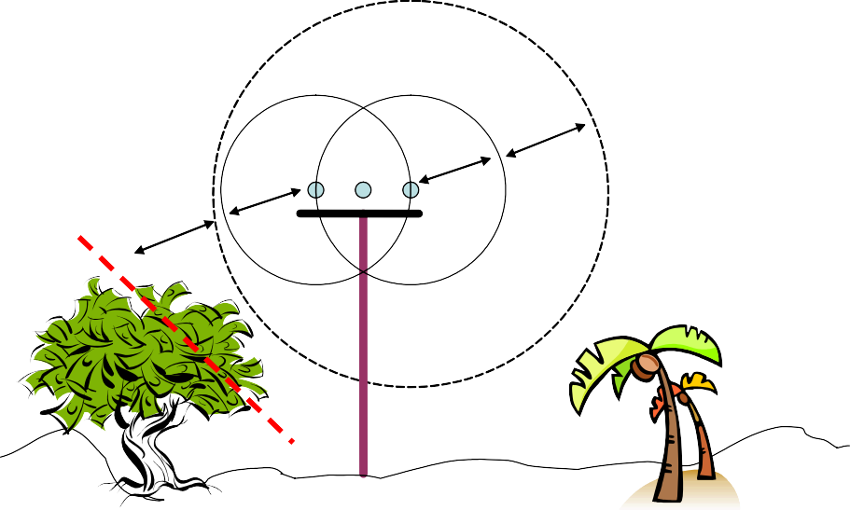
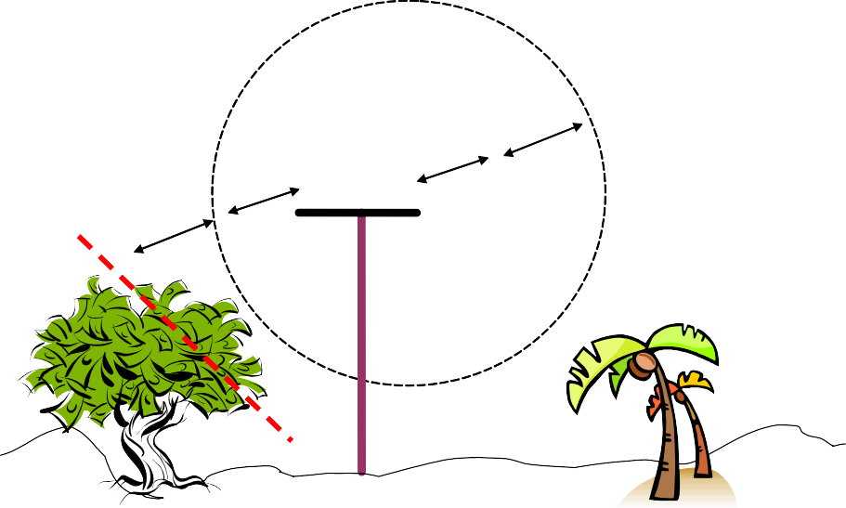
A
B
A
B

Figure 2: Low Voltage Lines

Trimming should take place along dotted line.

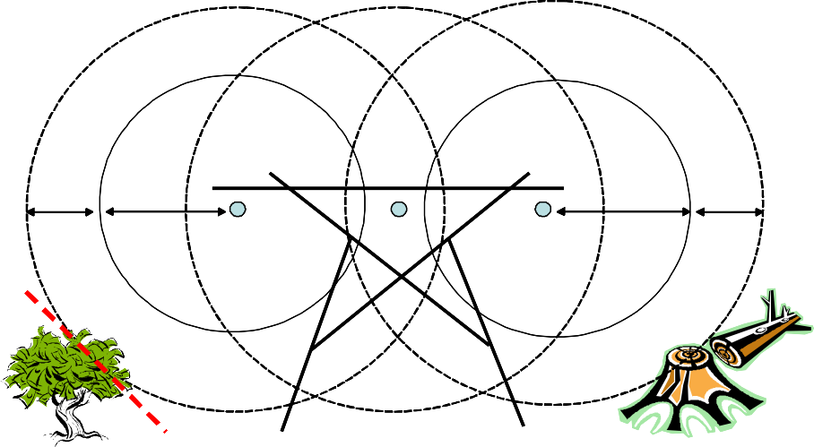

Figure 3: Mid Voltage Lines

Trimming requirements on dotted lines.

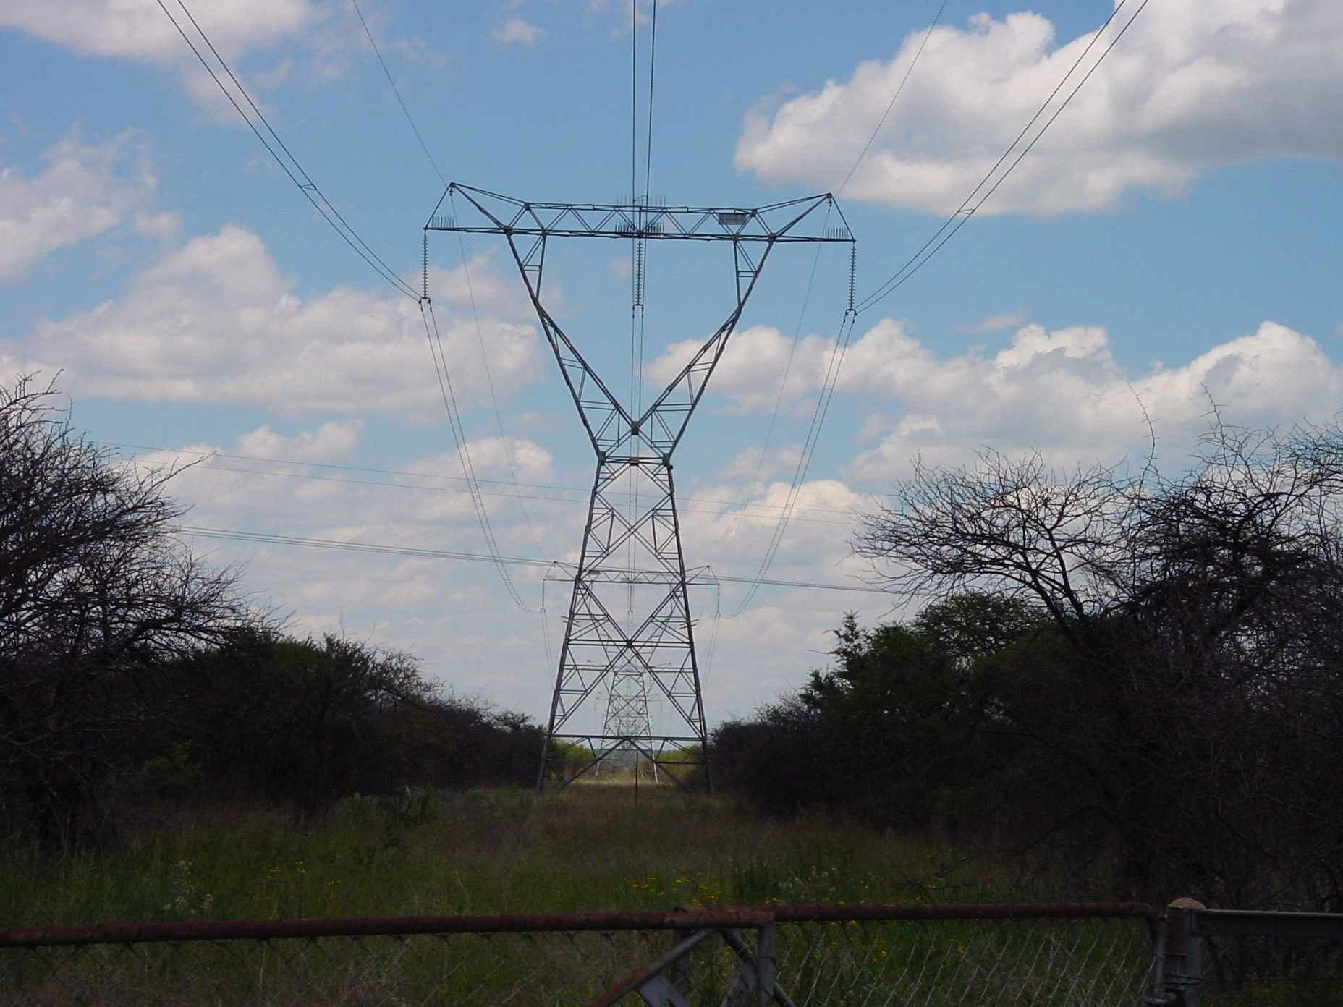


Figure 4: High Voltage lines

Note: Servitude directly under lines is cleared to reduce biomass build-up and reduce fire risk in line with Eskom standards

  - Example of vegetation clearance for a self-supporting structure in line with Eskom standards

  - High Risk Trees
Trees growing to a height more than the horizontal distance of that tree from the nearest conductor which are identified as a risk to safe operation of the powerline shall be treated and prevented from growing in such a manner as to endanger the line should they fall.

Annexure B




Figure 6: Projected growth before next cutting

Above tree is out of the MVCD, and the projected growth before the next cutting, but still poses a threat to the line should it fall

Annexure C
(informative)

Vegetation clearing requirements for power lines
a) The minimum standards to be used for vegetation clearing for new and existing powerline construction or maintenance are listed in the table below. These specifications shall be used in conjunction with the ELECTRICAL MAINTENANCE PLAN that arises from the EIA.

Item | Standard | Follow up
Centre line of proposed powerline | Specification for width of vegetation clearance on new lines (above 33kV) shall be determined based on the EIA and Electrical Maintenance Plan.  New power line 33kV and below an 8 meter (or as determined per site) wide strip of identified vegetation along the center line should be cleared.  If required, 5-meter-wide strip to be cut close to the ground (50 mm) for access purposes. | Re-growth shall be cut within 50 mm of the ground and/or treated with herbicide as necessary.
Inaccessible valleys (trace line) | If no other alternative, clear a 1-meter strip for access by foot, only for the pulling of a pilot wire by hand, or make use of a helicopter, or other technique, to fly line across. | Vegetation not to be disturbed after initial clearing – vegetation to re-grow.
Tower position and support/stay wire position | Clear all vegetation within proposed tower position and within a maximum (depending on the tower type and voltage) radius of 5 m around the position, including de-stumping /cutting stumps to ground level, treating with an herbicide and re-compaction of soil. | Re-growth to be cut at ground level and treated with herbicide as necessary.
Indigenous vegetation within servitude area (outside of the maximum 8 m strip) | Selective trimming or cutting down of those identified plants interfering or posing a threat to the integrity of the powerline.  See Annex B and D relating to MVCDs (minimum vegetation clearance distances) | Selective trimming
Alien species (Declared Weeds  ito CARA Reg 229) within servitude area (outside of the maximum 8 m strip) | Control programme to be implemented as per above procedure. Trimming need not be selective. | Cut and treat with appropriate herbicide.

Annexure D
(informative)

Servitude widths and clearances in line with Eskom standards
  - General Servitude Widths

Maximum voltage | Servitude building restriction widths (measured from the center line of the  powerline) *
11 kV | 9 m to 11 m
22 kV | 11 m
88 kV | 11 m
132 kV | 15,5 m
275 kV | 22 m to 23,5 m
400 kV | 23,5 m to 27,5 m
765 kV | 40 m
533 kV (d.c.) | 15 m
Cross rope suspension | 27,5 m
* Refer to the powerline deed of servitude or other agreement for the exact dimension of the powerline servitude width in question. The blow out of the conductor must be taken into consideration.

  - Clearance distances
Refer also to: – “Electrical machinery regulations or its latest version”.
- Invoices and verification there-off.
As per the Bill of Quantity invoices shall be as follows:
All works orders shall be verified to clearly indicate the task at hand and a draft quote shall be submitted based on the actual approved tender rates.
The above shall be finalized prior to the Purchase order for execution of the work.

Any claim can only be for the counting of trees and the and the diameter per tree.
Actual span length stays one. See part C of the Bill of Quantities.

