REQUEST FOR PROPOSALS FROM SERVICE PROVIDERS
FOR A BACKUP AND DISASTER RECOVERY SOLUTION FOR A PERIOD OF 36 MONTHS

REFERENCE NUMBER: 3410/2021/01

Technical Enquiries:
David Hodges
Tel: 031 368 9614
Email: david@tikzn.co.za

Procurement Enquiries:
Aphelele Tshangela
Tel: 031 368 9613
Email: aphelele@tikzn.co.za

- INTRODUCTION
Trade & Investment KwaZulu-Natal (TIKZN) is a provincial trade and investment promotion public entity, mandated by the Department of Economic Development, Tourism and Environmental Affairs (EDTEA) to promote the province as an investment destination and to promote trade by assisting KwaZulu-Natal (KZN) based companies to identify local and international markets to export their products.

  - PROJECT PURPOSE
The purpose of this project is to appoint a suitable service provider who will provide a backup and disaster recovery solution for TIKZN for a period of 36 months.

  - CONSULTANT'S TERMS OF REFERENCE
It is the intention of TIKZN to enter into a formal Service Level Agreement with the successful Service Provider to provide the services described hereunder.

The Terms of Reference (TOR) would serve to guide the process of selecting and appointing a qualified service provider by ensuring a match between TIKZN’s requirements and the knowledge and experience of the service provider. These TORs and the consultant’s proposal will form the basis of the service level agreement to be entered between the parties.

  - BACKGROUND AND SCOPE OF SERVICES
Trade and Investment KZN requests proposals for the following items:
Backup
The solution must include the following elements:
- Veeam based solution.
- Network attached storage (NAS) solution for local backups with a minimum of 50TB (terabytes) of storage space.
- Backups will include the following elements:
  - 3 x VMWare Hosts all with dual processors
  - 1 x Physical Windows-based server with dual processors
Disaster Recovery
- Veeam based solution.
- Cloud-based storage for replication of backups that would be run overnight daily.
- Veeam console for the tracking of cloud consumption and to access and recover data if necessary.
Installation, licensing, and setup of all elements must be included. Please refer to the matrix below for the average daily bandwidth usage and provisioned sizes of the servers.
Server | Used size (GB) | Provisioned size (GB) | Daily Backup (Avg)
Server 1 | 678 | 678 | 3GB
Server 2 | 23 | 86.2 | Servers 2 to 6 – daily average 13GB
Server 3 | 30 | 86.2 | Servers 2 to 6 – daily average 13GB
Server 4 | 32.5 | 86.2 | Servers 2 to 6 – daily average 13GB
Server 5 | 178 | 514.3 | Servers 2 to 6 – daily average 13GB
Server 6 | 176 | 812.6 | Servers 2 to 6 – daily average 13GB
Server 7 | 175.2 | 200 | 6.5GB
Cloud Storage |  |  | Variable (+-20GB/day)

  - METHODOLOGY
The Service Providers proposal must outline the methodology they intend adopting to meet the deliverables specified in paragraph 1.3 above. This outline should cover the following:
- Indicate how the project will be carried out.
- Provide a project charter with timelines.
- Provide a detailed budget for the project which must also outline a sign off and payment schedule.
- The Service Provider is expected to put clearly defined targets in line with the scope of work. The budget breakdown would therefore be linked to the target and outputs, milestones, and timing thereof and the schedule of costs and payments.

- INSTRUCTION TO SERVICE PROVIDERS
The services required by Trade & Investment KwaZulu-Natal are described in these Terms of Reference and therefore all applicable annexures which are listed as mandatory must be comprehensively covered in your proposal.

- REQUIRED EXPERTISE AND COMPETENCIES
The Service Providers proposal must outline the expertise and competencies on offer and should expressly detail their previous experience in dealing with projects of this nature. This may be supported by the CV’s of the team or managers. To achieve the scope of work, the service provider/s appointed to undertake this project, should demonstrate the following key competencies:
a) Comprehensive knowledge and proven track record of the successful implementation of backup and disaster recovery solutions using Veeam.
b) Capacity, expertise, and applicable resources to render the services throughout the contract period.
KINDLY NOTE THAT A FAILURE TO FULLY COVER THIS IN YOUR PROPOSAL MAY RESULT IN YOUR PROPOSAL BEING REJECTED WITHOUT FURTHER CONSIDERATION

- SUPPORTING DOCUMENTATION
Service Providers are required to submit the following documents:
- An original valid Tax Clearance Certificate must be submitted with the bid proposal. (Failure to submit
the original and valid Tax Clearance Certificate will result in the invalidation of the bid proposal. Certified copies of the Tax Clearance Certificate will not be acceptable). In bids where Consortia /Joint Ventures/Subcontractors are involved each party must submit a separate valid Tax Clearance Certificate.
- Verifiable references.
- B-BBEE Verification Certificate (would be an advantage).
- Annexure B - DECLARATION OF INTEREST FORM (SBD4).
- Annexure C - PREFERENTIAL POINTS CLAIM FORM (SBD6.1).
- Annexure F – CONTRACT FORM – RENDERING OF SERVICES (SBD 7.2)
- Annexure G - CERTIFICATE OF INDEPENDANT BID DETERMINATION FORM (SBD9).
- Annexure I - DECLARATION OF BIDDERS PAST SUPPLY CHAIN MANAGEMENT PRACTICES (SBD8).
- Annexure J - PRICING SCHEDULE FOR CLEANING SERVICES

KINDLY NOTE THAT A FAILURE TO SUBMIT THE MANDATORY DOCUMENTS LISTED IN ANNEXURES (B, F, G, I AND J) WITH THE PROPOSAL WILL RESULT IN YOUR PROPOSAL BEING REJECTED WITHOUT FURTHER CONSIDERATION.

5. SERVICE LEVEL AGREEMENT
a) The acceptance of any proposal shall only be confirmed with the conclusion of a written service level agreement between Trade & Investment KwaZulu-Natal and the Successful Service Provider, in terms of which the rights and duties of the parties are recorded, which agreement shall regulate the relationship between Trade & Investment KwaZulu-Natal and the Successful Service Provider.
b) Until such time that an appropriate service level agreement has been concluded between Trade & Investment KwaZulu-Natal and successful Service Provider, no rights shall be conferred nor shall any legitimate expectations be conferred to the successful Service Provider to carry out the works or services provided for in this call for proposals.

6. FEE STRUCTURE
a) Trade & Investment KwaZulu-Natal reserve the right to negotiate any aspect of the proposed fees and disbursements with the preferred Service Provider.

7. VALUE OF BID
The value of this bid is estimated not to exceed R50 000 000 (all applicable taxes included) and therefore the 80/20 preference point system shall be applicable.

8 PREFERENCE POINTS
The preference points awarded for this bid shall be for:
- Price and B-BBEE status level of contribution.
- The maximum 100 points which includes the Price and the B-BBEE status level of contribution.

9. THE AWARDING OF POINTS
For the 80/20 or the 90/10 preference point systems, the awarding of points will be done for Price, Functionality and B-BBEE status level of contribution.

9.1. POINTS AWARDED FOR PRICE
For the 80/20 or the 90/10 preference point systems, a maximum of 80 or 90 points is allocated for price on the following basis:
80/20 90/10
Ps = 90 1 Pt — P min
Pmin P min
Ps = 80 1 Pt — P min
Pmin P min

Ps = Points scored for comparative price of bid under consideration
Pt = Comparative price of bid under consideration
Pmin = Comparative price of lowest acceptable bid

9.2. FUNCTIONALITY
The below mentioned criteria will guide the evaluation of functionality / technical phase and bidders who score less than 60% in this phase will be disqualified for the next phase of evaluation.

FUNCTIONALITY ASSESSMENT SCORING CRITERIA | Weight | Score | Total
- Key Personnel (30/100):  Demonstrated ability of the Individual/Team to render the service and the expertise of key staff members. This must be supported with a submission of an organogram and CV’s of team members. | Weight | Score | Total
 | 30
(Rating score values for key personnel is allocated as follows: Over 1 year to 2 years = 1; Over 2 years to 3 year = 2; Over 3 years to 4 years = 3; Over 4 years to 5 years = 4 and 5 years and above = 5. The score value will be allocated per number of years’ experience of the company. The Evaluation Committee may, at its own discretion, consider the total years of experience of the combined team who will be working on the project. The maximum score value which can be awarded is 5).
2. Project plan of the solution, or concept for the implementation of the proposed solution.  The service provider must show a project plan, or proof of concept for the solution that they are proposing.  (Rating score values for the work program is allocated as follows: No program = 0; Poor program (insufficient information provided) = 1; Adequate program (work items shown) = 2; Good program (all necessary work items shown) = 3; Very good program (all necessary and major work)= 4 and Excellent program (all necessary work items shown, including links between tasks and health risks as well as additional information) = 5. The maximum score value which can be awarded is 5 | 25
3. Successful completion of similar projects in the last five years/personnel within the company who have similar experience (15/100):  - This must be supported by the submission of a list of all projects successfully completed, as well as letters of completion and references from current/previous clients.  The bidder must attach duly signed relevant references letters to qualify for the indicated points  - 0 Reference letters -0 points  - 1 Reference letter – 1 point  - 2 Reference letters = 2 points  - 3 Reference letters = 3 points  - 4 Reference letters = 4 points  - Above 4 Reference letters = 5points | 15
- Work Plan (2:  - The quality and reasonableness of the project work plan will be assessed / evaluated and therefore a detailed work program outlining the various workflow items/tasks required for this project must be submitted. | 30
(Rating score values for the work program is allocated as follows: No program = 0; Poor program (insufficient information provided) = 1; Adequate program (work items shown) = 2; Good program (all necessary work items shown) = 3; Very good program (all necessary and major work items shown) = 4 and Excellent program (all necessary work items shown, including links between tasks and additional information) = 5. The maximum score value which can be awarded is 5).
TOTAL | 100

9.3. B-BBEE STATUS LEVEL OF CONTRIBUTION
In terms of Regulation 6 (2) and 7 (2) of the Preferential Procurement Regulations, preference points must be awarded to a bidder for attaining the B-BBEE status level of contribution in accordance with the table below:

B-BEE status level of contribution | Number of points (90/10) system | Number of points (80/20) system
1 | 10 | 20
2 | 9 | 18
3 | 6 | 14
4 | 5 | 12
5 | 4 | 8
6 | 3 | 6
7 | 2 | 4
8 | 1 | 2
Non-compliant contributor | 0 | 0

9.3.1. Bidders who qualify as EMEs in terms of the B-BBEE Act must submit an affidavit issued by the EME representative and attested by a Commissioner of Oaths.

9.3.2. Bidders other than EMEs must submit their original and valid B-BBEE status level verification certificate or a certified copy thereof, substantiating their B-BBEE rating issued by a Verification Agency accredited by SANAS.

9.3.3. A trust, consortium, or joint venture will qualify for points for their B-BBEE status level as a legal entity, provided that the entity submits their B-BBEE status level certificate.

9.3.4. A trust, consortium or joint venture will qualify for points for their B-BBEE status level as an unincorporated entity, provided that the entity submits their consolidated B-BBEE scorecard as if they were a group structure and that such a consolidated B-BBEE scorecard is prepared for every separate bid.

9.3.5. Tertiary institutions and public entities will be required to submit their B-BBEE status level certificates in terms of the specialized scorecard contained in the B-BBEE Codes of Good Practice.

9.3.6. A person will not be awarded points for B-BBEE status level if it is indicated in the bid documents that such a bidder intends sub-contracting more than 25% of the value of the contract to any other enterprise that does not qualify for at least the points that such a bidder qualifies for, unless the intended sub-contractor is an EME that has the capability and ability to execute the sub-contract.

9.3.7. A person awarded a contract may not sub-contract more than 25% of the value of the contract to any other enterprises that does not have equal or higher B-BBEE status level than the person concerned unless the contract is subcontracted to an EME that has the capability and ability execute the sub-contract.

10. B-BBEE STATUS LEVEL OF CONTRIBUTION CLAIMED
Bidders who claim points in respect of B-BBEE Status Level of Contribution must complete Annexure C: Preferential Points Claim Form. (Points claimed must be in accordance with the table reflected in paragraph 9.3. and must be substantiated by means of a B-BBEE certificate issued by a Verification Agency accredited by SANAS.

11. SUBMISSION OF PROPOSALS
The sealed envelopes must be placed in the tender box at the Reception of the Trade and Investment House, 1 Arundel Close, Kingsmead Office Park, and Durban by no later than 12: 00pm on Thursday 16th September 2021. Any proposal not in the tender box at the time of the proposal closing, such a proposal will be regarded as a late proposal. Late proposal will not be considered. No proposal received by telegram, telex, e-mail, facsimile, or similar medium will be considered. Bids may be addressed to the following:
The Procurement Officer
Trade and Investment House
1 Arundel Close
Kingsmead Office Park
Durban
4000
South Africa

LIST OF OPTIONAL OR MANDATORY ANNEXURES

ANNEXURES | ANNEXURE DESCRIPTION | OPTIONAL OR MANDATORY
ANNEXURE A | INVITATION TO BID DOCUMENTATION FORM (SBD1) | MANDATORY
ANNEXURE B | DECLARATION OF INTEREST FORM (SBD 4) | MANDATORY
ANNEXURE C | PREFERENTIAL POINTS CLAIM FORM (SBD 6.1) | OPTIONAL
ANNEXURE E | PRICING SCHEDULE FOR PROFESSIONAL SERVICES FORM (SBD 3.1) | MANDATORY
ANNEXURE F | CONTRACT FORM – RENDERING OF SERVICES (SBD 7.2) | MANDATORY
ANNEXURE G | CERTIFICATE OF INDEPENDANT BID DETERMINATION FORM (SBD 9) | MANDATORY
ANNEXURE H | AUTHORITY TO SIGN A BID FORM | MANDATORY
ANNEXURE I | DECLARATION OF BIDDERS PAST SUPPLY CHAIN MANAGEMENT PRACTICES (SBD 8) | MANDATORY
ANNEXURE J | PRICING SCHEDULE FOR CLEANING SERVICES, clearly indicating fogging pricing separately | MANDATORY

ANNEXURE A PART A SBD1
INVITATION TO BID
YOU ARE HEREBY INVITED TO BID FOR REQUIREMENTS OF THE TRADE & INVESTMENT KWAZULU-NATAL
BID NUMBER: |  |  | CLOSING DATE: |  |  |  |  | CLOSING TIME:
DESCRIPTION
BID RESPONSE DOCUMENTS MAY BE DEPOSITED IN THE BID BOX SITUATED AT Trade & Investment House, 1 Arundel Close, Kingsmead Office Park, Durban
SUPPLIER INFORMATION
NAME OF BIDDER
POSTAL ADDRESS
STREET ADDRESS
TELEPHONE NUMBER |  | CODE |  |  | NUMBER
CELLPHONE NUMBER
FACSIMILE NUMBER |  | CODE |  |  | NUMBER
E-MAIL ADDRESS
VAT REGISTRATION NUMBER
SUPPLIER COMPLIANCE STATUS |  | TAX COMPLIANCE SYSTEM PIN: |  | OR |  | CENTRAL SUPPLIER DATABASE No: | MAAA
B-BBEE STATUS LEVEL VERIFICATION CERTIFICATE |  | TICK APPLICABLE BOX]  Yes No |  | B-BBEE STATUS LEVEL SWORN AFFIDAVIT |  |  |  |  | [TICK APPLICABLE BOX]  Yes No
[A B-BBEE STATUS LEVEL VERIFICATION CERTIFICATE/ SWORN AFFIDAVIT (FOR EMES & QSEs) MUST BE SUBMITTED IN ORDER TO QUALIFY FOR PREFERENCE POINTS FOR B-BBEE]
ARE YOU THE ACCREDITED REPRESENTATIVE IN SOUTH AFRICA FOR THE GOODS /SERVICES /WORKS OFFERED? |  | Yes No  [IF YES ENCLOSE PROOF] |  | ARE YOU A FOREIGN BASED SUPPLIER FOR THE GOODS /SERVICES /WORKS OFFERED? |  |  |  |  | Yes No  [IF YES, ANSWER THE QUESTIONNAIRE BELOW]
QUESTIONNAIRE TO BIDDING FOREIGN SUPPLIERS
IS THE ENTITY A RESIDENT OF THE REPUBLIC OF SOUTH AFRICA (RSA)? YES NO
DOES THE ENTITY HAVE A BRANCH IN THE RSA? YES NO
DOES THE ENTITY HAVE A PERMANENT ESTABLISHMENT IN THE RSA? YES NO
DOES THE ENTITY HAVE ANY SOURCE OF INCOME IN THE RSA? YES NO
IS THE ENTITY LIABLE IN THE RSA FOR ANY FORM OF TAXATION? YES NO
IF THE ANSWER IS “NO” TO ALL OF THE ABOVE, THEN IT IS NOT A REQUIREMENT TO REGISTER FOR A TAX COMPLIANCE STATUS SYSTEM PIN CODE FROM THE SOUTH AFRICAN REVENUE SERVICE (SARS) AND IF NOT REGISTER AS PER 2.3 BELOW.

PART B
TERMS AND CONDITIONS FOR BIDDING
- BID SUBMISSION:
  - BIDS MUST BE DELIVERED BY THE STIPULATED TIME TO THE CORRECT ADDRESS. LATE BIDS WILL NOT BE ACCEPTED FOR CONSIDERATION.
  - ALL BIDS MUST BE SUBMITTED ON THE OFFICIAL FORMS PROVIDED–(NOT TO BE RE-TYPED) OR IN THE MANNER PRESCRIBED IN THE BID DOCUMENT.
  - THIS BID IS SUBJECT TO THE PREFERENTIAL PROCUREMENT POLICY FRAMEWORK ACT, 2000 AND THE PREFERENTIAL PROCUREMENT REGULATIONS, 2017, THE GENERAL CONDITIONS OF CONTRACT (GCC) AND, IF APPLICABLE, ANY OTHER SPECIAL CONDITIONS OF CONTRACT.
  - THE SUCCESSFUL BIDDER WILL BE REQUIRED TO FILL IN AND SIGN A WRITTEN CONTRACT FORM (SBD7).
- TAX COMPLIANCE REQUIREMENTS
- BIDDERS MUST ENSURE COMPLIANCE WITH THEIR TAX OBLIGATIONS.
- BIDDERS ARE REQUIRED TO SUBMIT THEIR UNIQUE PERSONAL IDENTIFICATION NUMBER (PIN) ISSUED BY SARS TO ENABLE THE ORGAN OF STATE TO VERIFY THE TAXPAYER’S PROFILE AND TAX STATUS.
- APPLICATION FOR TAX COMPLIANCE STATUS (TCS) PIN MAY BE MADE VIA E-FILING THROUGH THE SARS WEBSITE WWW.SARS.GOV.ZA.
- BIDDERS MAY ALSO SUBMIT A PRINTED TCS CERTIFICATE TOGETHER WITH THE BID.
- IN BIDS WHERE CONSORTIA / JOINT VENTURES / SUB-CONTRACTORS ARE INVOLVED, EACH PARTY MUST SUBMIT A SEPARATE TCS CERTIFICATE / PIN / CSD NUMBER.
- WHERE NO TCS PIN IS AVAILABLE BUT THE BIDDER IS REGISTERED ON THE CENTRAL SUPPLIER DATABASE (CSD), A CSD NUMBER MUST BE PROVIDED.
- NO BIDS WILL BE CONSIDERED FROM PERSONS IN THE SERVICE OF THE STATE, COMPANIES WITH DIRECTORS WHO ARE PERSONS IN THE SERVICE OF THE STATE, OR CLOSE CORPORATIONS WITH MEMBERS PERSONS IN THE SERVICE OF THE STATE.”

NB: FAILURE TO PROVIDE / OR COMPLY WITH ANY OF THE ABOVE PARTICULARS MAY RENDER THE BID INVALID.

SIGNATURE OF BIDDER: ……………………………………………

CAPACITY UNDER WHICH THIS BID IS SIGNED: ……………………………………………
(Proof of authority must be submitted e.g. company resolution)

DATE: …………………………………………...

ANNEXURE B: DECLARATION OF INTEREST FORM (SBD 4)
Any legal person, including persons employed by the state', or persons having a kinship with persons employed by the state, including a blood relationship, may make an offer or offers in terms of this invitation to bid (includes an advertised competitive bid, a limited bid, a proposal or written price quotation). In view of possible allegations of favouritism, should the resulting bid, or part thereof, be awarded to persons employed by the state, or to persons connected with or related to them, it is required that the bidder or his/her authorised representative declare his/her position in relation to the evaluating/adjudicating authority where-
- the bidder is employed by the state; and/or
- the legal person on whose behalf the bidding document is signed, has a relationship with persons/a person who are/is involved in the evaluation and or adjudication of the bid(s), or where it is known that such a relationship exists between the person or persons for or on whose behalf the declarant acts and persons who are involved with the evaluation and or adjudication of the bid.

In order to give effect to the above, the following questionnaire must be completed and submitted with the bid.
- Full Name of bidder or his or her representative: .................................................................................

- Identity Number:............................................................................................................................................

- Position occupied in the Company (director, trustee, shareholder, member):..........................................

- Registration number of company, enterprise, close corporation, partnership agreement or trust:................

- Tax Reference Number:....................................................................................................................

- Vat Registration Number:..................................................................................................................

- The names of all directors / trustees / shareholders / members, their individual identity numbers, tax reference numbers and, if applicable, employee / PERSAL numbers must be indicated in the paragraph below.
"State" means —
- any national or provincial department, national or provincial public entity or constitutional institution within the meaning of the Public Finance Management Act, 1999 (Act No. 1 of 1999);
- any municipality or municipal entity;
- provincial legislature;
- national Assembly or the national Council of Entities; or
- Parliament.
“Shareholder means” – a person who owns shares in the company and is actively involved in the management of the enterprise or business and exercises control over the enterprise.
- Are you or any person connected with the bidder presently employed by the state? YES/NO
If so, furnish the following particulars:
- Name of person / director / trustee/shareholder/ member: ..................................................................
- Name of state institution to which the person is connected: .............................................................
- Position occupied in the state institution: ..........................................................................................
- Any other particulars: ........................................................................................................................

- If you are presently employed by the state, did you obtain the appropriate authority to undertake remunerative work outside employment in the public sector? YES/NO
If yes, did you attach proof of such authority to the bid document? YES/NO
(Note: Failure to submit proof of such authority, where applicable, may result in the disqualification of the bid)
if no, furnish reasons for non-submissions of such proof: .................................................................................
- Did you or your spouse, or any of the company’s directors/ trustees/shareholders / members of their spouses conduct business with the stat in the previous twelve months? YES/NO
If so, furnish particulars: .........................................................................................................................
- Do you, or any person connected with the bidder, have any relationship (family, friend, other) with a person employed by the state and who may be involved with the evaluation and or adjudication of this bid? YES/NO
If so, furnish particulars: ...........................................................................................................................
- Are you, or any person connected with the bidder, aware of any relationship, family, friend, other) between any other bidder and any person employed by the state who may be involved with the evaluation and or adjudication of this bid? YES/NO
If so, furnish particulars: ........................................................................................................................
- Do you or any of the directors /trustees /shareholders/members of the company have any interest in any other related companies whether or not they are bidding for this contract? YES/NO
If so, furnish details of directors /trustees /members /shareholders:
Full Name | Identity Number | Personal Income Tax Reference Number | State Employee Number / Perusal Number

DECLARATION
I, THE UNDERSIGNED CERTIFY THAT THE INFORMATION FURNISHED IN PARAGRAPHS 2 and 3 ABOVE IS CORRECT. I ACCEPT THAT THE STATE MAY REJECT THE BID OR ACT AGAINST ME SHOULD THIS DECLARATION PROVE TO BE FALSE.

............................................................... ...............................................................
Name of Bidder Signature of Bidder

................................................................ ...............................................................
Position Date

ANNEXURE C SBD 6.1
PREFERENCE POINTS CLAIM FORM IN TERMS OF THE PREFERENTIAL PROCUREMENT REGULATIONS 2017
This preference form must form part of all bids invited. It contains general information and serves as a claim form for preference points for Broad-Based Black Economic Empowerment (B-BBEE) Status Level of Contribution
NB: BEFORE COMPLETING THIS FORM, BIDDERS MUST STUDY THE GENERAL CONDITIONS, DEFINITIONS AND DIRECTIVES APPLICABLE IN RESPECT OF B-BBEE, AS PRESCRIBED IN THE PREFERENTIAL PROCUREMENT REGULATIONS, 2017.

- GENERAL CONDITIONS
  - The following preference point systems are applicable to all bids:
- the 80/20 system for requirements with a Rand value of up to R50 000 000 (all applicable taxes included); and
- the 90/10 system for requirements with a Rand value above R50 000 000 (all applicable taxes included).
  - Points for this bid shall be awarded for:
- Price; and
- B-BBEE Status Level of Contributor.
  - The maximum points for this bid are allocated as follows:
 | POINTS
PRICE
B-BBEE STATUS LEVEL OF CONTRIBUTOR
Total points for Price and B-BBEE must not exceed | 100
  - Failure on the part of a bidder to submit proof of B-BBEE Status level of contributor together with the bid, will be interpreted to mean that preference points for B-BBEE status level of contribution are not claimed.
  - The purchaser reserves the right to require of a bidder, either before a bid is adjudicated or at any time subsequently, to substantiate any claim in regard to preferences, in any manner required by the purchaser.
- DEFINITIONS
- “B-BBEE” means broad-based black economic empowerment as defined in section 1 of the Broad-Based Black Economic Empowerment Act;
- “B-BBEE status level of contributor” means the B-BBEE status of an entity in terms of a code of good practice on black economic empowerment, issued in terms of section 9(1) of the Broad-Based Black Economic Empowerment Act;
- “bid” means a written offer in a prescribed or stipulated form in response to an invitation by an organ of state for the provision of goods or services, through price quotations, advertised competitive bidding processes or proposals;
- “Broad-Based Black Economic Empowerment Act” means the Broad-Based Black Economic Empowerment Act, 2003 (Act No. 53 of 2003);
- “EME” means an Exempted Micro Enterprise in terms of a code of good practice on black economic empowerment issued in terms of section 9 (1) of the Broad-Based Black Economic Empowerment Act;
- “functionality” means the ability of a tenderer to provide goods or services in accordance with specifications as set out in the tender documents.
- “prices” includes all applicable taxes less all unconditional discounts;
- “proof of B-BBEE status level of contributor” means:
- B-BBEE Status level certificate issued by an authorized body or person;
- A sworn affidavit as prescribed by the B-BBEE Codes of Good Practice;
- Any other requirement prescribed in terms of the B-BBEE Act;
- “QSE” means a qualifying small business enterprise in terms of a code of good practice on black economic empowerment issued in terms of section 9 (1) of the Broad-Based Black Economic Empowerment Act;
- “rand value” means the total estimated value of a contract in Rand, calculated at the time of bid invitation, and includes all applicable taxes;
- POINTS AWARDED FOR PRICE
  - THE 80/20 OR 90/10 PREFERENCE POINT SYSTEMS
A maximum of 80 or 90 points is allocated for price on the following basis:

80/20 or 90/10
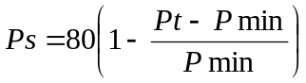 or 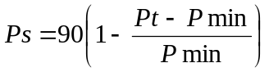
Where
Ps = Points scored for price of bid under consideration
Pt = Price of bid under consideration
Pmin = Price of lowest acceptable bid
- POINTS AWARDED FOR B-BBEE STATUS LEVEL OF CONTRIBUTOR
  - In terms of Regulation 6 (2) and 7 (2) of the Preferential Procurement Regulations, preference points must be awarded to a bidder for attaining the B-BBEE status level of contribution in accordance with the table below:
B-BBEE Status Level of Contributor | Number of points  (90/10 system) | Number of points  (80/20 system)
1 | 10 | 20
2 | 9 | 18
3 | 6 | 14
4 | 5 | 12
5 | 4 | 8
6 | 3 | 6
7 | 2 | 4
8 | 1 | 2
Non-compliant contributor | 0 | 0
- BID DECLARATION
  - Bidders who claim points in respect of B-BBEE Status Level of Contribution must complete the following:

- B-BBEE STATUS LEVEL OF CONTRIBUTOR CLAIMED IN TERMS OF PARAGRAPHS 1.4 AND 4.1
  - B-BBEE Status Level of Contributor: . = ………(maximum of 10 or 20 points)
(Points claimed in respect of paragraph 7.1 must be in accordance with the table reflected in paragraph 4.1 and must be substantiated by relevant proof of B-BBEE status level of contributor.
- SUB-CONTRACTING
  - Will any portion of the contract be sub-contracted?
(Tick applicable box)
YES |  | NO
    - If yes, indicate:
- What percentage of the contract will be subcontracted............…………….…………%
- The name of the sub-contractor…………………………………………………………..
- The B-BBEE status level of the sub-contractor......................................……………..
- Whether the sub-contractor is an EME or QSE
(Tick applicable box)
YES |  | NO
- Specify, by ticking the appropriate box, if subcontracting with an enterprise in terms of Preferential Procurement Regulations,2017:

Designated Group: An EME or QSE which is at last 51% owned by: | EME  √ | QSE  √
Black people
Black people who are youth
Black people who are women
Black people with disabilities
Black people living in rural or underdeveloped areas or townships
Cooperative owned by black people
Black people who are military veterans
OR
Any EME
Any QSE

- DECLARATION WITH REGARD TO COMPANY/FIRM
  - Name of company/firm:…………………………………………………………………………….
  - VAT registration number:……………………………………….…………………………………
  - Company registration number:…………….……………………….…………………………….
  - TYPE OF COMPANY/ FIRM
Partnership/Joint Venture / Consortium
One person business/sole propriety
Close corporation
Company
(Pty) Limited
[Tick applicable box]
DESCRIBE PRINCIPAL BUSINESS ACTIVITIES
………………………………………………………………………………………………………………………………………………………………………………………………………………………………………………………………………………………………………………………………………………
  - COMPANY CLASSIFICATION
Manufacturer
Supplier
Professional service provider
Other service providers, e.g. transporter, etc.
[Tick applicable box]
  - Total number of years the company/firm has been in business:…………………………
  - I/we, the undersigned, who is / are duly authorised to do so on behalf of the company/firm, certify that the points claimed, based on the B-BBE status level of contributor indicated in paragraphs 1.4 and 6.1 of the foregoing certificate, qualifies the company/ firm for the preference(s) shown and I / we acknowledge that:
- The information furnished is true and correct;
- The preference points claimed are in accordance with the General Conditions as indicated in paragraph 1 of this form;
- In the event of a contract being awarded as a result of points claimed as shown in paragraphs 1.4 and 6.1, the contractor may be required to furnish documentary proof to the satisfaction of the purchaser that the claims are correct;
- If the B-BBEE status level of contributor has been claimed or obtained on a fraudulent basis or any of the conditions of contract have not been fulfilled, the purchaser may, in addition to any other remedy it may have –
  - disqualify the person from the bidding process;
  - recover costs, losses or damages it has incurred or suffered as a result of that person’s conduct;
  - cancel the contract and claim any damages which it has suffered as a result of having to make less favourable arrangements due to such cancellation;
  - recommend that the bidder or contractor, its shareholders and directors, or only the shareholders and directors who acted on a fraudulent basis, be restricted by the National Treasury from obtaining business from any organ of state for a period not exceeding 10 years, after the audi alteram partem (hear the other side) rule has been applied; and
  - forward the matter for criminal prosecution.

WITNESSES
- ……………………………………..
- …………………………………….

……………………………………….
SIGNATURE(S) OF BIDDERS(S)
DATE: …………………………………..
ADDRESS …………………………………..
…………………………………..
…………………………………..

ANNEXURE E PRICING SCHEDULE
(Professional Services)

NAME OF BIDDER…………………………………………………………………………………BID NO.: ……………………

CLOSING TIME 12:00……………………………………………………………………………………CLOSING DATE…………

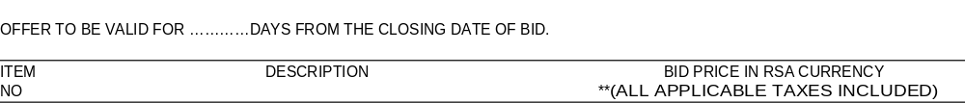
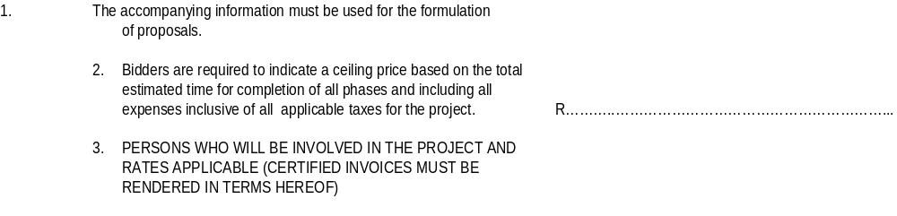
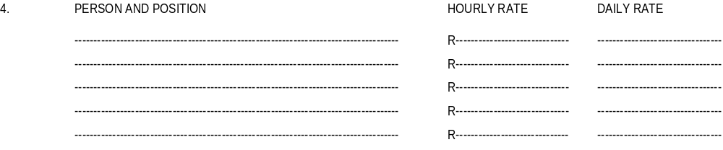
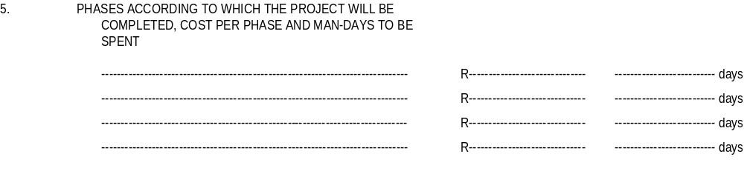
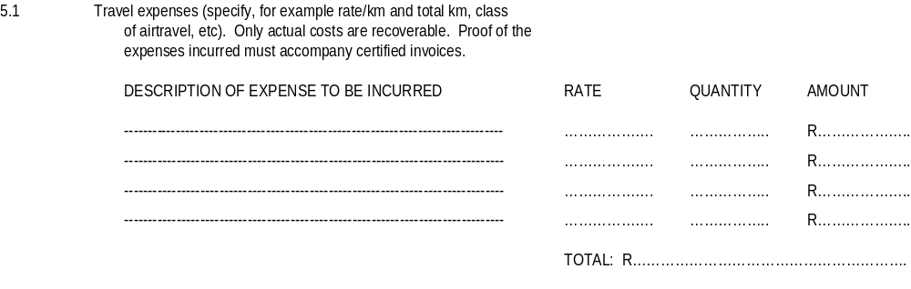

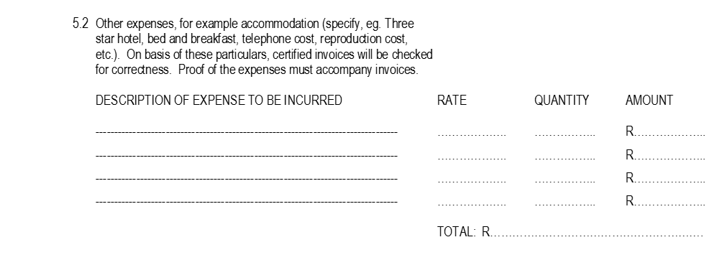
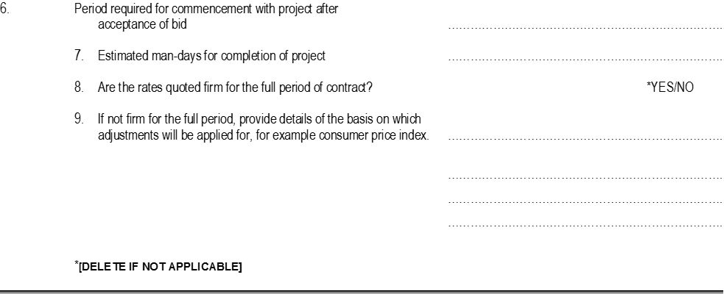

Any enquiries regarding bidding procedures may be directed to the –

TRADE & INVESTMENT KWAZULU-NATAL
TRADE & INVESTMENT HOUSE
1 ARUNDEL CLOSE
KINGSMEAD OFFICE PARK
DURBAN

Tel: 031- 368 9600

Or for technical information –

Tel: SAME AS ABOVE

ANNEXURE F SBD 7.2

CONTRACT FORM - RENDERING OF SERVICES
THIS FORM MUST BE FILLED IN DUPLICATE BY BOTH THE SERVICE PROVIDER (PART 1) AND THE PURCHASER (PART 2). BOTH FORMS MUST BE SIGNED IN THE ORIGINAL SO THAT THE SERVICE PROVIDER AND THE PURCHASER WOULD BE IN POSSESSION OF ORIGINALLY SIGNED CONTRACTS FOR THEIR RESPECTIVE RECORDS.

PART 1 (TO BE FILLED IN BY THE SERVICE PROVIDER)
- I hereby undertake to render services described in the attached bidding documents to (name of the institution)……………………………………. in accordance with the requirements and task directives / proposals specifications stipulated in Bid Number………….……….. at the price/s quoted. My offer/s remain binding upon me and open for acceptance by the Purchaser during the validity period indicated and calculated from the closing date of the bid .

- The following documents shall be deemed to form and be read and construed as part of this agreement:
- Bidding documents, viz
- Invitation to bid;
- Tax clearance certificate;
- Pricing schedule(s);
- Filled in task directive/proposal;
- Preference claims for Broad Based Black Economic Empowerment Status Level of Contribution in terms of the Preferential Procurement Regulations 2011;
- Declaration of interest;
- Declaration of bidder’s past SCM practices;
- Certificate of Independent Bid Determination;
- Special Conditions of Contract;
- General Conditions of Contract; and
- Other (specify)

- I confirm that I have satisfied myself as to the correctness and validity of my bid; that the price(s) and rate(s) quoted cover all the services specified in the bidding documents; that the price(s) and rate(s) cover all my obligations and I accept that any mistakes regarding price(s) and rate(s) and calculations will be at my own risk.

- I accept full responsibility for the proper execution and fulfilment of all obligations and conditions devolving on me under this agreement as the principal liable for the due fulfillment of this contract.

- I declare that I have no participation in any collusive practices with any bidder or any other person regarding this or any other bid.

- I confirm that I am duly authorised to sign this contract.
WITNESSES
- …….…………………………….

- ……….………………………….

DATE: ……………………………..
NAME (PRINT) …………………………….

CAPACITY …………………………….

SIGNATURE …………………………….

NAME OF FIRM …………………………….
DATE …………………………….

SBD 7.2
CONTRACT FORM - RENDERING OF SERVICES

PART 2 (TO BE FILLED IN BY THE PURCHASER)

- I……………………………………………. in my capacity as……………………...………………………
accept your bid under reference number………………dated………………………for the rendering of services indicated hereunder and/or further specified in the annexure(s).

- An official order indicating service delivery instructions is forthcoming.

- I undertake to make payment for the services rendered in accordance with the terms and conditions of the contract, within 30 (thirty) days after receipt of an invoice.

DESCRIPTION OF  SERVICE | PRICE (ALL APPLICABLE TAXES INCLUDED) | COMPLETION DATE | B-BBEE STATUS LEVEL OF CONTRIBUTION | MINIMUM THRESHOLD FOR LOCAL PRODUCTION AND CONTENT (if applicable)

4. I confirm that I am duly authorised to sign this contract.

SIGNED AT ………………………………………ON………………………………..

NAME (PRINT) ………………………………………….

SIGNATURE …………………………………………

OFFICIAL STAMP
WITNESSES
- ….…………………………….

- …..…………………………….

DATE: ……………………………..

ANNEXURE G: CERTIFICATE OF INDEPENDENT BID DETERMINATION FORM (SBD 9)
- This Standard Bidding Document (SBD) must form part of all bids' invited.

- Section 4 (1) (b) (iii) of the Competition Act No. 89 of 1998, as amended, prohibits an agreement between, or concerted practice by, firms, or a decision by an association of firms, if it is between parties in a horizontal relationship and if it involves collusive bidding (or bid rigging).² Collusive bidding is a pe se prohibition meaning that it cannot be justified under any grounds.

- Treasury Regulation 16A9 prescribes that accounting officers and accounting authorities must take all reasonable steps to prevent abuse of the supply chain management system and authorizes accounting officers and accounting authorities to:
- Disregard the bid of any bidder if that bidder or any of its directors have abused the institution's supply chain management system and or committed fraud or any other improper conduct in relation to such system.
- Cancel a contract awarded to a supplier of goods and services if the supplier committed any corrupt or fraudulent act during the bidding process or the execution of that contract.

- This SBD serves as a certificate of declaration that would be used by institutions to ensure that, when bids are considered, reasonable steps are taken to prevent any form of bid-rigging.
- In order to give effect to the above, the attached Certificate of Bid Determination (SBD 9) must be completed and submitted with the bid:
- Includes price quotations, advertised competitive bids, limited bids and proposals.
- Bid rigging (or collusive bidding) occurs when businesses that would otherwise be expected to compete secretly conspire to raise prices or lower the quality of goods and / or services for purchasers who wish to acquire goods and/or services through a bidding process.
- Bid rigging is, therefore, an agreement between competitors not to compete.

I, the undersigned, in submitting the accompany bid (Bid number and Description): ......................................
In response to the invitation for the bid made by Trade and Investment KwaZulu-Natal, do hereby make the following statements that certify to be true and complete in every respect. I certify, on behalf (Name of Bidder): .................................................................
that:
- I have read and I understand the contents of this Certificate;
- I understand that the accompanying bid will be disqualified if this Certificate is found not to be true and complete in every respect;
- I am authorized by the bidder to sign this Certificate, and to submit the accompanying bid, on behalf of the bidder;
- Each person whose signature appears on the accompanying bid has been authorized by the bidder to determine the terms of, and to sign the bid, on behalf of the bidder;
- For the purposes of this Certificate and the accompanying bid, I understand that the word "competitor" shall include any individual or organization, other than the bidder, whether or not affiliated with the bidder, who:
- has been requested to submit a bid in response to this bid invitation;
- could potentially submit a bid in response to this bid invitation, based on their qualifications, abilities or experience; and
- provides the same goods and services as the bidder and/or is in the same line of business as the bidder
- The bidder has arrived at the accompanying bid independently from, and without consultation, communication, agreement or arrangement with any competitor. However, communication between partners in a joint venture or consortium' will not be construed as collusive bidding.
- In particular, without limiting the generality of paragraphs 6 above, there has been no consultation, communication, agreement or arrangement with any competitor regarding:
- prices;
- geographical area where product or service will be rendered (market allocation);
- methods, factors or formulas used to calculate prices;
- the intention or decision to submit or not to submit, a bid;
- the submission of a bid which does not meet the specifications and conditions of the bid; or
- bidding with the intention not to win the bid.
- In addition, there have been no consultations, communications, agreements or arrangements with any competitor regarding the quality, quantity, specifications and conditions or delivery particulars of the products or services to which this bid invitation relates.

- The terms of the accompanying bid have not been, and will not be, disclosed by the bidder, directly or indirectly, to any competitor, prior to the date and time of the official bid opening or of the awarding of the contract.
Joint venture or Consortium means an association of persons for the purpose of combining their expertise, property, capital, efforts, skill and knowledge in an activity for the execution of a contract.

- I am aware that, in addition and without prejudice to any other remedy provided to combat any restrictive practices related to bids and contracts, bids that are suspicious will be reported to the Competition Commission for investigation and possible imposition of administrative penalties in terms of section 59 of the Competition Act No 89 of 1998 and or may be reported to the National Prosecuting Authority (NPA) for criminal investigation and or may be restricted from conducting business with the public sector for a period not exceeding ten (10) years in terms of the Prevention and Combating of Corrupt Activities Act No 12 of 2004 or any other applicable legislation.

............................................................................ ......................................................

Signature Date
............................................................................ .........................................................
Position Name of Bidder

ANNEXURE H: AUTHORITY TO SIGN A BID FORM

- If a Bidder is a company, a certified copy of the resolution by the board of directors, personally signed by the chairperson of the board, authorising the person who signs this bid to do so, as well as to sign any contract resulting from this bid and any other documents and correspondence in connection with this bid and/or contract on behalf of the company must be submitted with this bid, that is before the closing time and date of the bid in the following format:
AUTHORITY BY BOARD OF DIRECTORS by resolution passed by the Board of Directors on .............20….
Mr/Mrs (whose signature appears below) has been duly authorised to sign all documents in connection with this bid on behalf of (Name of Company): ............................................................................................
IN HIS/HER CAPACITY AS: ..................................................................................................................................
SIGNED ON BEHALF OF COMPANY (PRINT NAME): ...................................................................................
SIGNATURE OF SIGNATORY: ...................................................... DATE: ..........................................................
WITNESSES:
1. ............................................................
2. ...........................................................

- If a Bidder is a sole proprietor (One-Person Business) the person who signs the bid to do so, as well as to sign any contract resulting from this bid and any other documents and correspondence in connection with this bid and/or contract on behalf of the sole proprietor must be submitted with this bid, that is before the closing time and date of the bid in the following format:
I, the undersigned ...............................................................................................................................hereby confirm that I am the sole owner of the business trading as ......................................................................
SIGNATURE OF SIGNATORY: ...................................................... DATE: ..........................................................
WITNESSES:
- .............................................................

- .............................................................

- If a Bidder is a partnership, the following particulars in respect of every partner must be furnished and signed by every partner:
Name of Partner | Residential Address | Signature
We, the undersigned partners in the business trading as...................hereby authorise............ to sign this bid as well as any contract resulting from the bid and any other documents and correspondence in connection with this bid and / or contract on behalf of
........................................................................... ......................................................................
SIGNATURE DATE

- In the case of a close corporation submitting a bid, a certified copy of the Founding Statement of such corporation shall be included with the bid, together with the resolution by its members authorising a member or other official of the corporation to sign the documents on their behalf.
By resolution of members at a meeting on .................20.....at......Mr/Ms , whose signature appears below, has been authorised to sign all documents in connection with this bid on behalf of (Name of Close Corporation)................
SIGNED ON BEHALF OF CLOSE CORPORATION: ........ (PRINT NAME) IN HIS/HER CAPACITY AS...............
DATE:...........................................
SIGNATURE OF SIGNATORY:

WITNESSES:
- ................................................

- ................................................

- If the Bidder is a Co-operative, A certified copy of the Constitution of the co-operative must be included with the bid, together with the resolution by its members authoring a member or other official of the co-operative to sign the bid documents on their behalf.

By resolution of members at a meeting on............................. 20........... at...................Mr/Ms ......whose
signature appears below, has been authorised to sign all documents in connection with this bid on behalf of (Name of cooperative): ...............................................................................................................

SIGNATUREOF AUTHORISED REPRESENTATIVE/SIGNATORY: .....................................................................
IN HIS/HER CAPACITY AS: .............................................DATE:...............
SIGNED ON BEHALF OF CO-OPERATIVE: .................................................................................................................
NAME IN BLOCK LETTERS: .........................................................................................................................
WITNESSES:

- ...................................................

- ...................................................

- If a bidder is a joint venture, a certified copy of the resolution/agreement passed/reached signed by the duly authorised representatives of the enterprises, authorising the representatives who sign this bid to do so, as well as to sign any contract resulting from this bid and any other documents and correspondence in connection with this bid and/or contract on behalf of the joint venture must be submitted with this bid, before the closing time and date of the bid.
AUTHORITY TO SIGN ON BEHALF OF THE JOINT VENTURE
By resolution / agreement passed / reached by the joint venture partners on: ................20...................
Mr/Mrs,......................................................................................................................................................
Mr/Mrs.......................................................................................................................................................
Mr/Mr........................................................................................................................................................and
Mr/Mrs............................................................................................................................................................
(whose signatures appear below) have been duly authorised to sign all documents in connection with this bid on behalf of: (Name of Joint Venture): ....................................................................................................
IN HIS/HER CAPACITY AS:...........................................................................................................................
SIGNED ON BEHALF OF (COMPANY NAME): .............................................................................................
SIGNATURE:.....................................................................DATE:......................................................................
IN HIS/HER CAPACITY AS: .........................................................................................................................
SIGNED ON BEHALF OF (COMPANY NAME): .............................................................................................................
SIGNATURE: DATE:...................................................................

IN HIS/HER CAPACITY AS: ......................................................................................................................
SIGNED ON BEHALF OF (COMPANY NAME): .......................................................................................................
SIGNATURE: ..............................................................................DATE: ........................................................

- If a bidder is a consortium, a certified copy of the resolution/agreement passed/reached signed by the duly authorised representatives of concerned enterprises, authorising the representatives who sign this bid to do so, as well as to sign any contract resulting from this bid and any other documents and correspondence in connection with this bid and/or contract on behalf of the consortium must be submitted with this bid, before the closing time and date of the bid.
AUTHORITY TO SIGN ON BEHALF OF THE CONSORTIUM
By resolution/agreement passed/reached by the consortium: on:.......................................................................20.........................Mr/Mrs....................................................
(whose signature appear below) have been duly authorised to sign all documents in connection with this bid on behalf of:....................................................................(Name of Consortium)
IN HIS/HER CAPACITY AS: ..................................................................................................................................
SIGNATURE:..............................................................................DATE:..............................................................

ANNEXURE I: DECLARATION OF BIDDER'S PAST SUPPLY CHAIN MANAGEMENT PRACTICES (SBD 8)
1. This Standard Bidding Document must form part of all bids invited.
2. It serves as a declaration to be used by institutions in ensuring that when goods and services are being procured; all reasonable steps are taken to combat the abuse of the supply chain management system.
3. The bid of any bidder may be disregarded if that bidder, or any of its directors have-
- abused the institution's supply chain management system;
- committed fraud or any other improper conduct in relation to such system; or
- failed to perform on any previous contract.
4. In order to give effect to the above, the following questionnaire must be completed and submitted with the bid.
Item | Question | Yes | No
4.1. | Is the bidder or any of its directors listed on the National Treasury's Database of Restricted Suppliers as companies or persons prohibited from doing business with the public sector?  (Companies or persons who are listed on this Database were informed in writing of this restriction by the Accounting Officer/Authority of the institution that imposed the restriction after the audi alteram partem rule was applied). The Database of Restricted Suppliers now resides on the National Treasury's website(www.treasury.gov.za) and can be accessed by clicking on its link at the bottom of the home page. | Yes | No
4.1.1. | If so, furnish particulars:
4.2. | Is the bidder or any of its directors listed on the Register for Tender Defaulters in terms of section 29 of the Prevention and Combating of Corrupt Activities Act (No 12 of 2004)?  The Register for Tender Defaulters can be accessed on the National Treasury's website (www.treasury.gov.za) by clicking on its link at the bottom of the home page. | Yes | No
4.2.1. | If so, furnish particulars:
4.3. | Was the bidder or any of its directors convicted by a court of law (including a court outside of the Republic of South Africa) for fraud or corruption during the past five years? | Yes | No
4.3.1. | If so, furnish particulars:
4.4. | Was any contract between the bidder and any organ of state terminated during the past five years on account of failure to perform on or comply with the contract? | Yes | No
4.4.1. | If so ,furnish particulars:

CERTIFICATION
I, THE UNDERSIGNED (FULL NAME)...........................................................................................................................
CERTIFY THAT THE INFORMATION FURNISHED ON THIS DECLARATION FORM IS TRUE AND CORRECT.
I ACCEPT THAT, IN ADDITION TO CANCELLATION OF A CONTRACT, ACTION MAY BE TAKEN AGAINST ME
SHOULD THIS DECLARATION PROVE TO BE FALSE.

......................................................................... ...............................................................
Signature Date

........................................................................... ...............................................................
Position Name of Bidder

