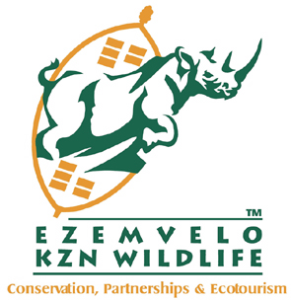

INVITATION TO BID
BID NUMBER: | EKZNW 02/2024/25
DESCRIPTION OF GOOD/SERVICE/WORK REQUIRED: | PROVISION OF CASH COLLECTION SERVICES FOR VARIOUS SITES OF EZEMVELO KZN WILDIFE FOR A PERIOD OF FIVE (5) YEARS
COMPULSORY BRIEFING SESSION DATE & ADDRESS: | Date:14 May 2024  Time: 11:00am  Venue: Ezemvelo KZN Wildlife, Head Office  Queen Elizabeth Park  1 Peter Brown Drive  Montrose, Pietermaritzburg  3202
CLOSING DATE AND TIME: | 30 May 2024  11:00am
BID VALIDITY PERIOD: | 120 calendar days (commencing from the Closing Date)
BID DOCUMENTS DELIVERY ADDRESS: | Ezemvelo KZN Wildlife, Head Office  Queen Elizabeth Park  No. 1 Peter Brown Drive  Montrose, Pietermaritzburg  3202  NB: Bidders to submit both hard copies and electronic documents in the form of a USB.

NAME OF BIDDER:
BID PRICE IN RSA CURRENCY WITH ALL APPLICABLE TAXES INCLUDED: | R
BIDDERS SIGNATURE:

