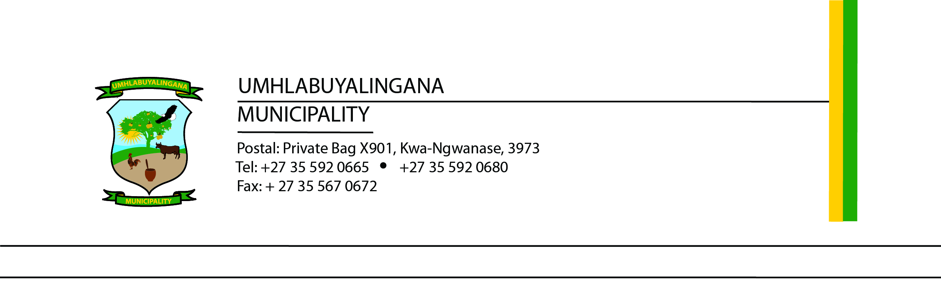

TENDER NOTICE
TENDER NUMBER | DESCRIPTION
UMHL20/2025/2026(A) | Provision of general security services for Manguzi & Skhemelele areas
UMHL20/2025/2026(B) | Provision of general security services for Mbazwana & Mseleni areas
UMHL21/2025/2026 | Provision of VIP security services
Umhlabuyalingana Local Municipality hereby invites tenderers to submit proposals for the Provision of Security Services for a period of 36 months.
Only tenderers with the capacity and capability to execute the works, whose tax matters and PSIRA status are in order, and who are not restricted from trading with the state are eligible to submit tenders.

Bid Documentation
Tender documents are available for free download from:
- National Treasury’s eTender Portal: http://www.etenders.gov.za
- Umhlabuyalingana Local Municipality website: www.umhlabuyalingana.gov.za
This tender document, once agreed to and appointed, shall constitute the contract.

Enquiries
- Procurement: Mr. NM Mthembu – bafanam@mhlabuyalingana.gov.za
- Technical Queries: Mr. CR Khumalo – celumusak@mhlabuyalingana.gov.za

Briefing Session
No compulsory briefing will be held.

Submission Details
- Closing Date and Time: 20 March 2026 at 12h00
- Submission Address: Bid Box, Foyer Umhlabuyalingana Local Municipality R22 Manguzi Main Road KwaNgwanase, 3973

Important Notes
- The Municipality will not be held liable for late delivery of proposals via courier or any other means not placed directly in the tender box before the closing date and time.
- Only proposals submitted on official tender documentation issued by the Municipality will be accepted.
- The Municipality reserves the right to accept any tender in whole or in part and is not bound to accept the lowest bid.
- Tender validity is 90 days from tender closing date.

Evaluation Criteria
Bids will be evaluated in accordance with the Umhlabuyalingana Local Municipality’s approved Supply Chain Management Policy.
- Only bidders who meet the mandatory returnable document requirements will be considered.
- Evaluation will be based on responsiveness.
- Bidders will be further evaluated on functionality, where a minimum score of 60% is required to proceed to the 80/20 preference point system:
  - 80 points – Price
  - 20 points – Specific goals (as detailed in the tender document)

Mr NPE Myeni
Municipal Manager

