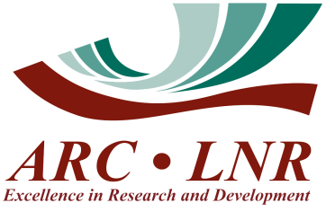
Agricultural Research Council
Plant Health and Protection
Private Bag X134, Queenswood, Pretoria 0121

Reference #: 07_09/24

PURCHASE AND DELIVERY OF A FINE SCALE DIGITAL ANALYTICAL BALANCE

PRODUCT DESCRIPTION AND SPECIFICATIONS:

- Weighing range: Approximately 10 mg to 520 g.
- Readability: 0.0001 g (0.1 mg).
- Repeatability (Max): 0.00025g (0.25 mg).
- Calibration: Internal (Automatic) and External.
- Pan diameter: ≥ 100 mm.
- Display: Touchscreen.
- Anti-draught chamber: Glass [Approx dimensions (W x D x H): 190 x 190 x 226 mm].

QUANTITY: One (1) digital analytical balance.

PROPOSED EXAMPLES: Radwag AS 520.X2.Plus Series or equivalent.

*PLEASE PROVIDE A DETAILED QUOTE* - Quotes should be fully itemised with a breakdown of all component parts so far as is possible. This should include the brand, model and list of included add-ons, accessories, adapters and/or spares if any, as well as the cost of delivery. Please specify any warranty if included.

DELIVERY LOCATION: Agricultural Research Council – Plant Health and Protection
KwaMhlanga/Moloto Road (R573)
Roodeplaat West, Pretoria, 0039
25°36’55.4”S 28°21’51.9”E

ENQUIRIES: Anthony King
Mobile: 082 480 5016
E-mail: KingA@arc.agric.za

