Office Chairs
General Specs:
- Ergonomic Heavy-duty 24-hour usage. Ergonomic Rating of 5 stars
- Lumbar support
- Seat – very high density foam with adjustable seat depth. Must recline.
- Backrest - Upholstered backrest
- Armrest – adjustable armrest
- Mechanism – Forward pivot with locking positions
- Gas Lift: Seat height adjustment

https://ergotherapy.co.za/products/high-back-office-chair-getone?variant=43239300104380&currency=ZAR&utm_medium=product_sync&utm_source=google&utm_content=sag_organic&utm_campaign=sag_organic&gad_source=1&gclid=EAIaIQobChMI4Mb1l4CwhwMV45RQBh1HYAceEAQYASABEgI6V_D_BwE

GetOne® High Back Ergonomic Office Chair – Black Leather ZAR 9,590.00 incl. Delivery
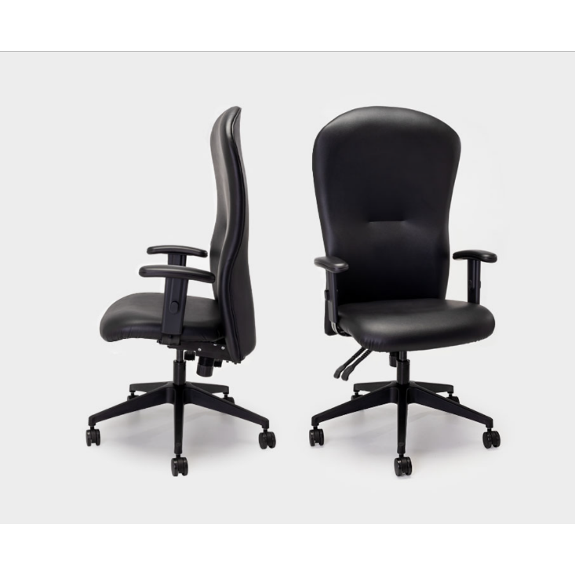
Specs:

The original Ergotherapy ergonomic chair
GetOne® High Back features a patented foam and infinite locking system to provide ultimate support for your lower back in both a neutral and slightly forward sitting position. Available in a wide range of materials and designs.
- 30 Day Comfort Guarantee
- Patented lumbar support
- Customisable Colours
- Free delivery within 5 working days (10 for Western Cape)

https://ixaxaoffice.co.za/products/texas-heavy-duty-chair

Texas Heavy Duty Chair 150kg 24/7 R 5,799.00
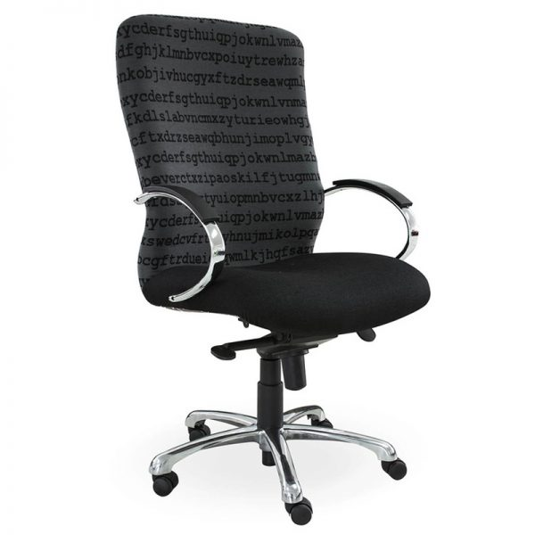
Specs:
A heavy duty office chair made to last, few office chairs can work as hard as you do but the King Cobra is one of them, paired with one of our elegant office desks you can take on the world while working all day.
Ixaxa Office Furniture can help you find the best office furniture you could envisage. From affordable office chairs to high end ergonomic office chairs, Office storage solutions and boardroom tables, Visit our showroom and try out our full range of office furniture with an option to suit every budget or need we sell office furniture that fits you.
Features :
Upholstery: Vulcan (WW) CL6 {Price varies based on fabric options}
Mechanism: Forward pivot
Head Rest: n/a
Lumber Support: Integrated
Seat : Very high density foam
Arms: Chrome LC285 {Price varies based on arm options}
Base: Polished aluminum {Price varies based on base options}
Warranty: 5 years
Weight Capacity :110 Kg
Shipping: 20 working days

https://www.redlineofficechairs.co.za/product/heathrow-24-7-orthopedic-chair/

Heathrow 24/7 Orthopedic Chair
R7,555.00*ex VAT
Priced & Stocked in Black Vulcan Fabric
180 KG Weight Limit for 24/7 Usage
Top of Form
Bottom of Form
SKU: ORTH95CATEGORIES: Orthopaedic Chairs, Heavy Duty Chairs, Karo Chairs

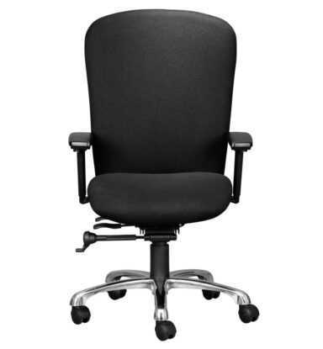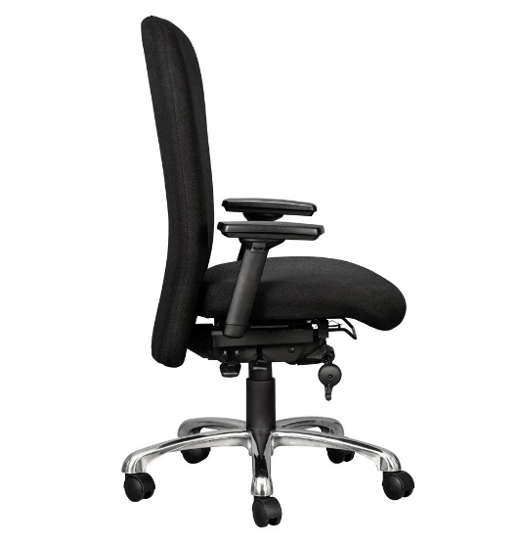
Specs:
The SABS certified HEATHROW 24/7 Heavy Duty Chair.
Control rooms and call centres require a seating solution that exceeds all design standards associated with task chairs used in a conventional office environment.
The Heathrow 24/7 heavy duty chair was specifically designed to meet the highly demanding 24 hour, 7 days a week work environment. Quite simply, all the components used in the Heathrow have been designed to out-perform and out-last any conventional task chair. With its classical style and 5-star ergonomic rating, the Heathrow provides strength and comfort beyond all expectations.
Standard Feature’s Include:
Warranty: 5 Year 24/7
Weight Rating: 180kg
Ergonomic Rating: 5-Star
Quality Certification: SABS
Backrest: Black Upholstered backrest
Seat: Black Upholstered seat with high-density automotive grade moulded foam
Armrests: 3D Fully Adjustable Armrests, attached on a steel bar directly to the mechanism
Mechanism: Heavy duty free-float with infinite locking positions. Seat depth adjustment from 47 to 52cm
Gas Lift: Seat height adjustment (floor to top of seat). Min 47cm, Max 57cm
Base: 700mm polished aluminium 5-star base with 60mm castors
Optional Extra’s Include:
Rubberized Castors

