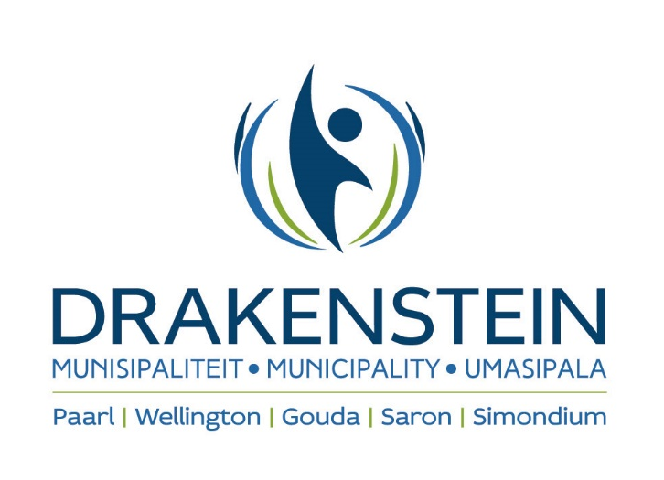

YOU ARE HEREBY INVITED TO BID FOR THE MAINTENANCE SERVICES FOR THE FOUR ELEVATORS AT DRAKENSTEIN OFFICE BUILDINGS IN PAARL FOR A PERIOD UP TO 30 JUNE 2025

TENDER NUMBER: CES 21/2021
DESCRIPTION : MAINTENANCE SERVICES FOR THE FOUR ELEVATORS AT DRAKENSTEIN OFFICE BUILDINGS IN PAARL FOR A PERIOD UP TO 30 JUNE 2025

CLOSING DATE : 14 April 2022
CLOSING TIME : 10H00am
Bids will be opened in the Civic Centre, 1st Floor, Berg River Boulevard, Paarl in public at 10h15.

CIDB : Tenderers must be registered with the CIDB in a SI2 class of construction works
and have a grading designation equal to or higher than that determined in accordance with
the sum tendered or a value determined in accordance with regulation 25(7A) of the
Construction Industry Development Regulations, 2004. It is estimated that tenderers will
need a grading designation of SI2 or higher.

INFORMATION : Obtain documentation:
Drakenstein Municipality
Building Management and Maintenance First Floor
First Floor
Civic Centre
Paarl (GPS: 33 44’ 13.77” S; 18 58’ 4.65” E)

Enquiries regarding tender documentation:
Mr. Arief Slamdien/Enver Tlhapane
Tel: 021 – 807 4621 / 7731
E-mail: Enver.Tlhapane@drakenstein.gov.za

Office hours for collection:
08h30 – 15h00 as from 24 March 2022. A non-refundable fee of R424.00 is payable to
Drakenstein Municipality for collection of documents. No fee will be charged when the tender documents is requested electronically.

A compulsory clarification meeting will be held on 31 March 2022 at 11:00 at Building Management and Maintenance, First floor, Civic Centre, Paarl. (GPS: 33 44’ 13.77” S; 18 58’ 4.65” E). Bidders that fail to attend the compulsory clarification meeting will be disqualified. A representative may only represent one tenderer at this meeting. Bidders that arrive after the starting time of the compulsory clarification meeting as indicated, will be disqualified.

Bids may only be submitted on the bid documentation provided by the municipality and must remain valid for a minimum of 120 days after bid closing.

Telegraphic, telephonic, telex, facsimile, e-mailed or late tenders will not be accepted. The lowest, only or any bid shall not necessarily be accepted and the Council reserves the right to accept any part of the bid.

TENDERS TO BE DEPOSITED IN: The tender box 1 1 in the foyer of the Civic Centre, Drakenstein Municipality, Berg River Boulevard, PAARL, 7620. The tender box 1 is open from Mondays until Thursdays from 08:00 until 16:45 and on Fridays from 08:00 until 15:30. This excludes weekends and public holidays.

NOTE: This tender will be evaluated in terms of the Preferential Procurement Regulations, 2017 that was promulgated by the Minister of Finance on 20 January 2017 in Government Gazette No 40553. Please take note of the responsiveness criteria as stipulated in the tender document.
PROCUREMENT PREFERENCE POINT SYSTEM: 80/20

The successful bidder will be required to fill in and sign a written contract form.
The following conditions to bid exist (failure to comply may result in your bid being disqualified):

1. This bid is subject to the General Conditions of contract for Construction works and special conditions of CIDB and Supply Chain Management.
2. Relevant specifications.
3. Bidders must be registered on Drakenstein Municipality’s supplier database if they wish to conduct business with the municipality.
4. The tax status requirements as per MBD 1 (Part B) must be complied with. No contract will be awarded to any bidder that is not deemed tax compliant at the date of award.
5. Bids submitted must be in a sealed envelope clearly marked with the bid number, placed in the tender box 1 before closing time. Failure will result in the bid being invalid.
6. Functionality is applicable to this bid. Bidders are required to attain a minimum score of 70% for functionality in order to be further evaluated in terms of the preference points system.

