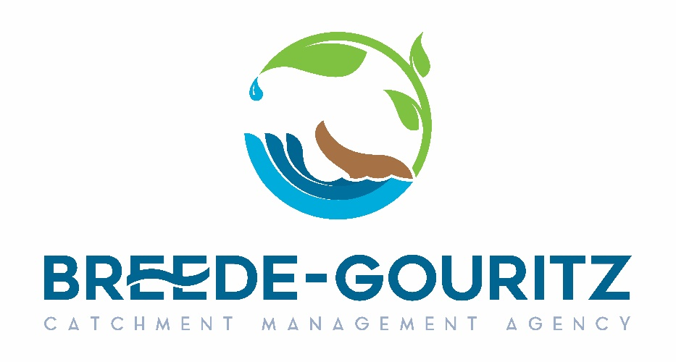
Cnr. Mountain Mill & East Lake Roads, Worcester 6850, Private Bag X3055 Worcester 6850
Enquiries: B Mdoda Tel: 023-3468000 Fax: 023-3472012 E-mail: bmdoda@bgcma.co.za

1

SPECIFICATION FOR THE SERVICE: PROPERTY SEARCH

1. PURPOSE

The WRM needs a system whereby they will draw a report to ensure that the properties that they deal with belongs to the rightful owners.

2. BACKGROUND

The Breede-Gouritz Catchment Management Agency (BGCMA) is an established Public Entity of the Department of Water and Sanitation. The Breede-Gouritz CMA exists to manage water resources responsibly through the continuous engagement with all stakeholders and devolve decision making to the lowest level for the benefit of all water users in the Breede-Gouritz CMA, including the environment. It is the responsibility of the agency to ensure that the water user’s information provided is the correct information and the WRM section needs a system to confirm such information.
Service Providers are required to quote according to the below specification:

Deeds Office Searches | Price Per Search
1 to 500 per month
501 to 1000 per month
1001 to 1500 per month
1501 to 2500 per month
Over 2500 per month
Document Copies (per document)
Other Property Searches
Surveyor-General Diagram (per image)
Street address/erf Conversion
Erf/street address Conversion
Scheme Conversion
Map Search (accessible for 30 days)
Property Transfers
Deeds Office Transfer (per line)
Historical Transfer (per line)
CIPC Searches
Director
Company
Property Search
Spider Search
"Not Found" and "No Result"
WinDeed Property Report
Transfer Instructions
Contact Information Search

Written Quotations must include but not limited to the following:
- Written Quotation, should indicate whether price include vat or not
- Original valid Tax Clearance Certificate,
- Proof to Claim Specific Goals
- Pricing (Service provider should indicate if there will be a price increase/yearly increase
- SBD forms
- The contract will be a 12 month contract
- All quotations will be evaluated on 80/20 evaluation process as per the PPR2022

SPECIFICATION FOR THE SERVICE: PROPERTY SEARCH

Compiled

________________________________
Data Manager: B Mdoda
Date: 15 August 2022

Reviewed and Approved

_______________________
Water Resource Manager: P Mahlaba
Date:15 August 2022

