WS7775: HIRE OF VACUUM TANKERS FOR THE TRANSPORT OF LIQUID SLUDGE FOR 36 MONTHS – QUESTIONS AND ANSWERS

Q: It's Jabulani Mdlalose here from Mzwenjabulo Pty ltd company I will like to know if I can able to submit truck documents after I have been awarded the contract for sluge at the period of 36 because they're hire possibility to outsource the truck but everyone I will submit?
A: All supporting documentation and returnable schedules (including schedule of fleet) required to meet the mandatory criteria, must be submitted with the tender before the closing date in order evaluate the submission and for legal/ compliance reasons. No supporting documentation can be accepted after the tender has closed. Tender documents without schedule of fleet, that fail to meet the mandatory criteria will be rejected as non-responsive.

Q: Thanks can U have a tender documents
A: The tender document is available on eTenders website. You can access via the link below:
https://www.durban.gov.za/pages/business/procurement

Q: I think etender portal website have technical issues
I have accessed the document via the link below and can confirm it works. Please note that I am not able to send you the document directly.

Q: I would just like to the Clarify the size of the tankers you have requested for this scope of work. 5 x 30 000L, 1 x 16000L?
I just want to find out if these sizes are Negotiable.
A: The scope of works requires the tenderer to have a minimum of 5 vacuum tankers and drivers of size ±30m³ with at least 1 tanker of size ±16m³. The size of the tankers must be within an appropriately suitable range and approximately equivalent to the specified sizes and no tankers smaller than 16m³ will be considered.

Q: Is it not possible to be allowed to quote per cube instead of daily rates ,because the truck and tank sizes are different
A: No, it is not allowed to quote per cube. As per the Bill of Quantity, please quote a daily rate for the hire of the tanker, for both the 30m³ (or equivalent) and 16m³ (or equivalent). Please ensure the rate is inclusive of all necessary costs/fees (fuel, drivers, tolls etc) in order to carry out the service as per section 7.2.12 under scope of works, in the tender document. The municipality will only reimburse the service provider for the daily rate quoted. No additional charges will be reimbursed.

Q: Is the municipality going to pay for disposal of the sludge or the contractor
A: The sludge will be disposed at an eThekwini municipality treatment works so there will not be any disposal costs for the service provider. Once the service provider is appointed, a permit will be issued which will allow the tankers to access and dispose municipal sludge at the treatment works site

Q: Can we get a breakdown of the places where the sludge will vacuumed at and the disposal site
Please see below for information. Please note that the sites below are not strict/rigid and may be subject to change. The municipality reserves the right to change the place where the sludge will be disposed off, within the municipal boundary.

From  Wastewater  Treatment Works | GPS  Coordinates | To  Wastewater Treatment Works | GPS Coordinates
Amanzimtoti | 30°00'23.0"S 30°55'10.2"E | Southern | 29°57'19.0"S 30°58'23.0"E
Kingsburgh | 30°04'32.9"S 30°51'23.0"E | Southern | 29°57'19.0"S 30°58'23.0"E
Umkomaas | 30°12'11.1"S 30°47'35.8"E | Southern | 29°57'19.0"S 30°58'23.0"E
Craigieburn | 30°12'29.0"S 30°45'07.2"E | Southern | 29°57'19.0"S 30°58'23.0"E
Isipingo | 29°59'31.7"S 30°54'21.8"E | Southern | 29°57'19.0"S 30°58'23.0"E
Hammarsdale | 29°47'58.9"S 30°39'42.1"E | Umhlatuzana | 29°52’44.8”S 30°53’02.3”E
Hillcrest | 29°47'40.2"S 30°45'21.8"E | Umhlatuzana | 29°52’44.8”S 30°53’02.3”E
Glenwood | 29°48'08.0"S 30°48'30.7"E | Umhlatuzana | 29°52’44.8”S 30°53’02.3”E
Umbilo | 29°50'40.6"S 30°53'20.5"E | Umhlatuzana | 29°52’44.8”S 30°53’02.3”E
Northern | 29°47'46.9"S 30°59'46.3"E | Southern | 29°57'19.0"S 30°58'23.0"E
New Germany | 29°48'21.3"S 30°53'45.2"E | Southern | 29°57'19.0"S 30°58'23.0"E
Dasssenhoek | 29°52'43.7"S 30°47'39.0"E | Umhlatuzana | 29°52’44.8”S 30°53’02.3”E
Mpumalanga | 29°48'12.2"S 30°35'29.4"E | Umhlatuzana | 29°52’44.8”S 30°53’02.3”E
KwaMashu | 29°43'40.1"S 31°00'42.3"E | Southern | 29°57'19.0"S 30°58'23.0"E
Phoenix | 29°40'48.3"S 31°02'11.1"E | Southern | 29°57'19.0"S 30°58'23.0"E
Verulam | 29°38'46.1"S 31°03'48.6"E | Southern | 29°57'19.0"S 30°58'23.0"E
Tongaat | 29°33'37.2"S 31°08'18.4"E | Southern | 29°57'19.0"S 30°58'23.0"E
Fredville | 29°41'37.9"S 30°40'06.3"E | Umhlatuzana | 29°52’44.8”S 30°53’02.3”E
KwaNdengezi | 29°52'05.1"S 30°46'02.1"E | Umhlatuzana | 29°52’44.8”S 30°53’02.3”E
Genezzanno | 29°36'29.8"S 31°09'25.3"E | Southern | 29°57'19.0"S 30°58'23.0"E
Umdloti | 29°40'12.1"S 31°06'59.5"E | Southern | 29°57'19.0"S 30°58'23.0"E
Umhlanga | 29°41'52.5"S 31°04'49.9"E | Southern | 29°57'19.0"S 30°58'23.0"E

Q: Which locations would the tankers be operating in so we may calculate rates accordingly.
Please see below for locations. Please note that the sites below are not strict/rigid and may be subject to change. The municipality reserves the right to change the place where the sludge will be disposed off, within the municipal boundary.

From  Wastewater  Treatment Works | GPS  Coordinates | To  Wastewater Treatment Works | GPS Coordinates
Amanzimtoti | 30°00'23.0"S 30°55'10.2"E | Southern | 29°57'19.0"S 30°58'23.0"E
Kingsburgh | 30°04'32.9"S 30°51'23.0"E | Southern | 29°57'19.0"S 30°58'23.0"E
Umkomaas | 30°12'11.1"S 30°47'35.8"E | Southern | 29°57'19.0"S 30°58'23.0"E
Craigieburn | 30°12'29.0"S 30°45'07.2"E | Southern | 29°57'19.0"S 30°58'23.0"E
Isipingo | 29°59'31.7"S 30°54'21.8"E | Southern | 29°57'19.0"S 30°58'23.0"E
Hammarsdale | 29°47'58.9"S 30°39'42.1"E | Umhlatuzana | 29°52’44.8”S 30°53’02.3”E
Hillcrest | 29°47'40.2"S 30°45'21.8"E | Umhlatuzana | 29°52’44.8”S 30°53’02.3”E
Glenwood | 29°48'08.0"S 30°48'30.7"E | Umhlatuzana | 29°52’44.8”S 30°53’02.3”E
Umbilo | 29°50'40.6"S 30°53'20.5"E | Umhlatuzana | 29°52’44.8”S 30°53’02.3”E
Northern | 29°47'46.9"S 30°59'46.3"E | Southern | 29°57'19.0"S 30°58'23.0"E
New Germany | 29°48'21.3"S 30°53'45.2"E | Southern | 29°57'19.0"S 30°58'23.0"E
Dasssenhoek | 29°52'43.7"S 30°47'39.0"E | Umhlatuzana | 29°52’44.8”S 30°53’02.3”E
Mpumalanga | 29°48'12.2"S 30°35'29.4"E | Umhlatuzana | 29°52’44.8”S 30°53’02.3”E
KwaMashu | 29°43'40.1"S 31°00'42.3"E | Southern | 29°57'19.0"S 30°58'23.0"E
Phoenix | 29°40'48.3"S 31°02'11.1"E | Southern | 29°57'19.0"S 30°58'23.0"E
Verulam | 29°38'46.1"S 31°03'48.6"E | Southern | 29°57'19.0"S 30°58'23.0"E
Tongaat | 29°33'37.2"S 31°08'18.4"E | Southern | 29°57'19.0"S 30°58'23.0"E
Fredville | 29°41'37.9"S 30°40'06.3"E | Umhlatuzana | 29°52’44.8”S 30°53’02.3”E
KwaNdengezi | 29°52'05.1"S 30°46'02.1"E | Umhlatuzana | 29°52’44.8”S 30°53’02.3”E
Genezzanno | 29°36'29.8"S 31°09'25.3"E | Southern | 29°57'19.0"S 30°58'23.0"E
Umdloti | 29°40'12.1"S 31°06'59.5"E | Southern | 29°57'19.0"S 30°58'23.0"E
Umhlanga | 29°41'52.5"S 31°04'49.9"E | Southern | 29°57'19.0"S 30°58'23.0"E

Q: What is the maximum number of tankers needed for this tender in its entirety?
Unfortunately, a maximum number of tankers needed for this contract cannot be estimated. The use of tankers for disposal is dependent on process operations, emergencies and/or available budget. The hiring of tankers would be on an adhoc basis and only if an official order number is given.

Q: With reference to Tender WS-7775 -HIRE OF VACUUM TANKERS FOR THE TRANSPORT OF LIQUID SLUDGE FOR 36 MONTHS
Please can you provide clarification on the below :
Schedule of Fleet - Tenderer is required to have a minimum of 5 vacuum tankers and drivers of size ±30m³ with at least 1 tanker of size ±16m³
• Vacuum Tankers do not come in 30m³ ,they come in 16m³ – Are you perhaps looking for 1 30m3 Tanker and the rest 16m³ Vacuum Tankers ?
A: The contract requires a minimum of 5 tankers and drivers. Of the 5 tankers, the tenderer is required to have 1 vacuum tanker of size ±16m³, and the rest need to be ±30m³

Q: Kindly provide clarity in simple terms of the following paragraph - :
On page 12 under SCT14 Mandatory criteria, on Schedule of fleets paragraph that states
"Tenderer is required to have a minimum of 5 vacuum rankers and drivers of size +/-30m³ with at least 1 tanker of size 16m³"
A: The contract requires a minimum of 5 tankers and drivers. Of the 5 tankers, the tenderer is required to have 1 vacuum tanker of size ±16m³, and 4 or more tankers need to be ±30m³

Q: Is the current service provider(s) on contract have such capacity?? Or this is a new contract for Municipality?
A: There is currently no service provider. The service provider on the previous contract had capacity.

Q: For the above mention tender number you need this truck on the below picture or?
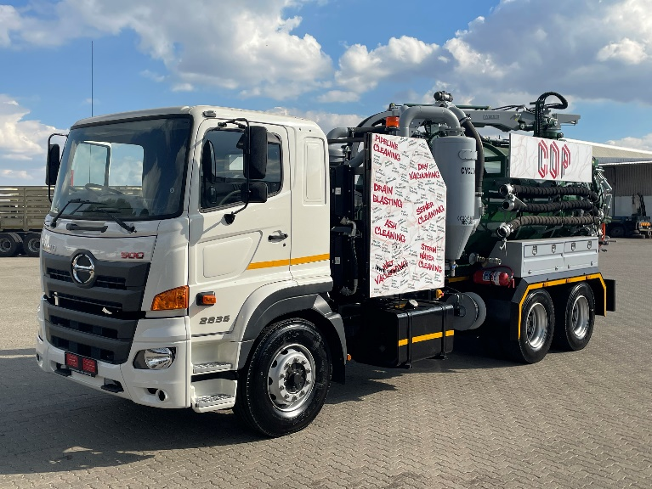
A: The conditions of the tender do not specify the make or look of the tanker, only the size of the tanker. The contract requires a minimum of 5 tankers and drivers. Of the 5 tankers, the tenderer is required to have 1 vacuum tanker of size ±16m³, and 4 or more tankers need to be ±30m³. The tanker must be suitable to carry out the service as per the scope of works.

Q: can i please enquire about the page below on what trailer is the document requesting

A: The document is requesting the registration details of the ±16m³ and/or ±30m³ tanker trailer (should the truck have a separate tanker).

