CAPEX SPECIFICATION:2024/25
Portable professional photo studio
40cm Folding Studio Shooting Tent, Soft Box Photography Lighting Kit with 4 Colors.
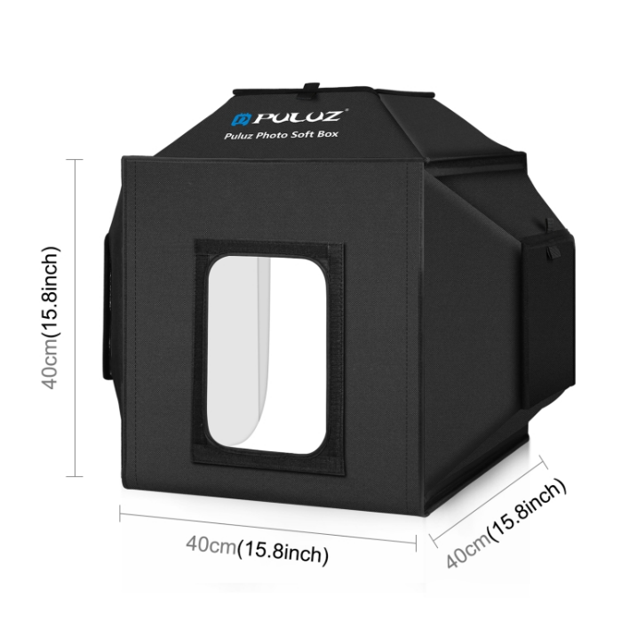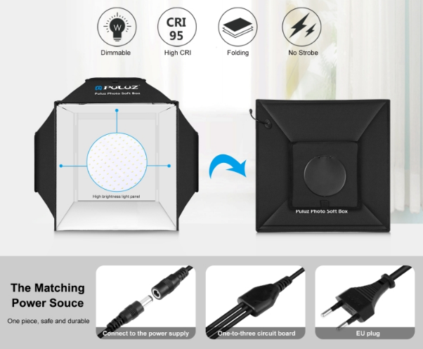

Specifications
1. Material: 600D nylon cloth
2. Number of LED lamp beads: 2 x 168 PCS, 1 x 144PCS=480PCS
3. Lamp bead model: 2835
4. Single lamp bead brightness: 24-26lm
5. White temperature: 5500K
6. Light board size: 180 x 190mm
7. Light board power: 1-30W
8. Voltage: 18V
9. CRI: Ra greater than or equal to 95
10. Power supply: Input: AC 100-240V 1.2A: Output: 18V 4A
11. Power: 72W

