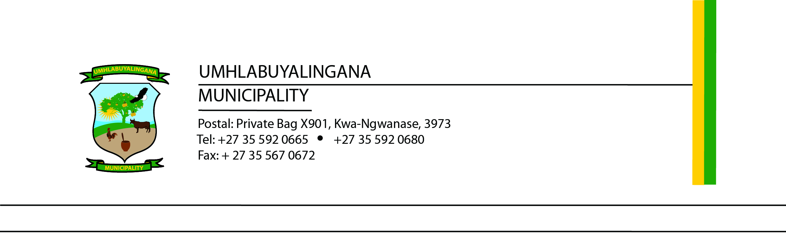

TENDER NOTICE

TENDER NUMBER | DESCRIPTION | CLOSING DATE & TIME
UMHL03/2024/2025 | TRAVELLING AGENCY FOR 36 MONTHS | 24 JULY 2024 @12H00 PM

UMhlabuyalingana Local Municipality hereby invites tenders from qualifying service providers to assist the Municipality with the Rendering of Services for 36 months as tabled above.

Tender documents will be made available to tenderers from Friday, 21 June 2024.
Tender documents can be downloaded and printed at the tenderer’s cost from the National Treasury eTender Publication Portal on www.etenders.gov.za or municipal website www.umhlabuyalingana.gov.za

Any enquiries relating to this tender must be forwarded to BafanaM@mhlabuyalingana.gov.za or SenzoM@mhlabuyalingana.gov.za (SCM Related) Please note that no enquiries will be attended to within the last three (3) calendar days before the date of tender closing.

Tenders must be submitted in hard copy contained in sealed envelopes and marked with “Tender No. and the Description” must be placed in the Tender Box located in the Foyer, Municipal Building, not later than 12h00 on Friday 24 July 2024 where they will be publicly opened. Only tenders placed in the Tender Box shall be accepted.

Tender Validity Period: Three (3) months (90 days) commencing from the closing date of tender.

- Tender Adjudication/Evaluation Criteria:
The tender shall be evaluated on a Two Stage Evaluation System Stage One: Functionality and; Tenderers are required to score more than 70 points as the minimum threshold for functionality.

Stage Two: 80/20 Special Goals System in accordance with the UMhlabuyalingana SCM Policy.

The UMhlabuyalingana Local Municipality does not bind itself to accept the lowest or any tender and reserves the right to accept the whole or any part of a tender. Each tenderer will be informed of the tender result.

MR NPE MYENI
MUNICIPAL MANAGER

