

VISUAL SCOPE OF WORKS REPORT

External Work – Road works and Walk ways
Prepared By: SRSQS QUANTITY SURVEYORS (PTY) LTD
Represented By: Ms. Duduzile Silinda
Approved by: Mr. Marito Mabunda
For:

Westcol Randfontein Campus – Gauteng Province
Represented by: Ms Thobile Nhlangothi (Project Manager)

RANDFONTEIN CAMPUS

ASPHALT ACCESS ROAD RUGBY FIELD TO MAIN ROAD

Construction of Asphalt access road and walk ways at Randfontein Rugby Field
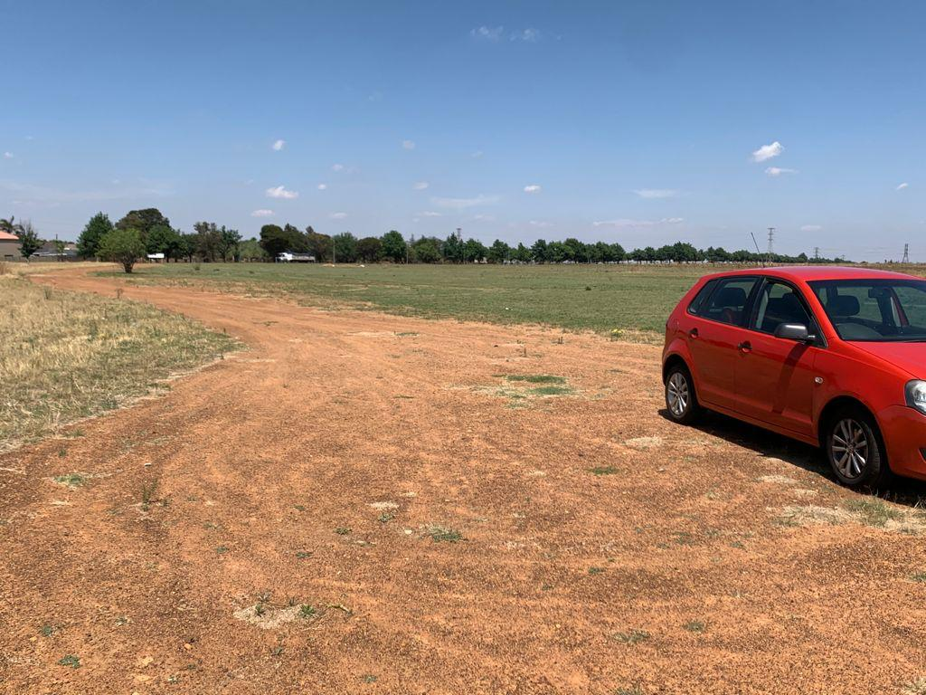
Construction of asphalt access road and walk ways.

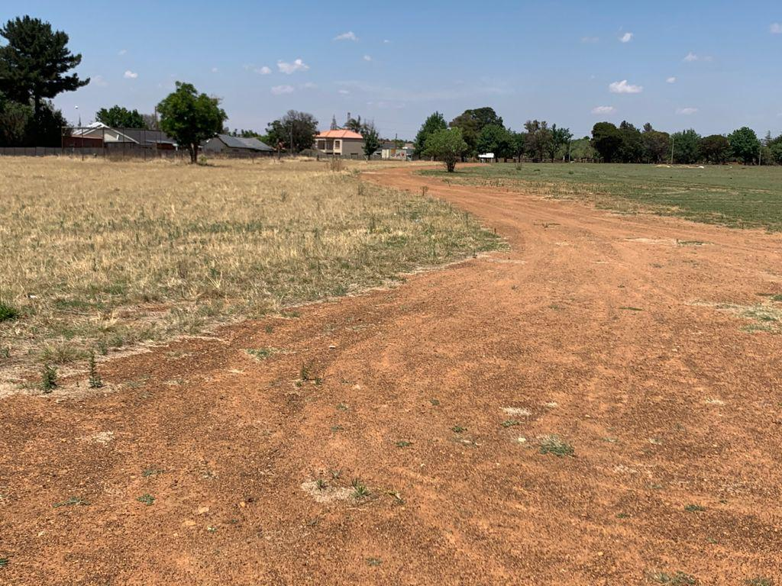
Construction of asphalt access road and walk ways.

