
ARC Infruitec-Nietvoorbij
Private Bag X5026, Stellenbosch, 7599, South Africa
Tel: (021) 809 3172
Fax: (021) 809 3400/3592
OFFICE OF SUPPLY CHAIN MANAGEMENT
- DESCRIPTION OF SERVICE: REPAIRS AND INSTALLATION OF CAR SEATS

REPAIRS AND INSTALLATION OF CAR SEATS |  | Quantity | If No, Please Indicate Deviation
1. Specific Description | Compliance to Specification (Yes)  *Describe If Specification Differs | Quantity | If No, Please Indicate Deviation
Toyota Hilux 2.4 D 1996 Model
- Replacement of the full car seats – upholstery
- Non-Compulsory site inspection Can be arranged with Nomfundo, also the vehicle is located in Elgin, Grabouw,
- Arrangement to bring vehicle to the supplier plant will be arranged once order is issued
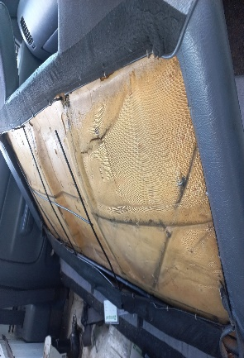

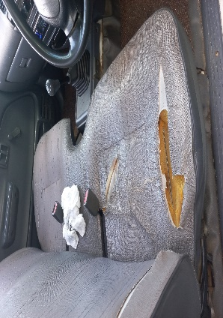

- PRICING SCHEDULE FOR REPAIRS AND INSTALLATION OF CAR SEATS

Item description | Quantity | Unit price | Total Price
- Replacement of the full car seats – upholstery
SUBTOTAL
VAT
GRANDTOTAL

Company name:……………………………………………………………………………………………….
Contact person:………………………………………………………………………………………………..
Contact number:……………………………………………………………………………………………….
Date and signature:…………………………………………………………………………………………
ARC contact person: Nomfundo Mposula - 021 809 3157 / 064 617 2300 – MposulaN@arc.agric.za
NB: Bidders must complete the table below as per the commitment of the RFQ.
AGREE WITH THE ABOVE SPECIFICATION: We the undersigned submit this RFQ in accordance with the conditions contained in the referenced above RFQ document and attach the documents required:
Bidders representative:…………………………………………………………………….
Capacity:………………………………………………………………………………………
Date and signature:…………………………………………………………………………

DISAGREE WITH THE ABOVE SPECIFICATION:
PAGE NUMBER | CLAUSE NUMBER | DEVIATION
Bidders representative and capacity …………………………………………………………………………..
Date and signature …………………………………………………………………………………………………………………………

- EVALUATION PROCESS & CRITERIA STAGE ONE REPAIRS AND INSTALLATION OF CAR SEATS ADMINISTRATIVE COMPLIANCE EVALUATION OF ALL PROPOSALS
 | Comply with specification. Please indicate Yes or No
 | Yes | No | If no, indicate deviation
EVALUATION PROCESS: NB: It must be noted that ARC reserve the rights to request for clarification if all the below questions are not answered properly.
STAGE ONE: ADMINISTRATION COMPLIANCE
All suppliers are duly lodged will be examined to determine compliance with quoting requirements and conditions. Quotes with obvious deviations from the requirements/conditions, will be eliminated or disqualified from further adjudication.
          - Mandatory
Quotes will only be compliant if supplier has submitted the following documents:
Administrative documents
- According to National Treasury SCM Instruction number 4 of 2016/2017, only suppliers who are registered on Central Supplier Database (CSD) may be appointed. Suppliers is therefore encourage to register their entities on CSD, www.csd.gov.za and such information will be verified through Central Supplier Database (CSD);
- All SBD documents must be submitted and completed;
          - Non-Mandatory
- Valid B-BBEE certificate or sworn affidavit certify by commissioner of oaths.

