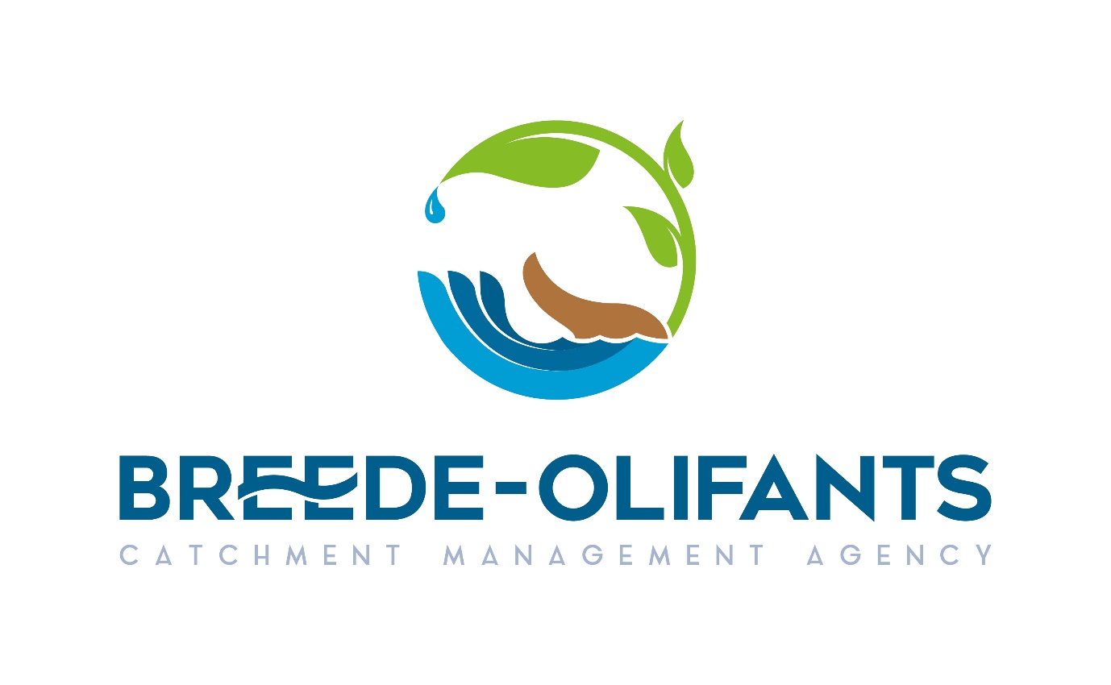
REQUEST FOR QUOTATION: PAYROLL SOFTWARE RENEWAL FOR THE PERIOD OF SIX (6) MONTHS

Item: Payroll software renewal
Quantity: 100 Licenses

Please see detailed specification:
PLREZ.ALFQ1  PLREZ.ALF01  PLRMALF01 | Annual License Fee - Partner Self Service  June 2024 to November 2024 - 100 employees  Annual License Fee - Partner Base Product  June 2024 to November 2024 - 100 employees  Annual License Fee – Partner Multi User  June 2024 to November 2024 - 100 employees

- SCM Related Enquiries:nmafanya@bocma.co.za or asithole@bocma.co.za
- Technical Enquiries: lvanwyk@bocma.co.za
- Closing Date RFQ: Friday 31 May 2024 @ 16:00

- quotations should be valid for a period of 30 days after closing date.

- Please complete the SBD Forms attached,
The following documents must be completed and fully signed.
5.1 SBD 4:
5.2 SBD 6.1
5.3 SBD 8
5.4 SBD 9
Please attach your Tax clearance clearly reflecting tax status Pin
TAX Clearance (reflecting tax status pin)
Evaluation Process:
This RFQ, will be evaluated as per the PPR of 2022 on the 80/20 principle
Where 80 points will be for price and the 20 points for specific goals.

NB: Service providers who did not complete the table on SBD 6.1 of PPR 2022 Completely will not be awarded the points as they would have not claimed the points, in order to claim points for specific goals, the service providers must claim the points on the in SBD 6.1
The specific goals will be evaluated as per the following:
Pricing and Specific goals
The following 80/20 criteria will be used for the evaluation of the proposals:
Pricing: 80 points
Specific Goals: 20 points
Specific goals:
 | 80/20 Preference point system
51% or more black owned | 10
51% or more black women owned | 10
Less than 51% black owned | 5
Less than 51% black women owned | 5
0% black owned | 0
Maximum points | 20

Please provide proof in order to claim specific goals.
Failure to submit proof for specific goals will not disqualify you but you will not score any points for specific goals

