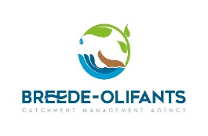
REQUEST FOR QUOTATION: SUPPLY AND DELIVERY OF BRANDED MATERIAL( BANNERS )
- Item: Supply and Delivery of Banners

- Quantity : See below Specification (on the last page of this RFQ )
- Detailed specification: See below Specification (on the last page of this RFQ)

- SCM Related Enquiries and RFQ submission: nmafanya@bocma.co.za

023 346 8000 / Technical Enquiries, Malehlohonolo Mlabateki mmlabateki@bocma.co.za

- Delivery – CNR Mountain Mill & East Lake Road, Worcester, 6850

- Advertised : 19 March 2026

- Closing Date RFQ: 25 March 2026 @ 10:00 am

SERVICE PROVIDERS TO REQUEST RFQ DOCUMENTS FROM NOXOLO MAFANYA USING THE ABOVE MENTIONED DOCUMENTS.

PREFERENCE WILL BE GIVEN TO THE SERVICES PROVIDERS IN WESTERN CAPE

