ADDENDUM NO. 1

Date: 25 April 2023

APPOINTMENT OF A SUITABLE SERVICE PROVIDER TO SUPPLY, DELIVER AND INSTALL HEAVY DUTY METAL CAGE FOR A HOUSING CONTAINER FOR VRYBURG VHF SITE.

RFQ NO: ATNS/SECURITY/RFQ019/06/03/2022/2023 Vryburg VHF Cage

TO ALL PROSPECTIVE BIDDERS

Please take note of the additional information to the Bidding Document for the appointment of a service provider to supply, deliver, and install heavy duty metal cage for a housing container for leeuwkop vhf site.

- Dimensions of the Vryburg container in terms of (Length, Width, and Height)
- Length: 6m
- Width: 3m by 3m
- Height: 2.4m
- The cage must surround the whole container

- Dimensions of the rear view of the leeuwkop container in terms of (Length, and Height)
- Length: 2.6m
- Height: 2.4m

Kindly refer to the picture below for ease of reference.

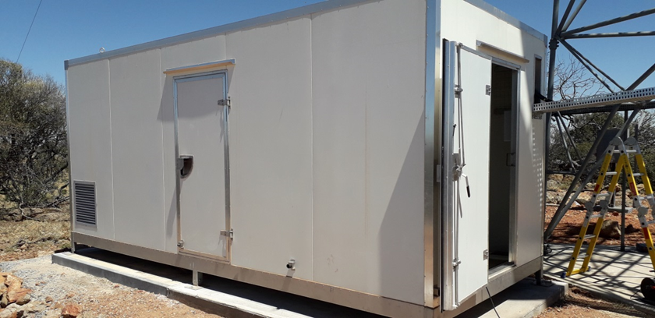

All the other terms and conditions shall remain the same as stipulated in the Bidding Document.

Yours Sincerely,

Molete Makhutle

Graduate: Procurement

