1. Preservation bath fitted with table
Option 1
I know one company in South Africa that specializes in drying equipment. The company is Dryer For Africa, situated at Kempton Park. Don't hesitate to get in touch with Cath@dryersforafrica.co.za. Contact is 0714988436
Or Option 2
- 100 Litres stainless steel computerized bath ( Please note that I need a single pot not a double but the size of a double pot in
- fitted with stainless steel table 2-3 complete with Epoxy legs

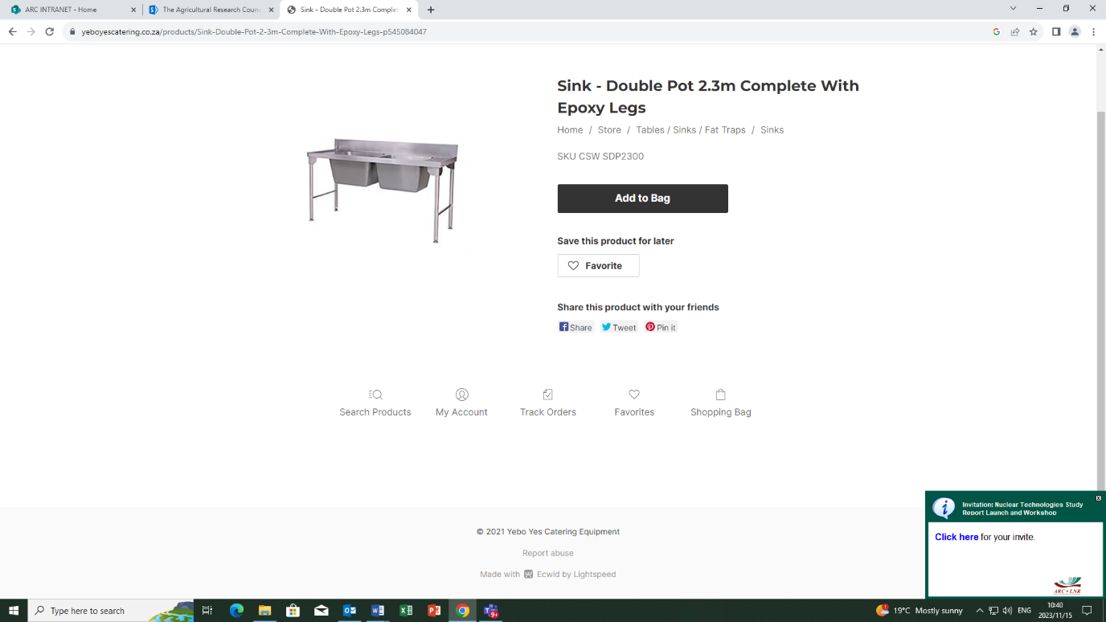
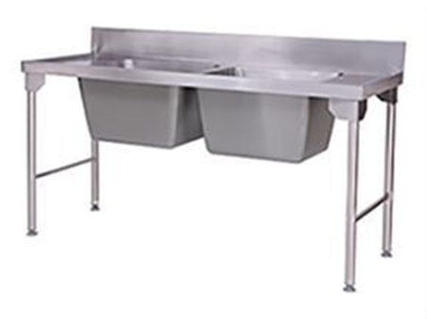

Fitted Table
