

CONFIDENTIAL
eTendering System
Suppliers Help Manual

Prepared by : Group IT Application Operations
Date: 28 August 2023
Revision Issue: 3.0

Table of Contents

1 Background 3
2 Problems 3
3 What’s New 3
4 Getting Started 4
5 Edit Registration 16
6 Log off Button 16
7 Password reset 17
8 General 19

Background

eTendering system is a web-based system that allows suppliers bidding for various tenders advertised on Tender Bulletin system to “upload” their tender documents. Currently the tenderers or suppliers submit tender documents at various Eskom tender offices. eTendering system replaces the manual or physical submission of tender documents at various Eskom tender offices. eTendering system in a nutshell is an electronic box where tender documents can be “dropped” or “uploaded”. Suppliers will be required to register their details before they can be granted access to the eTendering system. An OTP (one time pin) will be sent to both their cell phone and email address.

Quick and direct access is also available by using the following links:

- Tender Bulletin Public website: https://tenderbulletin.ntcsa.co.za - this is used by members of the public, to view and access NTCSA published tenders. eTendering hyperlink will be found on this site. Members of the public may follow prompt instructions once they have clicked on the eTendering link (https://eTendering.eskom.co.za). This link will allow them to upload the required tender documentation.

- eTendering website Public website: https://eTendering.eskom.co.za - this is used by members of the public, to view information about published tenders and submit their tender documents.

- N.B: Members of the public would need to have a CSD number to gain access to eTendering system.

Problems
A channel of communication has been created in case users of the system experiences a problem with the system. In a case users come across some difficulties in using Tender bulletin, eTendering and OpenText systems they need to contact the buyer responsible for the published tender.

What’s New

A new functionality to “add closed tenders”. Closed tenders refers to the tenders which are not listed on Tenderbulletin as normal tenders, but are tenders sent directly to the relevant and potential suppliers who meet the selection and evaluation criteria to offer what the buyer needs. These suppliers will be sent a link via email to bid privately.

Getting Started
To gain access to eTendering portal
- Open your web browser

- Type TenderBulletin (eskom.co.za) or https://eTendering.eskom.co.za

- eTendering system login page will be displayed:

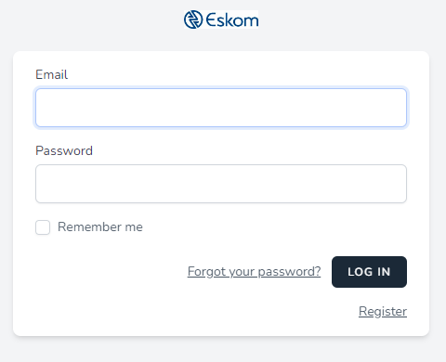

Fig 1

Registration Form | Steps to follow
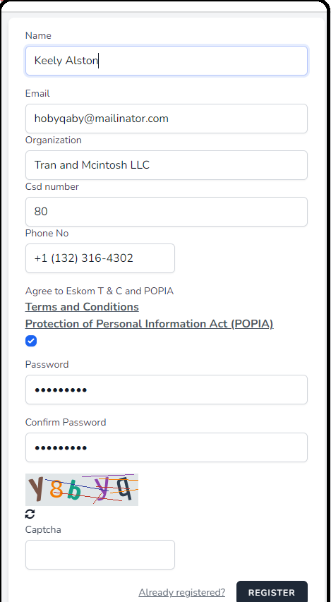 | - Complete all the fields  - Contact number must start with a Plus prefix e.g +27  - Ensure that you also fill in the capture picture to validate that you are not a robot.  - Once all columns have been filled click on register button  - Pop-up message will be displayed asking the registerer to verify the email sent to the provided email address.  - If the email does not come through, click on “Resend Verification Email” button  - email to be resent,  - Once you have received the email click on link provided on the email.  - Then you will be directed back to etendering site with a login screen displayed, now complete the login with your verified email address and password

Fig1.1

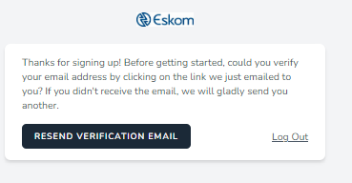
Fig2a.
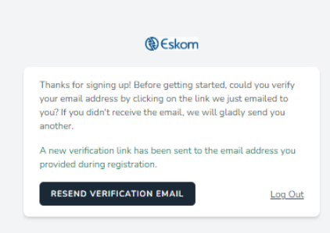
Fig2b.
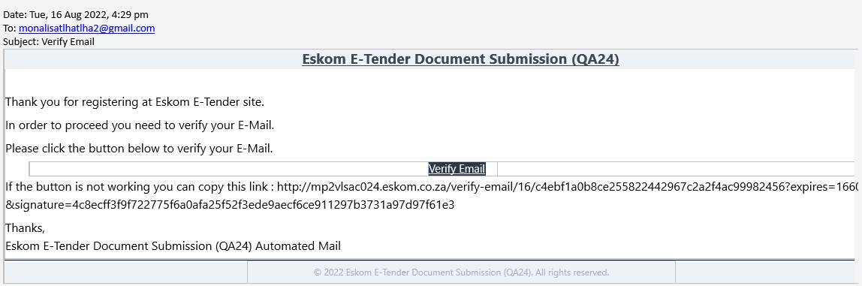
Fig3.

- Once the email is verified, login using your registered email address and password then the OTP page will be displayed

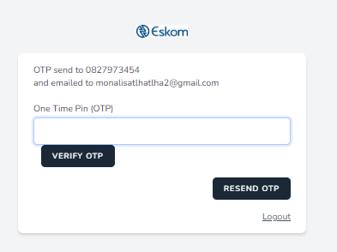
- OTP sent to the registered cellphone number and email address
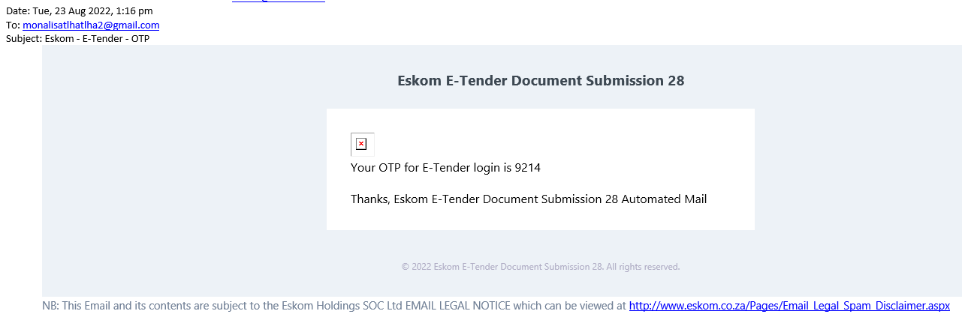

- Insert the otp number then click “Verify OTP” button, to resend OTP click on “Resend OTP” button
- Landing page once OTP is verified
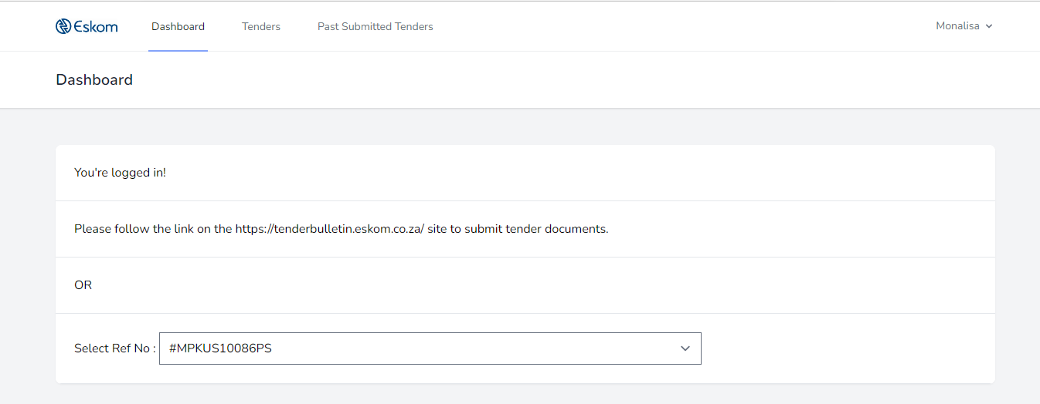

- Select the preferred “Ref No”
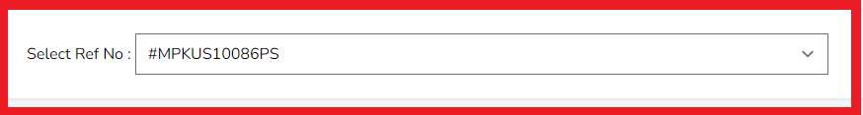

- A page with the preferred Tender information is displayed before tender documentation can be submitted.

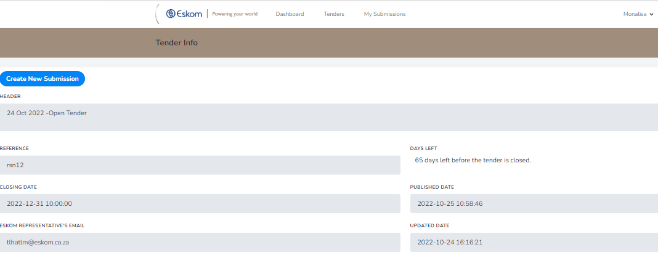
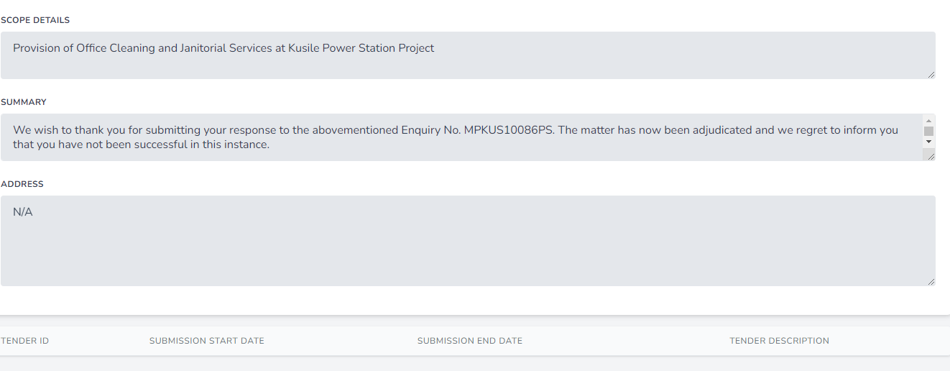

- Click on “Create New Submission” button to submit required Tender documents


- Landing page once clicked on “Create New Submission” button. Take note of the mentioned disclaimers.
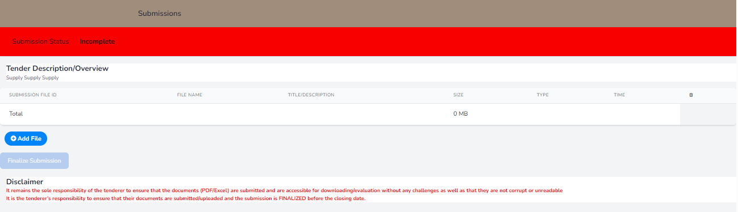
- To submit tender documents, click on “Add file” button
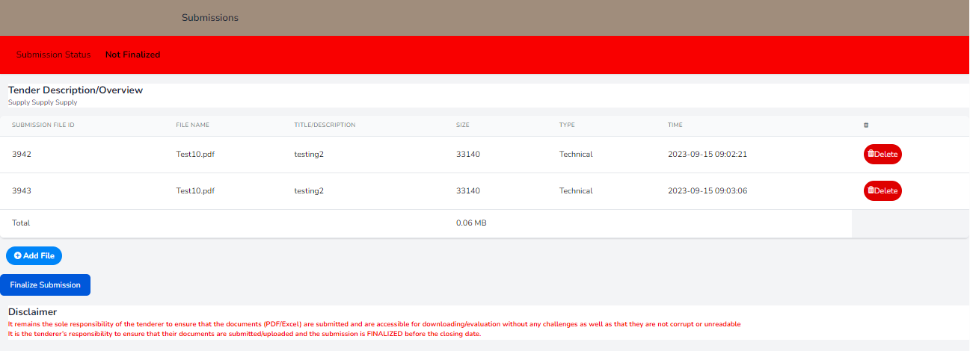
- Upload required tender documents by:

- Giving the file a name
- Select the listed file type e.g.: Technical, commercial, finance and etc
- Choose the file you need to upload
- Then click on “Upload” button, Fig5.
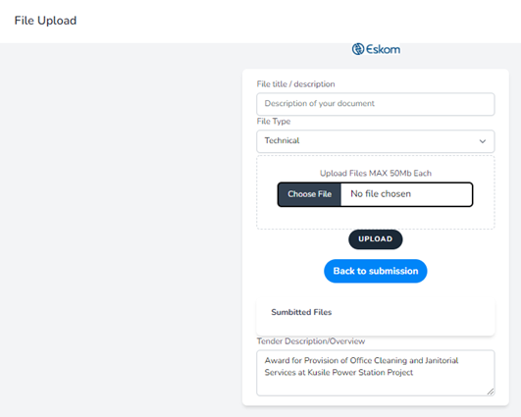
Fig4.
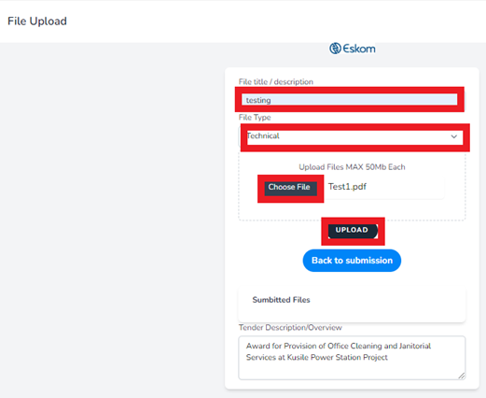
Fig5.
- Once clicked on “Upload” button, this page will be displayed with the submitted document(s). Continue to submit all the required documents under the correct category ,i.e: Technical should be selected if technical documentation is uploaded and etc. Verify all required documents are uploaded before making ‘Final Submission’ by clicking on ‘Finalize Submission’ button.
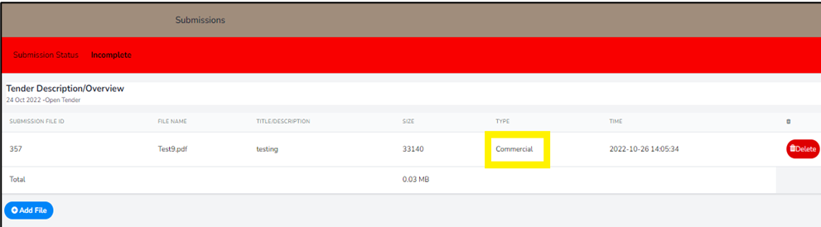

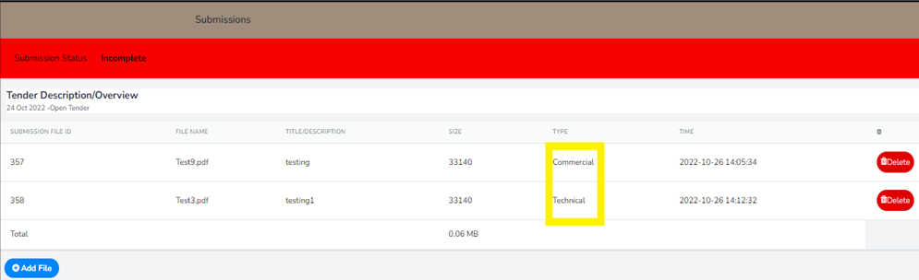
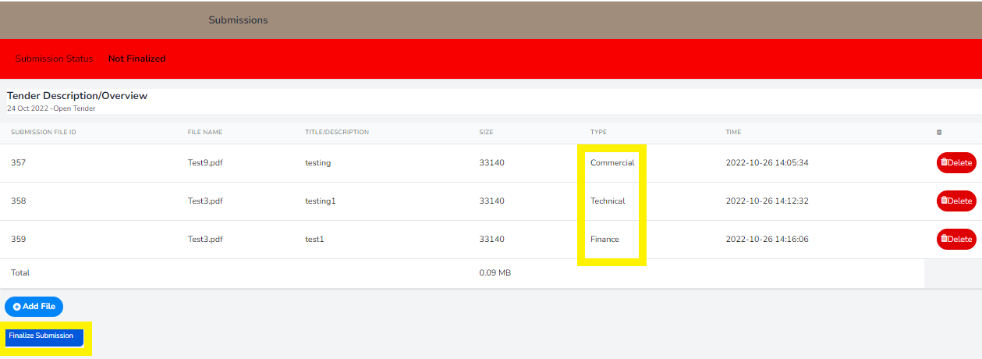

- Click on “Finalize Submission” button. A file size cannot exceed 50MB and a total size of all uploaded files should not exceed 900MB.
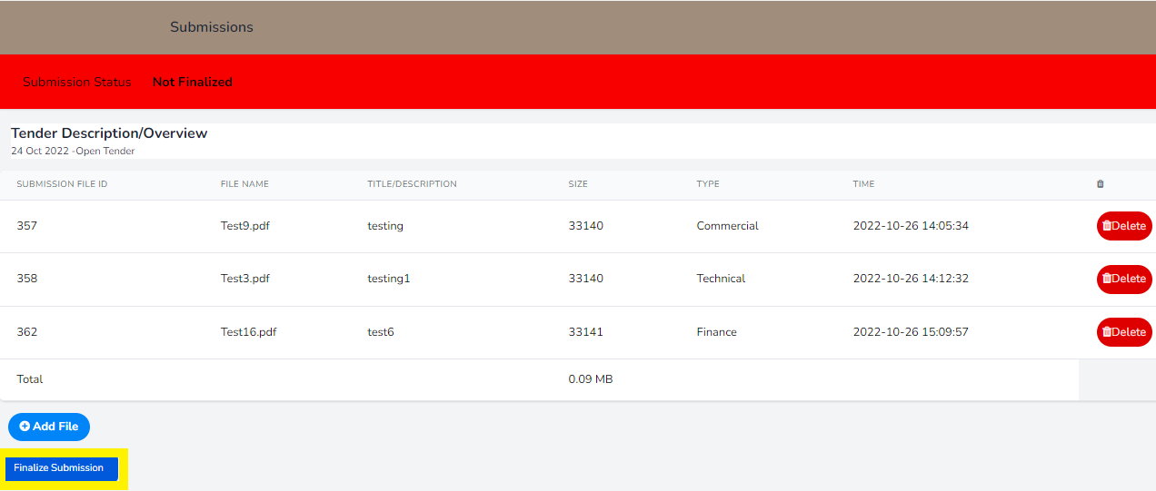

- Once “Finalize Submission” button is clicked the pop-up message confirming the submission will pop-up
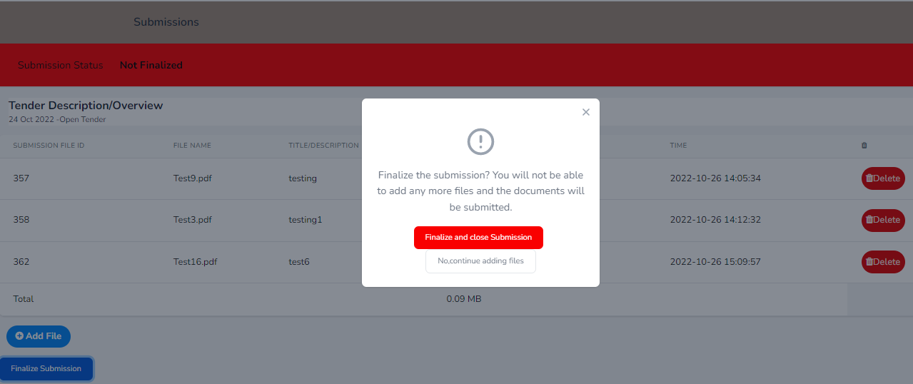

- Click on “Finalise and Close Submission” button to finalize the submission of documents.

If not all documents were submitted or still wish to add or submit more documents, click on “No, continue adding files” button.
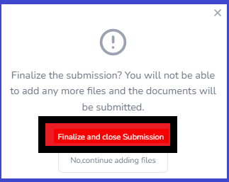
- Once the submission is finalised the page with all submitted documents will display with the submission and closed time and date timestamp at the bottom.
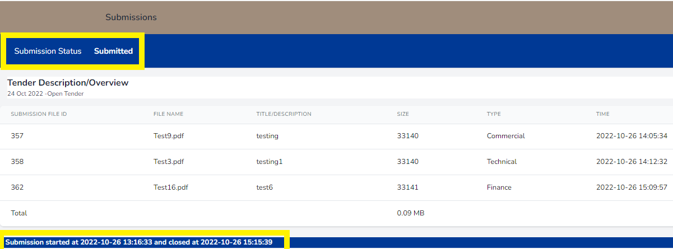
- To view submitted tenders, click on “My Submissions” menu option. All your individually submitted tenders will be displayed.

If you want to view or verify the submitted documents, click on “View Submission” button
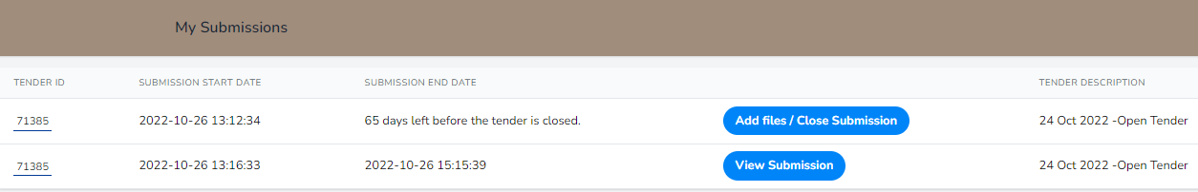
- Once the submission process is complete an email with be sent to the submitter with all submitted documents on email,Fig6.This is the final step for the submitter or tenderer.

It is vital to save the email with the submission ID for future enquiry if need be.

--------Originalmessage--------
From:Eskom E-Tender Document Submission 28 <noone@eskom.co.za>
Date:Tue,23Aug2022,3:42pm
To:monalisatlhatlha2@gmail.com
Subject: Response To Submitter
Eskom E-Tender Document Submission 28

Hi Monalisa
You have finalized a new submission with submission id:14 on tender #MPKUS10086PS closing date : 2022-11-30 10:00:00.
Have started the submission from 2022-08-23 14:28:33 and finalized at 2022-08-23 15:42:28
Tender Description:
Award for Provision of Office Cleaning and Janitorial Services at Kusile Power Station Project

Files Submitted:
ID Original Name Title Size Type
38 Test7.pdf testingCom 33141 Commercial
40 Test1.pdf testingTech 33502 Technical
41 Test15.pdf testingFin 33141 Finance
Thanks,
Eskom E-Tender Document Submission 28 Automated Mail

© 2022 Eskom E-Tender Document Submission 28. All rights reserved.

NB: This Email and its contents are subject to the Eskom Holdings SOC Ltd EMAIL LEGAL NOTICE which can be viewed at http://www.eskom.co.za/Pages/Email_Legal_Spam_Disclaimer.aspx

Fig6.

Edit Registration
To edit already registered information such as Name, Organization, CSD and cell phone number select “Edit Registration” on the drop down, Fig1. New window with information that needs to be updated pop ups,Fig2. Click on “Update” button to update registration details.
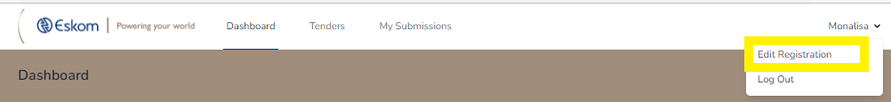
Fig1.
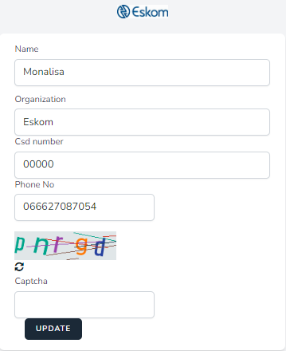
Fig2.

Log off Button
To logout, click “Log out” on the dropdown next to your name
Fig1.

Password reset
To reset a forgotten password, click “Forgot your password” Fig1. and a new screen will pop up to enter an alternative email where the new password will be sent Fig2.Confirmation message will be sent to the user, Fig3.

Fig1.

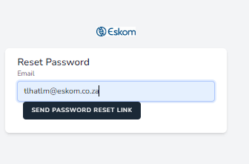

Fig2.

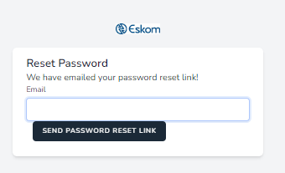

Fig3.
An email confirming password reset will be sent to the email provided.
Click on the link or “Reset Password” button to reset the password.

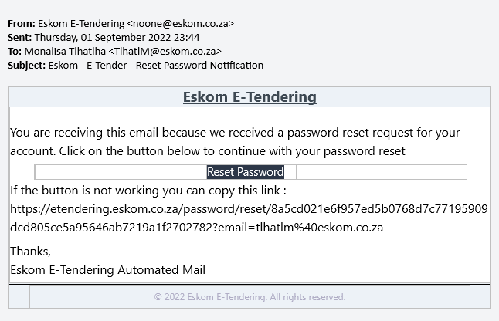

Fig4.

A new window will pop up to reset and confirm the new password, Fig5.Enter new password and confirm then click on “Reset Password” button.

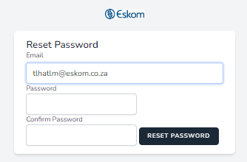

Fig5.

OTP window will pop up, type in the OTP sent to either the cell phone or email address.

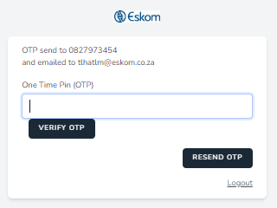

Fig6.
OTP successfully goes through and lands on the below screen, password is successfully reset.

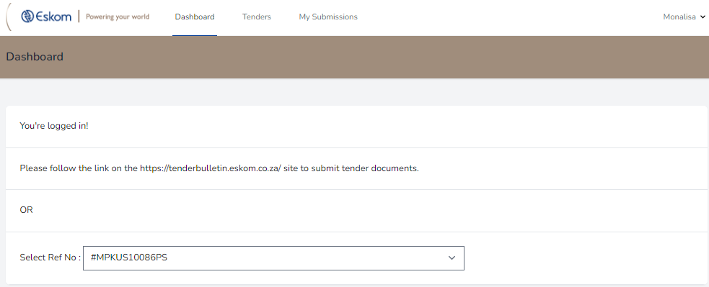

Fig7.

General
This system is compatible to most web browsers however we recommend Ms Edge.

The end.

