

PROVINCE OF KWAZULU-NATAL
DEPARTMENT OF TRANSPORT

QUOTATION DOCUMENT

FOR

SUPPLY & DELIVERY OF ZIBAMBELE TOOLS-AREA OFFICE UMSHWATI

QUOTATION NUMBER No. ZNQ01854/00000/00/PMC/GEN/21/T
Name of Service Provider:
----------------------------------------------------------------

Service Provider: Central Suppliers Database Registration No

-----------------------------------------------------------------
This Quotation closes at 11h00 on Friday,
15 October 2021 at the offices of the Department of Transport, Regional Office, located at 01 Woodlands Road Mountain Rise Pietermaritzburg 3201
No Late submissions will be considered

DOCUMENTS DELIVERED BY HAND MUST BE DEPOSITED IN THE QUOTATION BOX SITUATED IN:

Main Entrance Foyer  Regional Office, 01 Woodlands Road  MOUNTAIN RISE  Pietermaritzburg  3201  Mon to Fri: 07:30 until 16:00 | THE QUOTATION BOX IS AVAILABLE ON THE FOLLOWING DAYS AND TIMES: MONDAYS TO FRIDAYS  08:00 – 16:00

SCM APPENDIX 1

(Supplier to complete & return.

Failure to complete, offer will be invalid)

INVITATION TO QUOTE
YOU ARE HEREBY INVITED TO QUOTE FOR REQUIREMENTS OF THE DEPARTMENT OF TRANSPORT
QUOTATION NUMBER: |  |  | ZNQ01854/00000/00/PMC/GEN/21/T | CLOSING DATE: |  | 15 October 2021 |  |  |  | CLOSING TIME: |  | 11h00
DESCRIPTION |  |  | SUPPLY AND DELIVERY OF ZIBAMBELE TOOLS -AREA OFFICE UMSHWATI
QUOTATION RESPONSE DOCUMENTS MAY BE DEPOSITED IN THE BID BOX SITUATED AT (STREET ADDRESS)
Regional Office PMB |  |  |  | Email:
Main Entrance Foyer |  |  |  | Under no circumstances must suppliers submit their quotation offers/ responses to the official whose name appear on the enquiries.
01 Woodlands Road/Cnr of Old Greytown Road
Pietermaritzburg, 3201
Mon to Fri: 07:30 until 16:00
BIDDING PROCEDURE ENQUIRIES MAY BE DIRECTED TO |  |  |  | TECHNICAL ENQUIRIES MAY BE DIRECTED TO:
CONTACT PERSON |  | Miss Thembelihle Dlomo |  | CONTACT PERSON |  |  |  | Mr Vusi Mthalane
TELEPHONE NUMBER |  | 033-392-6607 |  | TELEPHONE NUMBER |  |  |  | 033 392 6600
FACSIMILE NUMBER |  | 086-544-9297 |  | FACSIMILE NUMBER
E-MAIL ADDRESS |  |  |  | E-MAIL ADDRESS
SUPPLIER INFORMATION
NAME OF BIDDER
POSTAL ADDRESS
STREET ADDRESS
TELEPHONE NUMBER | CODE |  |  |  |  | NUMBER
CELLPHONE NUMBER
FACSIMILE NUMBER | CODE |  |  |  |  | NUMBER
E-MAIL ADDRESS
VAT REGISTRATION NUMBER
SUPPLIER COMPLIANCE STATUS | TAX COMPLIANCE SYSTEM PIN: |  |  |  | OR |  | CENTRAL SUPPLIER DATABASE No: |  | MAAA
B-BBEE STATUS LEVEL VERIFICATION CERTIFICATE | TICK APPLICABLE BOX]  Yes No |  |  | B-BBEE STATUS LEVEL SWORN AFFIDAVIT |  |  |  |  |  |  | [TICK APPLICABLE BOX]  Yes No
[A B-BBEE STATUS LEVEL VERIFICATION CERTIFICATE/ SWORN AFFIDAVIT (FOR EMES & QSEs) MUST BE SUBMITTED IN ORDER TO QUALIFY FOR PREFERENCE POINTS FOR B-BBEE]
ARE YOU THE ACCREDITED REPRESENTATIVE IN SOUTH AFRICA FOR THE GOODS /SERVICES /WORKS OFFERED? | Yes No  [IF YES ENCLOSE PROOF] |  |  | ARE YOU A FOREIGN BASED SUPPLIER FOR THE GOODS /SERVICES /WORKS OFFERED? |  |  |  |  |  |  | Yes No  [IF YES, ANSWER PART B:3 ]
B3: QUESTIONNAIRE TO BIDDING FOREIGN SUPPLIERS
IS THE ENTITY A RESIDENT OF THE REPUBLIC OF SOUTH AFRICA (RSA)? YES NO
DOES THE ENTITY HAVE A BRANCH IN THE RSA? YES NO
DOES THE ENTITY HAVE A PERMANENT ESTABLISHMENT IN THE RSA? YES NO
DOES THE ENTITY HAVE ANY SOURCE OF INCOME IN THE RSA? YES NO
IS THE ENTITY LIABLE IN THE RSA FOR ANY FORM OF TAXATION? YES NO
IF THE ANSWER IS “NO” TO ALL OF THE ABOVE, THEN IT IS NOT A REQUIREMENT TO REGISTER FOR A TAX COMPLIANCE STATUS SYSTEM PIN CODE FROM THE SOUTH AFRICAN REVENUE SERVICE (SARS) AND IF NOT REGISTER AS PER 2.3 BELOW.

SCM APPENDIX 2

(Supplier to complete & return.

Failure to complete, offer will be invalid)

TERMS AND CONDITIONS FOR QUOTING
- BID SUBMISSION:
  - BIDS MUST BE DELIVERED BY THE STIPULATED TIME TO THE CORRECT ADDRESS. LATE BIDS WILL NOT BE ACCEPTED FOR CONSIDERATION.
  - ALL BIDS MUST BE SUBMITTED ON THE OFFICIAL FORMS PROVIDED–(NOT TO BE RE-TYPED) OR IN THE MANNER PRESCRIBED IN THE BID DOCUMENT.
  - THIS BID IS SUBJECT TO THE PREFERENTIAL PROCUREMENT POLICY FRAMEWORK ACT, 2000 AND THE PREFERENTIAL PROCUREMENT REGULATIONS, 2017, THE GENERAL CONDITIONS OF CONTRACT (GCC) AND, IF APPLICABLE, ANY OTHER SPECIAL CONDITIONS OF CONTRACT.
  - IF THE BID WAS INVITED THROUGH A CLOSE QUOTATION PROCESS; WHERE SUPPLIERS WERE SOURCED FROM CSD USING THE COMMODITY PROCESS; SUPPLIERS WHO WERE NOT INVITED WILL NOT BE CONSIDERED.
  - USE OF OMISSION IN THE DOCUMENT IS PROHIBITED, ALL CORRECTIONS MUST BE INITIALLED BY TENDERR AND USE OF CORRECTION FLUID IS PROHIBITED.
  - FAILING TO COMPLY WITH THE ABOVE REQUIREMENTS WILL RESULT IN THE BID BEING NON-RESPONSIVE.
  - THE SUCCESSFUL BIDDER WILL BE REQUIRED TO FILL IN AND SIGN A WRITTEN CONTRACT FORM (SBD7).
- TAX COMPLIANCE REQUIREMENTS
- BIDDERS MUST ENSURE COMPLIANCE WITH THEIR TAX OBLIGATIONS.
- BIDDERS ARE REQUIRED TO SUBMIT THEIR UNIQUE PERSONAL IDENTIFICATION NUMBER (PIN) ISSUED BY SARS TO ENABLE THE ORGAN OF STATE TO VERIFY THE TAXPAYER’S PROFILE AND TAX STATUS.
- APPLICATION FOR TAX COMPLIANCE STATUS (TCS) PIN MAY BE MADE VIA E-FILING THROUGH THE SARS WEBSITE WWW.SARS.GOV.ZA.
- BIDDERS MAY ALSO SUBMIT A PRINTED TCS CERTIFICATE TOGETHER WITH THE BID.
- IN BIDS WHERE CONSORTIA / JOINT VENTURES / SUB-CONTRACTORS ARE INVOLVED; EACH PARTY MUST SUBMIT A SEPARATE TCS CERTIFICATE / PIN / CSD NUMBER.
- WHERE NO TCS IS AVAILABLE BUT THE BIDDER IS REGISTERED ON THE CENTRAL SUPPLIER DATABASE (CSD), A CSD NUMBER MUST BE PROVIDED.
- NO BIDS WILL BE CONSIDERED FROM PERSONS IN THE SERVICE OF THE STATE, COMPANIES WITH DIRECTORS WHO ARE PERSONS IN THE SERVICE OF THE STATE, OR CLOSE CORPORATIONS WITH MEMBERS PERSONS IN THE SERVICE OF THE STATE.”
- COMPLIANCE AND RETURNABLES: THE FOLLOWING RETURNABLE DOCUMENTS MUST RETURNED WITH THE QUOTATION DOCUMENT
- SCM APPENDIX 1 INVITATION TO QUOTE (SBD1 PART A)
- SCM APPENDIX 2 – TERMS AND CONDITIONS FOR BIDDING (SBD1 PART B)
- SCM APPENDIX 3 – OFFICIAL BRIEFING SESSION/SITE INSPECTION CERTIFICATE
- SCM APPENDIX 4 - PRICE INFORMATION PAGE (MUST BE SIGNED OR THE BID IS INVALID)
- SBD 4 - DECLARATION OF INTEREST FORM
- SBD 6.1 - PREFERENCE POINTS CLAIM FORM IN TERMS OF THE PREFERENTIAL PROCUREMENT REGULATIONS 2017;
- SBD 6.2 – DECLARATION CERTIFICATE FOR LOCAL PRODUCTION AND CONTENT TOGETHER WITH ANNEXURE C (COMPLETED IF APPLICABLE)
- SBD 8 - DECLARATION OF SUPPLIERS PAST PERFORMANCE FORM
- SBD 9 - CERTIFICATE OF INDEPENDENT BID DETERMINATION.
NB: FAILURE TO PROVIDE / OR COMPLY WITH ANY OF THE ABOVE PARTICULARS MAY RENDER THE BID INVALID.

SIGNATURE OF BIDDER: ______________________________

CAPACITY UNDER WHICH THIS BID IS SIGNED: ______________________________
(Proof of authority must be submitted e.g. company resolution)

DATE: ______/_______/________________

SCM APPENDIX 3

OFFICIAL BRIEFING SESSION/SITE INSPECTION CERTIFICATE

N. B.: THIS FORM IS ONLY TO BE COMPLETED WHEN APPLICABLE TO THE BID.

Site/Building/Institution Involved: Department of Transport

ZNQ No: ZNQ01854/00000/00/PMC/GEN/21T

Service: SUPPLY AND DELIVERY OF ZIBAMBELE TOOLS -AREA OFFICE UMSHWATI

*******************************************************

N/A
This is to certify that (name) ______________________________________________________

On behalf of ___________________________________________________________________

Visited and inspected the site on ___/___/_________ (date) and is therefore familiar with the circumstances and the scope of the service to be rendered.

________________________________________________
Signature of Bidder or Authorized Representative
(PRINT NAME)

DATE: ___/___/_________

________________________________________________
Name of Departmental Representative
(PRINT NAME)

Departmental Stamp With Signature

QUOTATION REF. NO.: |  |  | ZNQ1854/00000/00/PMC/GEN/21T |  | SCM APPENDIX 4 (Supplier to complete & return. Failure to complete, offer will be invalid)
(ZIBAMBELE TOOLS)
DESCRIPITION & PRICE DETAILS OF GOODS/SERVICE REQUIRED
Quantity | Description |  |  |  |  |  | Price per unit | Price
250 | WHEELBARROW (SABS STANDARD)
200 | SPADES (SABS STANDARD)
200 | PICK HEADS (SABS STANDARD)
200 | PICK HANDLE (SABS STANDARD)
200 | CANE KNIVES (SABS STANDARD)
100 | SLASHERS (SABS STANDARD)
100 | SICKLES (SABS STANDARD)
*Supplier to quote exactly what is and not alternatives …*
Sub-total
(If a VAT Vendor provide proof of VAT Registration) @ 15%
TOTAL
Delivery period after order issued |  |  |  |  |  |  | ONE WEEK
AMOUNT IN WORDS
VALIDITY PERIOD OF OFFER (in months) |  |  |  | 120 days (4 Months)
Supplier Business Stamp
IF APPLICABLE DID THE SUPPLIER ATTEND THE COMPULSORY SITE INSPECTION/BRIEFING SESSION/? YES/NO/NA
I (full name)__________________________________________, in my capacity as ___________________________, the duly authorized representative of __________________________________________________(business name) hereby declares that the offer is in accordance with the attached specification, notes to suppliers & accepts all conditions/clauses contained in the said documents.
Signature of duly authorised representative |  |  |  |  |  | Date: _______________________

NB: failure to sign and full complete as per instructions given on this price page will invalidate the bid.

SBD 4
DECLARATION OF INTEREST

- Any legal person, including persons employed by the state¹, or persons having a kinship with persons employed by the state, including a blood relationship, may make an offer or offers in terms of this invitation to bid (includes an advertised competitive bid, a limited bid, a proposal or written price quotation). In view of possible allegations of favouritism, should the resulting bid, or part thereof, be awarded to persons employed by the state, or to persons connected with or related to them, it is required that the bidder or his/her authorised representative declare his/her position in relation to the evaluating/adjudicating authority where-

- the bidder is employed by the state; and/or
- the legal person on whose behalf the bidding document is signed, has a relationship with persons/a person who are/is involved in the evaluation and or adjudication of the bid(s), or where it is known that such a relationship exists between the person or persons for or on whose behalf the declarant acts and persons who are involved with the evaluation and or adjudication of the bid.

- In order to give effect to the above, the following questions must be completed and submitted with the bid.

  - The names of all directors / trustees / shareholders2 / members/individuals, their individual identity numbers, tax reference numbers to inserted in the table below. If applicable, employee / PERSAL numbers must be indicated in the last column.

Full Name | Position held  (shareholder, director, trustee, member, individual etc.) | Identity Number | Personal Income Tax Reference Number | State Employee Number / Persal Number
If space provided is insufficient, details as specified above can be attached, however, this must be clearly indicated in this table

Full names of bidder or his or her representative:

………………………………………………………………………………………………………………………………………………

Identity Number:

…………………………………………………………………………………………………………………………………………………

Position occupied in the Company (Director, trustee, shareholder, member)

……………………………………………………………………………………………………………………………………………………

Registration number of company, enterprise, close corporation, partnership, agreement or trust

……..……………………………………………………………………………………………………………………………………………

Tax reference number:

…………………………………………………………………………………………………………………………………………………

VAT Registration number:

……………………………………………………………………………………………………………………………………………………

 | Are you or any person connected with the bidder presently employed by the state? Kindly mark the applicable answer with a tick √.  If so, furnish the following particulars:
  YES
  NO
Name of person/director/trustee/shareholder/member:

…………………………………………………………………………………………………………………………………………………

Name of state institution at which you or the person connected to the bidder is employed:

…………………………………………………………………………………………………………………………………………………

Position occupied in the state institution:

……………………………………………………………………………………………………………………………………………………

Any other particulars:

……………………………………………………………………………………………………………………………………………………

……………………………………………………………………………………………………………………………………………………..

……………………………………………………………………………………………………………………………………………………..

 | If you or any person connected with the bidder are presently employed by the state, did you obtain the appropriate authority to undertake remunerative work outside employment in the public sector? Kindly mark the applicable answer with a tick √.
  YES
  NO
  N/A
 | If yes, did you attach proof of such authority to the bid document?  (Note: failure to submit proof of such authority, where applicable, may arise in the disqualification of the bid. Kindly mark the applicable answer with a tick √.
  YES
  NO
  N/A
If no, furnish reasons for non-submission of such proof:

……………………………………………………………………………………………………………………………………………………

……………………………………………………………………………………………………………………………………………………

……………………………………………………………………………………………………………………………………………………

 | Did you or your spouse, or any of the company’s directors/ trustees/ members of their spouses conduct business with the state in the previous twelve months?  Kindly mark the applicable answer with a tick √.
  YES
  NO
If yes, furnish particulars:

……………………………………………………………………………………………………………………………………………………

…………………………………………………………………………………………………………………………………………………….

………………………………………………………………………………………………………………………………………………….

 | Do you, or any person connected with the bidder, have any relationship (family, friend, other) with a person employed by the state and who may be involved with the evaluation or adjudication of the bid? Kindly mark the applicable answer with a tick √.
  YES
  NO
If yes, furnish particulars:

……………………………………………………………………………………………………………………………………………………

…………………………………………………………………………………………………………………………………………………….

………………………………………………………………………………………………………………………………………………….

 | Are you, or any person connected with the bidder, aware of any relationship (family, friend, other) between any other bidder and any person employed by the state who may be involved with the evaluation and or adjudication of this bid?  Kindly mark the applicable answer with a tick √.
  YES
  NO
If yes furnish particulars.

……………………………………………………………………………………………………………………………………………………

……………………………………………………………………………………………………………………………………………………

……………………………………………………………………………………………………………………………………………………

 | Do you or any of the directors / trustees / shareholders / members of the company have any interest in any other related companies whether or not they are bidding for this contract? Kindly mark the applicable answer with a tick √.
  YES
  NO
If yes, furnish particulars.
………………………………………………………………………………………………………………………………………………

………………………………………………………………………………………………………………………………………………

………………………………………………………………………………………………………………………………………………

 | Have you or any of the directors / trustees / shareholders / members of the company or the company in general provided any gifts, rewards, awards, sponsorships, donations or hospitality to the department or any of its employees or their family in the last 12 months?  Kindly mark the applicable answer with a tick √.
  YES
  NO
If yes, furnish particulars, including estimated value.

……………………………………………………………………………………………………………………………………

……………………………………………………………………………………………………………………………………

……………………………………………………………………………………………………………………………………

DECLARATION

I, THE UNDERSIGNED

(NAME)_____________________________________________________________________

CERTIFY THAT THE INFORMATION FURNISHED IN PARAGRAPHS 2 AND 3 ABOVE IS CORRECT, AND I HAVE TAKEN REASONABLE DILIGENT STEPS (AS REQUIRED BY S76 OF THE COMPANIES ACT, 2011, WHERE APPLICABLE), TO ENSURE THAT THE INFORMATION PROVIDED IS CORRECT.

I ACCEPT THAT THE STATE MAY REJECT THE BID OR ACT AGAINST ME SHOULD THIS DECLARATION PROVE TO BE FALSE.

NAME OF BIDDER: _____________________________________

POSITION: _____________________________________

SIGNATURE: _____________________________________

DATE: _____________________________________

Every question must be answered individually on this form, whether a relationship is present or not: Failure to do so will invalidate your tender/bid

SBD 6.1

PREFERENCE POINTS CLAIM FORM IN TERMS OF THE PREFERENTIAL PROCUREMENT REGULATIONS 2017

This preference form must form part of all bids invited. It contains general information and serves as a claim form for preference points for Broad-Based Black Economic Empowerment (B-BBEE) Status Level of Contribution

NB: BEFORE COMPLETING THIS FORM, BIDDERS MUST STUDY THE GENERAL CONDITIONS, DEFINITIONS AND DIRECTIVES APPLICABLE IN RESPECT OF B-BBEE, AS PRESCRIBED IN THE PREFERENTIAL PROCUREMENT REGULATIONS, 2017.

- GENERAL CONDITIONS
  - The following preference point systems are applicable to all bids:
- the 80/20 system for requirements with a Rand value of up to R50 000 000 (all applicable taxes included); and
- the 90/10 system for requirements with a Rand value above R50 000 000 (all applicable taxes included).

a) The value of this bid is estimated to not exceed R50 000 000 (all applicable taxes included) and therefore the 80/20 preference point system shall be applicable; or
b) The 80/20 preference point system will be applicable to this tender.

  - Points for this bid shall be awarded for:
- Price; and
- B-BBEE Status Level of Contributor.
  - The maximum points for this bid are allocated as follows:
 | POINTS
PRICE | 80
B-BBEE STATUS LEVEL OF CONTRIBUTOR | 20
Total points for Price and B-BBEE must not exceed | 100

  - Failure on the part of a bidder to submit proof of B-BBEE Status level of contributor together with the bid, will be interpreted to mean that preference points for B-BBEE status level of contribution are not claimed.
  - The purchaser reserves the right to require of a bidder, either before a bid is adjudicated or at any time subsequently, to substantiate any claim in regard to preferences, in any manner required by the purchaser.

- DEFINITIONS
- “B-BBEE” means broad-based black economic empowerment as defined in section 1 of the Broad-Based Black Economic Empowerment Act;
- “B-BBEE status level of contributor” means the B-BBEE status of an entity in terms of a code of good practice on black economic empowerment, issued in terms of section 9(1) of the Broad-Based Black Economic Empowerment Act;
- “bid” means a written offer in a prescribed or stipulated form in response to an invitation by an organ of state for the provision of goods or services, through price quotations, advertised competitive bidding processes or proposals;
- “Broad-Based Black Economic Empowerment Act” means the Broad-Based Black Economic Empowerment Act, 2003 (Act No. 53 of 2003);
- “EME” means an Exempted Micro Enterprise in terms of a code of good practice on black economic empowerment issued in terms of section 9 (1) of the Broad-Based Black Economic Empowerment Act;
- “functionality” means the ability of a tenderer to provide goods or services in accordance with specifications as set out in the tender documents.
- “prices” includes all applicable taxes less all unconditional discounts;
- “proof of B-BBEE status level of contributor” means:
- B-BBEE Status level certificate issued by an authorized body or person;
- A sworn affidavit as prescribed by the B-BBEE Codes of Good Practice;
- Any other requirement prescribed in terms of the B-BBEE Act;
- “QSE” means a qualifying small business enterprise in terms of a code of good practice on black economic empowerment issued in terms of section 9 (1) of the Broad-Based Black Economic Empowerment Act;

- “rand value” means the total estimated value of a contract in Rand, calculated at the time of bid invitation, and includes all applicable taxes;

- POINTS AWARDED FOR PRICE
  - THE 80/20 OR 90/10 PREFERENCE POINT SYSTEMS
A maximum of 80 or 90 points is allocated for price on the following basis:

80/20 or 90/10

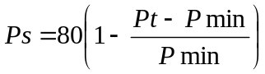 or 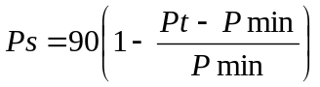
Where
Ps = Points scored for price of bid under consideration
Pt = Price of bid under consideration
Pmin = Price of lowest acceptable bid

- POINTS AWARDED FOR B-BBEE STATUS LEVEL OF CONTRIBUTOR
  - In terms of Regulation 6 (2) and 7 (2) of the Preferential Procurement Regulations, preference points must be awarded to a bidder for attaining the B-BBEE status level of contribution in accordance with the table below:
B-BBEE Status Level of Contributor | Number of points  (90/10 system) | Number of points  (80/20 system)
1 | 10 | 20
2 | 9 | 18
3 | 6 | 14
4 | 5 | 12
5 | 4 | 8
6 | 3 | 6
7 | 2 | 4
8 | 1 | 2
Non-compliant contributor | 0 | 0

4.2. EME’S AND QSE’S MUST COMPLETE THE FOLLOWING APPLICABLE AFFIDAVIT FORM TO CLAIM PREFERENCE POINTS
SWORN AFFIDAVIT – B-BBEE EXEMPTED MICRO ENTERPRISE

I, the undersigned,

Full name & Surname
Identity number

Hereby declare under oath as follows:

- The contents of this statement are to the best of my knowledge a true reflection of the facts.
- I am a member / director / owner of the following enterprise and am duly authorised to act on its behalf:

Enterprise Name
Trading Name (If
Applicable):
Registration Number
Enterprise Physical
Address:
Type of Entity (CC, (Pty)
Ltd, Sole Prop etc.):
Nature of Business:
Definition of “Black  People” | As per the Broad-Based Black Economic Empowerment Act 53 of 2003 as  Amended by Act No 46 of 2013 “Black People” is a generic term which  means Africans, Coloureds and Indians –  - who are citizens of the Republic of South Africa by birth or descent;  or  - who became citizens of the Republic of South Africa by naturalisationi-  - before 27 April 1994; or  - on or after 27 April 1994 and who would have been entitled to acquire citizenship by naturalization prior to that date;”
Definition of “Black  Designated Groups” | “Black Designated Groups means:  - unemployed black people not attending and not required by law to attend an educational institution and not awaiting admission to an educational institution;  - Black people who are youth as defined in the National Youth Commission Act of 1996;  - Black people who are persons with disabilities as defined in the Code of Good Practice on employment of people with disabilities issued under the Employment Equity Act;  - Black people living in rural and under developed areas;  - Black military veterans who qualifies to be called a military veteran in terms of the Military Veterans Act 18 of 2011;”

- I hereby declare under Oath that:
- The Enterprise is ______________% Black Owned as per Amended Code Series 100 of the amended Codes of Good Practice issued under section 9 (1) of B-BBEE Act No 53 of 2003 as amended by Act No 46 of 2013,
- The Enterprise is ______________% Black Female Owned as per Amended Code Series 100 of the Amended Codes of Good Practice issued under section 9 (1) of B-BBEE Act No 53 of 2003 as Amended by Act No 46 of 2013,
- The Enterprise is ______________% Black Designated Group Owned as per Amended Code Series 100 of the Amended Codes of Good Practice issued under section 9 (1) of B-BBEE Act No 53 of 2003 as Amended by Act No 46 of 2013,
- Black Designated Group Owned % Breakdown as per the definition stated above:
- Black Youth % = ______________%
- Black Disabled % =______________%
- Black Unemployed % =______________%
- Black People living in Rural areas % = ______________%
- Black Military Veterans % =______________%
- Based on the Financial Statements/Management Accounts and other information available on the latest financial year-end of ___/___/_______, (dd/mm/yyyy) the annual Total Revenue was R10,000,000.00 (Ten Million Rands) or less
- Please Confirm on the below table the B-BBEE Level Contributor, by ticking the applicable box.
100% Black Owned | Level One (135% B-BBEE procurement recognition  level)
At least 51% Black  Owned | Level Two (125% B-BBEE procurement  recognition level)
Less than 51% Black  Owned | Level Four (100% B-BBEE procurement recognition  level)

- I know and understand the contents of this affidavit and I have no objection to take the prescribed oath and consider the oath binding on my conscience and on the Owners of the Enterprise, which I represent in this matter.
- The sworn affidavit will be valid for a period of 12 months from the date signed by commissioner.

Deponent Signature: ___________________

Date: _____/______/___________________

Stamp

______________________
Signature of Commissioner of Oaths

SWORN AFFIDAVIT – B-BBEE QUALIFYING SMALL ENTERPRISE

I, the undersigned,

Full name & Surname
Identity number

Hereby declare under oath as follows:

- The contents of this statement are to the best of my knowledge a true reflection of the facts.
- I am a member / director / owner of the following enterprise and am duly authorised to act on its behalf:

Enterprise Name
Trading Name (If
Applicable):
Registration Number
Enterprise Physical
Address:
Type of Entity (CC, (Pty)
Ltd, Sole Prop etc.):
Nature of Business:
Definition of “Black  People” | As per the Broad-Based Black Economic Empowerment Act 53 of 2003 as  Amended by Act No 46 of 2013 “Black People” is a generic term which  means Africans, Coloureds and Indians –  - who are citizens of the Republic of South Africa by birth or descent;  or  - who became citizens of the Republic of South Africa by naturalisationi-  - before 27 April 1994; or  - on or after 27 April 1994 and who would have been entitled to acquire citizenship by naturalization prior to that date;”
Definition of “Black  Designated Groups” | “Black Designated Groups means:  - unemployed black people not attending and not required by law to attend an educational institution and not awaiting admission to an educational institution;  - Black people who are youth as defined in the National Youth Commission Act of 1996;  - Black people who are persons with disabilities as defined in the Code of Good Practice on employment of people with disabilities issued under the Employment Equity Act;  - Black people living in rural and under developed areas;  - Black military veterans who qualifies to be called a military veteran in terms of the Military Veterans Act 18 of 2011;”

- I hereby declare under Oath that:
- The Enterprise is ______________% Black Owned as per Amended Code Series 100 of the amended Codes of Good Practice issued under section 9 (1) of B-BBEE Act No 53 of 2003 as amended by Act No 46 of 2013,
- The Enterprise is ______________% Black Female Owned as per Amended Code Series 100 of the Amended Codes of Good Practice issued under section 9 (1) of B-BBEE Act No 53 of 2003 as Amended by Act No 46 of 2013,
- The Enterprise is ______________% Black Designated Group Owned as per Amended Code Series 100 of the Amended Codes of Good Practice issued under section 9 (1) of B-BBEE Act No 53 of 2003 as Amended by Act No 46 of 2013,
- Black Designated Group Owned % Breakdown as per the definition stated above:
- Black Youth % = ______________%
- Black Disabled % =______________%
- Black Unemployed % =______________%
- Black People living in Rural areas % = ______________%
- Black Military Veterans % =______________%
- Based on the Financial Statements/Management Accounts and other information available on the latest financial year-end of ___/___/_______, (dd/mm/yyyy) the annual Total Revenue was between R10,000,000.00 (Ten Million Rands) and R50,000,000.00 (Fifty Million Rands),
- Please Confirm on the below table the B-BBEE Level Contributor, by ticking the applicable box.
100% Black Owned | Level One (135% B-BBEE procurement recognition level)
At Least 51% black owned | Level Two (125% B-BBEE procurement recognition level)

- I know and understand the contents of this affidavit and I have no objection to take the prescribed oath and consider the oath binding on my conscience and on the Owners of the Enterprise, which I represent in this matter.
- The sworn affidavit will be valid for a period of 12 months from the date signed by commissioner.

Deponent Signature: ___________________

Date: _____/______/___________________

Stamp

______________________
Signature of Commissioner of Oaths

- BID DECLARATION
  - Bidders who claim points in respect of B-BBEE Status Level of Contribution must complete the following:
- B-BBEE STATUS LEVEL OF CONTRIBUTOR CLAIMED IN TERMS OF PARAGRAPHS 1.4 AND 4.1
  - B-BBEE Status Level of Contributor: . = ………(maximum of 10 or 20 points)
(Points claimed in respect of paragraph 7.1 must be in accordance with the table reflected in paragraph 4.1 and must be substantiated by relevant proof of B-BBEE status level of contributor.
- SUB-CONTRACTING
  - Will any portion of the contract be sub-contracted?
(Tick applicable box)

YES |  | NO

    - If yes, indicate:
- What percentage of the contract will be subcontracted............…………….…………%
- The name of the sub-contractor…………………………………………………………..
- The B-BBEE status level of the sub-contractor......................................……………..
- Whether the sub-contractor is an EME or QSE
(Tick applicable box)
YES |  | NO
- Specify, by ticking the appropriate box, if subcontracting with an enterprise in terms of Preferential Procurement Regulations,2017:

Designated Group: An EME or QSE which is at last 51% owned by: | EME  √ | QSE  √
Black people
Black people who are youth
Black people who are women
Black people with disabilities
Black people living in rural or underdeveloped areas or townships
Cooperative owned by black people
Black people who are military veterans
OR
Any EME
Any QSE

- DECLARATION WITH REGARD TO COMPANY/FIRM
  - Name of company/firm:…………………………………………………………………………….
  - VAT registration number:……………………………………….…………………………………
  - Company registration number:…………….……………………….…………………………….
  - TYPE OF COMPANY/ FIRM
Partnership/Joint Venture / Consortium
One person business/sole propriety
Close corporation
Company
(Pty) Limited
[Tick applicable box]
  - DESCRIBE PRINCIPAL BUSINESS ACTIVITIES
…………………………………………………………………………………………………………………………………………………………………………………………………………………………………………………………………………………………………………………………………………………………………………………………………………………………..
  - COMPANY CLASSIFICATION
Manufacturer
Supplier
Professional service provider
Other service providers, e.g. transporter, etc.
[Tick applicable box]

  - Total number of years the company/firm has been in business:……………………………
  - I/we, the undersigned, who is / are duly authorised to do so on behalf of the company/firm, certify that the points claimed, based on the B-BBE status level of contributor indicated in paragraphs 1.4 and 6.1 of the foregoing certificate, qualifies the company/ firm for the preference(s) shown and I / we acknowledge that:
- The information furnished is true and correct;
- The preference points claimed are in accordance with the General Conditions as indicated in paragraph 1 of this form;
- In the event of a contract being awarded as a result of points claimed as shown in paragraphs 1.4 and 6.1, the contractor may be required to furnish documentary proof to the satisfaction of the purchaser that the claims are correct;
- If the B-BBEE status level of contributor has been claimed or obtained on a fraudulent basis or any of the conditions of contract have not been fulfilled, the purchaser may, in addition to any other remedy it may have –
  - disqualify the person from the bidding process;
  - recover costs, losses or damages it has incurred or suffered as a result of that person’s conduct;
  - cancel the contract and claim any damages which it has suffered as a result of having to make less favourable arrangements due to such cancellation;
  - recommend that the bidder or contractor, its shareholders and directors, or only the shareholders and directors who acted on a fraudulent basis, be restricted by the National Treasury from obtaining business from any organ of state for a period not exceeding 10 years, after the audi alteram partem (hear the other side) rule has been applied; and
  - forward the matter for criminal prosecution.

WITNESSES

- ……………………………………..
- …………………………………….

……………………………………….
SIGNATURE(S) OF BIDDERS(S)

DATE: …………………………………..
ADDRESS …………………………………..
…………………………………..
…………………………………..

SBD 6.2

DECLARATION CERTIFICATE FOR LOCAL PRODUCTION AND CONTENT FOR DESIGNATED SECTORS

This Standard Bidding Document (SBD) must form part of all bids invited. It contains general information and serves as a declaration form for local content (local production and local content are used interchangeably).

Before completing this declaration, bidders must study the General Conditions, Definitions, Directives applicable in respect of Local Content as prescribed in the Preferential Procurement Regulations, 2017, the South African Bureau of Standards (SABS) approved technical specification number SATS 1286:2011 (Edition 1) and the Guidance on the Calculation of Local Content together with the Local Content Declaration Templates [Annex C (Local Content Declaration: Summary Schedule), D (Imported Content Declaration: Supporting Schedule to Annex C) and E (Local Content Declaration: Supporting Schedule to Annex C)].

- General Conditions

  - Preferential Procurement Regulations, 2017 (Regulation 8) make provision for the promotion of local production and content.

  - Regulation 8.(2) prescribes that in the case of designated sectors, organs of state must advertise such tenders with the specific bidding condition that only locally produced or manufactured goods, with a stipulated minimum threshold for local production and content will be considered.

  - Where necessary, for tenders referred to in paragraph 1.2 above, a two stage bidding process may be followed, where the first stage involves a minimum threshold for local production and content and the second stage price and B-BBEE.

  - A person awarded a contract in relation to a designated sector, may not sub-contract in such a manner that the local production and content of the overall value of the contract is reduced to below the stipulated minimum threshold.

  - The local content (LC) expressed as a percentage of the bid price must be calculated in accordance with the SABS approved technical specification number SATS 1286: 2011 as follows:

LC = [1 - x / y] * 100

Where
x is the imported content in Rand
y is the bid price in Rand excluding value added tax (VAT)

Prices referred to in the determination of x must be converted to Rand (ZAR) by using the exchange rate published by South African Reserve Bank (SARB) on the date of advertisement of the bid as indicated in paragraph 3.1 below.

The SABS approved technical specification number SATS 1286:2011 is accessible on http:/www.thedti.gov.za/industrial development/ip.jsp at no cost.

  - A bid may be disqualified if this Declaration Certificate and the Annex C (Local Content Declaration: Summary Schedule) are not submitted as part of the bid documentation;

- The stipulated minimum threshold(s) for local production and content (refer to Annex A of SATS 1286:2011) for this bid is/are as follows:

Description of services, works or goods Stipulated minimum threshold
nil
_______________________________ _______%
nil
_______________________________ _______%
nil
_______________________________ _______%

3. Does any portion of the goods or services offered
have any imported content?
(Tick applicable box)

YES |  | NO

3..1 If yes, the rate(s) of exchange to be used in this bid to calculate the local content as prescribed in paragraph 1.5 of the general conditions must be the rate(s) published by SARB for the specific currency on the date of advertisement of the bid.

The relevant rates of exchange information is accessible on www.resbank.co.za

Indicate the rate(s) of exchange against the appropriate currency in the table below (refer to Annex A of SATS 1286:2011):

Currency | Rates of exchange
US Dollar
Pound Sterling
Euro
Yen
Other

NB: Bidders must submit proof of the SARB rate (s) of exchange used.

4. Where, after the award of a bid, challenges are experienced in meeting the stipulated minimum threshold for local content the dti must be informed accordingly in order for the dti to verify and in consultation with the AO/AA provide directives in this regard.

LOCAL CONTENT DECLARATION
(REFER TO ANNEX B OF SATS 1286:2011)

LOCAL CONTENT DECLARATION BY CHIEF FINANCIAL OFFICER OR OTHER LEGALLY RESPONSIBLE PERSON NOMINATED IN WRITING BY THE CHIEF EXECUTIVE OR SENIOR MEMBER/PERSON WITH MANAGEMENT RESPONSIBILITY (CLOSE CORPORATION, PARTNERSHIP OR INDIVIDUAL)

IN RESPECT OF BID NO. .................................................................................

ISSUED BY: (Procurement Authority / Name of Institution): .........................................................................................................................
NB
- The obligation to complete, duly sign and submit this declaration cannot be transferred to an external authorized representative, auditor or any other third party acting on behalf of the bidder.
- Guidance on the Calculation of Local Content together with Local Content Declaration Templates (Annex C, D and E) is accessible on http://www.thedti.gov.za/industrial_development/ip.jsp. Bidders should first complete Declaration D. After completing Declaration D, bidders should complete Declaration E and then consolidate the information on Declaration C. Declaration C should be submitted with the bid documentation at the closing date and time of the bid in order to substantiate the declaration made in paragraph (c) below. Declarations D and E should be kept by the bidders for verification purposes for a period of at least 5 years. The successful bidder is required to continuously update Declarations C, D and E with the actual values for the duration of the contract.

I, the undersigned, …………………………….................................................... (full names),
do hereby declare, in my capacity as ……………………………………… ………..
of ...............................................................................................................(name of bidder entity), the following:

- The facts contained herein are within my own personal knowledge.

- I have satisfied myself that:
- the goods/services/works to be delivered in terms of the above-specified bid comply with the minimum local content requirements as specified in the bid, and as measured in terms of SATS 1286:2011; and
- The local content percentage (%) indicated below has been calculated using the formula given in clause 3 of SATS 1286:2011, the rates of exchange indicated in paragraph 3.1 above and the information contained in Declaration D and E which has been consolidated in Declaration C:
Bid price, excluding VAT (y) | R
Imported content (x), as calculated in terms of SATS 1286:2011 | R
Stipulated minimum threshold for local content (paragraph 2 above)
Local content %, as calculated in terms of SATS 1286:2011

If the bid is for more than one product, the local content percentages for each product contained in Declaration C shall be used instead of the table above.
The local content percentages for each product has been calculated using the formula given in clause 3 of SATS 1286:2011, the rates of exchange indicated in paragraph 3.1 above and the information contained in Declaration D and E.

- I accept that the Procurement Authority / Institution has the right to request that the local content be verified in terms of the requirements of SATS 1286:2011.
- I understand that the awarding of the bid is dependent on the accuracy of the information furnished in this application. I also understand that the submission of incorrect data, or data that are not verifiable as described in SATS 1286:2011, may result in the Procurement Authority / Institution imposing any or all of the remedies as provided for in Regulation 14 of the Preferential Procurement Regulations, 2017 promulgated under the Preferential Policy Framework Act (PPPFA), 2000 (Act No. 5 of 2000).

SIGNATURE:_________________________

WITNESS No. 1 DATE: ___________

WITNESS No. 2 DATE: ___________

SBD 8

DECLARATION OF BIDDER’S PAST SUPPLY CHAIN MANAGEMENT PRACTICES

- This Standard Bidding Document must form part of all bids invited.

- It serves as a declaration to be used by institutions in ensuring that when goods and services are being procured, all reasonable steps are taken to combat the abuse of the supply chain management system.

- The bid of any bidder may be disregarded if that bidder, or any of its directors have-

  - abused the institution’s supply chain management system;
  - committed fraud or any other improper conduct in relation to such system; or
  - failed to perform on any previous contract.

- In order to give effect to the above, the following questionnaire must be completed and submitted with the bid.

Item | Question | Yes | No
4.1 | Is the bidder or any of its directors listed on the National Treasury’s Database of Restricted Suppliers as companies or persons prohibited from doing business with the public sector?  (Companies or persons who are listed on this Database were informed in writing of this restriction by the Accounting Officer/Authority of the institution that imposed the restriction after the audi alteram partem rule was applied).  The Database of Restricted Suppliers now resides on the National Treasury’s website(www.treasury.gov.za) and can be accessed by clicking on its link at the bottom of the home page. | Yes | No
4.1.1 | If so, furnish particulars:
4.2 | Is the bidder or any of its directors listed on the Register for Tender Defaulters in terms of section 29 of the Prevention and Combating of Corrupt Activities Act (No 12 of 2004)?  The Register for Tender Defaulters can be accessed on the National Treasury’s website (www.treasury.gov.za) by clicking on its link at the bottom of the home page. | Yes | No
4.2.1 | If so, furnish particulars:
4.3 | Was the bidder or any of its directors convicted by a court of law (including a court outside of the Republic of South Africa) for fraud or corruption during the past five years? | Yes | No
4.3.1 | If so, furnish particulars:
4.4 | Was any contract between the bidder and any organ of state terminated during the past five years on account of failure to perform on or comply with the contract? | Yes | No
4.4.1 | If so, furnish particulars:

SBD 8

CERTIFICATION

I, THE UNDERSIGNED (FULL NAME) …………………………………………………
CERTIFY THAT THE INFORMATION FURNISHED ON THIS DECLARATION FORM IS TRUE AND CORRECT.

I ACCEPT THAT, IN ADDITION TO CANCELLATION OF A CONTRACT, ACTION MAY BE TAKEN AGAINST ME SHOULD THIS DECLARATION PROVE TO BE FALSE.

………………………………………... …………………………..
Signature Date

………………………………………. …………………………..
Position Name of Bidder

SBD 9
CERTIFICATE OF INDEPENDENT BID DETERMINATION

1 This Standard Bidding Document (SBD) must form part of all bids¹ invited.
2 Section 4 (1) (b) (iii) of the Competition Act No. 89 of 1998, as amended, prohibits an agreement between, or concerted practice by, firms, or a decision by an association of firms, if it is between parties in a horizontal relationship and if it involves collusive bidding (or bid rigging).² Collusive bidding is a pe se prohibition meaning that it cannot be justified under any grounds.
3 Treasury Regulation 16A9 prescribes that accounting officers and accounting authorities must take all reasonable steps to prevent abuse of the supply chain management system and authorizes accounting officers and accounting authorities to:

a. disregard the bid of any bidder if that bidder, or any of its directors have abused the institution’s supply chain management system and or committed fraud or any other improper conduct in relation to such system.

b. cancel a contract awarded to a supplier of goods and services if the supplier committed any corrupt or fraudulent act during the bidding process or the execution of that contract.

- This SBD serves as a certificate of declaration that would be used by institutions to ensure that, when bids are considered, reasonable steps are taken to prevent any form of bid-rigging.
- In order to give effect to the above, the attached Certificate of Bid Determination (SBD 9) must be completed and submitted with the bid:

¹ Includes price quotations, advertised competitive bids, limited bids and proposals.

² Bid rigging (or collusive bidding) occurs when businesses, that would otherwise be expected to compete, secretly conspire to raise prices or lower the quality of goods and / or services for purchasers who wish to acquire goods and / or services through a bidding process. Bid rigging is, therefore, an agreement between competitors not to compete.

SBD 9

CERTIFICATE OF INDEPENDENT BID DETERMINATION

I, the undersigned, in submitting the accompanying bid:
________________________________________________________________________
(Bid Number and Description)

in response to the invitation for the bid made by:
______________________________________________________________________________
(Name of Institution)

do hereby make the following statements that I certify to be true and complete in every respect:

I certify, on behalf of:_______________________________________________________that:
(Name of Bidder)
- I have read and I understand the contents of this Certificate;
- I understand that the accompanying bid will be disqualified if this Certificate is found not to be true and complete in every respect;
- I am authorized by the bidder to sign this Certificate, and to submit the accompanying bid, on behalf of the bidder;
- Each person whose signature appears on the accompanying bid has been authorized by the bidder to determine the terms of, and to sign the bid, on behalf of the bidder;
- For the purposes of this Certificate and the accompanying bid, I understand that the word “competitor” shall include any individual or organization, other than the bidder, whether or not affiliated with the bidder, who:

(a) has been requested to submit a bid in response to this bid invitation;
(b) could potentially submit a bid in response to this bid invitation, based on their qualifications, abilities or experience; and
(c) provides the same goods and services as the bidder and/or is in the same line of business as the bidder

SBD 9

- The bidder has arrived at the accompanying bid independently from, and without consultation, communication, agreement or arrangement with any competitor. However communication between partners in a joint venture or consortium³ will not be construed as collusive bidding.
- In particular, without limiting the generality of paragraphs 6 above, there has been no consultation, communication, agreement or arrangement with any competitor regarding:
- prices;
- geographical area where product or service will be rendered (market allocation)
(c) methods, factors or formulas used to calculate prices;
(d) the intention or decision to submit or not to submit, a bid;
(e) the submission of a bid which does not meet the specifications and conditions of the bid; or
(f) bidding with the intention not to win the bid.
- In addition, there have been no consultations, communications, agreements or arrangements with any competitor regarding the quality, quantity, specifications and conditions or delivery particulars of the products or services to which this bid invitation relates.
- The terms of the accompanying bid have not been, and will not be, disclosed by the bidder, directly or indirectly, to any competitor, prior to the date and time of the official bid opening or of the awarding of the contract.
- I am aware that, in addition and without prejudice to any other remedy provided to combat any restrictive practices related to bids and contracts, bids that are suspicious will be reported to the Competition Commission for investigation and possible imposition of administrative penalties in terms of section 59 of the Competition Act No 89 of 1998 and or may be reported to the National Prosecuting Authority (NPA) for criminal investigation and or may be restricted from conducting business with the public sector for a period not exceeding ten (10) years in terms of the Prevention and Combating of Corrupt Activities Act No 12 of 2004 or any other applicable legislation.

………………………………………………… …………………………………
Signature Date

…………………………………………………. …………………………………
Position Name of Bidder
Js914w 2

³ Joint venture or Consortium means an association of persons for the purpose of combining their expertise, property, capital, efforts, skill and knowledge in an activity for the execution of a contract.

SPECIFICATION

Annexures of SBD 6.2 Local Production and Content
Annexure C
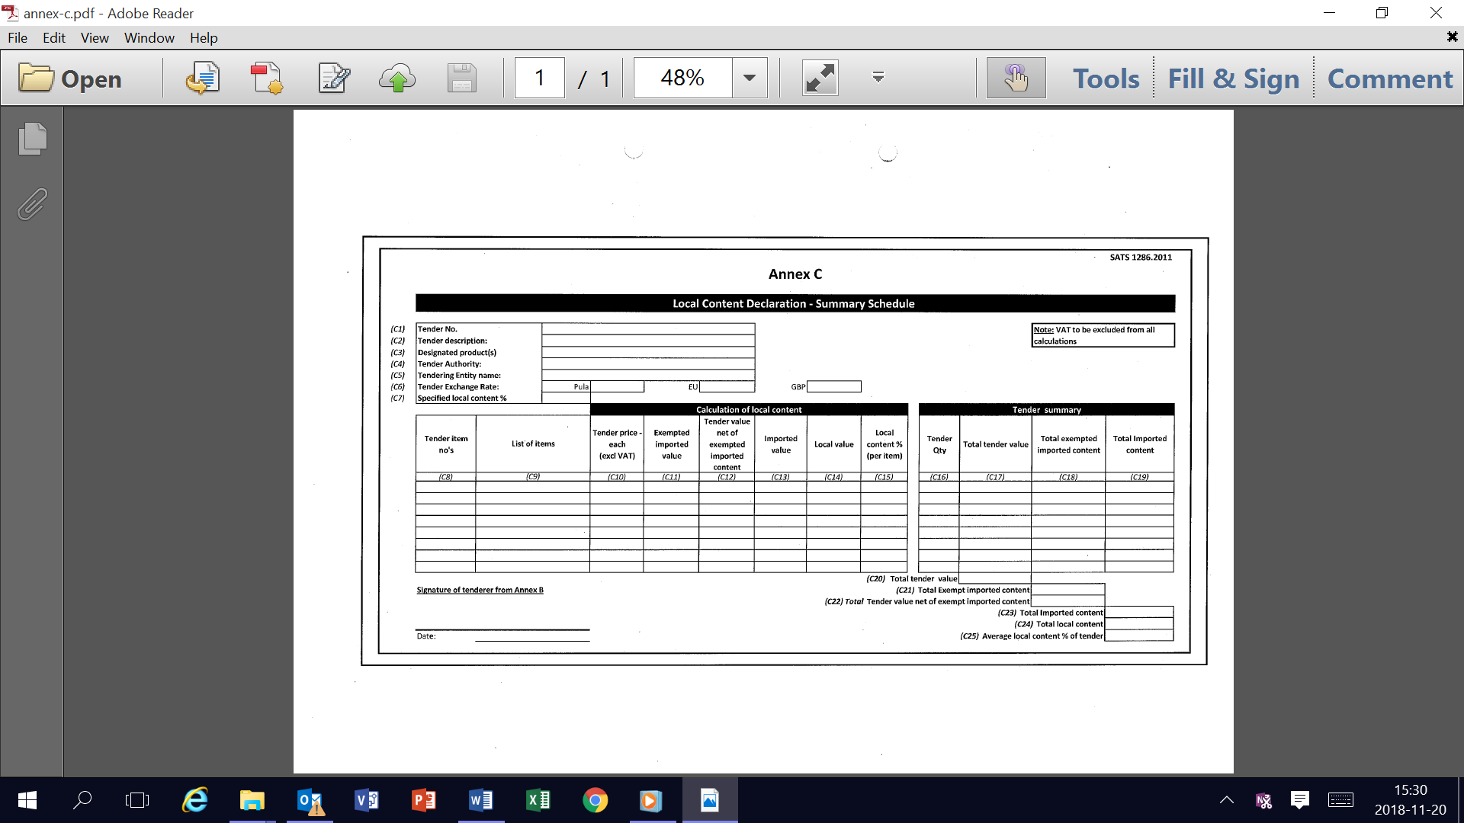

Annexure D
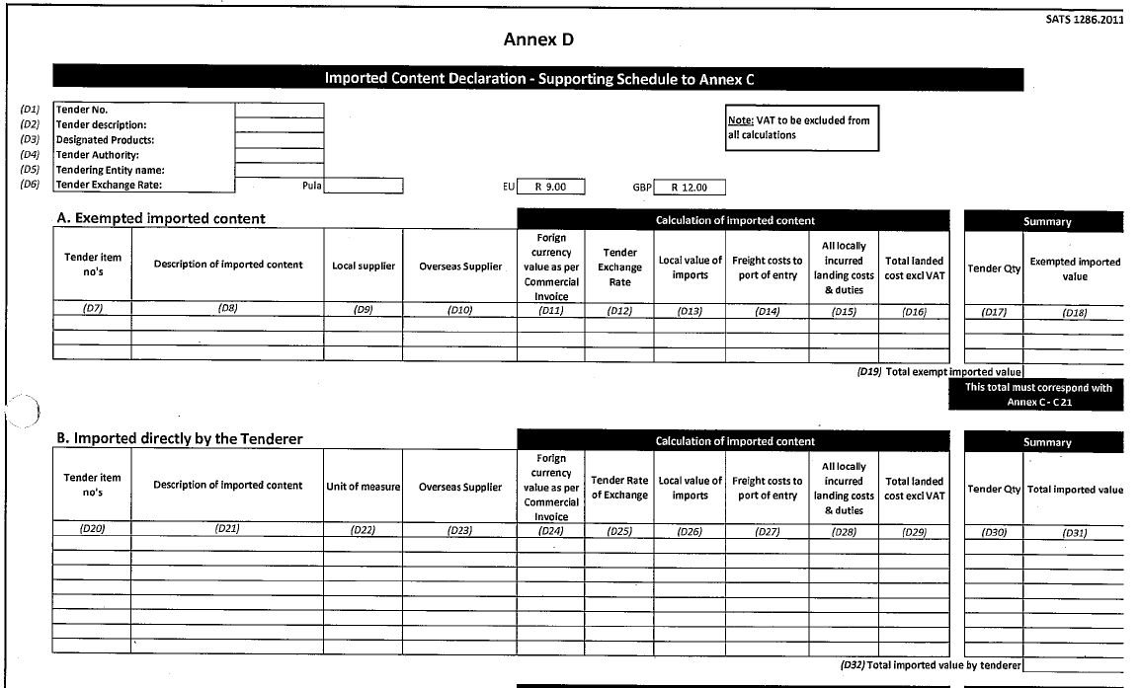
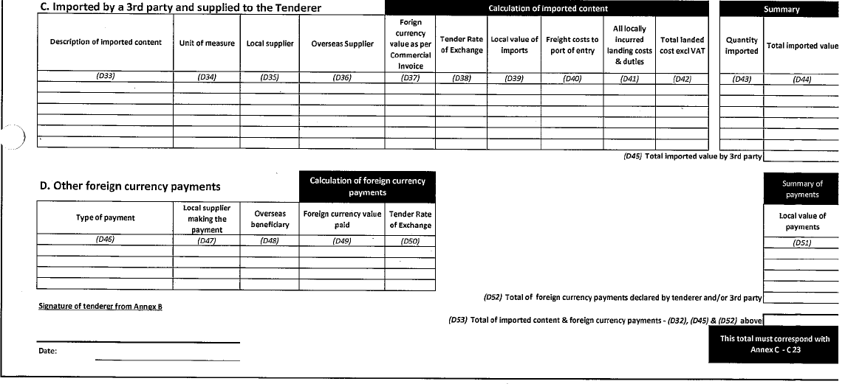

Annexure E

