Questions and Answers for Contract No: 30849(5W); 30850(5W); 30851(5W) & 30852 (5W)

Question 1:
- With regards to item PS-16 on page 83 of the above-mentioned tender documents, we notice that pre and post flow logging is required per zone as per the image below. We don’t see it listed as a line item on the BOQ for any of the tenders. Kindly advise how we should accommodate for this?

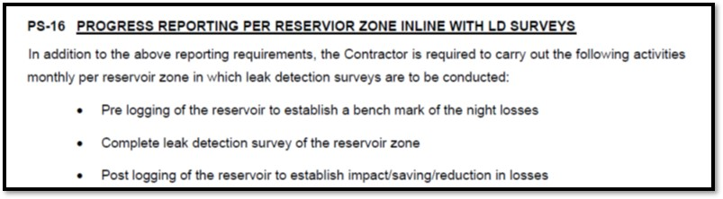

- What are the % limits of subcontracting of the total value of works for these contracts?

Answer:

Please see screenshot of PS-16 which is accounted for in the BOQ. (Pg 66) Tenderer should price according to their consideration of the project.

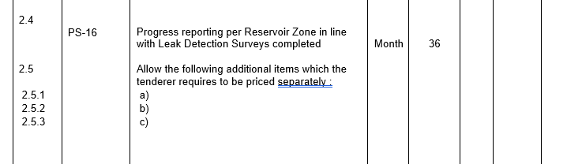

Please see % for Subcontracting (Pg 61)

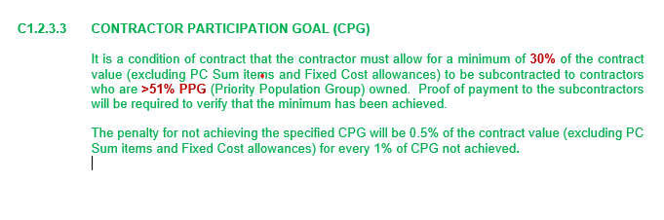

Question 2:
On page 64 of each of the above documents, under item 2.2, its shows FOUR, but in brackets (5) directly after. Kindly advise on which number is to be used?
I’ve attached a screenshot below for reference purposes.

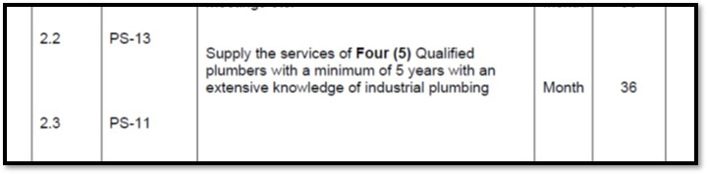

Answer:
The correct value is FOUR (4).

Question 3

Could you kindly advise if you are looking for a service provider for tender number 30849- 5W that has both 5CE and CO, or any between the two?

Answer:
The service provider is required to have both 5CE and SO as the project requires expertise of both Civil Engineering and Plumbing works.

