To whom it may concern | Date | 30 September 2026
To whom it may concern | Enquiries | 2
To whom it may concern | E-mail address | lebekogb@eskom.co.za
Dear Sir/Madam
Request for Enquiry Number | E3507GXNOU
Description / Project Title | The supply and delivery of whole or part of the scope for various Mechanical Consumables and Components at Koeberg Operating Unit for a period of 1 year
Tender Questions Closing Date

Item | Questions | Answers | Clarity Published Dates
 | DRAWING: 444KBY1312 | 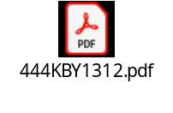 | 30/09/2026
 | Obsolete items | The supplier must quote for all items they intend to supply and fill in the Exception Sheet detailing all deviations from what was requested. An official obsolescence letter from the OEM must also be provided as supporting evidence. The complete tender submission will then be reviewed at evaluation stage, and Eskom will decide on a way forward.  