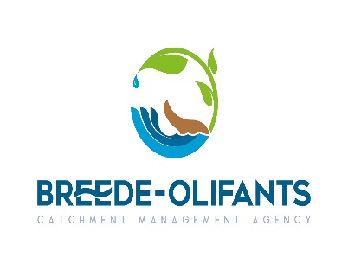
REQUEST FOR QUOTATION: SUPPLU AND DELIVERY OF CISCO CATALYST
Please quote according to the attached specification
Service Providers to note that below evaluation process and also submit the quotation with the SBD forms requested below:

- Item: Cisco Catalyst 2960S
- Quantity : 1x WS-C2960S-24PS-L ; 4 x SFP LAN Base
- Specification : 1x WS-C2960S-24PS-L Cisco Catalyst 2960S Switch 24 GigE PoE 370W, 4 x SFP LAN Base
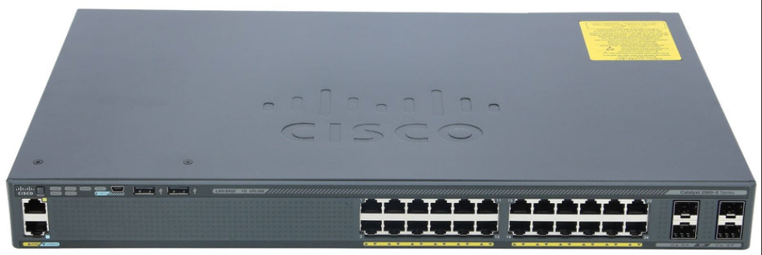

4. Delivery: CNR Mountain Mill and East Lake Road, Worcester, 6850
5. SCM Related Enquiries: nmafanya@bocma.co.za 023 346 8000
6. Closing Date RFQ: 24 July 2025 @ 13:00pm

Please complete the SBD Forms attached,
SBD4 Declaration of Interest of Interest
SBD 6.1 Preferential Procurement Points
Please attach your Tax clearance clearly reflecting tax status Pin

Evaluation Process:
This RFQ, will be evaluated as per the PPR of 2022 on the 80/20 principle
Where 80 points will be for price and the 20 points for specific goals.

NB: Service providers who did not complete the table on SBD 6.1 of PPR 2022 Completely will not be awarded the points as they would have not claimed the points, in order to claim points for specific goals, the service providers must claim the points on the in SBD 6.1

The specific goals will be evaluated as per the following:
Pricing and Specific goals
The following 80/20 criteria will be used for the evaluation of the proposals:
Pricing : 80 points
Specific Goals: 20 points
SPECIFIC GOALS:

 | 80/20 Preference point system
Enterprises 51% or more black woman owned | 10
Enterprise owned e by people with disability or Youth | 5
Enterprise with 51% or more black owned | 5
Maximum Points | 20

Please provide proof to claim specific goals
Failure to submit proof for specific goals will not disqualify you but you will not score any points for specific goals
The following documents will be used as verification documents
- BEE Certificate / Affidavit
- Certified Identity Document
- Letter from the Doctor confirming Disability

