REQUEST FOR QUOTATION (RFQ)
DATE ISSUED | 03/12/2021
PROJECT NAME | Supply and delivery for Diaries
CLOSING DATE AND TIME | 07/12/2021 at 11:00
DELIVERY TIME | 1 week from date of PO
NAME OF PROPOSER/TENDERER
TELEPHONE NUMBER
FAX NUMBER
CSD (CENTRAL SUPPLIER DATABASE) NUMBER
EMAIL ADDRESS
PHYSICAL ADDRESS

COMPANY REGISTRATION NUMBER
VAT REGISTRATION NUMBER
QUOTE PRICE (INCL VAT)
SIGNATURE

ENQUIRY: NAME:
TEL:
E-MAIL:
SPECIFICATION OF THE PRODUCT/SERVICE REQUIRED | SPECIFICATIONS/SCOPE OF WORK  Supply and delivery.  - 3 x 2022 Diaries: A5 (6 holes).  - 15 x 2022 Diaries: A5.  - 9 x 2022 Diaries: A4.  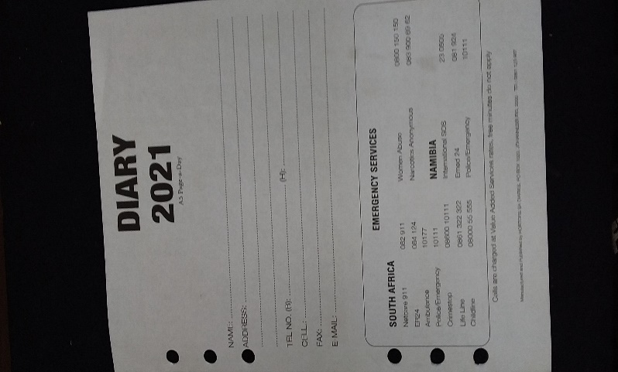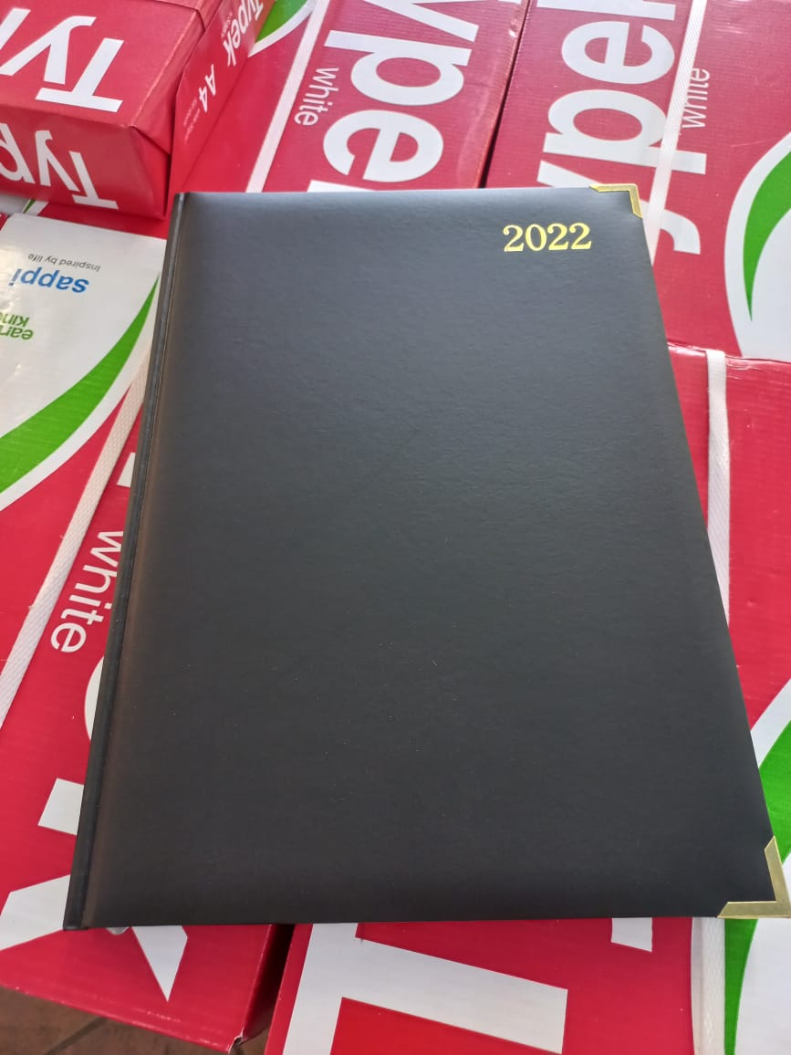  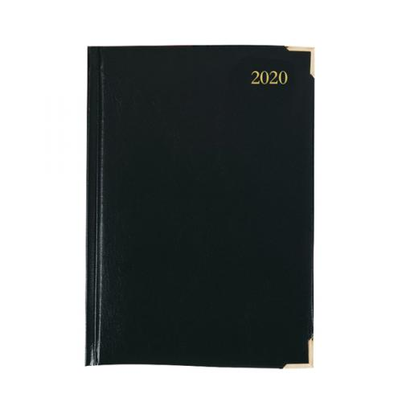
 | Email quotation with the RFQ to: dmogale@sansa.org.za

