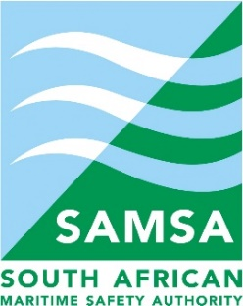

SOUTH AFRICAN MARITIME SAFETY AUTHORITY (SAMSA)

AWARDING OF TENDER

Name of institution | South African Maritime Safety Authority (SAMSA)
Contract description | Appointment of service provider (Supplier) to provide SAMSA Maritime Special Projects & Miscellaneous service for a period not exceeding 26 October 2026 on behalf of the MLRF
Contract number | SAMSA /044/2022/23
Date of award | 31 October 2022

Name of successful bidder | Sturrock Grindrod Maritime (Pty) Ltd
Name of Directors | Nicola Truter
Period Cover | Not exceeding 26 October 2026

