

Specifications for Vereeniging Campus

Centre Lathe  Swing dia over bed: 250 mm. Distance between centres: 500 mm. Swing over cross slide: 140 mm. Collet capacity: 26 mm Spindle bore: 38 mm | 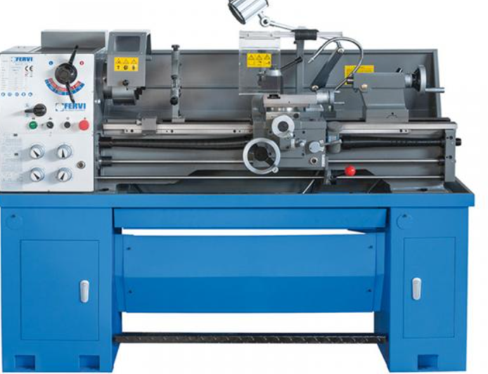 | 14

Pedestal Drilling Machine  Electrical connection 400 V / 3 Ph ~50 Hz  Motor power 0,55 kW  Drilling capacity in steel (S235JR) 20 mm  Continuous drilling cap. steel 18 mm  Throat depth 170 mm  Spindle stroke 80 mm  Spindle seat MT 3  Spindle speeds 210 – 2.220 min-1  Number of steps 12 Steps  Drilling table size length x width 275 x 275 mm  T-slot size (slot width) 14 mm, diagonal  Drilling table slewable +/- 45 degree  Drilling table rotatable 360 degree  Distance spindle – table max. 760 mm | 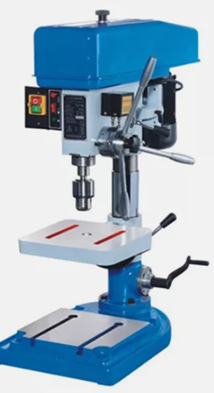 | 06
CNC Lathe  TypeHorizontalmax. length of workpiece (mm)500machining capacityHeavyDuty  max. weight of workpiece(kg)500no. of spindlesSinglePhase  number of axes2travel (x axis)(mm)530travel (z axis)(mm)5000positioning accuracy (mm)±0.001repeatability (x/y/z) (mm)±0.012voltage3Phase 380V 50HZ  tool post stations12,8, 10, 6, 4  weight (kg)8500  range of spindle speed(r.p.m)4- 300 r.p.m  cutting torque1width of bed (mm)600mmShandong,  dimension(l*w*h)7200*1820*1780brand nameLuYoung  model numberCk61125cnc control systemGSKkey selling pointsHighProductivity  machinery test reportProvidedvideo outgoing-inspectionProvided Service ProvidedEngineersavailable to service machinery overseas  Automatic GradeAutomaticCNC or NotCNCMachine Typemachinemetal turning cnc lathe heavy duty cnc lathe machine  Max.swing over bed1250mmMax.swing over cross slide900mmSpindle bore105mmSpindle speed30-84/53-150/125-350/300-835rpm  Processing length1500/2000/3000/5000mmControl  Selling unitsSingleitem  Single package size15X15X15cm  Single gross weight15.000kg  Include: Cnc simulator/software/license | 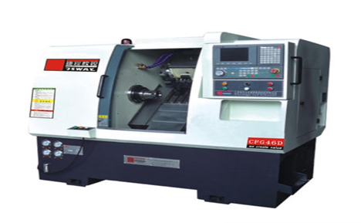 | 01
CNC MILLING MACHINE  • Vertical Spindle, 3-axis milling machine • Min worktable size: 600 x 1200 mm • Worktable must have 18mm T-slots, minimum of 5 • Table load: 800 kg min • Minimum Travel: o X Axis : 800 mm o Y Axis : 600 mm o Z Axis : 600 mm • controller compatible/interfaceable with Edgecam Software • LAN Interface Spindle • Spindle hole taper : BT40 • Min Spindle power : 10 kW • Min. spindle speed: 10000 rpm Feed • Min. feed speed : 8000 mm/min • Min Rapid feed speed : 30/30/25 m/min (X/Y/Z) Tool Magazine: • Min. Tool magazine capacity: 24 T • Tool Diameter (neighbour empty) : 120mm Positioning Accuracy: • Positioning accuracy (X/Y/Z) : 0.008 mm or better • Re-positioning accuracy (X/Y/Z) : 0.005 mm or better Accessories • Renshaw NC4 laser non-contact tool setter • Renshaw OMP40-2 optical transmission probe • Must connect to LAN. Internal (no internet) network • Spindle Air Sealing • Spindle Ring Spray • Chip Conveyor • Operational Manual • Coolant Gun for machine cleaning • Coolant Through Spindle • 4th Axis Prep • BT40 toolholders x24 • Collet set for tools from 1mm to 25mm  Include: Cnc simulator/software/license | 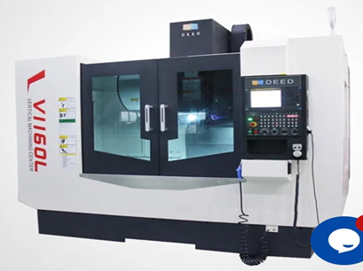 | 01
KP-225 power hacksaw  Power Hacksaw, Cutting Capacity Round 225mm,square 240x210mm Length of stroke 140mm,Blade size 400x32x1.6mm, motor 2hp Dimensions 1400x850x1200mm net weight 485kg | 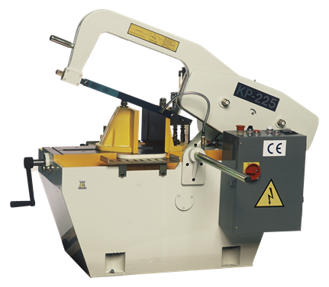 | 04

Pricing Table: Vereeniging Campus

No. | Description of Item | Quantity | Unit Price | Total Price (Incl. VAT)
1 | Centre lathe | 14 | R | R
2 | Pedestal drilling machine | 06 | R | R
3 | CNC lathe | 01 | R | R
4 | CNC milling machine | 01 | R | R
5 | KP-225 power hacksaw | 04 | R | R
TOTAL PRICING FOR ALL ITEMS (INCLUDING VAT) AND DELIVERY |  |  |  | R

SUPPLIER ARE ADVISED TO STICK TO THE SPECIFICATION

Specifications for Heidelberg Campus:
Oscilloscope  25 MHZ Digital Storage Oscilloscope. Two Channels. Displays values of frequency, Period and Peak Voltage  Dimension 330 x 165 x 165 mm. Color White and Grey | 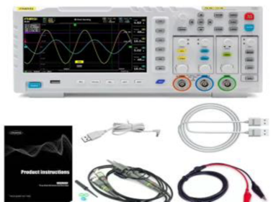 | 35
Function Generator 5 MHZ Sweep with Red LED Display. Signal types; Sine, Sawtooth, Triangle, Square. Supply voltage 230 Vac.  Dimensions 250 x 105 x 280mm | 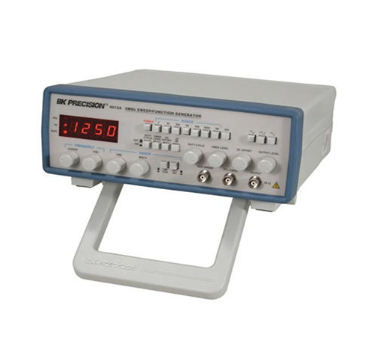 | 35
DC Single Power Supply with LED Display, output voltage 0-30 V, output current 0-3A, input voltage 230 Vac, constant output voltage and constant output current | 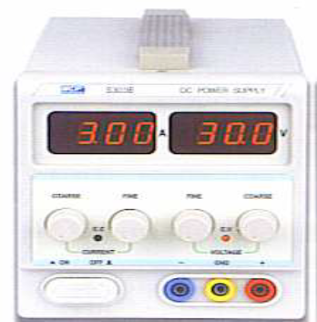 | 35
Electronic Bench with four sockoutlets | 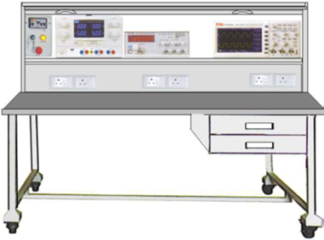 | 35
Metal Work Bench with Bench Vices; Table 900mm x 900m. with 4 x 150mm Bench Vices. Column 900mm with | 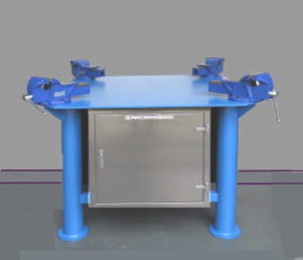 | 05
Single Phase Variac M10-522 Series. Input 230 Vac, 50 Hz,  Output voltage 0 – 230 Vac. Socket outlet 4 mm and input plug 4mm. |  | 05
CNC Lathe  typeHorizontalmax. length of workpiece (mm)500machining capacityHeavyDuty  max. weight of workpiece(kg)500no. of spindlesSinglePhase  number of axes2travel (x axis)(mm)530travel (z axis)(mm)5000positioning accuracy (mm)±0.001repeatability (x/y/z) (mm)±0.012voltage3Phase 380V 50HZ  tool post stations12,8, 10, 6, 4  weight (kg)8500  range of spindle speed(r.p.m)4- 300 r.p.m  cutting torque1width of bed (mm)600mmShandong,  dimension(l*w*h)7200*1820*1780  model numberCk61125cnc control points High Productivity  machinery test reportProvidedvideo outgoing-inspectionProvided Service ProvidedEngineersavailable to service machinery overseas  Automatic GradeAutomaticCNC or NotCNCMachine Typemachinemetal turning cnc lathe heavy duty cnc lathe machine  Max.swing over bed1250mmMax.swing over cross slide900mmSpindle bore105mmSpindle speed30-84/53-150/125-350/300-835rpm  Processing length1500/2000/3000/5000mmControl  Selling unitsSingleitem  Single package size15X15X15cm  Single gross weight15.000kg  Include: Cnc simulator/software/license | 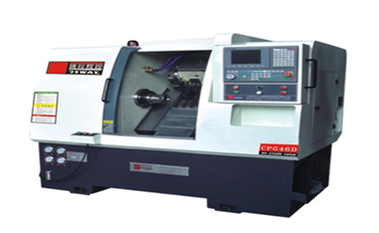 | 02
CNC MILLING MACHINE  • Vertical Spindle, 3-axis milling machine • Min worktable size: 600 x 1200 mm • Worktable must have 18mm T-slots, minimum of 5 • Table load: 800 kg min • Minimum Travel: o X Axis : 800 mm o Y Axis : 600 mm o Z Axis : 600 mm • controller compatible/interfaceable with Edgecam Software • LAN Interface Spindle • Spindle hole taper : BT40 • Min Spindle power : 10 kW • Min. spindle speed: 10000 rpm Feed • Min. feed speed : 8000 mm/min • Min Rapid feed speed : 30/30/25 m/min (X/Y/Z) Tool Magazine: • Min. Tool magazine capacity: 24 T • Tool Diameter (neighbour empty) : 120mm Positioning Accuracy: • Positioning accuracy (X/Y/Z) : 0.008 mm or better • Re-positioning accuracy (X/Y/Z) : 0.005 mm or better Accessories • Renshaw NC4 laser non-contact tool setter • Renshaw OMP40-2 optical transmission probe • Must connect to LAN. Internal (no internet) network • Spindle Air Sealing • Spindle Ring Spray • Chip Conveyor • Operational Manual • Coolant Gun for machine cleaning • Coolant Through Spindle • 4th Axis Prep • BT40 toolholders x24 • Collet set for tools from 1mm to 25mm  Include: CNC simulator/software/license | 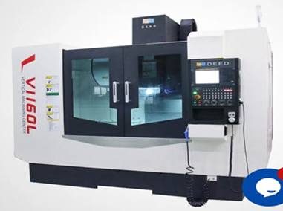 | 02
Cutaway 2.5” Long coupled centrifugal pump (see attachment) | 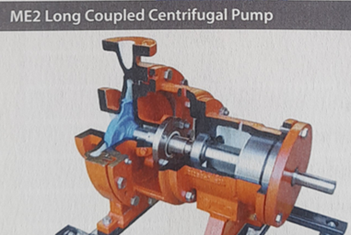 | 02
Cutaway 2”/DN50 Internal gear pump (see attachment) | 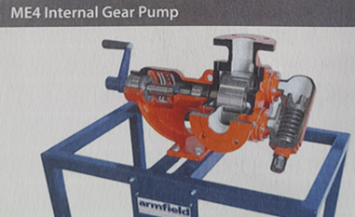 | 02
Cutaway 2”/DN65 Vane pump (see attachment) | 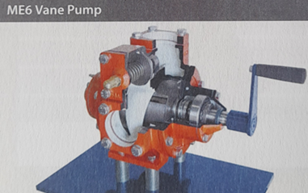 | 02
Cutaway 2”/D50 Ball check valve (see attachment) | 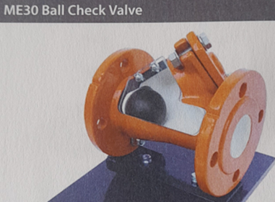 | 02
Cutaway 2”/ DN50 Spring safety valve (see attachment) | 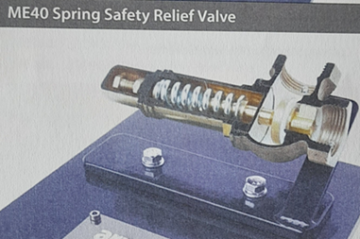 | 02
Cutaway 2”/DN50 Swing check valve (see attachment) | 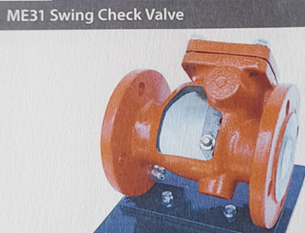 | 02
Cutaway 2”/DN50 Butterfly valve (see attachment) | 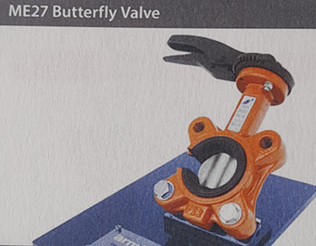 | 02
Cutaway 2”/DN50 Globe valve (see attachment) | 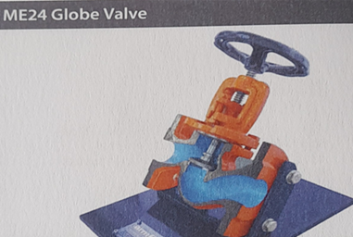 | 02
Cutaway 2”/DN50 Ball valve (see attachment) | 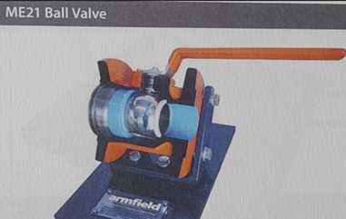 | 02
Cutaway 2”/DN65 Vane pump (see attachment) | 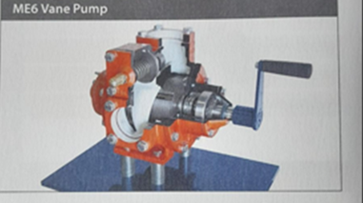 | 02
Cutaway Triple screw pump (see attachment) | 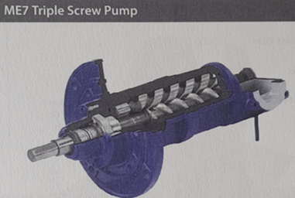 | 02
Gate valve trainer (see attachment) | 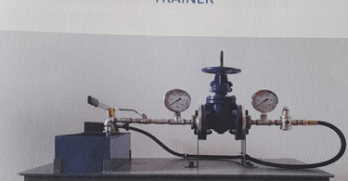 | 02
DTI Trainer alignment simulator (see attachment) | 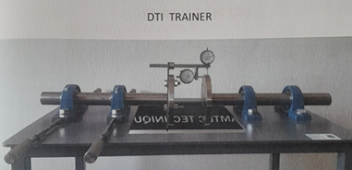 | 02
4, 5. And 7-hole Jig (see attachment) | 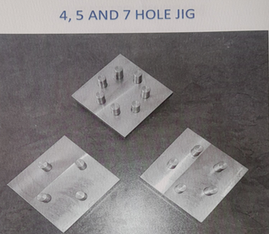 | 02
Centrifugal pump training/operation, installation, and maintenance kit | 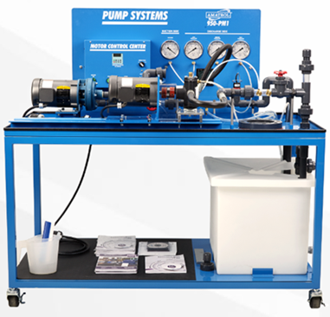 | 01
- Column Diameter:  - 150 mm – 300 mm  - Arm Length (Radial Arm):  - 800 mm – 2500 mm  - Determines how far the drill head can travel from the column  - Distance Between Spindle & Base:  - 250 mm – 1200 mm (vertical adjustment)  - Spindle Speeds:  - Multi-speed gearbox with 8–24 speed steps  - Range: 25 – 2000 RPM  - Spindle Travel (Drilling Depth):  - 200 mm – 500 mm  - Spindle Taper:  - Morse Taper MT-3, MT-4, MT-5, or MT-6 (depending on size)  - Motor Power:  - 1.5 HP – 5 HP (1.1 – 3.7 kW) for spindle drive  - Separate motor for arm elevation (0.5 – 1 HP)  - Working Table:  - Can be a box table or base plate  - Dimensions: 500 × 500 mm to 1200 × 1200 mm  - Arm Elevation:  - Powered (motor-driven) vertical movement of the arm along the column  - Swivel:  - Arm can rotate 360° around the column | 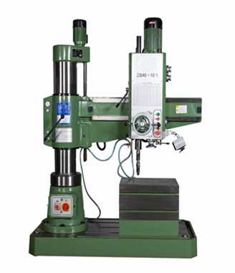 | 01
Soldering Machine, input 230 Vac, output 50 Watts, temperature controlled | 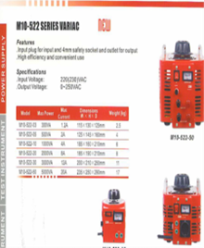 | 01
Single-Phase Motor, 230 V AC, 50 Hz, 0.25 KW, 4 Pole, Aluminium Frame, Frame Size 71L, Foot Mounted, IP55, |  | 35
Metal Cutting Bend Saw  7 Inch x 12 Inch Metal Cutting Horizontal Band saw* | 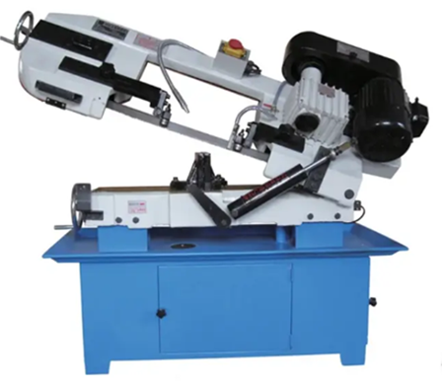 | 04
Pedestal Drilling Machine  Electrical connection 400 V / 3 Ph ~50 Hz  Motor power 0,55 kW  Drilling capacity in steel (S235JR) 20 mm  Continuous drilling cap. steel 18 mm  Throat depth 170 mm  Spindle stroke 80 mm  Spindle seat MT 3  Spindle speeds 210 – 2.220 min-1  Number of steps 12 Steps  Drilling table size length x width 275 x 275 mm  T-slot size (slot width) 14 mm, diagonal  Drilling table slewable +/- 45 degree  Drilling table rotatable 360 degree  Distance spindle – table max. 760mm | 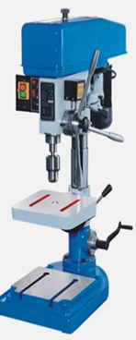 | 04
Bend Saw  Blade size Dimensions 34mm – 54mm width  Motor Power 3 – 7.5kw  Hydraulic motor 0.75 – 1.5kw  Vice clamping systems Hydraulic | 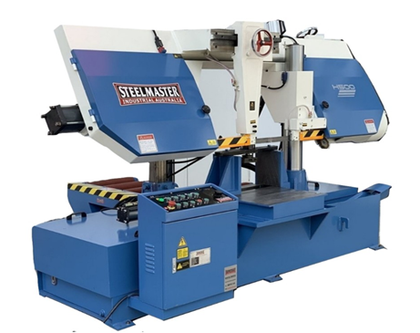 | 01
Pillar Drilling Machine  Auto-feed Bolted to the floor  Heavy duty  Column diameter 112mm  Spindle speed 40 – 2050rpm  Table size 375mm  Motor 2HP | 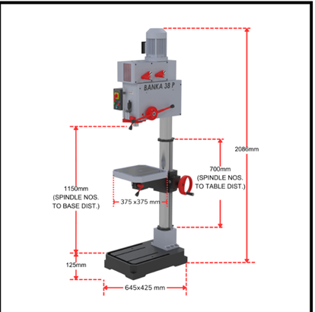 | 03

Pricing Table: Heidelberg Campus

No. | Description of Item | Quantity | Unit Price | Price (Incl. VAT)
1 | Oscilloscope | 35 | R | R
2 |  | 35 | R | R
3 |  | 35 | R | R
TOTAL PRICING FOR ALL ITEMS (INCLUDING VAT) AND DELIVERY |  |  |  | R

Specifications for Sebokeng Campus:

Metal Cutting Bend Saw  7 Inch x 12 Inch Metal Cutting Horizontal Band saw* | 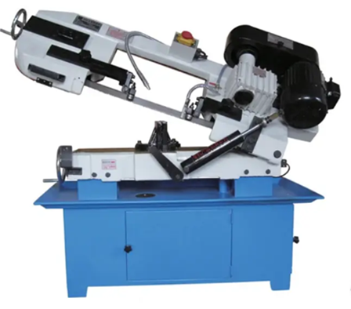 | 04
Swing dia over bed: 250 mm. Distance between centres: 500 mm. Swing over cross slide: 140 mm. Collet capacity: 26 mm Spindle bore: 38 mm | 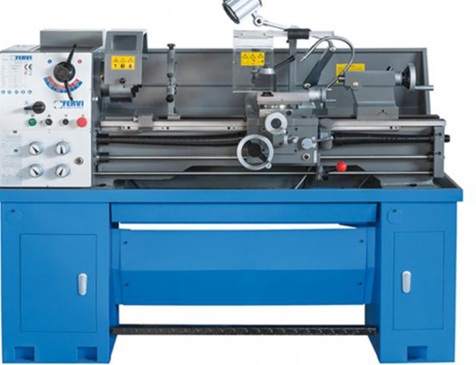 | 05

Pedestal Drilling Machine  Electrical connection 400 V / 3 Ph ~50 Hz  Motor power 0,55 kW  Drilling capacity in steel (S235JR) 20 mm  Continuous drilling cap. steel 18 mm  Throat depth 170 mm  Spindle stroke 80 mm  Spindle seat MT 3  Spindle speeds 210 – 2.220 min-1  Number of steps 12 Steps  Drilling table size length x width 275 x 275 mm  T-slot size (slot width) 14 mm, diagonal  Drilling table slewable +/- 45 degree  Drilling table rotatable 360 degree  Distance spindle – table max. 760mm | 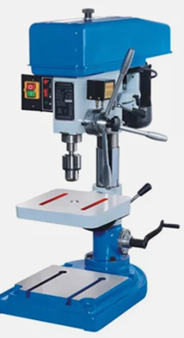 | 04
Diesel running engine on a stand (Rotary pump). 2.0L, 8 VALVE* | 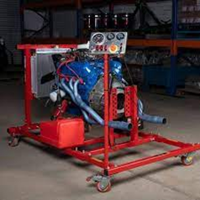 | 01
50 INCH manual slip Rolling machine | 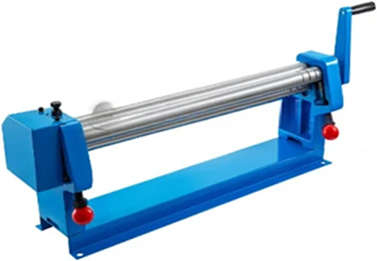 | 02
14 INCH METAL CUT OFF GRINDER | 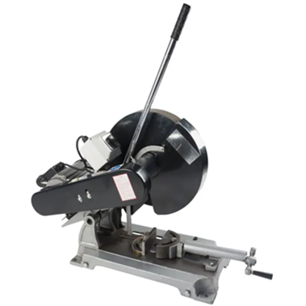 | 02
Combined Punching Shearing Machine – Hydraulic Ironworker for Metal Sheet Processing* | 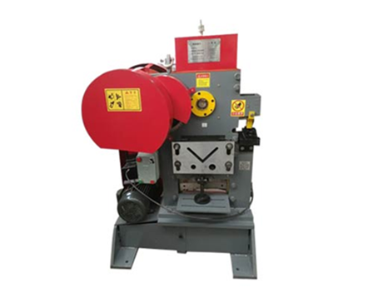 | 01
48" Heavy Duty Sheet Metal Pan & Box Brake | 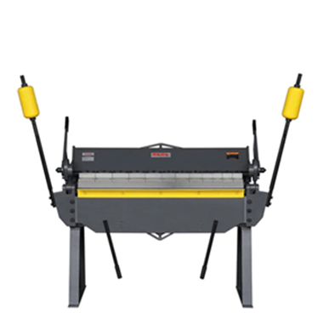 | 01
Profile Gas Cutting Machine HK-12 Beetle Oxy Fuel Cutting Machine Automatic Manual. X2 H2& L8 | 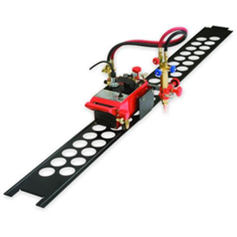 | 02
HEAVY DUTY ROTARY HAMMER AND DRILL MACHINE, 3kg 28mm. X2 for H2&L8 | 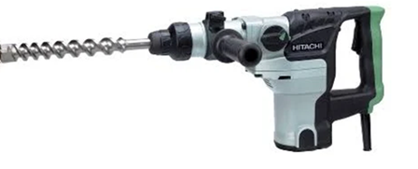 | 02
230mm Angle Grinder. | 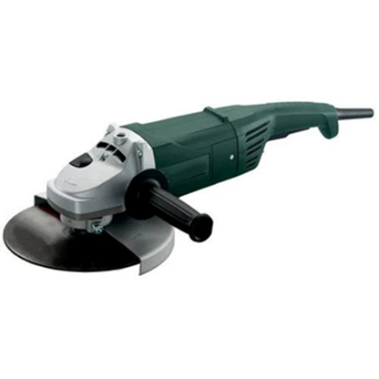 | 06
COMBINATION PANNEL WITH TWO THREE PHASE(0.55KW, SPEED OF 2800r/min) AND SINGLE PHASE(0.55KW, SPEED OF 1370r/min) MOTORS | 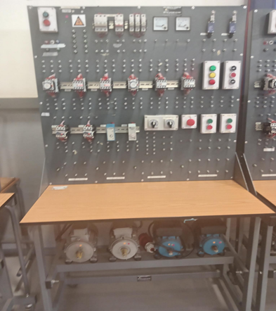 | 6
Electric Reinforced Steel Rebar Bending Machine  Model GW40  Motor Type High-quality copper wire motor  Bending Capacity Various steel rod diameters  Gear Type Enclosed gearbox with worm gear  Surface Treatment Plastic-spray treatment, chrome plated  Accessory Hardness Ultra-high hardness | 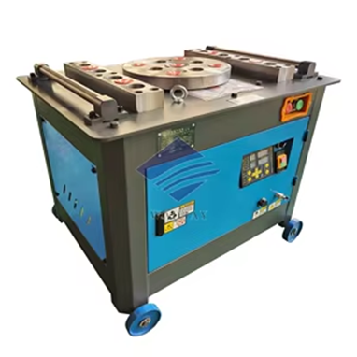 | 02
TABLE SAW  Ideal choice when powerful and accurate cuts are needed  545 mm rip cut capacity; cutting depths of 80 mm straight & 55 mm angle  1,800 W motor with high torque and ideal overload capacity  Precision made easy: robust steel table ensures stability while working | 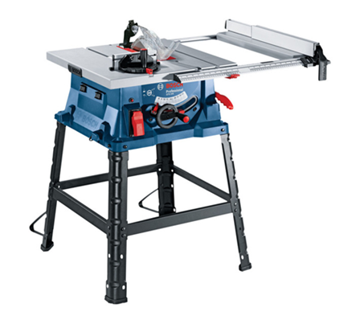 | 05
Compression Strength testing machine  Heavy-duty concrete testers, such as digital rebound hammers, feature a measuring range typically from 10–70 N/mm², an impact energy of 2.207 Nm (0.225kgm), and an accuracy of ±0.1R, with models offering Bluetooth or USB connectivity for data transfer, and a hard aluminium shell for durability. For compression testing, specialized machines like can handle sample sizes up to 200mm cubes with load rates from 10–1000 kN/min, but they are large, static, and require significant power. | 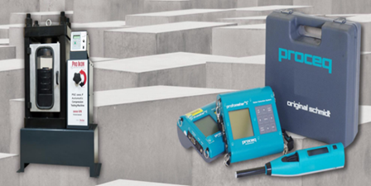 | 02
Turbo Circular SAW  Powerful motor with 2.050 W power input for a fast work rate  Robust design for long-lasting operation in various kinds of applications  Double the overload lifetime of the current GKS 235 | 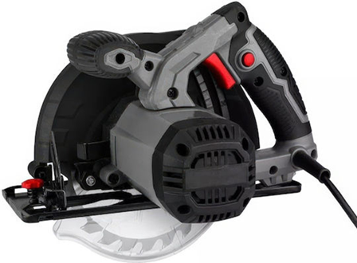 | 06
Poker vibrator  A poker vibrator's specifications include the vibrator head diameter (e.g., 25mm, 45mm, 60mm), flexible shaft length (e.g., 2m, 6m), and vibrating frequency (e.g., 12,000 vibrations/min or 200Hz | 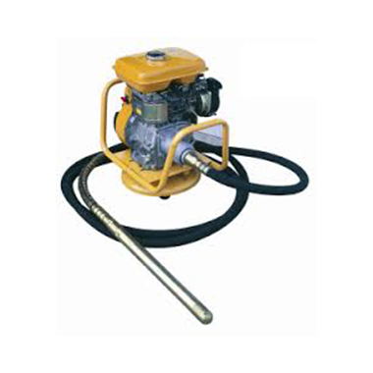 | 04
Pedestal Grinding Machine*  Grinding wheel: Ø250x32xØ32  Grinding wheel speed: 2950rpm  Motor: 900W  Dimensions: 320 x 320 x 1020mm  Weight: 45kg | 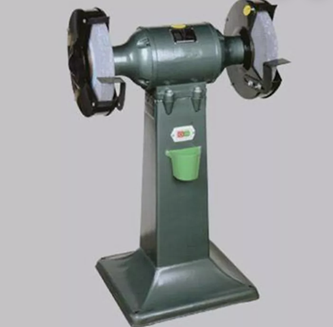 | 04
CNC Lathe  TypeHorizontalmax. length of workpiece (mm)500machining capacityHeavyDuty  max. weight of workpiece(kg)500no. of spindlesSinglePhase  number of axes2travel (x axis)(mm)530travel (z axis)(mm)5000positioning accuracy (mm)±0.001repeatability (x/y/z) (mm)±0.012voltage3Phase 380V 50HZ  tool post stations12,8, 10, 6, 4  weight (kg)8500  range of spindle speed(r.p.m)4- 300 r.p.m  cutting torque1width of bed (mm)600mmShandong,  dimension(l*w*h)7200*1820*1780brand nameLuYoung  model numberCk61125cnc control systemGSKkey selling pointsHighProductivity  machinery test reportProvidedvideo outgoing-inspectionProvided Service ProvidedEngineersavailable to service machinery overseas  Automatic GradeAutomaticCNC or NotCNCMachine Typemachinemetal turning cnc lathe heavy duty cnc lathe machine  Max.swing over bed1250mmMax.swing over cross slide900mmSpindle bore105mmSpindle speed30-84/53-150/125-350/300-835rpm  Processing length1500/2000/3000/5000mmControl  Selling unitsSingleitem  Single package size15X15X15cm  Single gross weight15.000kg  Include: Cnc simulator/software/license | 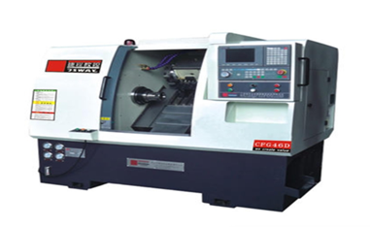 | 02
CNC MILLING MACHINE  • Vertical Spindle, 3-axis milling machine • Min worktable size: 600 x 1200 mm • Worktable must have 18mm T-slots, minimum of 5 • Table load: 800 kg min • Minimum Travel: o X Axis : 800 mm o Y Axis : 600 mm o Z Axis : 600 mm • controller compatible/interfaceable with Edgecam Software • LAN Interface Spindle • Spindle hole taper : BT40 • Min Spindle power : 10 kW • Min. spindle speed: 10000 rpm Feed • Min. feed speed : 8000 mm/min • Min Rapid feed speed : 30/30/25 m/min (X/Y/Z) Tool Magazine: • Min. Tool magazine capacity: 24 T • Tool Diameter (neighbour empty) : 120mm Positioning Accuracy: • Positioning accuracy (X/Y/Z) : 0.008 mm or better • Re-positioning accuracy (X/Y/Z) : 0.005 mm or better Accessories • Renshaw NC4 laser non-contact tool setter • Renshaw OMP40-2 optical transmission probe • Must connect to LAN. Internal (no internet) network • Spindle Air Sealing • Spindle Ring Spray • Chip Conveyor • Operational Manual • Coolant Gun for machine cleaning • Coolant Through Spindle • 4th Axis Prep • BT40 toolholders x24 • Collet set for tools from 1mm to 25mm  Include: Cnc simulator/software/license | 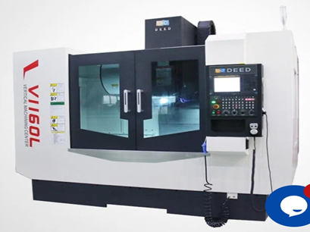 | 02

Pricing Table – Sebokeng Campus

No. | Description of Item | Quantity | Price (Incl. VAT)
1 |  | 1 | R
2 |  | 1 | R
3 |  | 1 | R
4 |  | 1 | R
5 |  | 1 | R
6 |  | 1 | R
TOTAL PRICING FOR ALL ITEMS (INCLUDING VAT) AND DELIVERY |  |  | R

