

SECTION 4- QUALITY REQUIREMENTS

Supplier Quality Management

Category 3
RSI Contract for KZN OU in the CentralEast Cluster
ENQUIRY NUMBER : KZN162

TENDERER NAME : ___________________________

TENDER CLOSING DATE : 29 November 2024

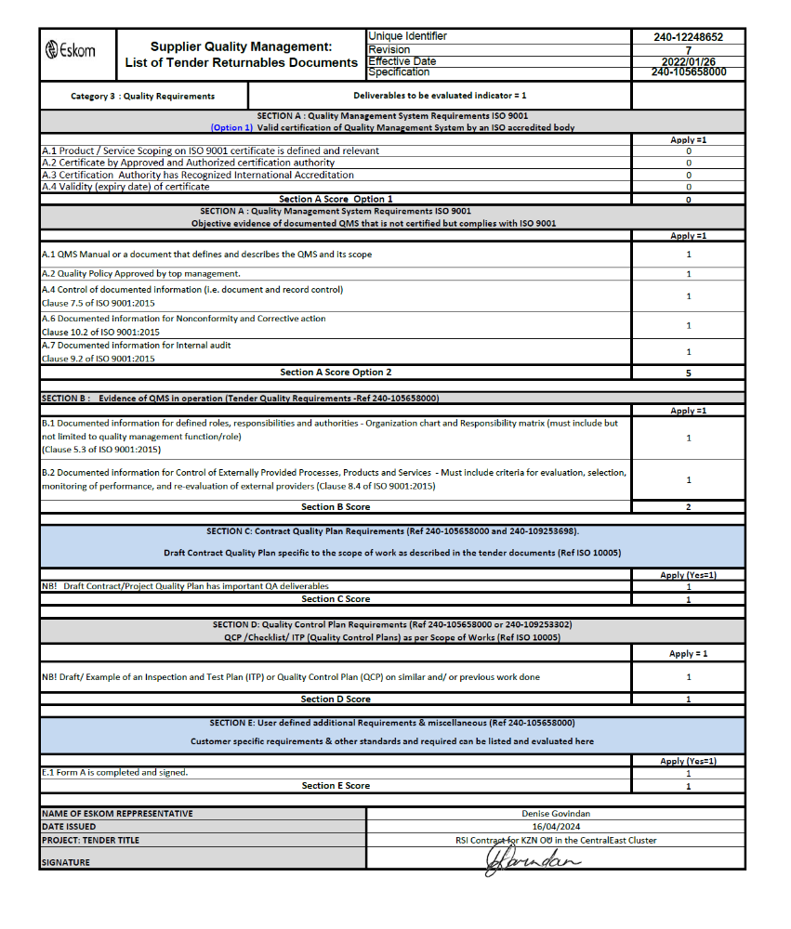

A.1
QMS Manual or a document that defines and describes the QMS and its scope or Quality Method statement based on the scope

A.2
Quality Policy Approved by Top Management

A.4

Control of documented information (i.e. document and record control)
Clause 7.5 of ISO 9001:2015

A.6
Documented information for Nonconformity and Corrective action
Clause 10.2 of ISO 9001:2015

A.7
Documented information for Internal audit
Clause 9.2 of ISO 9001:2015

B.1
B.1 Documented information for defined roles, responsibilities and authorities - Organization chart and Responsibility matrix (must include but not limited to quality management function/role)
(Clause 5.3 of ISO 9001:2015)

B.2
Documented information for Control of Externally Provided Processes, Products and Services - Must include criteria for evaluation, selection, monitoring of performance, and re-evaluation of external providers
(Clause 8.4 of ISO 9001:2015)

C1
Contract Quality Plan Requirements Draft contract quality plan specific to the scope of work as described in the tender documents (Ref ISO 10005)
Draft Contract/Project Quality Plan has important QA deliverables
Refer to attached template - 

SECTION D:
Quality Control Plan Requirements - (QCP /Checklist/ ITP (Quality Control Plans) as per Scope of Works (Ref ISO 10005 & QM 58)

Example of an Inspection and Test Plan (ITP) or Quality Control Plan (QCP) on similar and/ or previous work done 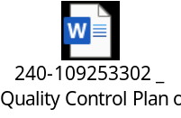

SECTION E : User defined additional Requirements & miscellaneous


