

For more information on TCTA, please visit our web site www.tcta.co.za

APPOINTMENT OF A SERVICE PROVIDER FOR THE PROVISION OF CLEANING SERVICES AT TCTA’S OFFICES IN CENTURION FOR A PERIOD OF 60 MONTHS

Bid Number | 022/2022/EWSS/CLEANING/RFB
Briefing Session: | Non-compulsory
Briefing Session Date and Time: | 13 September 2022 @ 10h00 a.m.
Briefing Session Venue: | Online: Microsoft Teams  Send an e-mail to tenders06@tcta.co.za to preregister and receive an invite.  Registration for the briefing session will end on 09 September 2022.
Closing Time & Date | 30 September 2022 @ 11h00 a.m.
Clarification Deadline: | 09 September 2022 @16h00
Bid Validity Period | 120 days
Bid Submission must be sent to: | Address: 265 West Avenue Tuinhof Building Stinkhout Wing Centurion
Copies of the Technical proposal to be submitted | 1 Original hard copy, 1 Copy of the hard copy, 1 soft copy
Copies of the financial proposal | 1 Original copy, 1 copy
Enquiries: | Name: Tefo Sekeleoane  Email Address: tenders06@tcta.co.za

TABLE OF CONTENTS
1. DEFINITIONS, ACRONYMS AND ABBREVIATIONS 1
2. PREPARATION AND BID SUBMISSIONS 3
3. BACKGROUND 3
4. SCOPE OF WORK 4
5. STAGE 1: PRE-QUALIFICATION 11
6. STAGE 2: RETURNABLES 11
7. STAGE 3: FUNCTIONALITY 13
8. STAGE 4: PRICE AND B-BBEE 14
9. STAGE 5: SUPPLIER VETTING 15
10. CONDITIONS OF BID 15
11. CONDITIONS OF CONTRACT 26
ANNEXURE A: FLOOR PLANS 32
ANNEXURE B: Cleaning Service Standards 35
ANNEXURE C: RESOURCE PLAN 45
Annexure D: COMPANY EXPERIENCE 48
Annexure E: SUPERVISOR’S EXPERIENCE 49
ANNEXURE F: SBD 1 – INVITATION TO BID 50
ANNEXURE G: SBD 4 – BIDDER’S DISCLOSURE 53
ANNEXURE H: SBD 6.1 – PREFERENCE POINTS CLAIM FORM IN TERMS OF THE PREFERENTIAL PROCUREMENT REGULATIONS 2017 55

DEFINITIONS, ACRONYMS AND ABBREVIATIONS
B-BBEE | Broad based black economic empowerment in terms of the broad based black economic empowerment act 53 of 2003 (B-BBEE Act).
B-BBEE STATUS LEVEL OF CONTRIBUTOR | The B-BBEE status received by a measured entity issued in terms of section 9(1) of the B-BBEE Act.
BID SUBMISSION | A bidder’s written proposal in response to an invitation for bids (request for bids/quotations/ information etc.)
BLACK PEOPLE | Africans, coloureds and Indians as defined in the broad based black economic empowerment act 53 of 2003
CONSORTIUM OR JOINT VENTURE OR CONSORTIUM | An association of persons for the purpose of combining their expertise, property, capital, efforts, skill and knowledge in an activity for the execution of a contract;
CONSULTANT | A professional person appointed to provide technical and specialist advice or to assist with the design and implementation of projects. The legal status of this person can be an individual, a partnership, a corporation or a company.
CONTRACT | A legal agreement or national treasury issued standard bid document number 7 signed by TCTA and a successful bidder. This term does not refer to the actual bid process.
CONTRACT MANAGER | A representative from the requesting department that will be responsible for monitoring the day to day activities related to the contract
DESIGNATED SECTORS | Sectors, sub-sectors or industries that have been designated by the department of trade and industry in line with national development and industrial policies for local production, where only locally produced services, works or goods or locally manufactured goods meet the stipulated minimum threshold for local production and content.
EME | Means an exempted micro enterprise in terms of a code of good practice on black economic empowerment issued in terms of section 9 (1) of the broad-based black economic empowerment act
PROCUREMENT SPECIALIST | Any person in the procurement unit who is responsible for managing a bid process from start to finish
PO | A purchase order generated by the procurement unit after the conclusion of a successful bid process authorizing the expenditure against an awarded contract.
QSE | Means a qualifying small business enterprise in terms of a code of good practice on black economic empowerment issued in terms of section 9 (1) of the Broad-Based Black Economic Empowerment Act;
RD | A requesting department withing TCTA or its representative
SUPPLIER | A juristic person or legal entity that provides goods or services to TCTA.

PREPARATION AND BID SUBMISSIONS
  - Bidders are required to comply fully with this Request for Bid including annexures during submission to TCTA;
  - In order for a Bid Submission to be acceptable, it must:
    - Not be late and it must be delivered to the address stated on the front page. TCTA shall not accept nor be obliged to accept Bid Submissions submitted after the stipulated closing date and time, notwithstanding that such late submission is as a result of circumstances beyond the Bidder’s control;
    - Clearly reflect the Bid description and bid number on the outer packaging;
    - Contain a firm and unconditional price; and
    - Contain all signed and completed Annexures.
  - TCTA reserves the right to reject bids that are not acceptable and to not evaluate them. This section is subject to the provisions in the Conditions of Bid.
  - Bidders must provide 2 (two) copies of the Bid submission and one electronic copy on an unencrypted USB.
  - This Bid has 5 stages of evaluation summarised in the document below. Each stage reflects the process of evaluation. Bid submissions must be neat and legible and prepared in the same order as the stages of evaluation. Each stage must be clearly marked.

BACKGROUND
TCTA is a schedule 2 State Entity under the Department of Water & Sanitation. TCTA is currently leasing office space situated at Byls Bridge Block 9 Centurion, which totals to 3950m2 over three floors (a portion of the ground floor lobby area, the entire 1st floor and the entire 2nd floor. Refer to Annexure A for the floor plans of building occupied by TCTA. It is against this background that TCTA is seeking to appoint reputable service provider for provision of cleaning services.

  - COMPANY EXPERIENCE
A minimum of four (4) years’ experience in provision of cleaning or hygiene services. The service provider must be a credible and reputable service provider. Bidders must complete the template of contactable references (Annexure D), with all fields properly completed. TCTA reserve the rights to contact the references to confirm the quality of service rendered

  - PERSONNEL EXPERIENCE
The supervisor must have a minimum of 3 years supervision experience in Cleaning. Service provider must complete Annexure E with all fields properly filled.

  - ADMINISTRATION COSTS OF THE CONTRACT

Bidder will be responsible for contract administration cost determined by the bidders for the duration of the contract. Section 3.3 of the costing template must be complete with these costs.

SCOPE OF WORK
TCTA is looking to appoint an experienced and reputable Service Provider for the provision of office cleaning services, the provision of all cleaning consumables, hygiene services and specialised cleaning services as per scope of work of this RFB.
The Service Provider will provide scheduled and reactive cleaning service to all areas of the TCTA office in accordance with the agreed access times to specific areas and within the provision of this specification and the service standards. The cleaning services that must be delivered must be as follows:

  - DAILY CLEANING SERVICES
    - Provision of all the Cleaning Consumables
The bidder will be responsible for the provision of all cleaning materials and accessories (dish clots, scotch brite, dishwasher liquid and tablets and salt, etc), for the dishes, the floors and all related consumables for the ablution facilities. Note that a schedule of cleaning material used and stored on site will be maintained and that copies of the applicable material safety data sheets will be always available.

    - Office Cleaning (Out of Office Hours, 18:00 – 8:00 Monday - Friday)
      - A minimum of 20 person hours per day must be demonstrated.
      - The office area must be cleaned by 08:00 from Monday to Friday excluding public holidays ( See all team KPAs below).
      - The team responsible for office cleaning, out of office hours, must be always managed by a supervisor.
      - The teams’ KPAs are as follows: -

OFFICE CLEANING (OUT OF OFFICE HOURS, 18:00 – 8:00 MONDAY – FRIDAY)
KPA | ACTIVITY | FREQUENCY
Washing crockery and cutlery | All crockery and cutlery must be washed and packed away | Daily
Dusting (dry cleaning) | Dust all horizontal surfaces low level (tables, chairs, partitions) | Daily
Dusting (dry cleaning) | Dust off workstations, partitions and office furniture use a damp and dry cloth only | Daily
Dusting (dry cleaning) | Clean and polish fittings and handrails | Daily
Dusting (dry cleaning) | Dust all high ledges and fittings | Tuesdays and Thursdays
Vacuuming | High traffic areas (entrances/ reception, corridor/ boardrooms, library, printing rooms, spiral staircase, etc. | Daily
Vacuuming | Normal traffic areas (offices) | Daily
Vacuuming | Low traffic areas (meeting rooms) | Daily
Vacuuming | Spot vacuum cleaning | Daily
Waste services (Wet and dry) | Empty and clean ashtrays in designated smoking areas where applicable | Daily
Waste services (Wet and dry) | Empty and clean all waste bins at workstations, in kitchens, etc. | Daily
Waste services (Wet and dry) | Sort waste into the various categories (wet waste, recyclable waste and general waste) and remove it to the respective areas. | Daily
Waste services (Wet and dry) | Waste categories are to be weighed and recorded on a sheet provided prior to being packaged and stored in a designated waste management areas. | Daily
Waste services (Wet and dry) | Records are to be submitted to the facilities manager weekly for reconciliation. | Weekly
Waste services (Wet and dry) | Waste and recycling to be moved to the designated collection location within the office park from which the municipality and recycling service provider will remove the waste. | Weekly
Waste services (Wet and dry) | Waste bins are to be cleaned and maintained in good order | Daily
Waste services (Wet and dry) | Disposal of Sani bin contents. Proof of the disposal of the contents will have to be given to TCTA on a monthly basis. | The collection dates will be as per the office park schedule
Cleaning of floors | Damp mop with soapy water (kitchens) | Daily
Cleaning of floors | Damp mop patio areas / balconies with soapy water | Daily
Cleaning of floors | Cleaning of all laminated floors as per manufactures specifications | Mondays, Wednesdays and Fridays
Damp wipe and spot clean | Spot clean all surfaces (walls, main entrance glass doors, all glass panels switches, furniture) | Tuesdays and Thursdays
Damp wipe and spot clean | Doormats and walls | Tuesdays and Thursdays
Windows | Foyer doors and windows, offices and meeting rooms | Mondays, Wednesdays and Fridays
Cleaning of kitchens | Clean floors and basins and wipe off all counter tops | Daily
Cleaning of kitchens | Wash crockery and cutlery and kitchen equipment e.g. microwave ovens, fridges etc. | Daily
Cleaning of balconies | Cleaning of all the balconies by ensuring that there is no dirt or leaves and that there is no growth of weeds or grass or any vegetation present. | Daily
Cleaning of basement parking | The basement parking bays and staircases must be cleaned. | Tuesdays and Fridays
Cleaning of lifts | Washing of lift floors with soapy water and cleaning lift mirrors | Daily
Cleaning of Ablution facilities | Cleaning of the toilets, urinals, basins, mirrors and floors. By the end of the shift, the ablution facilities must be clean for the next shift. | Daily
Cleaning of lobby Areas | Washing of floors with soapy water (1st floor and second floor) | Daily

    - Office Cleaning (During Office Hours)
      - Provision of the following resources: -
        - 1 supervisor,
        - 4 cleaners; two (2) cleaners posted per floor, one of which will be assigned to the servicing of the meeting room area and the other cleaner on the floor.
        - 2 cleaners (1 male to clean the male toilet and 1 female to clean the female toilets) to maintain cleanliness of the lobby areas (ground floor as well) and toilets including stairs, lifts and toilets from 08:00 - 17:00 (9 hours including statutory lunch breaks) Monday to Friday (excluding public holidays).
        - The team responsible for office cleaning, during office hours, must be managed, at all times by a supervisor, I.e. the supervisor must be present during the shift
        - The teams’ KPAs are as follows:
OFFICE CLEANING (DURING OFFICE HOURS)
KPA | ACTIVITY | FREQUENCY
Washing of Dishes | All kitchens must be cleaned. All crockery and cutlery must be washed and packed away at all times. Dishwashers are provided for bulk use (crockery and cutlery). | Hourly
Washing of Dishes | All dirty cups and plates must be cleared off from all workstations in the open plan and office areas. | At two-hour intervals
Preparing of Meeting Rooms, kitchens and stocking of beverages | Ensure that all meeting rooms are clean & tidy | After each meeting or break
 | Fresh water in jugs with glasses to be placed in all meeting rooms | After each meeting or break
 | Removal and replacement of all dirty crockery and all water jugs and replenish (water jugs) with water once cleaned | After each meeting or break
 | Ensure that the meeting rooms are supplied with stationery as advised upon. (Stationery supplied by TCTA) | Daily
 | Filling up of urns, water jugs, water dispensing units and ensure that consumables are filled up in all floors | Daily
 | Setting up tables for catered meals, serving it for all meetings and cleaning up afterwards | As Required
 | Bar fridge to be stocked by 08:00 and if required during the day, all soft drink cans must be washed off in bicarbonate of soda before being stocked in the bar fridge. | As Required
Reception area | Ensure that the reception area is clean and neat. | Daily
Coordination of groceries | Ensure that minimum stock levels of groceries in all kitchens are maintained. Groceries will be supplied by TCTA. | Daily
Cleaning of Ablution facilities and lobby areas | Cleaning of toilets and lobby areas. Refer to the cleaning standards | By 8:00 and hourly intervals thereafter daily
Cleaning of Ablution facilities and lobby areas | Toilets and lobby areas must be cleaned and all consumables in the toilets must be replenished on an ongoing basis. | By 8:00 and hourly intervals thereafter daily
Cleaning of Ablution facilities and lobby areas | Cleaning of the mirrors in the toilets as well as all the automatic hand dryers | By 8:00 and hourly intervals thereafter daily
Cleaning of Ablution facilities and lobby areas | A cleaning schedule will have to be attached on the  inside of the main door of each toilet on all the floors  outlying the following, but not limited to:  - The time the toilets were cleaned  - The name of the cleaner that cleaned the toilet  - Time the consumables were replaced  - Sign off by the supervisor at the start and end of each shift | By 8:00 and hourly intervals thereafter daily
Cleaning of Ablution facilities and lobby areas | Replenishing of hand soap, toilet rolls, hand wipes, Sani Wipes in all toilets of the floors occupied by TCTA. | As required
Breakages | Identification and reporting of lost and damaged equipment to the TCTA contracts manager | Daily
Cleaning of office area and offices | Ensuring that workstations are always free from dust and dirt.  Cleaning at least three times a day of all workstations that being used.  Ensure that the open plan area and offices are always clean.  Emptying of all office bins into main bins in the kitchens.  All waste must be separated, weighed and the weights must be recorded on the waste sheet (format to be provided) and must be signed off by the supervisor daily. Records are to be provided to TCTA by the supervisor on a weekly basis. The waste must then be transported to the landlord’s waste disposal area and disposed of in line with the site requirements. | Daily
Cleaning of office area and offices | - Dust all vertical surfaces (walls, cabinets etc.)  - Dust all window ledges (high and low)  - Dust all vertical blinds and pictures | 1 x weekly
Cleaning of office kitchen equipment | Sterilization of all water jugs and kettles. | 1 x week
Cleaning of office kitchen equipment | Defrosting of fridges | 2 x a month
Cleaning of office kitchen equipment | Cleaning of Microwave ovens | 5 x weekly

    - Hygiene Services (The provision of Cleaning Consumables and equipment’s)
      - The teams’ KPAs are as follows:
HYGIENE SERVICES DELIVERABLES
KPA | ACTIVITY | FREQUENCY
Replenishing of hand soap | - Liquid hand soap for the soap dispensers. (Specification as per approved SABS requirements). | Daily
Replenishing of toilet rolls | - Provision of toilet rolls. Two ply toilet rolls in all the toilets. (Specification as per approved SABS requirements). There is existing toilet roll dispensing equipment which is provided for by the landlord. | Daily
Hand wipes | - The provision of hand wipes (specification as per approved SABS requirements). The hand wipes must be placed in the lobby areas in a stainless-steel dispensing container at the entrance doors with a waste stainless steel waste container and plastic liner bags. The waste container must be emptied at least thrice a day or before it is full. | Daily
Hand wipes equipment | - The bidder must supply the stainless waste bin and the stainless hand wipe dispensing container including all costs (installation costs, removal costs and re-instatement costs at the end of the contract) | Once off
Sani Wipes | - One dispensing unit must be placed in each bathroom (not each toilet cubicle) and it must be kept filled on a daily basis. There is a total of 12 toilets on the 2 floors. | Daily
Sani Wipes equipment | - The dispensing unit must be made of stainless steel. All costs (installation costs, removal costs and re-instatement costs at the end of the contract) on a monthly rental basis. The provision of Sani Seat Wipe unit (the wipes must be environmentally friendly). There is a combined total of 12 toilets on the 2 floors occupied by TCTA. | Once off
SHE Bins | - The provision and maintenance of all SHE Bins | Twice a week

  - NON-DAILY CLEANING SERVICES
    - Cleaning of IT Equipment
This requirement entails the supply and provision of all cleaning material for this function, cleaning twice a month during office hours, of the following equipment: -
      - 10 monitors in the meeting rooms,
      - 200 laptops,
      - 100 screens,
      - 80 pc mouses and keyboards
These are indicative volumes only for costing purposes. TCTA does not have an obligation to incur these costs, however when the monthly service is provided, the actual volumes will have to be indicated and signed off by a TCTA official.

    - Other Specialised Services (Outside of Office Hours)
OTHER SPECIALISED SERVICES (OUTSIDE OFFICE HOURS)
KPA | ACTIVITY | FREQUENCY
Deep Cleaning | - Deep cleaning of carpets in the office area approximately 3000 m².  - Deep cleaning of 200 office and meeting room chairs.  - Deep cleaning of 12 one seater couches and 30 two-seater couches | Monthly
Deep Cleaning | - Deep cleaning of toilets | Twice a month
Cleaning of the building windows and all office and meeting room glass panels | - Cleaning of the building windows on the inside only. | Monthly
Cleaning of pool vehicles | - 10 x pool vehicles must be cleaned inside (vacuuming, washing, wiping dusting) and outside (washing with soapy water). Water must not be wasted. | Weekly
Cleaning of storerooms and archives | - Sweeping and then the washing down of floors with soapy water and the dusting the walls. | Monthly
Cleaning of emergency exit stairs | - Sweeping of all the emergency exit stairs. | Monthly

  - CLEANING STANDARDS
Refer to Annexure B for the manufacturer’s specification on the process and requirements for the cleaning of the:
- Tiles in the kitchens, lobby areas and bathrooms.
- Laminated flooring.
- Carpets.

  - COMPLIANCE REQUIREMENTS

4.4.1 The successful service provider must deliver to the scope of work with due regard for the following:-
        - Basic Conditions of Employment Act as amended,
        - Prevailing industry standards and norms, industry acceptable training levels and any other relevant regulations (e.g. South African Bureau of Standards (SABS) for all cleaning material,
        - Section 89 of Compensation for Occupational Injuries and Diseases (COID) Act
        - Occupational Health and Safety Act, Act 85 of 1993 (OHS Act), Labour Relations Act as amended, Skills Development Act as amended, and any Sectoral Determination as amended in the cleaning industry.
TCTA will monitor compliance on these statutory requirements on a monthly basis where reasonable practical.

4.4.2 All cleaning personnel must be neatly clothed in protective clothing clearly showing the company logo, including the following when needed:
        - Headgear as and when required
        - Eye protection as and when required
4.4.3 Respiratory protection as and when required
        - Protective hand gloves as and when required
        - Safety Shoes
4.4.4 The successful service provider will have to provide uniforms for all their staff members taking into consideration the following: -
4.4.4.1 The service provider’s branding, company logo, etc must be clearly visible on the uniforms.
        - Three (3) complete winter uniforms annually for the duration of the contract.
        - Three (3) complete summer uniforms annually for the duration of the contract.
        - Two (2) sets of safety shoes annually for the duration of the contract.
        - The successful service provider must ensure that their staff’s uniforms are always clean and neat during the duration of the contract.

Daily spot checks must be conducted by the supervisor and a report must be presented to TCTA on a weekly basis outlining performance against output as defined in the KPAs for the various deliverables. Material safety data sheets (MSDS) for all chemicals must always be on the TCTA premises.

STAGE 1: PRE-QUALIFICATION
  - ONLY ONE OR MORE OF THE FOLLOWING BIDDERS MAY RESPOND:
    - A bidder having the minimum stipulated B-BBEE status level of contributor of 1
The following document/s must be provided as proof of the above-mentioned criteria:
        - BBBEE Certificate issued by verification Agency approved by SANAS or Sworn Affidavit for Exempted Micro Enterprise or Qualifying Small Enterprise which are 100% black owned
        - In the case of Joint Ventures:
A Consolidated BBBEE certificate issued by verification Agency approved by SANAS.

STAGE 2: RETURNABLES
All returnables are required for purposes of evaluation irrespective of whether they are designated mandatory or not. Bidders are required to use the number requirements (E.g. Section 1, Section 2, etc) as set out in this section for their submissions.
No | Document Type | DESCRIPTION | STATUS
Section 1  SCM Compliance Documents | Compliance | SBD 1: Invitation to bid and terms and conditions for bidding | Non-Mandatory
Section 1  SCM Compliance Documents | Compliance | SBD 4: Declaration of Interest | Mandatory
Section 1  SCM Compliance Documents | Compliance | SBD 6.1: Preference points claim form in terms of the Preferential Procurement Regulations 2017 | Non-Mandatory
Section 2  CSD | Compliance | Proof of registration on National Treasury Central Supplier Database | Non-Mandatory
Section 3  Tax Compliance | Compliance | Tax Clearance certificate with tax Compliance Status Pin | Non-Mandatory
Section 4  Company Experience | Compliance | Completion of Annexure D (Form 1 for Company experience) must be done. All applicable fields must be completed. Proof all projects claimed must be submitted (service level agreement or a copy of the contract or a letter from the bidder’s customer confirming the contract and period (duration can be accumulative) | Mandatory
Section 5  Supervisor Experience | Compliance | Completion of Annexure E (Form 2 for Supervisor’s experience must be done. All applicable fields must be complete d.  Bidders will score zero points for non-compliance to this submission requirements.  Bidders will score zero points for non-compliance to this submission requirements | Mandatory
Section 6 | Pre-qualification | BBBEE Certificate issued by a registered Auditor approved by IRBA or Verification Agency approved by SANAS, or a sworn Affidavit for EME and QSE. Consolidated BBBEE for Joint Venture tenderers issued by a registered Auditor approved by IRBA or Verification Agency approved by SANAS, or a sworn Affidavit for EME and QSE | Mandatory
Section 6 | Compliance | Completion of Annexure C (Resourcing plan). All applicable fields must be completed. Non completion of any of the fields will result in the bidder being disqualified. | Mandatory
Section 6 | Compliance | Bidders must comply with the minimum wage requirements for cleaners and supervisor for the sectoral determination applicable to the cleaning industry. | Mandatory
Section 6 | Compliance | Bidders must submit the bank rating letter, stating that the bidder has R70 000.00 financial standing / facility | Mandatory
Section 7 | Price | Financial Proposal (Price and Preference)  Bidders must price their bid submission according to TCTA Pricing Cost Template of the RFB. | Mandatory

Any bidder who fails to submit a non-mandatory document will receive zero points where that document is linked to specific functionality criteria. Any bidder who fails to submit a mandatory document will be disqualified at this stage and not be evaluated further.

STAGE 3: FUNCTIONALITY
TCTA will evaluate the submissions for functional capacity and capability. A minimum score of 25 points out 40 points must be achieved for bidders to move on to Stage 4 of the evaluation process. TCTA will evaluate the submissions in terms of the functional criteria set out below.
Table 2: Technical Evaluation Criteria
EVALUATION CRITERIA |  | SCORE
Company Experience | Company experience:  The company must have a minimum of four (4) years’ experience in the provision of cleaning offices services: Proof of the service level agreement, award letters, purchase orders (POs) or reference letters from the bidder’s customer confirming at least four (4) years in provision of cleaning service must be submitted (both accumulative or once off service will be considered). The scoring methodology is as follows: -Years of Experience in provisioning of Cleaning/hygiene Services: | 15 points
Company Experience | - +7 years of work experience: 15 points  - 5 – 6 of work experience: 10 points  - 4 years of work experience: 5 points  NB: Years of experience will be calculated from all projects listed under ANNEXURE D (starting dates & end dates in (months & years, must be clearly stated | 15 points
Company Experience | Cleaning / hygiene Services Projects:  - +7 References = 15 points  - 5 – 6 References = 10 points  - 4 References = 5 points  NB: Years of experience will be calculated from all projects listed under ANNEXURE D (starting dates & end dates in (months & years, must be clearly stated | 15 points
Supervisor Experience | Supervisor Experience:  The supervisor must have a minimum of 3 years supervision experience in Cleaning or Hygiene services.  - +5 years’ experience = 10 points  - 4 years’ experience = 7 points.  - 3 years’ experience = 5 points | 10 points
TOTAL |  | 40 points
Prospective Bidders will have to attain a minimum score of 25 (twenty five) points out of 40 (forty) points to proceed to phase 4 of evaluation process where bids will be evaluated in terms of Price and Preference point system. Failure by the bidder to attain a score of 25 (twenty five) points out of 40 (forty) points will lead to the bidder being disqualified in terms of PPPFA Regulations, 2017s5(6).

- STAGE 4: PRICE AND B-BBEE
- TCTA will evaluate all Bid Submissions in terms of the Preferential Procurement Policy Framework Act, No.5 of 2000 (PPPFA).
- Bidders are required to provide a total fixed price over the contract period as per the TCTA Cost Template of the RFB.

  - B-BBEE
    - A bidder who fails to submit proof of B-BBEE status level of contributor or a non-compliant bidder will not be disqualified at this stage but:
      - May only score points out of 80 or 90 depending on which preference point system is applicable; and
      - Scores 0 out of 20 or 0 out of 10 depending on which preference point system is applicable.
    - Section 14.1.1 shall not apply if this bid has a pre-qualification stage.
    - A joint venture or consortium must submit a consolidated B-BBEE certificate in order to earn B-BBEE points.

    - All B-BBEE certificates must be obtained from verification agencies accredited by SANAS unless the bidder is an EME or QSE in which case they must submit a validly commissioned affidavit QSEs that do not meet level 1 or 51% black ownership thresholds are obliged to show compliance with all five of the categories on the BEE scorecard therefore, a B-BBEE certificates must be obtained from verification agencies accredited by SANAS.
    - An EME or QSE with 100% black ownership qualifies at a Level One.
    - An EME or QSE with more than 51% black ownership qualifies at a Level Two.
    - If black ownership of an EME is below 51%, it qualifies at a Level Four.
    - If black ownership of a QSE is below 51%, it is required to be measured in terms of the QSE scorecard to confirm its B-BBEE Status Level.

  - PRICE
    - If the price offered by the highest scoring bidder is not market related, TCTA reserves the right not to award to that bidder in terms of its Procurement policies.
    - Price must be reflected Excluding and Including VAT.
    - All prices must include disbursements.
    - Prices must be firm and unconditional. Bids with conditional prices will not be acceptable and will be treated as such.

  - PREFERENTIAL POINTS CALCULATION
The weighting of the Preferential points calculation is as follows:
 | POINTS
PRICE | 80
B-BBEE STATUS LEVEL OF CONTRIBUTOR | 20
Total points for Price and B-BBEE must not exceed | 100

STAGE 5: SUPPLIER VETTING
TCTA may disqualify a successful bidder who/whose:
    - Submits fraudulent information or information that they do not have to authority to submit;
    - Is listed on National Treasury’s list of Blacklisted Suppliers or Defaulters or similar;
    - Poses a risk in terms of any vetting process conducted either by TCTA internally or the National Intelligence Agency;
    - Has a director and/or shareholder who is employed by any organ of state. This does not apply to any organ of state acting as a bidder; and
    - Tax affairs are not in order at the time of award after being requested to resolve the non-compliance status with SARS within the prescribed period.

CONDITIONS OF BID
Any bid submission that does not meet the conditions of bid may be rejected and not evaluated at all. Such a bid submission will not be acceptable.

  - COSTS OF BIDDING
    - Bidders shall bear their own costs, disbursements and expenses associated with the preparation and submission of the Bid Submissions, including submission of any additional information requested by TCTA or attending the compulsory briefing session.
    - TCTA shall not under any circumstances be liable nor assume liability to any Bidder for costs, disbursements and/or expenses incurred by Bidders regardless of the outcome of the Bid process or by virtue of cancellation and/or postponement of the Bid process. Where applicable a non-refundable fee for documents may be charged.

  - CLARIFICATIONS
    - All questions or queries regarding the Request for Bid must be directed to the person stated on the front page of this document, stating the relevant Bid number in the subject field, at least five business days before the stipulated closing date and time of the Request for Bid. No e-mails, faxes and/or telephone calls should be directed to any other employees of TCTA.
    - TCTA shall not be liable nor assume liability for any failure to respond to any questions and/or queries raised by potential Bidders.
    - Should a Bidder fail to complete the annexures TCTA may call upon the Bidder to complete and submit such annexures except where such annexures are indicated as mandatory or are required for purposes of functional and preferential points evaluation. TCTA reserves the right to request clarity and to clarify and ambiguities in the documents that have already been submitted. If a Bidder fails to submit any of the requested documents and / or annexures duly completed within 5 (five) working days of being called upon to do so, then the TCTA may disqualify the Bidder.

  - AMENDMENTS
    - TCTA reserves the right, in its sole and absolute discretion, to amend any terms and conditions of the Request for Bid and/or to stipulate additional requirements, provided that such amended terms and conditions and/or additional requirements are placed on TCTA’s website at least 3 (three) business days prior to the stipulated closing date and time.
    - Any amended terms and conditions and/or stipulation of additional requirements by TCTA shall be deemed to form part of this Request for Bid.
    - TCTA shall not be liable, nor assume liability of any nature whatsoever, for the failure of a Bidder to receive information if sent to the e-mail, fax or postal address supplied.
    - TCTA reserves the right to stipulate additional Bid requirements as it deems appropriate in its sole and absolute discretion.
    - TCTA shall not be liable nor assume liability to any potential Bidder/s for any failure by such Bidder/s to receive any request for additional information.
    - In the event that TCTA amends its Bid requirements or requests additional information, any Bidder shall be entitled to withdraw its Bid Submission submitted by it prior to the stipulated closing date and time and re-submit a replacement Bid Submission by not later than the stipulated closing date and time.

  - MODIFICATION, ALTERATION OR SUBSTITUTION AND/OR WITHDRAWAL OF A BID SUBMISSION
    - Any Bidder shall be entitled to withdraw or modify its Bid Submission at any time prior to the stipulated closing date and time.
    - Any amendment or alteration to the Bid documents must be received before the closing date and time of the Bid as stipulated in the Special conditions of Bid. The words “Amendment to Bid” and the description of the Bid must be clearly reflected on the envelope containing the documents or courier packaging as referred to in Condition 8.2.
    - No modification, alteration or substitution of Bid Submissions will be permitted after the stipulated closing date and time.
    - TCTA reserves the right to request Bids for clarification needed to evaluate their Bids, however, such request for clarification shall not allow or entitle Bidders to change the substance or price of their Bids after Bid opening. Any request for clarification and the Bidder’s responses will be made in writing.

  - VALIDITY PERIOD
    - All Bid Submissions must remain valid from the stipulated closing date and time of the Request for Bid for the period stated in this Bid. Each Bid Submission will constitute an irrevocable offer which remains open for acceptance by TCTA during the validity period.
    - If TCTA issues a request to extend the validity period, failure to respond to such a request shall be deemed to be an approval to extend the bid validity period on the same terms and conditions as per your original bid submission.
    - If a bidder rejects the extension of validity period with no further comments. The bidder’s rejection shall be accepted as a withdrawal from the bid process.
    - If a bidder rejects the extension of the validity period and requests an adjustment to their bid price. Such adjustment must be in line with the Consumer Price Index applicable at the time of request for extension and/or a recognised industry pricing guide. Adjustments outside of these parameters or for any other reason will not be acceptable and the bidders original bid price shall be deemed to be applicable for the extended validity period.

  - DISCLAIMER - PROTECTION OF PERSONAL INFORMATION ACT
    - By participating in this bid process, you hereby acknowledge that you have read and accept the following Protection of Personal Information (POPI) disclaimer.
    - You (the Bidder, herein after referred to in the first person for purposes of this disclaimer) understand and agree that all information provided, whether personal or otherwise, may be used and processed by TCTA and such use may include placing such information in the public domain.
    - Further by partaking in this process you specifically agree that the TCTA will use such information provided by you, irrespective of the nature of such information.
    - TCTA shall take all reasonable measures to protect the personal information of users and for the purpose of this disclaimer “personal information” shall be defined as detailed in the Promotion of Access to Information Act, Act 2 of 2000 (“PAIA”) and the Protection of Personal Information Act, Act 4 of 2013 (“POPI”).
    - As per the POPI Act personal information refers to information that identifies or relates specifically to you as a person or data subject, for example, your name, age, gender, identity number and your email address.

    - We may collect the following information about you:
      - Your name, address, contact details, date of birth, place of birth, identity number, passport number, bank details, details about your employment, tax number and financial information;
      - Information about your beneficial owner if we are required to do so in terms of POPIA.
      - Records of correspondence or enquiries from you or anyone acting on your behalf.
      - Details of transactions you carry out with us.
      - Details of contracts you carry out with us; and
      - Sensitive or special categories of personal information, including biometric information, such as images, fingerprints, and voiceprints.
    - If you are under 18 years old, please do not provide us with any personal information unless you have the permission of your parent or legal guardian to do so.
    - Why we collect Personal Information
    - Employee and Contractor Information
      - To Remunerate the person.
      - To comply with laws authorizing or requiring such processing, including (but not limited to) the Basic Conditions of Employment Act 75 of 1997; the Labour Relations Act 66 of 1995 as amended; the Employment Equity Act 55 of 1998; the Occupational Health and Safety Act 85 of 1993, the Income Tax Act 58 of 1962 and the VAT Act 89 of 1991.
      - To Admit the person to the Pension Fund and/or Medical Aid providers, if applicable.
      - To conduct criminal, credit, employment reference and other related reference checks.
      - To provide value added services such as human resource administration, training, performance reviews, talent management and other reasons related to the management of employees and/or contractors.
    - Client Information
      - To render client related services and administration of client accounts.
      - To conduct criminal, credit, reference, and other related reference checks.
      - To authenticate the client.
      - To provide the client with information which TCTA believes may be of interest to the client, such as information relating to public awareness campaigns and matters of public interest in which TCTA is involved or has decided to lend its support to.

    - Supplier and Third-Party Contractor/Service Provider Information
      - To secure the products and services of the supplier/service provider or contractor as part of TCTA’s product and service offering.
      - To manage the TCTA supply chain and relationship with the supplier and/or contractor for any purposes required by law by virtue of the relationship between the supplier and TCTA.
      - To render services relating to the administration of supplier supplier/service provider or contractor accounts.
      - To provide the supplier/service provider or contractor with information which TCTA believes may be of interest, such as information relating to public awareness campaigns and matters of public interest in which TCTA is involved or has decided to lend its support to.
    - Sources of Personal Information
      - Personal information may be collected from the following sources:
      - Directly from the person when he/she applies for any TCTA related employment, provide services to TCTA, submit forms requests or transactions, use our websites, or make use of any of the TCTA services.
      - From public registers, credit bureaus and law enforcement agencies and any other organisation from which TCTA may acquire your information.
      - From people and entities employed by TCTA to provide services to TCTA which may be legally entitled to provide TCTA with personal information.
    - The Storage of Personal Information
      - All personal information collected by TCTA will be stored as follows:
      - In a secure and safe manner according to strict information security principles with safeguards to ensure its privacy and confidentiality.
      - For no longer than is necessary to achieve the purpose for which it was collected unless further retention is:
      - Required by law or contractual obligation.
      - Otherwise reasonably required by TCTA for lawful purposes related to its functions and activities.
      - Retained further with the person’s consent:
      - After which the information will be de-identified and disposed of as per the TCTA Records policy.
    - Sharing of Personal Information
      - Any information supplied to TCTA will be treated as confidential and TCTA will not disclose information unless legally permitted thereto. No information will be transferred to a Third Party without the explicit consent of the data subject unless legally obliged thereto. By providing the personal information, the data subject agrees that TCTA may transfer the information to the following people and organisation’s in pursuit of the data processing purposes set out in our Policy on the Protection of Personal Information.
      - To the divisions and departments in TCTA, including directors, employees, contractors, agents, auditors, legal and other professional advisors who are authorised to process this information.
      - To financial and government organisation’s who may request information from TCTA, in which case the data subject will be notified in advance; the provision of such information, including banks, governmental, judicial, regulatory and law enforcement bodies including the South African Revenue services and the National Credit Regulator.
      - To persons employed by TCTA to provide services on our behalf and that adhere to principles like TCTA regarding the treatment of personal information.
      - To any person to whom TCTA cede, delegate, transfer or assign any of our rights or obligations pertaining to products and/or services provided to the person or contracts concluded with the person.
      - To any person who acts as legal guardian, executor of an estate, curator or in a similar capacity.
      - To any person or persons who may be permitted by applicable law or that you may consent to, including persons or entities who may request such information to evaluate the credit worthiness of the person.
    - Your Rights regarding your Personal Information
      - A data subject (employee, contractor, supplier and/or customer) has the following rights to his/her personal information collected, processed, and stored by TCTA:
      - Right of access to and the right to rectify or update the personal information collected.
      - The right to object at any time to the processing of the personal information in which event the consequences of the objection will be explained to the data subject.
      - The right to request TCTA to no longer process the personal information of the data subject should the information not be required for further processing or by law.

    - General Conditions pertaining to Personal Information
      - TCTA accepts no liability whatsoever for any loss, damage (whether direct, indirect, special, or consequential) and/or expenses of any nature whatsoever which may arise because of, or which may be attributable directly or indirectly from information made available on this document, or actions or transaction resulting there from.
    - This disclaimer shall be read together with the TCTA terms and conditions also available on the TCTA website https://www.tcta.co.za .

  - CONFLICTS OF INTEREST
    - Bidders are required to provide professional, objective and impartial advice/services and at all times and to hold the client’s interest’s paramount, without any consideration for future work and strictly avoid conflicts with other assignments or their own corporate interests.
    - Bidders may not be appointed for any bid that would be in conflict with their prior or current obligations to other clients, or that may place them in a position of not being able to carry out the scope of work in the best interest of TCTA. The bidders appointment will be in the sole discretion of TCTA having considered the bidders connection to their earlier obligations to TCTA and shall be considered by Procurement on a case by case basis.
    - Without limitation on the generality of this rule, bidders should not be participating in the bid process and/or be appointed where the bidder:
      - has been engaged by the accountingofficer/authority to provide goods or works for a project and any of its affiliates, should be disqualified from providing consulting services for the same project.
      - Has been appointed to provide consulting services for the preparation or implementation of a project and any of its affiliates, should be disqualified from subsequently providing goods or works or services related to the initial assignment (other than a continuation of the firm’s earlier consulting services as described below) for the same project, unless the various firms (consultants, contractors, or suppliers) are performing the contractor’s obligations under a turnkey or design-and-build contract;
      - Bidders or any of their affiliates should not be hired for any assignment which, by its nature, may be in conflict with another assignment of that entity. As an example, bidders may be appointed to prepare an engineering design for an infrastructure project should not be engaged to prepare an independent environmental assessment for the same project, and bidders assisting a client in the privatization of public assets should not purchase, nor advise purchasers of such assets.
    - The limitation of participation shall not apply to bidders who are organs of state.

  - RIGHT NOT TO AWARD
TCTA reserves the right, at its sole discretion, not to award to any of the Bidders or to cancel a Bid in line with regulation 13 of the Preferential Procurement Regulations, 2017:
    - Due to changed circumstances; there is no longer a need for the goods, or the services specified in the invitation;
    - Funds are no longer available to cover the total envisaged expenditure;
    - No acceptable Bid is received; or
    - There are material irregularities in the Bid process

  - SUBCONTRACTING AFTER AWARD
The successful bidder:
    - May only subcontract this scope of work no less than 6 (six) months after award;
    - May only subcontract with the prior written approval from the Contract Manager appointed by TCTA.
    - May only sub-contract more than 25% of the contract to a third party that has a B-BBEE status level that is more or equal to that of the successful bidder unless the third party is an EME capable of executing the contract.

  - NOTIFICATION OF UNSUCCESSFUL BIDDERS
If no correspondence or communication is received from TCTA within the validity period, the relevant Bid Submissions submitted will be deemed to be unsuccessful.

  - PROHIBITION OF BRIBERY, FRAUDULENT AND CORRUPT PRACTICES
    - No Bidders shall directly or indirectly commit, or attempt to commit, for the benefit of the Bidder or any other person, any of the following:
    - Influencing, or attempting to influence, any TCTA’s employees or agents in respect of the award of a Bid or the outcome of the Bid process in relation to any contract for the provision of goods or services; and/or

    - Offering, or giving gratification to, and/or inducing, or attempting to induce, as defined in the Prevention and Combating of Corrupt Activities Act No. 12 of 2004, as amended from time to time, any of TCTA’s employees or agents, in favour of or for the benefit of the Bidder and/or any other party; and/or
    - Bribing, or attempting to bribe, any TCTA’s employees or agents in order to influence the outcome of a Bid process in favour of or for the benefit of the Bidder and/or any other party.
    - TCTA shall be entitled to disqualify any Bidder/s if it has reason to believe that any conduct relating to that set out in Condition 16.1 above has occurred.

  - FRONTING
    - The TCTA supports the spirit of Broad-Based Economic Empowerment and recognizes that real empowerment can only be achieved through individuals and businesses conducting themselves in accordance with the Constitution and in an honest, fair, equitable, transparent and legally compliant manner. Against this background TCTA condemns any form of fronting.
    - TCTA, in ensuring that Bidders conduct themselves in an honest manner will, as part of the bid evaluation process, conduct or initiate the necessary probity investigation to determine the accuracy of the representation made in the bid document. Should any of the fronting indicators as contained in the Guidelines on Complex Structures and Transactions and Fronting, issued by the Department of Trade and Industry be established during such enquiry / investigation, the onus will be on the Bidder to prove that fronting does not exist.
    - Failure to do so within a period of 14 days from the date of notification may invalidate the Bid/contract and may also result in the restriction of the Bidder, by National Treasury, to conduct business with the public sector for a period not exceeding ten years, in addition to any other remedies the National Treasury may have against the bidder concerned.

  - JOINT VENTURE OR CONSORTIUM
    - TCTA encourages the formation of a joint venture or consortium as a condition for the award of a contract, in order to promote the participation of Black Owned Enterprises. In this case, the TCTA has both a moral obligation and a vested interest in ensuring that both the Black Owned Enterprises and its established joint venture or consortium partner are treated reasonably and equitably in terms of a sound, written agreement.

    - The members of a joint venture or consortium formed in response to transformation policies should share in at least the following aspects of the joint venture or consortium’s activities in a meaningful and equitable manner:
      - Control
      - Management
      - Operations
    - The joint venture or consortium agreement:
      - Must clearly and comprehensively set out the contributions to be made by each member towards the activities of the joint venture or consortium in securing and executing the contract and should allocate monetary values to such contributions.
      - Must record the percentage participation by each member.
      - Must provide for meaningful input by all members to the policy making and management activities of the joint venture or consortium;
      - Must provide for the establishment of a management body for the joint venture or consortium;
      - Must provide measures to limit, as far as possible, losses to the joint venture or consortium by the default of a member;
      - Must promote consensus between the members whilst ensuring that the activities of the joint venture or consortium will not be unduly hindered by failure to achieve it;
      - Must provide for rapid, affordable and easy interim dispute resolution and for effective final dispute resolution, if required; and
      - Must be sufficiently flexible to allow for joint venture or consortiums which differ in nature, objectives, inputs by members, management systems, etc;
      - Must submit on annual basis consolidated BBBEE scorecard for the Joint Venture failure which TCTA will implement contractual remedies.
    - Right to review the joint venture or consortium agreement
TCTA reserves the right to review the joint venture or consortium agreement between the parties to ensure that the minimum conditions set out above are adhered to and that the Black Owned Enterprise partner is not disadvantaged by conditions of the resultant agreement.
    - Amendment of the joint venture or consortium agreement
The composition or the constitution of the joint venture or consortium shall not be altered without the prior consent of the Employer.

CONDITIONS OF CONTRACT
  - Once the successful bidder is issued with a Letter of Award, a pre-liminary contract will be deemed to have been concluded between TCTA and the successful Bidder, which contract will include the following documents:
    - The contents of this Request for Bid, including all annexures hereto and any additional requirements as may have been stipulated by TCTA;
    - The relevant Bid Submissions;
    - The letter of acceptance to the successful Bidder/s; and
    - Any correspondence between TCTA and the relevant Bidder/s including all additional documents submitted by the relevant Bidder/s and accepted by TCTA for clarification purposes; and
    - The terms and conditions of any agreement/s proposed to be entered into by TCTA with the successful Bidder/s.
  - The Bidder will be deemed to have accepted the terms and conditions of an agreement and/or terms of reference attached to and issued with this Request for Bid. The terms and conditions of the attached agreement are non-negotiable
  - In the event that TCTA and the relevant Bidder are unable to reach consensus on the terms and/or conditions of the final written agreement, then TCTA reserves the right to cancel the award of the Bid, without liability of any nature, and to conclude an agreement with any other Bidder as may be necessary to meet TCTA’s requirements.
  - Variations and Contract Price Adjustments
    - No variations to the contract price or contract price adjustments will be accepted within 6 months from the date of award, unless otherwise stipulated in the Letter of Award.
    - Notwithstanding the above, the increases to the contract value in terms of contract price adjustments (CPA), if expressly included as a condition in the Contract, shall be dealt with as follows:
    - If the original award/contract made provision for the increase:
      - The Contract Manager must prepare a notice of increase based on CPA to the service provider,
      - Once the Contract Manager and the Procurement Specialist have signed the letter, the Procurement Specialist must issue the notice to the supplier;
      - Such a letter must be sent at least 2 weeks prior to the effective date of the increase;

    - If the original award/legal agreement did not make provision for the increase:
      - The supplier must request the CPA increase in writing quoting the relevant contract name and PO Number and send the request to the Contract Manager;
      - The Contract Manager must prepare a requisition for the variation to the relevant Procurement Specialist;
      - The Procurement Specialist must together with the Contract Manager prepare a submission for variation of the contract;
      - The relevant authority must approve the submission and once done; the Procurement Specialist must request an addendum to the contract from the Legal Department;
      - Once an addendum has been prepared, the Contract Manager must ensure that both parties sign the addendum;
      - The original addendum must be provided to the Procurement Specialist for safekeeping and a copy can be emailed to the supplier notifying them of the increase.
      - The Procurement Specialist must notify the Procurement Administrator to adjust the contract register accordingly within 48 hours of receiving the signed addendum.
  - Performance Management
    - This contract shall be subject to performance management in line with TCTA’s Contract Management Policy and Procedure as amended from time to time. Failure to provide satisfactory goods or services may result in the bidder’s blacklisting within TCTA or other organs of state.
    - If the final signed contract between the parties does not stipulate the number of times performance management meetings shall be held, they must be held as outlined below.
More than 3 years | at least twice in 12 months
1 year to 3 years | at least twice in the contract’s duration
6 months to 1 year | at least once in the contract’s duration
Less than 6 months | optional

  - Communication
The successful bidder must forward all communication in respect to this contract to the Contract Manager stipulated in the Letter to Award.

  - Cession of Rights
    - The successful bidder may cede their rights to a third-party provided that:
      - The cession does not take place less than 6 (six) months from the date of award;
      - The third-party is registered on the CSD and its Tax affairs are compliant;
      - The third-party has a BBBEE status level of contributor equal to or higher than that of the successful bidder;
      - The parties prepare a draft a cession agreement that meets all the legal requirements on a template of their own choosing and at their own legal costs; and
      - The cession agreement is submitted for vetting by TCTA prior to signature.
    - TCTA may reject the cession should it not meet the requirements set out above and provide reasons to the supplier.
  - Supplier Code of Conduct
    - All suppliers and their representatives shall conduct their business activities in full compliance with the applicable laws and regulations of the Republic of South Africa while conducting business with and/or on behalf of the TCTA. In addition to any specific obligations under the supplier's agreement with TCTA, all suppliers shall, without limitation:
      - Comply with the anti-corruption laws of the Republic of South Africa and any other country in which it does business, including the Prevention and Combating of Corrupt Activities Act.
      - Conduct business in full compliance with antitrust and fair competition laws within the Republic of South Africa.
      - Comply with all applicable environmental laws and regulations regarding hazardous materials, air emissions, waste and wastewater discharges, including the manufacture, transportation, storage, disposal and release to the environment of such materials.
      - Be honest, direct and truthful in discussions with regulatory agency representatives and government officials.
    - Suppliers and their representatives shall conduct their business interactions and activities with integrity and in accordance with their obligations under their specific agreements. In addition to those obligations, all our suppliers shall, without limitation:
      - Honestly and accurately record and report all business information and comply with all applicable laws regarding their completion and accuracy.
      - Create, retain and dispose of business records in full compliance with all applicable legal and regulatory requirements.
      - Protect and responsibly use both the physical and intellectual assets of TCTA, including its property, data and equipment when authorized to use such assets.
      - Use TCTA provided information technology and systems (including email) only for authorized business-related purposes. TCTA strictly prohibits suppliers and their representatives from using Company-provided technology and systems to create, access, store, print, solicit or send any material that is intimidating, harassing, threatening, abusive, sexually explicit or otherwise offensive or inappropriate and/or send any false, derogatory or malicious communications using provided information assets and systems.
      - Comply with the intellectual property ownership rights of TCTA and others including but not limited to copyrights, patents, trademarks and trade secrets. Use software, hardware and content only in accordance with their associated license or terms of use.
      - Speak to the press on TCTA's behalf only if supplier and/or representative is expressly authorized in writing to do so by TCTA.
    - TCTA expects its suppliers to share its commitment to human rights and equal opportunity in the workplace. TCTA suppliers shall conduct their employment practices in full compliance with all applicable laws and regulations, and shall, without limitation:
      - Cooperate with TCTA's commitment to a workforce free of harassment and unlawful discrimination. We believe that supplier companies should not engage in discrimination in hiring, compensation, access to training, promotion, termination or retirement based on religion, age, disability, gender, marital status, sexual orientation, union membership, political affiliation or any other category protected by applicable law.
      - Comply in all respects with the Employment equity act, in line with TCTA’s commitment to redress the racial makeup of the South African economy,
      - Provide a safe and healthy work environment and fully comply with all applicable safety and health laws, regulations and practices. Adequate steps shall be taken to minimize the causes of hazards inherent in the working environment. While on TCTA property, suppliers shall comply with all rules and regulations concerning the operation of the property and the interaction with other individuals with access to the property, whether TCTA, its clients, or other suppliers, employees or guests.
      - Prohibit the use, possession, distribution and sale of illegal drugs while on TCTA owned, leased or managed property.
      - Use only voluntary labour. The use of forced labour whether in the form of indentured labour, bonded labour, or prison labour by a Company supplier or its subcontractors is prohibited.
      - Workers should not be required to lodge "deposits" or their identity papers with their employer and are free to leave their employer after reasonable notice without penalty.
      - Comply with all local minimum working age laws and requirements and not utilize child Employees shall not be under the legal minimum working age of the respective region or shall not be less than 16 years of age (whichever is higher). We only support the development of legitimate workplace apprenticeship programs for the educational benefit of younger people and will not do business with those who abuse such systems.
      - Not engage in physical discipline or abuse. Physical abuse or discipline, the threat of physical abuse, sexual or other harassment and verbal abuse or other forms of intimidation is prohibited.
      - Pay living wages under humane conditions. All workers shall be provided with clear, written information about their employment conditions with respect to wages before they enter employment and as needed throughout their term of employment. Deductions from wages as a disciplinary measure shall not be permitted nor shall any deductions from wages not provided for by national law be permitted without the express permission of the worker concerned. All disciplinary measures should be recorded. Wages and benefits paid for a standard working week meet, at a minimum, national legal standards.
      - Not require workers to work more than the maximum hours of daily labour set by the Department of Labour; ensure that overtime is paid in accordance with applicable laws and
      - Keep employee records in accordance with acts and prescripts issued by the Department of Labour.
    - TCTA expects its suppliers to share the same social responsibility of growing business in a sustainable fashion. At TCTA, we believe that environmental stewardship and local business development are of utmost importance, and we constantly seek new ways to fulfil our responsibilities to the environment.
    - Adopt an environmentally friendly policy and share our commitment to sustainability. Comply with all applicable environmental laws and regulations.
    - TCTA expects its suppliers to share its commitment to Broad Based Black Economic Empowerment and supplier diversity. TCTA suppliers shall implement supplier diversity programs that meet the requirements of the Broad Based Black Economic Empowerment Codes of Good Conduct. At all times the supplier undertakes to ensure that they are in possession of a valid BBBEE certificate.
    - TCTA will not tolerate any retribution or retaliation taken against any individual who has in good faith sought out advice or has reported questionable behaviour or a possible violation.
  - Payment Process
    - Monthly invoicing and payment of fees and disbursements will take place based on the actual services rendered, and payment of invoices shall be affected within 30 days from date of receipt.
    - Invoices must be submitted with supporting documents, where requested. No invoice shall be accepted for goods/services that are not received unless otherwise stipulated in the contract between the parties.
    - No payment shall be made unless the following information has been presented to TCTA to its satisfaction:
      - VAT registration certificate, if the successful Bidder is a VAT vendor;
      - Without deduction of PAYE and/or SITE, if the successful Bider is not registered for VAT; or
      - Statement setting out details of services rendered, accompanying invoice.
      - Statement of account detailing cumulative costs claimed from contract inception against the contract amount.
    - All invoices shall contain a Purchase Order number, TCTA and successful Bidder’s VAT number, if registered for VAT, successful Bidder’s name, date of invoice, amount due, services rendered, due date, and any other relevant details. TCTA’s VAT number is 4360104923.
    - Payment will only be made against original invoices which complies with the requirements of the VAT Act. Failure to remit fully compliant invoice will result in late payment, without forfeiture of any settlement discounts that may be due to TCTA.

ANNEXURE A: FLOOR PLANS
GROUND FLOOR LOBBY AREA
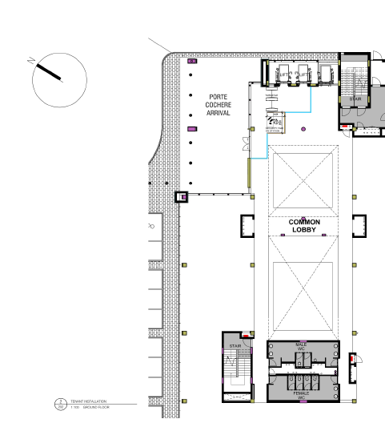
The area highlighted in blue will be occupied by TCTA.

1ST FLOOR
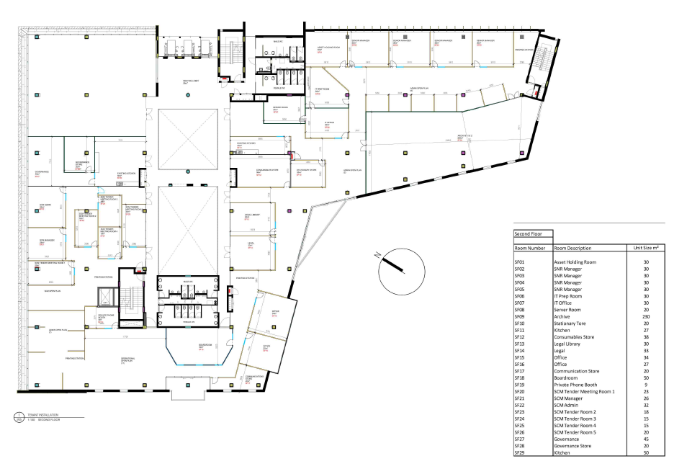
2nd FLOOR
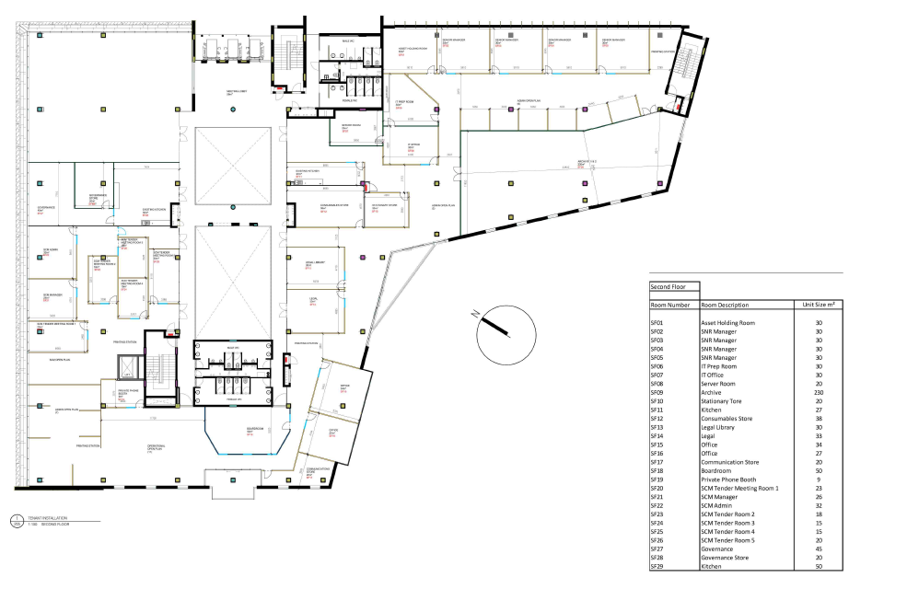

ANNEXURE B: Cleaning Service Standards
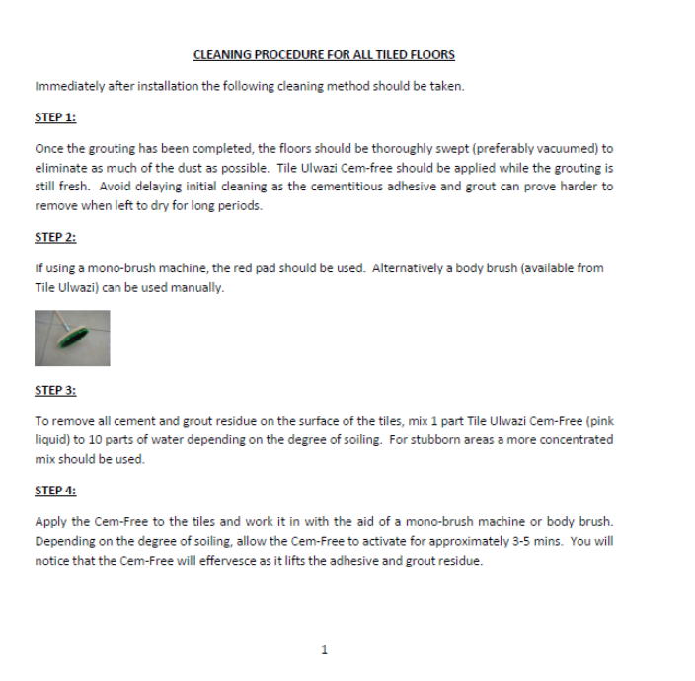

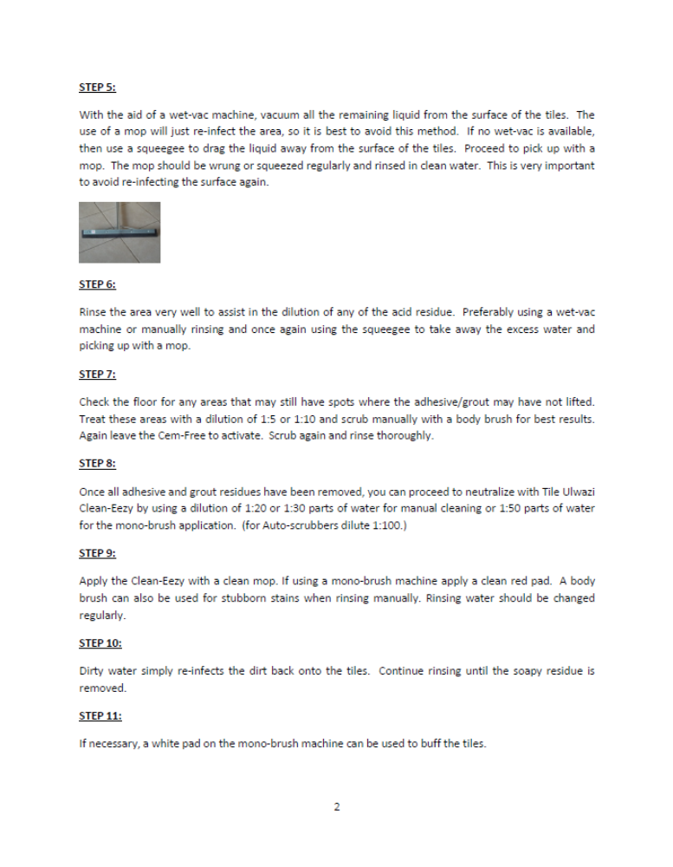

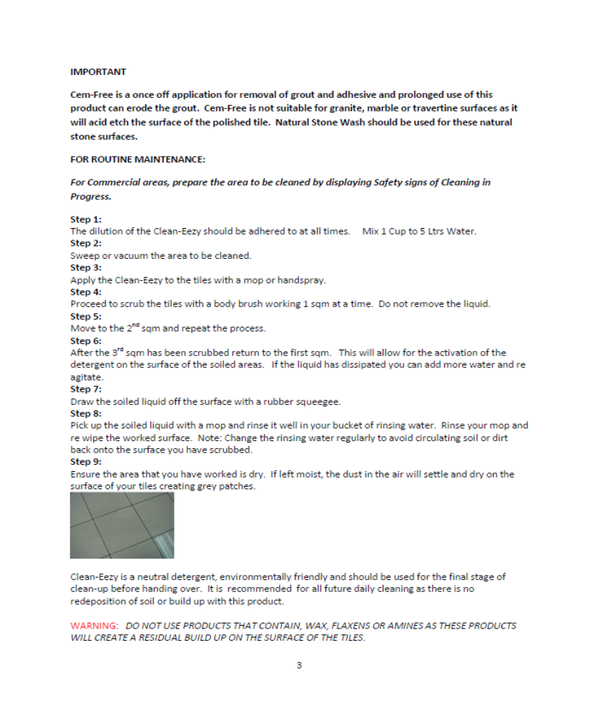



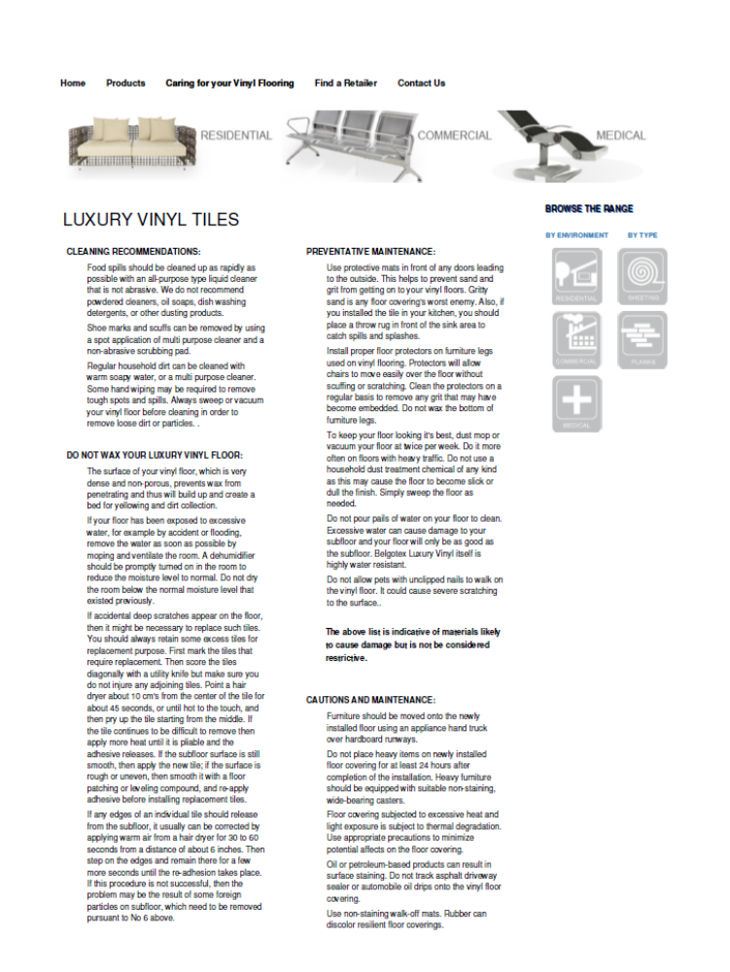

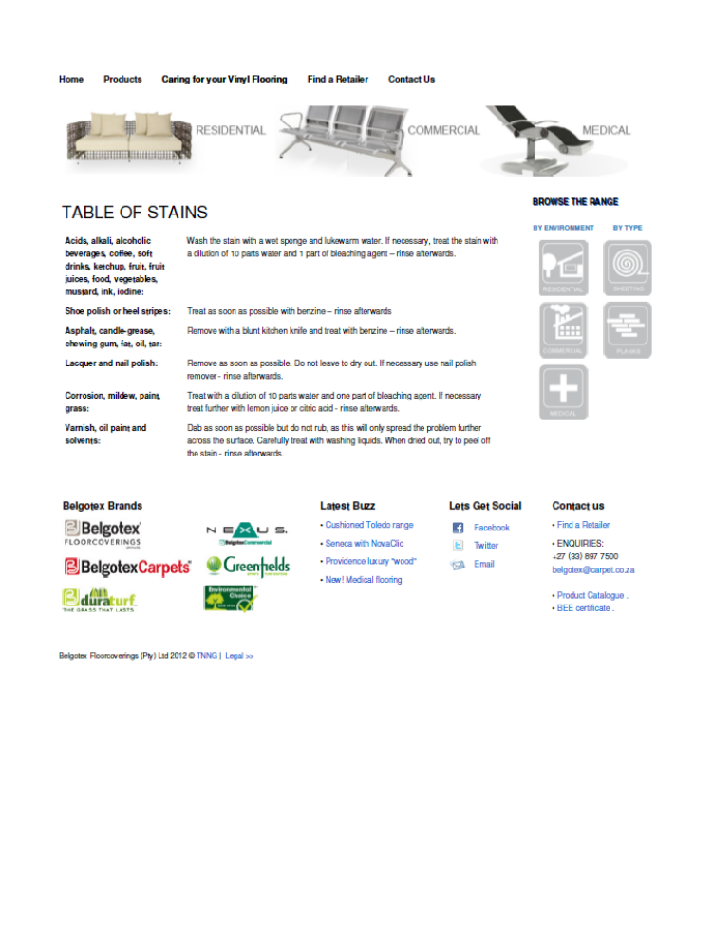

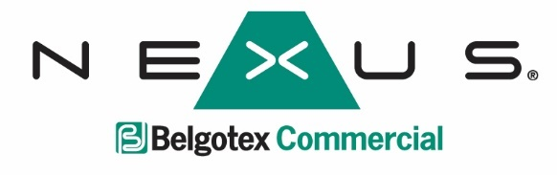


VACUUMING
Regular/Daily vacuuming is the most important component of carpet maintenance. It is the primary means of removing dry soil, the basis of effective soiling control.
Loose particles account for up to 80% of the total soil in a carpet, and become harder to remove the further they are pushed into the pile. Daily vacuuming removes loose soil from the installation and keeps damage from hard, sharp dirt particles to a minimum.
Both medium and heavy contract locations should be vacuumed at least once daily.

WET CLEANING
Nexus recommends that wet cleaning should occur on a regular basis. The frequency of wet cleaning will depend on the level of traffic and the nature of soiling.
Periodic wet cleaning is best left to the professional carpet cleaner, as he will be able to judge accurately which cleaning method will give optimum results. There are three methods at his disposal:
- Rotary brush shampooing
- Spray extraction (steam cleaning)
- Removal and washing method

STAIN REMOVAL PROCEDURES
Prompt action is important to prevent a spillage from penetrating the pile fibres and becoming permanent. It is advisable to have spot and stain removal products and equipment on hand for immediate use.
If the nature of the spills is unknown, start with clean warm water or a mild crystallising carpet cleaning shampoo. If the stain persists, a specialised spot cleaning product should be used. Cleaning products should be checked for colourfastness on a hidden area of the carpet.
Step 1
- Remove any excess spillage immediately.
- Solids should be removed by scraping towards the centre of the stain with a spoon or palette knife, preventing the substance from spreading.
- Liquids should be blotted up thoroughly using white tissues or paper towels, pressing them down into the backing.

Step 2
- Determine exactly what has been split.
- Take not of the accompanying stain removal chart and apply the appropriate shampoo or chemicals in small quantities to avoid over wetting the carpet.
- Work the stain from the edge inwards to prevent it spreading.
- Blot the carpet pile, rather than rubbing it.
- Rinse the treated area with clean water afterwards and avoid walking on the damp spot, as this can cause quick re-soiling.

REMOVAL OF URINE STAINS
Blot the area with an absorbent cloth inwards to the centre from beyond the outside edge of the mark, using warm water and a household detergent, followed by plain water to remove any soapy residue. To remove the odour of urine, apply a solution of 1 tablespoon of vinegar to 500ml water. If the stain reappears, repeat the procedure. This reappearance of a stain is called “wicking”

THE TREATMENT OF SPECIFIC STAINS
Pre-test all cleaning solutions and detergents, on inconspicuous areas of the carpet before using
- Ammonia
White vinegar, rinse with plain water
- Beer/Blood
Detergent solution*, rinse with plain water
- Butter/fats/grease/crayon
Detergent solution*, rinse with plain water
- Carbon paper
Methylated/surgical spirits, detergent solution*, rinse with plain water
- Chewing Gum
Ice, then scrape hardened gum with knife

- Chocolate/cocoa
Detergent solution*, rinse with plain water
- Coal dust
Detergent solution*, rinse with plain water
- Coke/Pepsi/coffee
Detergent solution*, rinse with plain water
- Egg
Detergent solution*, rinse with plain water
- Fruit juice/gravy
Detergent solution*, rinse with plain water
- Hair lacquer/nail varnish
Surgical spirits/acetone
- Ice Cream/jelly
Detergent solution*, rinse with plain water
- Iodine
Sodium-thiosulphate
- Jam
Detergent solution*, rinse with plain water
- Milk/mustard
Detergent solution*, rinse with plain water
- Oil (Vegetable oil/suntan or baby oil)
Detergent solution*, rinse with plain water
- Paint (Oil bound paint)
Professional cleaner
- Water emulsion paint
Professional cleaner
- Shoe/furniture polish/wax
Detergent solution*, rinse with plain water

- Sauces
Methylated/surgical spirits, detergent solution*, rinse with plain water
- Spirits/syrup
Detergent solution*, rinse with plain water
- Tar/asphalt
Consult professional cleaner
- Vomit/faeces
Detergent solution*, white vinegar, rinse with plain water
- Varnish
Consult professional cleaner
- Wine
Detergent solution*, rinse with plain water

Ink:
- Ballpoint Pen
Methylated/surgical spirits/acetone
- Felt tip pen
Acetone
- Fountain pen
Detergent solution*, rinse with plain water
- Indian pen
Acetone
- Marking ink
Detergent solution*, plain water, acetone
- Red ink
Methylated/surgical spirits, detergent solution*, rinse with plain water

Note:
In addition to the above maintenance guide Nexus recommends that the SABS - SANS 10245-1993 code of practice for the maintenance of textile floor coverings be followed.

ANNEXURE C: RESOURCE PLAN
RESOURCE PLAN
Description | Requirement |  | Proposal
Outside office hours cleaning | i) | The amount of resources that will be provided and their cleaning hours. (A minimum of 20 person hours per day must be demonstrated)
Outside office hours cleaning | ii) | The cleaning methods that will be used for the office to be cleaned by 8:00?
Office hours cleaning | i) | How will the supervisor manage the 7 resources?
Office hours cleaning | ii) | Will these workers be part of the out of office hours cleaning team?  If the answer is YES state how the hours worked for each employee will work in line with the Basic Conditions of Employment Act and the minimum hours worked?
Office hours cleaning | iii) | Will these workers be part of the out of office hours cleaning team and how this will work?
Covering for employees on leave or absent | i) | What plans are in place to ensure that the services are provided as per the scope of works when cleaning staff are absent?
List of cleaning consumables to be used each month including the QTY as a guide. This list including the quantities can be varied. | Consumable (e.g. dishwashing soap) |  | QTY | Bidder proposed quantities
 | i) | Floor cleaner | 20 litres
 | ii) | Toilet Disinfectant | 20 litres
 | iii) | Duo cubes for the urinals | 5 kg
 | iv) | Table polish | 5 litres
 | v) | Dishwashing liquid | 10 litres
 | vi) | Bleach | 10 litres
 | vii) | Liquid hand soap | 15 litres
 | viii) | Scouring sponge | 50 pieces
 | ix) | Dishcloths | 15 pieces
 | x) | Dishwasher tablets | 2.5 kg
 | xi) | Dishwasher salt | 1.250 kg
 | xii) | Flying and crawling insect killer | 7.50 litres
 | xiii) | Aerosol air freshener | 15 litres
 | ivx)
 | xv)
 | xvi)
 | xvii)
 | xviii)
 | ixx)
 | xx)
Cleaning IT Equipment | i) | The days of the month this will be done and the number of people employed
Cleaning IT Equipment | ii) | If employed will they be separate workers , part of the office hours workers or part of the out of office hours workers
Cleaning IT Equipment | iii) | The methods and the and the cleaning equipment and chemicals that will be used
Deep cleaning of soft furnishing, carpets, couches and chairs) | i) | Will this be done during the week, out of office hours or on the weekend and the number of people employed (or whether this service will be subcontracted and to whom)
Deep cleaning of toilets | i) | How will this function be performed outside of office hours?
Cleaning of windows in spiral staircase | i) | How will this function be performed? Specify the type of equipment that will be used and the amount of resources.
Cleaning of pool vehicles | i) | State whether this will be done during the week (out of office hours) or on the weekend and the number of people employed?
Cleaning of storerooms and archives | i) | State whether this will be done during the week (out of office hours) or on the weekend and the number of people employed?
Cleaning of emergency exit stairs | i) | State whether this will be done during the week (out of office hours) or on the weekend and the number of people employed?
Sterilization of all water jugs | i) | State whether this will be done during the week (out of office hours) or on the weekend and the number of people employed?
Dust all vertical surfaces (walls, cabinets etc.) | i) | State whether this will be done during the week (out of office hours) or on the weekend and the number of people employed?
Dust all window ledges (high and low) | i) | State whether this will be done during the week (out of office hours) or on the weekend and the number of people employed?
Dust all vertical blinds and pictures | i) | State whether this will be done during the week (out of office hours) or on the weekend and the number of people employed?
Defrosting of fridges | i) | State whether this will be done during the week (out of office hours) or on the weekend and the number of people employed?
Hourly rate:
Supervisors | i)
Cleaners | ii)

NB: Non-compliance of the Hourly rates to the sectorial determination will result in the bidder being disqualified.

Annexure D: COMPANY EXPERIENCE
FORM 1: COMPANY EXPERIENCE

Name of Bidder: …...........................................………

How many years has the bidding company been providing cleaning or hygiene services? ________________

Use the below table to list all projects reflecting experience of at least (4) years in provision of cleaning or hygiene services

Client Name | Office Cleaning (tick if applicable) | Specialised cleaning (tick if applicable) | Hygiene Services  (tick if applicable) | Project start date (indicate months & years) | Project finish date (indicate months & years) | Client Contact Person | Telephone Number | E-mail Address | Specify YES / NO, if the reference document submitted
 |  |  |  | dd/mm/yyyy | dd/mm/yyyy

SIGNATURE: ............................................……… NAME OF BIDDER ..............…....................................
(Person authorised to sign on behalf of the bidder)

Annexure E: SUPERVISOR’S EXPERIENCE
FORM 2: SUPERVISOR’S EXPERIENCE

Name of Supervisor: ..............................................……… Identity Number …………………………………

Client Name | Office Cleaning (tick if applicable) | Specialised cleaning (tick if applicable) | Hygiene Services  (tick if applicable) | Contract start and finish dates | Client Contact Person | Telephone Number | E-mail Address
 |  |  |  | dd/mm/yyyy

ANNEXURE F: SBD 1 – INVITATION TO BID
PART A: INVITATION TO BID
YOU ARE HEREBY INVITED TO BID FOR REQUIREMENTS OF THE (NAME OF DEPARTMENT/ PUBLIC ENTITY)
BID NUMBER: | 022/2022/EWSS/CLEANING/RFB |  |  | CLOSING DATE: |  |  |  | 30 Sep 2022 |  |  |  | CLOSING TIME: |  |  |  | 11H00 a.m.
DESCRIPTION | APPOINTMENT OF A SERVICE PROVIDER FOR THE PROVISION OF CLEANING SERVICES AT TCTA’S OFFICES IN CENTURION FOR A PERIOD OF 60 MONTHS
THE SUCCESSFUL BIDDER WILL BE REQUIRED TO FILL IN AND SIGN A WRITTEN CONTRACT FORM (SBD7).
BID RESPONSE DOCUMENTS MAY BE DEPOSITED IN THE BID BOX SITUATED AT (STREET ADDRESS)
265 West Avenue
Tuinhof Building Stinkhout Wing
Centurion
SUPPLIER INFORMATION
NAME OF BIDDER
POSTAL ADDRESS
STREET ADDRESS
TELEPHONE NUMBER |  | CODE |  |  |  |  |  |  |  | NUMBER
CELLPHONE NUMBER
FACSIMILE NUMBER |  | CODE |  |  |  |  |  |  |  | NUMBER
E-MAIL ADDRESS
VAT REGISTRATION NUMBER
SUPPLIER COMPLIANCE STATUS |  | TAX COMPLIANCE SYSTEM PIN: |  |  |  |  |  |  | OR |  | CENTRAL SUPPLIER DATABASE No:
B-BBEE STATUS LEVEL VERIFICATION CERTIFICATE |  | [TICK APPLICABLE BOX]  Yes No |  |  |  |  | B-BBEE STATUS LEVEL SWORN AFFIDAVIT |  |  |  |  |  | [TICK APPLICABLE BOX]  Yes No
AN ACCOUNTING OFFICER AS CONTEMPLATED IN THE CLOSE CORPORATION ACT (CCA) AND NAME THE APPLICABLE IN THE TICK BOX |  |  | AN ACCOUNTING OFFICER AS CONTEMPLATED IN THE CLOSE CORPORATION ACT (CCA)
 |  |  | A VERIFICATION AGENCY ACCREDITED BY THE SOUTH AFRICAN ACCREDITATION SYSTEM (SANAS)
 |  |  | A REGISTERED AUDITOR
 |  |  | NAME:

[A B-BBEE STATUS LEVEL VERIFICATION CERTIFICATE/ SWORN AFFIDAVIT (FOR EMES & QSEs) MUST BE SUBMITTED IN ORDER TO QUALIFY FOR PREFERENCE POINTS FOR B-BBEE]
ARE YOU THE ACCREDITED REPRESENTATIVE IN SOUTH AFRICA FOR THE GOODS /SERVICES /WORKS OFFERED? | Yes No  [IF YES ENCLOSE PROOF] | ARE YOU A FOREIGN BASED SUPPLIER FOR THE GOODS/ SERVICES /WORKS OFFERED? | Yes No  [IF YES, ANSWER PART B:3 BELOW ]
SIGNATURE OF BIDDER |  | DATE
CAPACITY UNDER WHICH THIS BID IS SIGNED (Attach proof of authority to sign this bid; e.g. resolution of directors, etc.)
TOTAL NUMBER OF ITEMS OFFERED |  | TOTAL BID PRICE (ALL INCLUSIVE)
BIDDING PROCEDURE ENQUIRIES MAY BE DIRECTED TO: |  | TECHNICAL INFORMATION MAY BE DIRECTED TO:
DEPARTMENT/PUBLIC ENTITY | TCTA | CONTACT PERSON
CONTACT PERSON | Tefo | TELEPHONE NUMBER
TELEPHONE NUMBER | 012 683 1217 | FACSIMILE NUMBER
FACSIMILE NUMBER |  | E-MAIL ADDRESS
E-MAIL ADDRESS | tenders06@tcta.co.za

PART B: TERMS AND CONDITIONS FOR BIDDING
1. BID SUBMISSION:
  - BIDS MUST BE DELIVERED BY THE STIPULATED TIME TO THE CORRECT ADDRESS. LATE BIDS WILL NOT BE ACCEPTED FOR CONSIDERATION.
  - ALL BIDS MUST BE SUBMITTED ON THE OFFICIAL FORMS PROVIDED–(NOT TO BE RE-TYPED) OR ONLINE
  - BIDDERS MUST REGISTER ON THE CENTRAL SUPPLIER DATABASE (CSD) TO UPLOAD MANDATORY INFORMATION NAMELY: ( BUSINESS REGISTRATION/ DIRECTORSHIP/ MEMBERSHIP/IDENTITY NUMBERS; TAX COMPLIANCE STATUS; AND BANKING INFORMATION FOR VERIFICATION PURPOSES). B-BBEE CERTIFICATE OR SWORN AFFIDAVIT FOR B-BBEE MUST BE SUBMITTED TO BIDDING INSTITUTION.
  - WHERE A BIDDER IS NOT REGISTERED ON THE CSD, MANDATORY INFORMATION NAMELY: (BUSINESS REGISTRATION/ DIRECTORSHIP/ MEMBERSHIP/IDENTITY NUMBERS; TAX COMPLIANCE STATUS MAY NOT BE SUBMITTED WITH THE BID DOCUMENTATION. B-BBEE CERTIFICATE OR SWORN AFFIDAVIT FOR B-BBEE MUST BE SUBMITTED TO BIDDING INSTITUTION.
  - THIS BID IS SUBJECT TO THE PREFERENTIAL PROCUREMENT POLICY FRAMEWORK ACT 2000 AND THE PREFERENTIAL PROCUREMENT REGULATIONS, 2017, THE GENERAL CONDITIONS OF CONTRACT (GCC) AND, IF APPLICABLE, ANY OTHER LEGISLATION OR SPECIAL CONDITIONS OF CONTRACT
2. TAX COMPLIANCE REQUIREMENTS
- BIDDERS MUST ENSURE COMPLIANCE WITH THEIR TAX OBLIGATIONS.
- BIDDERS ARE REQUIRED TO SUBMIT THEIR UNIQUE PERSONAL IDENTIFICATION NUMBER (PIN) ISSUED BY SARS TO ENABLE THE ORGAN OF STATE TO VERIFY THE TAXPAYER’S PROFILE AND TAX STATUS.
- APPLICATION FOR TAX COMPLIANCE STATUS (TCS) PIN MAY BE MADE VIA E-FILING THROUGH THE SARS WEBSITE WWW.SARS.GOV.ZA.
- BIDDERS MAY ALSO SUBMIT A PRINTED TCS CERTIFICATE TOGETHER WITH THE BID.
- IN BIDS WHERE CONSORTIA / JOINT VENTURE OR CONSORTIUMS / SUB-CONTRACTORS ARE INVOLVED, EACH PARTY MUST SUBMIT A SEPARATE TCS CERTIFICATE / PIN / CSD NUMBER.
- WHERE NO TCS PIN IS AVAILABLE BUT THE BIDDER IS REGISTERED ON THE CENTRAL SUPPLIER DATABASE (CSD), A CSD NUMBER MUST BE PROVIDED.
3. QUESTIONNAIRE TO BIDDING FOREIGN SUPPLIERS
3.1 IS THE ENTITY A RESIDENT OF THE REPUBLIC OF SOUTH AFRICA (RSA)? YES NO
3.2 DOES THE ENTITY HAVE A BRANCH IN THE RSA? YES NO
3.3 DOES THE ENTITY HAVE A PERMANENT ESTABLISHMENT IN THE RSA? YES NO
3.4 DOES THE ENTITY HAVE ANY SOURCE OF INCOME IN THE RSA? YES NO
IF THE ANSWER IS “NO” TO ALL OF THE ABOVE, THEN IT IS NOT A REQUIREMENT TO REGISTER FOR A TAX COMPLIANCE STATUS SYSTEM PIN CODE FROM THE SOUTH AFRICAN REVENUE SERVICE (SARS) AND IF NOT REGISTER AS PER 2.3 BELOW.

NB: FAILURE TO PROVIDE / OR COMPLY WITH ANY OF THE ABOVE PARTICULARS MAY RENDER THE BID INVALID.
SIGNATURE OF BIDDER: ……………………………………………
CAPACITY UNDER WHICH THIS BID IS SIGNED: ……………………………………………
(Proof of authority must be submitted e.g. company resolution)
DATE: …………………………………………...

ANNEXURE G: SBD 4 – BIDDER’S DISCLOSURE
BIDDER’S DISCLOSURE
- PURPOSE OF THE FORM
Any person (natural or juristic) may make an offer or offers in terms of this invitation to bid. In line with the principles of transparency, accountability, impartiality, and ethics as enshrined in the Constitution of the Republic of South Africa and further expressed in various pieces of legislation, it is required for the bidder to make this declaration in respect of the details required hereunder.
Where a person/s are listed in the Register for Tender Defaulters and / or the List of Restricted Suppliers, that person will automatically be disqualified from the bid process.

- BIDDER’S DECLARATION
2.1 Is the bidder, or any of its directors / trustees / shareholders / members / partners or any person having a controlling interest in the enterprise, employed by the state? YES/NO
2.1.1 If so, furnish particulars of the names, individual identity numbers, and, if applicable, state employee numbers of sole proprietor/ directors / trustees / shareholders / members/ partners or any person having a controlling interest in the enterprise, in table below.
Full Name | Identity Number | Name of State institution

- Do you or any person connected with the bidder, have a relationship with any person who is employed by the procuring institution ? | YES / NO
2.2.1 If so, furnish the following particulars:
……....………………………………………………………………………
……....………………………………………………………………………
  - Does the bidder or any of its directors / trustees / shareholders / members / partners or any person having a controlling interest in the enterprise have any interest in any other related enterprise whether or not they are bidding for this contract?
2.3.1 If so, furnish the following particulars:
……....………………………………………………………………………
……....………………………………………………………………………

- DECLARATION
I, the undersigned, (name)……………………………………………………………………. in submitting the accompanying bid, do hereby make the following statements that I certify to be true and complete in every respect:
3.1 I have read and I understand the contents of this disclosure;
3.2 I understand that the accompanying bid will be disqualified if this disclosure is found not to be true and complete in every respect;
3.3 The bidder has arrived at the accompanying bid independently from, and without consultation, communication, agreement or arrangement with any competitor. However, communication between partners in a joint venture or consortium will not be construed as collusive bidding.
3.4 In addition, there have been no consultations, communications, agreements or arrangements with any competitor regarding the quality, quantity, specifications, prices, including methods, factors or formulas used to calculate prices, market allocation, the intention or decision to submit or not to submit the bid, bidding with the intention not to win the bid and conditions or delivery particulars of the products or services to which this bid invitation relates.
3.5 The terms of the accompanying bid have not been, and will not be, disclosed by the bidder, directly or indirectly, to any competitor, prior to the date and time of the official bid opening or of the awarding of the contract.
3.6 There have been no consultations, communications, agreements or arrangements made by the bidder with any official of the procuring institution in relation to this procurement process prior to and during the bidding process except to provide clarification on the bid submitted where so required by the institution; and the bidder was not involved in the drafting of the specifications or terms of reference for this bid.
3.7 I am aware that, in addition and without prejudice to any other remedy provided to combat any restrictive practices related to bids and contracts, bids that are suspicious will be reported to the Competition Commission for investigation and possible imposition of administrative penalties in terms of section 59 of the Competition Act No 89 of 1998 and or may be reported to the National Prosecuting Authority (NPA) for criminal investigation and or may be restricted from conducting business with the public sector for a period not exceeding ten (10) years in terms of the Prevention and Combating of Corrupt Activities Act No 12 of 2004 or any other applicable legislation.
I CERTIFY THAT THE INFORMATION FURNISHED IN PARAGRAPHS 1, 2 and 3 ABOVE IS CORRECT.
I ACCEPT THAT THE STATE MAY REJECT THE BID OR ACT AGAINST ME IN TERMS OF PARAGRAPH 6 OF PFMA SCM INSTRUCTION 03 OF 2021/22 ON PREVENTING AND COMBATING ABUSE IN THE SUPPLY CHAIN MANAGEMENT SYSTEM SHOULD THIS DECLARATION PROVE TO BE FALSE.

……………………………… ..……………………………………………
Signature Date

……………………………… ………………………………………………
Position Name of bidder

ANNEXURE H: SBD 6.1 – PREFERENCE POINTS CLAIM FORM IN TERMS OF THE PREFERENTIAL PROCUREMENT REGULATIONS 2017
This preference form must form part of all bids invited. It contains general information and serves as a claim form for preference points for Broad-Based Black Economic Empowerment (B-BBEE) Status Level of Contribution
NB: BEFORE COMPLETING THIS FORM, BIDDERS MUST STUDY THE GENERAL CONDITIONS, DEFINITIONS AND DIRECTIVES APPLICABLE IN RESPECT OF B-BBEE, AS PRESCRIBED IN THE PREFERENTIAL PROCUREMENT REGULATIONS, 2017.
- GENERAL CONDITIONS
  - The following preference point systems are applicable to all bids:
- the 80/20 system for requirements with a Rand value of up to R50 000 000 (all applicable taxes included); and
- the 90/10 system for requirements with a Rand value above R50 000 000 (all applicable taxes included).

- The value of this bid is estimated to exceed/not exceed R50 000 000 (all applicable taxes included) and therefore the …80/20……… preference point system shall be applicable; or
- The 80/20 preference point system will be applicable to this tender.
  - Points for this bid shall be awarded for:
- Price; and
- B-BBEE Status Level of Contributor.
  - The maximum points for this bid are allocated as follows:
 | POINTS
PRICE | 80
B-BBEE STATUS LEVEL OF CONTRIBUTOR | 20
Total points for Price and B-BBEE must not exceed | 100

  - Failure on the part of a bidder to submit proof of B-BBEE Status level of contributor together with the bid, will be interpreted to mean that preference points for B-BBEE status level of contribution are not claimed.
  - The purchaser reserves the right to require of a bidder, either before a bid is adjudicated or at any time subsequently, to substantiate any claim in regard to preferences, in any manner required by the purchaser.

- DEFINITIONS
- “B-BBEE” means broad-based black economic empowerment as defined in section 1 of the Broad-Based Black Economic Empowerment Act;
- “B-BBEE status level of contributor” means the B-BBEE status of an entity in terms of a code of good practice on black economic empowerment, issued in terms of section 9(1) of the Broad-Based Black Economic Empowerment Act;
- “bid” means a written offer in a prescribed or stipulated form in response to an invitation by an organ of state for the provision of goods or services, through price quotations, advertised competitive bidding processes or proposals;
- “Broad-Based Black Economic Empowerment Act” means the Broad-Based Black Economic Empowerment Act, 2003 (Act No. 53 of 2003);
- “EME” means an Exempted Micro Enterprise in terms of a code of good practice on black economic empowerment issued in terms of section 9 (1) of the Broad-Based Black Economic Empowerment Act;
- “functionality” means the ability of a tenderer to provide goods or services in accordance with specifications as set out in the tender documents.
- “prices” includes all applicable taxes less all unconditional discounts;
- “proof of B-BBEE status level of contributor” means:
- B-BBEE Status level certificate issued by an authorized body or person;
- A sworn affidavit as prescribed by the B-BBEE Codes of Good Practice;
- Any other requirement prescribed in terms of the B-BBEE Act;
- “QSE” means a qualifying small business enterprise in terms of a code of good practice on black economic empowerment issued in terms of section 9 (1) of the Broad-Based Black Economic Empowerment Act;
- “rand value” means the total estimated value of a contract in Rand, calculated at the time of bid invitation, and includes all applicable taxes;

- POINTS AWARDED FOR PRICE
  - THE 80/20 OR 90/10 PREFERENCE POINT SYSTEMS
A maximum of 80 or 90 points is allocated for price on the following basis:
80/20 or 90/10
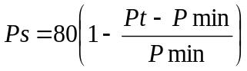 or 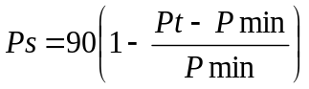
Where:
Ps = Points scored for price of bid under consideration
Pt = Price of bid under consideration
Pmin = Price of lowest acceptable bid

- POINTS AWARDED FOR B-BBEE STATUS LEVEL OF CONTRIBUTOR
  - In terms of Regulation 6 (2) and 7 (2) of the Preferential Procurement Regulations, preference points must be awarded to a bidder for attaining the B-BBEE status level of contribution in accordance with the table below:
B-BBEE Status Level of Contributor | Number of points  (90/10 system) | Number of points  (80/20 system)
1 | 10 | 20
2 | 9 | 18
3 | 6 | 14
4 | 5 | 12
5 | 4 | 8
6 | 3 | 6
7 | 2 | 4
8 | 1 | 2
Non-compliant contributor | 0 | 0

- BID DECLARATION
  - Bidders who claim points in respect of B-BBEE Status Level of Contribution must complete the following:

- B-BBEE STATUS LEVEL OF CONTRIBUTOR CLAIMED IN TERMS OF PARAGRAPHS 1.4 AND 4.1
  - B-BBEE Status Level of Contributor: . = ……… (maximum of 10 or 20 points)
(Points claimed in respect of paragraph 7.1 must be in accordance with the table reflected in paragraph 4.1 and must be substantiated by relevant proof of B-BBEE status level of contributor.

- SUB-CONTRACTING
  - Will any portion of the contract be sub-contracted?
(Tick applicable box)
YES |  | NO

    - If yes, indicate:
- What percentage of the contract will be subcontracted ............…………….…………%
- The name of the sub-contractor ……………………………………………………………..
- The B-BBEE status level of the sub-contractor .........................................……………..
- Whether the sub-contractor is an EME or QSE
(Tick applicable box)
YES |  | NO

- Specify, by ticking the appropriate box, if subcontracting with an enterprise in terms of Preferential Procurement Regulations,2017:
Designated Group: An EME or QSE which is at last  51% owned by: | EME  √ | QSE  √
Black people
Black people who are youth
Black people who are women
Black people with disabilities
Black people living in rural or underdeveloped areas or townships
Cooperative owned by black people
Black people who are military veterans
OR
Any EME
Any QSE

- DECLARATION WITH REGARD TO COMPANY/FIRM
  - Name of company/firm:…………………………………………………………………………….
  - VAT registration number:……………………………………….…………………………………
  - Company registration number:…………….……………………….…………………………….
  - TYPE OF COMPANY/ FIRM
- Partnership/Joint venture or consortium / Consortium
- One person business/sole propriety
- Close corporation
- Company
- (Pty) Limited

[Tick applicable box]

  - DESCRIBE PRINCIPAL BUSINESS ACTIVITIES
……………………………………………………………………………………………………………………………………………………………………………………………………………………………………………………………………………………………………………………………………………………………………………………………………………………
  - COMPANY CLASSIFICATION
- Manufacturer
- Supplier
- Professional service provider
- Other service providers, e.g. transporter, etc.

[Tick applicable box]

  - Total number of years the company/firm has been in business:……………………………
  - I/we, the undersigned, who is / are duly authorised to do so on behalf of the company/firm, certify that the points claimed, based on the B-BBE status level of contributor indicated in paragraphs 1.4 and 6.1 of the foregoing certificate, qualifies the company/ firm for the preference(s) shown and I / we acknowledge that:
- The information furnished is true and correct;
- The preference points claimed are in accordance with the General Conditions as indicated in paragraph 1 of this form;
- In the event of a contract being awarded as a result of points claimed as shown in paragraphs 1.4 and 6.1, the contractor may be required to furnish documentary proof to the satisfaction of the purchaser that the claims are correct;
- If the B-BBEE status level of contributor has been claimed or obtained on a fraudulent basis or any of the conditions of contract have not been fulfilled, the purchaser may, in addition to any other remedy it may have –
  - disqualify the person from the bidding process;
  - recover costs, losses or damages it has incurred or suffered as a result of that person’s conduct;
  - cancel the contract and claim any damages which it has suffered as a result of having to make less favourable arrangements due to such cancellation;
  - recommend that the bidder or contractor, its shareholders and directors, or only the shareholders and directors who acted on a fraudulent basis, be restricted by the National Treasury from obtaining business from any organ of state for a period not exceeding 10 years, after the audi alteram partem (hear the other side) rule has been applied; and
  - forward the matter for criminal prosecution.

WITNESSES  - ……………………………………..  - ……………………………………. |  | SIGNATURE(S) OF BIDDERS(S)  DATE: …………,,,……………………………..  ADDRESS: ……………,,,…………………………..  ……………,,,…………………………..  ……………,,,…….…………………..

the power, by one person or a group of persons holding the majority of the equity of an enterprise, alternatively, the person/s having the deciding vote or power to influence or to direct the course and decisions of the enterprise.
Joint venture or Consortium means an association of persons for the purpose of combining their expertise, property, capital, efforts, skill and knowledge in an activity for the execution of a contract.

